To use ANSYS Fluent in your house, please use VDI (See below Link)
https://etc.engineering.uiowa.edu/help-desk/how-use/vdi-how-use-virtual-windows-desktop

Verification and Validation of Turbulent Flow

around a Clark-Y Airfoil

ME:5160 Intermediate Mechanics of Fluids

CFD LAB 2

(ANSYS 2022 R1; Last Updated: July 19, 2022)

By Timur Dogan, Michael Conger, Dong-Hwan Kim,
Christian Milano, Maysam Mousaviraad, Tao Xing and Fred Stern

IIHR-Hydroscience & Engineering
The University of Iowa
C. Maxwell Stanley Hydraulics Laboratory
Iowa City, IA 52242-1585

- Purpose

The Purpose of CFD Lab 2 is to simulate turbulent airfoil flows following “CFD process” by an interactive step-by-step approach and to conduct verifications. Students will have “hands-on” experiences using ANSYS to conduct verification for lift coefficient and pressure coefficient distributions, and validation for pressure coefficient distribution, including effect of numerical scheme. Students will manually generate C type mesh and investigate the effect of domain size and effect of angle of attack on simulation results. Students will analyze the differences between CFD and EFD, analyze possible sources of errors, and present results in a CFD Lab report.

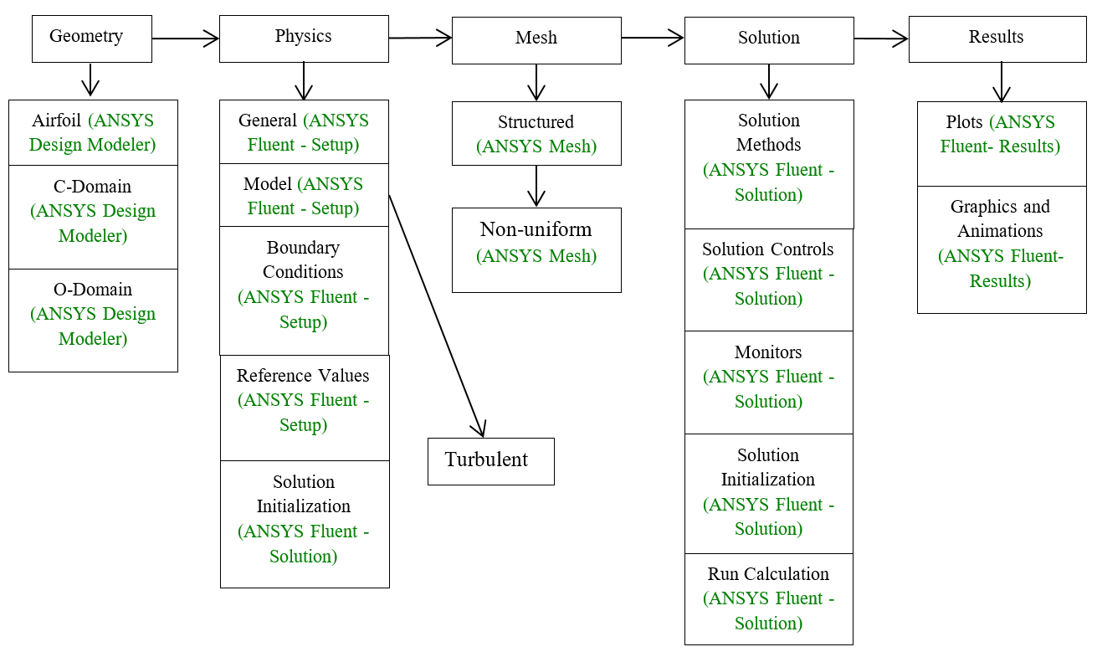
Flow Chart for “CFD Process” for airfoil flow
- Simulation Design

The problem to be solved is that of turbulent flows around a Clark-Y airfoil. Reynolds number is 143,000 based on the inlet velocity and airfoil chord length. The following figures show the illustrations for C type and O type domains (Note: the figures are not in the exact scale as the true size of the domain and airfoil).

Table 1 - Main particulars
Parameter | Symbol | Unit | O-type | C-Type
Chord Length | C | m | 0.3048 | 0.3048
Downstream length | Lo | m | - | 5
Radius | Rc | m | 5,4,3,2,1 | 5
Angle of attack | α | degree | 0,6 | 0

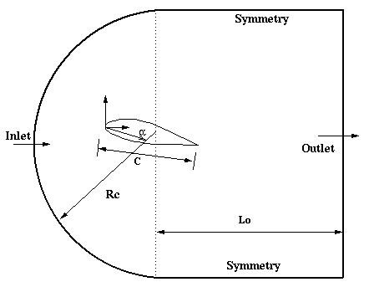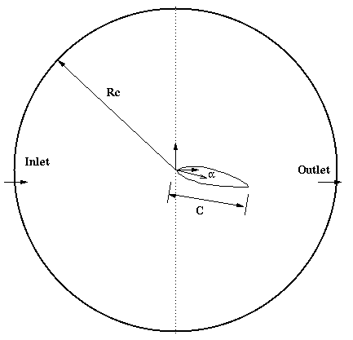

Figure 1 – C and O domain shapes and boundary conditions

In CFD Lab 2, boundary conditions for C type of mesh will be “inlet”, “outlet”, “symmetry” and “airfoil”, as described later. Boundary conditions for O type of meshes will be “inlet”, “outlet”, and “airfoil”. Uniform flow was specified at inlet. For outlet, zero gradients are fixed for all velocities and pressure is constant. No-slip boundary condition will be used on the “airfoil”. Symmetric boundary condition will be applied on the “symmetry”. The meshes and the simulations that will be conducted are shown in Tables 2 and 3 respectively.

Table 2 - Mesh
Mesh Name | Domain Type | Radius [m] | Angle of Attack (AOA) [degree]
C-mesh | C | 5 | 0
fine | O
medium
coarse
Domain-R5
Domain-R4 |  | 4
Domain-R3 |  | 3
Domain-R2 |  | 2
Domain-R1 |  | 1
AOA6 |  | 5 | 6

Table 3 - Simulation Matrix
Study | Mesh
Domain size | Domain-R1, Domain-R2, Domain-R3, Domain-R4, Domain-R5
V&V and effect of numerical scheme | fine, medium, coarse
Domain shape | C-mesh
Angle of attack | AOA6

All EFD data and CFD materials for turbulent airfoil flow in this Lab can be downloaded from class website (http://www.engineering.uiowa.edu/~me_160/).

- ANSYS Workbench

  - Start > All Programs > ANSYS 2022 R1> Workbench 2022 R1

  - Toolbox > Component Systems. Drag and drop Geometry, Mesh and Fluent components to Project Schematic and name components as per below (Only C-Domain requires Geometry; i.e. other cases directly use Mesh skipping Geometry). Create connection as per below.
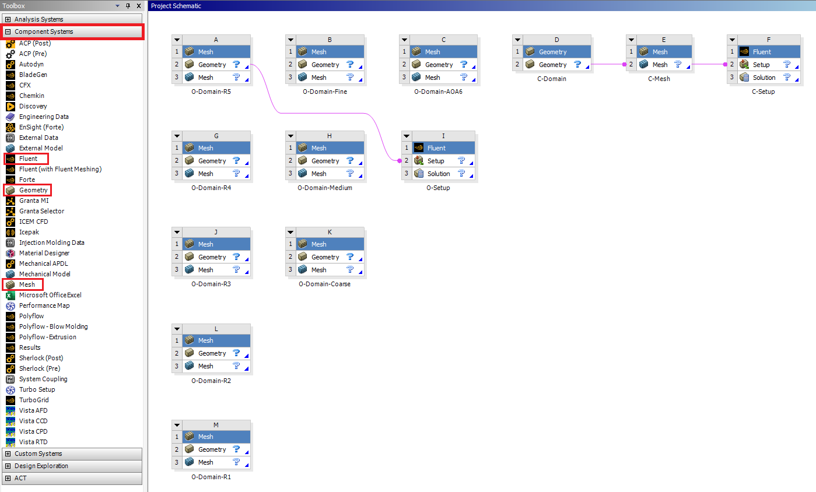

  - File > Save As…. Save project on the network drive so that you can access anywhere in Engineering building (recommended). Name the file “CFD Lab 2”.

- Geometry

  - From the Project Schematic, right click on the C-Domain Geometry and select New DesignModeler Geometry…

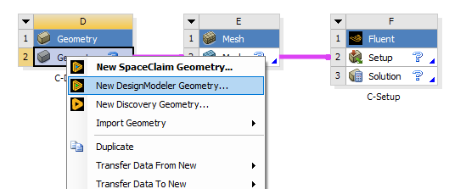

  - Make sure that Unit is set to Meter (default value).
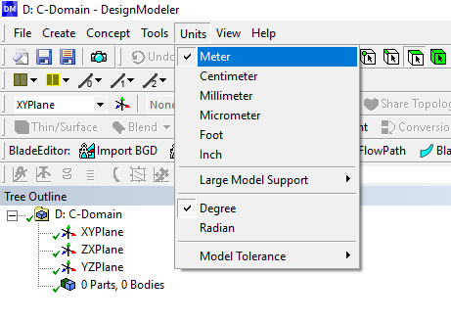

  - Go to the class website and download Airfoil geometry (You can download the file by right clicking and selecting Save as or Save target as).

  - File > Import External Geometry File… Select airfoil.igs downloaded and click Open. Click Generate. Please remind that view can be moved to xy-plane view by clicking z-axis on 3-D axis at right bottom of the window. Drag and drop with right mouse button only for zooming in. Use wheel to zoom in/out. Press F7 to restore the view.
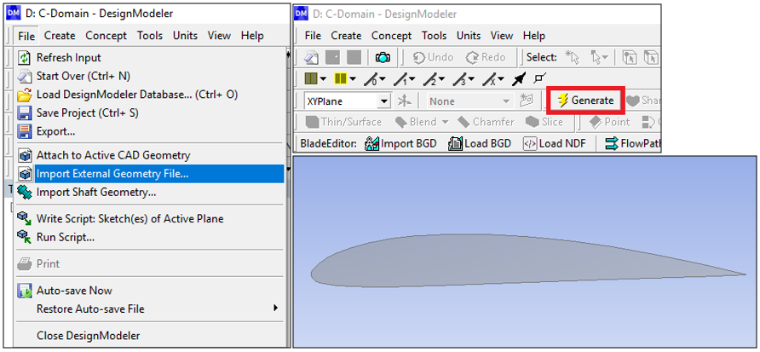

  - Add a new plane by selecting the New Plane (not New Sketch) button. For the Type select From Point and Normal.
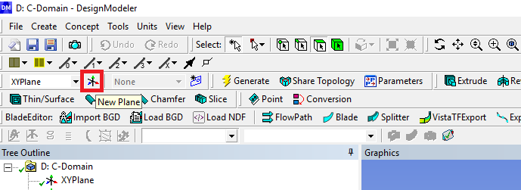

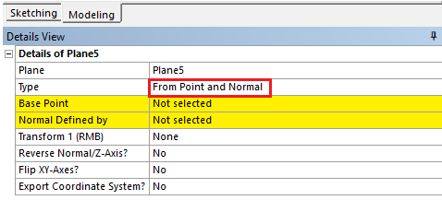

  - For the Base Point, zoom in and select the point at the trailing edge as seen below and click Apply.
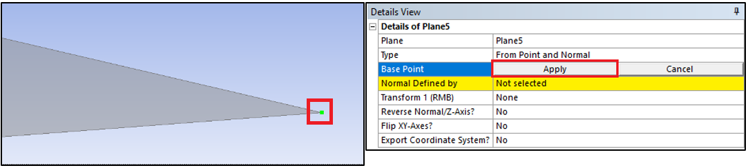

  - For the Normal Defined By, select the XYPlane on the Tree Outline and click Apply. Then click Generate. This creates a plane with the origin at the trailing edge point.
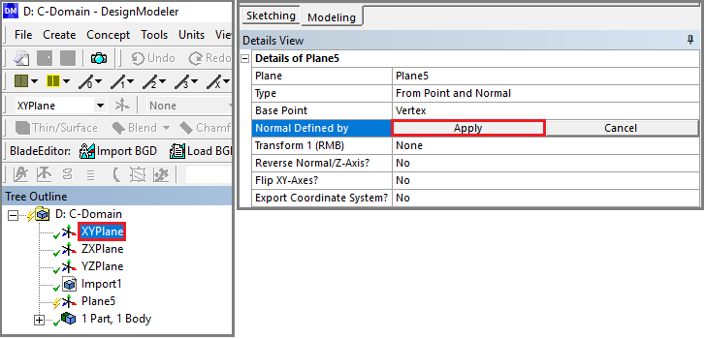
  - Make sure the plane you just created is selected under tree outline then click the New Sketch button.
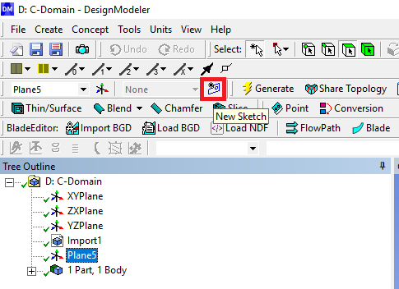
  - In Sketching Toolboxes>Constraints, Enable the Auto Constraints option to pick the exact point as below
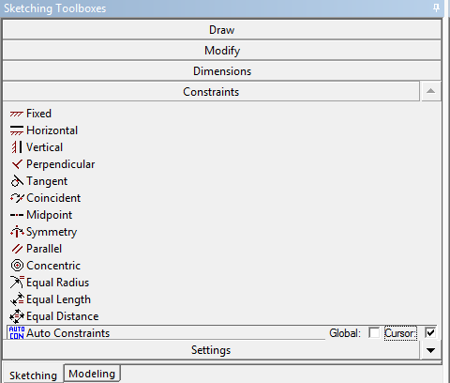

  - Sketching > Draw > Arc by Center. Draw an arc centered at the trailing edge origin as per below. Make sure the end points are on the y-axis. The Auto Constraint will show “P” on the mouse point when it goes near the origin and “C” near the y-axis.
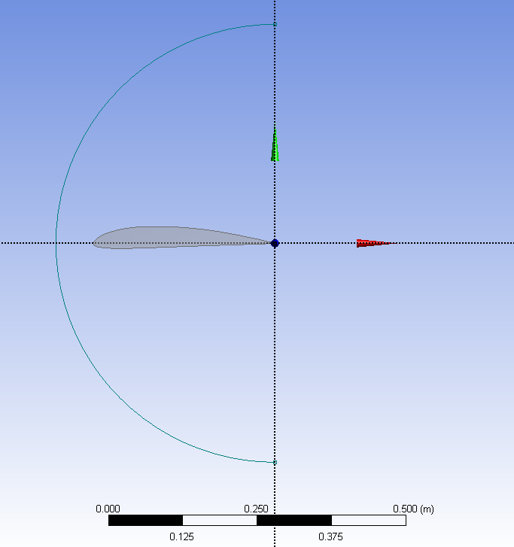
  - Sketching > Draw > Rectangle by 3 Points. Draw a rectangle as per below. Start by selecting one of the arc’s ends and then select the other arc end, then pull the rectangle out to the right so it looks like the figure below and left click. Make sure, when selecting the arc ends, the “P” shows up ensuring you are selecting the point at the end of the arc.
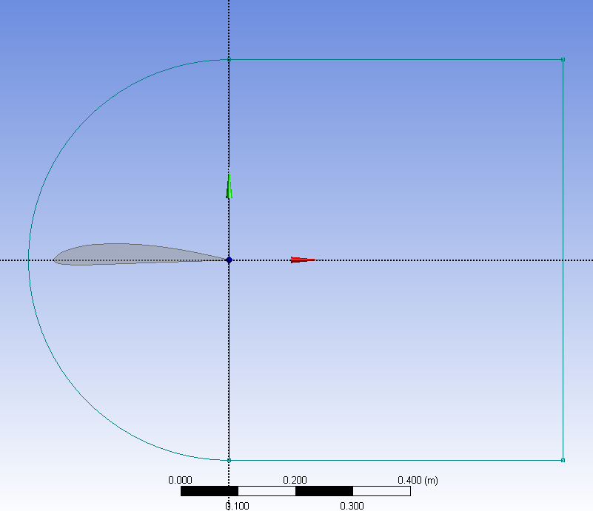

  - Dimensions > General. Size the arc and rectangle with a radius of 5m and a width of 5m respectively as seen below (Do not add unit [m] when you put in the values). To use the tool, left click on the edge you want and click somewhere outside from the edge.

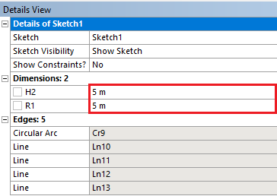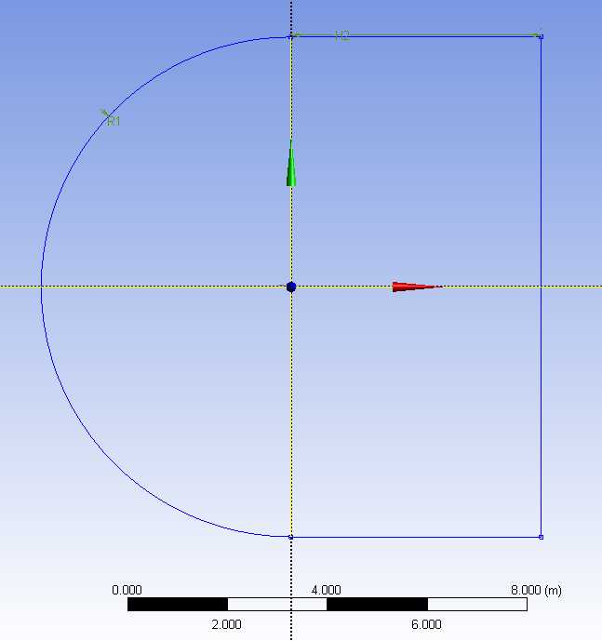
  - Delete the line that makes the left side of the rectangle by highlighting as yellow by selecting it and pressing Delete on the keyboard (This works only when “Sketching” tab is activated).

  - Concept > Surfaces from Sketches. Select the sketch you just made under tree outline, click Apply then click Generate.
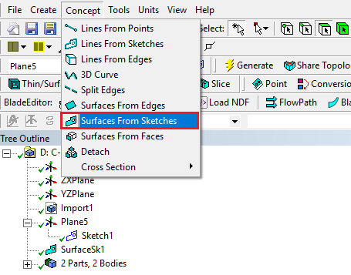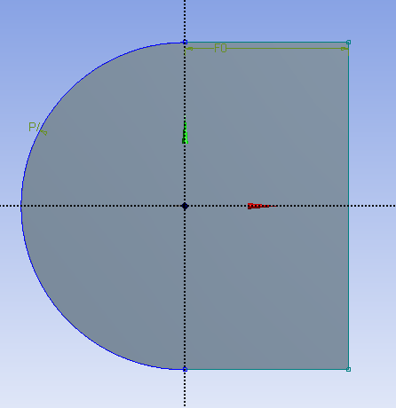

  - Create > Boolean. Make sure the Operation is set to Subtract. For the Target Body select the gray domain and click Apply. For the Tool Bodies select the airfoil by selecting the first Surface Body under the Tree Outline which corresponds to the airfoil (or simply zoom in near to the airfoil and select it) and click Apply. Then click Generate. This step will make the domain hollow as airfoil shape.

  - Concept > Split Edges. Select the arc and click Apply. Make sure the Fraction is set to 0.5. This splits the edge in half. Click Generate.
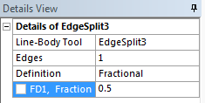

  - Select the upper half of the arc you just split. Concept > Split Edges. Click Apply and change the Fraction to 0.25. This splits the top arc into two parts with the small piece towards the top of the screen. Click Generate.

  - Repeat step 4.16 for the bottom piece of the arc you originally split but this time change the Fraction to 0.75. This will split the arc with the smaller piece towards the bottom of the screen. Click Generate.

  - Split the vertical line from the rectangle in half as well. Make sure that Fraction is set to 0.5. Concept > Split Edges. Select the vertical line and click Apply. Click Generate.

  - Concept > Lines From Points draw lines from the domain perimeter to the perimeter of the airfoil always starting from the domain and ending at the airfoil. Do this by selecting the point on the domain, hold Ctrl and select the point on the airfoil. Click Apply and then Generate. Repeat this process to create all the lines shown below. NOTE: If you do not create your lines starting from domain and ending in airfoil you will need to use a different bias type in the Mesh Generation section.

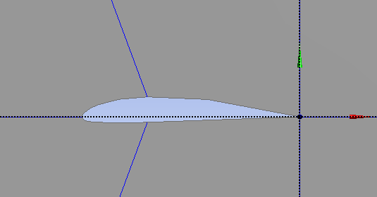
  - Tools > Projection. For the Edges select all the lines you just created by holding Ctrl while selecting them and then click Apply. For the Target select the surface of the domain and click Apply. Click Generate. This splits the domain into six sections as seen below.

  - File > Save Project. Close window.

- Mesh

In this section C-Mesh will be manually generated and the O-type Meshes will be imported.

  - From the Project Schematic right click on C-Mesh and select Edit.

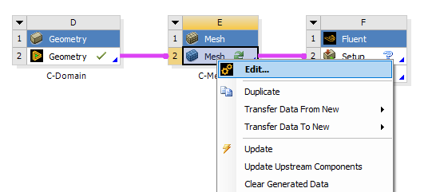

  - Right click on Mesh > Insert > Face Meshing. Select all six surfaces while holding Ctrl and click Apply in the yellow Geometry selection box.

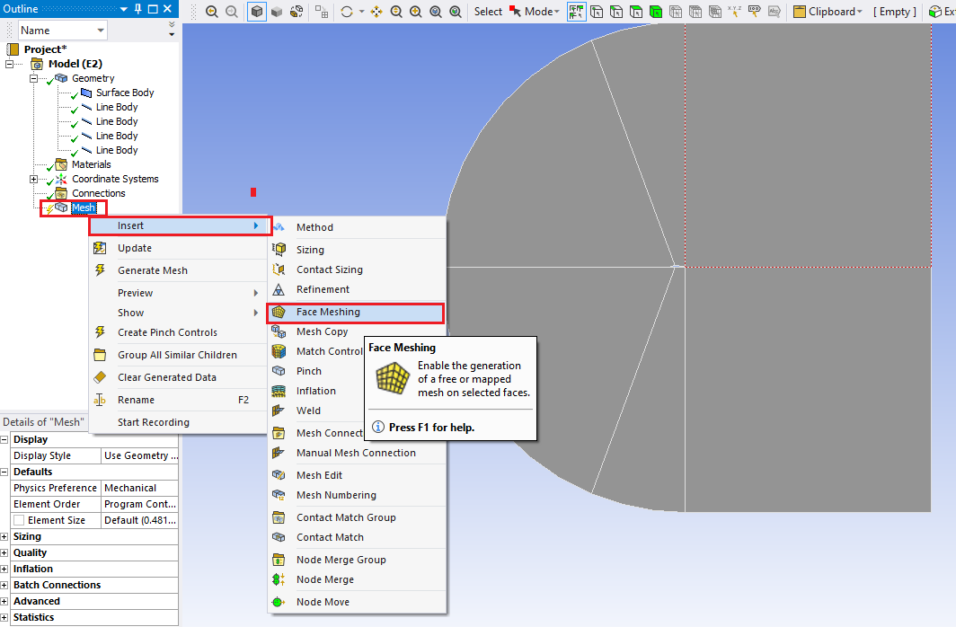
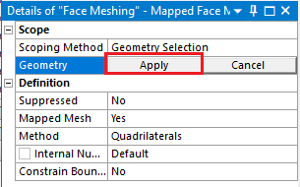

  - Select the edge button.
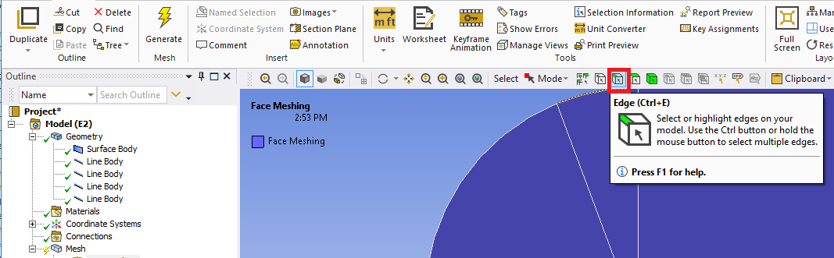

  - Right click on Mesh > Insert > Sizing. Select five lines below and click Apply. Change parameters as per below. NOTE: The divisions must be finer toward the airfoil. If they are not fine toward the airfoil you may need to change the bias direction by changing bias type for the edges having issue.
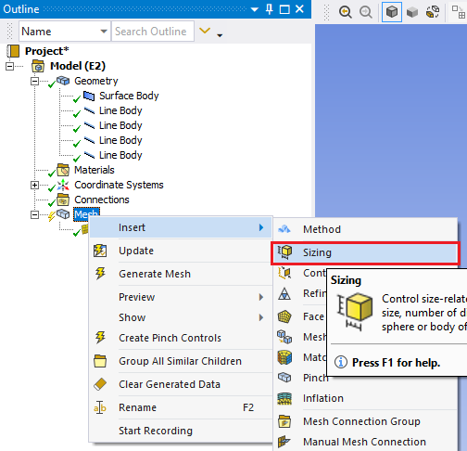
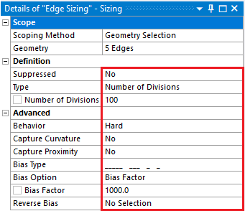
4
5
3
2
1

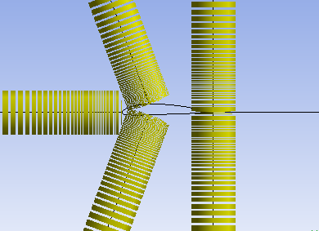

  - Right click on Mesh > Insert > Sizing. Select the line below and click Apply. Change parameters as per below. Divisons must be finer toward the airfoil.
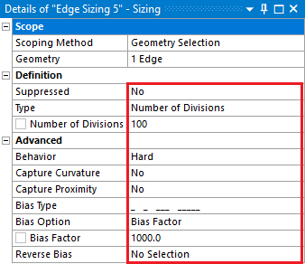
→

  - Right click on Mesh > Insert > Sizing. Select the line below and click Apply. Change parameters as per below. Divisons must be finer toward the airfoil.
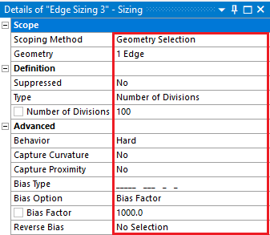
→

  - Right click on Mesh > Insert > Sizing. Select two lines below and click Apply. Change parameters as per below. Divisons must be finer toward the airfoil.
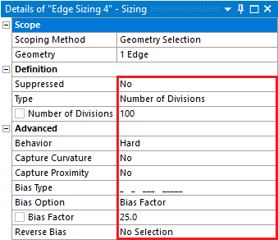
↓
↓

  - Right click on Mesh > Insert > Sizing. Select the line below and click Apply. Change parameters as per below. Divisons must be finer toward the airfoil.
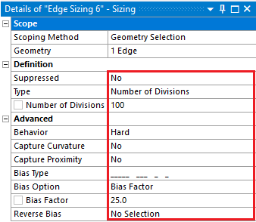
↑

  - Right click on Mesh > Insert > Sizing. Select two lines below and click Apply. Change parameters as per below.
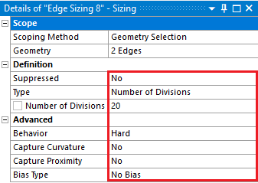
↓
↑

  - Right click on Mesh > Insert > Sizing. Select two lines below and click Apply. Change parameters as per below.
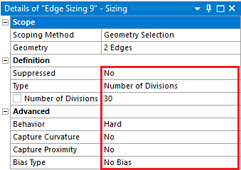
←
←

  - Right click on Mesh > Insert > Sizing. Select two lines below and click Apply. Change parameters as per below.
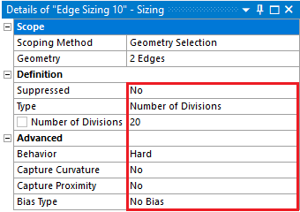
←
←

  - Right click on Mesh > Insert > Sizing. Selct the line below and click Apply. Change parameters as per below. Divisons must be finer toward the airfoil’s leading edge.
←
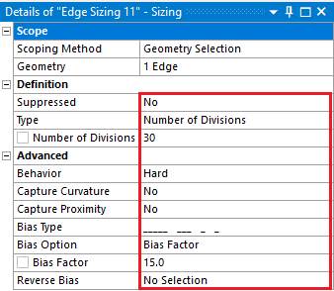
  - Right click on Mesh > Insert > Sizing. Selct the line below and click Apply. Change parameters as per below. Divisons must be finer toward the airfoil’s leading edge.
←
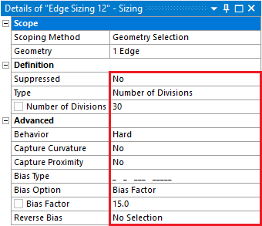
  - Click on Mesh under the Outline and under the Details of “Mesh” change the Physics Preference from Mechanical to CFD.
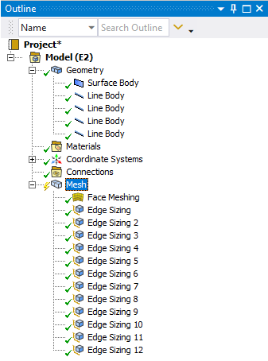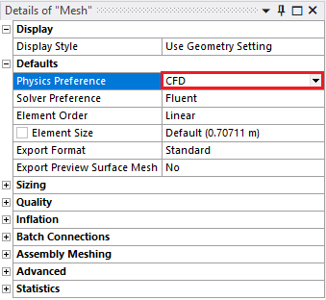

  - Click Generate Mesh. Your mesh should like the figures below.
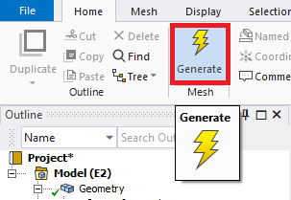
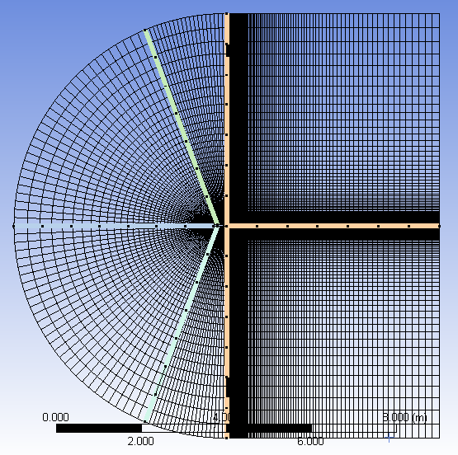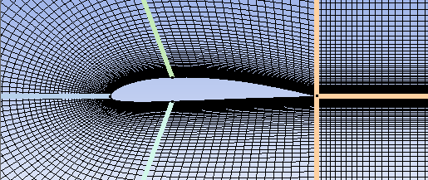
  - Select all the edge parts that make up the arc by holding down Ctrl and selecting them individually. Right click the selection and select Create Named Selection. Change the name to inlet and click OK.
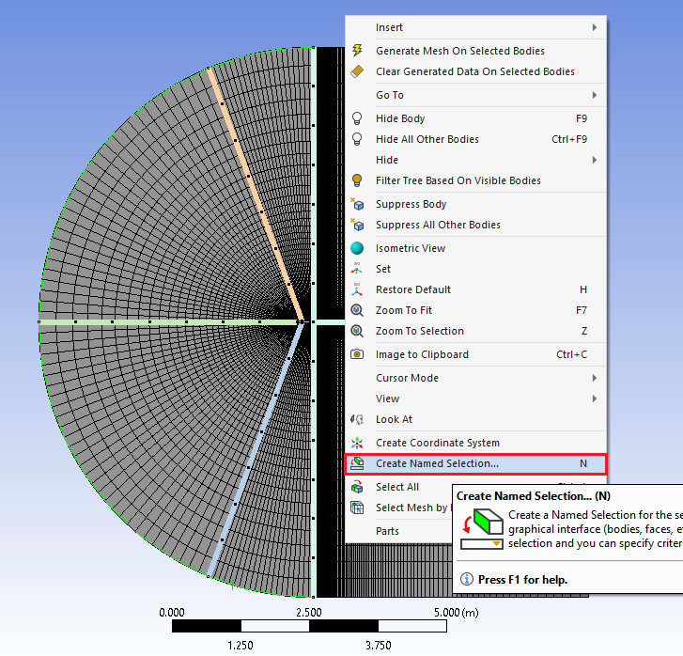

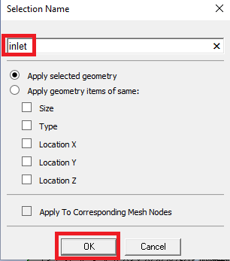

  - Select the vertical lines on the right side of the domain and right click it, then select Create Named Selection. Name this outlet.
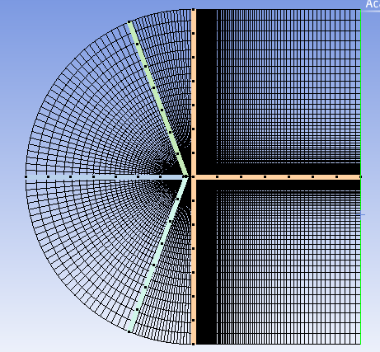

  - Select the two horizontal lines below, right click and Create Named Selections. Name them symmetry.
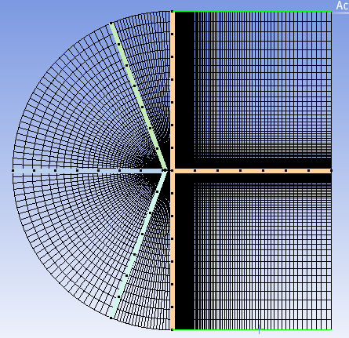
  - Select the four edges that make the airfoil, right click and Create Named Selections. Name them airfoil.
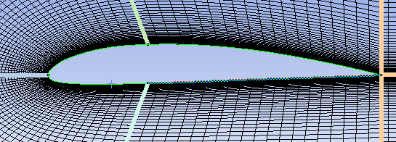

  - Select the six faces of the domain and right click them, select Create Named Selections (Make sure to select the face selecting pointer from the toolbox as shown at below to select “faces”, not the “edges”). Name them fluid.

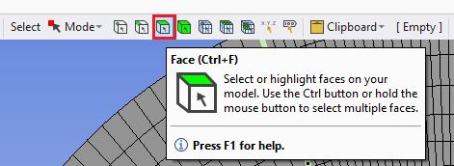
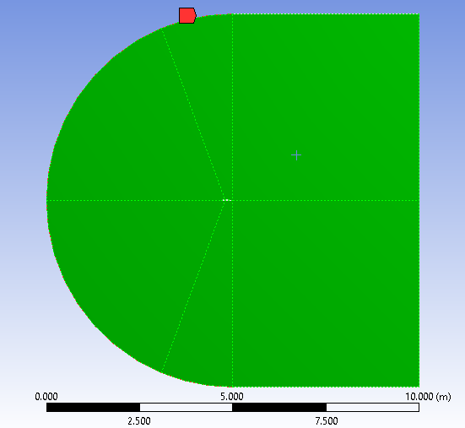

  - File > Save Project. Close Meshing window.

  - Right click on Mesh and click Update.
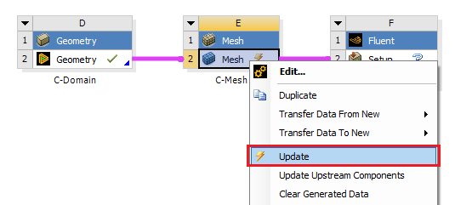

  - Go to class website (http://www.engineering.uiowa.edu/~me_160/) and download the mesh files. You will need to extract the files from their compressed format, simply right click on the .rar file and select Extract Here.

  - Right click on Meshes for O-Domains and select Import Mesh File > Browse. Select the Mesh file corresponding to mesh name and click Open. You need to change the import file type from CFX Mesh Files(*.gtm;*.cfx) to Fluent Files(*.cas;*.msh;*.cas.gz;*msh.gz).
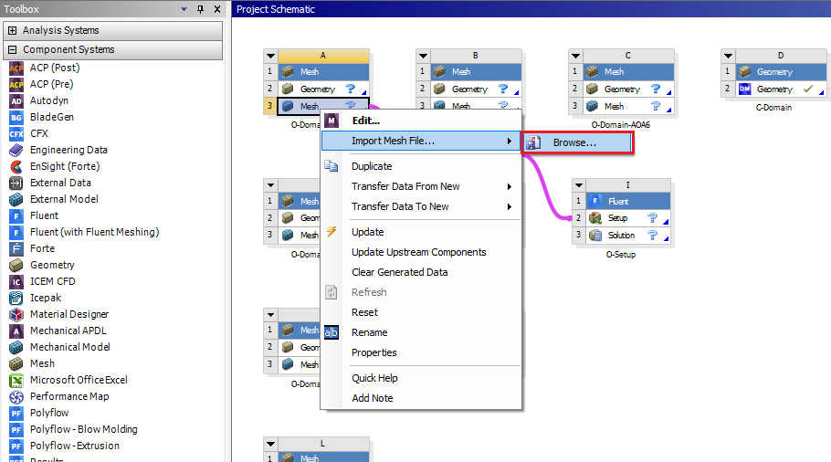
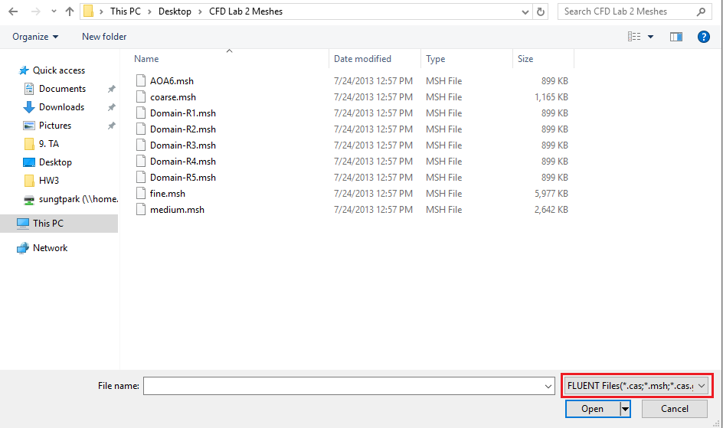

  - After completion of the previous step you will have a schematic as per below.

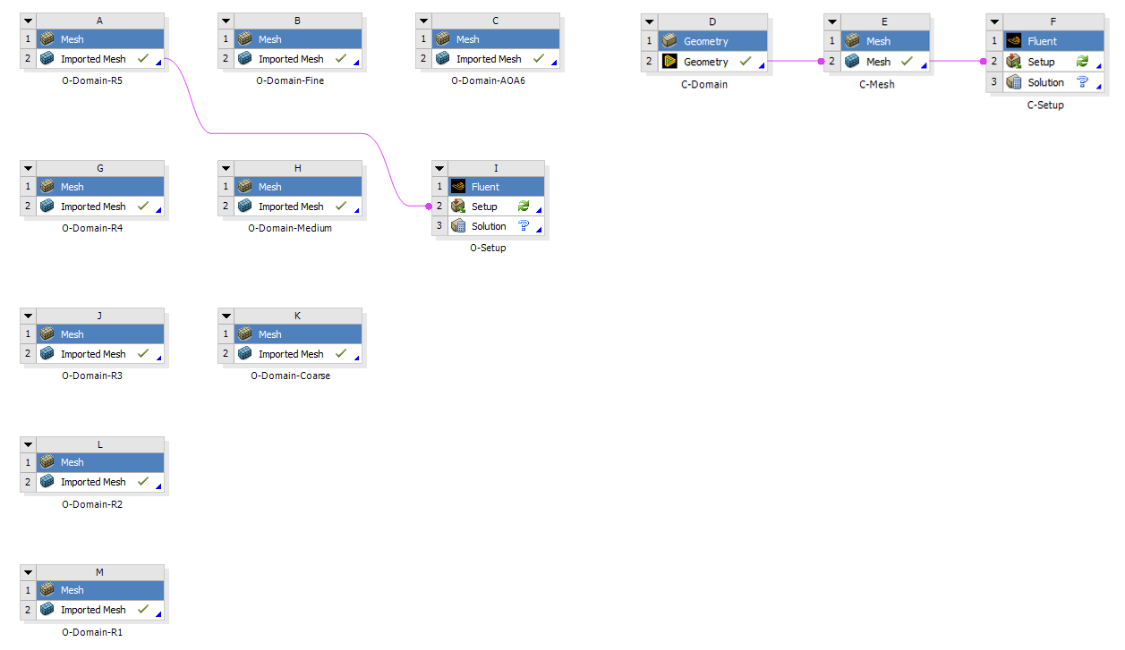

- Setup

In this section you will create solver setups for C-mesh and O-Domain-R5. For the rest of the simulation, you will duplicate the setup from O-Domain-R5 case.

  - Right click Setup and select Edit.
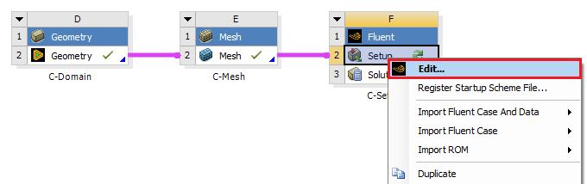

  - Select Double Precision and click Start. After entering the Fluent, if you see any pop-up, you can ignore it by clicking cancel.

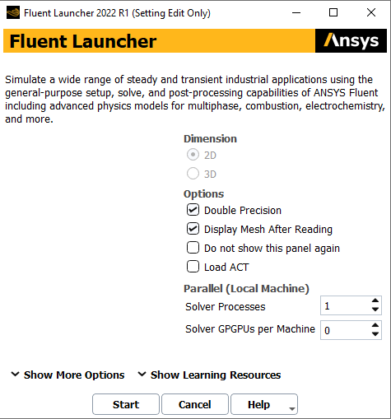

  - Tree > Setup > General > Check. Click Check and check the output (red box shown below) to see if there is any error for Mesh.

C-Mesh
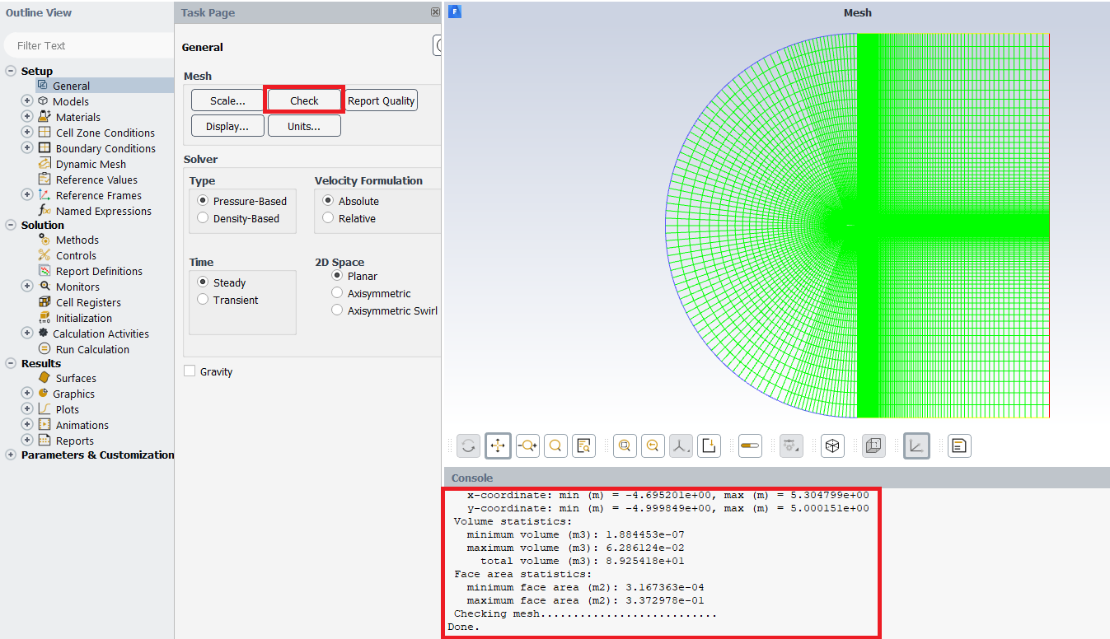

O-Domain-R5 Mesh
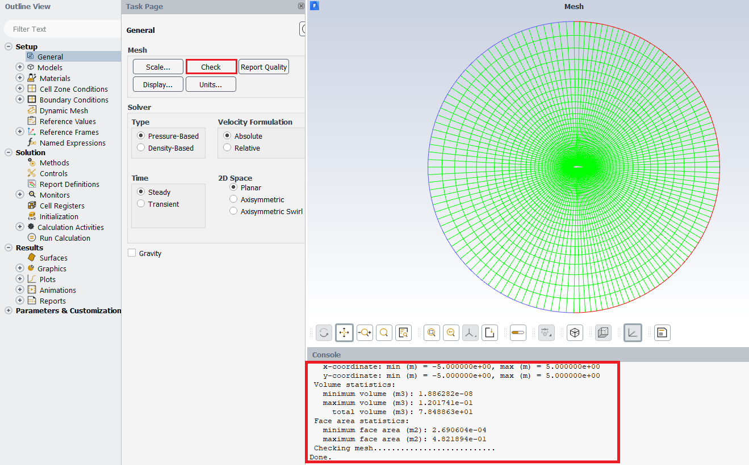

  - Tree > Setup > Models > Viscous > Edit… Choose the options below and click Ok
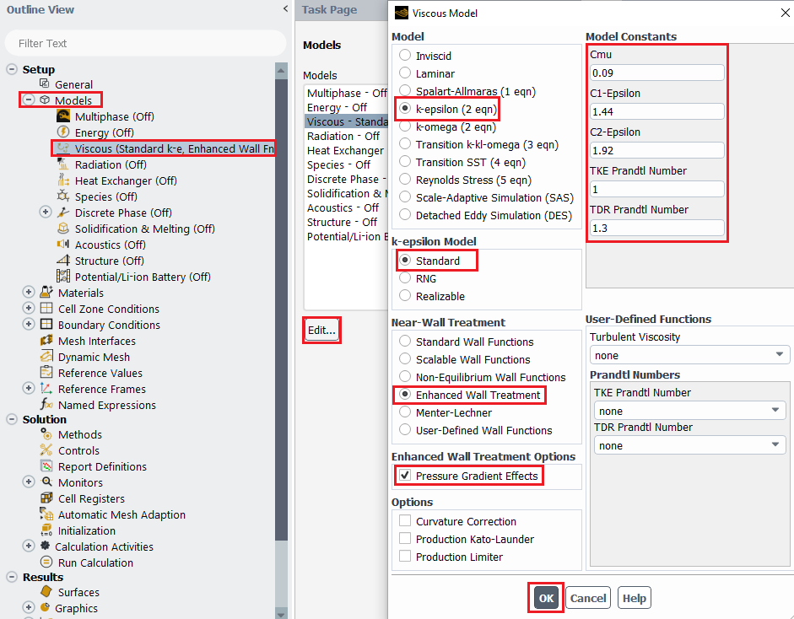

  - Tree > Setup > Materials > Fluid > air > Create/Edit. Change Density and Viscosity to experimental values and click Change/Create then click Close.
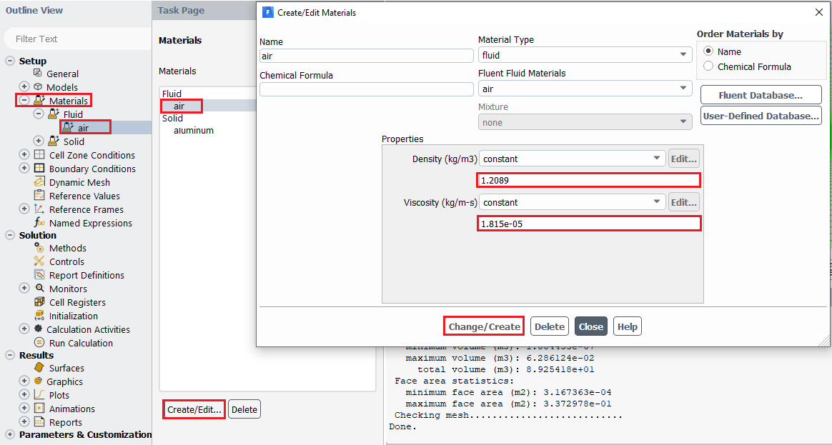
  - Tree > Setup > Boundary Conditions > inlet > Edit… Change velocity to experimental condition and the rest of the parameters to values shown below and click OK(Apply).
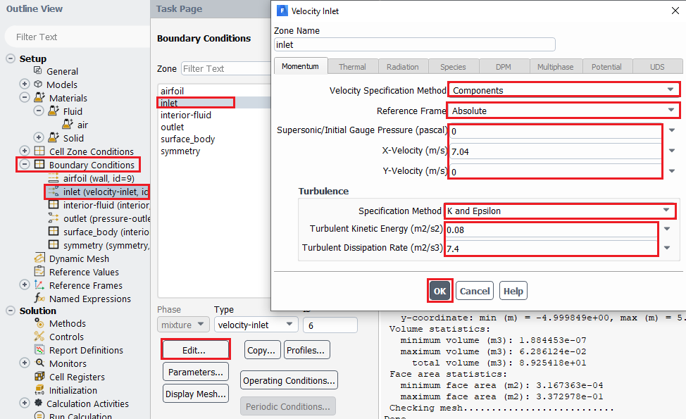
Inlet Boundary Condition
Variable | u (m/s) | v (m/s) | P (Pa) | k (m^2/s^2) | e(m^2/s^3)
Magnitude | 7.04 | 0 | 0 | 0.08 | 7.4
Zero Gradient | - | - | - | - | -

  - Tree > Setup > Boundary Conditions > outlet > Edit… Change Turbulence parameters to values shown below and click OK(Apply).
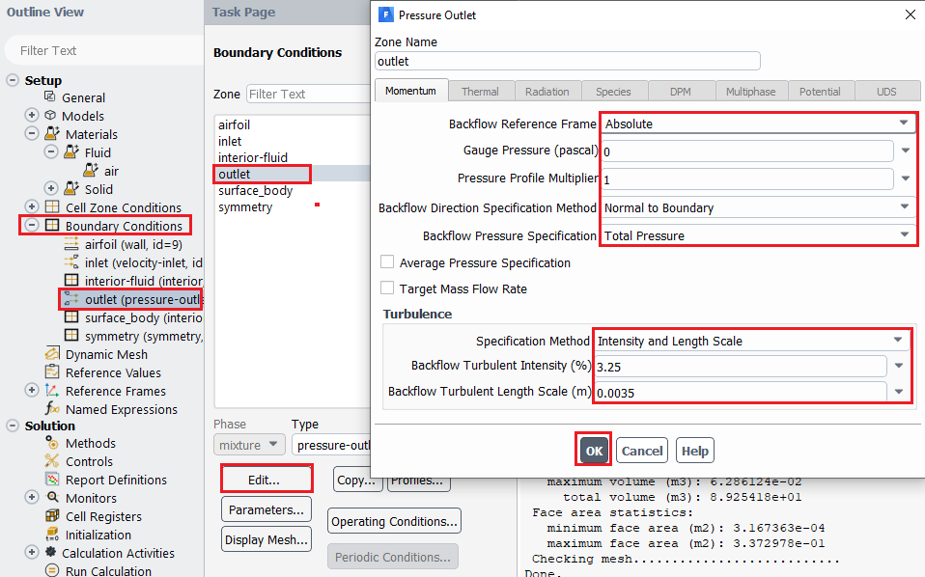
Outlet Boundary Condition
Variable | u (m/s) | v (m/s) | P (Pa) | Intensity (%) | Length scale (m)
Magnitude | - | - | 0 | 3.25 | 0.0035
Zero Gradient | Y | Y | - | - | -
  - Tree > Setup > Boundary Conditions > interior-fluid/surface body (you will have surface body in addition to default-interior for C-mesh). Make sure those Types are interior.
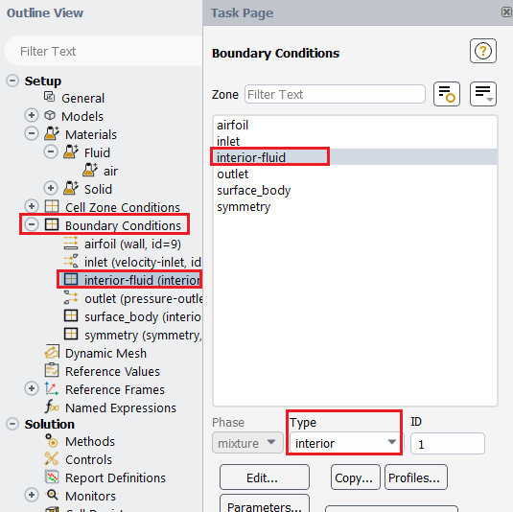

  - Tree > Setup > Boundary Conditions > airfoil. Make sure wall is selected under Type.
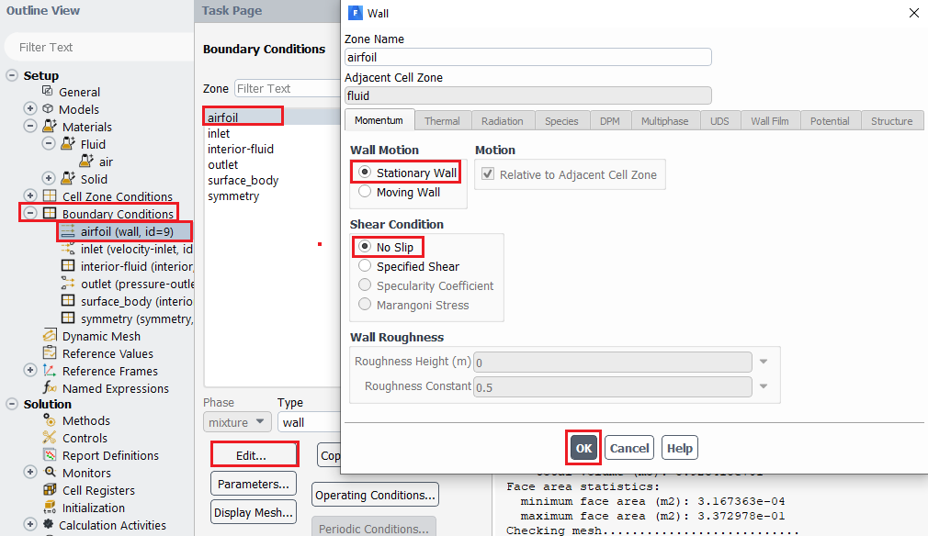
Airfoil Boundary Condition
Variable | u (m/s) | v (m/s) | P (Pa) | k (m^2/s^2) | e (m^2/s^3)
Magnitude | 0 | 0 | - | 0 | 0
Zero Gradient | - | - | Y | - | -
  - Tree > Setup> Boundary Conditions > Symmetry. Make sure symmetry is selected under Type. (If you are setting up O-Domain-R5, skip this step)
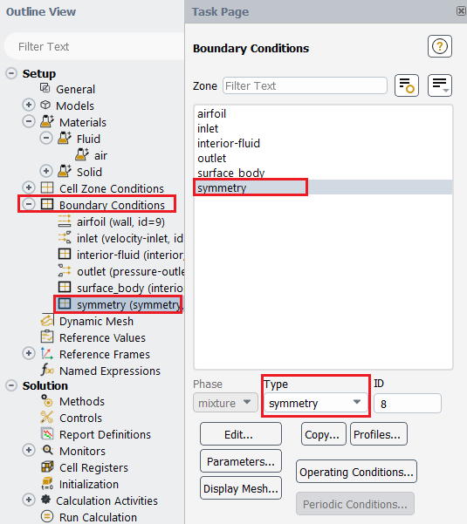

Symmetry Boundary Condition
Variable | u (m/s) | v (m/s) | P (Pa) | k (m^2/s^2) | e (m^2/s^3)
Magnitude | - | 0 | 0 | - | -
Zero Gradient | Y | N | - | Y | Y

  - Tree > Setup > Reference Values. Change Reference Values of Density, Temperature, Velocity, and Viscosity to experimental values and change remaining values as per below.
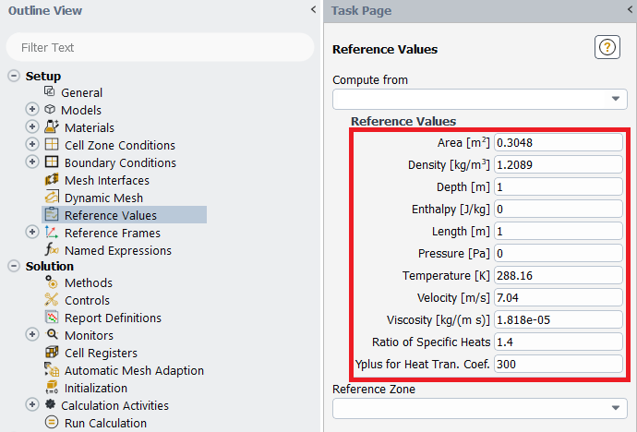
In case of ‘Yplus for Heat Tran. Coef’ leave it as a default value (300)
  - Tree > Solution > Methods. Select the option as per below.
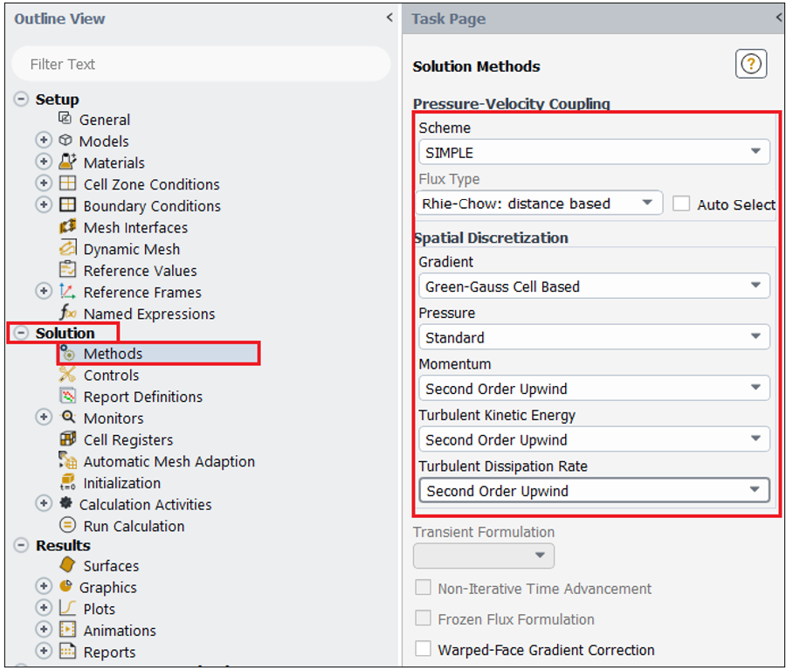

  - Tree > Solution > Controls. Change the Under-Relaxation Factors for, Momentum, Turbulent Kinetic Energy, and Turbulent Dissipation Rate to the values below. If your solution diverges try reducing under-relaxation factors.
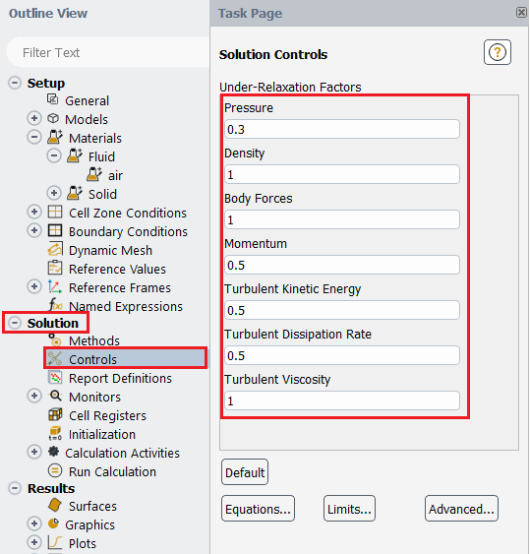
  - Tree > Solution > Monitors > Residual… Change convergence criterions for all 5 equations and click OK(Apply).
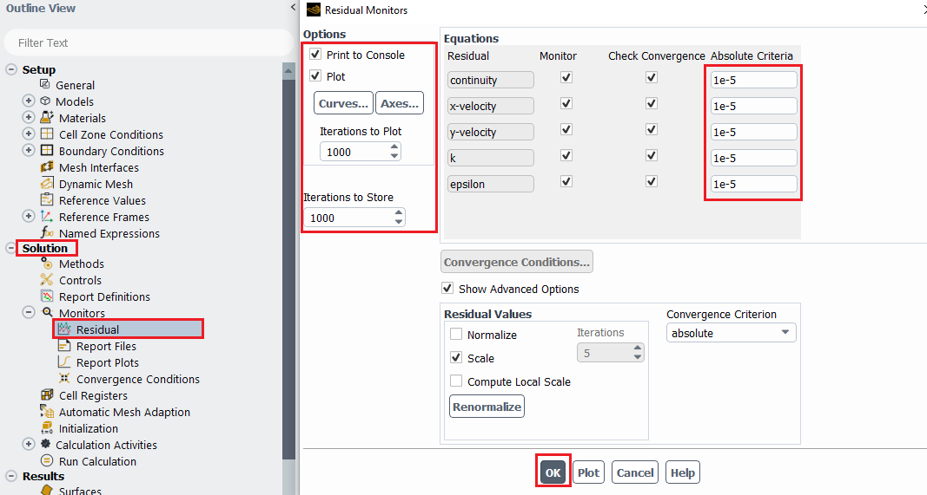

  - Tree > Solution > Monitors > Report files > New... Then, inside the New Report File, New > Force Report > Lift… Set parameters as per below, make sure to select airfoil and click OK. This will show the time history of lift coefficient. (This section is only for C mesh)
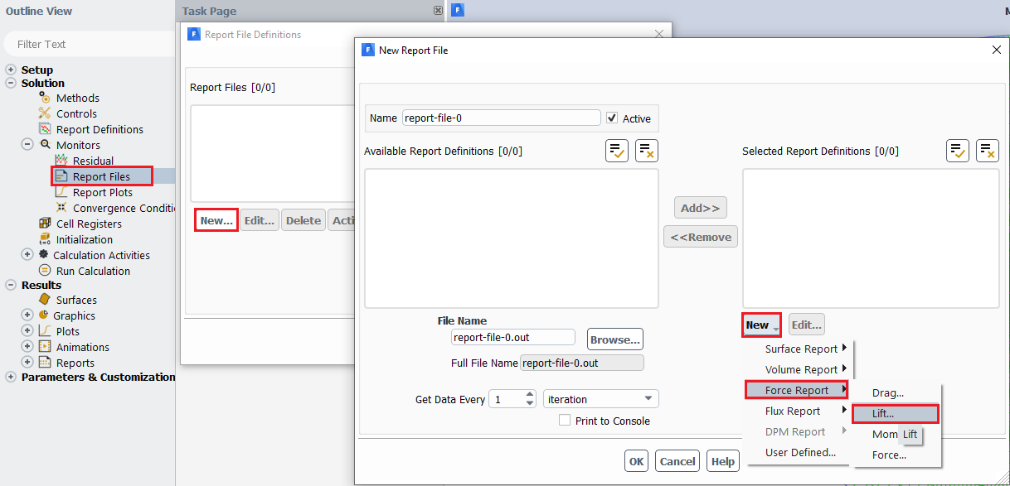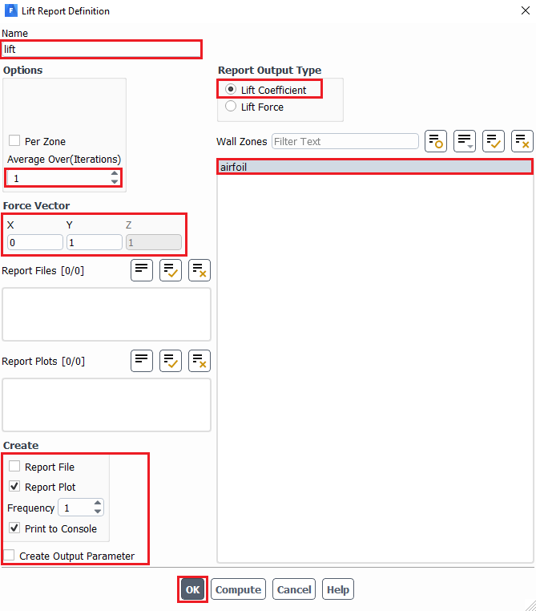
  - (6.15 continued) In New Report File dialog, specify the file location of the lift coefficient time-history file by clicking Browse… Check Print to Console and click OK(Apply). Close Report File Definitions dialog as well.
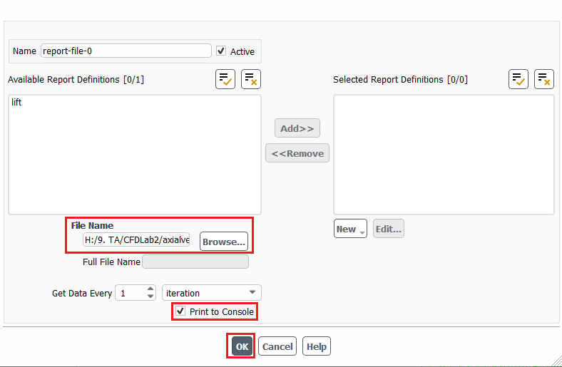

  - Tree > Solution > Initialization. Change the X Velocity to the experimental value and the rest of the parameters as per below and click Initialize.
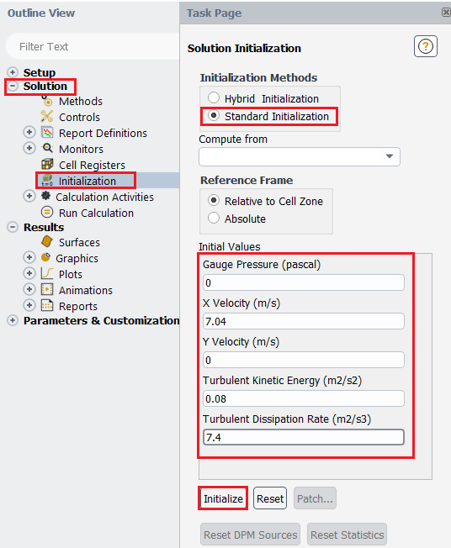
  - Tree > Solution > Run Calculation. Change Number of Iterations to 10,000 and click Calculate. You will see the residual and lift coefficient figures for the C type mesh in windows 1 and 2, respectively. Save the lift coefficient figure for C mesh before continuing.
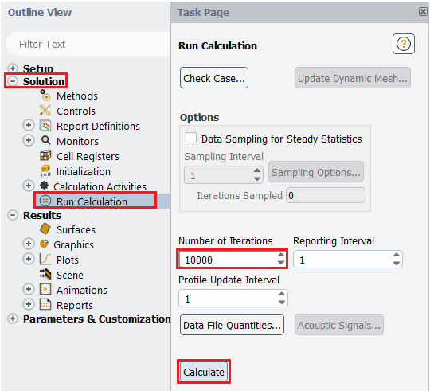

  - File > Save Project. Close fluent. (Please complete setup for O-Domain-R5 and C-mesh before continuing).

  - Once you completed the setups for Domain-R5 and C-mesh your schematic should look like the figure below. Next, we will copy O-setup and modify it where necessary for other cases.
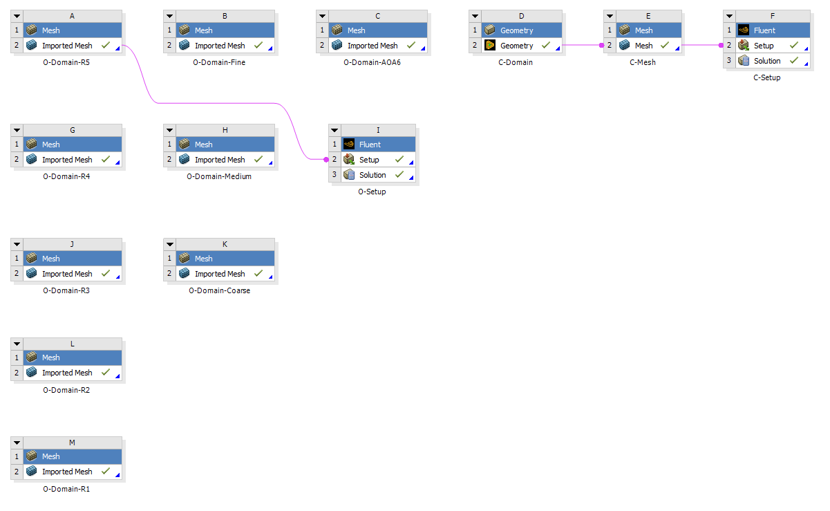
  - Right click on O-setup and click Duplicate as per below. This will create a new setup.

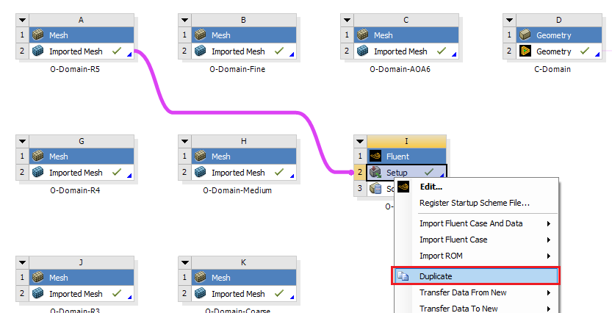

  - Select the connection between O-Domain-R5 and copy of O-setup then hit delete button on your keyboard.

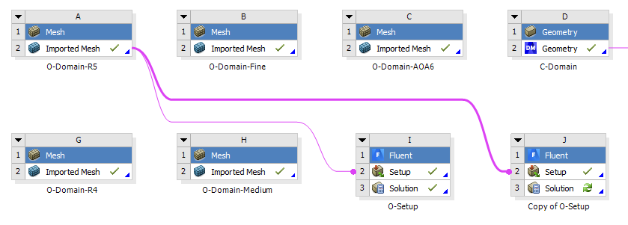

  - Drag and move the copy of O-setup next to Domain –R4 as per below: click on the name of the box (Shaded with Blue) when dragging components (e.g. click and drag Fluent).

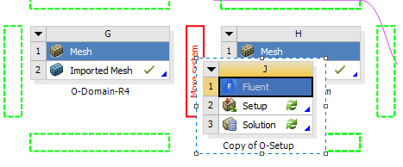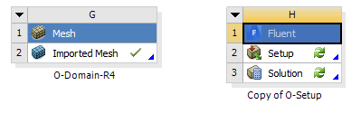
  - Create a new connection between copy of O-setup and Domain-R4 as per below. You have copied the setup from Domain-R5 to Domain-R4. Since they have the same setup, all you have to do is initializing and running inside the Setup.

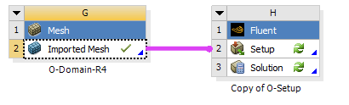

  - Repeat the process for copying setup and get the project schematic as per below.
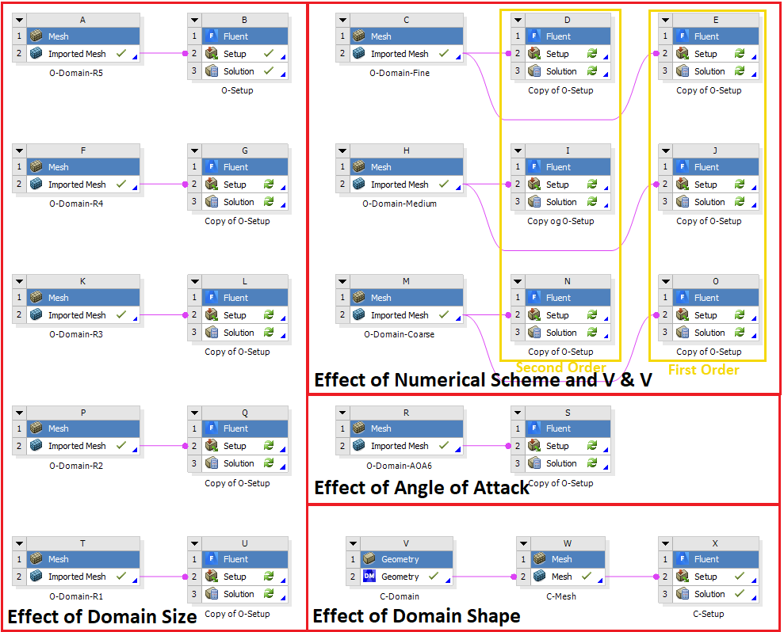
  - Setups for rest of the simulations are the same except for 3 simulations labeled with “First Order” in the figure above at V&V section. We need to change the scheme from second order to first order. Simply open fluent of cases with first order schemes. You will get message below, just click yes. Tree > Solution > Methods. Modify solution methods as per below and close Fluent.

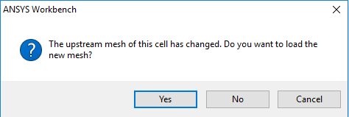

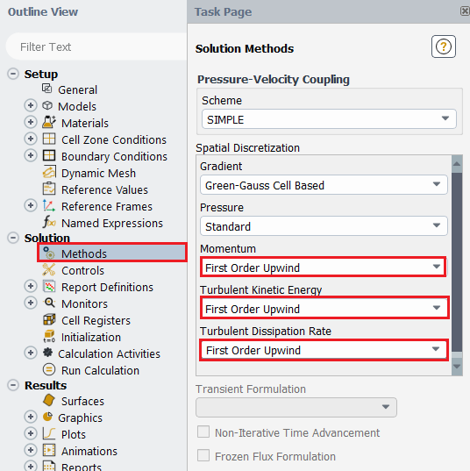

  - Now you can run all the cases and save the ANSYS file. For this Lab2 only, find one partner in the class to form a group. One student will run V&V using first order upwind scheme, the other will use 2nd order upwind scheme. You will need to run rest of the cases by yourself.

- Results

This section shows how to analyze your results. You do not need to do all the analysis for every case. Please read the exercises before continuing.

  - Saving Picture
File > Save Picture. Choose options and click Save.

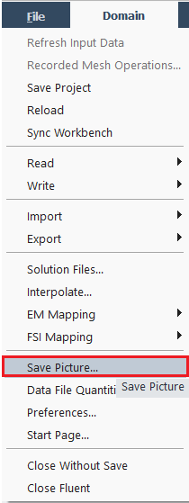
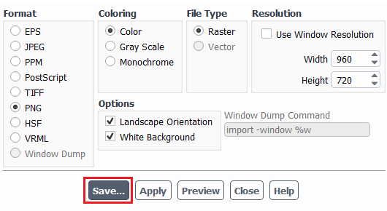
  - Displaying Residuals
Tree > Solution > Monitors > Residuals > Plot. Save Picture with 7.1.
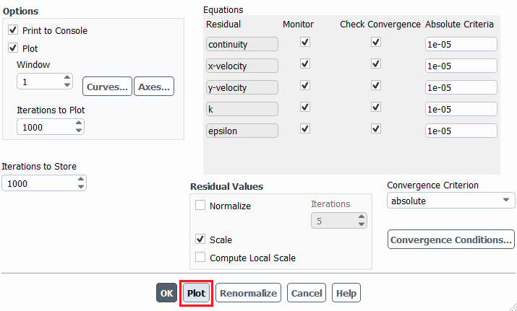

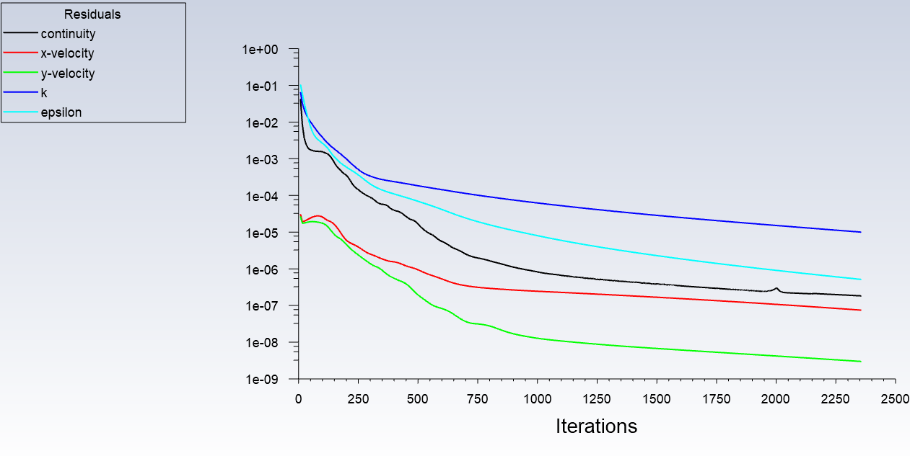

  - Displaying Mesh
Setting Up Domain > Display. Save Picture with 7.1.
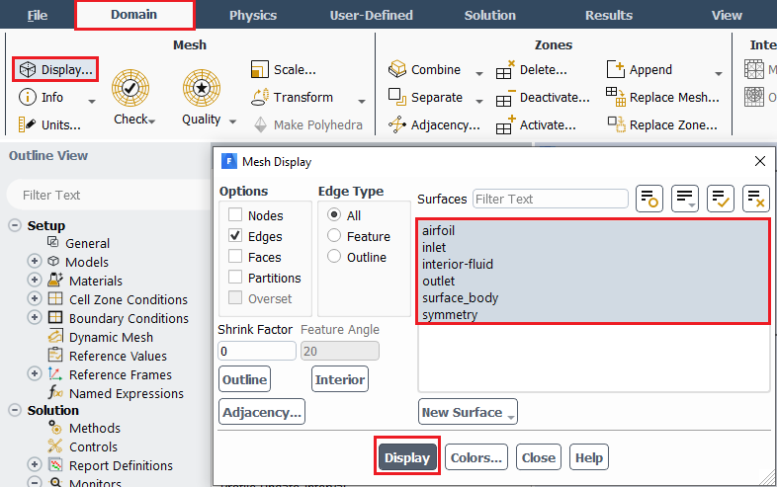
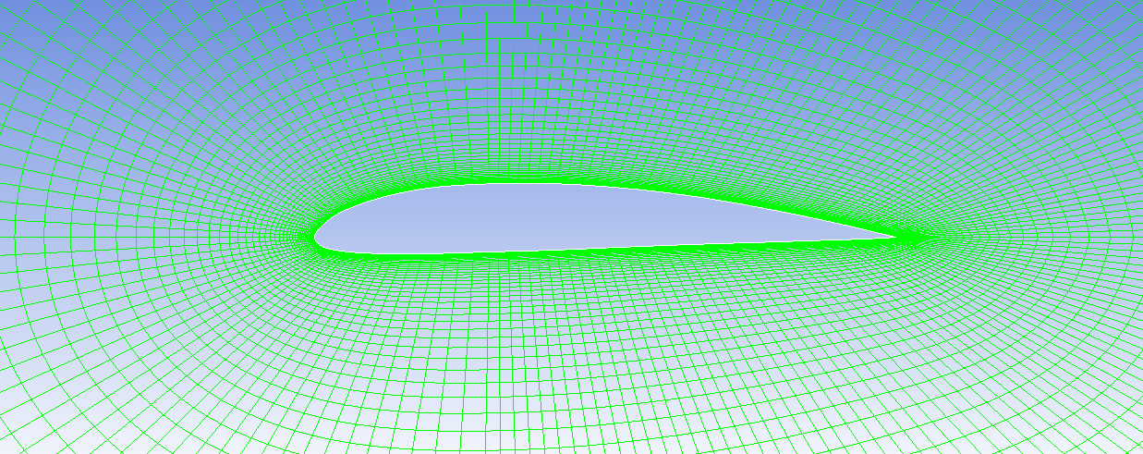

  - Printing Forces
Tree > Results > Reports > Forces. You can write the result as well by clicking Write… and save the data as a file at your working directory.
Drag (Direction Vector=[1, 0])
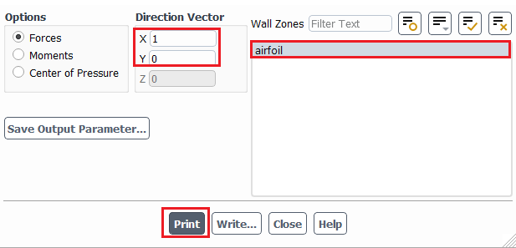

Lift (Direction Vector=[0, 1])
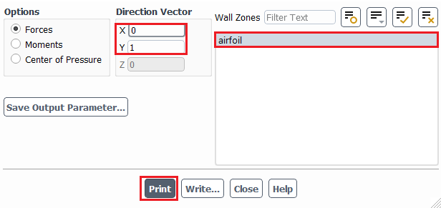

Example of Printed Drag (C-Mesh)
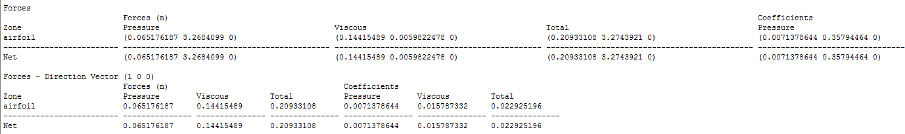

Example of Printed Lift (C-Mesh)
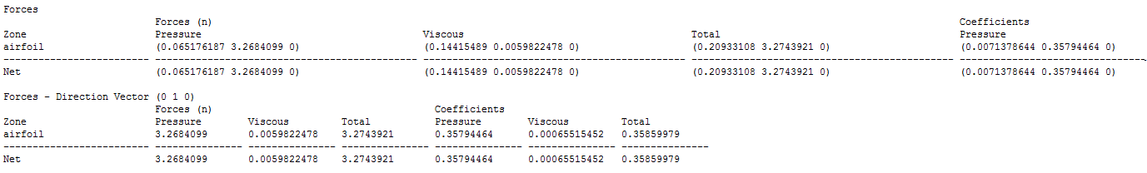

  - Plotting Pressure Coefficient on Airfoil Surface
Tree > Results > Plots > XY Plot. Select parameter as per below and click Plot.
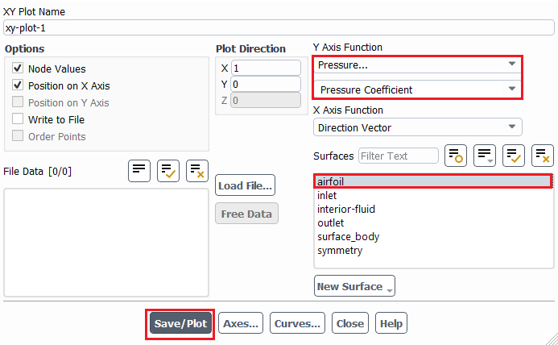
To plot experimental data on top of CFD result, click Load File… and load the experimental pressure coefficient file, then click Plot.
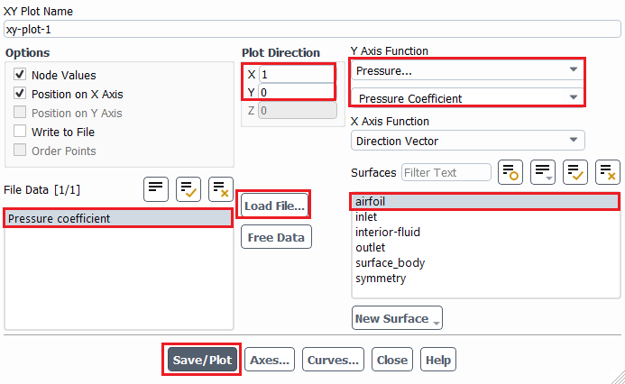

Example of Plot for Pressure Coefficient on Airfoil Surface
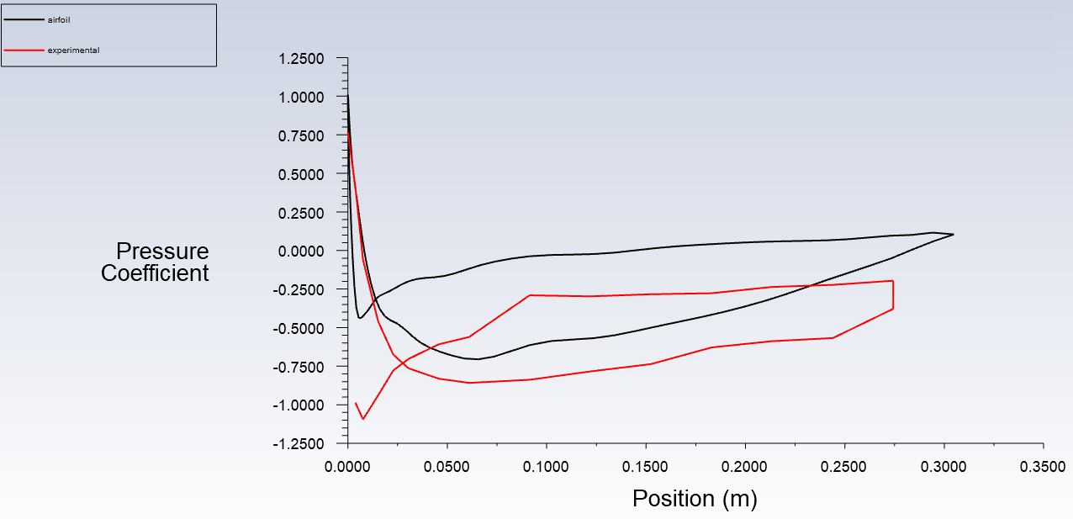

  - Plotting Pressure Contour
Tree > Results > Graphics > Contours. Check Filled, select Static Pressure and click Display.
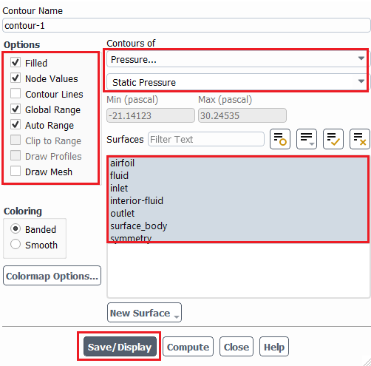

Among Surfaces, the surface fluid can be added in the list by allocating zone name for the existing fluid zone (fluid isn’t on the list by default). Setting Up Domain > Surface > Create > Zone.
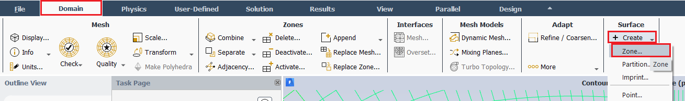

You can add fluid by highlighting fluid from the zone list and clicking Create. You can now go back to contour part and finish plotting.
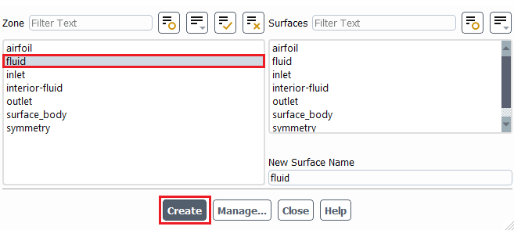

Example of Pressure Contour
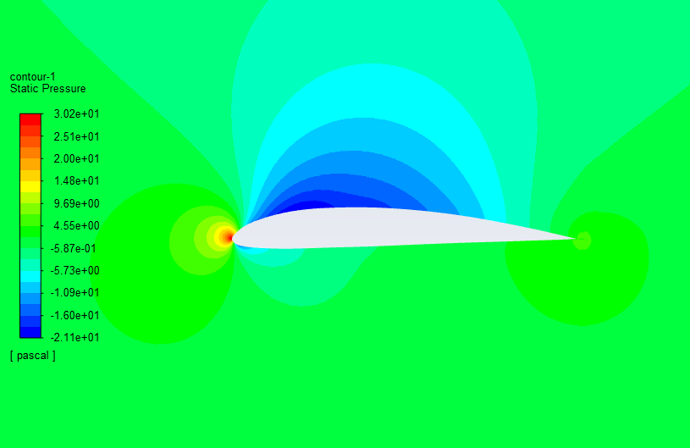

  - Plotting Velocity Vectors
Tree > Results > Graphics > Vectors > Set Up. Click Display.
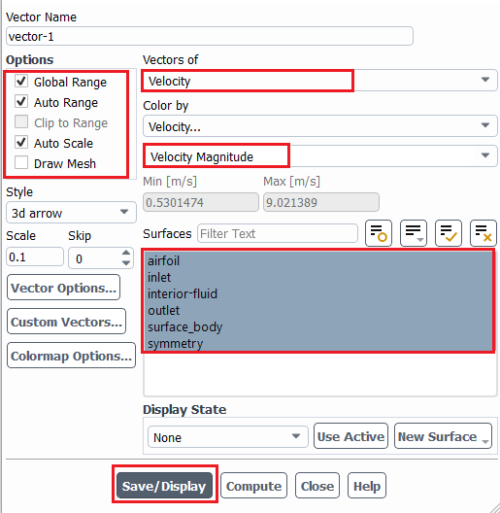
Example of Velocity Vector
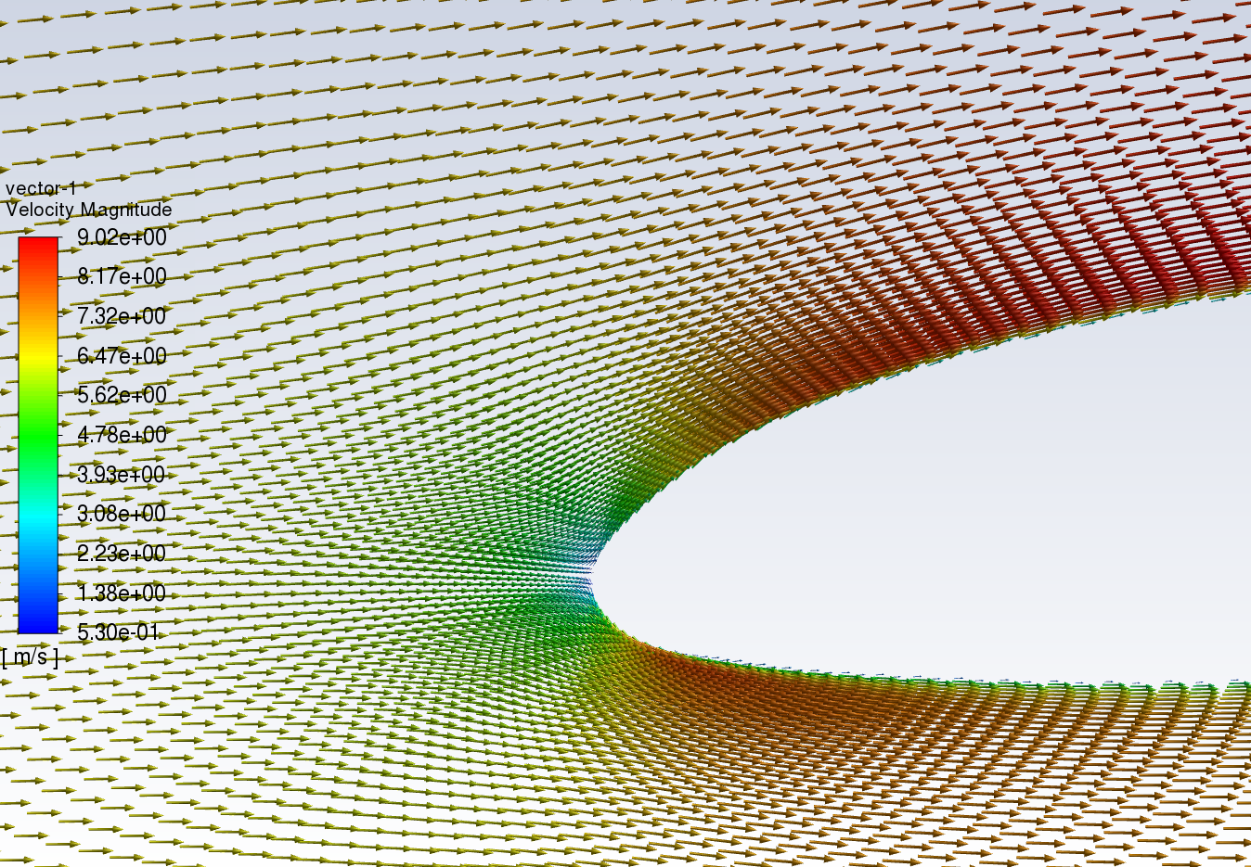
  - Plotting Streamline
Tree > Results > Graphics > Contours > Set Up… Select parameters as per below and click Display. You can adjust the Min and Max to get a better figure.
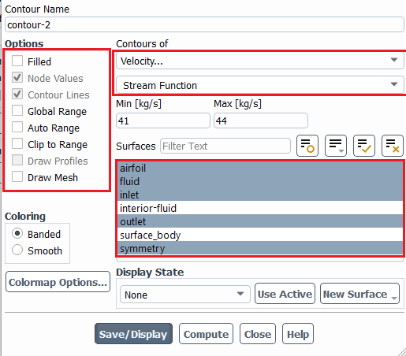

Example of Streamline
- Verification and Validation (For V&V Simulations Only)

  - From the Project Schematic, right click on the Fluent Solution and select Edit… from the dropdown menu
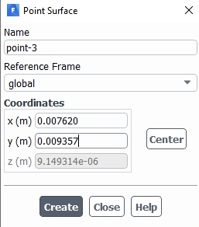
Please make 29 Points manually using below Points.
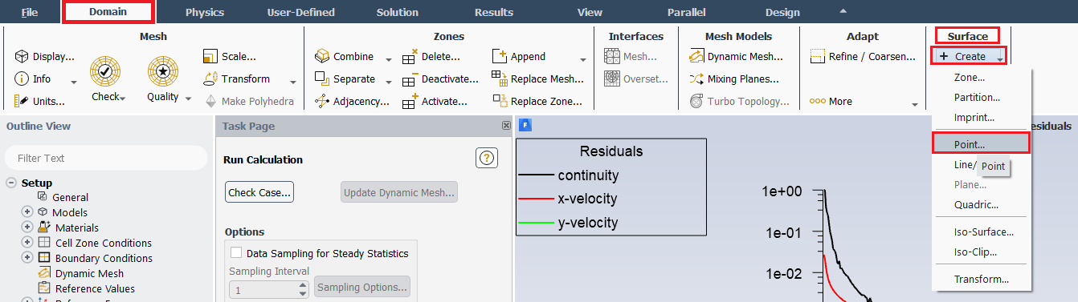

 | X | Y
Point 1 | 0.000000 | 0.000000
Point 2 | 0.003810 | 0.006121
Point 3 | 0.007620 | 0.009357
Point 4 | 0.015200 | 0.013944
Point 5 | 0.022860 | 0.017059
Point 6 | 0.030500 | 0.019640
Point 7 | 0.045720 | 0.023500
Point 8 | 0.061000 | 0.026059
Point 9 | 0.091440 | 0.028093
Point 10 | 0.122000 | 0.028242
Point 11 | 0.152400 | 0.026656
Point 12 | 0.183000 | 0.023618
Point 13 | 0.213360 | 0.019255
Point 14 | 0.244000 | 0.013626
Point 15 | 0.274320 | 0.007302
Point 16 | 0.274320 | -0.001214
Point 17 | 0.244000 | -0.002221
Point 18 | 0.213360 | -0.003142
Point 19 | 0.183000 | -0.004193
Point 20 | 0.152400 | -0.005436
Point 21 | 0.122000 | -0.006680
Point 22 | 0.091440 | -0.007523
Point 23 | 0.061000 | -0.008457
Point 24 | 0.045720 | -0.008685
Point 25 | 0.030500 | -0.008307
Point 26 | 0.022860 | -0.007929
Point 27 | 0.015200 | -0.007243
Point 28 | 0.007620 | -0.005942
Point 29 | 0.003810 | -0.004674

  - Tree > Results > Plots > XY Plot > Setup... Select parameters as per below, make sure to select points 1 through 29, and click Write. Name the file for future reference. (This only needs to be done for coarse, medium, and fine manual meshes, which are used for V&V calculations. It is not needed for other mesh.)
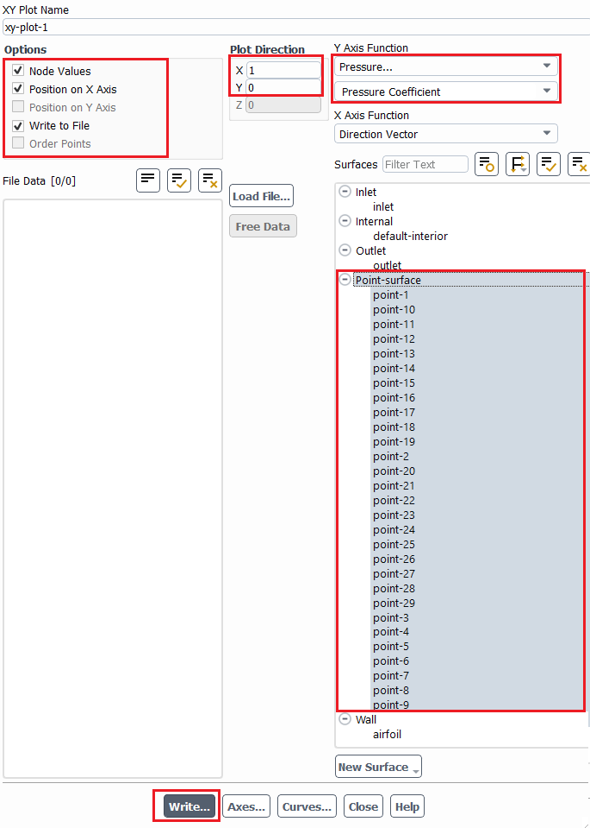

  - Open the V&V Excel.

  - Copy and paste the pressure coefficients into the proper sheet corresponding to the mesh size. To do this open the saved pressure coefficient data in TextPad, use the “Ctrl + A” function to select all, then right click and select Copy.
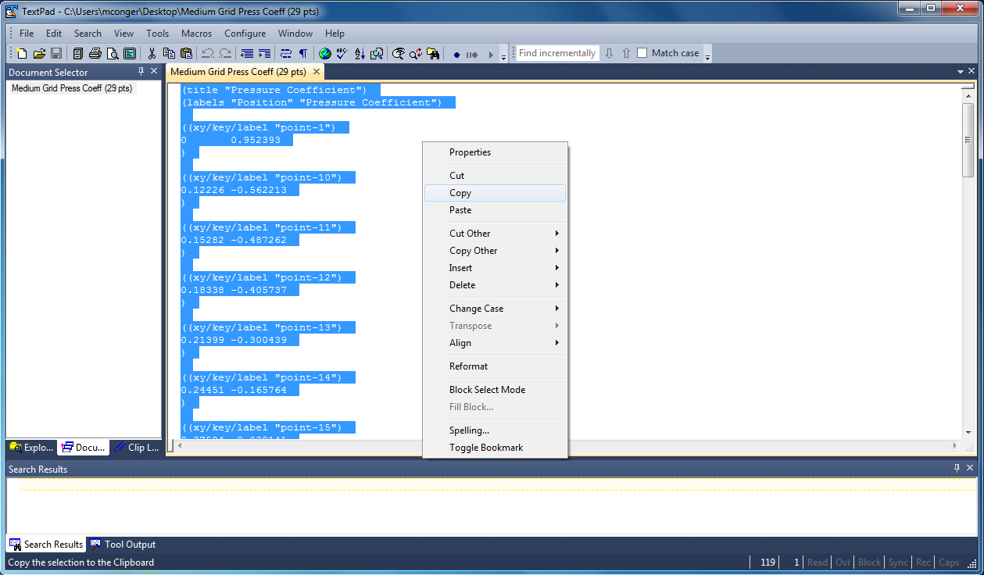
  - Paste this data into cell A1 of the corresponding pressure coefficient tab. Right click on cell A1 and select Keep Text Only. The cells to the right should auto populate extracting the correct data from the pasted data. If all the x coordinate cells are not green, there was an error in the pasting of the copied data.
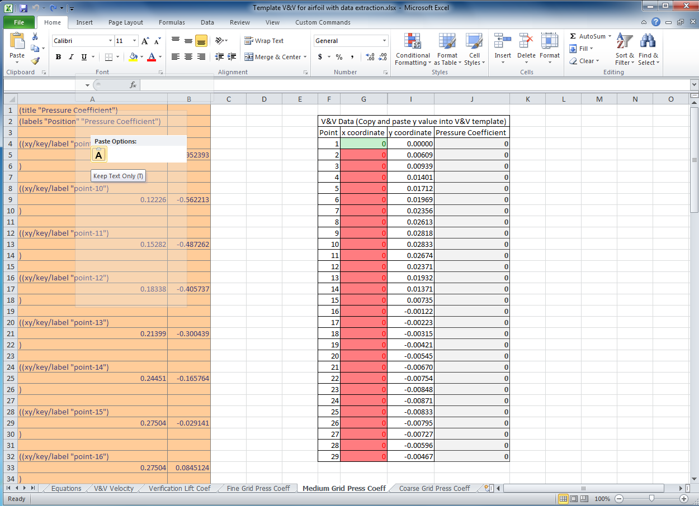
  - Repeat these steps for the remaining mesh sizes.

  - Once all the data is pasted into the three Press Coeff tabs, the V&V Velocity tab auto populates and calculates V&V values.

  - Open the Verification Lift Coef tab and input values from y force report into the cells corresponding to the mesh size. The V&V values auto calculate.

- Data Analysis and Discussion

You need to complete the following assignments and present results in your lab report following the lab report instructions.

  - Effect of domain size (+9)

Run 5 simulations using five different domain sizes using mesh O-Domain-R5, O-Domain-R4, O-Domain-R3, O-Domain-R2 and O-Domain-R1. Fill the table below with lift coefficient with their relative difference between two successive meshes. If the relative change between two successive domain sizes should be less than 1%, then which domain sizes will be enough large to make the CFD simulation results to be independent of the domain size?

Circle radius (m) | 1 | 2 | 3 | 4 | 5
Lift Coefficient
Relative change | N/A | ( )% | ( )% | ( )% | ( )%
- Figures need to be reported: None.
- Data need to be reported: the above table with values.

  - Effect of numerical scheme on Verification study for lift coefficient and validation of pressure coefficient (+17)

Use fine, medium and course meshes to conduct your V&V analysis. For this exercise only, find one partner in the class to form a group, one student will run V&V using first order upwind scheme, the other will use 2nd order upwind scheme. Then, you must borrow the figures/data from the other student and present in your lab report.

Based on verification results for lift coefficient, which numerical scheme is closer to the asymptotic range? Which numerical scheme has a lower mesh uncertainty? Discuss the verification and validation for pressure coefficient. For which locations of 29 points the pressure coefficient has been validated? For which locations the pressure coefficient has not been validated?
- Figures need to be reported: Figures in V&V excel sheet for 1st and 2nd order numerical schemes.
- Data need to be reported: Tables in V&V excel sheet for 1st and 2nd order numerical schemes.

  - C mesh generation (+5)

Follow the instructions in the manual and create the geometry and mesh manually. Does the lift coefficient for C mesh differ from O mesh? For iterative history of lift coefficient, what is the minimum iteration number for you to determine the lift coefficient has converged to a “constant” value?
- Figures need to be reported: C mesh generated by yourself, time history of lift coefficient.
- Data need to be reported: converged lift coefficient.

  - Effect of angle of attack on airfoil flow (+12)

Compare results from AOA6 (6 degree angle of attack) and O-Domain-R5 (0 degree angle of attack) meshes. O-Domain-R5 and AOA has the same mesh with the different angle of attack. Analyze the difference of the flow field. Which case has a higher lift coefficient, which has a higher drag coefficient?
- Figures need to be reported (for both attack angles): pressure contours, comparisons with EFD on pressure coefficient distribution, velocity vectors near airfoil surface, streamlines near the airfoil surface.
- Data need to be reported (for both attack angles): lift and drag coefficients.

  - Questions need to be answered when writing CFD report

    - Answer all the questions in exercises 1 to 4
    - Analyze the difference between CFD/EFD and possible error sources (+2)

- Grading scheme for CFD Lab Report

(Applied to all CFD Lab reports)

Section Points

1 Title Page 5
1.1 Course Name
1.2 Title of report
1.3 Submitted to “Instructor’s name”
1.4 Your name (with email address)
1.5 Your affiliation (group, section, department)
1.6 Date and time lab conducted
2 Test and Simulation Design 10
Purpose of CFD simulation
3 CFD Process 20
Describe in your own words how you implemented CFD process
(Hint: CFD process block diagram)
4 Data Analysis and Discussion Section 9 (Page# 55) for CFD Lab 2 45
Answer questions given in Exercises of the CFD lab handouts
5 Conclusions 20
Conclusions regarding achieving purpose of simulation
Describe what you learned from CFD
Describe the “hands-on” part
Describe future work and any improvements
Total 100

Additional Instructions:

- Each student is required to hand in individual lab report.
- Conventions for graphical presentation (CFD):
* Color print of figures recommended but not required
3. Reports will not be graded unless section 1 is included and complete

