Chapter 9 Flow over Immersed Bodies

Basic Considerations

Recall separation of drag components into form and skin-friction

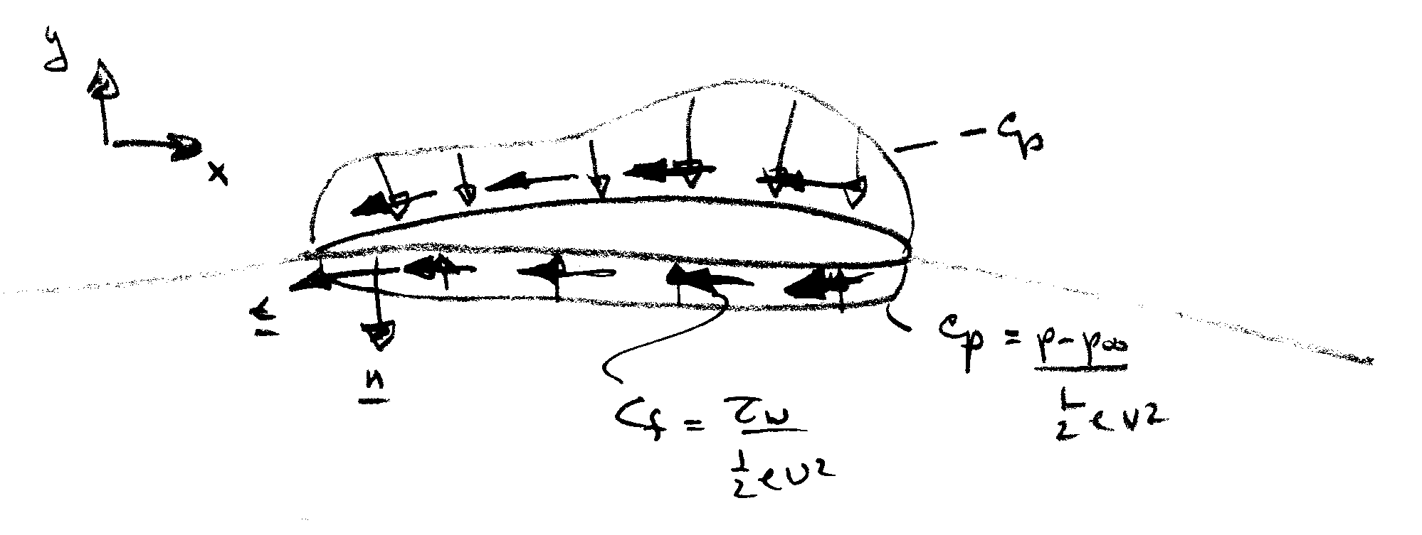
$$C_{D}=\frac{1}{\frac{1}{2}{ρV}^{2}A}\left\{\int_{S}{\left(p−p_{∞}\right)\underline{n}⋅\hat{i}\text{dA}}+\int_{S}{τ_{w}\underline{t}⋅\hat{i}\text{dA}}\right\}$$
C_{Dp} C_{f}

$$C_{L}=\frac{1}{\frac{1}{2}{ρV}^{2}A}\left\{\int_{S}{\left(p−p_{∞}\right)}\underline{n}⋅\hat{j}\text{dA}\right\}$$

$\frac{t}{c}$ << 1 C_{f} > > C_{Dp} streamlined body

$\frac{t}{c}$ ∼ 1 C_{Dp} > > C_{f} bluff body

Streamlining: One way to reduce the drag

Make a body streamlined:

→ reduce the flow separation→reduce the pressure drag
→ increase the surface area → increase the friction drag

→ Trade-off relationship between pressure drag and friction drag

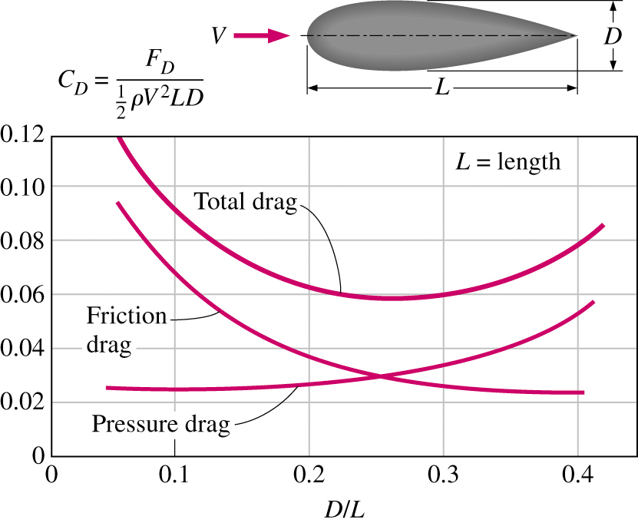
Trade-off relationship between pressure drag and friction drag

Benefit of streamlining: reducing vibration and noise
Qualitative Description of the Boundary Layer

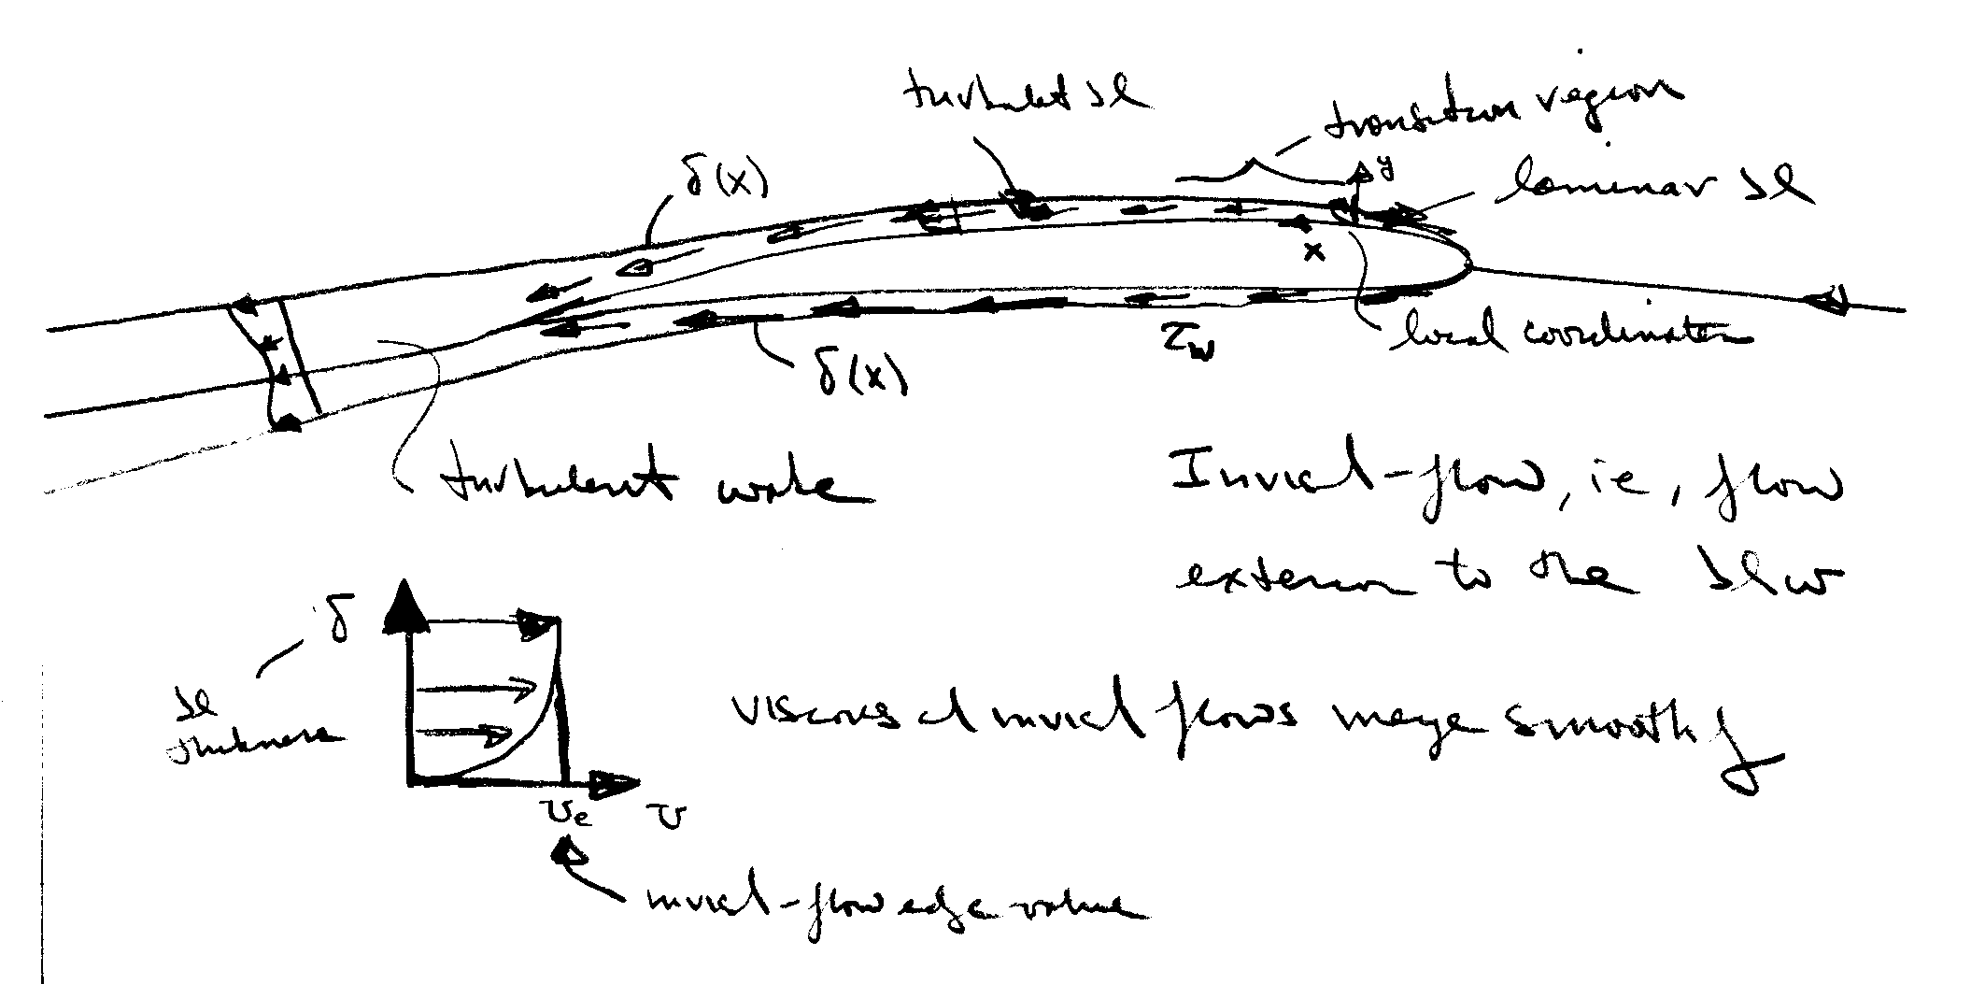
Recall our previous description of the flow-field regions for high Re flow about slender bodies

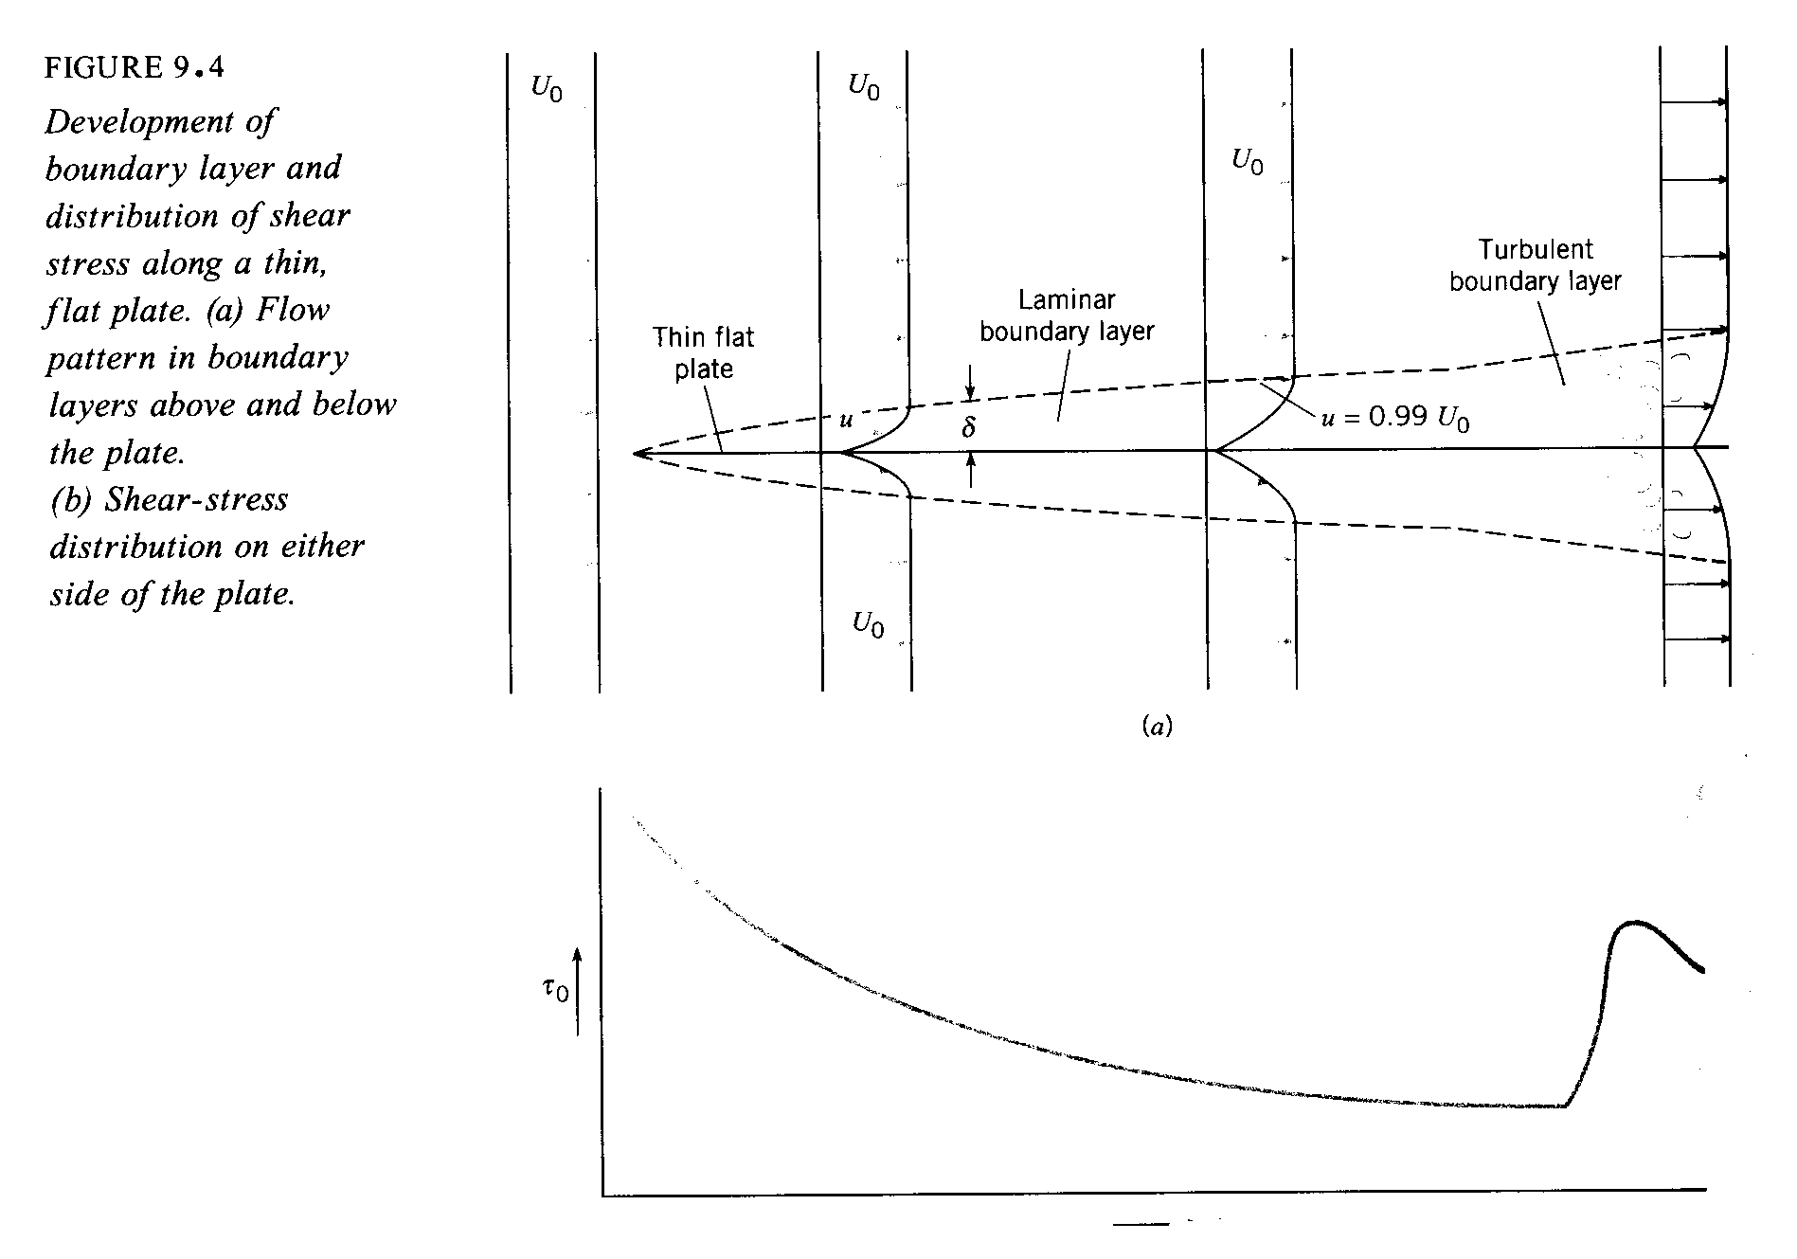

τ_{w} = shear stress

τ_{w} ∝ rate of strain (velocity gradient)

=$μ\frac{∂u}{∂y}|_{y=0}$

large near the surface where
fluid undergoes large changes to satisfy the no-slip condition

Boundary layer theory is a simplified form of the complete NS equations and provides τ_{w} as well as a means of estimating C_{form}. Formally, boundary-layer theory represents the asymptotic form of the Navier-Stokes equations for high Re flow about slender bodies. As mentioned before, the NS equations are 2nd order nonlinear PDE and their solutions represent a formidable challenge. Thus, simplified forms have proven to be very useful.

Near the turn of the century (1904), Prandtl put forth boundary-layer theory, which resolved D’Alembert’s paradox. As mentioned previously, boundary-layer theory represents the asymptotic form of the NS equations for high Re flow about slender bodies. The latter requirement is necessary since the theory is restricted to unseparated flow. In fact, the boundary-layer equations are singular at separation, and thus, provide no information at or beyond separation. However, the requirements of the theory are met in many practical situations and the theory has many times over proven to be invaluable to modern engineering.

The assumptions of the theory are as follows:

Variable order of magnitude
u U O(1)
v δ<<L O(ε) ε = δ/L
$\frac{∂}{∂x}$ L O(1)
$\frac{∂}{∂y}$ 1/δ O(ε⁻¹)
ν δ² ε²

The theory assumes that viscous effects are confined to a thin layer close to the surface within which there is a dominant flow direction (x) such that u ∼ U and v << u. However, gradients across δ are very large in order to satisfy the no slip condition.

Next, we apply the above order of magnitude estimates to the NS equations.
$u\frac{∂u}{∂x}+v\frac{∂u}{∂y}=−\frac{∂p}{∂x}+μ\left(\frac{∂^{2}u}{∂x^{2}}+\frac{∂^{2}u}{∂y^{2}}\right)$
1 1 ε ε⁻¹ ε² 1 ε⁻²

$u\frac{∂v}{∂x}+v\frac{∂v}{∂y}=−\frac{∂p}{∂y}+μ\left(\frac{∂^{2}v}{∂x^{2}}+\frac{∂^{2}v}{∂x^{2}}\right)$
elliptic
1 ε ε 1 ε² 1 ε⁻¹

$\frac{∂u}{∂x}+\frac{∂v}{∂y}=0$
- 1

Retaining terms of O(1) only results in the celebrated boundary-layer equations
$u\frac{∂u}{∂x}+v\frac{∂u}{∂y}=−\frac{∂p}{∂x}+μ\frac{∂^{2}u}{∂y^{2}}$
parabolic
$\frac{∂p}{∂y}=0$
$$\frac{∂u}{∂x}+\frac{∂v}{∂y}=0$$

Some important aspects of the boundary-layer equations:
- the y-momentum equation reduces to

$$\frac{∂p}{∂y}=0$$
i.e., p = p_{e} = constant across the boundary layer
edge value, i.e., inviscid flow value!
from the Bernoulli equation:
$p_{e}+\frac{1}{2}{ρU}_{e}^{2}=$constant
i.e., $\frac{∂p_{e}}{∂x}=−{ρU}_{e}\frac{∂U_{e}}{∂x}$

Thus, the boundary-layer equations are solved subject to a specified inviscid pressure distribution

- continuity equation is unaffected

- Although NS equations are fully elliptic, the boundary-layer equations are parabolic and can be solved using marching techniques

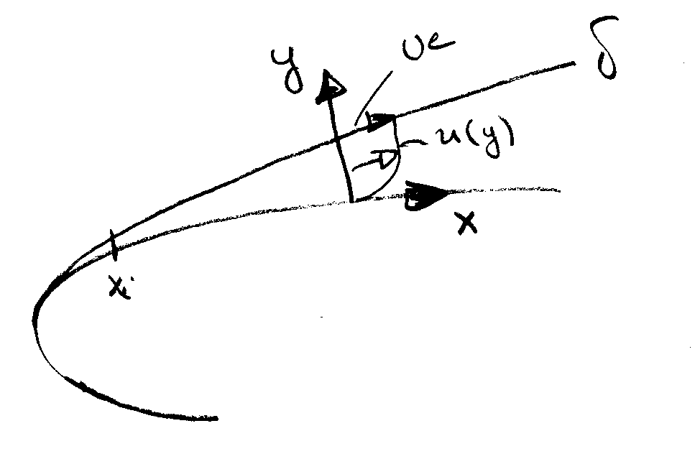
- Boundary conditions

u = v = 0 y = 0

u = U_{e} y = δ

+ appropriate initial conditions @ x_{i}

There are quite a few analytic solutions to the boundary-layer equations. Also numerical techniques are available for arbitrary geometries, including both two- and three-dimensional flows. Here, as an example, we consider the simple, but extremely important case of the boundary layer development over a flat plate.

Quantitative Relations for the Laminar Boundary Layer

Laminar boundary-layer over a flat plate: Blasius solution (1908) student of Prandtl
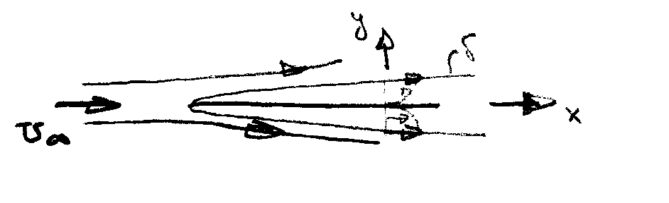
$\frac{∂u}{∂x}+\frac{∂v}{∂y}=0$
Note: $\frac{∂p}{∂x}$ = 0 for a flat plate
$u\frac{∂u}{∂x}+v\frac{∂u}{∂y}=ν\frac{∂^{2}u}{∂y^{2}}$

u = v = 0 @ y = 0 u = U∞ @ y = δ

We now introduce a dimensionless transverse coordinate and a stream function, i.e.,

$η=y\sqrt{\frac{U_{∞}}{νx}}∝\frac{y}{δ}$

$ψ=\sqrt{ν{\text{xU}}_{∞}}f\left(η\right)$
$u=\frac{∂ψ}{∂y}=\frac{∂ψ}{∂η}\frac{∂η}{∂y}=U_{∞}f^{'}\left(η\right)$ $f^{'}=u/{U_{∞}}$

$v=−\frac{∂ψ}{∂x}=\frac{1}{2}\sqrt{\frac{{νU}_{∞}}{x}}\left(ηf^{'}−f\right)$

substitution into the boundary-layer equations yields

$ff^{''}+2f^{'''}=0$ Blasius Equation
$f=f^{'}=0$ @ η = 0 $f^{'}=1$ @ η = 1

The Blasius equation is a 3rd order ODE which can be solved by standard methods (Runge-Kutta). Also, series solutions are possible. Interestingly, although simple in appearance no analytic solution has yet been found. Finally, it should be recognized that the Blasius solution is a similarity solution, i.e., the non-dimensional velocity profile f′ vs. η is independent of x. That is, by suitably scaling all the velocity profiles have neatly collapsed onto a single curve.

Now, lets consider the characteristics of the Blasius solution:
$\frac{u}{U_{∞}}$ vs. y
$\frac{v}{U_{∞}}\sqrt{\frac{U_{∞}}{V}}$ vs. y
$δ=\frac{5x}{\sqrt{\text{Re}}}$ value of y where u/U∞ = .99

$${\text{Re}}_{x}=\frac{U_{∞}x}{ν}$$

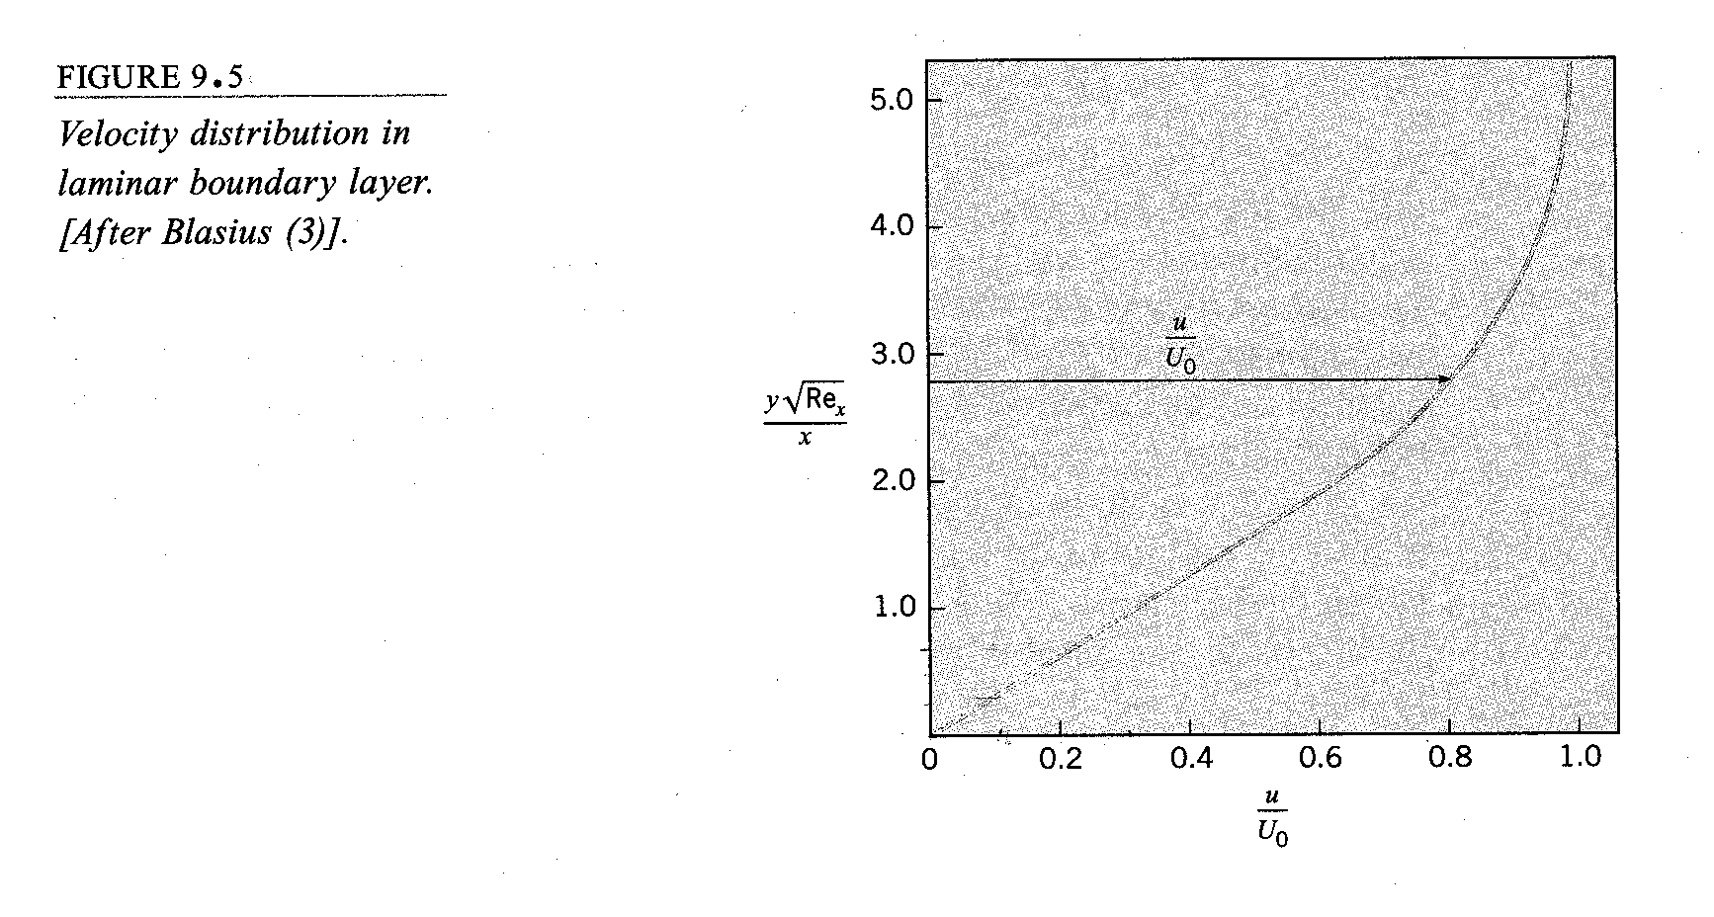
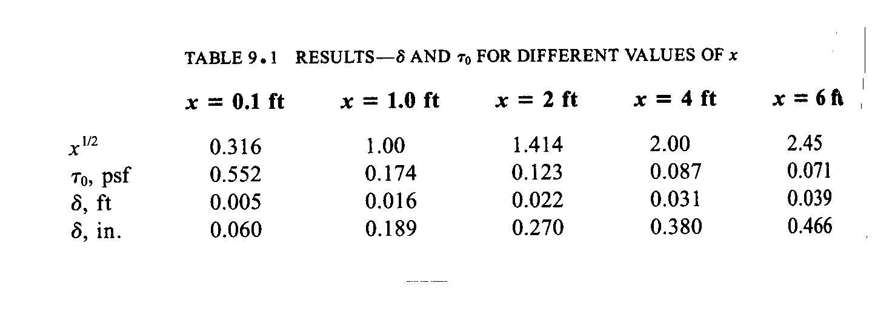
$τ_{w}=\frac{{μU}_{∞}f^{''}(0)}{\sqrt{2{νx}/{U_{∞}}}}$

i.e., $c_{f}=\frac{2τ_{w}}{{ρU}_{∞}^{2}}=\frac{0\text{.}\text{664}}{\sqrt{{\text{Re}}_{x}}}=\frac{θ}{x}$ see below

$C_{f}=\frac{1}{L}\int_{0}^{L}{c_{f}\text{dx}=2c_{f}(L)}$
=$\frac{1\text{.}\text{328}}{\sqrt{{\text{Re}}_{L}}}$

$\frac{U_{∞}L}{ν}$
Other:
$δ^{}=\int_{0}^{δ}{\left(1−\frac{u}{U_{∞}}\right)\text{dy}=1\text{.}\text{7208}\frac{x}{\sqrt{{\text{Re}}_{x}}}}$ displacement thickness

measure of displacement of inviscid flow to due boundary layer

$θ=\int_{0}^{δ}{\left(1−\frac{u}{U_{∞}}\right)\frac{u}{U_{∞}}\text{dy}=0\text{.}\text{664}\frac{x}{\sqrt{{\text{Re}}_{x}}}}$ momentum thickness

measure of loss of momentum due to boundary layer

H = shape parameter = $\frac{δ^{}}{θ}$=2.5916

Quantitative Relations for the Turbulent Boundary Layer

2-D Boundary-layer Form of RANS equations
$$\frac{∂u}{∂x}+\frac{∂v}{∂y}=0$$

$$u\frac{∂u}{∂x}+v\frac{∂u}{∂y}=−\frac{∂}{∂x}\left(\frac{p_{e}}{ρ}\right)+ν\frac{∂^{2}u}{∂y^{2}}−\frac{∂}{∂y}\left(\overline{u^{'}v^{'}}\right)$$
requires modeling

Momentum Integral Analysis

Background: History and Modern Approach: FD

To obtain general momentum integral relation which is valid for both laminar and turbulent flow
For flat plate or δ for general case
$$\int_{y=0}^{∞}{\left(\text{momentum} \text{equation} + (u−v) \text{continuity}\right)}\text{dy}$$

$\frac{τ_{w}}{{ρU}^{2}}=\frac{1}{2}c_{f}=\frac{dθ}{\text{dx}}+\left(2+H\right)\frac{θ}{U}\frac{\text{dU}}{\text{dx}}$ $−\frac{\text{dp}}{\text{dx}}=ρU\frac{\text{dU}}{\text{dx}}$
flat plate equation $\frac{\text{dU}}{\text{dx}}=0$

$θ=\int_{0}^{δ}{\frac{u}{U}\left(1−\frac{u}{U}\right)\text{dy}}$ momentum thickness

$H=\frac{δ^{}}{θ}$ shape parameter

$δ^{}=\int_{0}^{δ}{\left(1−\frac{u}{U}\right)}\text{dy}$ displacement thickness

Can also be derived by CV analysis as shown next for flat plate boundary layer.

Momentum Equation Applied to the Boundary Layer

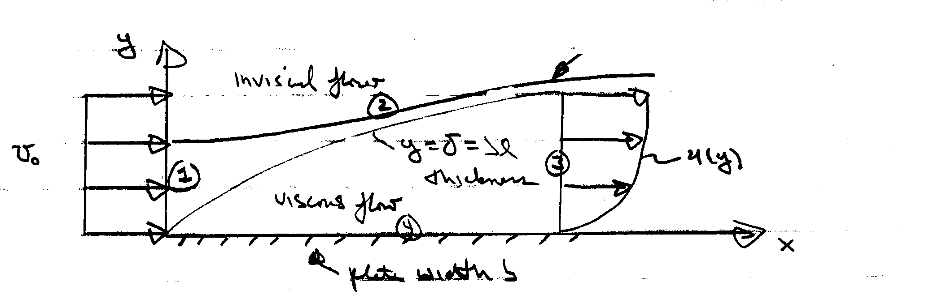
y = h + δ*= streamline
starts in uniform flow
merges with δ at 3

Steady
ρ = constant
neglect g
v << u = u_{o} ⇒ p = constant
i.e., -∇p = 0

CV = 1, 2, 3, 4

$−D=\text{drag}=b\int_{0}^{x}{τ_{w}\text{dx}}$ pressure force = 0 for v << U_{o}
force on CV wall shear stress u ∼ U_{o}

$$\sum{F_{x}=−D=ρ\int_{1}{u\left(\underline{V}⋅\underline{\text{dA}}\right)}}+ρ\int_{3}{u\left(\underline{V}⋅\underline{\text{dA}}\right)}$$

=$ρ\left(−U_{o}^{2}\text{bh}\right)+ρb\int_{3}{u^{2}\text{dy}}$

$$D(x)={ρU}_{o}^{2}\text{bh}−ρb\int_{0}^{δ}{u^{2}\text{dy}}$$
next eliminate h using continuity

$\begin{aligned}0=ρ\int_{1}{\underline{V}⋅\underline{\text{dA}}}+ρ\int_{3}{\underline{V}⋅\underline{\text{dA}}} \\ {ρU}_{o}\text{bh}=ρb\int_{0}^{δ}{\text{udy}} \\ U_{o}h=\int_{0}^{δ}{\text{udy}}\end{aligned}$
depends on u(y)

$D\left(x\right)=ρ{\text{bU}}_{o}\int_{0}^{δ}{\text{udy}}−ρb\int_{0}^{δ}{u^{2}\text{dy}}$
=$ρb\int_{0}^{δ}{u\left(U_{o}−u\right)\text{dy}}$

$C_{D}=\frac{D}{\frac{1}{2}{ρU}_{o}^{2}\text{bL}}=\frac{2}{L}\int_{0}^{δ}{\frac{u}{U_{o}}\left(1−\frac{u}{U_{o}}\right)\text{dy}}$
θ = momentum thickness

$C_{D}=\frac{2θ}{L}$
$C_{D}=\frac{D}{\frac{1}{2}{ρU}_{o}^{2}A}=\frac{b\int_{0}^{x}{τ_{w}\text{dx}}}{\frac{1}{2}{ρU}_{o}^{2}\text{bL}}=\frac{2θ}{L}$

$\int_{0}^{x}{\frac{τ_{w}}{\frac{1}{2}{ρU}_{o}^{2}}\left(x\right)\text{dx}=2θ\left(x\right)}$
$\frac{1}{2}\left(\frac{τ_{w}}{\frac{1}{2}{ρU}_{o}^{2}}\right)=\frac{dθ}{\text{dx}}$

$\frac{c_{f}}{2}=\frac{dθ}{\text{dx}}$ c_{f} = local skin friction coefficient

momentum integral relation for
flat plate boundary layer

$θ=\int_{0}^{δ}{\frac{u}{u_{o}}\left(1−\frac{u}{u_{o}}\right)\text{dy}}$

Approximate solution for a laminar boundary-layer

Assume cubic polynomial for u(y)

$$\frac{u}{U_{∞}}=A+\text{By}+{\text{Cy}}^{2}+{\text{Dy}}^{3}$$

$u=\frac{∂^{2}u}{∂y^{2}}=0$ y = 0 A = 0 B = $\frac{3}{2}δ$
$u=U_{∞}; \frac{∂u}{∂y}=0$ y = δ C = 0 D = $−\frac{1}{2}δ^{3}$
i.e., $\frac{u}{U}=\frac{3}{2}\frac{y}{δ}+\frac{1}{2}{\left(\frac{y}{δ}\right)}^{3}$
$$u_{y}=U\left(\frac{3}{2δ}+\frac{3}{2}\frac{y^{2}}{δ}\right)|_{y=0}=\frac{U3}{2δ}$$

$\frac{τ_{w}}{{ρU}^{2}}=\frac{1}{2}c_{f}=\frac{dθ}{\text{dx}}$ momentum integral equation for $\frac{\text{dp}}{\text{dx}}=0$

$\frac{1}{{ρU}^{2}}\left[μU\frac{3}{2δ}\right]=\text{.}\text{139}\frac{dδ}{\text{dx}}$ $θ=\int_{0}^{δ}{\frac{u}{U}\left(1−\frac{u}{U}\right)}\text{dy}$

$τ_{w}=μ\frac{\text{du}}{\text{dy}}$
Compare with
Exact Blassius
i.e., $δ=\frac{4\text{.}\text{65}x}{\sqrt{{\text{Re}}_{x}}}$ $\frac{5x}{\sqrt{{\text{Re}}_{x}}}$ 7% ↓

$τ_{w}=\frac{\text{.}\text{323}{ρV}^{2}}{\sqrt{{\text{Re}}_{x}}}$ $\frac{\text{.}\text{332}{ρU}^{2}}{\sqrt{{\text{Re}}_{x}}}$ 3%↓

$c_{f}=\frac{\text{.}\text{646}}{\sqrt{{\text{Re}}_{x}}}$ $\frac{\text{.}\text{664}}{\sqrt{{\text{Re}}_{x}}}$

$C_{f}=\frac{1\text{.}\text{29}}{\sqrt{{\text{Re}}_{L}}}$ $\frac{1\text{.}\text{33}}{\sqrt{{\text{Re}}_{L}}}$
$$C_{f}=\frac{1}{\frac{1}{2}{ρU}^{2}\text{bL}}\int_{0}^{L}{τ_{w}\left(x\right)\text{dx}}$$
span length

total skin-friction drag coefficient

Approximate solution Turbulent Boundary-Layer

Re_{t} ∼ 3 X 10⁶ for a flat plate boundary layer
Re_{crit} ∼ 500,000
$\frac{c_{f}}{2}=\frac{dθ}{\text{dx}}$

as was done for the approximate laminar flat plate boundary-layer analysis, solve by expressing c_{f} = c_{f} (δ) and θ = θ(δ) and integrate, i.e.

assume log-law valid across entire turbulent boundary-layer

$\frac{u}{u^{}}=\frac{1}{κ}\text{ln}\frac{{\text{yu}}^{}}{ν}+B$
neglect laminar sub layer and velocity defect region

at y = δ, u = U

$$\frac{U}{u^{}}=\frac{1}{κ}\text{ln}\frac{{δu}^{}}{ν}+B$$
${\text{Re}}_{δ}{\left(\frac{c_{f}}{2}\right)}^{1/2}$
or ${\left(\frac{2}{c_{f}}\right)}^{1/2}=2\text{.}\text{44}\text{ln}\left[{\text{Re}}_{δ}{\left(\frac{c_{f}}{2}\right)}^{1/2}\right]+5$
c_{f} (δ)

$c_{f}≃\text{.}\text{02}{\text{Re}}_{δ^{{−1}/6}}$ power-law fit
Next, evaluate
$\frac{dθ}{\text{dx}}=\frac{d}{\text{dx}}\int_{0}^{δ}{\frac{u}{U}\left(1−\frac{u}{U}\right)\text{dy}}$

can use log-law or more simply a power law fit
$$\frac{u}{U}={\left(\frac{y}{δ}\right)}^{1/7}$$

Note: can not be used to obtain c_{f} (δ) since τ_{w} → ∞

$$θ=\frac{7}{\text{72}}δ=θ\left(δ\right)$$
⇒ $τ_{w}=c_{f}\frac{1}{2}{ρU}^{2}={ρU}^{2}\frac{dθ}{\text{dx}}=\frac{7}{\text{72}}{ρU}^{2}\frac{dδ}{\text{dx}}$
$${\text{Re}}_{δ^{{−1}/6}}=9\text{.}\text{72}\frac{dδ}{\text{dx}}$$
or $\frac{δ}{x}=\text{.}\text{16}{\text{Re}}_{x}^{{−1}/7}$
i.e., much faster growth rate than laminar boundary layer

$δ∝x^{6/7}$ almost linear

$$c_{f}=\frac{\text{.}\text{027}}{{\text{Re}}_{x}^{1/7}}$$
$$C_{f}=\frac{\text{.}\text{031}}{{\text{Re}}_{L}^{1/7}}=\frac{7}{6}C_{f}\left(L\right)$$
Alternate forms given in text depending on experimental information and power-law fit used, etc. (i.e., dependent on Re range.)

Some additional relations given in texts for larger Re are as follows:
Total shear-stress coefficient
Re > 10⁷

$\frac{δ}{L}=c_{f}\left(\text{.}\text{98}{\text{logRe}}_{L}−\text{.}\text{732}\right)$
Local
shear-stress coefficient
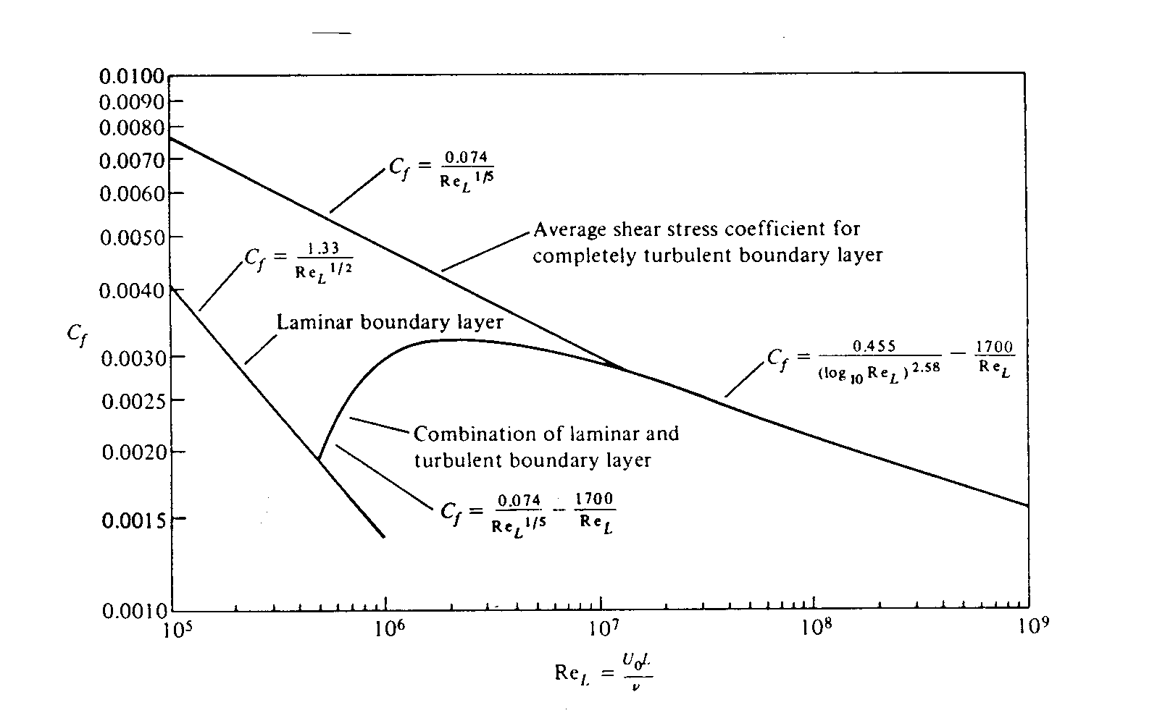
$c_{f}={\left(2{\text{logRe}}_{x}−\text{.}\text{65}\right)}^{−2\text{.}3}$

Finally, a composite formula that takes into account both the initial laminar boundary-layer (with translation at
Re_{CR} = 500,000) and subsequent turbulent boundary layer
is $C_{f}=\frac{\text{.}\text{074}}{{\text{Re}}_{L}^{1/5}}−\frac{\text{1700}}{{\text{Re}}_{L}}$ 10⁵ < Re < 10⁷
Drag of 2-D Bodies

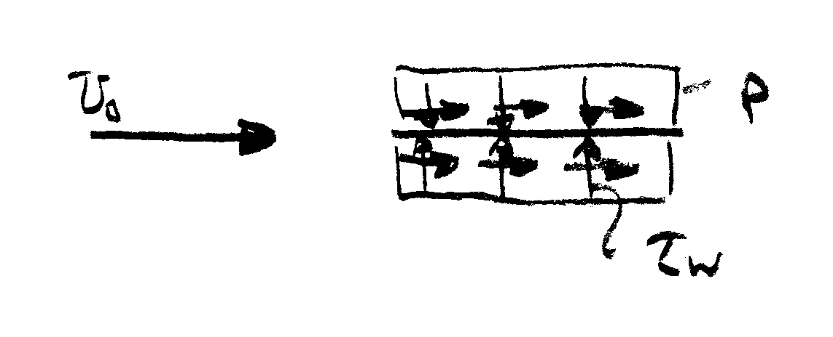
First consider a flat plate both parallel and normal to the flow

$$C_{\text{Dp}}=\frac{1}{\frac{1}{2}{ρV}^{2}A}\int_{S}{\left(p−p_{∞}\right)\underline{n}⋅\hat{i}}=0$$

$$C_{f}=\frac{1}{\frac{1}{2}{ρV}^{2}A}\int_{S}{τ_{w}\underline{t}⋅\hat{i}\text{dA}}$$

= $\frac{1\text{.}\text{33}}{{\text{Re}}_{L}^{1/2}}$ laminar flow

= $\frac{\text{.}\text{074}}{{\text{Re}}_{L}^{1/5}}$ turbulent flow
flow pattern
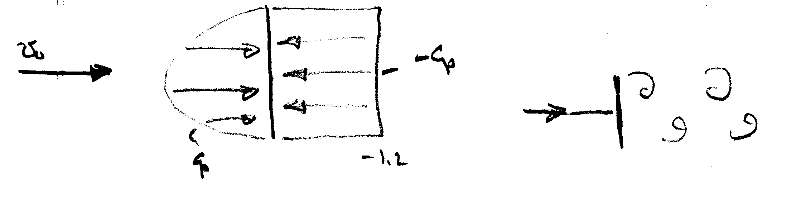

vortex wake
typical of bluff body flow

where C_{p} based on experimental data

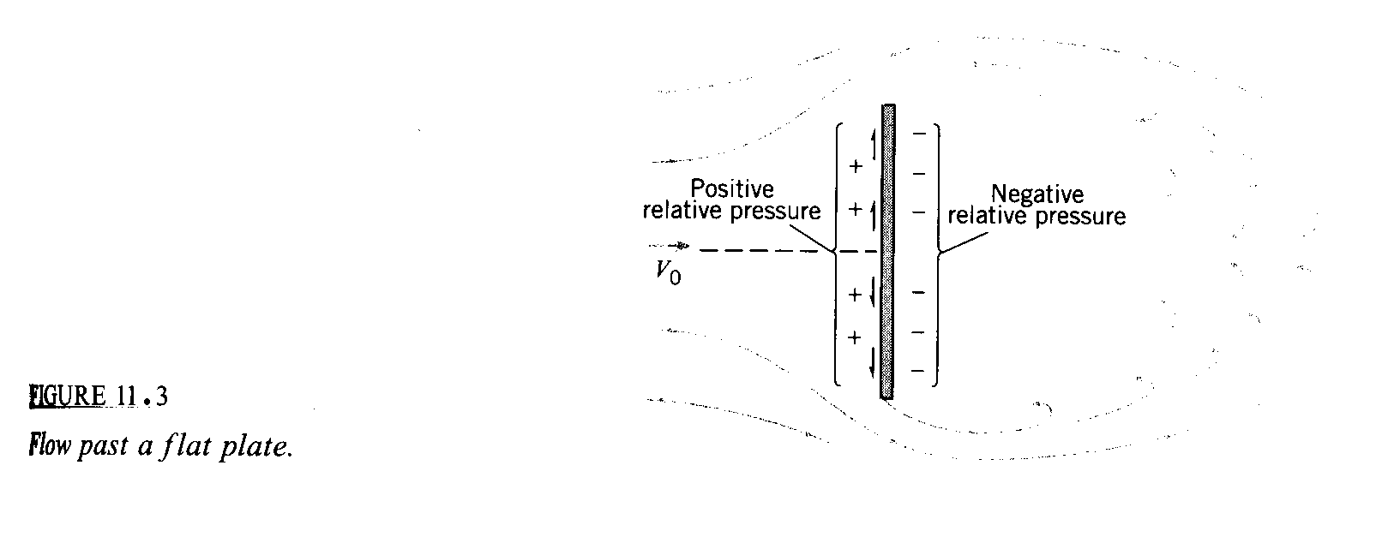

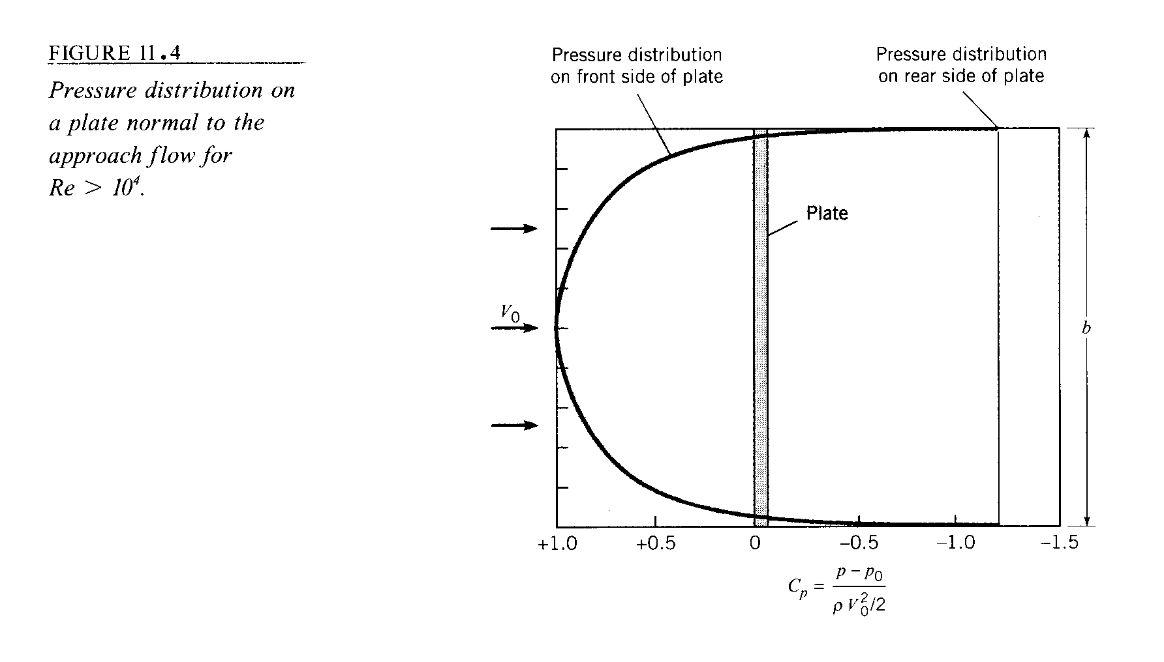
$$C_{\text{Dp}}=\frac{1}{\frac{1}{2}{ρV}^{2}A}\int_{S}{\left(p−p_{∞}\right)\underline{n}⋅\hat{i}\text{dA}}$$
= $\frac{1}{A}\int_{S}{C_{p}\text{dA}}$
= 2 using numerical integration of experimental data

C_{f} = 0

For bluff body flow experimental data used for c_{D}.

In general, Drag = f(V, L, ρ, μ, c, t, ε, T, etc.)
from dimensional analysis
c/L

$$C_{D}=\frac{\text{Drag}}{\frac{1}{2}{ρV}^{2}A}=f\left(\text{Re,} \text{Ar}, \frac{t}{L}, \frac{ε}{L}, T, \text{etc}\text{.}\right)$$

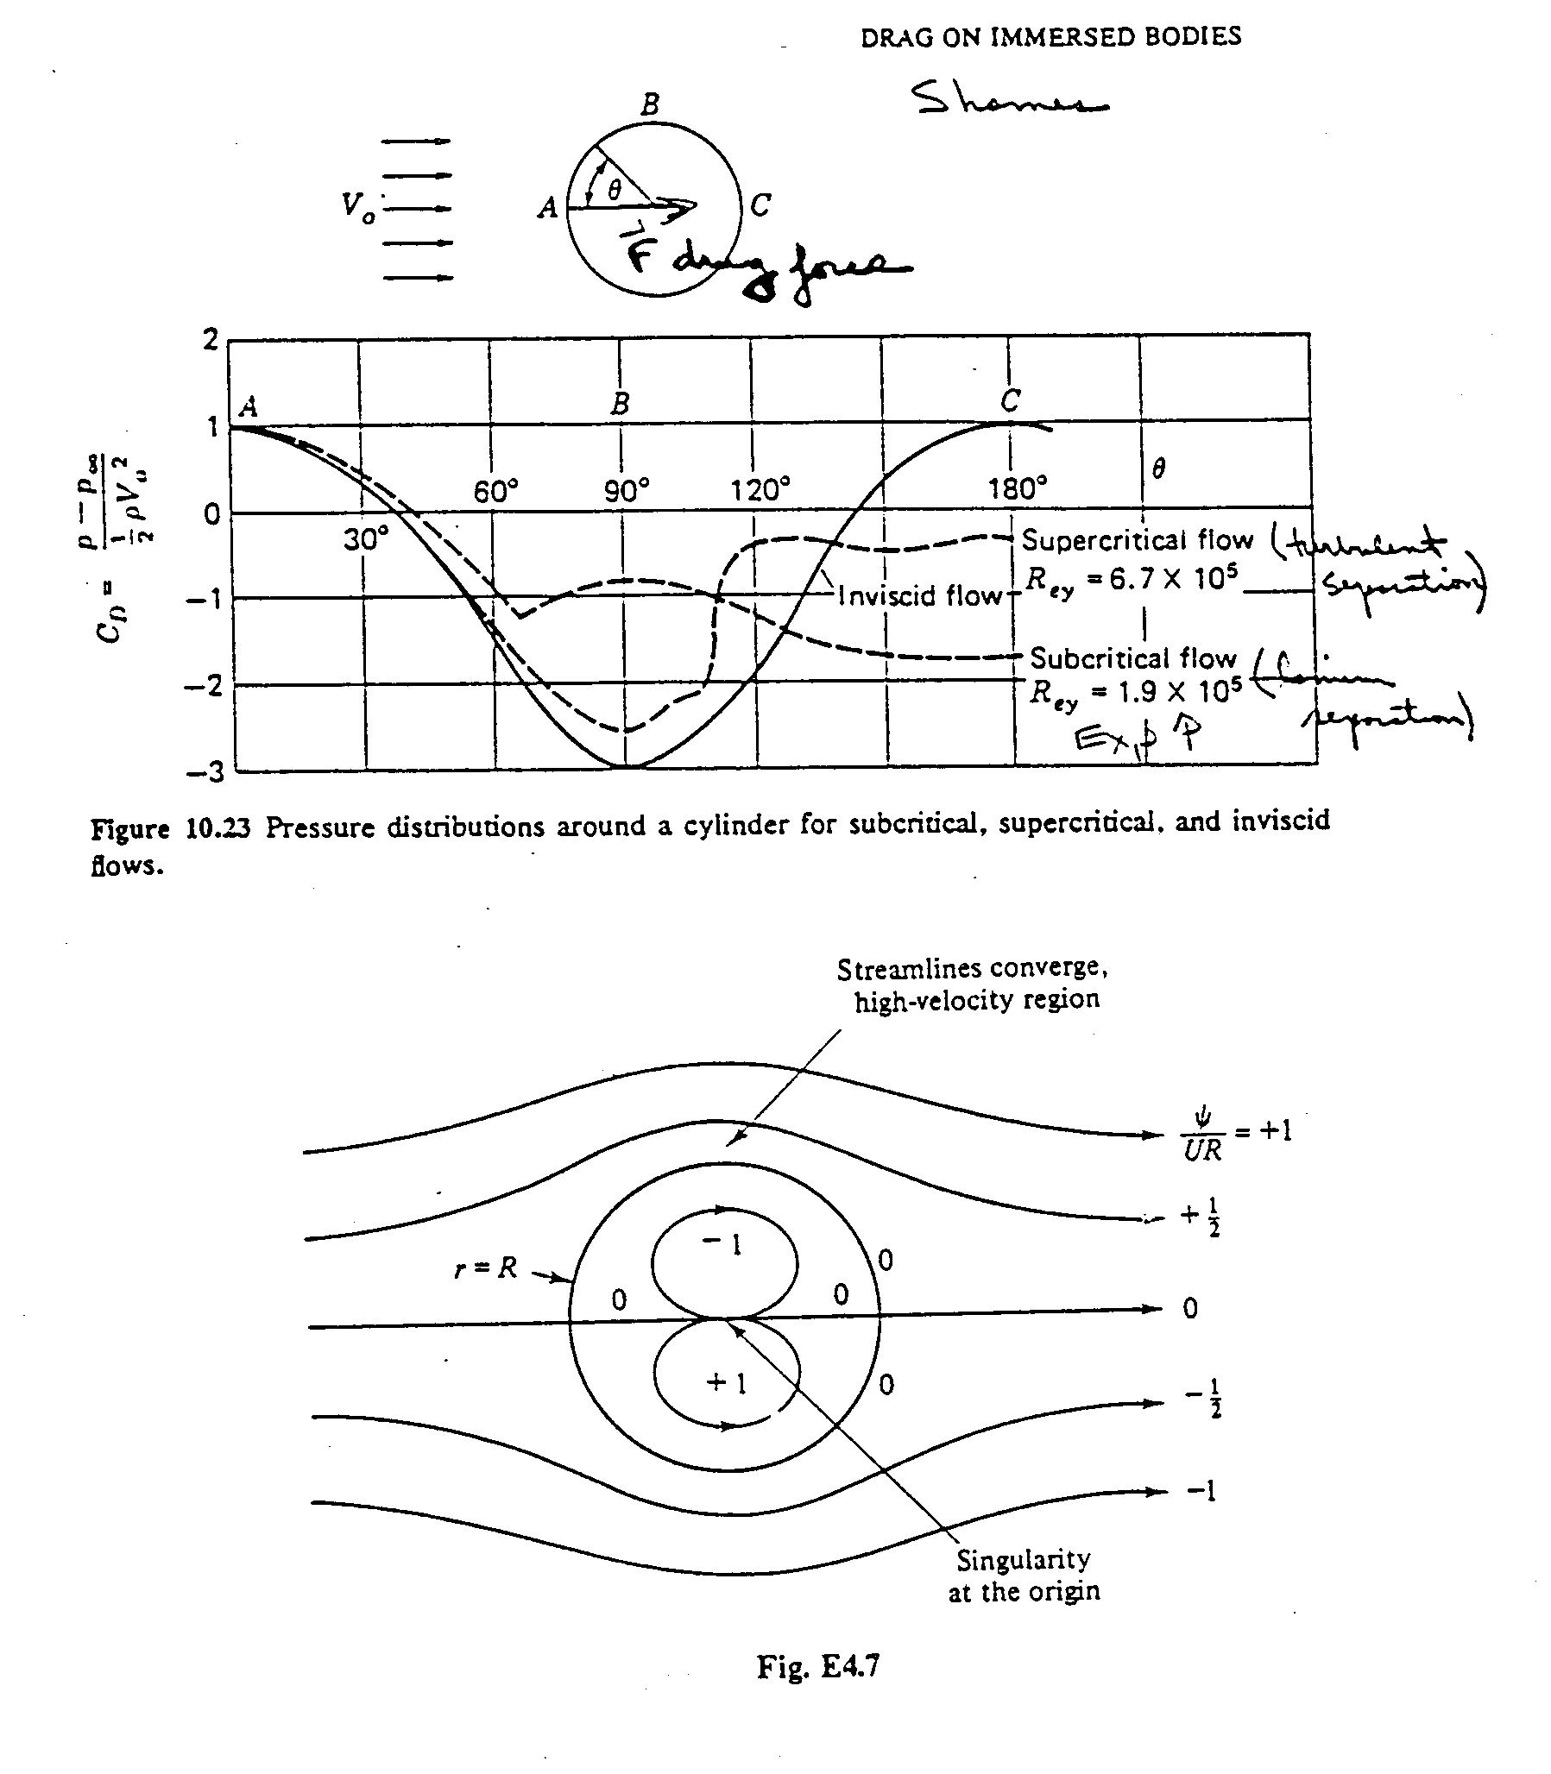
scale factor
Potential Flow Solution: $ψ=−U_{∞}\left(r−\frac{a^{2}}{r}\right)\text{sin}θ$
$$\begin{aligned}u_{r}=\frac{1}{r}\frac{∂ψ}{∂θ} \\ \\ u_{θ}=−\frac{∂ψ}{∂r}\end{aligned}$$
$p+\frac{1}{2}{ρV}^{2}=p_{∞}+\frac{1}{2}{ρU}_{∞}^{2}$

$C_{p}=\frac{p−p_{∞}}{\frac{1}{2}{ρU}_{∞}^{2}}=1−\frac{u_{r}^{2}+u_{θ}^{2}}{U_{∞}^{2}}$
$C_{p}\left(r=a\right)=1−4{\text{sin}}^{2}θ$ surface pressure

Flow Separation

Flow separation:
→The fluid stream detaches itself from the surface of the body at
sufficiently high velocities. Only appeared in viscous flow!!

Flow separation forms the region called ‘separated region’

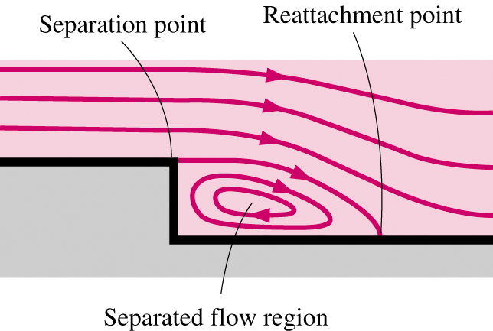

Inside the separation region:
→low-pressure, existence of recirculating/backflows
→viscous and rotational effects are the most significant!

Important physics related to flow separation:
→’Stall’ for airplane (Recall the movie you saw at CFD-PreLab2!)
→Vortex shedding
(Recall your work at CFD-Lab2, AOA=16°! What did you see in your velocity-vector plot at the trailing edge of the air foil?)

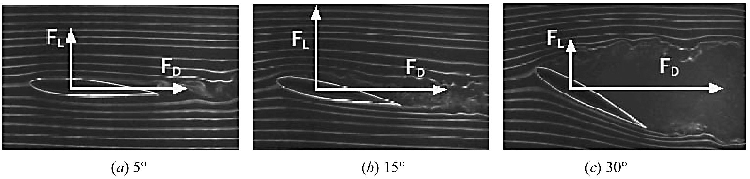

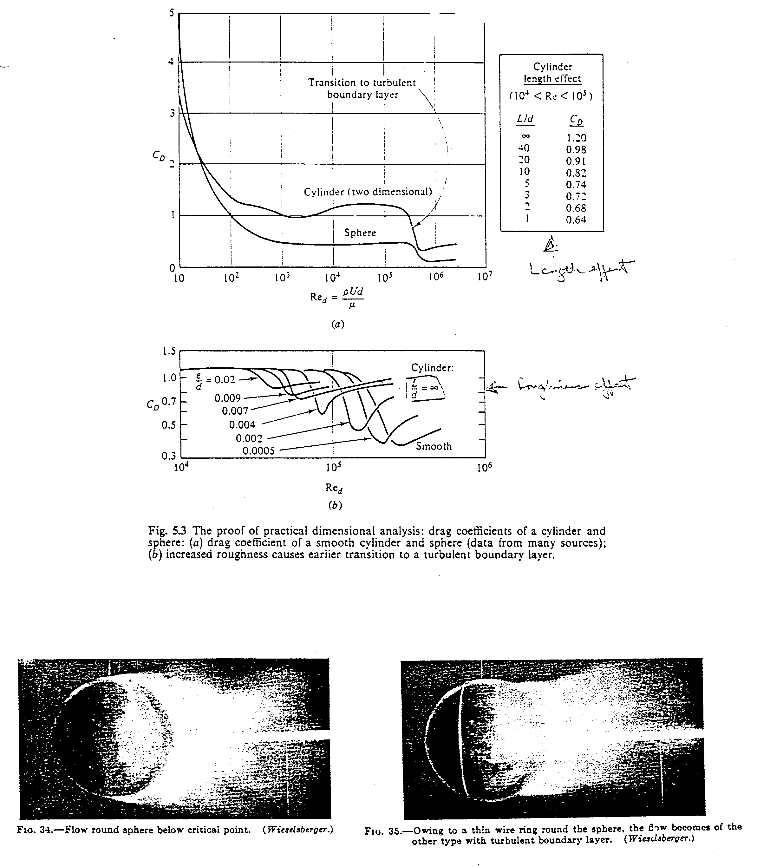
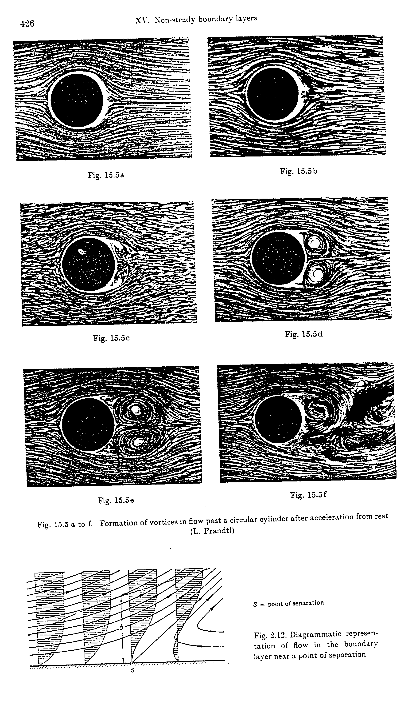
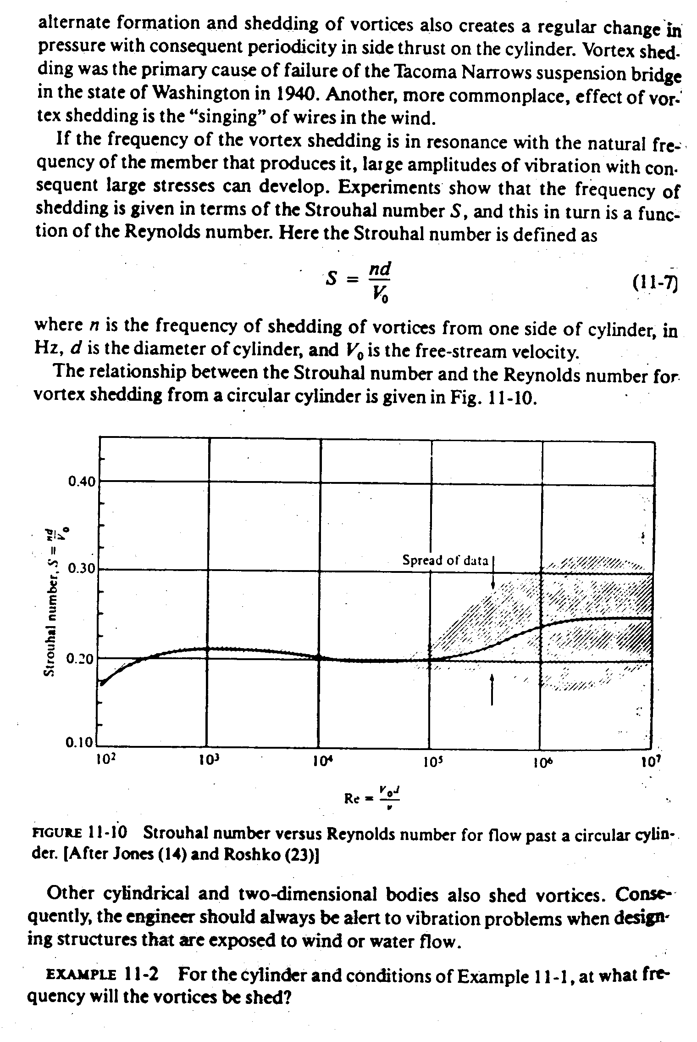
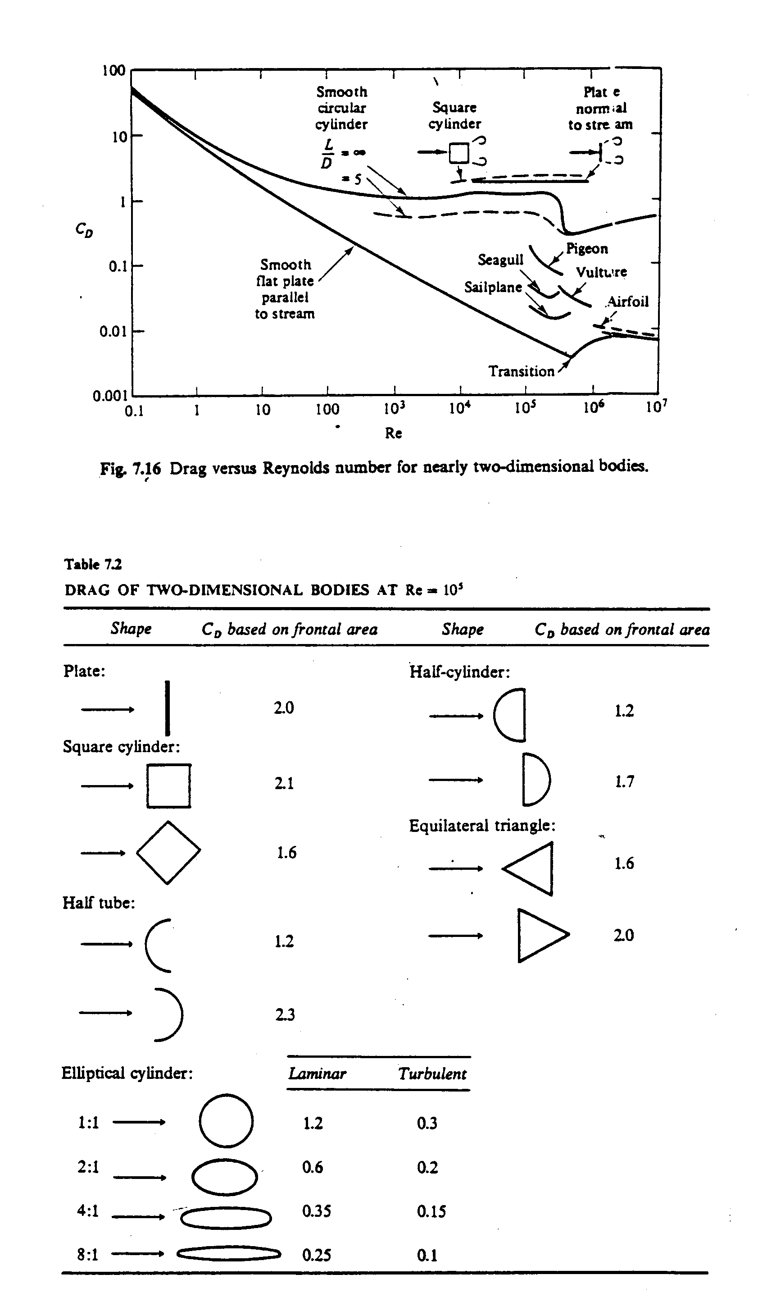
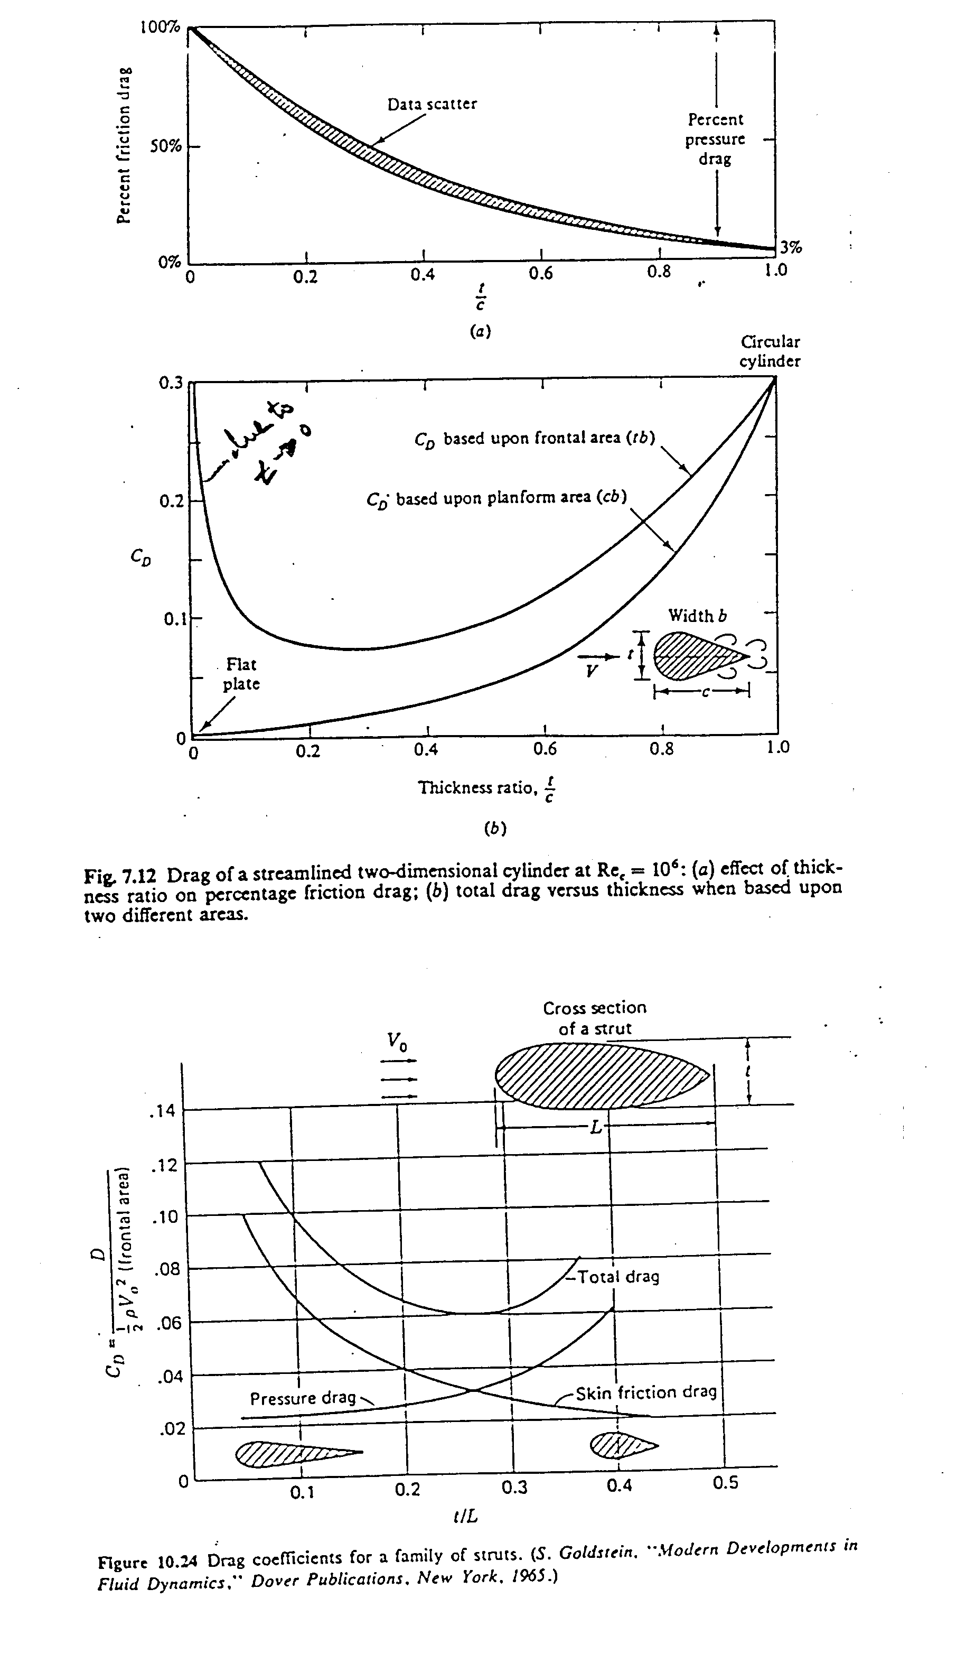
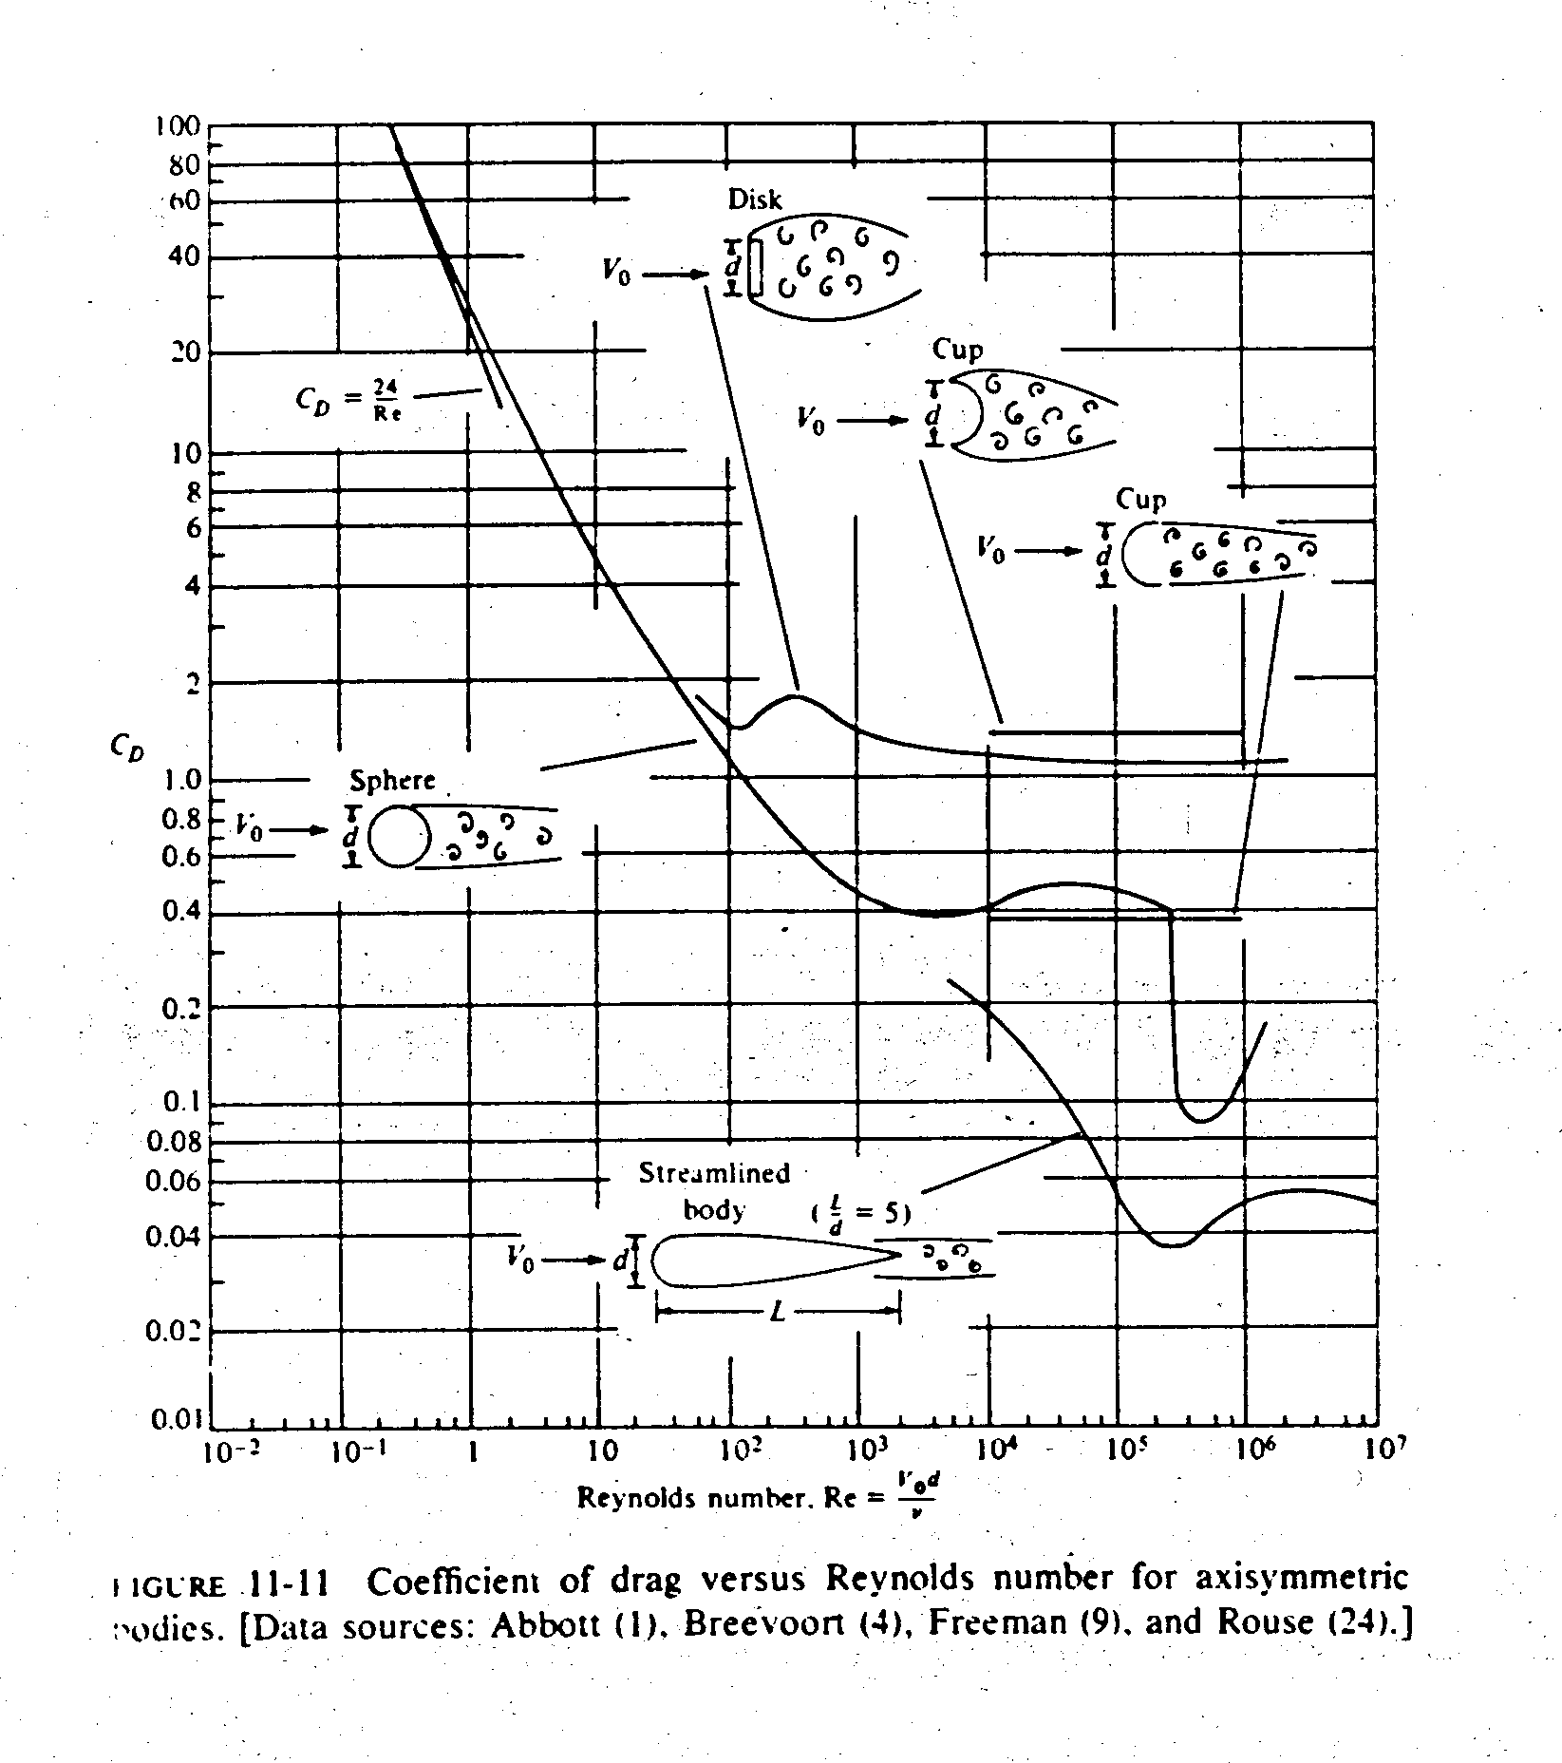

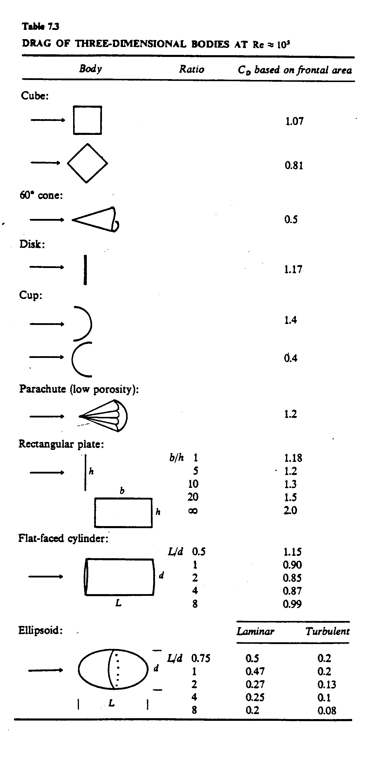
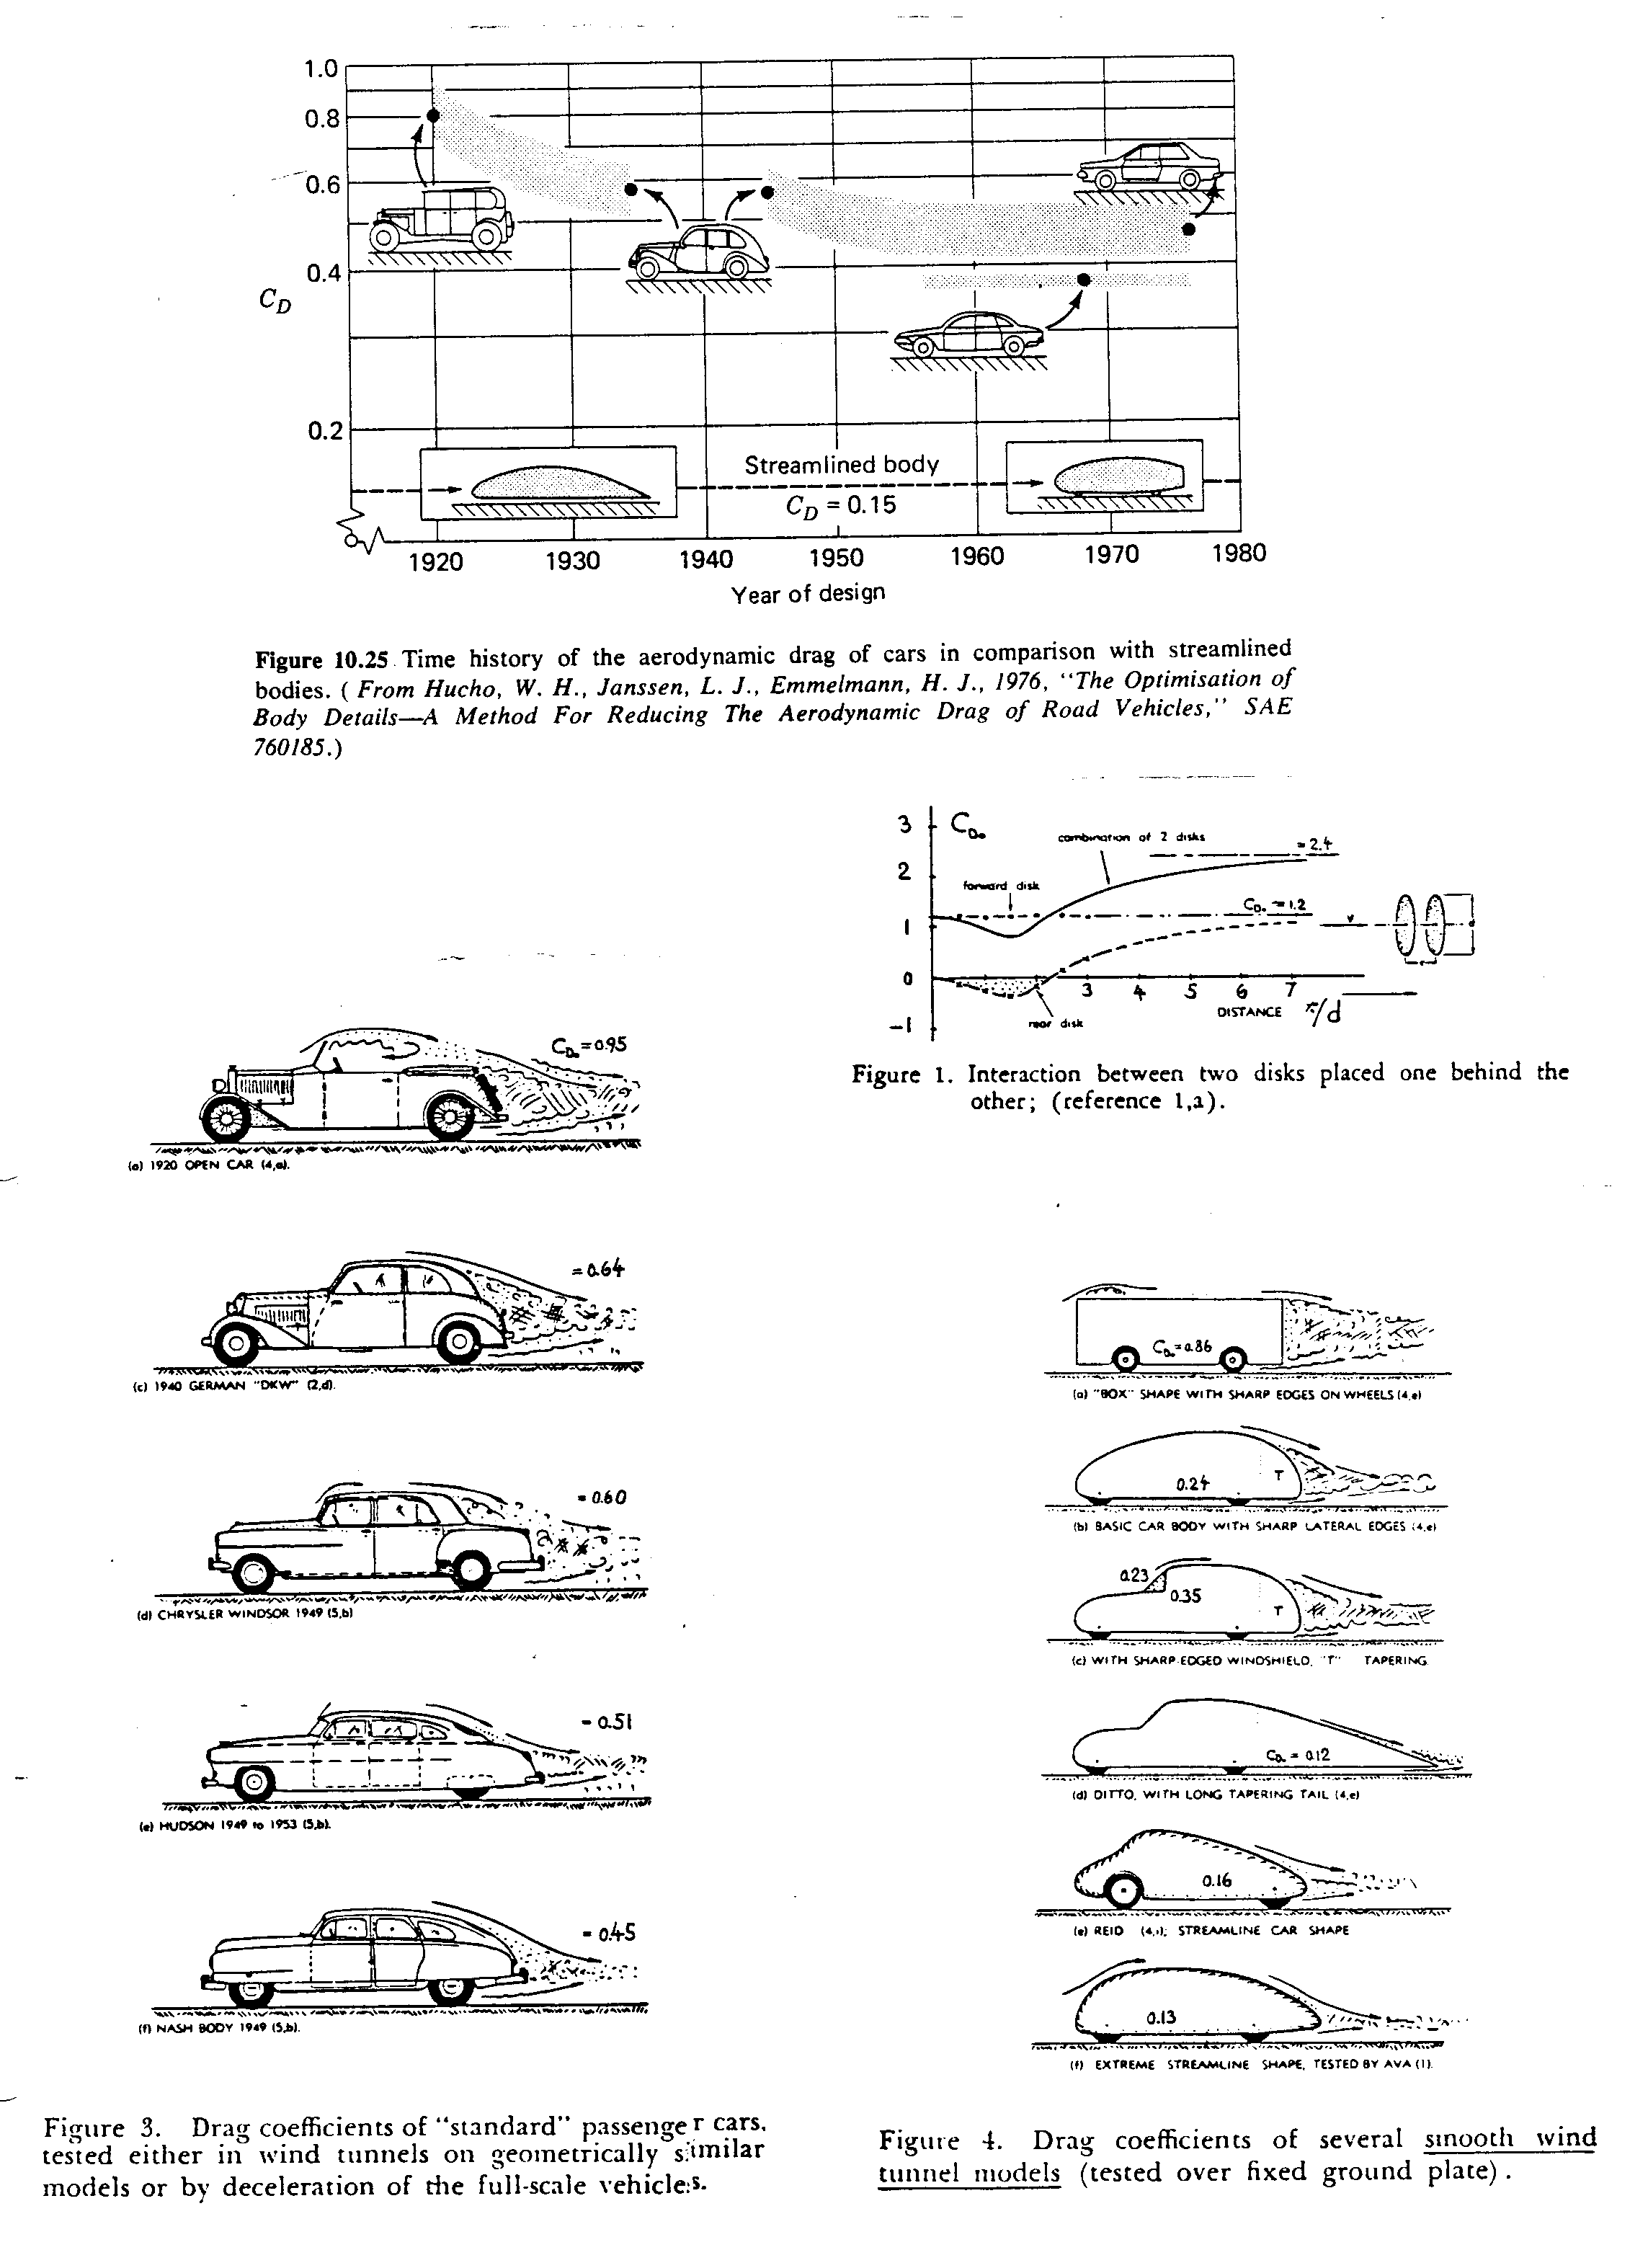

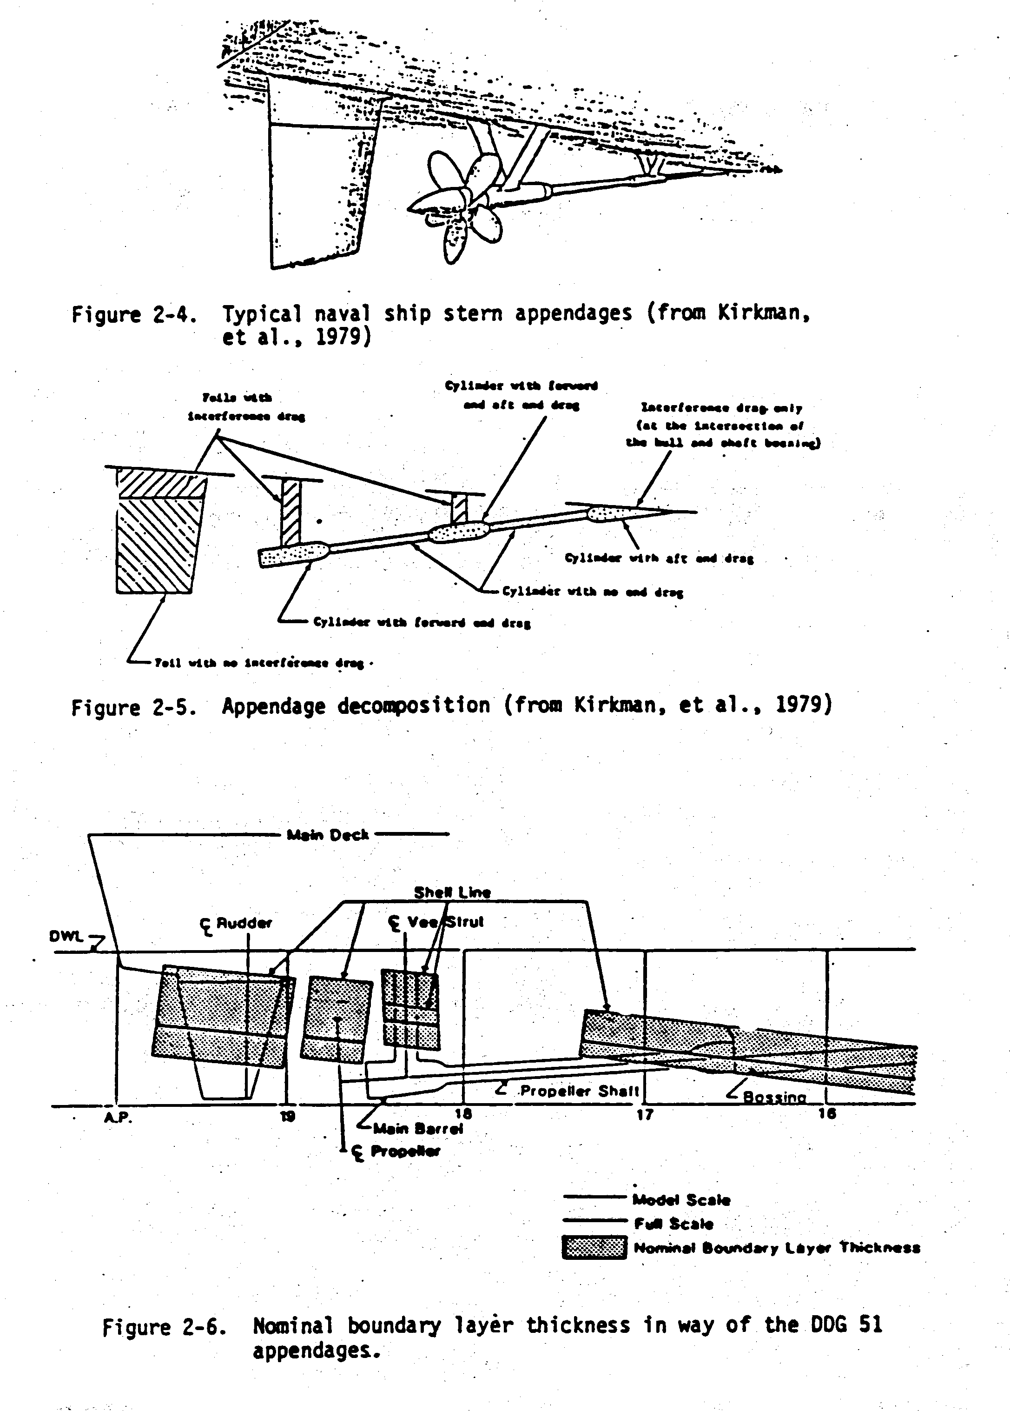

Magnus effect: Lift generation by spinning

Breaking the symmetry causes the lift!
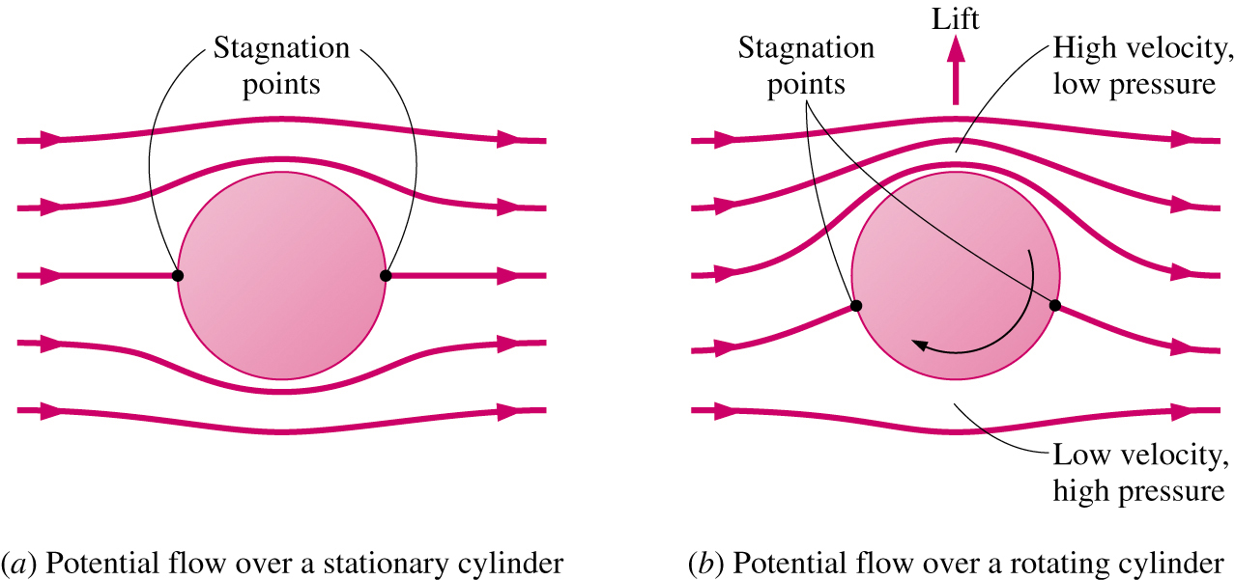

Effect of the rate of rotation on the lift and drag coefficients of a smooth sphere:
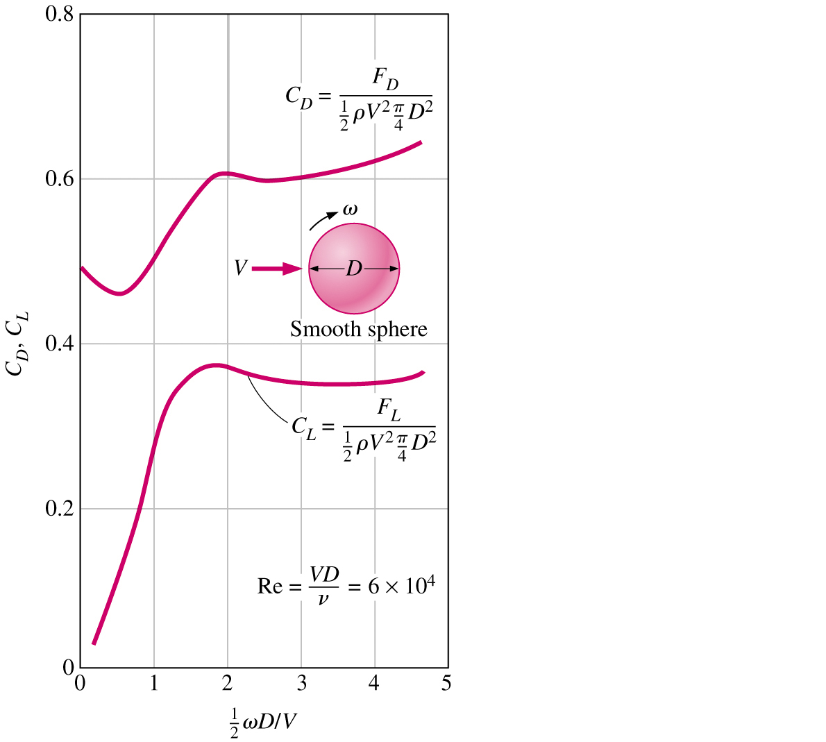
Lift acting on the airfoil

Lift force: the component of the net force (viscous+pressure) that is perpendicular to the flow direction

Variation of the lift-to-drag ratio with angle of attack:
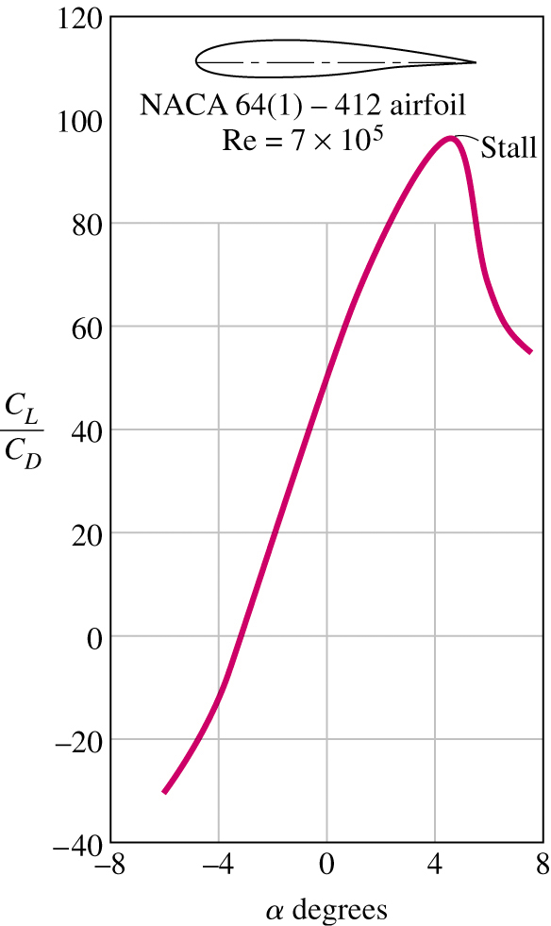
The minimum flight velocity:
→Total weight W of the aircraft be equal to the lift

$$W=F_{L}=\frac{1}{2}C_{L\text{,max}}{ρV}_{\text{min}}^{2}A→V_{\text{min}}=\sqrt{\frac{2W}{{ρC}_{L\text{,max}}A}}$$
Effect of Compressibility on Drag: CD = CD(Re, Ma)

$$\text{Ma}=\frac{U_{∞}}{a}$$
speed of sound = rate at which infinitesimal
disturbances are propagated from their source into undisturbed medium
< 0.3 flow is incompressible,
i.e., ρ ∼ constant
Ma < 1 subsonic
Ma ∼ 1 transonic (=1 sonic flow)
Ma > 1 supersonic
Ma >> 1 hypersonic

C_{D} increases for Ma ∼ 1 due to shock waves and wave drag

Ma_{critical}(sphere) ∼ .6

Ma_{critical}(slender bodies) ∼ 1

For U > a: upstream flow is not warned of approaching
disturbance which results in the formation of shock waves across which flow properties and streamlines change discontinuously

