Simulation of Laminar Pipe Flows

ENGR:2510 Mechanics of Fluids and Transport Processes

CFD PRELAB 1

(ANSYS 17.1; Last Updated: Oct. 7, 2016)

By Timur Dogan, Michael Conger, Dong-Hwan Kim, Andrew Opyd,
Maysam Mousaviraad, Tao Xing and Fred Stern

IIHR-Hydroscience & Engineering
The University of Iowa
C. Maxwell Stanley Hydraulics Laboratory
Iowa City, IA 52242-1585

- Purpose

The Purpose of CFD PreLab 1 is to teach students how to use the CFD educational interface (ANSYS), be familiar with the options in each step of CFD Process, and relate simulation results to AFD concepts. Students will simulate laminar pipe flow following the “CFD process” by an interactive step-by-step approach. Students will have “hands-on” experiences using ANSYS to compute axial velocity profile, centerline velocity, centerline pressure, and wall shear stress. Students will compare simulation results with AFD data, analyze the differences and possible numerical errors, and present results in CFD Lab 1 report.

Geometry
Physics
Mesh
Solution
Results
Pipe (ANSYS Design Modeler)
Structure (ANSYS Mesh)
Non-uniform (ANSYS Mesh)
Uniform (ANSYS Mesh)
General (ANSYS Fluent - Setup)
Model (ANSYS Fluent - Setup)
Boundary Conditions (ANSYS Fluent -Setup)
Reference Values (ANSYS Fluent - Setup)
Laminar
Turbulent
Solution Methods (ANSYS Fluent - Solution)
Monitors (ANSYS Fluent - Solution)
Solution Initialization (ANSYS Fluent -Solution)
Plots (ANSYS Fluent- Results)
Graphics and Animations (ANSYS Fluent- Results)

Flow chart for “CFD Process” for pipe flow

- Simulation Design

In EFD Lab 2, you conducted experimental study for turbulent pipe flow. The data you have measured will be used for CFD Lab 1. In CFD PreLab 1, simulation will be conducted only for laminar circular pipe flows, i.e. the Reynolds number is less than 2300. Reynolds number based on pipe diameter and mean inlet velocity is 654.75 in the current simulation. CFD predictions of friction factor and fully developed axial velocity profile will be compared with AFD data.

Table 1 – Geometry dimensions
Parameter | Unit | Value
Radius of Pipe | m | 0.02619
Diameter of Pipe | m | 0.05238
Length of the Pipe | m | 7.62

Figure 1 - Geometry
Outlet
Inlet
Symmetry Axis Axis
Pipe Wall

Non-uniform mesh
Uniform mesh
Velocity Profile

Since the flow is axisymmetric we only need to solve the flow in a single plane from the centerline to the pipe wall. Boundary conditions need to be specified include inlet, outlet, wall, and axis, as will be described in details later. Uniform flow is specified at inlet, the flow will reach the fully developed regions after a certain distance downstream. No-slip boundary condition will be used on the wall and constant pressure for the outlet. Symmetric boundary condition will be applied on the pipe axis. Since the flow is laminar, turbulence models are not necessary.

Navigation Tips
- To zoom in and out use the magnifying glass with a plus sign in it and drag, from top left to bottom right over the are you wish to zoom.
- To look at a view plane, simply click on the arrow in the coordinate system identifier in the bottom right of the screen. i.e if you wish to look at the XYplane, click on the Z Arrow.
- Open ANSYS Workbench

  - Start > All Programs > ANSYS 17.1 > Workbench 17.1
(Note: You may ignore the firewall warnings by closing the pop-up window)

  - From the ANSYS Workbench home screen (Project Schematic), drag and drop the Geometry component for the Component Systems in the Toolbox into the Project Schematic.
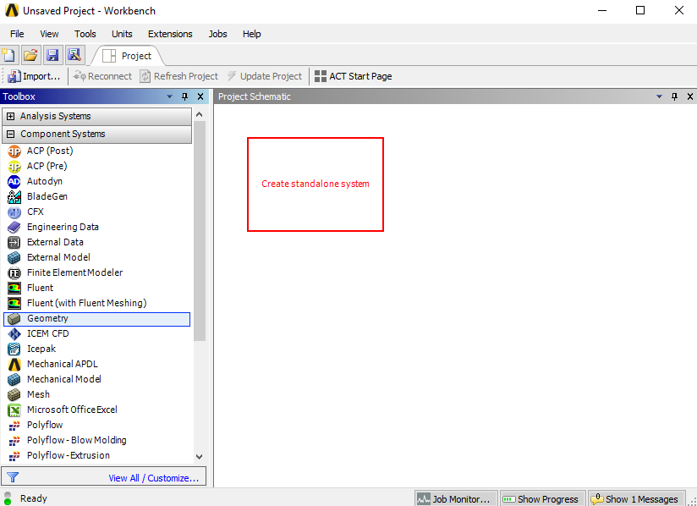
Drag and drop

  - Rename the geometry “Pipe” by right clicking on the down arrow of the Geometry component and selecting Rename.
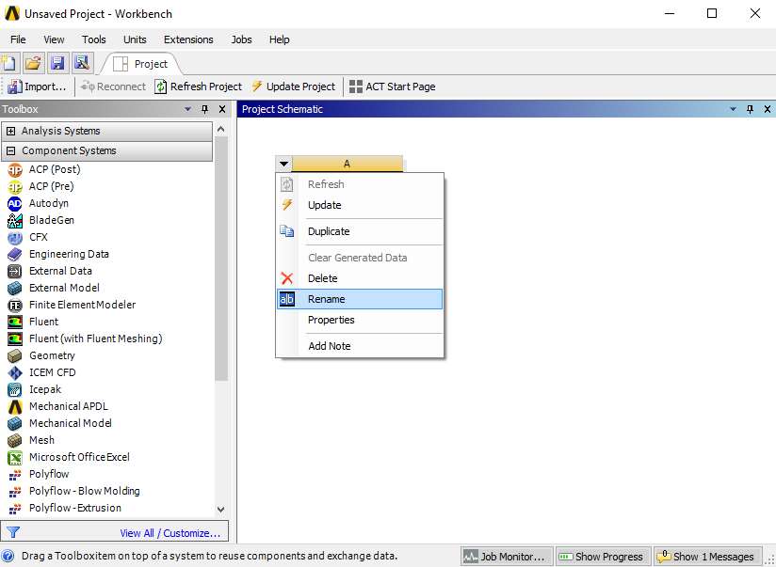

  - Drag and drop a Mesh component and a Fluent component into the Project Schematic as shown below. Rename the components as “Uniform” and “Laminar” for Mesh and Fluent components respectively.
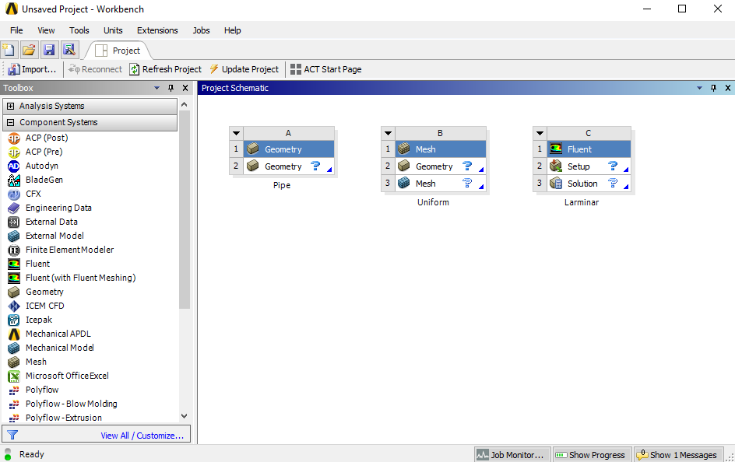

  - Make the connections as per below by dragging connections exactly as per below. Drag and drop “Geometry” to “Mesh” and “Mesh” to “Setup”.
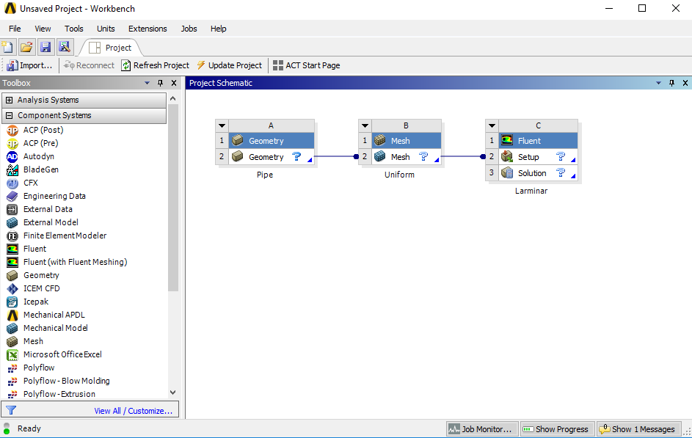

  - Create a folder on the network drive (home.iowa.uiowa.edu) called “CFD Pre-Lab and Lab 1”.
  - Save the project file by clicking File > Save As…
  - Save the project onto the folder you just created and name it “CFD Pre-Lab and Lab 1 Pipe Flow”. (This project file will be used for both Pre-Lab 1 and Lab 1.)

- Geometry Creation

  - Right click on Geometry and from the drop down menu select New DesignModeler Geometry…

  - Make sure that Unit is set to Meter (default value).

  - Select the XYPlane under the Tree Outline and click New Sketch button.

  - Right click XYPlane and select Look at.
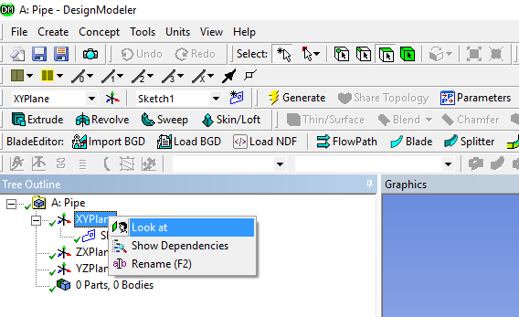

  - Select Sketching > Constraints > Auto Constraints. Enable the auto constraints option to pick the exact point as below.
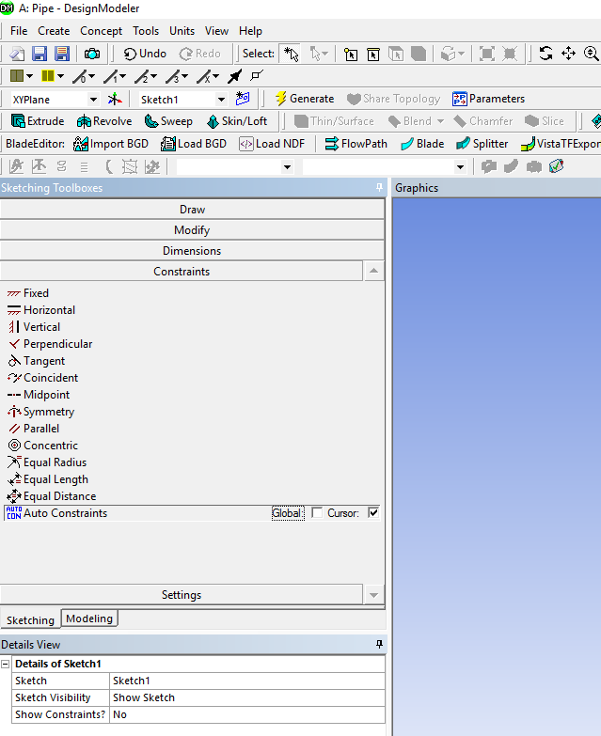

  - Select Sketching > Draw >Rectangle. Create a rectangle geometry as per below, make sure to start from the origin, the mouse arrow should change to a “P” when on the origin.
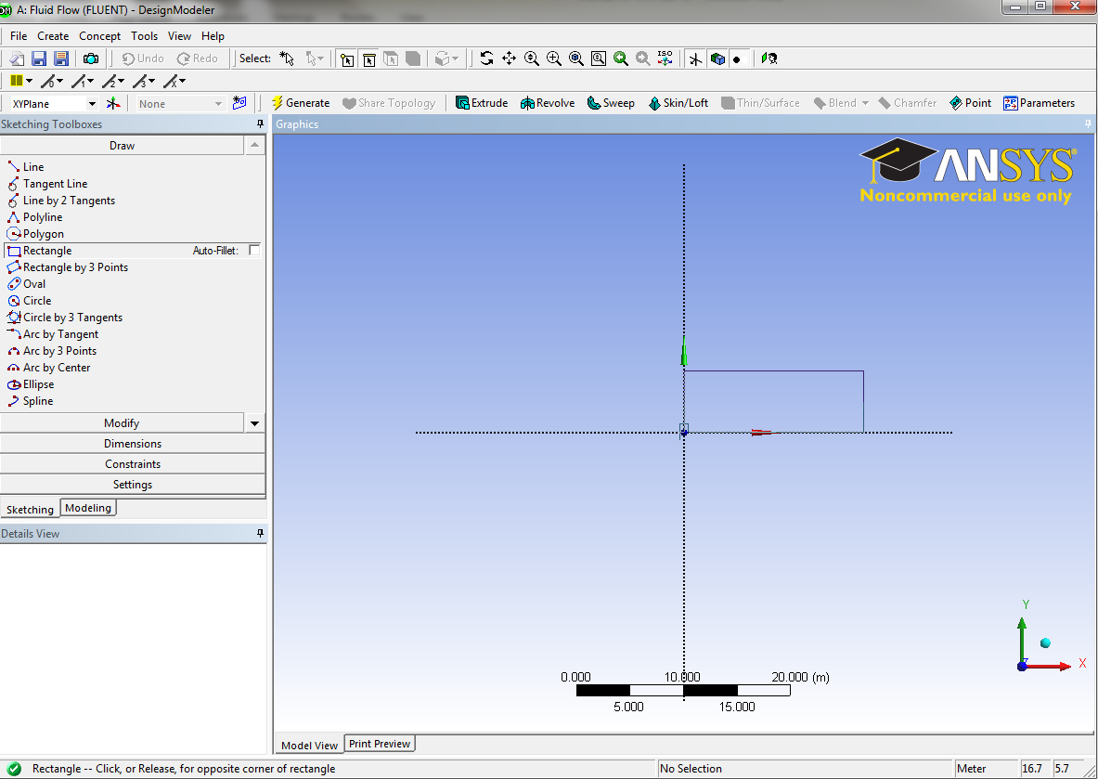

  - Select Dimensions > General. Click on top edge then click above the geometry to place the dimension. Repeat the same thing for one of the vertical edges. You should have a similar figure as per below.

  - Click on H1 under Details View, in the bottom left of the screen, and change H1 to 7.62m. Click on V2 and change it to 0.02619m. (Don’t include unit “m” when put in the values)
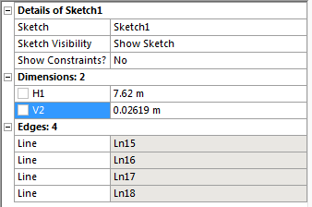

  - Concept > Surfaces From Sketches, select the sketch by left clicking on Sketch1 in the Tree Outline and hit Apply in the Detatils View.

  - Click Generate. This will create a surface.
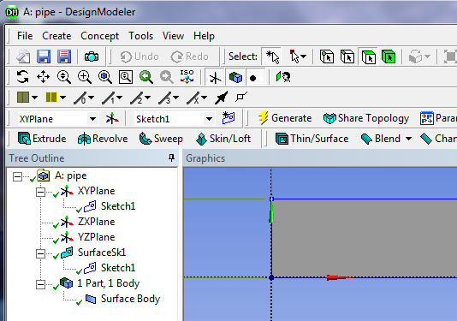

  - File >Save Project. Save project and close the Design Modeler window.
- Mesh Generation

  - From the Project Schematic right click on Mesh component and select Edit…

  - Right click on Mesh then select Insert > Face Meshing.

  - Select your geometry by clicking the yellow box which says No Selection, then click on the geometry surface, and click Apply. (Note: You can change orientation of your view to xy plane by clicking the z-axis figure on the lower right corner. Press “F7” on your keyboard to restore to the “whole view”. Zoom in by holding the right mouse button and selecting a region.)
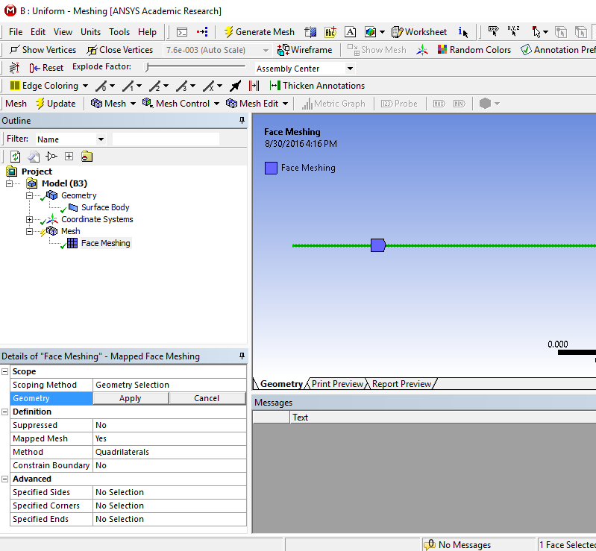

  - Click on the edge button. This will allow you to select edges of your geometry.

  - Right click on Mesh then select Insert > Sizing.

  - Hold Ctrl button and select the top and bottom edge of the rectangle then click Apply on Geometry. Specify details of sizing as per below in the Details of “Edge Sizing” – Sizing window.
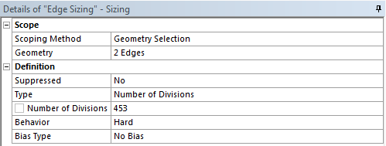
  - Repeat step 5.5. to insert Sizing. Select the left and right edge of the rectangle and click Apply then change sizing parameters as per below (Please see 5.3. for view restoring and zooming in).
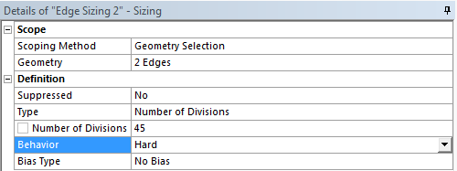

  - Click on Generate Mesh button. Click Mesh under Outline. The mesh should look like the mesh pictured below.
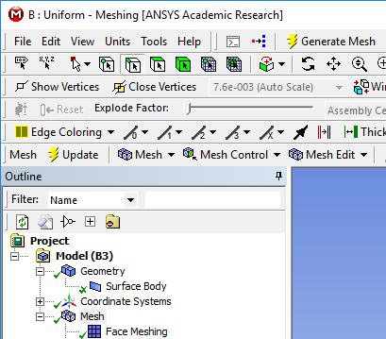

Uniform Mesh

  - Change the edge names by selecting the edge, then right click on the edge and select Create Named Selection. Name left, right, bottom and top edges as inlet, outlet, axis and wall respectively. Your outline should look same as the figure below (next page).

  - File > Save Project. Save the project and close the window. Update mesh on Project Schematic by right clicking on Mesh and selecting Update.
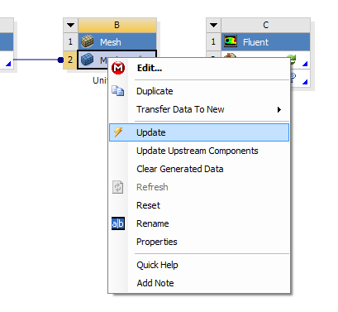

- Solve (Physics)

  - Right click Setup and select Edit…
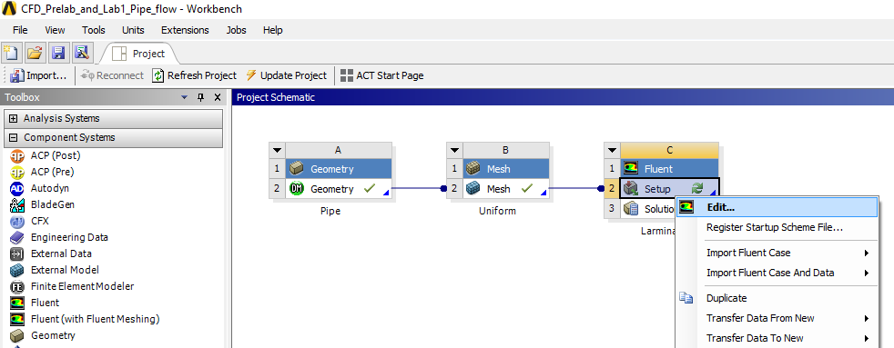

  - Check Double Precision and click OK.
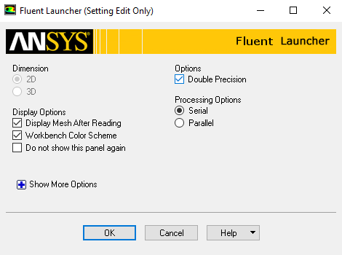

  - Tree > Setup > General > Check. (Note: If you get an error message you may have made a mistake while creating you mesh. Review steps in mesh generation and make changes.)
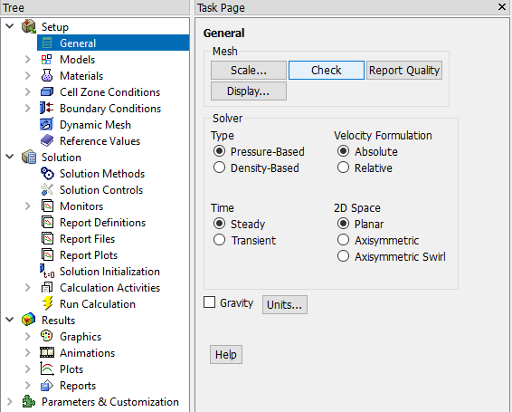

  - Tree > Setup > General. Choose Axisymmetric option shown below.
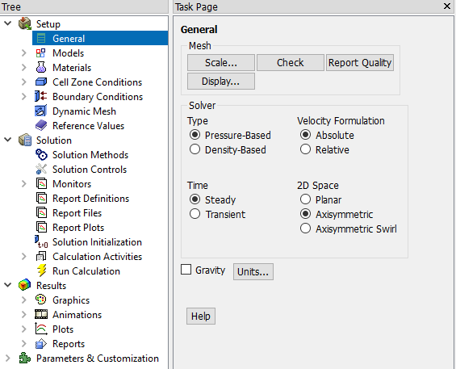

  - Tree > Setup > Models > Viscous (RMB click) > Model. Select Laminar.
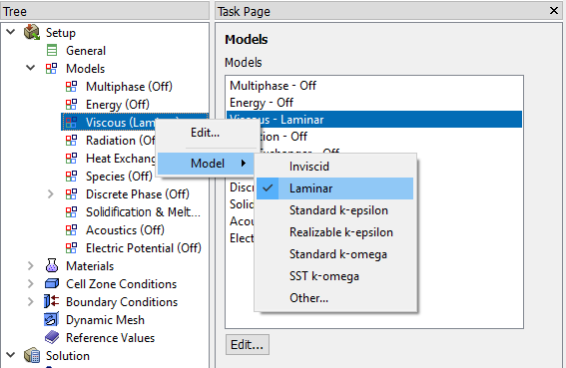

  - Tree > Setup > Materials. Right click on air and left click on Create/edit… . Change the Density and Viscosity as per below and click Change/Create. Close the dialog box when finished.
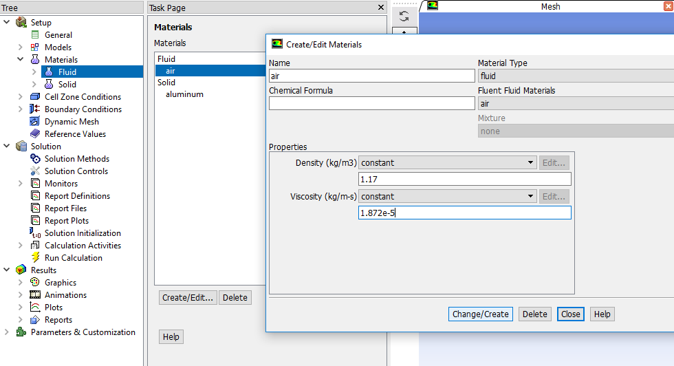

  - Tree > Setup > Cell Zone Conditions > Zone > surface_body. Change type to fluid. Select Material Name as air and click OK. This should be defaulted to fluid.
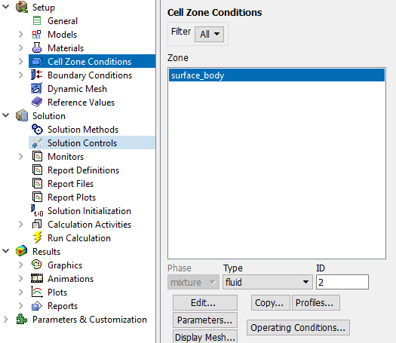

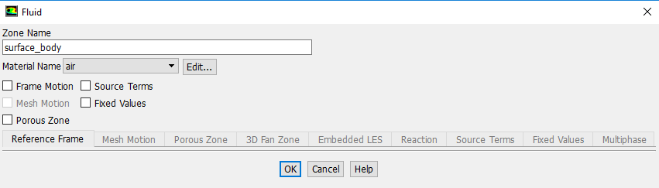

  - Tree > Setup > Boundary Conditions > inlet > Edit… Change parameters as per below and click OK. Table below shows the details of the boundary conditions.
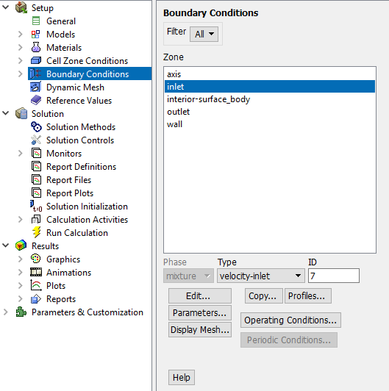

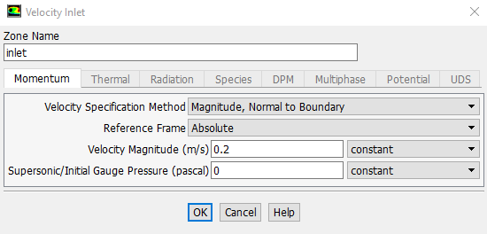

Inlet Boundary Condition
Variable | u (m/s) | v (m/s) | P (Pa)
Magnitude | 0.2 | 0 | -
Zero Gradient | N | N | Y

  - Tree > Setup > Boundary Conditions > outlet > Edit… Change parameters as per below and click OK. Table below shows the details of the boundary conditions.
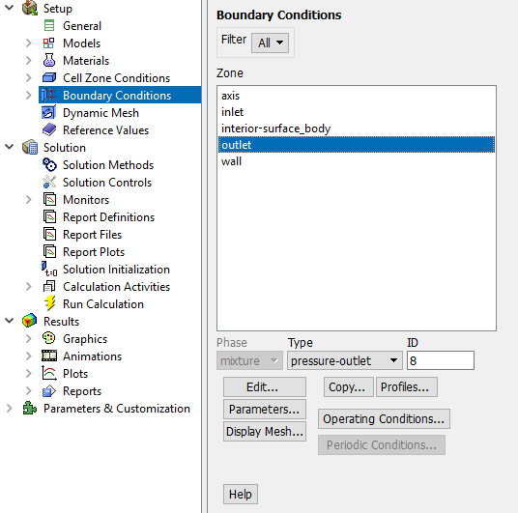

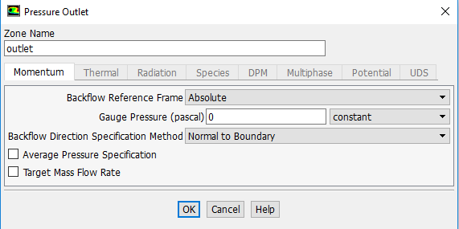

Outlet Boundary Condition
Variable | u (m/s) | v (m/s) | P (Pa)
Magnitude | - | - | 0
Zero Gradient | Y | Y | N

  - Tree > Setup > Boundary Conditions > wall > Edit… Change parameters as per below and click OK. Table below shows the details of the boundary conditions.
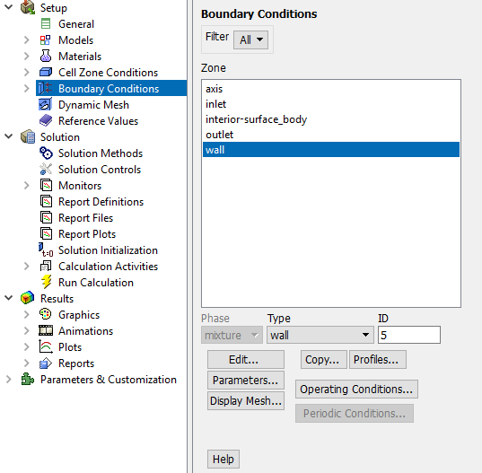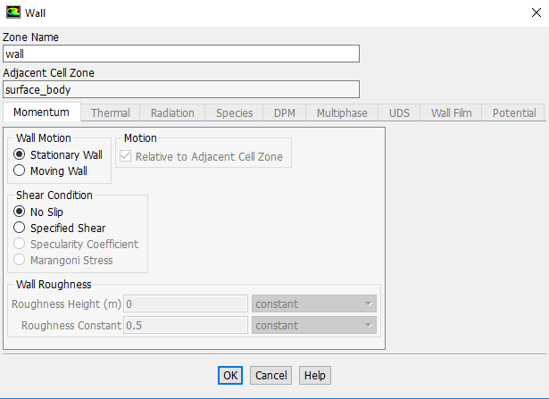

Wall Boundary Condition
Variable | u (m/s) | v (m/s) | P (Pa)
Magnitude | 0 | 0 | -
Zero Gradient | N | N | Y

  - Tree > Setup > Boundary Conditions > axis. Make sure that axis is selected as per below.
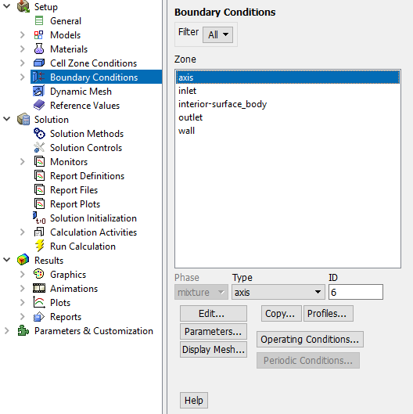

Axis Boundary Condition
Variable | u (m/s) | v (m/s) | P (Pa)
Magnitude | - | 0 | -
Zero Gradient | Y | N | Y

  - Tree > Setup > Boundary Conditions > Operating Condition. Change parameters as per below and click OK.
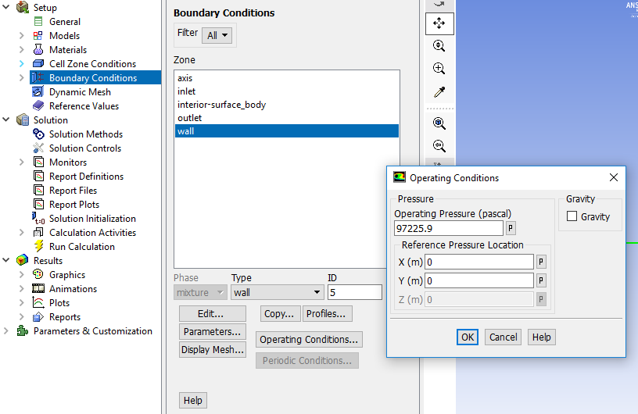

  - Tree > Setup > Reference Values. Change parameters as per below.
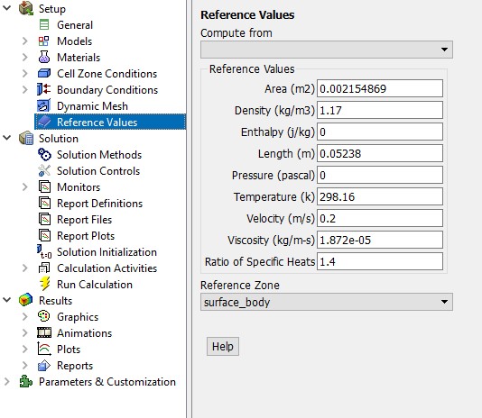

  - Tree > Solution > Solution Methods. Change parameters as per below.
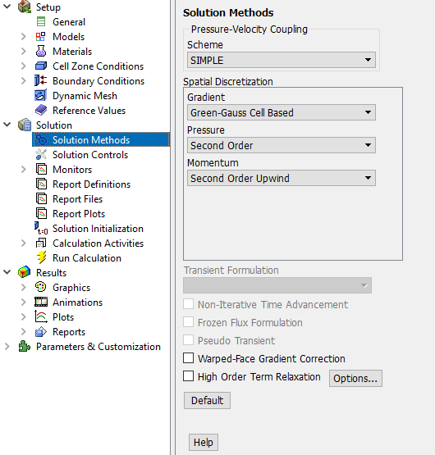

  - Tree > Solution > Monitors > Residual. Right click Residual and select Edit… Change convergence criterion to 1e-06 for all three equations as per below and click OK.
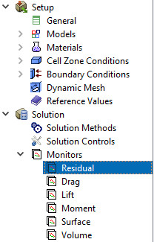

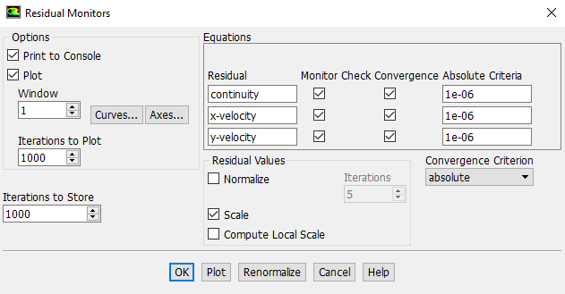

  - Tree > Solution > Solution Initialization. Change parameters as per below and click Initialize.
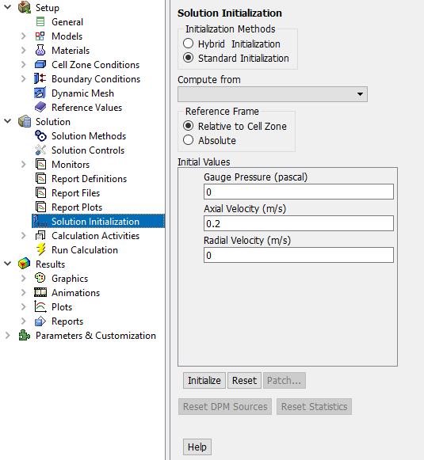

  - Tree > Solution > Run Calculation. Change Number of Iterations to 1000 and click Calculate.
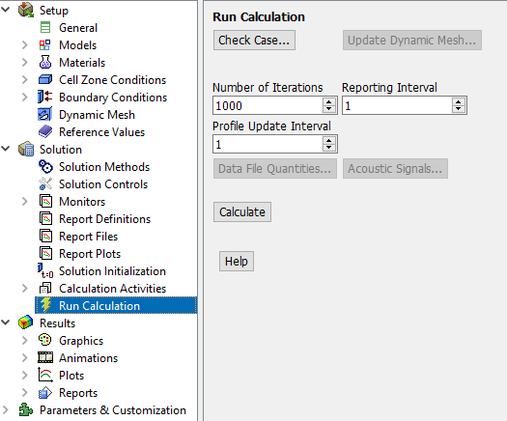

  - Once the solution converges, click OK. (The residuals should be comparable to the ones below.)
NOTE: ANSYS determines when to stop a calculation based on the iteration number and convergent limit you specified. If: 1. the maximum iteration number is reached, but convergent limit is not reached, or 2. convergent limit is satisfied, but maximum iteration number is not reached, ANSYS will terminate the computation.

  - File > Save Project. Save the project

- Results

Please read exercises before continuing. This section tells you how to post-process the results.

  - Displaying Mesh

Setting Up Domain > Display> Mesh. Select all Surfaces you wish to be visible and select Display then click Close.
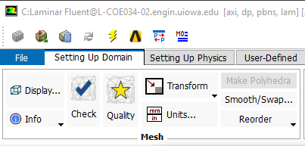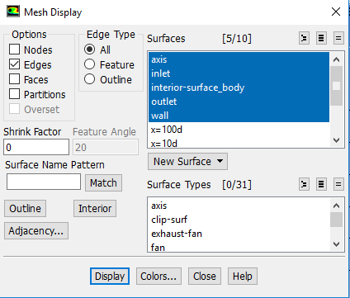

Zoom in to the inlet by using the magnifying glass with a plus sign in the middle of it. The mesh should look like the one below.

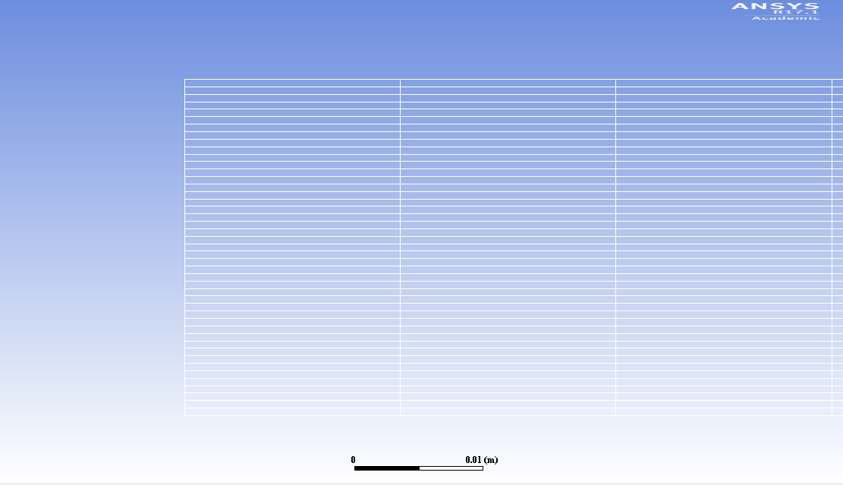

  - Saving Pictures

To save a picture of the screen, select File > Save Picture. Make sure all the parameters are set similar to the ones below and click Save (To preview the picture, before you save click Preview in the Save Picture window)
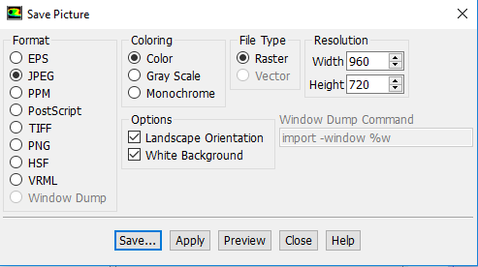

Name the File, navigate to the CFD Pre-Lab 1 file you created and save it in that file. Then close the Save Picture window.
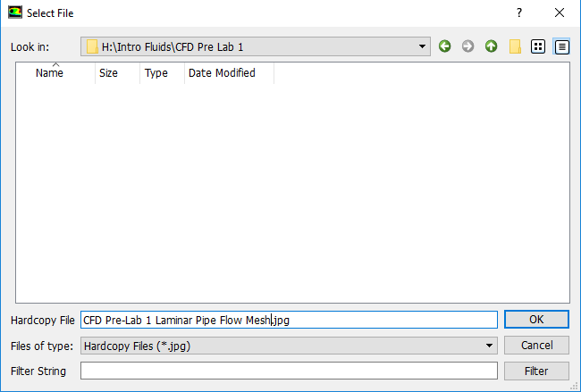

  - Plotting Residuals

To display the residuals click Tree > Solution > Monitors. Right click Residuals select Edit, click Plot then click Cancel.
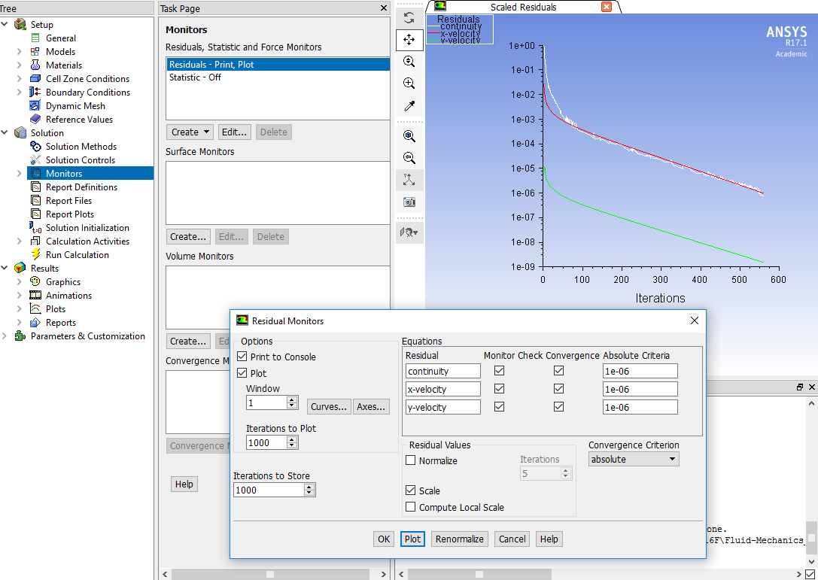

You can save this picture the same way you saved the mesh. Name it “CFD Pre-Lab 1 Laminar Pipe Flow Residuals History” and save it to the folder you created on the network drive.

  - Plotting Centerline Pressure Distribution

To plot results, click Tree > Results > Plots. Right click XY Plot, then click Set Up. To plot the Centerline Pressure Distribution, copy the parameters as per below and click Plot.
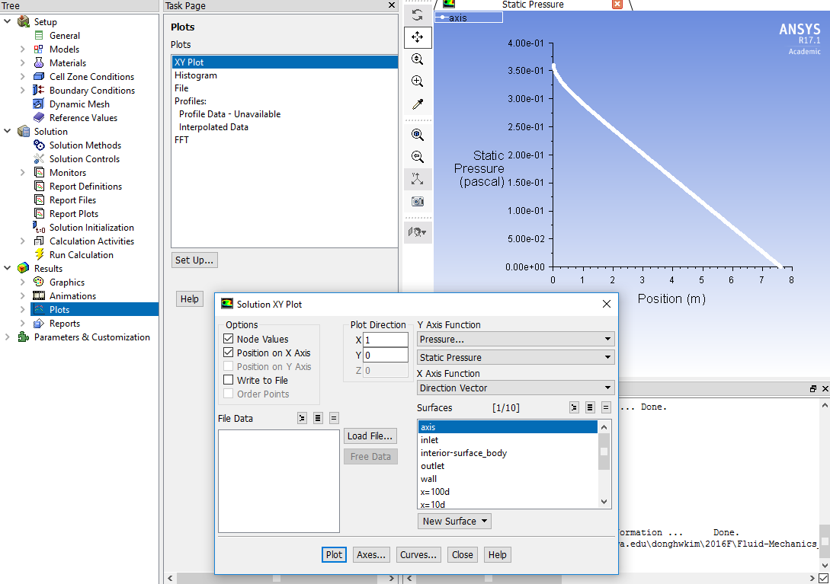

Save the picture as you did for the mesh and call it “CFD Pre-Lab 1 Laminar Pipe Flow Centerline Pressure Distribution” and save it in the folder you created.

.

  - Plotting Centerline Velocity Distribution

To plot Centerline Velocity Distribution, click Tree > Results > Plots. Right click XY Plot, then click Set Up. Copy the parameters as per below and click Plot.
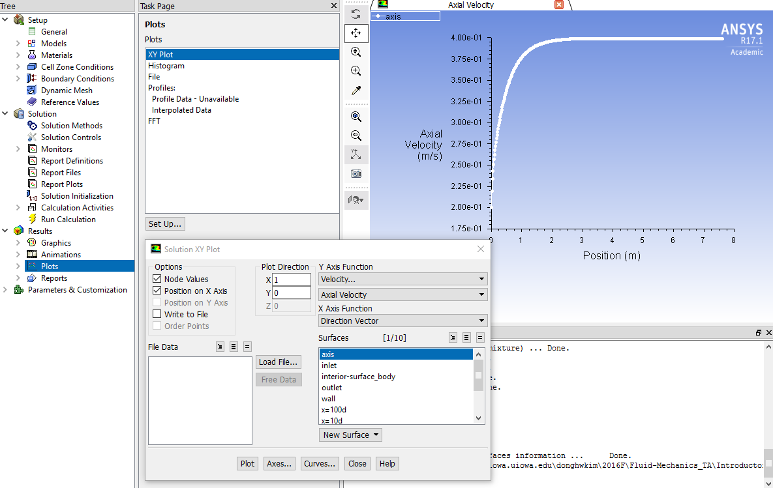

Save the picture as you did for the mesh and call it “CFD Pre-Lab 1 Laminar Pipe Flow Centerline Velocity Distribution” and save it in the folder you created.

  - Plotting Wall Shear Stress Distribution

To plot the Wall Shear Stress Distribution, click Results > Plots. Right click XY Plot, then click Set Up. Copy the parameters as per below and click Plot.
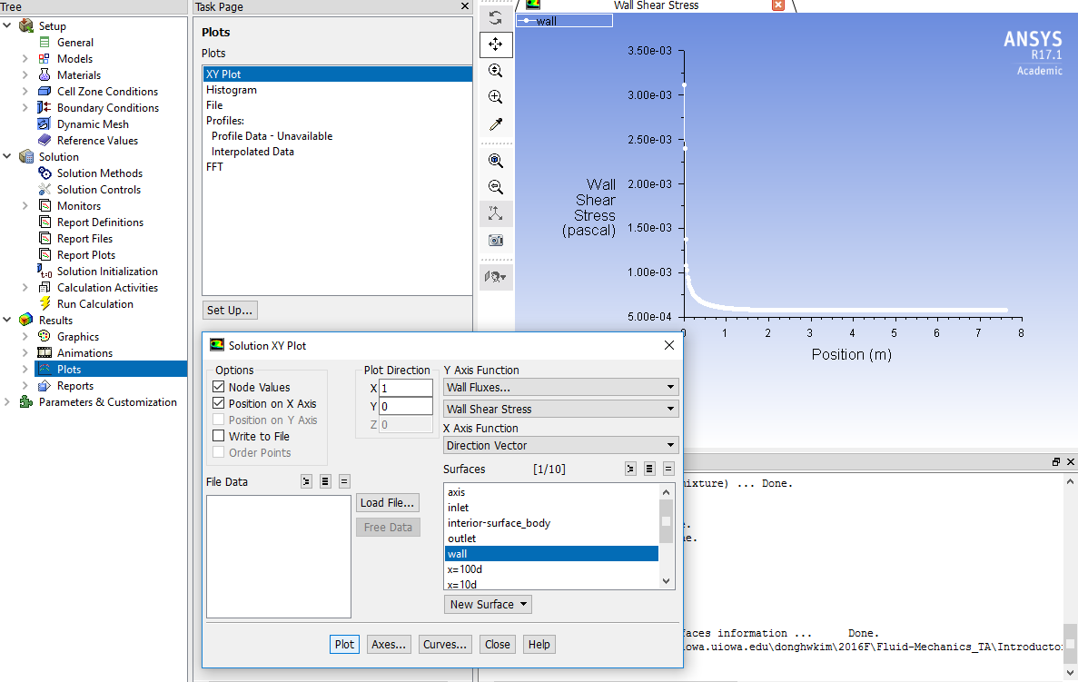

Save the picture as you did for the mesh and call it “CFD Pre-Lab 1 Laminar Pipe Flow Wall Shear Stress Distribution” and save it in the folder you created.

  - Plotting Profiles of Axial Velocity at All Axial Locations

To plot Profiles of Axial Velocity at All Axial Locations with AFD Data, click Setting Up Domain > Create > Line/Rake.
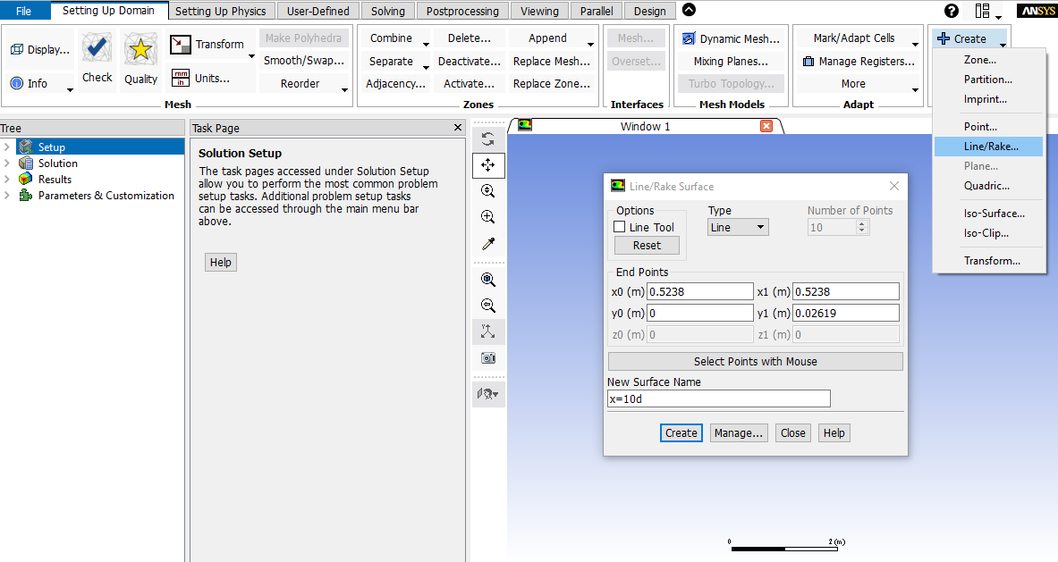

Change x and y values as per above, name the surface, and click Create. Repeat this for all lines shown in the table.
Surface Name | X0 | Y0 | X1 | Y1
x=10d | 0.5238 | 0 | 0.5238 | 0.02619
x=20d | 1.0476 | 0 | 1.0476 | 0.02619
x=40d | 2.0952 | 0 | 2.0952 | 0.02619
x=60d | 3.1428 | 0 | 3.1428 | 0.02619
x=100d | 5.238 | 0 | 5.238 | 0.02619

When all lines are created, click Close.

Click Tree > Results > Plots. Right click XY Plot and click edit….Click Load File and select “axialvelocityAFD-laminar-pipe.xy”, which is downloadable from the class website. Click OK.
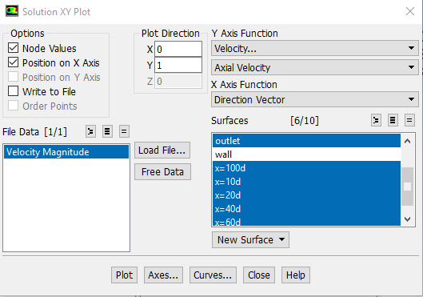

Change Parameters as per below. Make sure to select the inlet and outlet as well.

Click Curves… > Change the Pattern to the pattern seen below and click Apply. Incriment the Curve # by one and repeat. Do this for curves 0 through 7 then click Close.
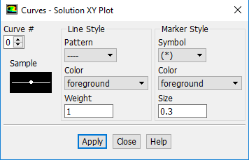

Click Plot.

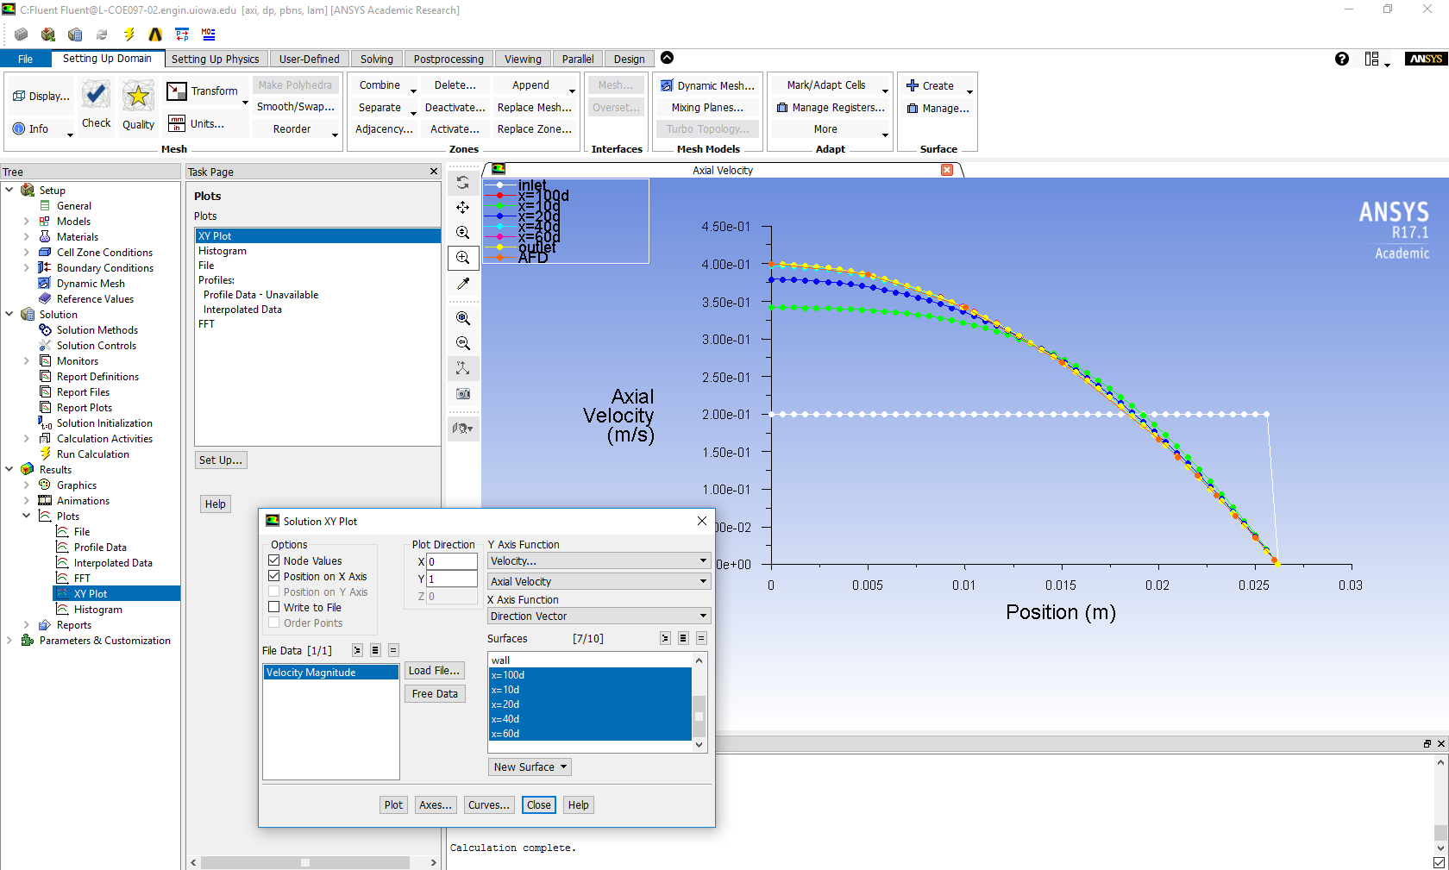

Save the picture as you did for the mesh and call it “CFD Pre-Lab 1 Laminar Pipe Flow Axial Velocity at All Axial Locations with AFD Data” and save it in the folder you created. Close the Solution XY Plot window.

  - Plotting Velocity Vectors

Click Tree > Results > Graphics > Vectors > Set Up. To plot the velocity vectors at the region flow begin to becomes fully developed, copy the parameters as per below and click Display. Zoom into the region where the flow is almost fully developed.
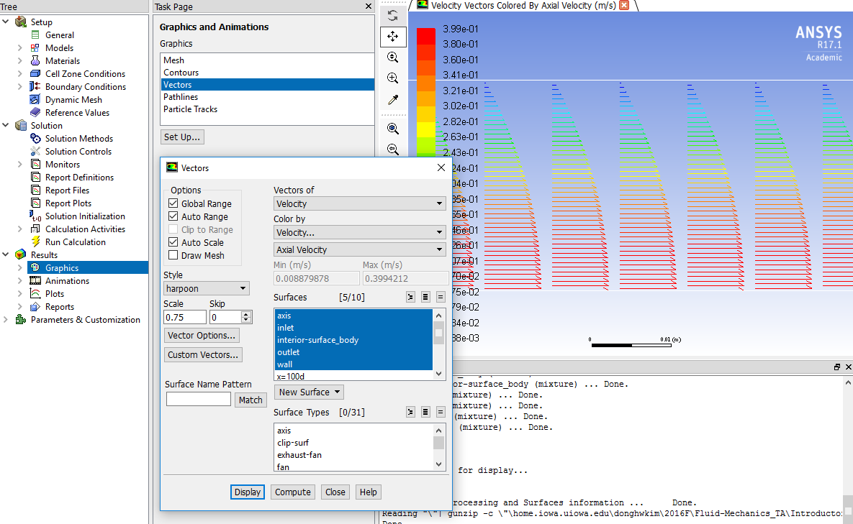

Save the picture as you did for the mesh and call it “CFD Pre-Lab 1 Laminar Pipe Flow Velocity Vectors at the Region Flow Begins to Become Fully Developed” and save it in the folder you created. Close the Vectors window.

  - Plotting Contours of Radial Velocity

Click Tree > Results > Graphics > Contours > Set Up… To plot the Contours of Radial Velocity, copy the parameters as per below and click Display. Zoom in to the pipe inlet to see the contours of radial velocity.
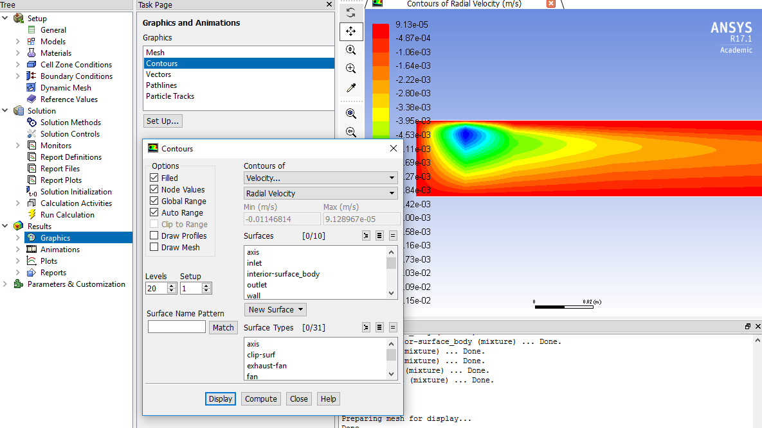

Save the picture as you did for the mesh and call it “CFD Pre-Lab 1 Contours of Radial Velocity” and save it in the folder you created. Close the Contours window.

  - Exporting Axial Velocity Profile at x=100d Location

To export solution value, click Tree > Results > Plots. Double click XY Plot. To export the Developed Axial Velocity Profile at x=100d, copy the parameters as per below and click Write…
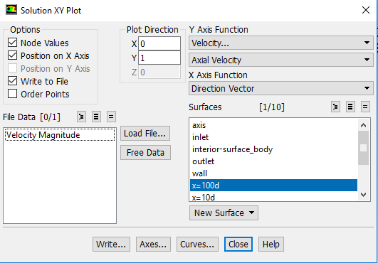

Name the file “CFD Pre-Lab 1 Laminar Pipe Flow Developed Axial Velocity Profile” and leave the Files of Type: as XY Files. Click OK.
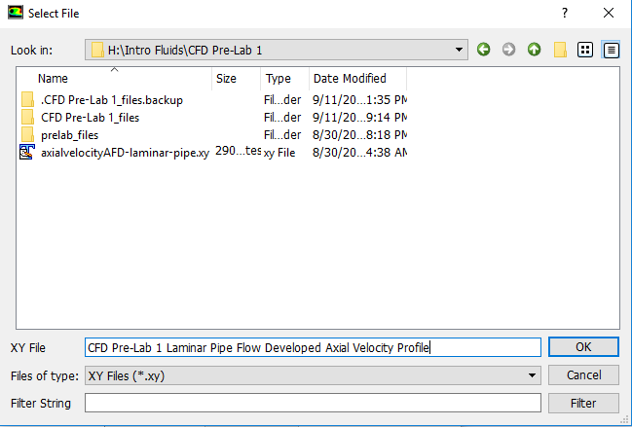

  - Exporting Wall Shear Stress Distribution

To export the wall shear stress distribution, click Tree > Results > Plots. Double click XY Plot. Copy the parameters as per below and click Write…
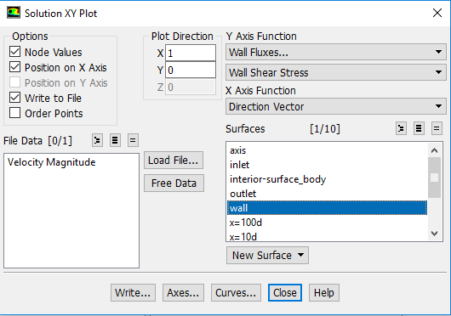

Name the file “CFD Pre-Lab 1 Laminar Pipe Flow Wall Shear Stress Distribution” and leave the Files of Type: as XY Files. Click OK. Close the Solution XY Plot.

File > Save Project. Save the project and close the Fluent window.

  - Normalizing Velocity Profile

- Open excel from Start Menu.
- Click File > Open, navigate to your folder you created on the network drive.
- Change the file type to all files.
- Select the file CFD Pre-Lab 1 Laminar Pipe Flow Developed Axial Velocity Profile and click Open.
- Select Yes on the Microsoft Excel message. (You might not see this pop-up depending on the version of Excel being used, if not then please proceed to next step)

- Make sure delimited is selected and click Next.
- Make sure that Tab and Space Delimiters are checked and hit Finish.
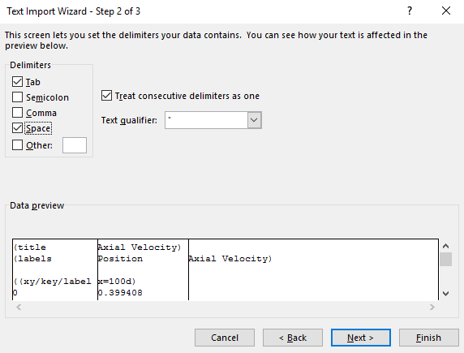

- In Cell C5 enter the formula as seen in the Formula Bar below. Then take the fill handle and drag to the end of the data. This normalizes the velocity profile from the max velocity.
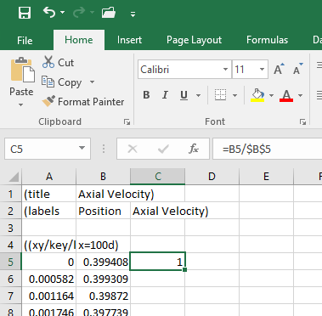

- Insert a Scatter Plot With Smooth Lines and Markers.
- For the x-axis use the radial position, and for the y-axis use the normalized velocity.
- Name it CFD Velocity Profile (Laminar).
- You can move this plot to a new tab by clicking on the chart Chart Tools > Design > Move Chart Location > New Sheet > OK
- Next open the file “Normalized-velocity-AFD-laminar-pipe.xy” in TextPad, highlight the data and paste it into your Excel spread sheet next to the CFD velocity profile data.
- Plot this in the same way as the other set on the existing plot and call this “AFD Velocity Profile (Laminar)”.
- Create axis titles and make sure the legend is shown. You should move the legend to the bottom of the chart. Call the axes Normalized Veloctity [-] and Radial Position [m].
- Save this Sheet by selecting File > Save As, name it “CFD Pre-Lab 1 Developed Axial Velocity Profile”.

- Exercises

You must complete all the following assignments and present results in your CFD Lab 1 reports following the CFD Lab Report Instructions.

Simulation of Laminar Pipe Flow
You need to use CFD Lab1 Report Template.doc to save all the figures and data

8.1. Compare CFD with AFD on friction factor

Use the instructions to generate the mesh and setup then iterate the simulation until it converges. Find the relative error between AFD friction factor (=0.097747231) and friction factor computed by CFD, which is computed by:
To get the value of, you need first write to file the wall Shear Stress Distribution. Then use EXCEL to open the data file and pick the value close to the pipe exit or inside the fully developed region. Next use the equation C=8*τ/(ρ*U^2) to solve for the Friction Factor. Where C is the friction factor, τ is wall shear stress, ρ is density and U is the inlet velocity.

Figures need to be saved: (1) Residual History (2) Centerline Pressure Distribution (3) Centerline Velocity Distribution (4) Wall Shear Stress Distribution (5) Profiles of Axial Velocity at all Streamwise Locations (inlet, outlet, x/D=10,20,40,60,100) with AFD data (6) Contour of Radial Velocity (7) Velocity Vectors in Fully Developed Region.
Data need to be saved: (1) Shear Stress in the Developed Region (2) Developing Length (=Length from the pipe inlet to the start of developed region. Use figure of centerline velocity distribution).

8.2. Normalized developed axial velocity profile

8.2.1. Export the axial velocity profile data at x=100d following the instructions in Step 7.10.
8.2.2. Use EXCEL to open the file you exported and normalize the profile using the centerline velocity
magnitude, which is the maximum value on that profile. Plot the normalized velocity profile in
EXCEL and paste the figure into your report together with other figures you made in Exercise 8.1.

8.3. Questions need to be answered when writing CFD Lab 1 report

8.3.1. Can you use centerline pressure distribution to determine the “developing length”? Why?
8.3.2. What is the value for radial velocity at developed region?
8.3.3. Summarize your findings in CFD Lab report and try to relate them to your classroom lectures
or textbooks.

