FlowLab Configuration
Before running Flowlab software, do the following configurations.
Go to My Computer and open your network drive (H):
Then find and open the “Flowlab.ini” file in your network drive:

After you open the flowlab.ini file, you see 3 lines as below:
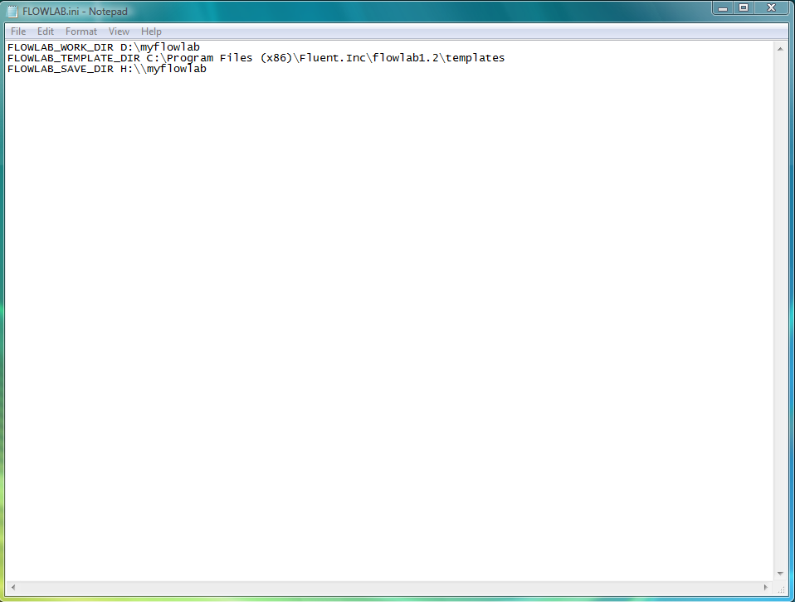

Replace the lines with the following:

FLOWLAB_WORK_DIR D:\myflowlab
FLOWLAB_TEMPLATE_DIR C:\Fluent.Inc\flowlab1.2\templates
FLOWLAB_SAVE_DIR H:\\myflowlab

Make sure you save the file before closing it. Now you should be able to open Flowlab and use it.

