Engineering Economy NAME ___________________
Quiz #3 Date: February 24, 2005 SHOW WORK
- Consider the following two mutually exclusive investment projects, which have unequal service lives. X requires an initial investment of $1 million and has a benefit of $400,000 for 3 years when it needs to be replaced. It has a salvage value of $300,000 at the end of its life. Y requires an initial investment of $1.5 million and has a benefit of $250,000 for 6 years when it needs to be replaced. It has no salvage value at the end of its life. Assume that both alternatives will be available in the future with the same investment and expenses. Given that i = 8%, determine which project should be selected on the basis of Net Present Value. (2.5 points)
- (2.5 points)
  - What is meant by
    - Current Assets can be converted to cash or its equivalent in less than one year.

    - Accounts Receivable: Money that is owed to the firm bet has not yet been received.

  - What is the equation that links assets, liabilities and stockholders equity (sometimes called net worth) on a balance sheet of a corporation?
Assets=Liabilities +Owners’ Equity

  - Why is IRR the most prevalent rigorous method for corporations to evaluate different projects?
1. Scalable 2. Easy to understand

- The NPW of a project is $250,000 at an interest rate of 13% and $-100,000 at an interest rate of 17%. Calculate the IRR. (2.5 points)

- Big Star Production Studios is looking into producing a movie based on the Madeline L’Engle book A Wrinkle in Time. The movie will be released straight to video. The cost of filming the movie will be $6 million, production costs to create the videos is $5 per unit. The videos will sell for $25 each. (2.5 points)
  - How many videos must be sold to break even? Show algebraic calculations and graphical representation.

Let denote the break-even volume

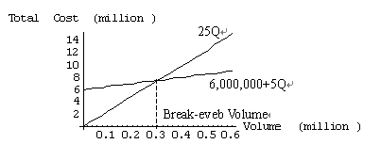

  - If 400,000 are produced, determine the Average Cost and Marginal Cost of each movie?

