PELTON TURBINE EXPERIMENT
T.A. Notes
12/05/06 Doug Houser

The IIHR Pelton turbine experiment demonstrates to the students a complete hydroelectric power system, from generation to consumer usage. The experiment is instrumented as to allow the students to measure hydraulic pressure and flow, turbine speed and torque, and generator speed, voltage, and current.

SETTING THE POWER & WATER FOR THE EXPERIMENTAL SETUP

The pump feeding this circuit is set in a pit in the neighborhood of the experiment (N side of East Annex), as shown in Figure 1. The power to this pump is supplied by a set of control panels as shown in Figure 1 and 2.
Check to make sure that the following connections on the water supply system are in place (see Figure 1)
- Valve 1, fully open
- Valve 2, fully closed
- The only valve controlling the water to the turbine is the one set near the turbine housing. It should be in the close position at the beginning of the experiment.
- Make sure that the handle on the on the SAFETY SWITCH located on the wall in the pump pit is in the On position (this is a switch used only for repairing situations)

Sequence of steps to power the pump (see Figure 2):
- Turn the handle on the PRIMARY DISCONNECT to On.
- Set the handle on the DOUBLE DISCONNECT to the upper On position (that corresponds for the Pelton experiment).
- On the digital display, push the Enter key to go into the Frequency menu. Set the desired frequency on the VFD using the ∧ and ∨ keys (for safety set the desired frequencies using small steps until you reach the targeted one; avoid setting frequencies larger that 90%. Note: the key for frequency setting runs in increasing frequency steps if kept continuously pressed. Consequently, monitor the display and push repeatedly the button). Push the Enter key on VFD to make the frequency effective.
- Finally, push Run.

Figure 1. Layout of the pump pit associated with the water feeding system to the Pelton turbine

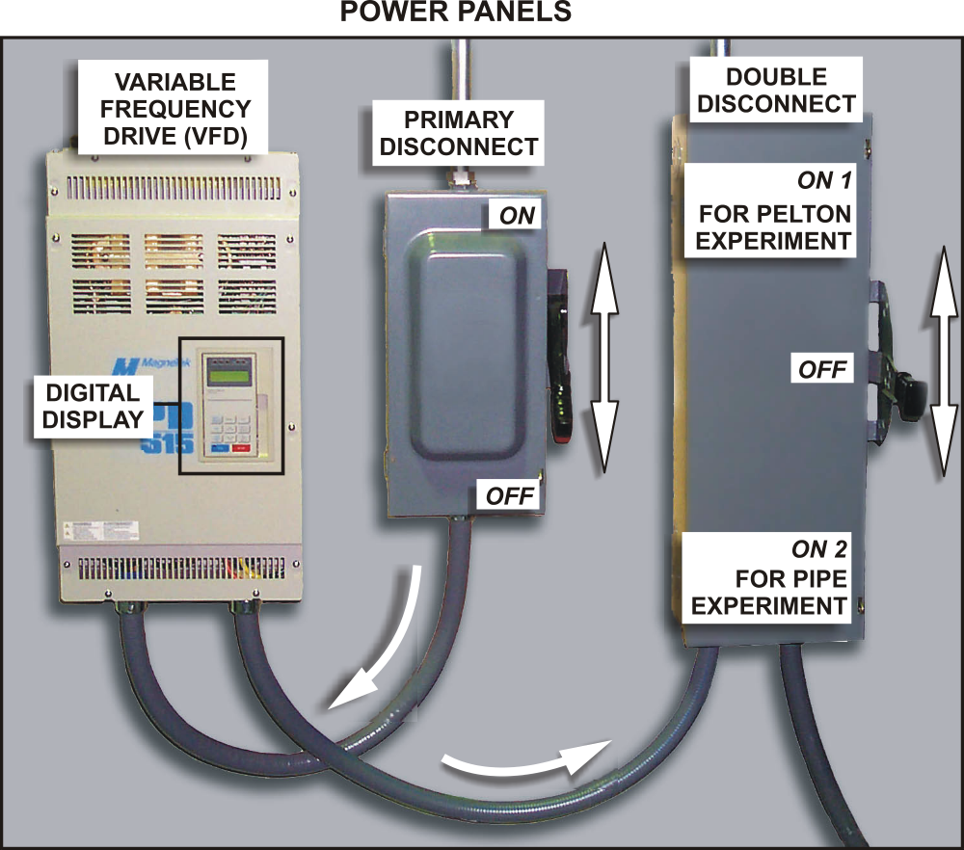
Figure 2. Power control panel

Before and after the measurements:

Before: Close the drain valves on the bottom of the basin. Make sure the discharge controlling valve (the yellow valve next to the pressure gauge) is open at all times. The cooling water valves for the friction plates have to be opened.
After: Turn the pump off, and open the drainage valves so that the holding tank will completely empty.

RUNNING THE EXPERIMENT
The reservoir elevation (head pressure) is simulated by the pump running at 90% of full speed, and is measured by the pressure gauge on the input to the turbine. The flow to the turbine is adjusted by the valve on the input to the turbine, and is measured by the point gage on the v-notch wear discharge of the turbine. The turbine speed is adjusted by the input flow valve and is measured by the digital turbine speed panel meter (RPM). The turbine torque is measured by an in-line rotating torque sensor and is displayed on the digital panel meter (lb-in).
A power curve for the turbine can be obtained by applying a frictional load to the output of the torque sensor by way of the small handwheel on the front panel. As load is applied to the turbine, the torque and speed can be measured by the digital panel meters, while the pressure and flow are measured by the pressure gauge and the point gage. Thus, by applying different loads at different speeds, you can obtain a power curve over the entire speed range of the turbine.
For the electrical generation part of the experiment, the frictional load is removed by turning the small handwheel out several revolutions.
The generator clutch is engaged at very low turbine speed by the front panel switch, and the generator is brought up to 60Hz as measured by the digital generator speed panel meter, using the input flow valve. It should be noted on the digital displays that the generator speed and the turbine speed are not the same, but the ratio between the two is constant. This shows that the generator must operate at 3600 RPM (60Hz), but the turbine can operate at its optimum design speed for maximum torque, and the connecting drivetrain between the two must compensate for this speed difference through a gearbox, sheave ratio, etc. At this point, even though we have no electrical load connected to the system, as evidenced by the generator voltage meter reading of approximately 240V AC and the generator current meter reading of 0, students can measure the input hydraulic pressure and flow to the turbine, and the output torque and speed of the turbine. This shows the energy used by the power company itself, before it has any energy available for sale to the public, and is used up in the forms of pipe friction, bearing and drivetrain friction, turbine efficiency, and generator excitation.
As the first electrical load (600w overhead lights) is applied to the generator, through the front panel switch, it will be seen that the generator speed slows down and the output voltage drops. The input valve must opened somewhat to maintain the standard 60Hz power line frequency. The input hydraulic energy (pressure and flow), the mechanical energy (turbine speed and torque) and electrical energy (voltage and current) can all be calculated. As the second electrical load (600w overhead lights) is applied to the generator along with the first, through the second front panel switch, it will be seen that again the generator speed slows down and the output voltage drops. Again, the input valve must be opened slightly to maintain 60Hz; energy losses and efficiencies can be calculated throughout the system. The process is repeated for electrical loads 3 and 4, each time measuring the hydraulic, mechanical, and electrical properties, and then calculating the efficiencies or losses.
As the fifth electrical load is applied to the generator, it will be shown that the input valve has reached the maximum and still the generator speed has not reached the standard operating frequency of 60Hz. This shows that consumer demand for power has exceeded the generating capability of our hydroelectric facility and a “brownout” condition has occurred. At this point, what usually happens is that the power utility company will disconnect a block of consumers so that the energy demand again falls within the generating capability of the system. This causes a “blackout” for those who were disconnected, but the remainder of the system operates at the standard of 60Hz. This is shown by turning off the fifth electrical load, and the students will see that the generator speed has exceeded 60Hz, and the input valve must be closed slightly to obtain the 60Hz standard generator speed.
Loads 4 through 1 are turned off one at a time, and each time it will be shown that the input valve must be closed somewhat to maintain the desired 60Hz generator speed. It should be pointed out to the students that even though this experiment is simplified, the relationship is still true in the “real world” systems, that as the electrical load demand of the consumer network increases and decreases, minute by minute, someone or something is compensating for that change by opening or closing the input flow to a turbine to maintain the 60Hz power frequency standard.

