**COLOR IMAGE PROCESSING**

Color image = multi-spectral image = vector-valued image

Each image pixel/voxel has intensity values from three different channels – R, G, B channes

Edges or other image features in a color image are derived by treating it as a vector-valued image

Ref:

1. R. Jain, R. Kasturi, B. G. Schunck, Machine Vision (Chapter 10), McGraw-Hill, Inc., 1995
2. A. Cumani, “Edge detection in multispectral images”, CVGIP: Graphical Models Image Processing, 53: 40-51, 1991
3. N. Evans and X. U. Liu, A morphological gradient approach to color edge detection, IEEE Trans. Image Processing, 15:1454-1463, 2006

**Theory of Multi-spectral edge detection**

Let $f=\left(f_{1}, f_{2}, …, f_{m}\right)$ be the intensity (vector-valued) function for a multi-spectral (e.g., color where $m=3$) image where $f_{i}:Z^{2}→ R$ for $i=1,2, …, m$; $Z$ and $R$ are sets of integers and real numbers, respectively.

Differential of the vector intensity function may be expressed as

$$df= \sum_{i=1}^{2}{\frac{df}{dx_{i}}dx_{i}}$$

The squared nor of the differential:

$${\left\|df\right\|}^{2}=\sum_{i=1}^{2}{\sum_{k=1}^{2}{\frac{df}{dx_{i}}\frac{df}{dx_{k}}dx_{i}dx_{k}}}=\sum_{i=1}^{2}{\sum_{k=1}^{2}{γ_{ik}dx_{i}dx_{k}}}$$

Where

$$γ_{ik}=\sum_{j=1}^{m}{\frac{df_{j}}{dx_{i}}\frac{df_{j}}{dx_{k}}}.$$

**IMPORTANT**

Unlike the case of a scalar-valued image, the squared norm of the differential $df$ is a function of the direction of the differential. Thus, Edge detection in a multi-spectral image may be defined as the task to find the maximum of this squared norm at each image pixel. Toward this aim, we define another term called squared local contrast of $f$ at a pixel $p$ in a direction $n$.

$$S\left(p,n\right)=\sum_{i=1}^{2}{\sum_{k=1}^{2}{γ_{ik}n_{i}n_{k}}}=En_{1}^{2}+2Fn_{1}n_{2}+Gn_{2}^{2}$$

Where $γ_{11}=E, γ_{12}=γ_{21}=F, γ_{22}=G.$

Thus $S$ is a quadratic function of the direction vector $n$ and there, $S$ has a unique maximum and minimum values. It is well know that these two extreme values coincides with the eigenvalues of the 2-by-2 matrix $\left[γ_{ik}\right]$, and are attained when $n$ is the corresponding eigenvectors. So, the two extreme values are

$$λ_{±}=\left(E+G±\sqrt{{\left(E-G\right)}^{2}+4F^{2}}\right)/2$$

And the corresponding eigenvectors are given by

$$n_{±}=\left(\cos{θ_{±}},\sin{θ_{±}}\right)$$

$$θ_{+}=\frac{1}{2}\tan^{-1}{\frac{2F}{E-G}}+kπ$$

$$θ_{-}=θ_{+}+\frac{π}{2}$$

Note that $θ_{+}$ and $θ_{-}$ define the local normal and tangent direction.

**Practice at home:**

Solve the multi-spectral edge detection for three-dimensional images.

**USE OF COLOR IN IMAGE REPRESENTATION**

Fuse multi-channel images

(e.g., PET CT fusion; challenge: registration)

CT: grey scale; PET: Hue of color)

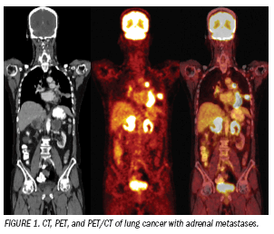

Display of different 3D structure

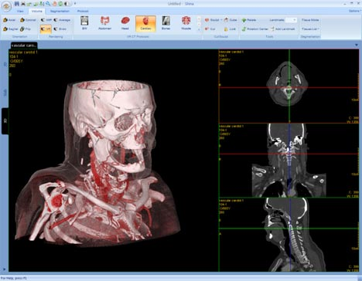

Display feature/measures in 3D

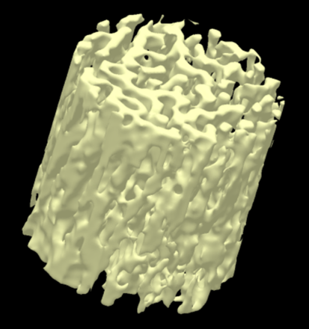 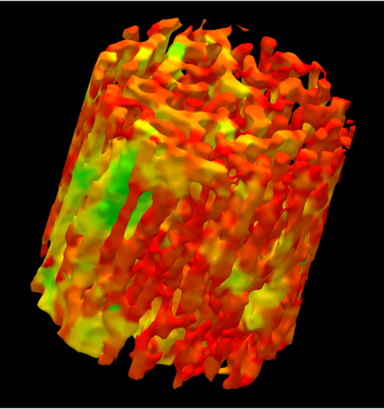 

Visual representation of local TB topology on the continuum between a perfect plate and a perfect rod

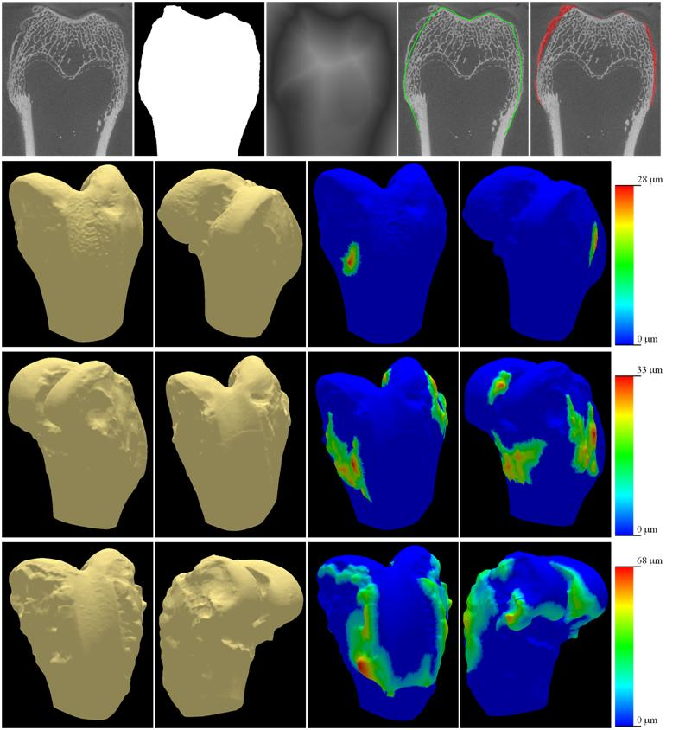

Local osteophyte heights