**Verification of Laminar and Validation of Turbulent Pipe Flows**

**ME:5160 Intermediate Mechanics of Fluids**

**CFD LAB 1**

**(ANSYS 19.4; Last Updated: Aug. 9, 2019)**

By Timur Dogan, Michael Conger, Dong-Hwan Kim, Sung-Tek Park,

Maysam Mousaviraad, Tao Xing and Fred Stern

IIHR-Hydroscience & Engineering

The University of Iowa

C. Maxwell Stanley Hydraulics Laboratory

Iowa City, IA 52242-1585

1. **Purpose**

The Purpose of CFD Lab 1 is to simulate steady **laminar** and **turbulent** pipe flow following the “CFD Process” by an interactive step-by-step approach. Students will have hands-on experiences using ANSYS to compute axial velocity profile, centerline velocity, centerline pressure, and friction factor. Students will conduct **verification studies for friction factor and axial velocity profile** of laminar pipe flows, including iterative error and grid uncertainties and effect of refinement ratio on verification. Students will validate **turbulent pipe flow** simulation using EFD data, analyze the differences between laminar and turbulent flows, and present results in CFD Lab report.

Geometry

Physics

Mesh/Grid

Solution

Results

Pipe (ANSYS Design Modeler)

Structure (ANSYS Mesh)

Non-uniform (ANSYS Mesh)

Uniform (ANSYS Mesh)

General (ANSYS Fluent - Setup)

Model (ANSYS Fluent - Setup)

Boundary Conditions (ANSYS Fluent -Setup)

Reference Values (ANSYS Fluent - Setup)

Laminar

Turbulent

Solution Methods (ANSYS Fluent - Solution)

Monitors (ANSYS Fluent - Solution)

Solution Initialization (ANSYS Fluent -Solution)

Plots (ANSYS Fluent- Results)

Graphics (ANSYS Fluent- Results)

Flow Chart for “CFD Process” for pipe flow

1. **Simulation Design**

In CFD Lab 1, simulation will be conducted for **laminar and turbulent** pipe flows. Reynolds number is 655 for laminar flow and 111,569 for turbulent pipe flow, respectively. The schematic of the problem and the parameters for the simulation are shown below.

Table 1 - Main Particulars

|  |  |  |
| --- | --- | --- |
| Parameter | Unit | Value |
| Radius of Pipe | m | 0.02619 |
| Diameter of Pipe | m | 0.05238 |
| Length of the Pipe | m | 7.62 |

**Outlet**

**Inlet**

**Symmetry Axis**

**Pipe Wall**

**Non-uniform Grid**

**Uniform Grid**

**Velocity Profile**

Since the flow is axisymmetric we only need to solve the flow in a single plane from the centerline to the pipe wall. **Boundary conditions** need to be specified include **inlet**, **outlet**, **wall**, and **axis**, as will be described details later. Uniform flow was specified at inlet, the flow will reach the fully developed regions after a certain distance downstream. No-slip boundary condition will be used on the wall and constant pressure for outlet. Symmetric boundary condition will be applied on the pipe axis. Uniform grids will be used for the laminar flow whereas non-uniform grid will be used for the turbulent flow.

Table 2 - Grids

|  |  |  |  |
| --- | --- | --- | --- |
| Grid/Mesh | Grid/Mesh Type | # of Divisions | |
| X | R |
| 8 | Uniform | 453 | 45 |
| 7 | 319 | 32 |
| 6 | 226 | 23 |
| 4 | 113 | 11 |
| 3 | 80 | 8 |
| 2 | 56 | 6 |
| 0 | 28 | 3 |
| T | Non-uniform | 564 | 15 |

Experimental, analytical results, and simulation results will be compared. Additionally, detailed verification and validation study will be conducted. All the studies are detailed in the Table 3. In this manual, detailed instructions are given for the laminar flow simulation and turbulent flow simulation using uniform grid 8 and non-uniform grid respectively. For the rest of the simulations, the grid and simulation setups have been provided with workbench uploaded on the class website:

(1) go to “<http://user.engineering.uiowa.edu/~me_160/>”

(2) go to “CFD Labs” tab

(3) go to “CFD Lab1: Pipe Flow” tab

(4) download “CFD Lab1 Workbench” by clicking “Download”

Please refer to the exercise at the end of the manual to ***determine*** the data and figures that need to be saved before you analyze (postprocess) any result. Even though the manual shows every possible step for analyzing the data at Section 7 & 8, only certain subsections (e.g. 7.3, 7.4, 7.7) will be required for each exercise.

Table 3 - Simulation Matrix

|  |  |  |
| --- | --- | --- |
| Study | Grid | Model |
| V&V of friction factor and axial velocity profile | 2,3,4 | Laminar |
| V&V of friction factor | 6,7,8 |
| V&V of friction factor | 0,2,4 |
| V&V of friction factor | 4,6,8 |
| Axial velocity, centerline velocity | 8 |
| Axial velocity, centerline pressure, centerline velocity | T | Turbulent |

All analytical data (AFD) and experimental data (EFD) needed for the comparison with laminar and turbulent flow CFD results, respectively, can be downloaded from the class website again:

(1) go to “<http://user.engineering.uiowa.edu/~me_160/>”

(2) Click RMB on “[axialvelocityAFD-laminar-pipe.xy](http://user.engineering.uiowa.edu/~me_160/documents/axialvelocityAFD-laminar-pipe.xy)” and select “Save link as…”

(3) Click RMB on “[axialvelocityEFD-turbulent-pipe.xy](http://user.engineering.uiowa.edu/~me_160/documents/axialvelocityEFD-turbulent-pipe.xy)” and select “Save link as…”

(4) Click RMB on “[pressure-EFD-turbulent-pipe.xy](http://user.engineering.uiowa.edu/~me_160/documents/pressure-EFD-turbulent-pipe.xy)” and select “Save link as…”

1. **Open ANSYS Workbench Template**
   1. **Start** > **All Programs** > **ANSYS 19.1** > **Workbench 19.1**

* 1. You can ignore all the pop-ups by clicking “Cancel” if you see any.
  2. **Toolbox** > **Component Systems**. **Click** and **Drag & Drop** **[Geometry]**, [**Mesh]** and [**Fluent]** components to **Project Schematic** as per below.

* 1. Click on the drop down arrow and select **Rename**. Change the names as per below to avoid any confusion during the work.

Result:

* 1. Create connections between component as per below. To make connections, click and drag the [**Geometry** **?]** box to the [**Mesh ?]** box, and the [**Mesh ?]** box to the [**Setup ?]** box as per below.

* 1. **File** > **Save As**. Save the workbench file to H drive (i.e. [home.iowa.uiowa.edu](http://home.iowa.uiowa.edu) drive). The H drive is shared between the computers in engineering labs.

1. **Geometry Creation**
   1. Right click **Geometry** and select **New DesignModelerGeometry…**. (Since all the geometries are linked together, only one geometry creation is required)

* 1. Make sure that Unit is set to **Meter** (default value).

* 1. Select the **XYPlane** under the **Tree Outline** and click **New Sketch** button.

* 1. Right click **Sketch1** and select **Look at**.

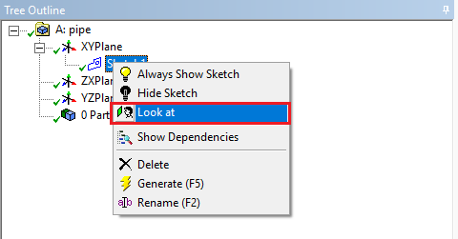

* 1. Enable the auto constraints option to pick the exact point as below. Select **Sketching** > **Constraints** > **Auto Constraints >** make sure Cursor is selected**.**

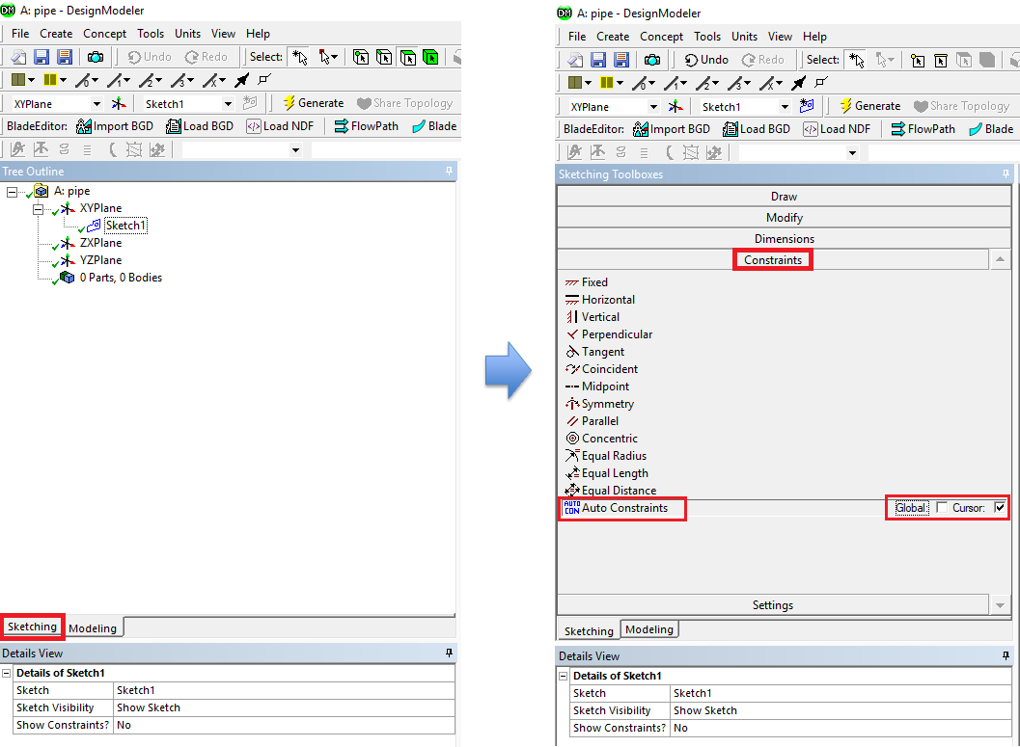

* 1. Select **Sketching** > **Draw** > **Rectangle**. Create a rectangle geometry as per below. The cursor will show “P” when it is on the origin point.

* 1. Select **Sketching** > **Dimensions** > **General**. Click on top edge then click anywhere else. Repeat the same thing for one of the vertical edges. You should have a similar figure as per below.

* 1. Click on **H2** under **Details View** and change it to *7.62m*. Click on **V1** and change it to *0.02619m*. Always omit units (“m” for this time) when you put in values.

* 1. **Concept** > **Surfaces From Sketches** and select **Sketch1** from the **Tree Outline** and hit **Apply** on **Base Objects** under **Details view**.

* 1. Click **Generate**. This will create a surface.

* 1. **File** > **Save Project**. Save project and close window.
  2. If you see the lightning sign next to **Geometry** in the workbench then right click on the **Geometry** and click **Update** as shown below. If you don’t see the check mark after the update, then you may have made a mistake when you were creating the geometry.

1. **Mesh Generation**
   1. Right click on **Mesh** and select **Edit**.

* 1. Right click on **Mesh** then select **Insert** > **Face Meshing**.

* 1. Select the pipe geometry by clicking anywhere on the pipe surface, then click the yellow box that says “No Selection” and click **Apply**. (From now on, rotate the view to xy-plane by clicking z-axis of 3D axis located at right bottom of the screen. You can drag and drop with right mouse button to zoom in. You can press F7 to restore the view.)

* 1. Click on the **Edge Button**. This will allow you to select edges of your geometry.

* 1. Right click on **Mesh** then select **Insert** > **Sizing**.

* 1. Hold Ctrl and select the top and bottom edge then click **Apply** in the **Details** box for **Geometry** on the right. Specify details of sizing as per below depending on the case.

**Laminar**

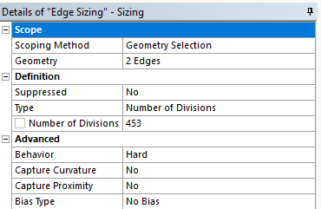

**Turbulent**

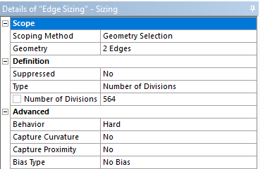

* 1. Repeat step 5.5. Select the left and right edge and click **Apply** for uniform grid flow and change sizing parameters as per below. Change the sizing parameters separately for non-uniform grid as per below. Make sure to select edges individually when changing sizing parameters for non-uniform grid.

**Uniform Grid 8**

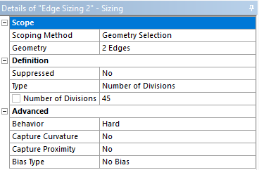

**Non-uniform Grid Left Edge**

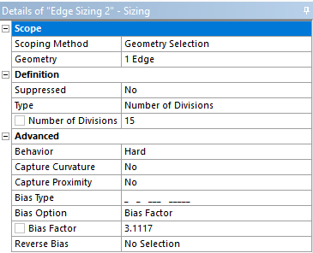

**Non-uniform Grid Right Edge**

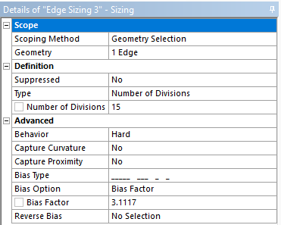

* 1. Click on **Generate Mesh** button and click **Mesh** under **Outline** to show mesh.

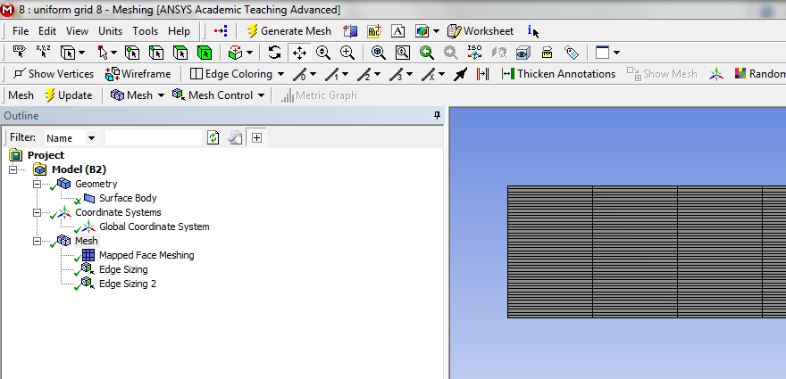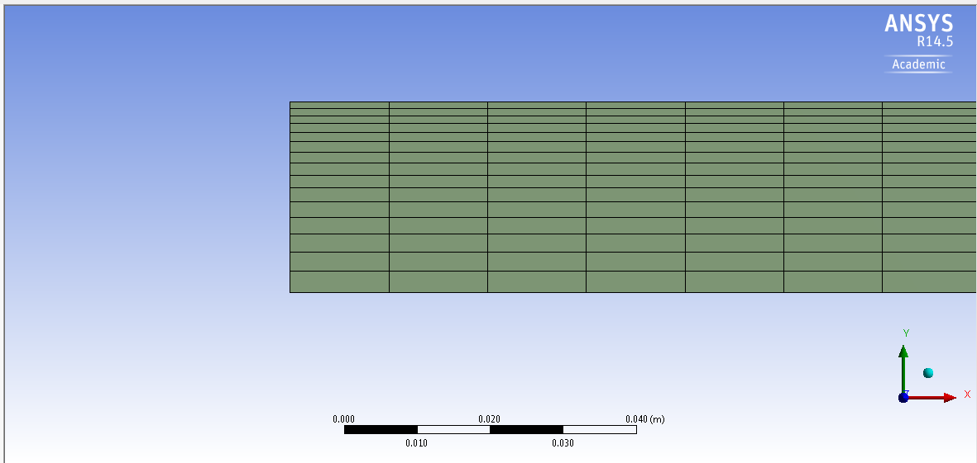

Non-uniform Grid

Uniform Grid 8

* 1. Change the edge names by clicking on the edge, clicking RMB and selecting **Create Named Selection**. Name left, right, bottom and top edges as inlet, outlet, axis and wall respectively. At this stage, your outline should look same as the figure below.

**Uniform Grid 8**

**Non-uniform Grid**

* 1. **File** > **Save Project**. Save the project and close the window. Update mesh by clicking RMB on **Mesh** and clicking **Update** on Workbench.

1. **Solve**
   1. Right click **Setup** and select **Edit**.

* 1. Under options check **Double Precision** and click **OK**.

* 1. Fold the upper tool box by clicking the button inside the red box to avoid any confusion. For this section 6, the “tree outline” on the left side bar will be used only.

* 1. **Tree > Setup** > **General** > **Check**. You may ignore the *warning* messages if pop up. (Note: If you get an *error* message you may have made a mistake while creating your mesh)

* 1. **Setup** > **General** > **Solver**. Choose an option shown below.

|  |  |  |  |  |  |  |  |  |
| --- | --- | --- | --- | --- | --- | --- | --- | --- |
| Axis Boundary Condition | | | | | | | | |
| Model | Laminar | | | Turbulent | | | | |
| Variable | u  [m/s] | v  [m/s] | P  [Pa] | u  [m/s] | v  [m/s] | P  [Pa] | k  [m2/s2] | e  [m2/s3] |
| Magnitude | - | 0 | - | - | 0 | - | - | - |
| Zero Gradient | Y | N | Y | Y | N | Y | Y | Y |

(above table explains the adaption of axisymmetric condition for the “axis” boundary condition)

* 1. **Tree > Setup** > **Models** >**Viscous (Laminar)** (double click). Select parameters as per below and click OK.

**Laminar flow**

**Turbulent flow**

* 1. **Tree > Setup** > **Materials** > **Fluid** > **air** (double click). Change the **Density** and **Viscosity** as per below and click **Change/Create**. Close the dialog box when finished.

* 1. **Tree > Setup** > **Cell Zone Conditions**(Double click) > **Zone** > **surface_body**. Change type to **fluid**, make sure **air** is selected and click **OK**.

* 1. **Tree > Setup** > **Boundary Conditions** > **inlet** (double click). Change parameters as per below and click **OK**.

**Laminar flow**

**Turbulent flow**

|  |  |  |  |  |  |  |  |  |
| --- | --- | --- | --- | --- | --- | --- | --- | --- |
| Inlet Boundary Condition | | | | | | | | |
| Model | Laminar | | | Turbulent | | | | |
| Variable | u [m/s] | v [m/s] | P [Pa] | u [m/s] | v [m/s] | P [Pa] | Intensity | Length Scale |
| Magnitude | 0.2 | 0 | - | 34.08 | 0 | - | 0.01 | 0.000294 |
| Zero Gradient | N | N | Y | N | N | Y | N | N |

* 1. **Tree > Setup** > **Boundary Conditions** > **outlet** (double click) or click **Edit…**. Change parameters as per below and click **OK**.

**Laminar flow**

**Turbulent flow**

|  |  |  |  |  |  |  |  |  |
| --- | --- | --- | --- | --- | --- | --- | --- | --- |
| Outlet Boundary Condition | | | | | | | | |
| Model | Laminar | | | Turbulent | | | | |
| Variable | u [m/s] | v [m/s] | P [Pa] | u [m/s] | v [m/s] | P [Pa] | k [m2/s2] | e [m2/s3] |
| Magnitude | - | - | 0 | - | - | 400 | 1 | 1 |
| Zero Gradient | Y | Y | N | Y | Y | N | Y | Y |

* 1. **Tree > Setup** > **Boundary Conditions** > **wall** (double Click) Change parameters as per below and click **OK**. No need to change for laminar cases.

**Laminar flow**

**Turbulent flow**

|  |  |  |  |  |  |  |  |  |  |
| --- | --- | --- | --- | --- | --- | --- | --- | --- | --- |
| Wall Boundary Condition | | | | | | | | | |
| Model | Laminar | | | Turbulent | | | | | |
| Variable | u  [m/s] | v  [m/s] | P  [Pa] | u  [m/s] | v  [m/s] | P  [Pa] | k  [m2/s2] | e  [m2/s3] | Roughness |
| Magnitude | 0 | 0 | - | 0 | 0 | - | - | - | 2.50E-05 |
| Zero Gradient | N | N | Y | N | N | Y | N | N | - |

* 1. **Tree > Setup** > **Boundary Conditions** > **Operating Condition…**. Change parameters as per below and click **OK**.

* 1. **Tree > Setup** > **Reference Values**. Change parameters as per below.

**Laminar flow**

**Turbulent flow**

* 1. **Tree > Solution** > **Methods**. Change parameters as per below.

**Laminar flow**

**Turbulent flow**

* 1. **Tree > Solution** > **Monitors** > **Residual** (double click). Change convergence criterion to 1e-6 for all three and five equations as per below for laminar and turbulent cases respectively and click **OK**. (Note: for iterative error study you will need to use 1e-5)

**Laminar flow**

**Turbulent flow**

* 1. **Tree > Solution** > **Initialization**. Change parameters as per below and click **Initialize**.

**Laminar flow**

**

* 1. **Tree > Solution** > **Run calculation**. Change number of iterations to 1000 and click **Calculate**.

* 1. **File > save project.** Make sure to save the project for later use.

1. **Results**

This section shows how to analyze your results in Fluent. You do not need to do all of the analysis for every case. Please refer to exercises at the end of this manual to determine what analysis you need to do for each simulation.

* 1. Saving Picture

**File > Save Picture.** Your current display can be saved as a picture file by adjusting formats or resolutions like below and by clicking **Save**. Use this function whenever you need to save pictures for the report.

* 1. Displaying Mesh

**Setting Up Domain** > **Display.** Select all the surface you want to display. Lines and points you create can be displayed here as well.

*Tips

Zoom in: Click mouse wheel and create a rectangular that starts from upper left to lower right.

Zoom out: Click mouse wheel and create a rectangular that starts from lower right to upper left.

Move: Move the mouse with holding both LMB and RMB

* 1. Plotting Residuals

Refer 6.15. Click **Plot** next to **Ok.** Residual plot for laminar case is at below as an example.

* 1. Creating Points

**Setting Up Domain > Surface** **> Create > Point**. Change x and y values as per below click **Create**. Repeat this for other lines shown in the table below.

|  |  |  |
| --- | --- | --- |
| Point Name | x0 | y0 |
| point-1 | 7.62 | 0.000 |
| point-2 | 7.62 | 0.005 |
| point-3 | 7.62 | 0.010 |
| point-4 | 7.62 | 0.015 |
| point-5 | 7.62 | 0.020 |
| point-6 | 7.62 | 0.021 |
| point-7 | 7.62 | 0.022 |
| point-8 | 7.62 | 0.023 |
| point-9 | 7.62 | 0.024 |
| point-10 | 7.62 | 0.025 |

* 1. Creating Lines

**Setting Up Domain > Surface** **> Create > Line/Rake**. Change x and y values as per below click **Create**. Repeat this for other lines shown in the table below.

|  |  |  |  |  |
| --- | --- | --- | --- | --- |
| Surface Name | x0 | y0 | x1 | y1 |
| x=10d | 0.5238 | 0 | 0.5238 | 0.02619 |
| x=20d | 1.0476 | 0 | 1.0476 | 0.02619 |
| x=40d | 2.0952 | 0 | 2.0952 | 0.02619 |
| x=60d | 3.1428 | 0 | 3.1428 | 0.02619 |
| x=100d | 5.2380 | 0 | 5.2380 | 0.02619 |

* 1. Plotting Velocity Profile

**Tree > Results** > **Plots** > **XY Plot** (double click). Select **inlet**, **outlet**, and the lines you created and change setting as per below then click **Plot**.

**Tree > Results** > **Plots** > **XY Plot** (double click) > **Curves.** For Curve # 0 select the Line Style **Pattern, Line Style Color** as per below and click **Apply**. Repeat this for all the curves 1 through 7.

Download the experimental data for the simulation from the class website: (http://user.engineering.uiowa.edu/~me_160/CFD%20Labs/Lab1/axialvelocityAFD-laminar-pipe.xy)

(http://user.engineering.uiowa.edu/~me_160/CFD%20Labs/Lab1/axialvelocityEFD-turbulent-pipe.xy)

**Tree > Results** > **Plots** > **XY Plot** (double click) > **Load File**. Select “axialvelocityAFD-laminar-pipe.xy” (if laminar) or “axialvelocityEFD-turbulent-pipe.xy” (if turbulent) downloaded and click **Plot**.

Result for laminar flow is presented as an example below.

* 1. Plotting Static Pressure Profile at Centerline

**Tree > Results** > **Plots** > **XY Plot** (double click). Change Y function to **Pressure…** and select **axis** then click **Plot**.

For the turbulent case, download the experimental data for the simulation from the class website: http://user.engineering.uiowa.edu/~me_160/CFD%20Labs/Lab1/pressure-EFD-turbulent-pipe.xy

**(Turbulent case continued) Tree > Results** > **Plots** > **XY Plot** (double click) > **Load File**. Select “pressure-EFD-turbulent-pipe.xy” downloaded and click **Plot.**

Result for laminar flow is presented as an example.

* 1. Plotting Velocity at Centerline

**Tree > Results** > **Plots** > **XY Plot** (double click). Change Y function to **Velocity…** and **Axial Velocity**. Select **axis** then click **Plot**. Change Plot Direction as below if necessary.

Example for the laminar case is presented.

* 1. Exporting Wall Shear Stress Values

**Tree > Results** > **Plots** > **XY Plot** (double click). Change Y function to **Wall Fluxes…** and **Wall Shear Stress**. Select **wall** then click **Write to File** to enable **Write.** Click **Write** to export the shear stress along the wall of the pipe. You will need this data to compute the shear stress coefficient at the developed region.

* 1. Plotting Velocity Vectors

**Tree > Results** > **Graphics** > **Vectors** (double click). Change the vector parameters as per below and click **Display**.

Result of laminar flow is presented as an example.

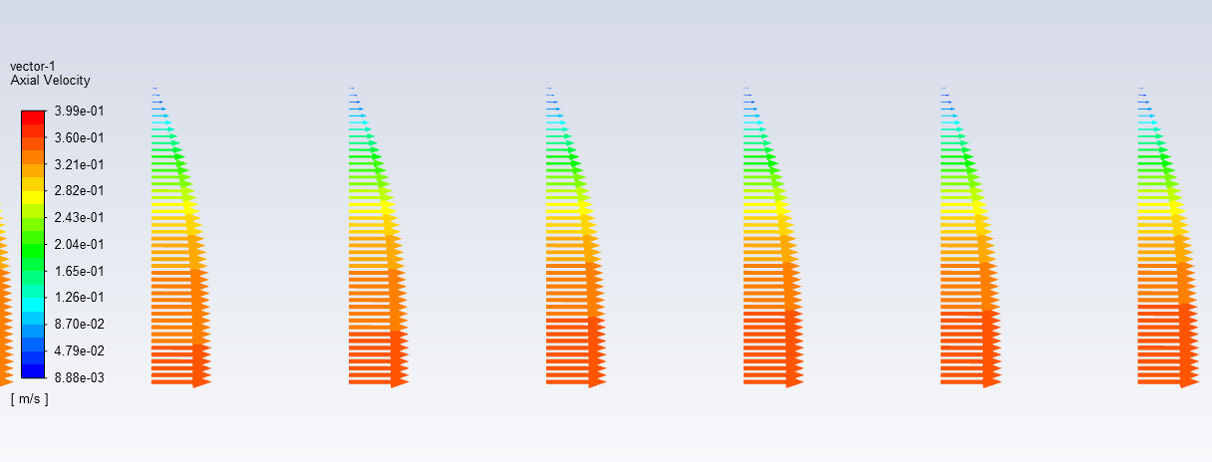

* 1. Plotting Velocity Contours

**Tree > Results** > **Graphics** > **Contours** (double click). Change the parameters as per below and click **Display**.

Result of laminar flow is presented as an example.

1. **V&V Instructions**

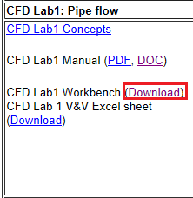

* 1. V&V Instructions for Velocity Profile

Download CFD Lab 1 Workbench file from class website (http://user.engineering.uiowa.edu/~me_160/)

Click update project button. This will run all the simulation on the workbench file and it may take few minutes.

Right click **Solution** > Select **Edit…**

Create reference points by following 7.4.

**Tree > Results** > **Plots** > **XY Plot** (double click). Change parameters as per below and click **Write…** Make sure to select points 1 through 10.

Name file according to which grid solution you are using.

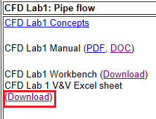Download V&V excel sheet for CFD Lab 1 from class website (http://user.engineering.uiowa.edu/~me_160/)

Open file using Textpad/Wordpad/Notepad, copy points to input into V&V Excel file.

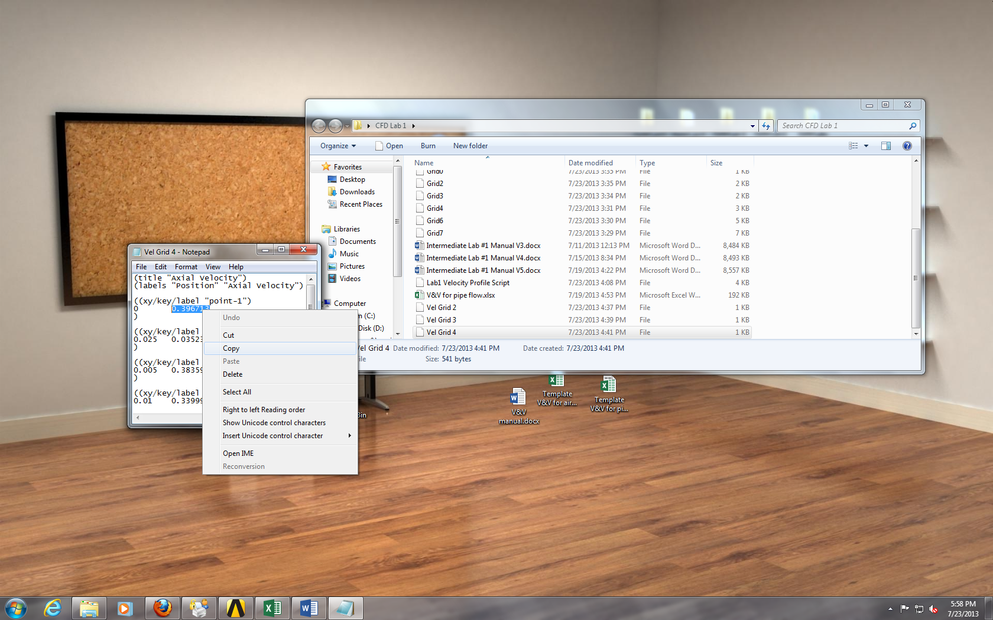

Paste value into V&V Excel file according to its y position and its grid number. Use the Keep Text Only paste function by right clicking in the cell and selecting it from the paste options.

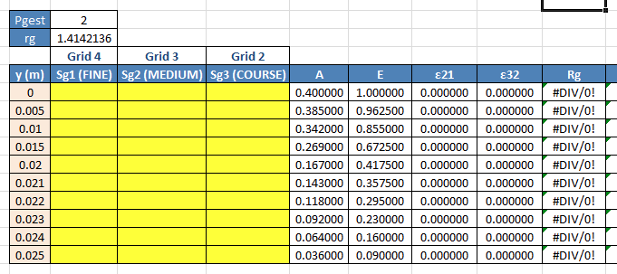

Repeat this process for the remaining y location points and then the two remaining grid solutions. All yellow cells should be filled.

* 1. V&V Instructions for the Friction Coefficient

Right click **Solution** > Select **Edit…**

**Tree > Results** > **Plots** > **XY Plot** (double click). Change parameters as per below and click **Write…**

Name the file according to grid number and save to project folder.

Open file with a text editor such as Textpad/Wordpad/Notepad and copy wall shear stress at the x location of approximately 7m.

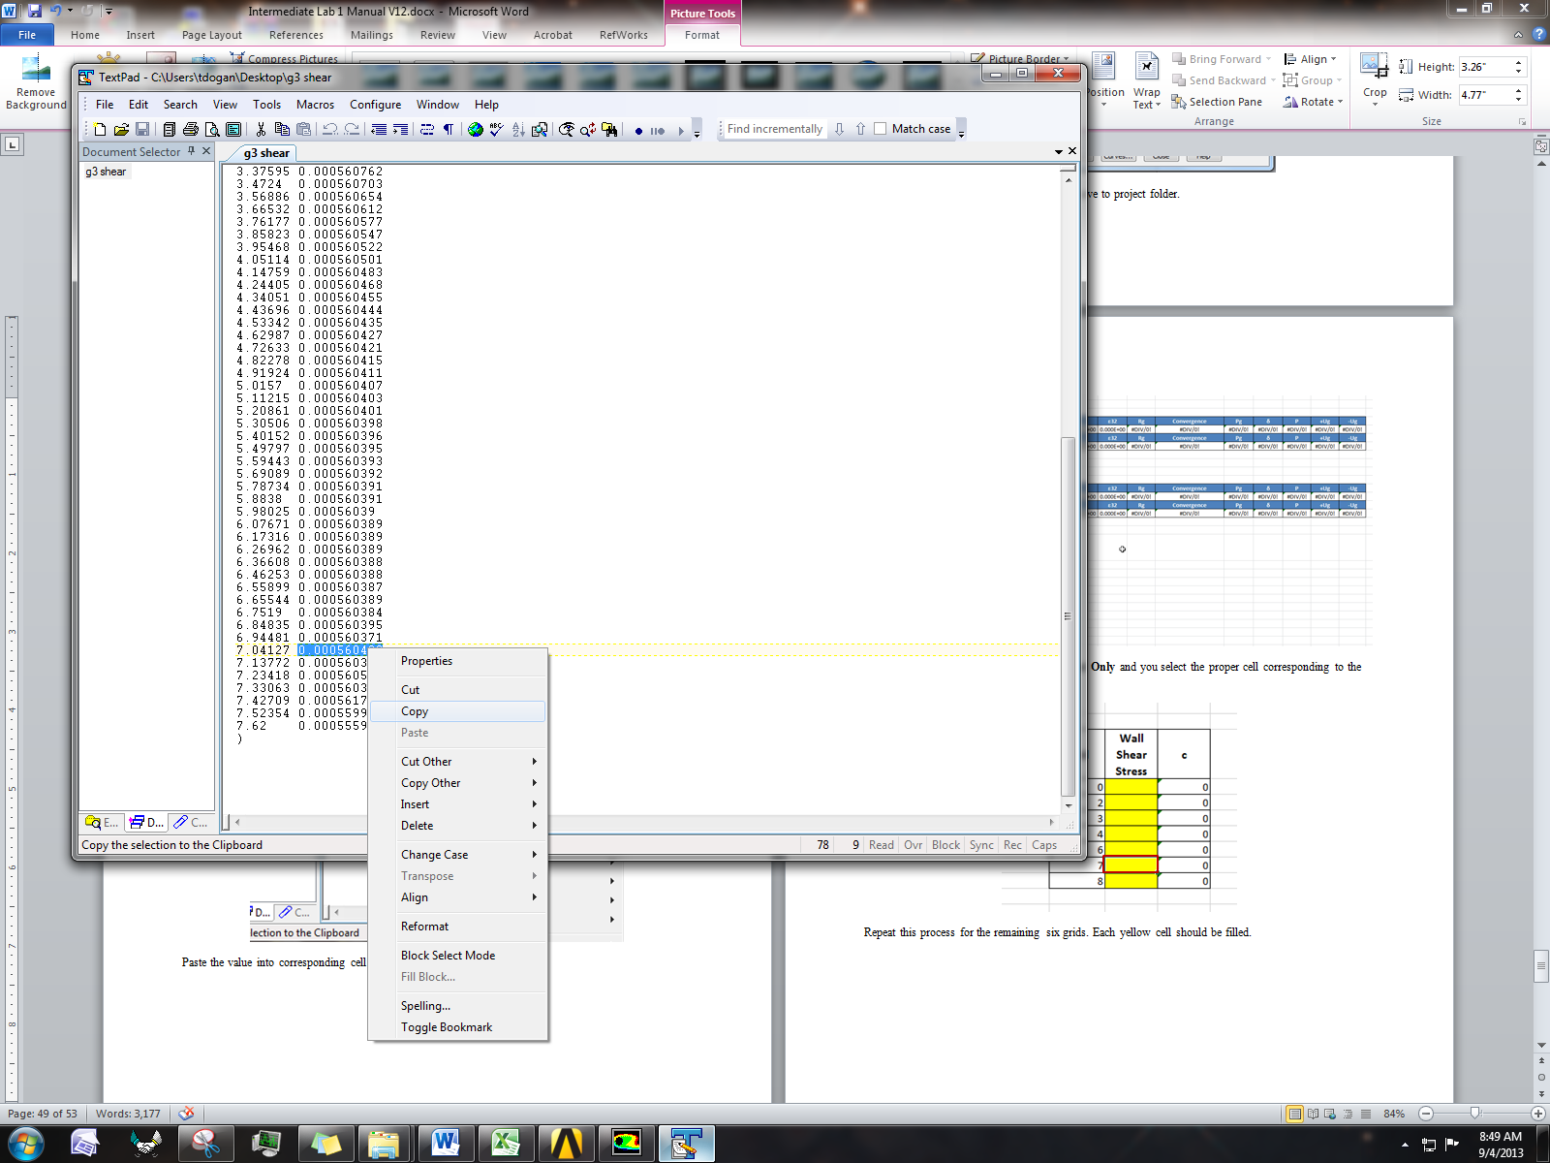

Paste the value into corresponding cell in the V&V template.

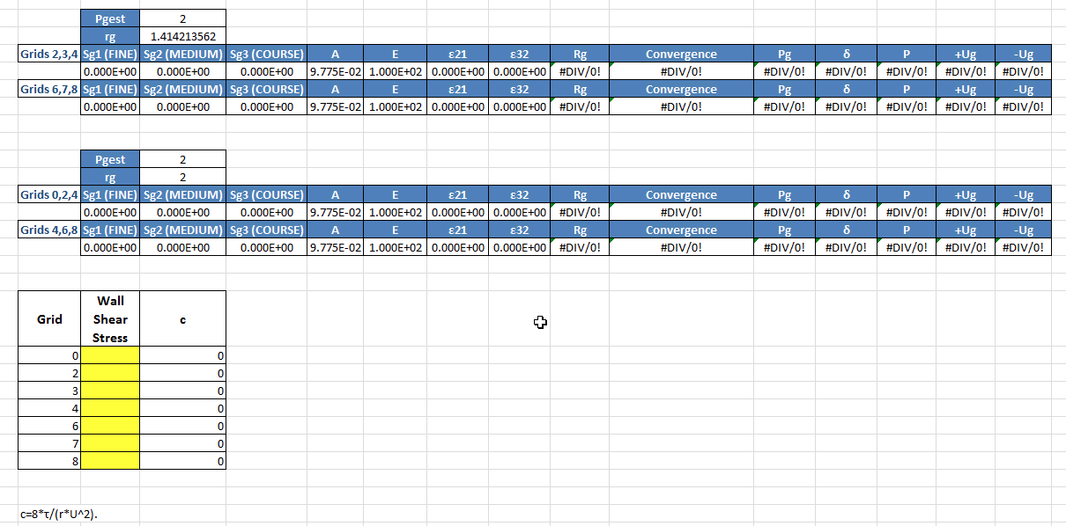

Make sure when pasting you select **Keep Text Only** and you select the proper cell corresponding to the grid number.

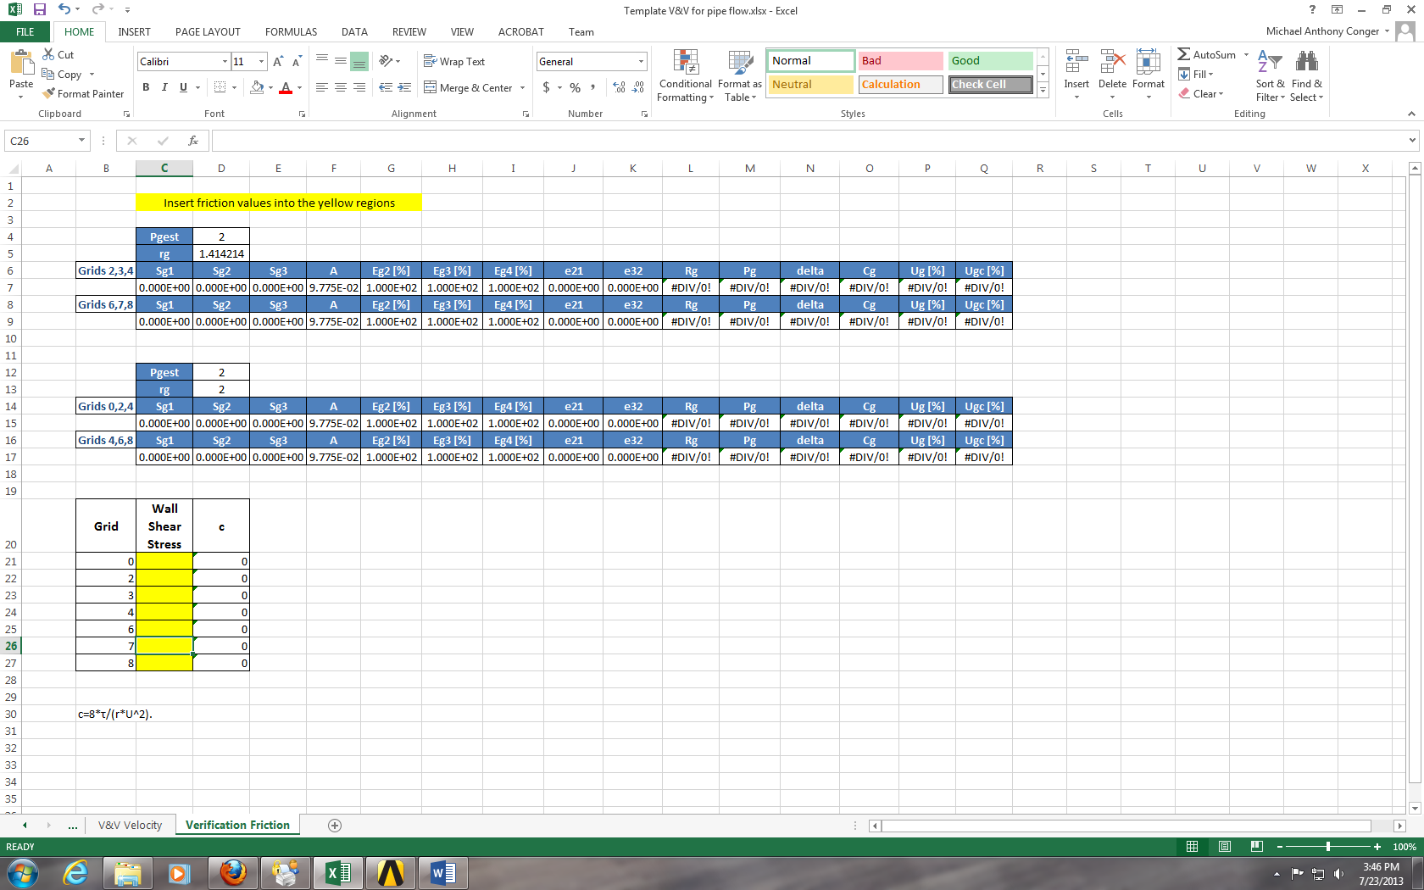

Repeat this process for the remaining six grids. Each yellow cell should be filled.

1. **Data Analysis and Discussion**

You need complete the following assignments and present results in your lab reports following the lab report instructions.

**\* 9.1.-9.4. and 9.6. are for laminar flows, 9.5. is for turbulent flows**

* 1. **Iterative error studies** **(+6)**

Use grid 4 and 8 with laminar flow conditions. Use two different convergent limits 10-5 and 10-6 and fill in the following table for the values on friction factors (grid 4 is given on workbench file which can be found on the class website). Find the relative error between AFD friction factor (0.097747231) and friction factor computed by CFD, which is computed by:



To get the value of ${ Factor}_{CFD}$, you need to export wall shear stress data. Then use the wall shear stress at the developed region to calculate the friction factor. The equation for the friction factor is C=8*τ/(r*U^2), where C is the friction factor, $τ$ is wall shear stress, r is density and U is the inlet velocity. Discuss the effect of convergent limit on results for these two meshes

|  |  |  |  |  |
| --- | --- | --- | --- | --- |
| Mesh No. | Friction Factor  with Convergence Limit 1e-5 | Relative Error with Convergence Limit 1e-5 | Friction Factor with Convergence Limit 1e-6 | Relative Error  with Convergence Limit 1e-6 |
| 4 |  |  |  |  |
| 8 |  |  |  |  |

* Figure need to be reported: residuals history for mesh 8 for two convergent limits.
* Data need to be reported: the above table with values for friction factor and relative error.
  1. **Verification study for friction factor of laminar pipe with refinement ratio √2** **(+7)**

Use the simulations with the meshes for grid 0, 2, 3, 4, 6, 7, and 8 with convergence limit 10-6 (Except for mesh 8 other meshes and their setup is provided on the workbench file in the class website). Export friction factor and insert the values into V&V excel sheet (Refer to V&V instructions for friction factor). For each parameter, refer to ‘Nomenclature’ sheet in V&V excel sheet.

Which set of meshes is closer to the asymptotic range and why (refer to CFD Lecture 1 on class website)? Which set has a lower grid uncertainty (Ug)? Which set is closer to the theoretical value of order of accuracy (2nd order)? For the fine mesh 8, also compare its relative error of the friction factor (the one using convergent limit 10-6 in the table in exercise 8.1) with the grid uncertainty for 6,7,8, which is higher and what does that mean for mesh 8?

* Figure need to be reported: Table from V&V spread sheet.
  1. **Verification study for friction factor of laminar pipe with refinement ratio 2** **(+5)**

Use the simulation for the meshes 0, 2, 4, 6 and 8 with convergence limit 1e-6. Results should already be included in V&V spread sheet from previous exercise (Refer to V&V instructions for friction factor). Compared to results in 9.2, which set of meshes is sensitive to grid refinement ratio? Why?

* Figures need to be reported: Table from V&V spread sheet.
  1. **Verification study of axial velocity profile** **(+7)**

Use mesh 4 as the “fine mesh”, use grid refinement ratio 1.414 and convergence limit 10-6. Follow the V&V for axial velocity profile in the results section. Save the figures and discuss if the simulation has been verified. Discuss which mesh solution is closest to the AFD data, give an explanation of why this is the case?

* Figures need to be reported: Figures and tables in the V&V excel sheet.
  1. **Simulation of turbulent pipe flow using Grid T** **(+9)**

Use simulation with convergence limit 10-6 and compare with EFD data on axial velocity profile and pressure distribution along the pipe. Export the axial velocity profile data at x=100D, use EXCEL to open the file you exported and normalize the profile using the centerline velocity magnitude at x=100D (Non-dimensionalize the profile by dividing with the reference value (For this exercise, reference value is the centerline velocity (=max. velocity)). Plot the normalized velocity profile in EXCEL and paste the figure into WORD.

* Figures need to be reported: Axial velocity profile with EFD data, normalized axial velocity profile at x=100D with EFD data, centerline pressure distribution with EFD data, centerline velocity distribution, contour of axial velocity, velocity vectors showing the developing region and developed regions.
* Data need to be reported: Developing length and compare it with that using formula in textbook.
  1. **Comparison between laminar and turbulent pipe flow** **(+9)**

Compare the results of laminar pipe flow using mesh 8 in exercise 9.1 (convergent limit 10-6) with results of turbulent pipe flow in exercise 9.5. Analyze the difference in normalized axial velocity profile and developing length for laminar and turbulent pipe flows.

* Figures need to be reported: Axial velocity profile with AFD data, normalized axial velocity profile at x=100D with AFD data, normalized axial velocity profile at x=100D comparing laminar and turbulent CFD results, centerline velocity distribution for laminar flow.
* Data need to be reported: Developing length for laminar pipe flow and compared it with that using formula in textbook.
  1. **Questions need to be answered in CFD Lab report**
     1. Answer all the questions in exercises 9.1 to 9.6
     2. Analyze the difference between CFD/AFD and CFD/EFD and possible error sources **(+2)**

1. **Grading scheme for CFD Lab Report**

**(Applied to all CFD Lab reports)**

Section Points

1 **Title Page** 5

1.1 Course Name

1.2 Title of report

1.3 Submitted to “Instructor’s name”

1.4 Your name (with email address)

1.5 Your affiliation (group, section, department)

1.6 Date and time lab conducted

2 **Test and Simulation Design** 10

Purpose of CFD simulation

3 **CFD Process** 20

Describe in your own words how you implemented CFD process

(Hint: CFD process block diagram)

4 **Data Analysis and Discussion 🡨Section 9 (Page# 51) for CFD Lab 1** 45

Answer questions given in **Exercises** of the CFD lab handouts

5 **Conclusions** 20

Conclusions regarding achieving purpose of simulation

Describe what you learned from CFD

Describe the “hands-on” part

Describe future work and any improvements

Total 100

**Additional Instructions**:

1. Each student is required to hand in individual lab report.
2. Conventions for graphical presentation (**CFD**):

**\*** Color print of figures recommended but not required

3. Reports will not be graded unless section 1 is included and complete