57:020 Mechanics of Fluids and Transport Processes

Simulation of Turbulent Flow around an Airfoil

Submitted to: Professor Frederick Stern

Name:______________

University ID:______________

E-mail:_____________

Department:______________

Group:______________

Date: Month/Date/2006

- CFD PreLab 2 Questions (submitted before PreLab1, 10 points)
- Test and Simulation Design (10 points)
Using your own words to describe the purpose of the CFD simulation.

III. CFD Process (10 points)
Using either table or Flow chart to describe the correct CFD Process, which options
will be used in CFD PreLab 1 and CFD Lab 1, and what parameters (with values)
need to be specified for each option.

IV. Data Analysis and Discussion (50 points)

1. Figures, data and questions in CFD PreLab 2 (Simulation of Turbulent flow
around an airfoil, 20 points)

A. Validation using EFD Lab 3 data using k-e model (7 points)
 | Figure 1. Residuals
   | EFD | CFD | Relative  Error (%)
  Lift coef.
  Drag coef.
Figure 2. Pressure coefficient distribution (CFD and EFD) | Figure 3. Contour of pressure
Figure 4. Contour of velocity magnitude | Figure 5. Velocity vectors
Figure 6. Streamlines close to airfoil surface

B. Inviscid Flow Simulation (7 points)
Lift Coefficient (CFD)=____________  Drag Coefficient (CFD)=_____________ | Figure 1. Residuals
Figure 2. Pressure coefficient distribution (CFD only) | Figure 3. Contour of pressure
Figure 4. Contour of velocity magnitude | Figure 5. Velocity vectors
Figure 6. Streamlines close to airfoil surface
C. Questions in CFD PreLab 2 (6 points)
(1). Does inviscid flow has boundary layer near the wall? Zoom in the near wall region and
describe the differences of velocity vectors near the airfoil surface for inviscid and
viscous flows.
Answer: …..

(2). What are the correct boundary conditions for velocity and pressure at “inlet” and “outlet”.
Answer: …..

(3). What are the values for lift and drag coefficients for inviscid flow around the airfoil? Are
they both zero?
Answer: …..

(4). Where are the highest and lowest locations for pressure and velocity magnitude? Why?
Is pressure constant for inviscid flows around airfoil?
Answer: …..

(5). For turbulent flow around airfoil, try to qualitatively explain why there is a lift force
(vertical up) on an airfoil using the contour plot of pressure or the XY plot of pressure
coefficient distribution.
Answer: …..

2. Figures, data, and questions in CFD Lab 2 (Parametric Studies of turbulent
flow around an airfoil, 30 points)

  - Figures and tables in CFD Lab 2 (Effect of Angle of attack, 6 points).
 | Figure 1. Residuals
   | EFD | CFD | Relative error (%)
  Lift coef.
  Drag coef.
Figure 2. Pressure coefficient distribution  (CFD and EFD) | Figure 3. Contour of pressure
Figure 4. Velocity vectors | Figure 5. Streamlines close to airfoil surface

  - Figures and tables in CFD Lab 2 (Effect of turbulent models, k-w, 6 points).
 | Figure 1. Residuals
   | EFD | CFD | Relative error (%)
  Lift coef.
  Drag coef.
Figure 2. Pressure coefficient distribution  (CFD and EFD) | Figure 3. Contour of pressure
Figure 4. Velocity vectors | Figure 5. Streamlines close to airfoil surface

  - Questions in CFD Lab 2 (18 points)
C.1. For effect of angle of attack:
(1). Which angle of attack simulation requires more iterations to converge?
Answer: …..

(2). Which angle of attack produces higher lift/drag coefficients? Why?
Answer: …..

(3). Describe the differences of streamline distributions near the trailing edge of airfoil
surface for these two different angles of attack. Do you observe separations for both?
Answer: …..

C.2. For effect of different turbulence models:
(1). Do the two different turbulence models have the same convergence path? If not,
which one requires more iterations to converge.
Answer: …..
(2). Do the two different turbulence models predict the same results? If not, which
model predicts more accurately by comparing with EFD data?
Answer: …..

C.3. For the following contour plot, qualitatively compare the values of pressure and
velocity magnitude at point 1 and 2, if the flow is from left to right. Which location
has higher pressure and which location has higher velocity magnitude? Why?
Answer: …..
1
2
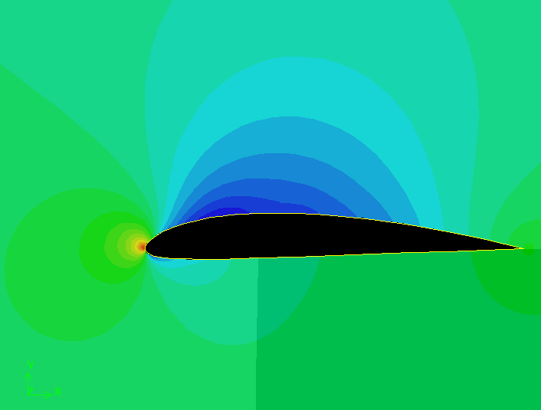

- Conclusions (15 points)
A. Conclusions regarding achieving purpose of simulation (3 points)
…..
B. What I have learned from CFD Lab. (6 points)
…..
C. Comments on the hands-on experience, the software interface, and
overall lab performance (4 points)
…..
D. Suggestions and improvements (2 points)

