Parametric Studies of Turbulent Flow around an Airfoil

57:020 Mechanics of Fluids and Transport Processes

CFD LAB 2

By Tao Xing and Fred Stern
IIHR-Hydroscience & Engineering
The University of Iowa
C. Maxwell Stanley Hydraulics Laboratory
Iowa City, IA 52242-1585

1. Purpose

The Purpose of CFD Lab 2 is to conduct parametric studies for turbulent flow around Clarky airfoil following the “CFD process” by an interactive step-by-step approach. Students will have “hands-on” experiences using FlowLab to investigate the effect of angle of attack and effect of different turbulence models on the simulations results. These effects will be studied by comparing simulation results with EFD data. Students will analyze the differences and possible numerical errors, and present results in Lab report.
Geometry
Post-processing
Report
Physics
Mesh
Contours
Vectors
Streamlines
Solve
Iterations
Conver-gent.
Limit
Precisions

Single
Double
Numerical Schemes

1st order
2nd order
QUICK
Steady/
Unsteady?
Coarse
Medium
Fine
Automatic
Manual
Structured
Unstruct-ured
Boundary
Conditions
Flow Properties
Viscous
Models
One Eq.
Two Eq.
Density and viscosity
Laminar
Turbulent
Inviscid
SA
k-e
k-w
Heat Transfer?
Incompress-ible?
Initial
Conditions
Clarky
NACA12
LS(1) 0417
Import Profile
Chord length
Angle of attack
Select domain
Select geometry
Wall shear stress
Skin friction Factor
XY plots
Verification and validation
Coefficient of lift
Coefficient of drag
Residuals
Pressure coef. Distri.
Shear stress Distri.
Airfoil Y plus

Flow Chart for ISTUE Teaching Module for Airfoil flow (red color illustrates the options you will use in CFD Lab 2)

2. Simulation Design

In EFD Lab 3, you have conducted experimental study for turbulent airfoil flow around a ClakY airfoil (Re≈300,000). The data you have measured were used for CFD PreLab 2. In CFD Lab 2, simulation will be conducted under the same conditions of EFD Lab 3, except angle of attack and turbulent models that will be changed in this lab.

The problem to be solved is the turbulent flow around the Clarky airfoil with angle of attack (α)
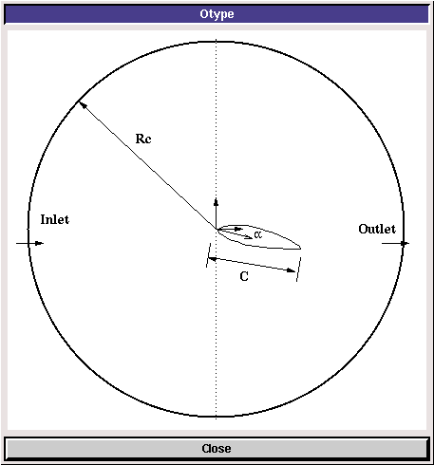
In the figure above, C is the chord length of the airfoil, α is the angle of attack, and Rc is the radius of the “O” domain.

3. CFD Process

Step 1: (Geometry)
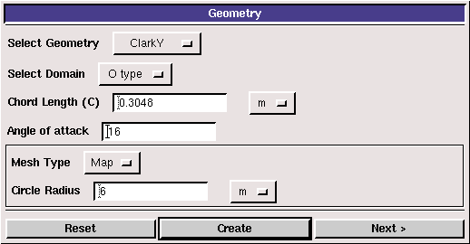
Choose “ClarkY” airfoil and “O type” domain. Input the following conditions:
- Select Geometry (Clarky)
- Select domain (O type)
- Chord length (0.3048 m)
- Angle of attack (16 degrees)
- Mesh type (Map)
- Circle Radius Rc (6m)

You need to push “create” button after you enter the values for the changes to take effect.

There are two angles of attack available in EFD Lab3 for all the groups, i.e., 0 and 16 degrees. In CFD PreLab2, you have conducted the simulation for 0 degree. In CFD Lab2, to investigate the “effect of angle attack”(exercise 1), you will simulate angle of attack 16 degrees and compare with CFD Prelab2 results. To investigate the “effect of turbulence models” (exercise 2), you will use the same angle of attack, i.e., 16 degree, and compare with results from exercise 1.

Step 2: (Physics)
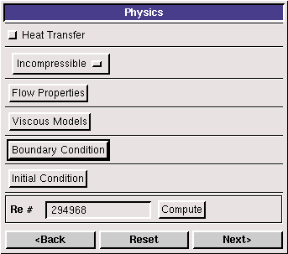
(1). With or without Heat Transfer?

Since we are not dealing with the thermal aspects of the flow, like heat transfer, etc., switch the <<Heat Transfer >> button OFF, which is the default setup.

(2). Incompressible

Choose “Incompressible”, which is the default setup.

(3). Flow Properties
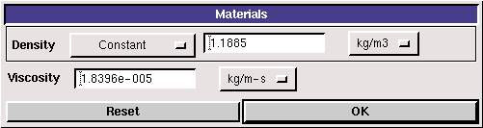
Use the air properties at the operating temperature of your EFD Lab3 and click <<OK>>. You can use the following website to calculate air properties if you know the temperature:
http://www.mhtl.uwaterloo.ca/old/onlinetools/airprop/airprop.html
The values in the figure above are for 24° temperature.
NOTE: viscosity used in FlowLab is the dynamic viscosity (), NOT kinematic viscosity ()

(4). Viscous Model
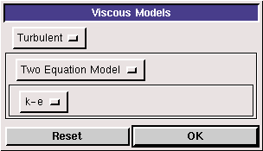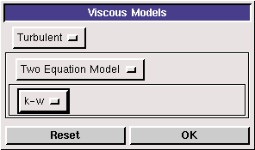
For exercise 1 (effect of angle of attack), use “k-e” model. For exercise 2 (effect of turbulence models), using “k-w” model.

(5). Boundary Conditions

At “Inlet”, we use constant pressure. Inlet velocity is 15 m/s. Use default values for “k”, “epsilon” and “omega(w).”
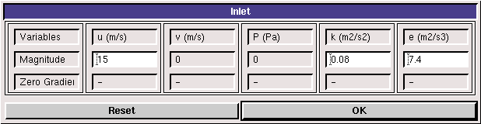
k-e

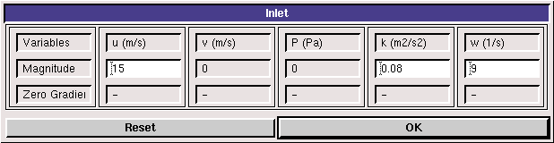
k-w

At “Outlet”, FlowLab uses magnitude for pressure and zero gradients for axial and radial velocities. Input “0” for gauge pressure and click <<OK>>.
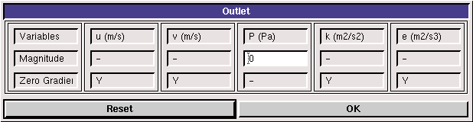
k-e

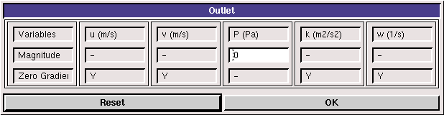
k-w

At “Airfoil”, if flow is turbulent, FlowLab uses no-slip boundary conditions for velocities and zero-pressure gradient. Turbulent quantities k and e are also specified to be zero, except for omega (w), on which zero-pressure gradient applied. Read all the values and click <<OK>>.
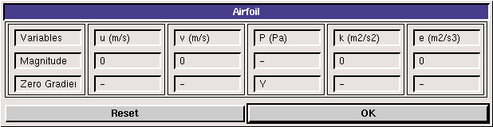
k-e
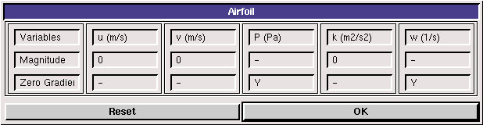
k-w

(6). Initial Conditions

Use the default setup for initial conditions.
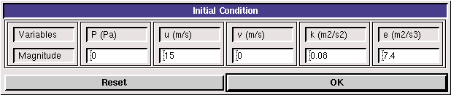
k-e

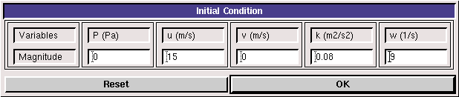
k-w

After specifying all the above parameters, click <<Compute>> button and FlowLab will automatically calculate the Reynolds number based on the inlet velocity, airfoil chord length, and flow properties. Click <<Next>>, it takes you to the next step, “Mesh”.

Step 3: (Mesh)
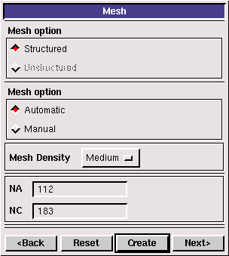

For CFD Lab 2, use “Automatic” meshing and “Medium” mesh. After clicking <<Create>>, mesh information will be displayed. NA and NC are the numbers of grid points on the airfoil surface and radial direction, respectively.
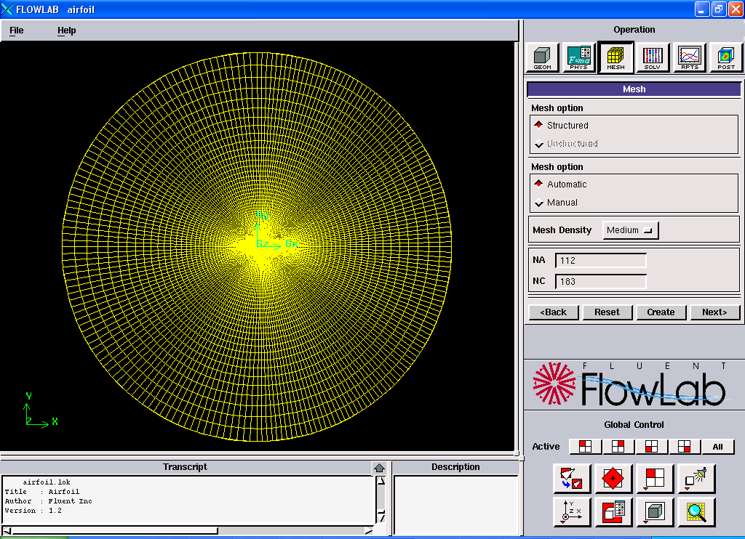

Step 4: (Solve)
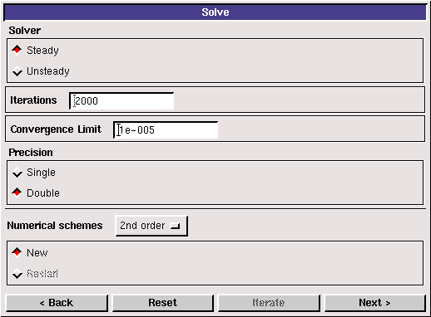

Specify the iteration number and convergence limit to be 2000 and 10⁻⁵, respectively. Choose “Double Precision”, “2nd order” for numerical schemes, and “New” calculation. Click <<Iterate>>, FlowLab will fire the XY plot for residuals that is dynamically updated during the calculation. Whenever you see the window, “Solution Converged”, click <<OK>>.
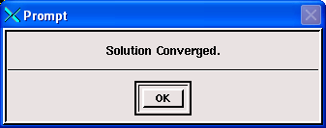

Step 5: (Reports)

“Reports” first provides you the information on “wall shear stress”, “skin friction factor”, “coefficient of lift”, and “coefficient of drag”. XY plot provide plots for “residuals”, “pressure distribution”, “pressure coefficient”, “friction coefficient”, “shear stress distribution”, and “Airfoil Y Plus distribution”. In this Lab, only XY plots for “residuals” and “pressure coefficient” are required.
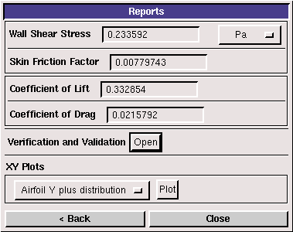

“XY Plots” provides the following options:
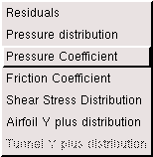

To import the EFD data on top of the above CFD results, just click <<File>> button and use the browse button to locate the file you want and click <<Import>>. Details have been described in previous CFD PreLab 1 for laminar pipe flow.
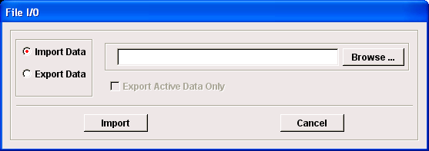
In this Lab:
- Since you already created your own EFD Lab 3 data in CFD PreLab 2, it is suggested that you use the same computer as you used in CFD PreLab2 unless if you have saved your work in your network drive, which is recommended.
- For exercise 1, you will compare the pressure coefficient distribution with EFD for an angle of attack that may be different from your own data in EFD Lab 3. Benchmark data of the pressure coefficients for different angles of attack can be downloaded from class website under “CFD Lab2”. The angle of attack can be told from the name of the file, such as “Pressure-coef-attack06.xy” is the EFD data of pressure coefficient for angle of attack equals 6 degrees.
- Benchmark data for lift and drag coefficients also can be found from the same place, or: http://www.engineering.uiowa.edu/~fluids/Lab-documents/CFD/CFD%20Lab2/Lift.xls

Step 6: (Post-processing)

Use the “contour”, “vector” buttons to show pressure contours and velocity vectors. All the details on how to plot those figures have been explained in details in previous lab instructions. The following shows some sample results only, your simulations in this lab will all be angle of attack 16.

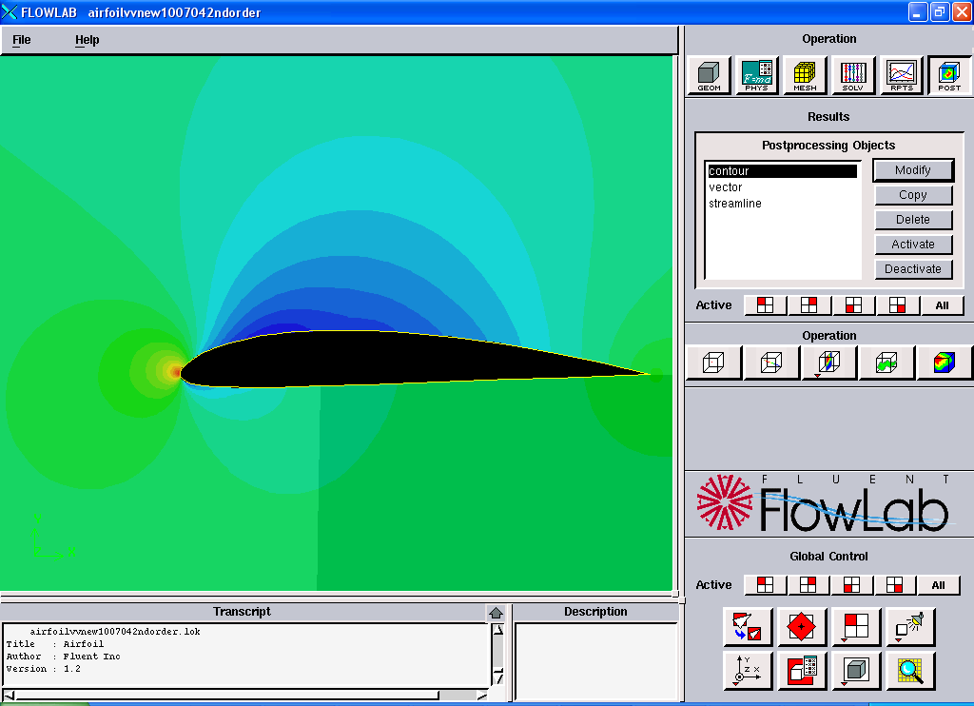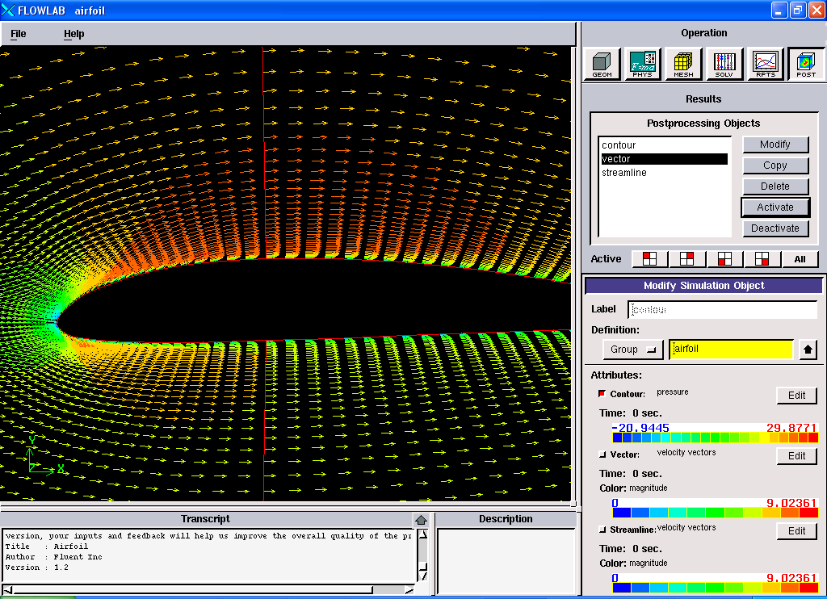
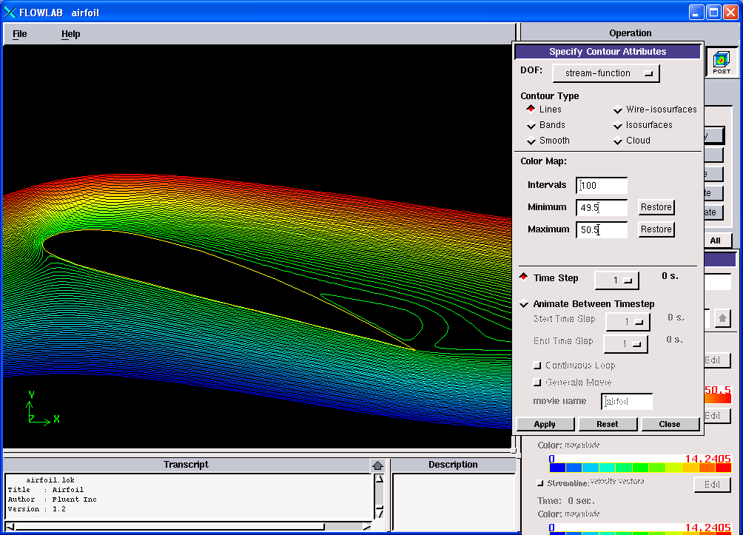

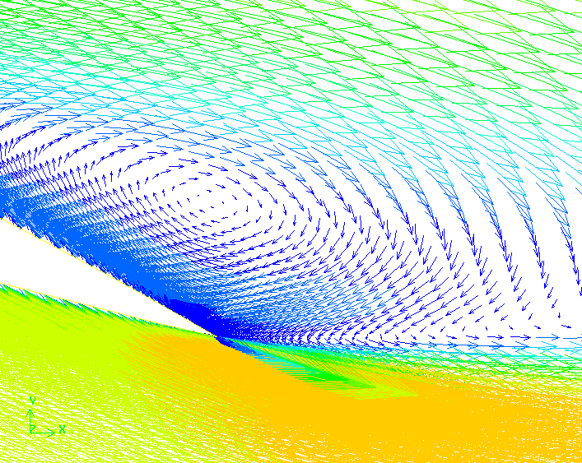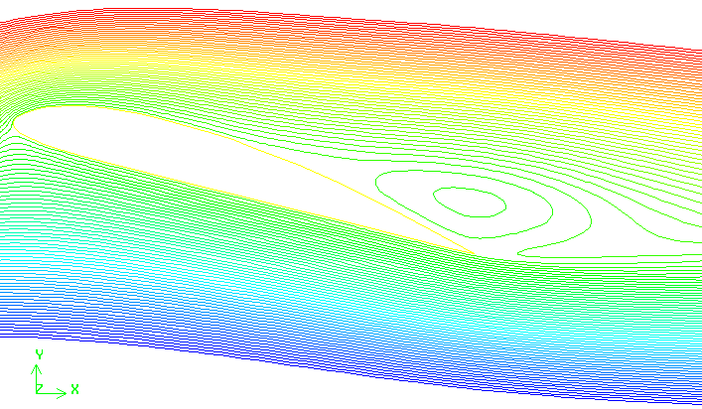

4. Exercises

Parametric Studies of Turbulent Flow around an Airfoil

- You must complete all the following assignments and present results in your CFD Lab 2 reports
following the CFD Lab Report Instructions.
- Use “CFDLab2-template.doc” to save the figures and data for each exercise below.
- Use the benchmark EFD data from the class website if your EFD Lab 3 data are with a different angle of attack than 16 degrees.

- Effect of angle of attack.
1.1. Use the same flow conditions as those in your EFD Lab 3, including geometry (chord length) and physics (Flow properties, Reynolds number, inlet velocity), EXCEPT use angle of attack 16
Degrees regardless of AOA in you EFD Lab 3. Use “O” mesh with domain size 6 meters, k-e model, automatic medium mesh, 2nd order upwind scheme, double precision with iteration number (2000) and convergent limit (10⁻⁵).
- Figures need to be saved: 1. Time history of residuals (residual vs. iteration number); 2.
Pressure coefficient distribution (CFD and EFD), 3. Contour of pressure, 4.Velocity vectors, and 5.
Streamlines
- Data need to be saved: lift and drag coefficients

- Effect of turbulence models
2.1. Use the same conditions as those in exercise 1, EXCEPT using the “k-w” for “viscous models”. Set up the boundary conditions following instructions part, set the iteration number to be (2000), and convergent limit to be 10⁻⁵. Perform the simulation and compare solutions with the simulation results using “k-e” model (you have finished in CFD PreLab2)
- Figures need to be saved: 1. Time history of residuals (residual vs. iteration number); 2. Pressure coefficient distribution (CFD and EFD), 3. Contour of pressure 4. Velocity vectors, and 5. Streamlines
- Data need to be saved: lift and drag coefficients

3. Questions need to be answered in CFD Lab2 report:
Using the figures obtained in exercises 1 and 2 in this Lab and those figures you created in CFD
PreLab2 to answer the following questions and present your answers in your CFD Lab 2 report.
Note: These questions are also available in the “CFDlab2-Template” where you will type answers.
3.1. For Exercise 1 (effect of angle of attack):
(1). Which angle of attack simulation requires more iterations to converge?
(2). Which angle of attack produces higher lift/drag coefficients? Why?
(3). What is the effect of angle of attack on lift and drag coefficients?
(4). Describe the differences of streamline distributions near the trailing edge of airfoil surface for
these two different angles of attack. Do you observe separations for both?

3.2. For Exercise 2 (different turbulence models):
(1). Do the two different turbulence models have the same convergence path? If not, which one
requires more iterations to converge.
(2). Do the two different turbulence models predict the same results? If not, which model predicts
more accurately by comparing with EFD data?
3.3. For the following contour plot, qualitatively compare the values of pressure and velocity
magnitude at point 1 and 2, if the flow is from left to right. Which location has higher pressure
and which location has higher velocity magnitude? Why?

1
2
3.4. Questions in CFD PreLab2.

