Ex) A jet strikes a vane which moves to the right at constant velocity $V_{C}$ on a frictionless cart. Compute (a) the force $F_{x}$ required to restrain the cart and (b) the power $P$ delivered to the cart. Also find the cart velocity for which (c) the force $F_{x}$ is a maximum and (d) the power $P$ is a maximum.

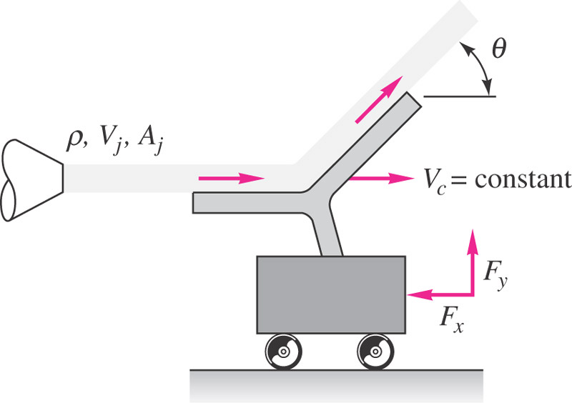

**Solution:**

$$∑\underline{F}=\frac{d}{dt}\int_{CV}{ρ\underline{V}dV}+\int_{CS}{ρ\underline{V} \underline{V_{R}}⋅\underline{n}dA}$$

where, $\underline{V_{R}}=\underline{V}-\underline{V_{CS}}$

Assume relative inertial coordinates with non-deforming CV i.e. CV moves at constant translational non-accelerating

$$\underline{V_{CS}}=u_{CS}\hat{i}+v_{CS}\hat{j}+w_{CS}\hat{k}=V_{C}\hat{i}$$

and steady flow $\underline{V}≠\underline{V}\left(t\right)$ with $ρ=constant$

Continuity:

$$0=\frac{d}{dt}\int_{CV}{ρdV}+\int_{CS}{ρ\underline{V_{R}}⋅\underline{n}dA}$$

$0=ρ\int_{CS}{\underline{V_{R}}⋅\underline{n}dA}$

Momentum:

$$∑\underline{F}=\int_{CS}{ρ\underline{V} \underline{V_{R}}⋅\underline{n}dA}$$

$=\int_{CS}{ρ\left(\underline{V_{R}}+\underline{V_{CS}}\right)\underline{V_{R}}⋅\underline{n}dA}$

0

$$=ρ\int_{CS}{\underline{V_{R}} \underline{V_{R}}⋅\underline{n}dA}+ρ\underline{V_{CS}}\int_{CS}{\underline{V_{R}}⋅\underline{n}dA}$$

$$∑\underline{F}=ρ\int_{CS}{\underline{V_{R}} \underline{V_{R}}⋅\underline{n}dA}$$

$$∑F_{x}=-F_{x}=ρ\int_{CS}{V_{R_{x}}\underline{V_{R}}⋅\underline{n}dA}$$

$$-F_{x}=ρV_{R_{x}1}\left(-V_{R1}A_{1}\right)+ρV_{R_{x}2}\left(V_{R2}A_{2}\right)$$

$$0=ρ\int_{CS}{\underline{V_{R}}⋅\underline{n}dA}$$

$$-ρV_{R1}A_{1}+ρV_{R2}A_{2}=0$$

$$V_{R1}A_{1}=V_{R2}A_{2}=\underset{V_{R1}=V_{R_{x}1}=V_{j}-V_{C}}{\underbrace{\left(V_{j}-V_{C}\right)}}A_{j}$$

$$-F_{x}=ρ\left(V_{j}-V_{C}\right)\left[-\left(V_{j}-V_{C}\right)A_{j}\right]+ρ\left(V_{j}-V_{C}\right)\cos{θ}\left(V_{j}-V_{C}\right)A_{j}$$

$$F_{x}=ρ{\left(V_{j}-V_{C}\right)}^{2}A_{j}\left[1-\cos{θ}\right]$$

$$Power=V_{C}F_{x}=V_{C}ρ{\left(V_{j}-V_{C}\right)}^{2}A_{j}\left(1-\cos{θ}\right)$$

$${F_{x}}_{max}=ρV_{j}^{2}A_{j}\left(1-\cos{θ}\right), V_{C}=0$$

$$P_{max}⇒\frac{dP}{dV_{C}}=0$$

$$P=V_{C}ρ\left(V_{j}^{2}-2V_{C}V_{j}+V_{C}^{2}\right)A_{j}\left(1-\cos{θ}\right)$$

$$=ρ\left(V_{j}^{2}V_{C}-2V_{C}^{2}V_{j}+V_{C}^{3}\right)A_{j}\left(1-\cos{θ}\right)$$

$$\frac{dP}{dV_{C}}=ρ\left(V_{j}^{2}-4V_{C}V_{j}+3V_{C}^{2}\right)A_{j}\left(1-\cos{θ}\right)=0$$

$$3V_{C}^{2}-4V_{j}V_{C}+V_{j}^{2}=0$$

$$V_{C}=\frac{+4V_{j}±\sqrt{16V_{j}^{2}-12V_{j}^{2}}}{6}=\frac{4V_{j}±2V_{j}}{6}$$

$$V_{C}=\frac{V_{j}}{3}$$

$$P_{max}=\frac{V_{j}}{3}ρ{\left(\frac{2V_{j}}{3}\right)}^{2}A_{j}\left(1-\cos{θ}\right)$$

$$=\frac{4}{27}V_{j}^{3}ρA_{j}\left(1-\cos{θ}\right)$$