Example: Air at 20°C and 1atm enters a 40-cm-square duct. Using the “displacement thickness” concept, estimate (a) the core velocity and (b) the mean pressure in the core of the flow at the position . (c) What is the average gradient, in Pa/m, in this section?
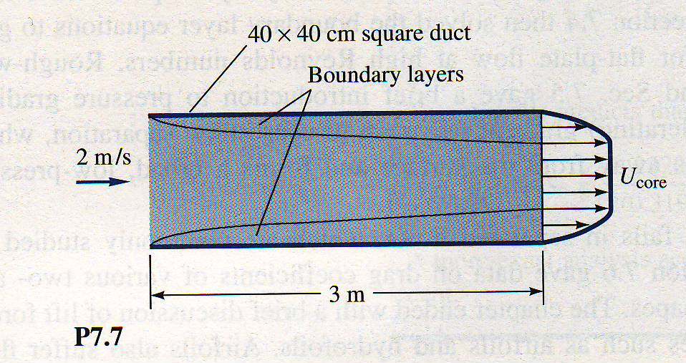
Solution:
For air at 20°C, take and . Using laminar boundary layer theory, compute the displacement thickness at :
(laminar)
Then, by continuity,

The pressure change in the (frictionless) core flow is estimated from Bernoulli’s equation. Using gage pressure, then at inlet .

The average pressure gradient is

