Chapter 9: Surface Resistance

  - Introduction: drag and lift on immersed bodies

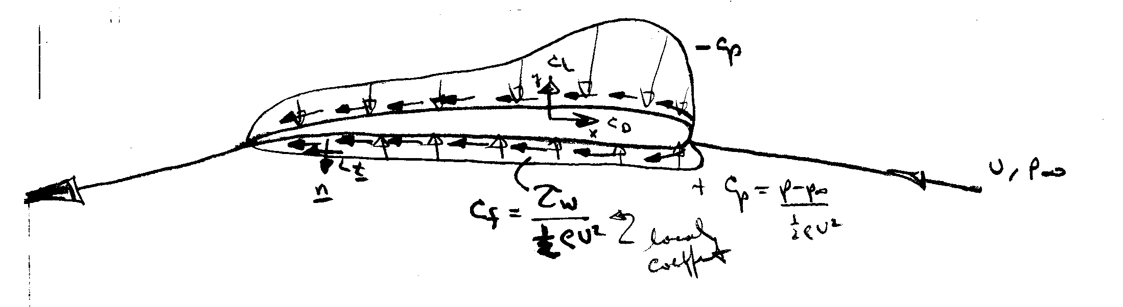
$C_{D}=\frac{1}{\frac{1}{2}{ρV}^{2}A}\left\{\int_{S}{\left(p−p_{∞}\right)\underline{n}⋅\hat{i}\text{dA}+\int_{S}{τ_{w}\underline{t}⋅\hat{i}\text{dA}}}\right\}$
= drag coefficient
C_{form} (form drag)
C_{f} (skin friction drag)

$C_{L}=\frac{1}{\frac{1}{2}{ρV}^{2}A}\left\{\int{\left(p−p_{∞}\right)\underline{n}⋅\hat{j}\text{dA}}\right\}$ = lift coefficient

For inviscid fluid, C_{D} = 0 since both the form and skin friction components are zero, which is known as D’Alembert paradox. However, C_{L} ≠ 0 and can often be predicted accurately with ideal-flow theory.

In general,

low Re < 1: C_{f} > C_{form} Stoke’s flow (lab 1)

med & high Re: 1. C_{f} >> C_{form}
t/c << 1 i.e., streamlined body
2. C_{form} >> C_{f}
t/c ∼ 1 i.e., bluff body

1. = subject of this chapter
2. = subject of chapter 11 along with C_{L}

Topics of Chapter 9

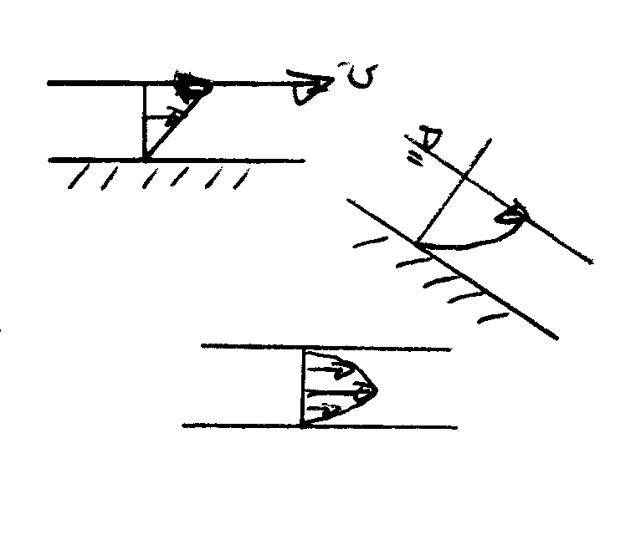
  - Surface Resistance with Uniform Laminar Flow

1. parallel plates (internal flow)
2. flow down an inclined plane (open channel flow)
3. parallel plates with pressure gradient (internal flow)

In this class:
1. parallel plates

2. extend as per 3. including inclined flow
3. flow down an inclined plane

  - Boundary Layer Flow
  - Laminar
external
flow
  - Turbulent
  - Transition control (brief comments)
  - Surface Resistance with Uniform Laminar Flow

We now discuss a couple of exact solutions to the Navier-Stokes equations. Although all known exact solutions (about 80) are for highly simplified geometries and flow conditions, they are very valuable as an aid to our understanding of the character of the NS equations and their solutions. Actually the examples to be discussed are for internal flow (Chapter 10) and open channel flow (Chapter 15), but they serve to underscore and display viscous flow. Finally, the derivations to follow utilize differential analysis. See the text for derivations using CV analysis.

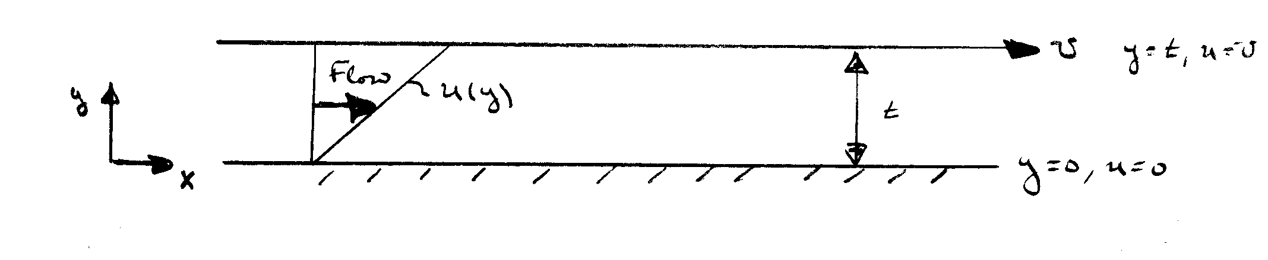
- Couette Flow
boundary conditions

First, consider flow due to the relative motion of two parallel plates

Continuity $\frac{∂u}{∂x}=0$
u = u(y)
v = o
$$\frac{∂p}{∂x}=\frac{∂p}{∂y}=0$$

Momentum $0=μ\frac{d^{2}u}{{\text{dy}}^{2}}$
or by CV continuity and momentum equations:
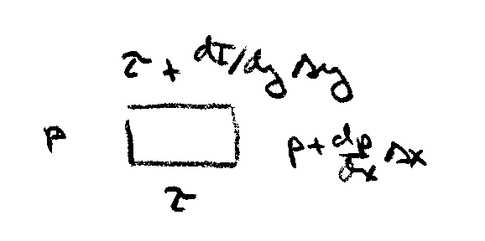
$${ρu}_{1}Δy={ρu}_{2}Δy$$
u₁ = u₂

$$\sum{F_{x}=}\sum{uρ\underline{V}⋅d\underline{A}=ρQ\left(u_{2}−u_{1}\right)=0}$$
$=pΔy−\left(p+\frac{\text{dp}}{\text{dx}}Δx\right)Δy−τΔx+\left(τ+\frac{dτ}{\text{dy}}\text{dy}\right)Δx$= 0

$\frac{dτ}{\text{dy}}=0$
i.e. $\frac{d}{\text{dy}}\left(μ\frac{\text{du}}{\text{dy}}\right)=0$
$μ\frac{d^{2}u}{{\text{dy}}^{2}}=0$

from momentum equation
$μ\frac{\text{du}}{\text{dy}}=C$
$u=\frac{C}{μ}y+D$
u(0) = 0 ⇒ D = 0
u(t) = U ⇒ C = $μ\frac{U}{t}$
$u=\frac{U}{t}y$
$τ=μ\frac{\text{du}}{\text{dy}}=\frac{μU}{t}=$constant
2. Generalization for inclined flow with a constant pressure gradient
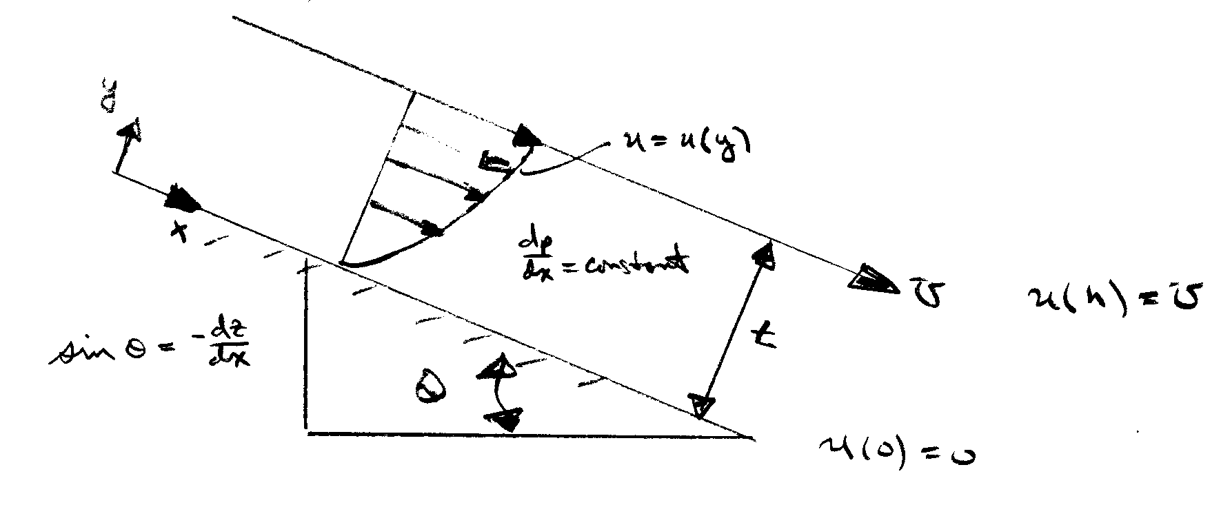

Continutity $\frac{∂u}{∂x}=0$
u = u(y)
v = o
$$\frac{∂p}{∂y}=0$$

Momentum $0=−\frac{∂}{∂x}\left(p+γz\right)+μ\frac{d^{2}u}{{\text{dy}}^{2}}$

i.e., $μ\frac{d^{2}u}{{\text{dy}}^{2}}=γ\frac{\text{dh}}{\text{dx}}$ h = p/γ +z = constant
plates horizontal $\frac{\text{dz}}{\text{dx}}=0$
plates vertical $\frac{\text{dz}}{\text{dx}}$=-1
which can be integrated twice to yield

$μ\frac{\text{du}}{\text{dy}}=γ\frac{\text{dh}}{\text{dx}}y+A$

$μu=γ\frac{\text{dh}}{\text{dx}}\frac{y^{2}}{2}+\text{Ay}+B$
now apply boundary conditions to determine A and B
u(y = 0) = 0 ⇒ B = 0
u(y = t) = U

$μU=γ\frac{\text{dh}}{\text{dx}}\frac{t^{2}}{2}+\text{At}⇒A=\frac{μU}{t}−γ\frac{\text{dh}}{\text{dx}}\frac{t}{2}$

$$u(y)=\frac{γ}{μ}\frac{\text{dh}}{\text{dx}}\frac{y^{2}}{2}+\frac{1}{μ}\left[\frac{μU}{t}−γ\frac{\text{dh}}{\text{dx}}\frac{t}{2}\right]$$

=$−\frac{γ}{2μ}\frac{\text{dh}}{\text{dx}}\left(\text{ty}−y^{2}\right)+\frac{U}{t}y$

This equation can be put in non-dimensional form:

$$\frac{u}{U}=−\frac{{γt}^{2}}{2μU}\frac{\text{dh}}{\text{dx}}\left(1−\frac{y}{t}\right)\frac{y}{t}+\frac{y}{t}$$

define: P = non-dimensional pressure gradient

= $−\frac{{γt}^{2}}{2μU}\frac{\text{dh}}{\text{dx}}$ $h=\frac{p}{γ}+z$
Y = y/t $=−\frac{{γz}^{2}}{2μU}\left[\frac{1}{γ}\frac{\text{dp}}{\text{dx}}+\frac{\text{dz}}{\text{dx}}\right]$

⇒ $\frac{u}{U}=P⋅Y(1−Y)+Y$
parabolic velocity profile
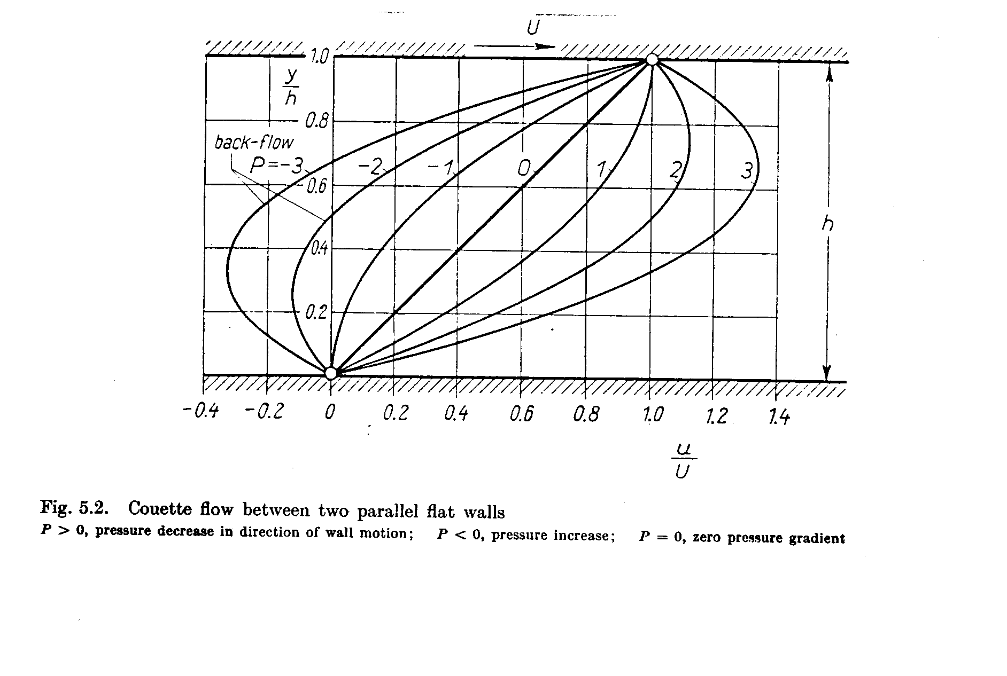

$$\frac{u}{U}=\frac{\text{Py}}{t}−\frac{{\text{Py}}^{2}}{t^{2}}+\frac{y}{t}$$

$$\begin{aligned}q=\int_{0}^{t}{\text{udy}} \\ \overline{u}=\frac{q}{t}=\frac{\int_{0}^{t}{U\left[ \right]\text{dy}}}{t}\end{aligned}$$

$$\frac{t\overline{u}}{U}=\int_{0}^{t}{\left[\frac{P}{t}y−\frac{P}{t^{2}}y^{2}+\frac{y}{t}\right]\text{dy}}$$

=$\frac{\text{Pt}}{2}−\frac{\text{Pt}}{3}+\frac{t}{2}$

$$\frac{\overline{u}}{U}=\frac{P}{6}+\frac{1}{2}⇒\overline{u}=\frac{t^{2}}{\text{12}μ}\left(−γ\frac{\text{dh}}{\text{dx}}\right)+\frac{U}{2}$$

For laminar flow $\frac{\overline{u}t}{ν}<\text{1000}$ Re_{crit} ∼ 1000

The maximum velocity occurs at the value of y for which:
$\frac{\text{du}}{\text{dy}}=0$ $\frac{d}{\text{dy}}\left(\frac{u}{U}\right)=0=\frac{P}{t}−\frac{2P}{t^{2}}y+\frac{1}{t}$

$⇒y=\frac{t}{2P}\left(P+1\right)=\frac{t}{2}+\frac{t}{2P}$ @ u_{max}
for U = 0, y = t/2

$∴ u_{\text{max}}=u\left(y_{\text{max}}\right)=\frac{\text{UP}}{4}+\frac{U}{2}+\frac{U}{4P}$

note: if U = 0: $\frac{\overline{u}}{u_{\text{max}}}=\frac{P}{6}/\frac{P}{4}=\frac{2}{3}$

The shape of the velocity profile u(y) depends on P:

1. If P > 0, i.e.,$\frac{\text{dh}}{\text{dx}}<0$ the pressure decreases in the
direction of flow (favorable pressure gradient) and the velocity is positive over the entire width

$$γ\frac{\text{dh}}{\text{dx}}=γ\frac{d}{\text{dx}}\left(\frac{p}{γ}+z\right)=\frac{\text{dp}}{\text{dx}}−γ\text{sin}θ$$

a) $\frac{\text{dp}}{\text{dx}}<0$

b) $\frac{\text{dp}}{\text{dx}}<γ\text{sin}θ$

- If P < 0, i.e., $\frac{\text{dh}}{\text{dx}}>0$ the pressure increases in the direction of flow (adverse pressure gradient) and the velocity over a portion of the width can become negative (backflow) near the stationary wall. In this case the dragging action of the faster layers exerted on the fluid particles near the stationary wall is insufficient to over come the influence of the adverse pressure gradient

$$\frac{\text{dp}}{\text{dx}}−γ\text{sin}θ>0$$

$\frac{\text{dp}}{\text{dx}}>γ\text{sin}θ$ or $γ\text{sin}θ<\frac{\text{dp}}{\text{dx}}$

- If P = 0, i.e., $\frac{\text{dh}}{\text{dx}}=0$ the velocity profile is linear
$$u=\frac{U}{t}y$$
Note: we derived this special case
a) $\frac{\text{dp}}{\text{dx}}=0$ and θ = 0
b) $\frac{\text{dp}}{\text{dx}}=γ\text{sin}θ$

For U = 0 the form $\frac{u}{U}=\text{PY}\left(1−Y\right)+Y$ is not appropriate

u = UPY(1-Y)+UY

= $−\frac{{γt}^{2}}{2μ}\frac{\text{dh}}{\text{dx}}Y\left(1−Y\right)+\text{UY}$

Now let U = 0: $u=−\frac{{γt}^{2}}{2μ}\frac{\text{dh}}{\text{dx}}Y\left(1−Y\right)$
Flow down an inclined plane

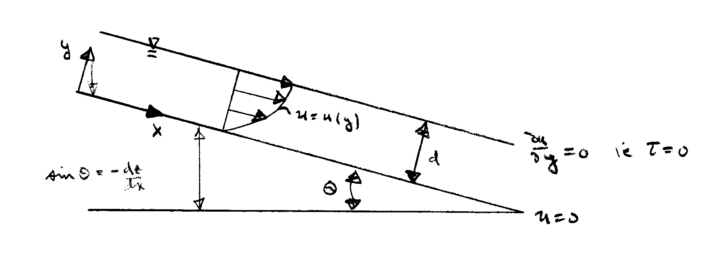
uniform flow ⇒ velocity and depth do not
change in x-direction

Continuity $\frac{\text{du}}{\text{dx}}=0$
x-momentum $0=−\frac{∂}{∂x}\left(p+γz\right)+μ\frac{d^{2}u}{{\text{dy}}^{2}}$
y-momentum $0=−\frac{∂}{∂y}\left(p+γz\right)⇒$hydrostatic pressure variation
$⇒\frac{\text{dp}}{\text{dx}}=0$

$μ\frac{d^{2}u}{{\text{dy}}^{2}}=−γ\text{sin}θ$

$\frac{\text{du}}{\text{dy}}=−\frac{γ}{μ}\text{sin}θy+c$

$u=−\frac{γ}{μ}\text{sin}θ\frac{y^{2}}{2}+\text{Cy}+D$

$$\frac{\text{du}}{\text{dy}}|_{y=d}=0=−\frac{γ}{μ}\text{sin}θd+c⇒c\text{=+}\frac{γ}{μ}\text{sin}θd$$

u(0) = 0 ⇒ D = 0

$u=−\frac{γ}{μ}\text{sin}θ\frac{y^{2}}{2}+\frac{γ}{μ}\text{sin}θ \text{dy}$

=$\frac{γ}{2μ}\text{sin}θ y\left(2d−y\right)$

u(y) =$\frac{g\text{sin}θ}{2ν}y\left(2d−y\right)$

$q=\int_{0}^{d}{\text{udy}}=\frac{γ}{2μ}\text{sin}θ{\left[{\text{dy}}^{2}−\frac{y^{3}}{3}\right]}_{0}^{d}$
discharge per unit width

= $\frac{1}{3}\frac{γ}{μ}d^{3}\text{sin}θ$

$${\overline{V}}_{\text{avg}}=\frac{q}{d}=\frac{1}{3}\frac{γ}{μ}d^{2}\text{sin}θ=\frac{{\text{gd}}^{2}}{3ν}\text{sin}θ$$

in terms of the slope S_{o} = tan θ ∼ sin θ

$\overline{V}=\frac{{\text{gd}}^{2}S_{o}}{3ν}$

Exp. show Re_{crit} ∼ 500, i.e., for Re > 500 the flow will become turbulent

$\frac{∂p}{∂y}=−γ\text{cos}θ$ ${\text{Re}}_{\text{crit}}=\frac{\overline{V}d}{ν}$ ∼ 500

$p=−γ\text{cos}θ y+C$

$p\left(d\right)=p_{o}=−γ\text{cos}θ d+C$

i.e., $p=γ\text{cos}θ \left(d−y\right)+p_{o}$

* p(d) > p_{o}

* if θ = 0 p = γ(d − y) + p_{o}
entire weight of fluid imposed

if θ = π/2 p = p_{o}
no pressure change through the fluid

9.3 Qualitative Description of the Boundary Layer

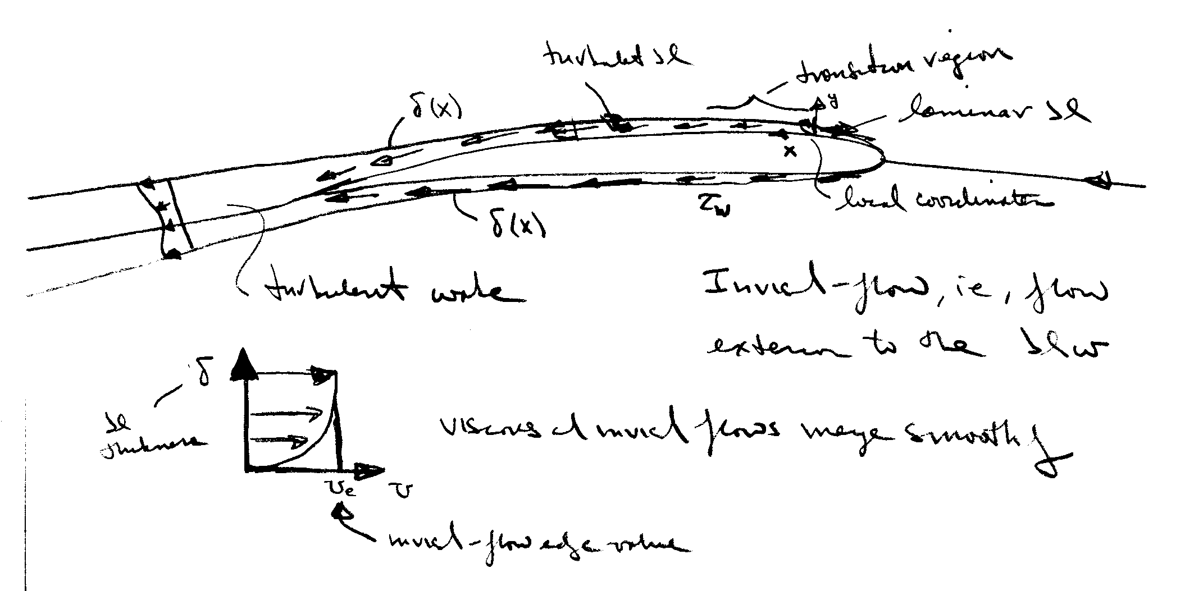
Recall our previous description of the flow-field regions for high Re flow about slender bodies

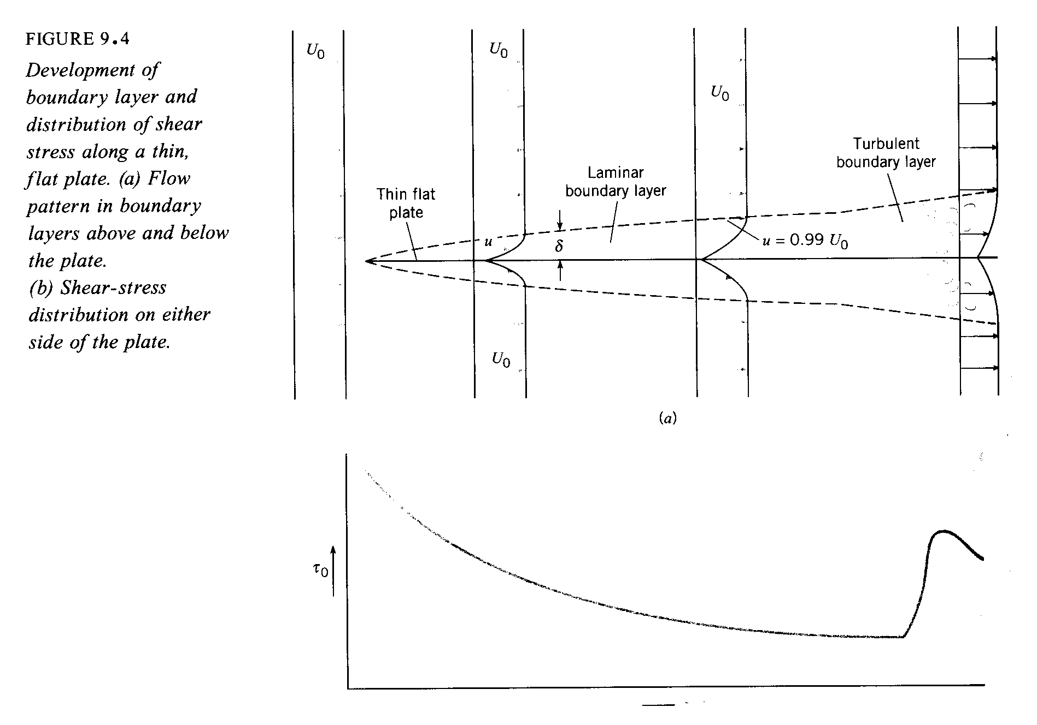

τ_{w} = shear stress

τ_{w} ∝ rate of strain (velocity gradient)

=$μ\frac{∂u}{∂y}|_{y=0}$

large near the surface where
fluid undergoes large changes to satisfy the no-slip condition

Boundary layer theory is a simplified form of the complete NS equations and provides τ_{w} as well as a means of estimating C_{form}. Formally, boundary-layer theory represents the asymptotic form of the Navier-Stokes equations for high Re flow about slender bodies. As mentioned before, the NS equations are 2nd order nonlinear PDE and their solutions represent a formidable challenge. Thus, simplified forms have proven to be very useful.

Near the turn of the century (1904), Prandtl put forth boundary-layer theory, which resolved D’Alembert’s paradox. As mentioned previously, boundary-layer theory represents the asymptotic form of the NS equations for high Re flow about slender bodies. The latter requirement is necessary since the theory is restricted to unseparated flow. In fact, the boundary-layer equations are singular at separation, and thus, provide no information at or beyond separation. However, the requirements of the theory are met in many practical situations and the theory has many times over proven to be invaluable to modern engineering.

The assumptions of the theory are as follows:

Variable order of magnitude
u U O(1)
v δ<<L O(ε) ε = δ/L
$\frac{∂}{∂x}$ L O(1)
$\frac{∂}{∂y}$ 1/δ O(ε⁻¹)
ν δ² ε²
The theory assumes that viscous effects are confined to a thin layer close to the surface within which there is a dominant flow direction (x) such that u ∼ U and v << u. However, gradients across δ are very large in order to satisfy the no slip condition.

Next, we apply the above order of magnitude estimates to the NS equations.
$u\frac{∂u}{∂x}+v\frac{∂u}{∂y}=−\frac{∂p}{∂x}+μ\left(\frac{∂^{2}u}{∂x^{2}}+\frac{∂^{2}u}{∂y^{2}}\right)$
1 1 ε ε⁻¹ ε² 1 ε⁻²

$u\frac{∂v}{∂x}+v\frac{∂v}{∂y}=−\frac{∂p}{∂y}+μ\left(\frac{∂^{2}v}{∂x^{2}}+\frac{∂^{2}v}{∂x^{2}}\right)$
elliptic
1 ε ε 1 ε² 1 ε⁻¹

$\frac{∂u}{∂x}+\frac{∂v}{∂y}=0$
- 1

Retaining terms of O(1) only results in the celebrated boundary-layer equations
$u\frac{∂u}{∂x}+v\frac{∂u}{∂y}=−\frac{∂p}{∂x}+μ\frac{∂^{2}u}{∂y^{2}}$
parabolic
$\frac{∂p}{∂y}=0$
$$\frac{∂u}{∂x}+\frac{∂v}{∂y}=0$$
Some important aspects of the boundary-layer equations:
- the y-momentum equation reduces to

$$\frac{∂p}{∂y}=0$$

i.e., p = p_{e} = constant across the boundary layer
edge value, i.e., inviscid flow value!
from the Bernoulli equation:
$p_{e}+\frac{1}{2}{ρU}_{e}^{2}=$constant
i.e., $\frac{∂p_{e}}{∂x}=−{ρU}_{e}\frac{∂U_{e}}{∂x}$

Thus, the boundary-layer equations are solved subject to a specified inviscid pressure distribution

- continuity equation is unaffected

- Although NS equations are fully elliptic, the boundary-layer equations are parabolic and can be solved using marching techniques

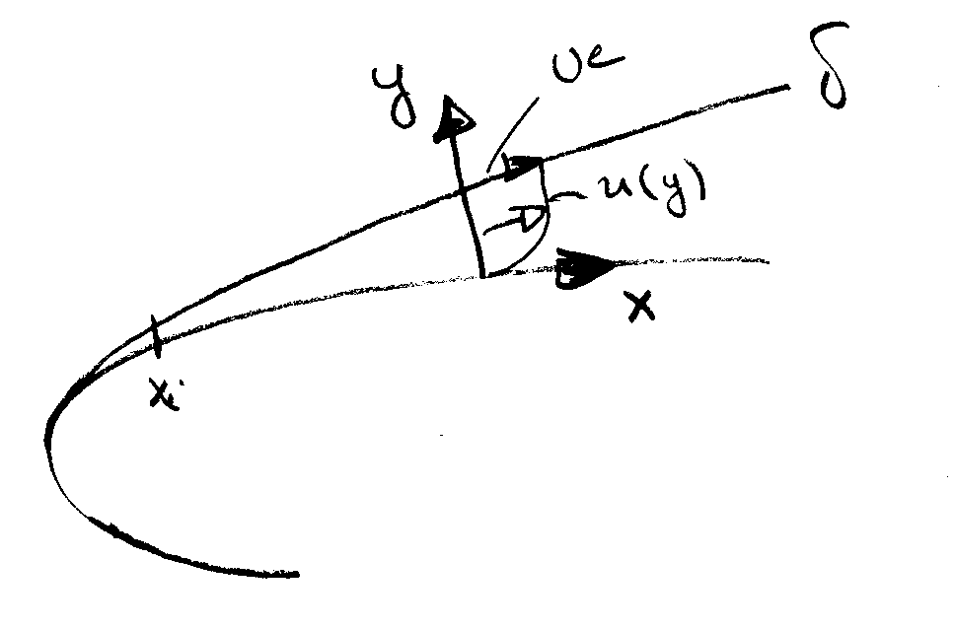
- Boundary conditions

u = v = 0 y = 0

u = U_{e} y = δ

+ appropriate initial conditions @ x_{i}
There are quite a few analytic solutions to the boundary-layer equations. Also numerical techniques are available for arbitrary geometries, including both two- and three-dimensional flows. Here, as an example, we consider the simple, but extremely important case of the boundary layer development over a flat plate.

9.4 Quantitative Relations for the Laminar Boundary Layer

Laminar boundary-layer over a flat plate: Blasius solution (1908) student of Prandtl
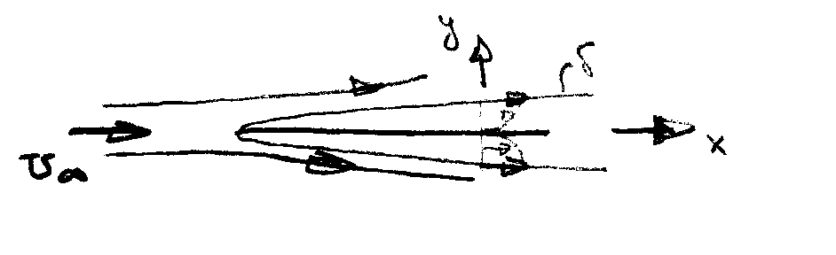
$\frac{∂u}{∂x}+\frac{∂v}{∂y}=0$
Note: $\frac{∂p}{∂x}$ = 0 for a flat plate
$u\frac{∂u}{∂x}+v\frac{∂u}{∂y}=ν\frac{∂^{2}u}{∂y^{2}}$

u = v = 0 @ y = 0 u = U∞ @ y = δ

We now introduce a dimensionless transverse coordinate and a stream function, i.e.,

$η=y\sqrt{\frac{U_{∞}}{νx}}∝\frac{y}{δ}$

$ψ=\sqrt{ν{\text{xU}}_{∞}}f\left(η\right)$
$u=\frac{∂ψ}{∂y}=\frac{∂ψ}{∂η}\frac{∂η}{∂y}=U_{∞}f^{'}\left(η\right)$ $f^{'}=u/{U_{∞}}$

$v=−\frac{∂ψ}{∂x}=\frac{1}{2}\sqrt{\frac{{νU}_{∞}}{x}}\left(ηf^{'}−f\right)$

substitution into the boundary-layer equations yields

$ff^{''}+2f^{'''}=0$ Blasius Equation

$f=f^{'}=0$ @ η = 0 $f^{'}=1$ @ η = 1

The Blasius equation is a 3rd order ODE which can be solved by standard methods (Runge-Kutta). Also, series solutions are possible. Interestingly, although simple in appearance no analytic solution has yet been found. Finally, it should be recognized that the Blasius solution is a similarity solution, i.e., the non-dimensional velocity profile f′ vs. η is independent of x. That is, by suitably scaling all the velocity profiles have neatly collapsed onto a single curve.

Now, lets consider the characteristics of the Blasius solution:
$\frac{u}{U_{∞}}$ vs. y

$\frac{v}{U_{∞}}\sqrt{\frac{U_{∞}}{V}}$ vs. y
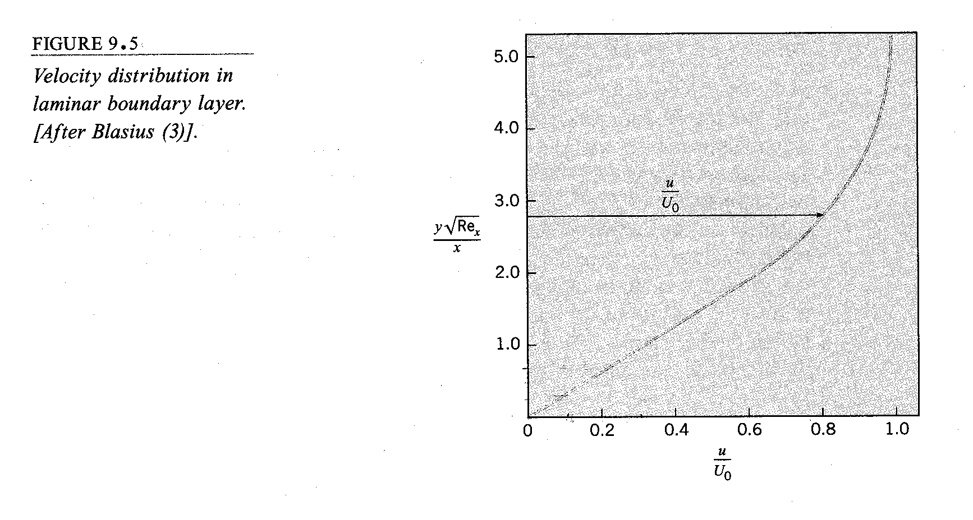
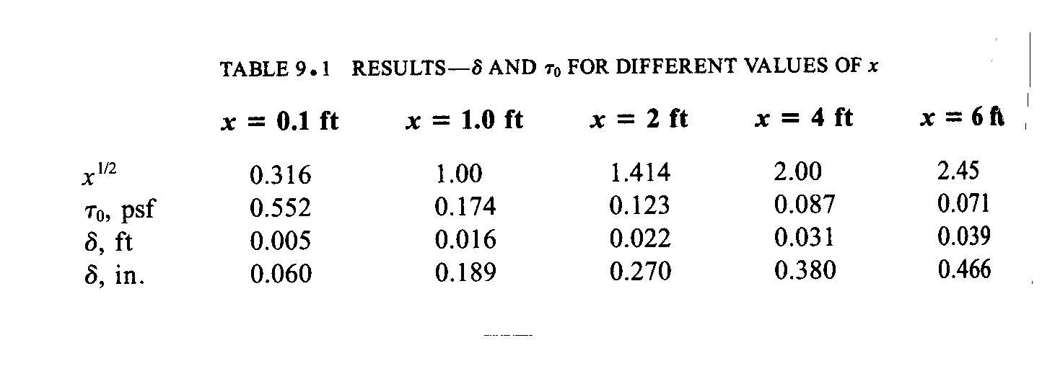

$δ=\frac{5x}{\sqrt{\text{Re}}}$ value of y where u/U∞ = .99

$${\text{Re}}_{x}=\frac{U_{∞}x}{ν}$$

$τ_{w}=\frac{{μU}_{∞}f^{''}(0)}{\sqrt{2{νx}/{U_{∞}}}}$

i.e., $c_{f}=\frac{2τ_{w}}{{ρU}_{∞}^{2}}=\frac{0\text{.}\text{664}}{\sqrt{{\text{Re}}_{x}}}=\frac{θ}{x}$ see below

$C_{f}=\frac{1}{L}\int_{0}^{L}{c_{f}\text{dx}=2c_{f}(L)}$
=$\frac{1\text{.}\text{328}}{\sqrt{{\text{Re}}_{L}}}$

$\frac{U_{∞}L}{ν}$
Other:
$δ^{}=\int_{0}^{δ}{\left(1−\frac{u}{U_{∞}}\right)\text{dy}=1\text{.}\text{7208}\frac{x}{\sqrt{{\text{Re}}_{x}}}}$ displacement thickness

measure of displacement of inviscid flow to due boundary layer

$θ=\int_{0}^{δ}{\left(1−\frac{u}{U_{∞}}\right)\frac{u}{U_{∞}}\text{dy}=0\text{.}\text{664}\frac{x}{\sqrt{{\text{Re}}_{x}}}}$ momentum thickness

measure of loss of momentum due to boundary layer

H = shape parameter = $\frac{δ^{}}{θ}$=2.5916

