Chapter 8 Flow in Conduits

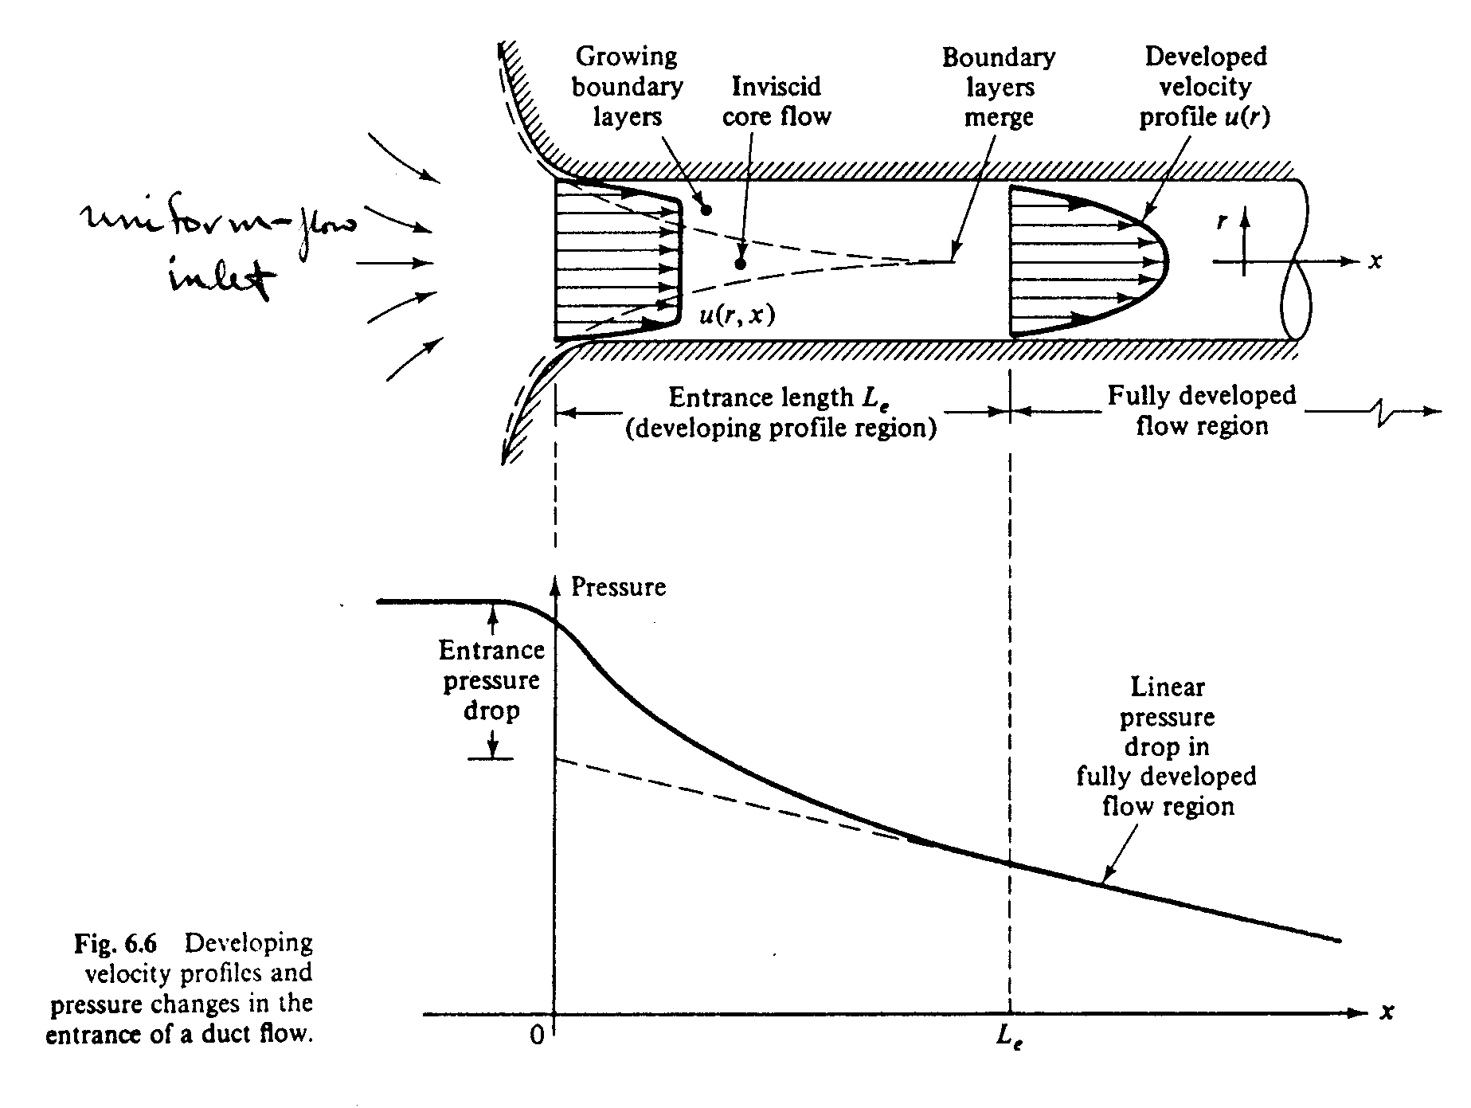
Entrance and developed flows

Le = f(D, V, ρ, μ)

Π_{i} theorem ⇒ Le/D = f(Re)

Laminar flow: Re_{crit} ∼ 2000, i.e., for Re < Re_{crit} laminar
Re > Re_{crit} turbulent

Le/D = .06Re from experiments

Le_{max} = .06Re_{crit}D ∼ 138D

maximum Le for laminar flow
Turbulent flow:

Re Le/D
4000 18
10⁴ 20
10⁵ 30
10⁶ 44
10⁷ 65
10⁸ 95
i.e., relatively shorter than for laminar flow
$\frac{\text{Le}}{D}$ ∼ $4\text{.}4{\text{Re}}^{1/6}$
from experiment

Laminar vs. Turbulent Flow
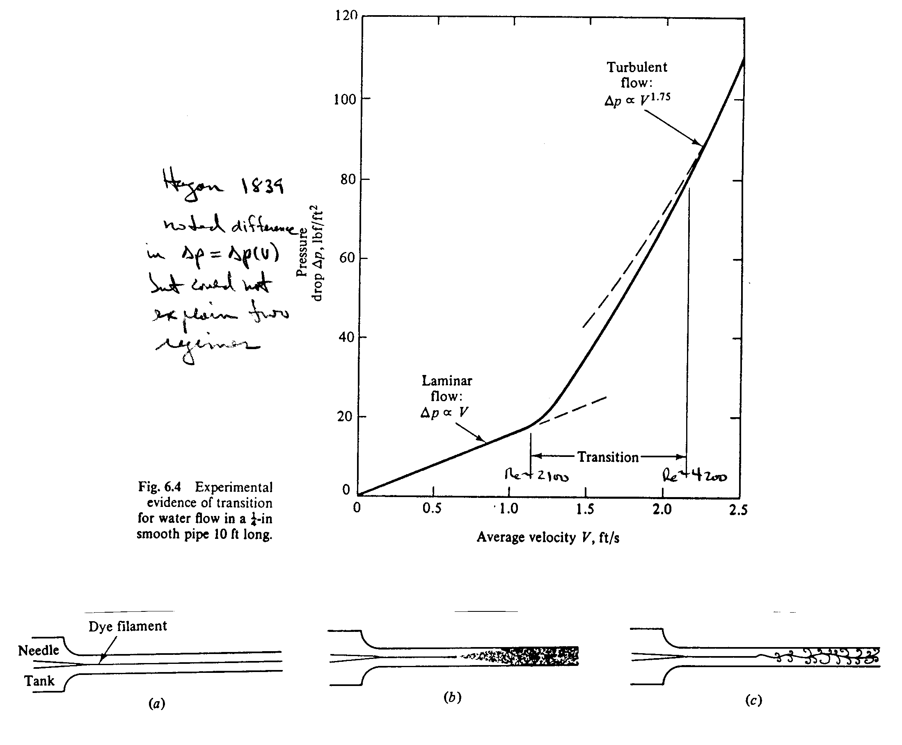

laminar turbulent spark photo

Reynolds 1883 showed difference depends on Re = $\frac{\text{VD}}{ν}$
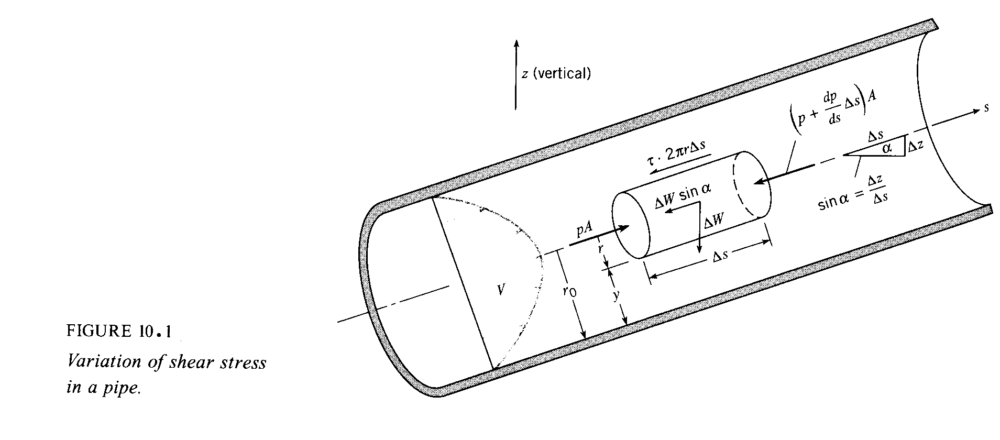
Shear-Stress Distribution Across a Pipe Section

Continuity: Q₁ = Q₂ = constant, i.e., V₁ = V₂ since A₁ = A₂

Momentum: $\sum{F_{s}=\sum{ρu\left(\underline{V}⋅\underline{A}\right)}}$
=${ρV}_{1}\left(−V_{1}A_{1}\right)−{ρV}_{2}\left(V_{2}A_{2}\right)$
=$ρQ\left(V_{2}−V_{1}\right)=0$
$$\text{pA}−\left(p+\frac{\text{dp}}{\text{ds}}\text{ds}\right)A−ΔW\text{sin}α−τ\left(2πr\right)\text{ds}=0$$
$ΔW=γ\text{Ads}$ $\text{sin}α=\frac{\text{dz}}{\text{ds}}$
$−\frac{\text{dp}}{\text{ds}}\text{dsA}−γ\text{Ads}\frac{\text{dz}}{\text{ds}}−τ\left(2πr\right)\text{ds}=0$
÷ Ads
$τ=\frac{r}{2}\left[−\frac{d}{\text{ds}}\left(p+γz\right)\right]$

τ varies linearly from 0.0 at r = 0 (centerline) to τ_{max} (= τ_{w}) at r = r₀ (wall), which is valid for laminar and turbulent flow.

Laminar Flow in Pipes

$$τ=μ\frac{\text{dV}}{\text{dy}}=−μ\frac{\text{dV}}{\text{dr}}=\frac{r}{2}\left[−\frac{d}{\text{ds}}\left(p+γz\right)\right]$$

y = wall coordinate = r_{o} − r ⇒ $\frac{\text{dV}}{\text{dr}}=\frac{\text{dV}}{\text{dy}}\frac{\text{dy}}{\text{dr}}=−\frac{\text{dV}}{\text{dy}}$
$$\frac{\text{dV}}{\text{dr}}=−\frac{r}{2μ}\left[−\frac{d}{\text{ds}}\left(p+γz\right)\right]$$

$$V=−\frac{r^{2}}{4μ}\left[−\frac{d}{\text{ds}}\left(p+γz\right)\right]+C$$

$$V\left(r_{o}\right)=0⇒C=\frac{r_{o}^{2}}{4μ}\left[−\frac{d}{\text{ds}}\left(p+γz\right)\right]$$
no slip condition
Exact solution to Navier-Stokes equations for laminar flow in circular pipe
where

$$Q=\int{\underline{V}⋅d\underline{A}}$$
=$\int_{0}^{r_{o}}{V\left(r\right)2π\text{rdr}}$

$$\text{dA}=\text{rdrd}θ=\text{rdr}\left(2π\right)$$

$Q=\frac{{πr}_{o}^{4}}{8μ}\left[−\frac{d}{\text{ds}}\left(p+γz\right)\right]$

For a horizontal pipe,
where L = length of pipe = ds

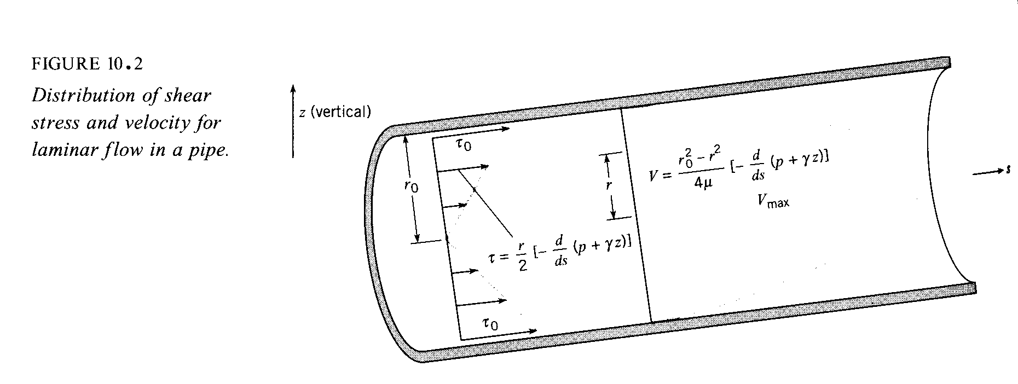

Energy equation:

$\frac{p_{1}}{γ}+\frac{V_{1}^{2}}{2g}+z_{1}=\frac{p_{2}}{γ}+\frac{V_{2}^{2}}{2g}+z_{2}+h_{L}$

Define friction factor $f=\frac{8τ_{w}}{ρ{\overline{V}}^{2}}$ $C_{f}=\frac{τ_{w}}{\frac{1}{2}{ρV}^{2}}$
friction coefficient for pipe flow
boundary layer flow

Darcy – Weisbach Equation, which is valid for both laminar and turbulent flow.

Friction factor definition based on turbulent flow analysis where thus n=6, m=3 and r=3 such that Π_{i=1,2,3} = $f=\frac{8τ_{w}}{ρ{\overline{V}}^{2}}$, , k/D; or f=f(Re, k/D) where k=roughness height. For turbulent flow f determined from turbulence modeling since exact solutions not known, as will be discussed next.

For laminar flow f not affected k and f(Re) determined from exact analytic solution to Navier-Stokes equations.

Exact solution:

For laminar flowthus n=4, m=3 and r=1 such that =constant. The constant depends on duct shape (circular, rectangular, etc.) and is referred to as Poiseuille number=P_{o}. P_{o}=4 for circular duct.

$$f=\frac{\text{32}μ}{{ρr}_{o}\overline{V}}=\frac{\text{64}μ}{ρ\overline{V}D}=\frac{\text{64}}{\text{Re}}$$
or $h_{f}=h_{L}=\frac{\text{32}μL\overline{V}}{{γD}^{2}}$ h_{f} = head loss due to friction

for Δz=0: as per Hagen!
Stability and Transition
Stability: can a physical state withstand a disturbance and still return to its original state.

In fluid mechanics, there are two problems of particular interest: change in flow conditions resulting in (1) transition from one to another laminar flow; and (2) transition from laminar to turbulent flow.

(1) Example of transition from one to another laminar flow: Centrifugal instability for Couette flow between two rotating cylinders when centrifugal force > viscous force , which is predicted by small-disturbance/linear stability theory.

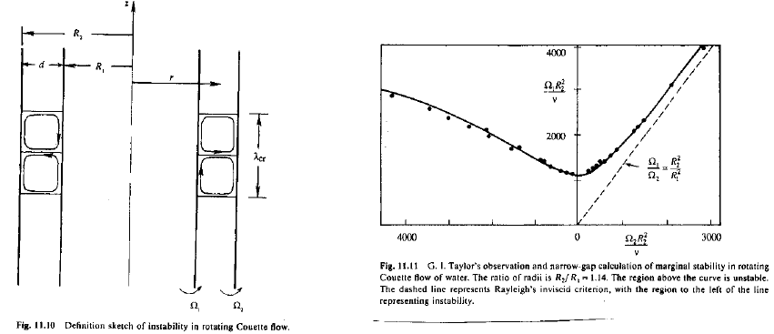

(2) Transition from laminar to turbulent flow

Not all laminar flows have different equilibrium states, but all laminar flows for sufficiently large Re become unstable and undergo transition to turbulence.

Transition: change over space and time and Re range of laminar flow into a turbulent flow.

${\text{Re}}_{\text{cr}}=\frac{Uδ}{υ}$ ~ 1000, δ = transverse viscous thickness
Re_{trans} > Re_{cr} with x_{trans} ~ 10-20 x_{cr}

Small-disturbance/linear stability theory also predicts Re_{cr} with some success for parallel viscous flow such as plane Couette flow, plane or pipe Poiseuille flow, boundary layers without or with pressure gradient, and free shear flows (jets, wakes, and mixing layers).

No theory for transition, but recent Direct Numerical Simualtions is helpful.

In general: Re_{trans}=Re_{trans}(geometry, Re, pressure gradient/velocity profile shape, free stream turbulence, roughness, etc.)

Criterion for Laminar or Turbulent Flow in a Pipe

Re_{crit} ∼ 2000 flow becomes unstable
Re_{trans} ∼ 3000 flow becomes turbulent
Re = $\overline{V}$D/ν

Turbulent Flow in Pipes

Continuity and momentum:
Energy: $h_{f}=\frac{L}{γ}\left[−\frac{d}{\text{ds}}\left(p+γz\right)\right]$
Combining: define = friction factor

$h_{f}=\frac{L}{ρg}⋅\frac{2}{r_{o}}⋅\frac{1}{8}ρ{\overline{V}}^{2}f$

$h_{f}=f⋅\frac{L}{D}⋅\frac{{\overline{V}}^{2}}{2g}$ Darcy – Weisbach Equation

f = f(Re, k/D) = still must be determined!

$\text{Re}=\frac{\overline{V}D}{ν}$ k = roughness

Description of Turbulent Flow

Most flows in engineering are turbulent: flows over vehicles (airplane, ship, train, car), internal flows (heating and ventilation, turbo-machinery), and geophysical flows (atmosphere, ocean).

V (x, t) and p(x, t) are random functions of space and time, but statistically stationary flaws such as steady and forced or dominant frequency unsteady flows display coherent features and are amendable to statistical analysis, i.e. time and space (conditional) averaging. RMS and other low-order statistical quantities can be modeled and used in conjunction with averaged equations for solving practical engineering problems.

Turbulent motions range in size from the width in the flow δ to much smaller scales, which come progressively smaller as the Re = Uδ/υ increases.
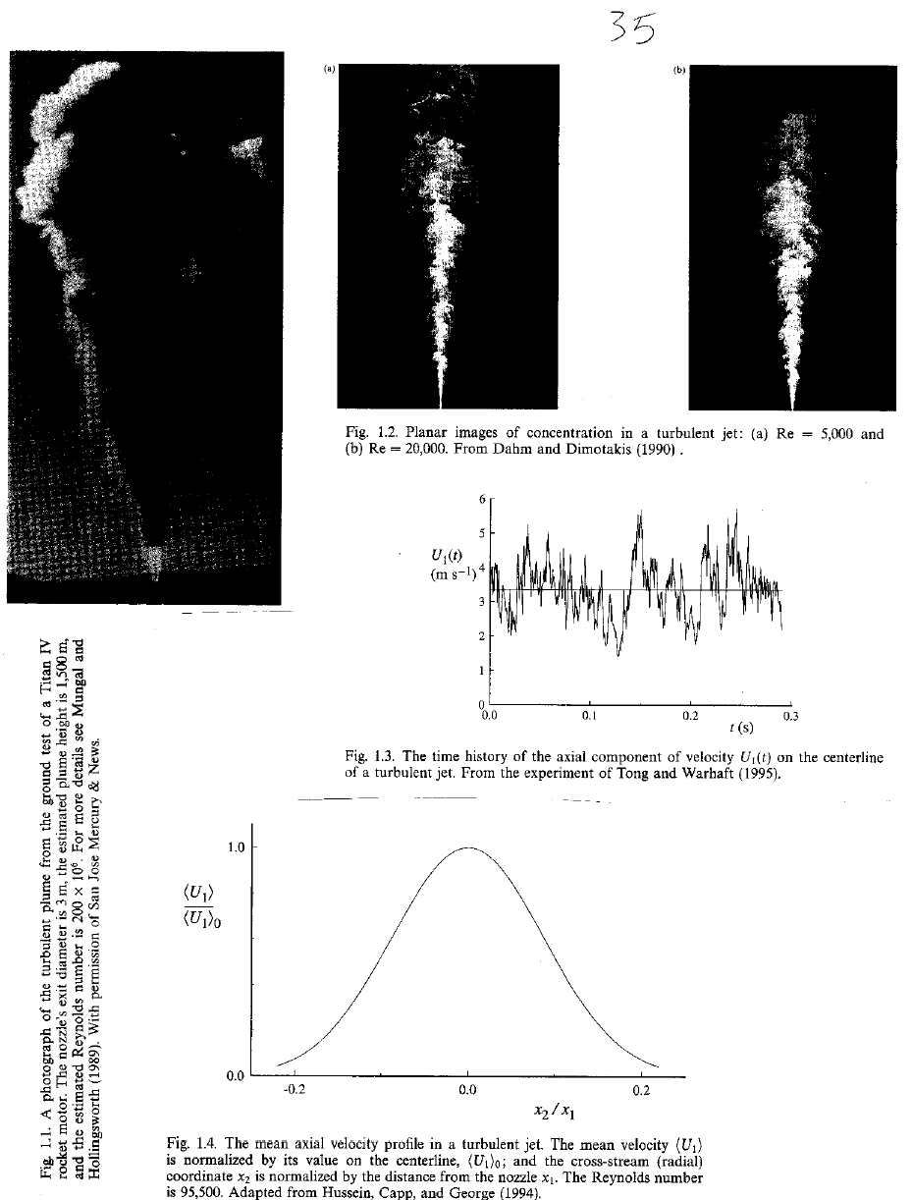
Physical description:

(1) Randomness and fluctuations:
Turbulence is irregular, chaotic, and unpredictable. However, for statistically stationary flows, such as steady flows, can be analyzed using Reynolds decomposition.

$u=\overline{u}+u'$ $\overline{u}=\frac{1}{T}\int_{t_{0}}^{t_{0}+T}{u \text{dT}}$ $\overline{u}'=0$ $\overline{u}'^{2}=\frac{1}{T}\int_{t_{0}}^{t_{0}+T}{u'^{2 }}\text{dT}$ etc.

$\overline{u}$ = mean motion
$u'$= superimposed random fluctuation
$\overline{u}'^{2}$= Reynolds stresses; RMS = $\sqrt{\overline{u}'^{2}}$

Triple decomposition is used for forced or dominant frequency flows

$$u=\overline{u}+u\text{''}+u'$$

Where $u\text{''}$ = organized component

(2) Nonlinearity
Reynolds stresses and 3D vortex stretching are direct result of nonlinear nature of turbulence. In fact, Reynolds stresses arise from nonlinear convection term after substitution of Reynolds decomposition into NS equations and time averaging.

(3) Diffusion
Large scale mixing of fluid particles greatly enhances diffusion of momentum (and heat), i.e.,

Reynolds Stresses: $−ρ\overline{u'_{i}u'_{j}}\text{>>} \overset{\text{viscous} \text{stress}}{\overbrace{τ_{\text{ij}}={\text{με}}_{\text{ij}}}}$
Isotropic eddy viscosity:

(4) Vorticity/eddies/energy cascade
Turbulence is characterized by flow visualization as eddies, which vary in size from the largest L_{δ} (width of flow) to the smallest. The largest eddies have velocity scale U and time scale L_{δ}/U. The orders of magnitude of the smallest eddies (Kolmogorov scale or inner scale) are:
L_{K} = Kolmogorov micro-scale =
L_{K} = O(mm) >> L_{mean free path} = 6 x 10⁻⁸ m
Velocity scale = (νε)^{1/4}= O(10⁻²m/s)
Time scale = (ν/ε)^{1/2}= O(10⁻²s)

Largest eddies contain most of energy, which break up into successively smaller eddies with energy transfer to yet smaller eddies until L_{K} is reached and energy is dissipated at rate ε by molecular viscosity.

Richardson (1922):
L_{δ} Big whorls have little whorls
Which feed on their velocity;
And little whorls have lesser whorls,
L_{K} And so on to viscosity (in the molecular sense).

(5) Dissipation
$$\begin{aligned}ℓ_{0}=L_{δ} \\ u_{0}=\sqrt{k} k=\overline{u'^{2}}+\overline{v'^{2}}+\overline{w'^{2}} \\ =0 (U) \\ {\text{Re}}_{δ}=u_{0}{ℓ_{0}}/υ=\text{big}\end{aligned}$$
Energy comes from largest scales and fed by mean motion

ε = rate of dissipation = energy/time
Dissipation occurs at smallest scales
$=u_{0}^{2}τ_{o}$ $τ_{o}=ℓ_{0}u_{0}$

=$u_{0}^{3}l_{0}$ independent υ $L_{K}={\left[\frac{υ^{3}}{ε}\right]}^{\frac{1}{4}}$
The mathematical complexity of turbulence entirely precludes any exact analysis. A statistical theory is well developed; however, it is both beyond the scope of this course and not generally useful as a predictive tool. Since the time of Reynolds (1883) turbulent flows have been analyzed by considering the mean (time averaged) motion and the influence of turbulence on it; that is, we separate the velocity and pressure fields into mean and fluctuating components.

It is generally assumed (following Reynolds) that the motion can be separated into a mean ($\overline{u}$, $\overline{v}$, $\overline{w}$,$p$) and superimposed turbulent fluctuating (u΄, v΄, w΄, p΄) components, where the mean values of the latter are 0.

$u=\overline{u}+u^{'}$ $p=\overline{p}+p^{'}$
$v=\overline{v}+v^{'}$ and for compressible flow
$w=\overline{w}+w^{'}$ $ρ=\overline{ρ}+ρ^{'} \text{and} T=\overline{T}+T^{'}$

where (for example)
and t₁sufficiently large that the average is independent of time
$\overline{u}=\frac{1}{t_{1}}\int_{t_{0}}^{t_{0}+t_{1}}{\text{udt}}$

Thus by definition $\overline{u^{'}}=0$, etc. Also, note the following rules which apply to two dependent variables f and g

$\overline{\overline{f}}=\overline{f}$ $\overline{f+g}=\overline{f}+\overline{g}$

$\overline{\overline{f}⋅g}=\overline{f}⋅\overline{g}$

$\overline{\frac{∂f}{∂s}}=\frac{∂\overline{f}}{∂s}$ $\overline{\int{\text{fds}}}=\int{\overline{f}\text{ds}}$
f = (u, v, w, p)
s = (x, y, z, t)

The most important influence of turbulence on the mean motion is an increase in the fluid stress due to what are called the apparent stresses. Also known as Reynolds stresses:

$$τ_{\text{ij}}^{'}=−ρ\overline{u_{i}^{'}u_{j}^{'}}$$

$−ρ\overline{u^{}}$ $−ρ\overline{u^{'}v^{'}}$ $−ρ\overline{u^{'}w^{'}}$
Symmetric 2nd order tensor
= $−ρ\overline{u^{'}v^{'}}$ $−ρ\overline{v^{}}$ $−ρ\overline{v^{'}w^{'}}$
$−ρ\overline{u^{'}w^{'}}$ $−ρ\overline{v^{'}w^{'}}$ $−ρ\overline{w^{}}$

The mean-flow equations for turbulent flow are derived by substituting $\underline{V}=\underline{\overline{V}}+\underline{V^{'}}$ into the Navier-Stokes equations and averaging. The resulting equations, which are called the Reynolds-averaged Navier-Stokes (RANS) equations are:

Continuity $∇⋅\underline{V}=0 i\text{.}e\text{.} ∇⋅\underline{\overline{V}}=0 \text{and} ∇⋅\underline{V^{'}}=0$

Momentum $ρ\frac{D\overline{V}}{\text{Dt}}+ρ\frac{∂}{∂x_{j}}\left(\overline{u_{i}^{'}u_{j}^{'}}\right)=−ρg\hat{k}−∇\overline{p}+μ∇^{2}\overline{\underline{V}}$

or $ρ\frac{D\overline{V}}{\text{Dt}}=−ρg\hat{k}−∇\overline{p}+∇⋅τ_{\text{ij}}$
u₁ = u x₁ = x
u₂ = v x₂ = y
u₃ = w x₃ = z
$τ_{\text{ij}}=μ\left[\frac{∂u_{i}}{∂x_{j}}+\frac{∂u_{j}}{∂x_{i}}\right]−ρ\overline{u_{i}^{'}u_{j}^{'}}$
$τ_{\text{ij}}^{'}$

Comments:

- equations are for the mean flow
- differ from laminar equations by Reynolds stress terms =
- influence of turbulence is to transport momentum from one point to another in a similar manner as viscosity
- since $\overline{u_{i}^{'}u_{j}^{'}}$ are unknown, the problem is indeterminate: the central problem of turbulent flow analysis is closure!

4 equations and 4 + 6 = 10 unknowns

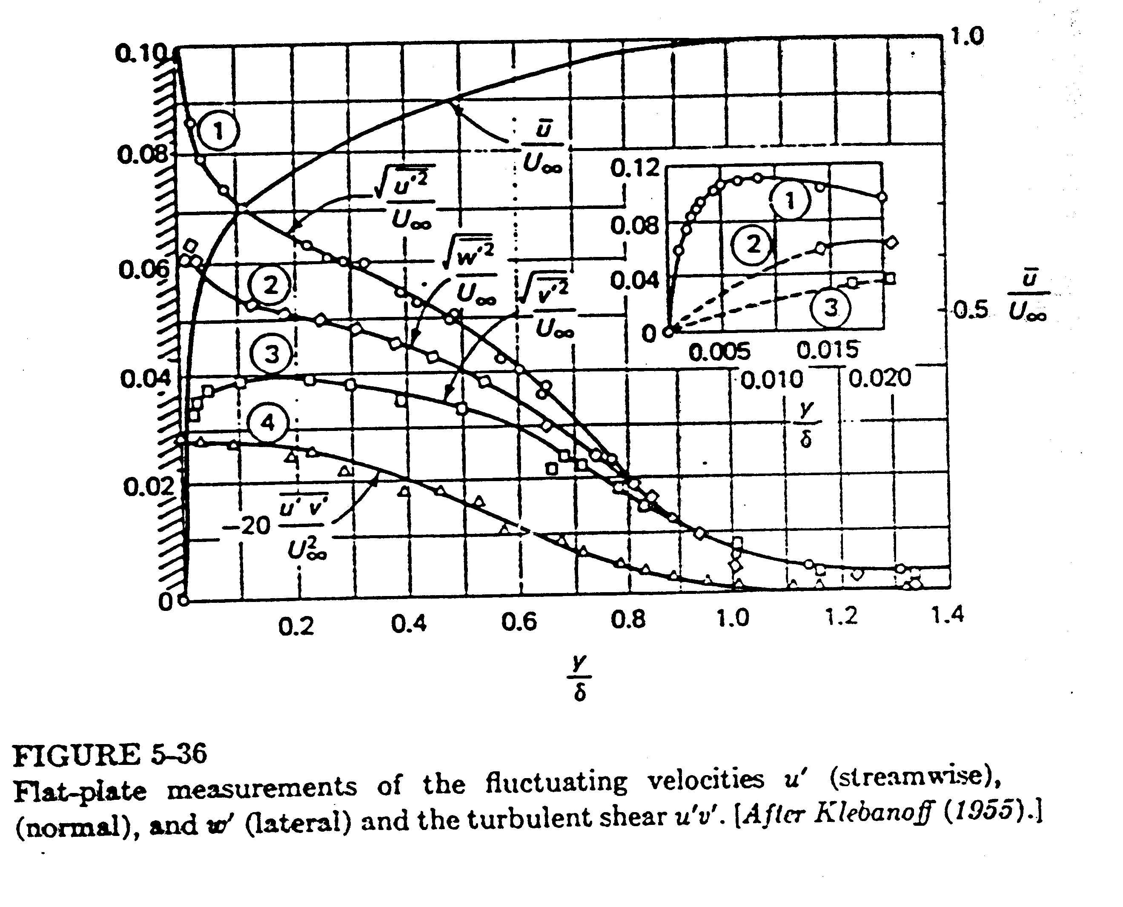
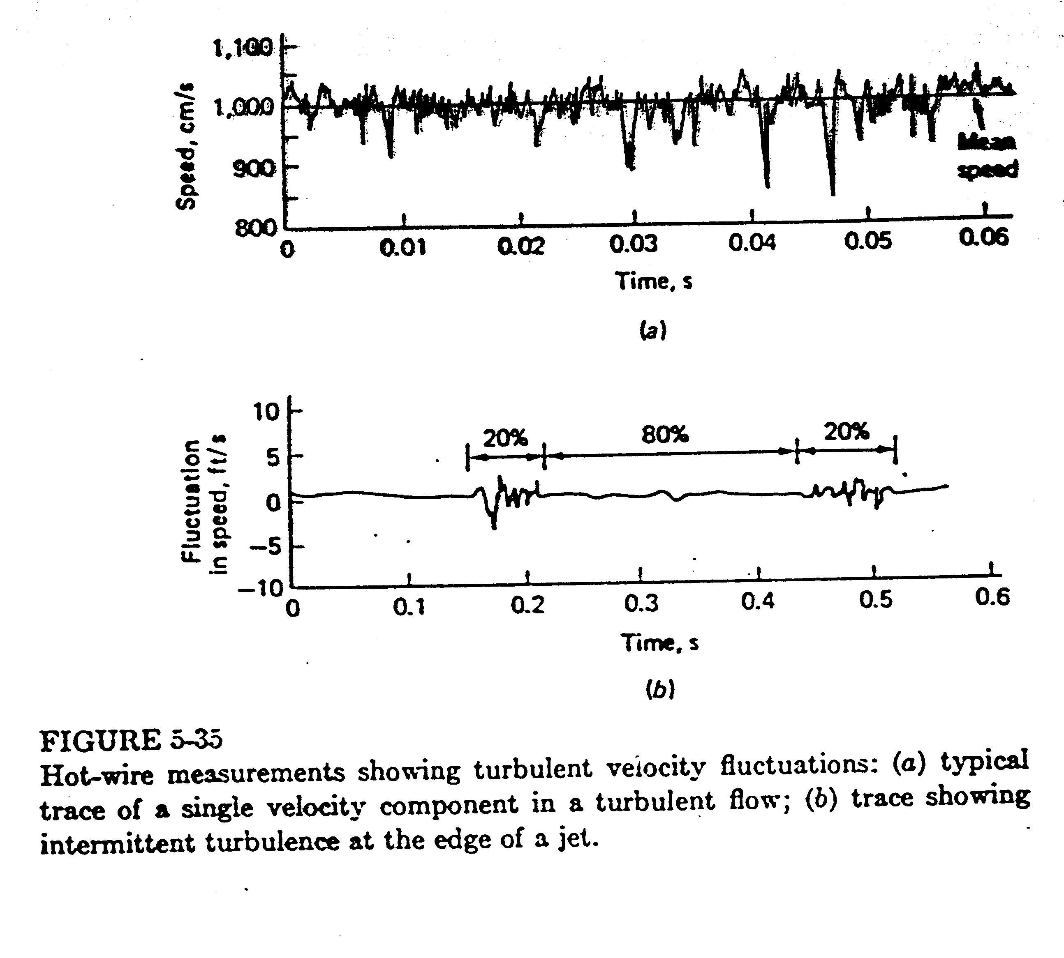

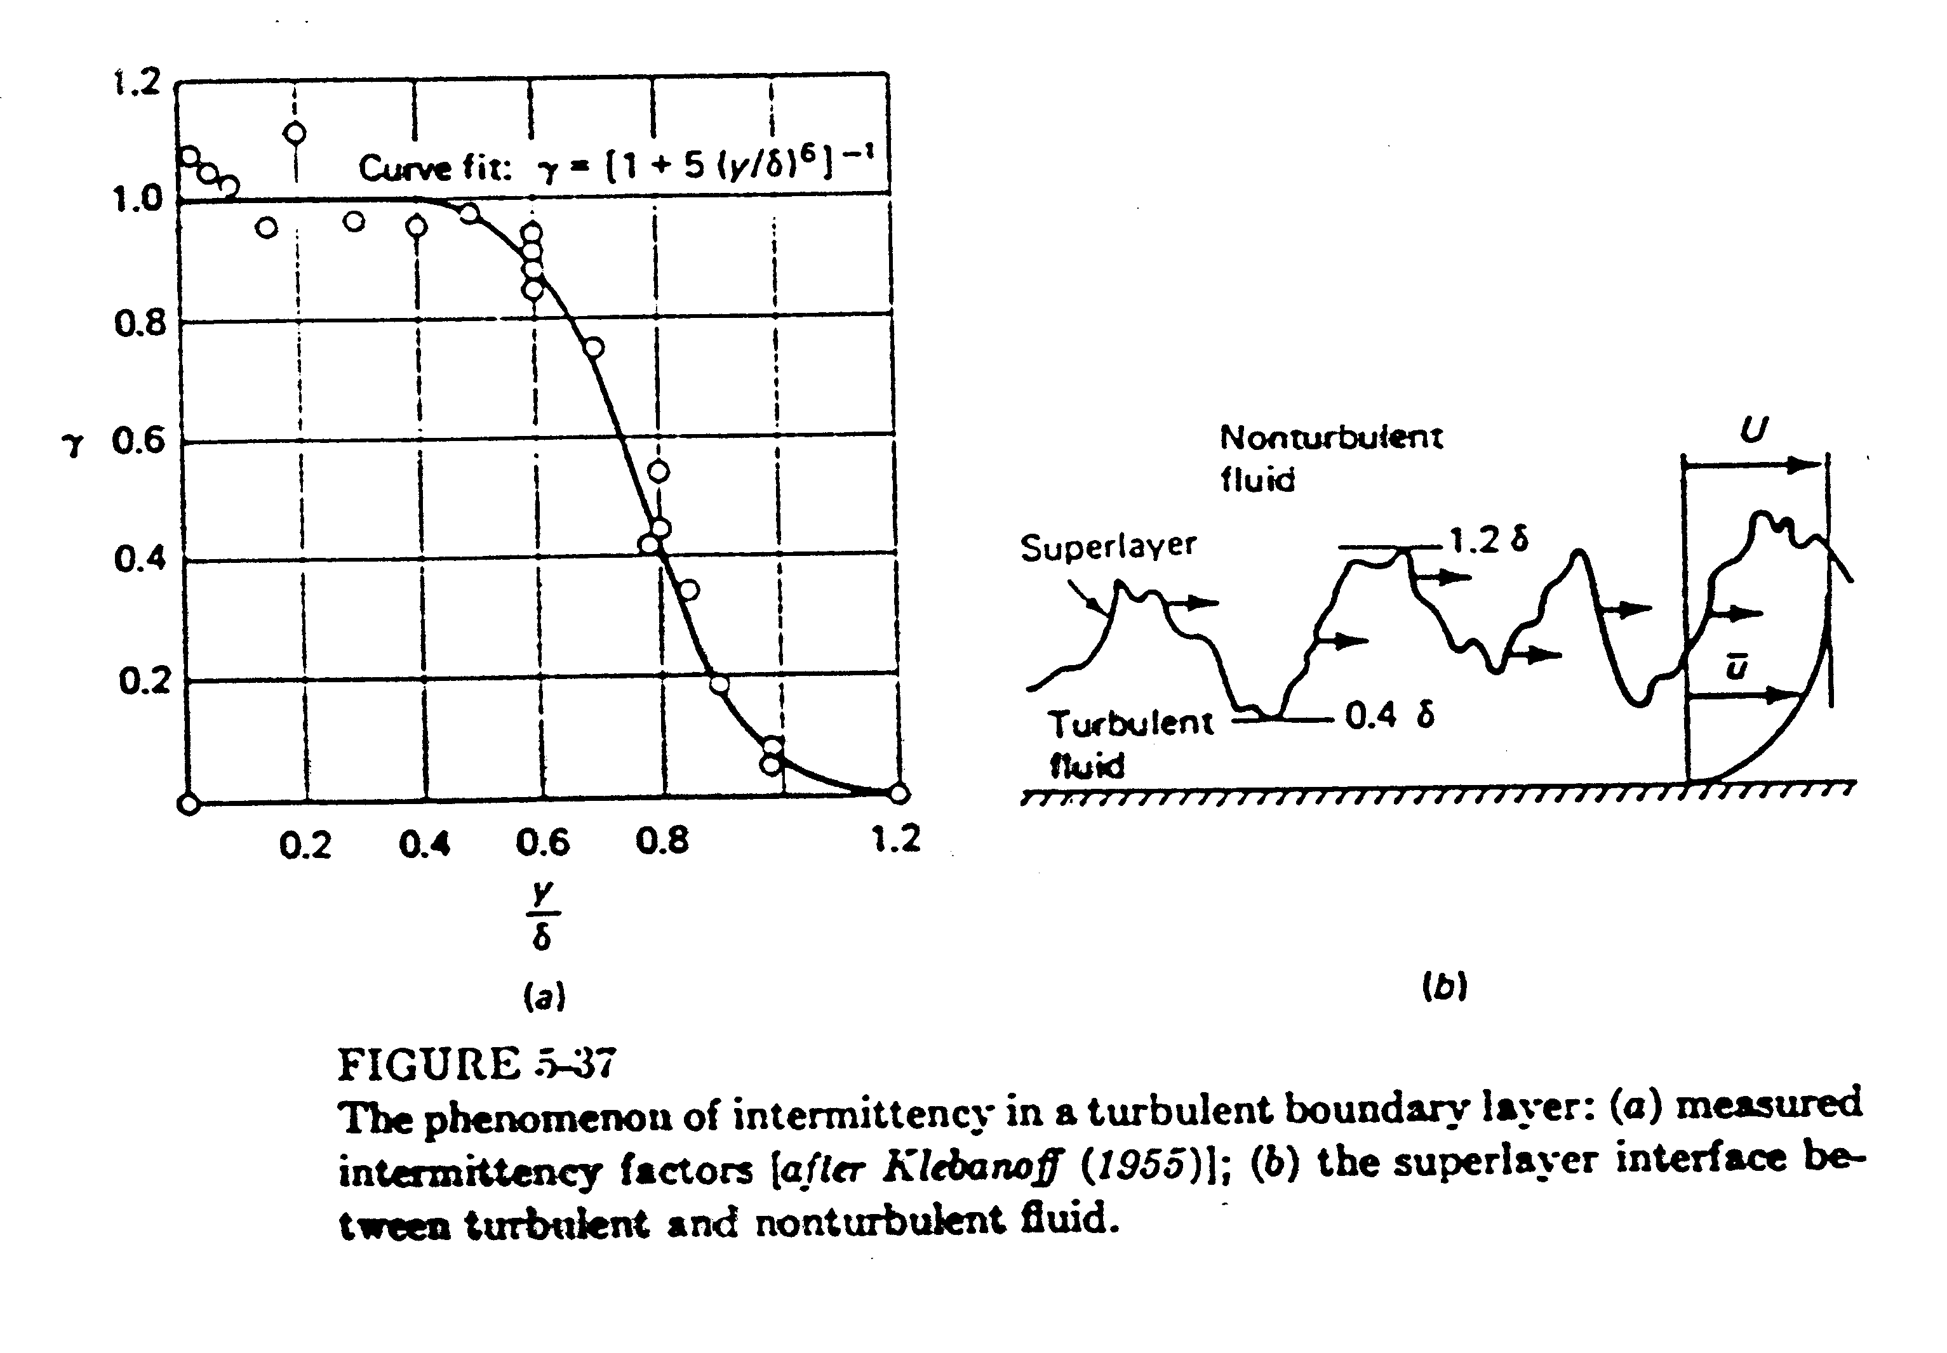

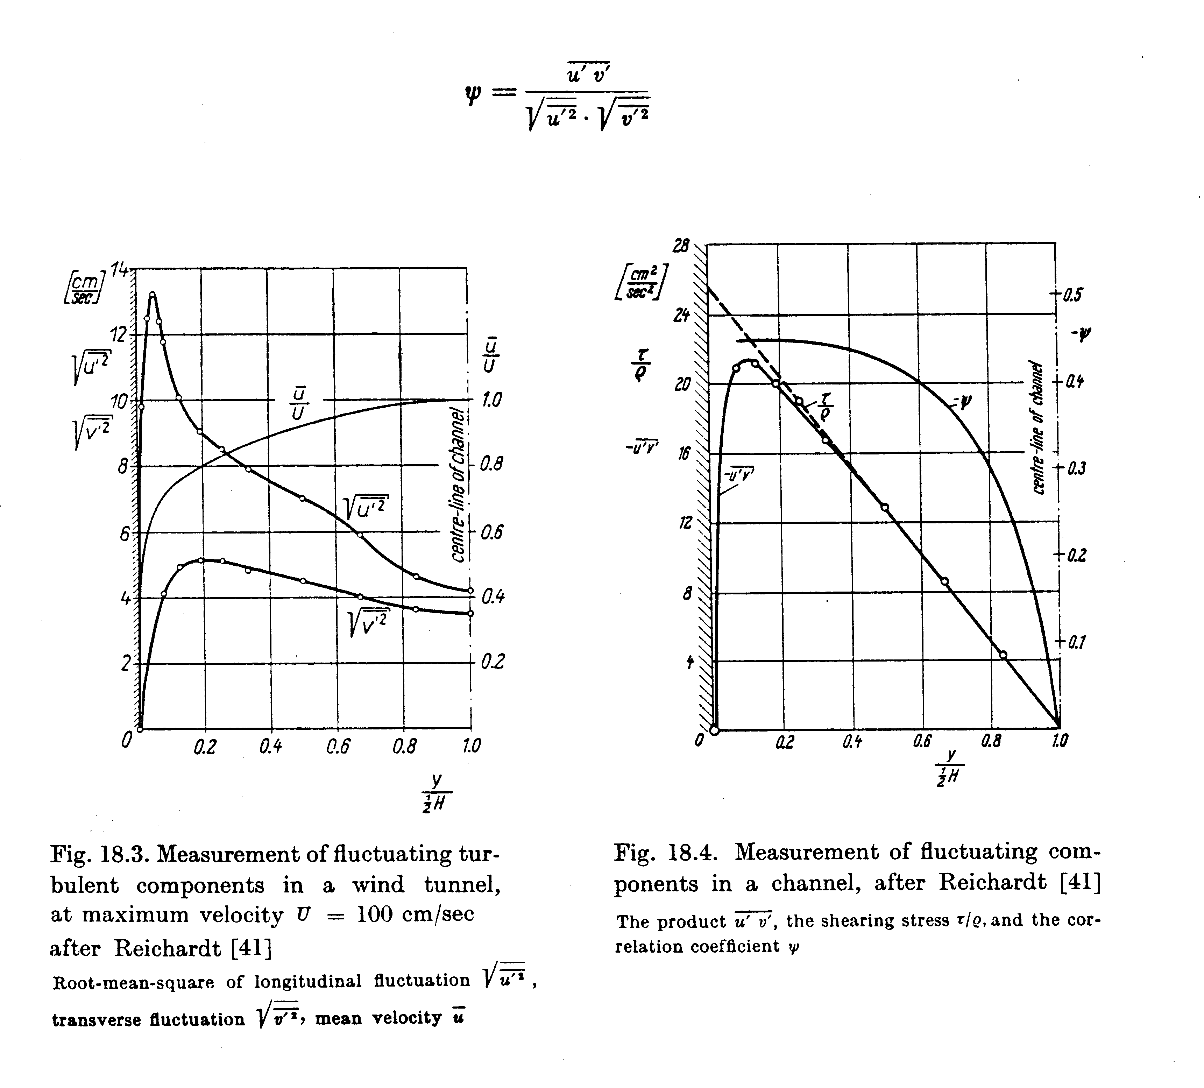

Turbulence Modeling
Closure of the turbulent RANS equations require the determination of $−ρ\overline{u^{'}v^{'}}$, etc. Historically, two approaches were developed: (a) eddy viscosity theories in which the Reynolds stresses are modeled directly as a function of local geometry and flow conditions; and (b) mean-flow velocity profile correlations, which model the mean-flow profile itself. The modern approaches, which are beyond the scope of this class, involve the solution for transport PDE’s for the Reynolds stresses, which are solved in conjunction with the momentum equations.

- eddy-viscosity: theories

$−ρ\overline{u^{'}v^{'}}=μ_{t}\frac{∂\overline{u}}{∂y}$
In analogy with the laminar viscous stress, i.e., τ_{t} ∝ mean-flow rate of strain
The problem is reduced to modeling μ_{t}, i.e.,
μ_{t} = μ_{t}(x, flow at hand)

Various levels of sophistication presently exist in modeling μ_{t}
$$μ_{t}={ρV}_{t}L_{t}$$
turbulent length scale
where V_{t} and L_{t} are based on large scale turbulent motion
turbulent velocity scale

The total stress is
$τ_{\text{total}}=\left(μ+μ_{t}\right)\frac{∂\overline{u}}{∂y}$
molecular viscosity
eddy viscosity
(for high Re flow μ_{t} >> μ)
Mixing-length theory (Prandtl, 1920)
based on kinetic theory of gases
$−ρ\overline{u^{'}v^{'}}=cρ\sqrt{{\overline{u^{'}}}^{2}}\sqrt{{\overline{v^{'}}}^{2}}$

$\sqrt{{\overline{u^{'}}}^{2}}=ℓ_{1}\frac{∂\overline{u}}{∂y}$
$ℓ_{1} \text{and} ℓ_{2}$are mixing lengths which are analogous to molecular mean free path, but much larger

$\sqrt{{\overline{v^{'}}}^{2}}=ℓ_{2}\frac{∂\overline{u}}{∂y}$

⇒
Known as a zero equation model since no additional PDE’s are solved, only an algebraic relation
distance across shear layer

$ℓ=ℓ\left(y\right)$

= f(boundary layer, jet, wake, etc.)

Although mixing-length theory has provided a very useful tool for engineering analysis, it lacks generality. Therefore, more general methods have been developed.

One and two equation models

C = constant

k = turbulent kinetic energy
=

ε = turbulent dissipation rate

Governing PDE’s are derived for k and ε which contain terms that require additional modeling. Although more general than the zero-equation models, the k-ε model also has definite limitation; therefore, relatively recent work involves the solution of PDE’s for the Reynolds stresses themselves. Difficulty is that these contain triple correlations that are very difficult to model. Most recent work involves direct and large eddy simulation of turbulence.

- mean-flow velocity profile correlations

As an alternative to modeling the Reynolds stresses one can model mean flow profile directly for wall bounded flows such as pipes/channels and boundary layers. For simple 2-D flows this approach is quite good and will be used in this course. For complex and 3-D flows generally not successful. Consider the shape of a turbulent velocity profile for wall bounded flow.

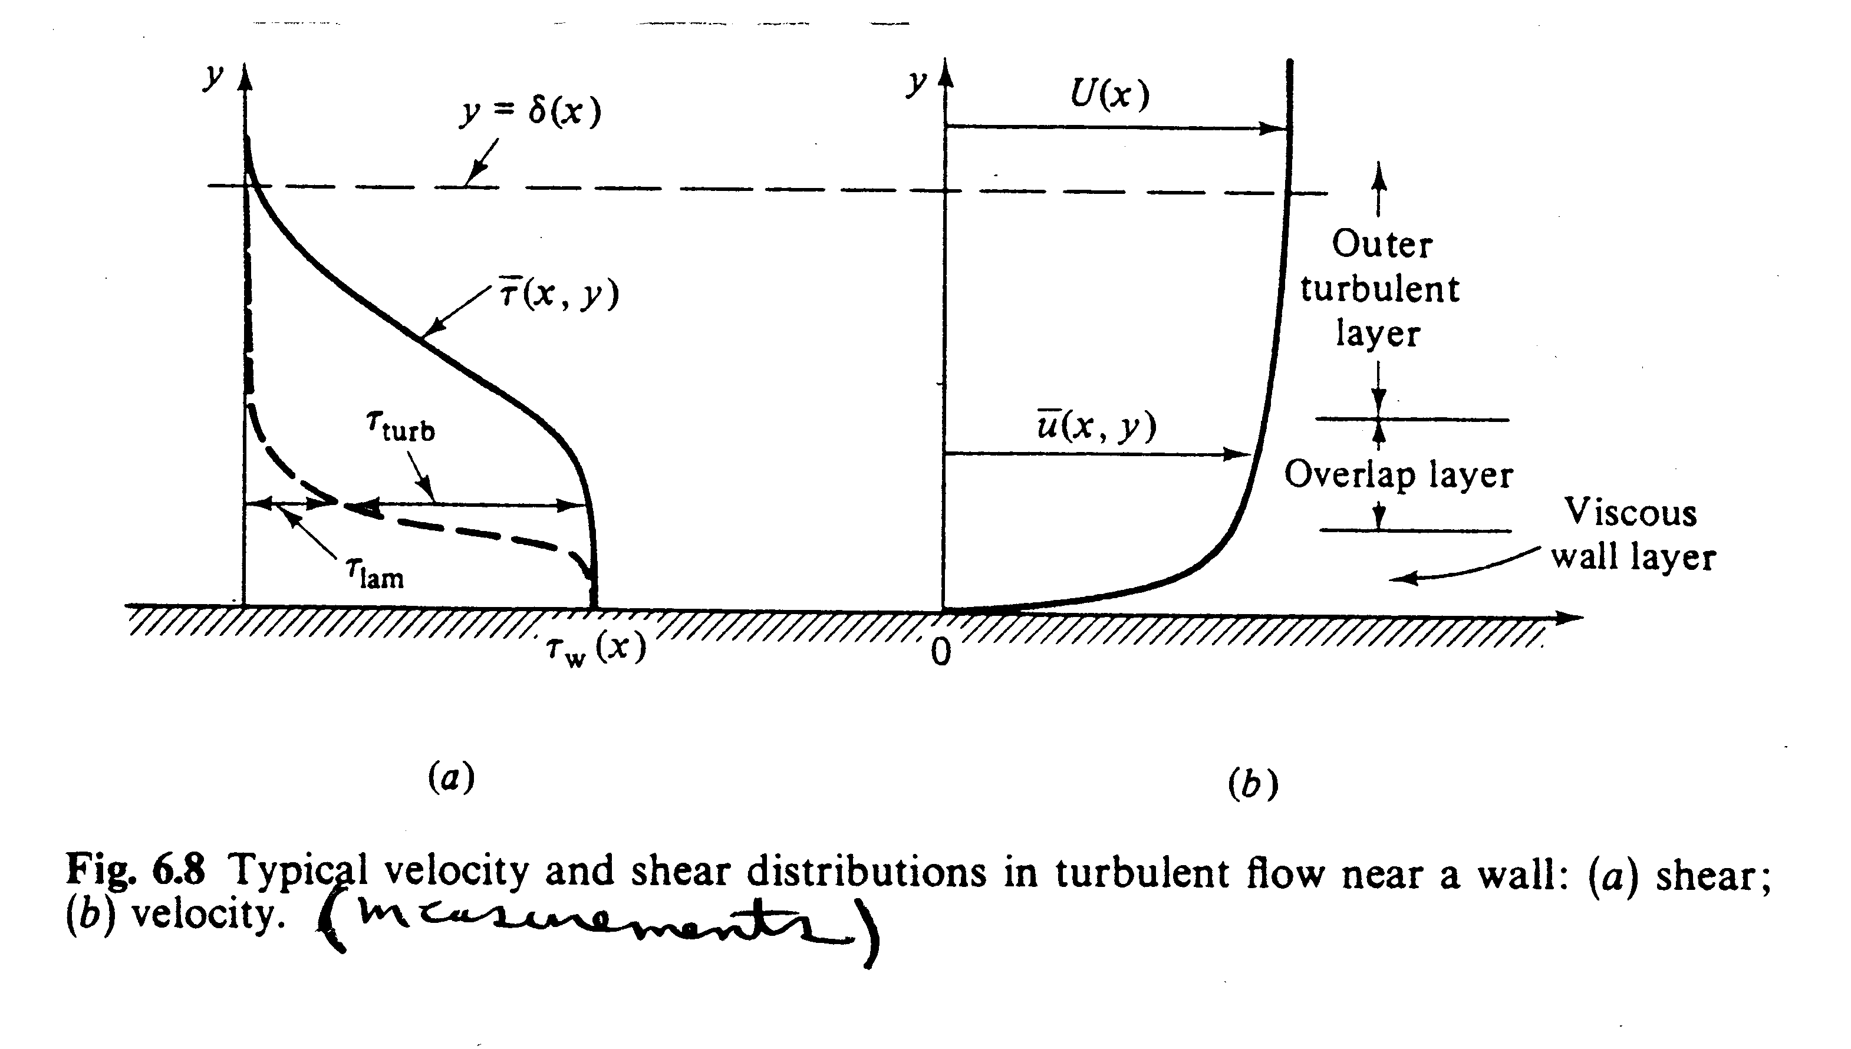

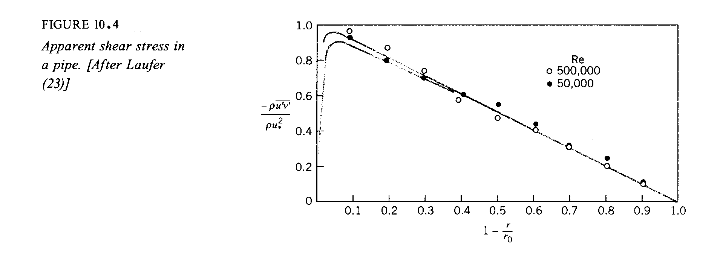

Note that very near the wall τ_{laminar} must dominate since
$−ρ\overline{u_{i}u_{j}}$= 0 at the wall (y = 0) and in the outer part turbulent stress will dominate. This leads to the three-layer concept:

Inner layer: viscous stress dominates

Outer layer: turbulent stress dominates

Overlap layer: both types of stress important

- laminar sub-layer (viscous shear dominates)

= f(μ, τ_{w}, ρ, y) note: not f(δ)
and δ=D and
y = r_{o} − r
for pipe flow
From dimensional analysis
$u^{+}=f\left(y^{+}\right)$ law-of-the-wall

where:

u* = friction velocity = $\sqrt{{τ_{w}}/ρ}$

$y^{+}=\frac{{\text{yu}}^{}}{ν}$

very near the wall:

τ ∼ τ_{w} ∼ constant = ⇒
i.e.,

$u^{+}=y^{+}$ 0 < y⁺ < 5

- outer layer (turbulent shear dominates)

note: independent of μ and actually also depends on $\frac{\text{dp}}{\text{dx}}$

velocity defect law
From dimensional analysis

- overlap layer (viscous and turbulent shear important)

It is not that difficult to show that for both laws to overlap, f and g are logarithmic functions:
Inner region:
Outer region:
$\frac{y}{u^{}}\frac{u^{{}^{2}}}{ν}\frac{\text{df}}{{\text{dy}}^{+}}=\frac{y}{u^{}}\frac{u^{}}{δ}\frac{\text{dg}}{dη}$; valid at large y⁺ and small η.
f(y+)
g(η)

Therefore, both sides must equal universal constant, $κ^{−1}$

(inner variables)
(outer variables)

$κ$, A, and B are pure dimensionless constants

$κ$ = 0.41 Von Karman constant
Values vary somewhat depending on different exp. arrangements

B = 5.5 (or 5.0)
The difference is due to loss of intermittency in duct flow. A = 0 means small outer layer
A = 2.35 BL flow
= 0.65 pipe flow

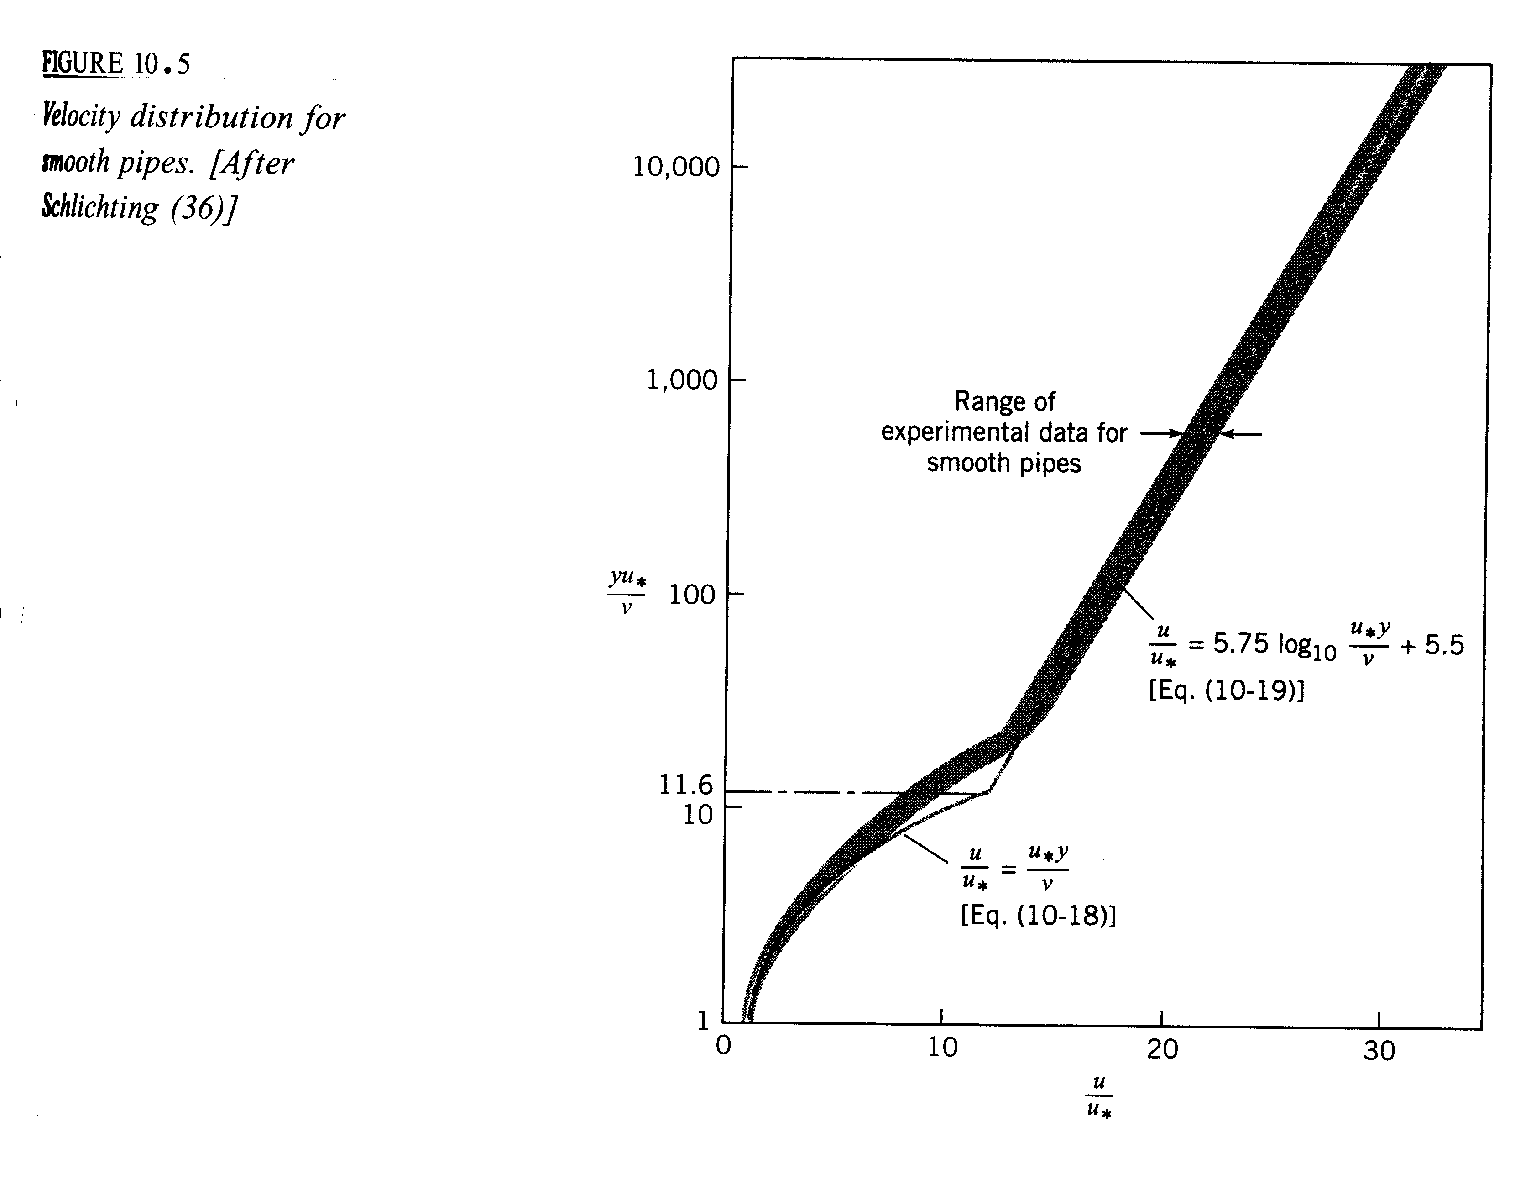
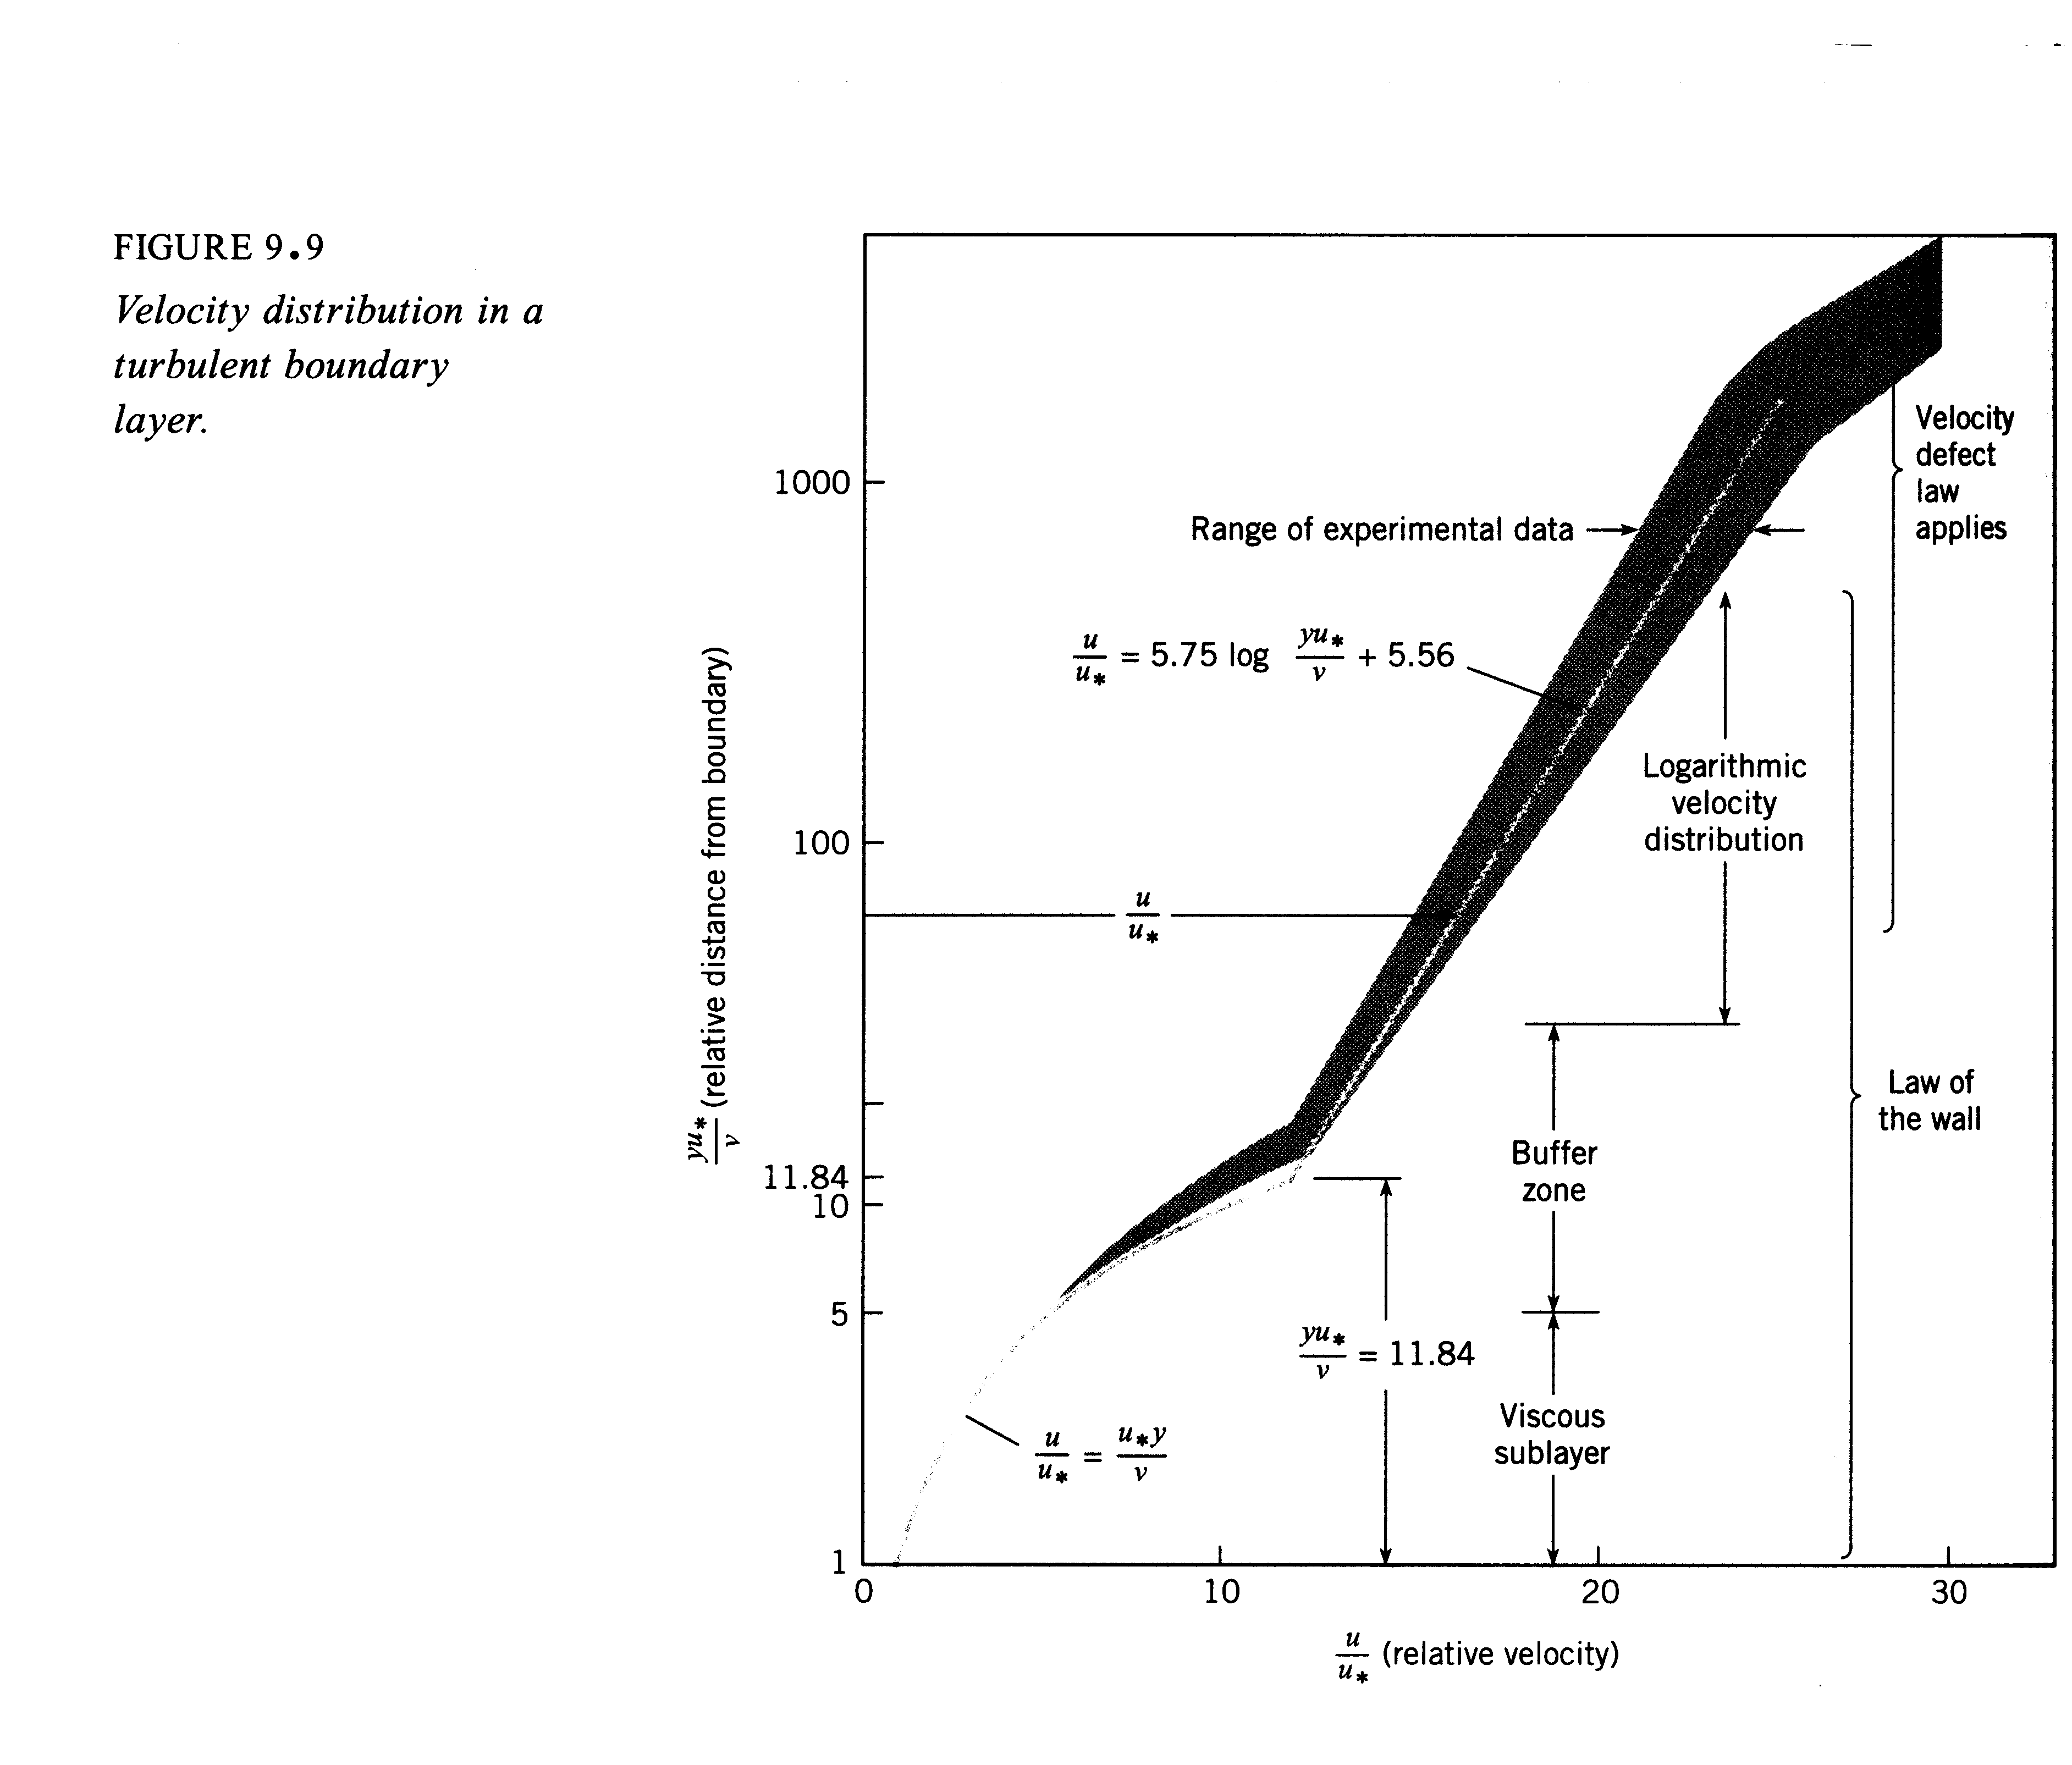

Note that the y⁺ scale is logarithmic and thus the inner law only extends over a very small portion of δ

Inner law region < .2δ

And the log law encompasses most of the pipe/boundary-layer. Thus as an approximation one can simply assume

is valid all across the shear layer. This is the approach used in this course for turbulent flow analysis. The approach is a good approximation for simple and 2-D flows (pipe and flat plate), but does not work for complex and 3-D flows.

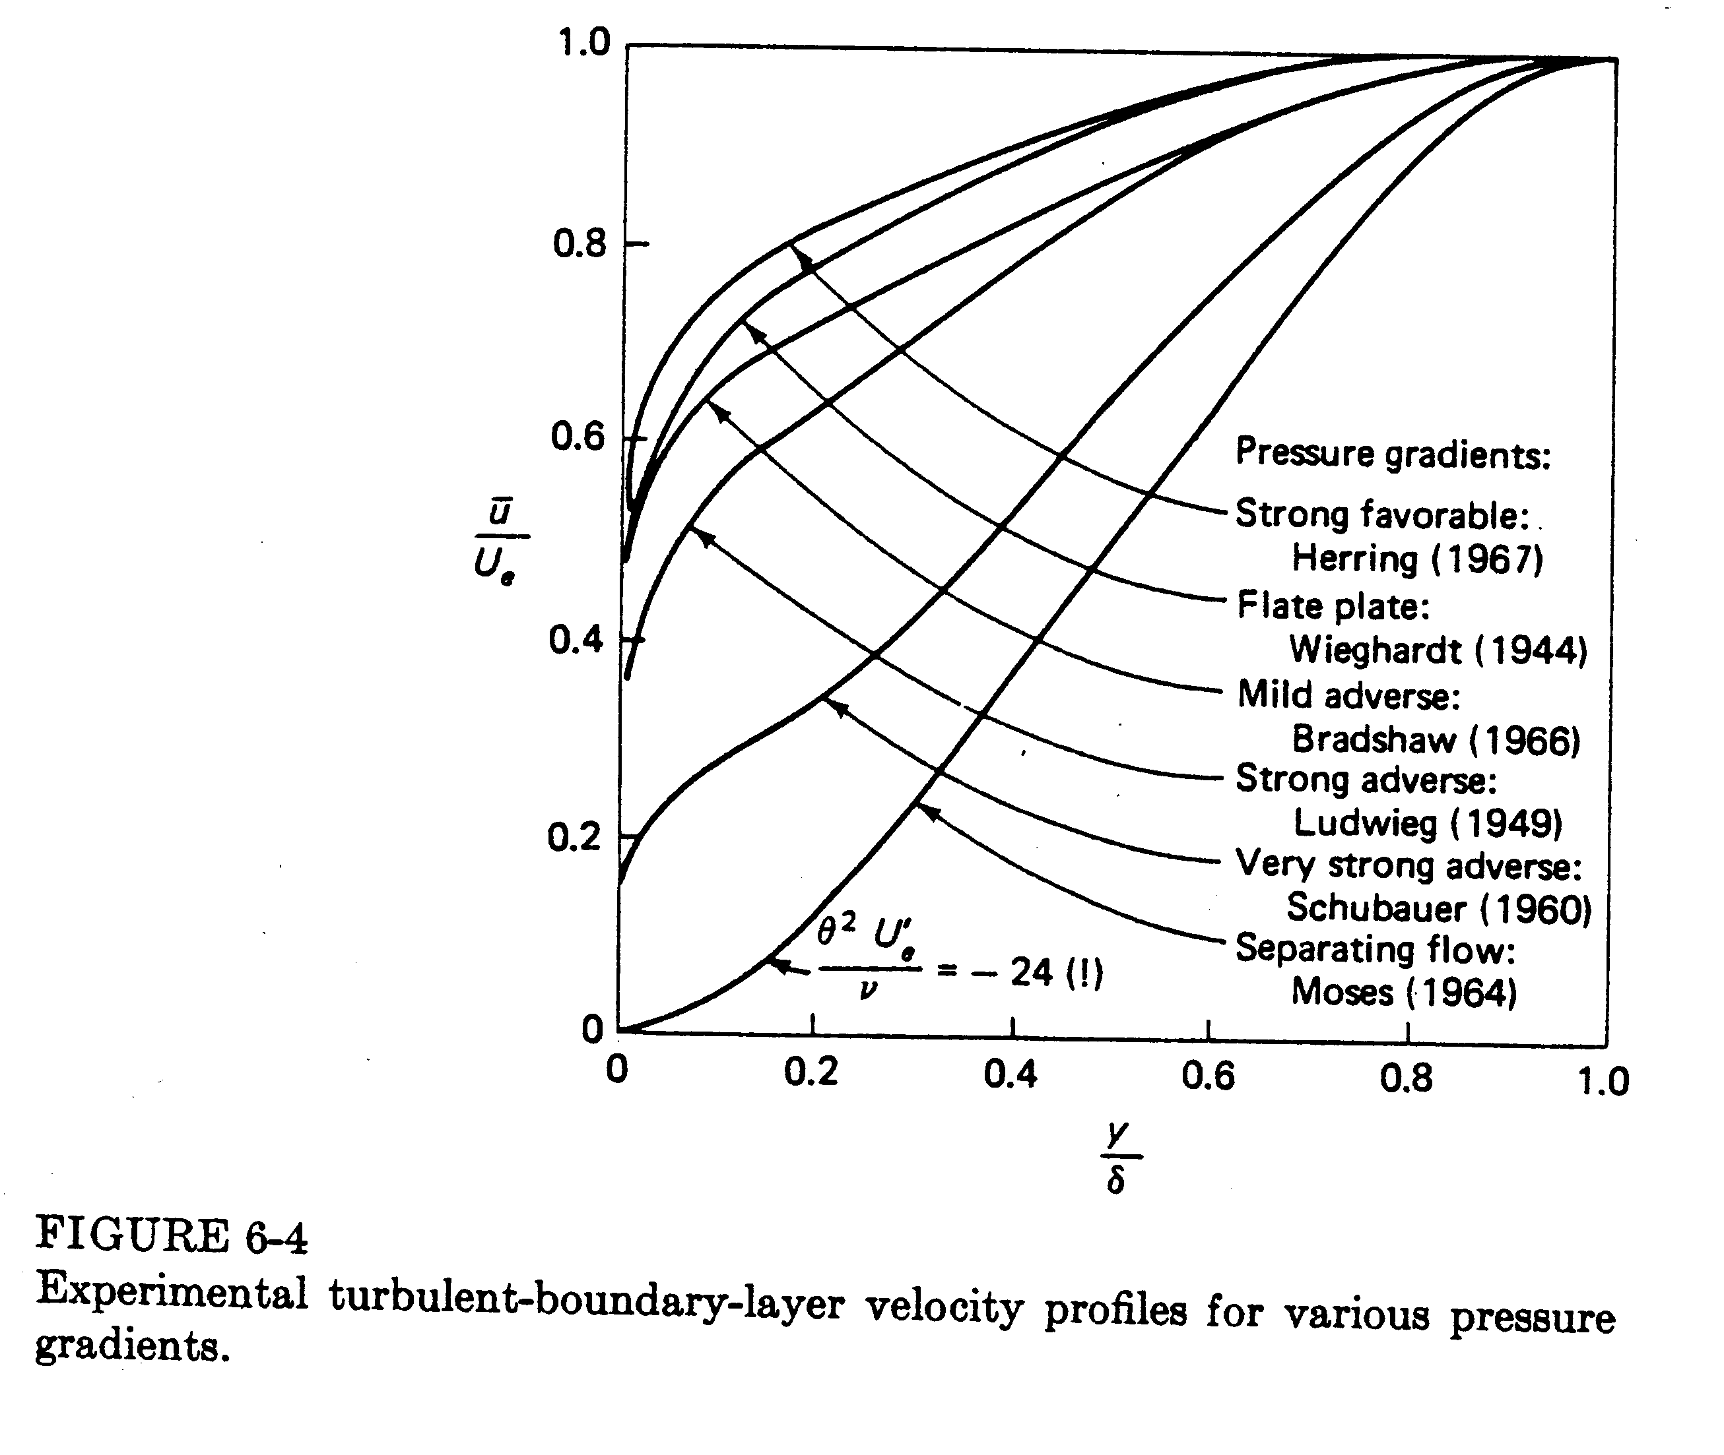

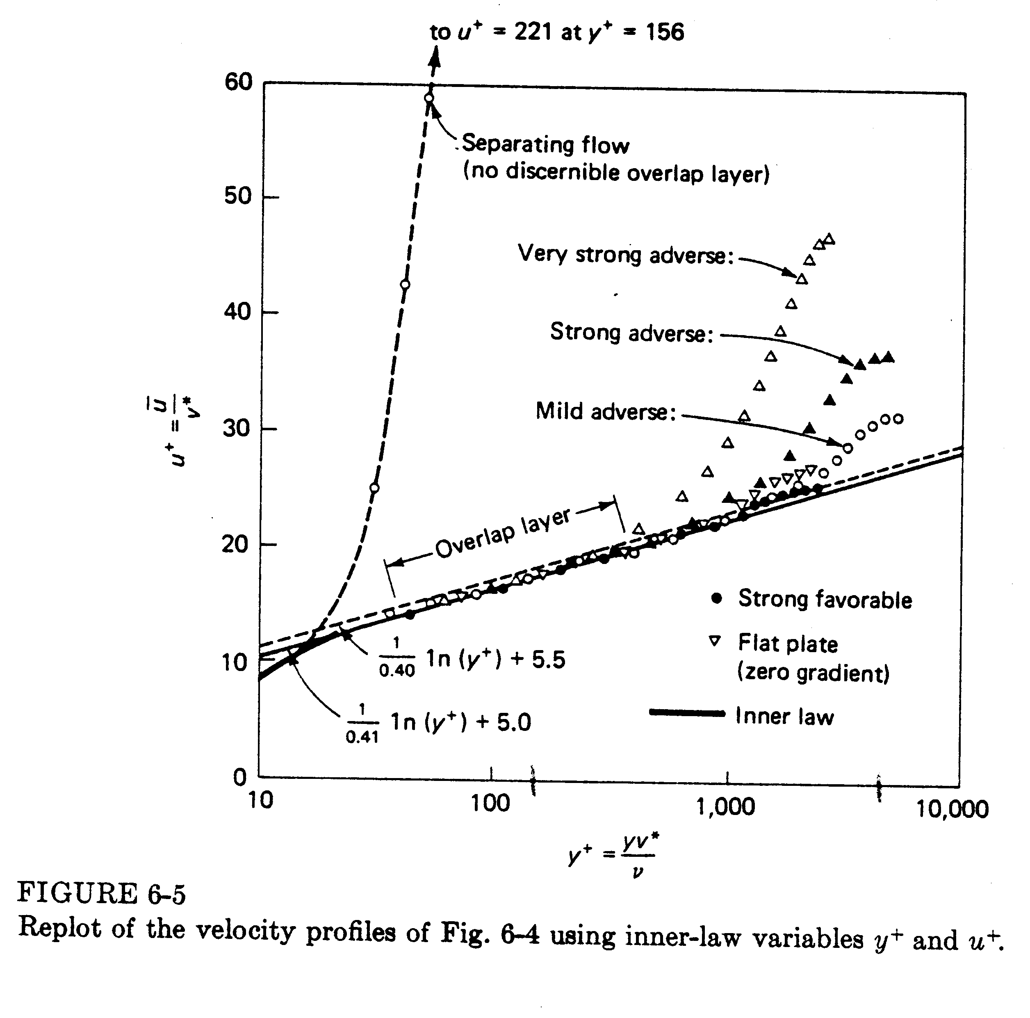
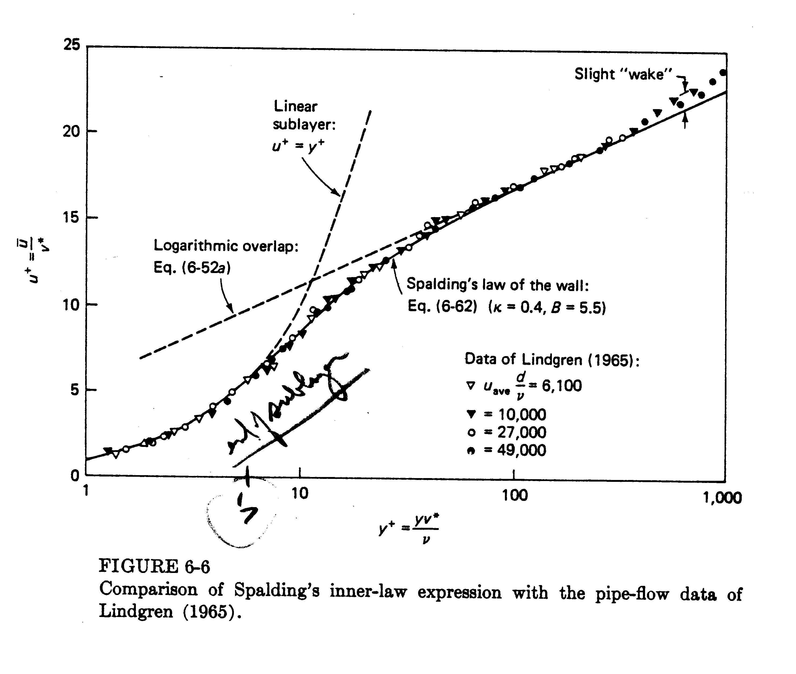

Velocity Distribution and Resistance in Smooth Pipes

Assume log-law is valid across entire pipe
friction
velocity

$\frac{V}{u^{}}=2\text{.}\text{44}\text{ln}\frac{r_{o}u^{}}{ν}+1\text{.}\text{34}={\left(\frac{ρV}{τ_{o}}\right)}^{1/2}={\left(\frac{8}{f}\right)}^{1/2}$
drop over bar:
$\frac{1}{2}\text{Re}{\left(\frac{f}{8}\right)}^{1/2}$

$$\frac{1}{\sqrt{f}}=1\text{.}\text{99}\text{log}\left(\text{Re} f^{1/2}\right)−1\text{.}\text{02}$$
constants adjusted using data
⇒ $\frac{1}{\sqrt{f}}=2\text{log}\left(\text{Re} f^{1/2}\right)−\text{.}8$ Re > 3000

Since f equation is implicit, it is not easy to see dependency on ρ, μ, V, and D
4000 < Re_{D} < 10⁵
Blasius (1911) power law curve fit to data
$f(\text{pipe})=0\text{.}\text{316}{\text{Re}}_{D}^{{−1}/4}$
for Δz=0 (horizontal)

Near quadratic (as expected)

Drops weakly with pipe size
Nearly linear
Only slightly with μ

$=0\text{.}\text{241}{Lρ}^{3/4}μ^{1/4}D^{−4\text{.}\text{75}}Q^{1\text{.}\text{75}}$

laminar flow: $Δp=8μ{\text{LQ}}/{{πR}^{4}}$

$Δp$ (turbulent) increases more sharply than $Δp$(laminar) for same Q; therefore, increase D for smaller $Δp$. 2D decreases $Δp$ by 27 for same Q.

Combine with

$Vu_{\text{max}}={\left(1+1\text{.}3\sqrt{f}\right)}^{−1}$

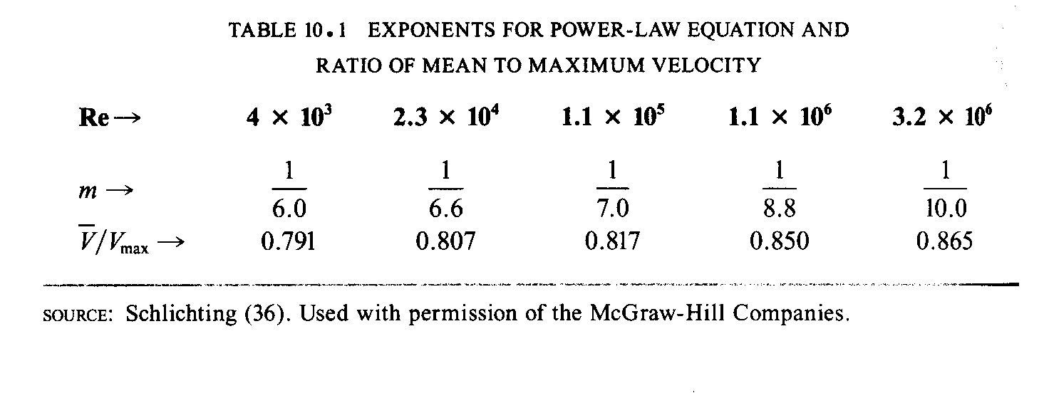

Power law fit to velocity profile:
m = m(Re)

Viscous Distribution and Resistance – Rough Pipes

For laminar flow, effect of roughness is small; however, for turbulent flow the effect is large. Both laminar sublayer and overlap layer are affected.

Inner layer:
= (y, k, ρ, τ_{w})
not function of μ as was case for smooth pipe (or wall)

u⁺ = u⁺(y/k)

Outer layer: unaffected

Overlap layer:
$u_{R}^{+}=\frac{1}{κ}\text{ln}\frac{y}{k}+$constant rough
$u_{S}^{+}=\frac{1}{κ}\text{ln}y^{+}+B$ smooth
$u_{S}^{+}−u_{R}^{+}=\frac{1}{κ}\text{ln}k^{+}+$constant $k^{+}=\frac{{\text{ku}}^{}}{ν}$
ΔB(k⁺)

i.e., rough-wall velocity profile shifts downward by ΔB(k⁺), which increases with k⁺.

Three regions of flow depending on k⁺

1. k⁺ < 5 hydraulically smooth (no effect of roughness)
2. 5 < k⁺ < 70 transitional roughness (Re dependence)
3. k⁺ > 70 fully rough (independent Re)

For 3, $ΔB=\frac{1}{κ}\text{ln}k^{+}−3\text{.}5$ from data

$u^{+}=\frac{1}{κ}\text{ln}\frac{y}{k}+8\text{.}5≠f\left(\text{Re}\right)$
fully rough flow

$\frac{V}{u^{}}=2\text{.}\text{44}\text{ln}\frac{D}{k}+3\text{.}2$

$\frac{1}{f^{1/2}}=−2\text{log}\frac{k/D}{3\text{.}7}$

Composite Log-Law
Smooth wall log law
$$u^{+}=\frac{1}{κ}\text{ln}y^{+}+B−ΔB\left(k^{+}\right)$$
B*
$B^{}=5−\frac{1}{κ}\text{ln}\left(1+\text{.}3k^{+}\right)$ from data

$\frac{1}{f^{1/2}}=−2\text{log}\left[\frac{k/D}{3\text{.}7}+\frac{2\text{.}\text{51}}{\text{Re} f^{1/2}}\right]$ Moody Diagram

=$1\text{.}\text{14}−2\text{log}\left(\frac{k_{s}}{D}+\frac{9\text{.}\text{35}}{\text{Re} f^{1/2}}\right)$
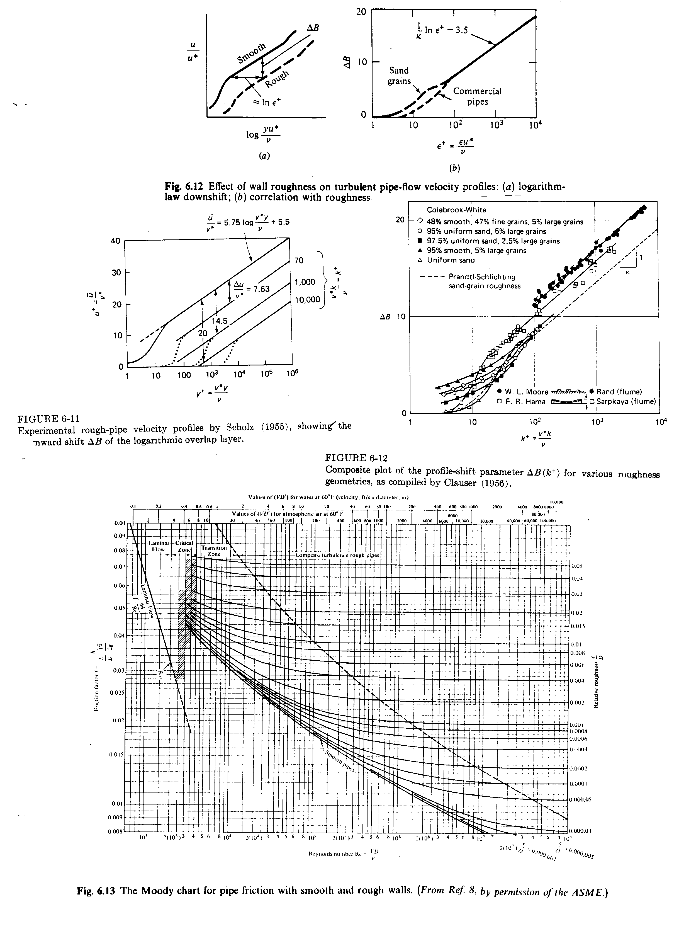

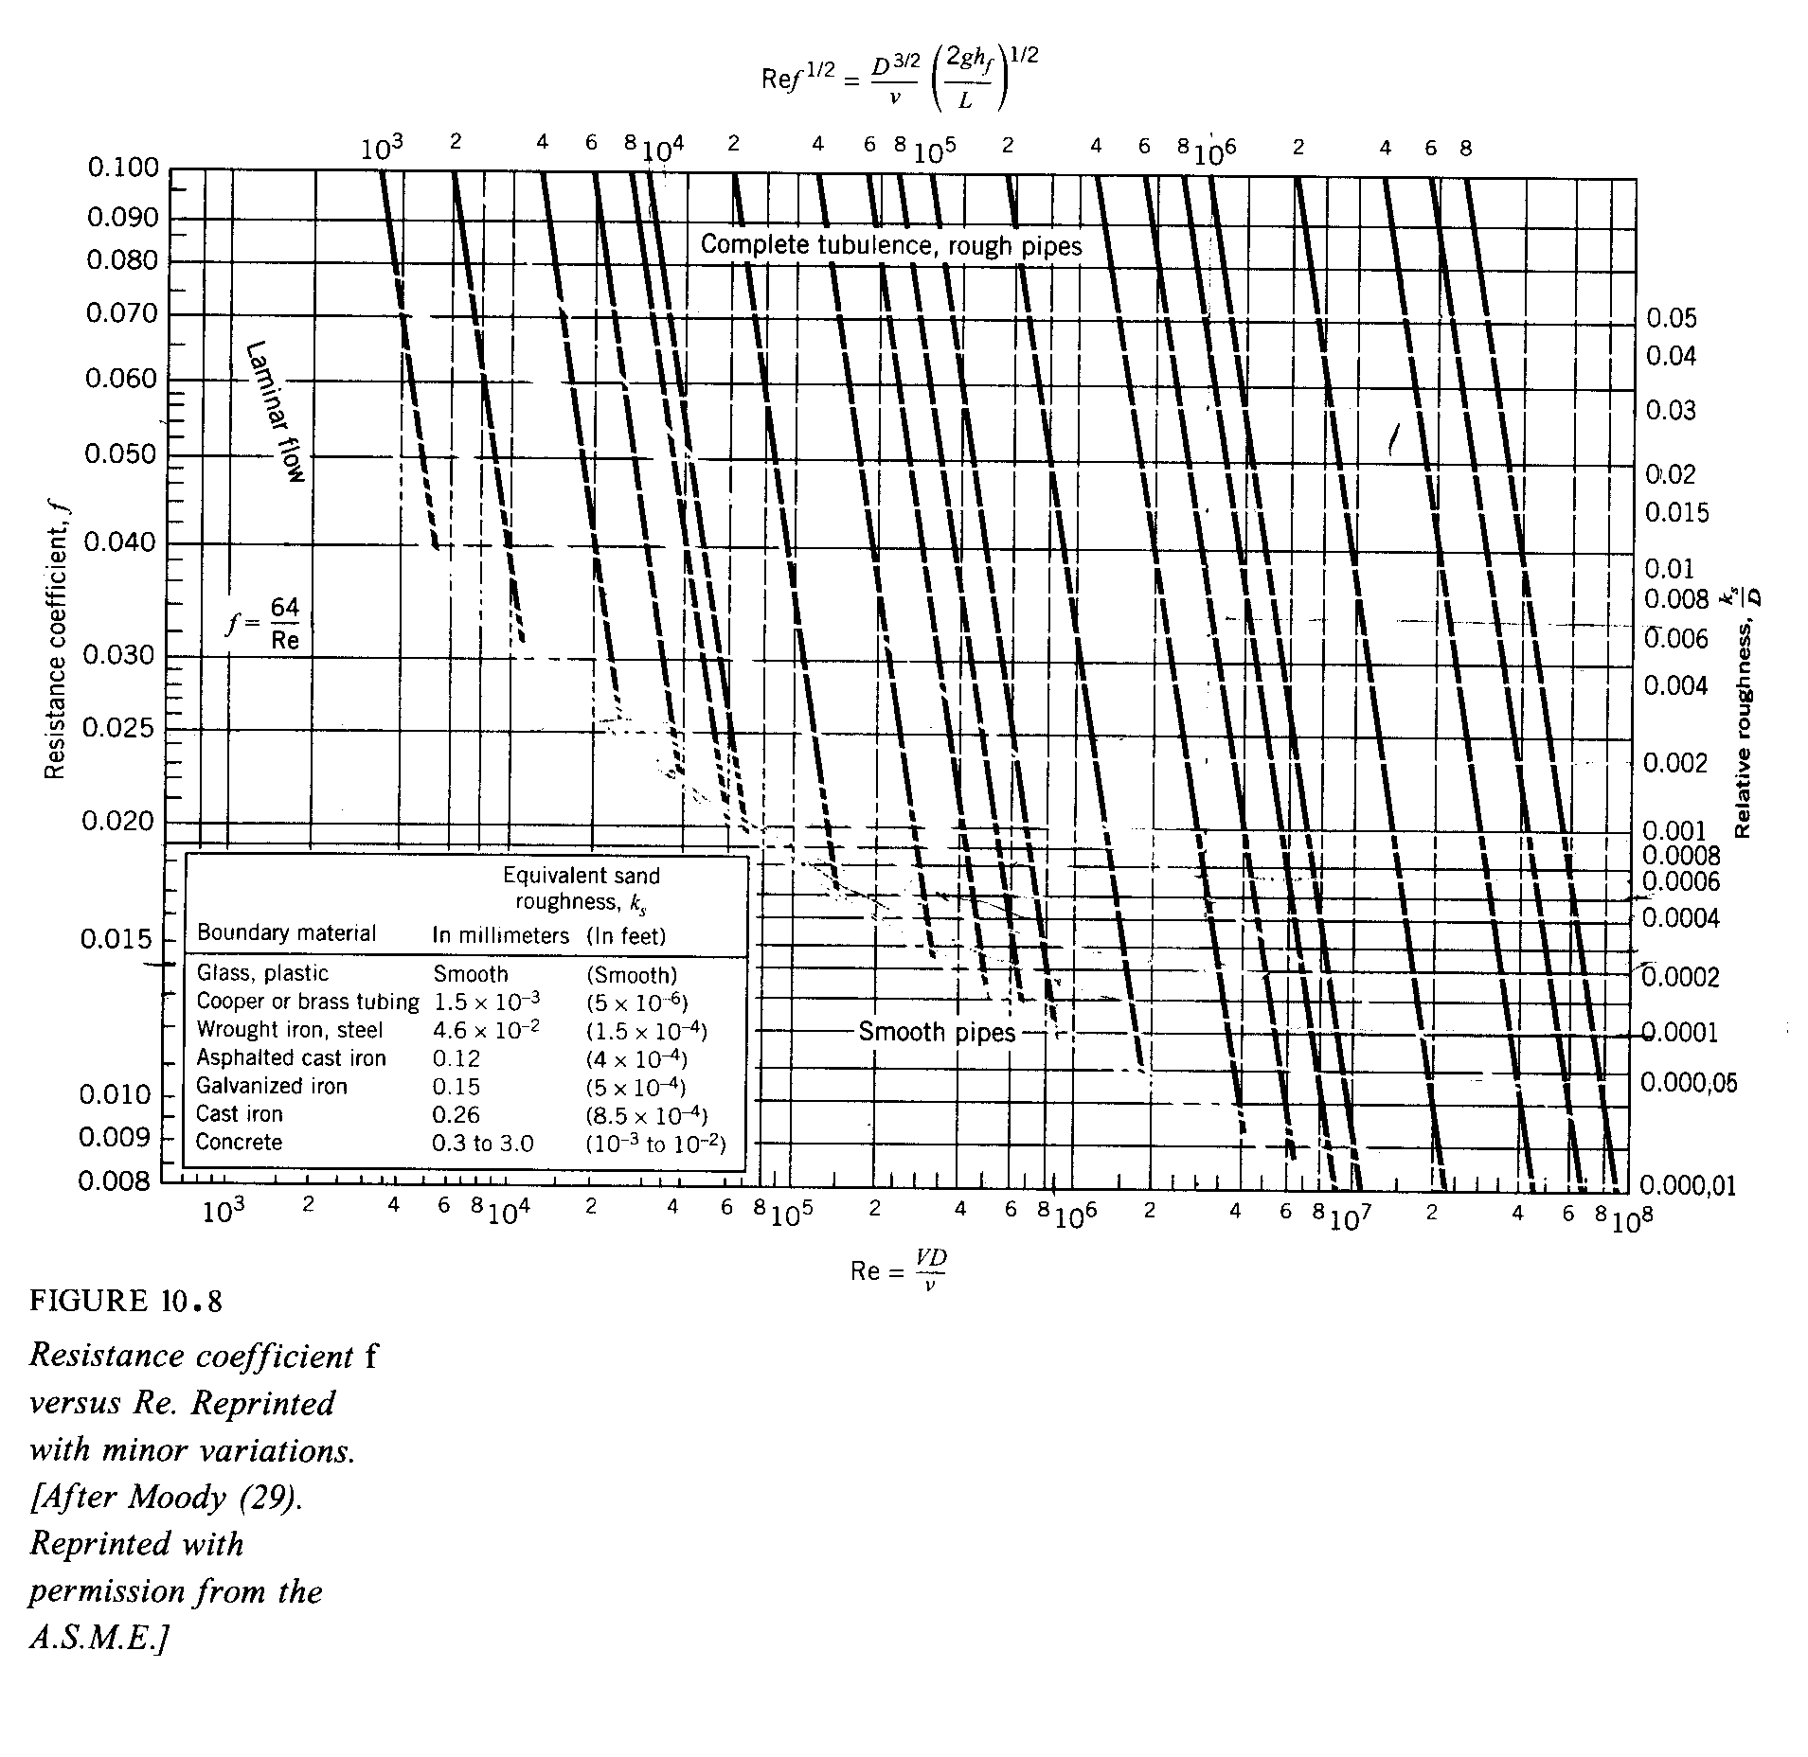
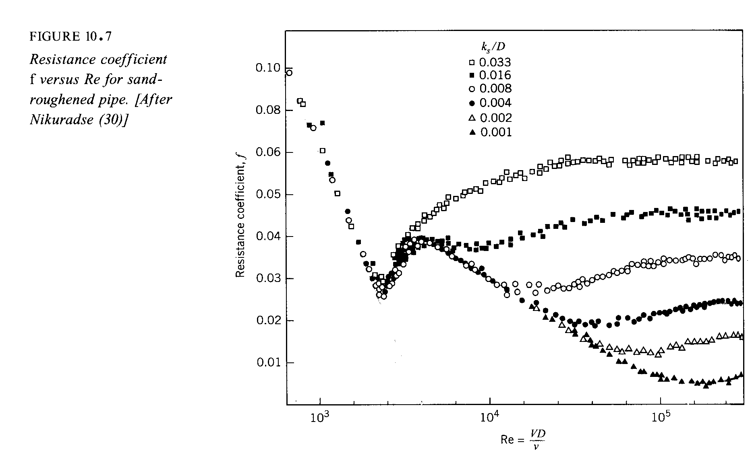

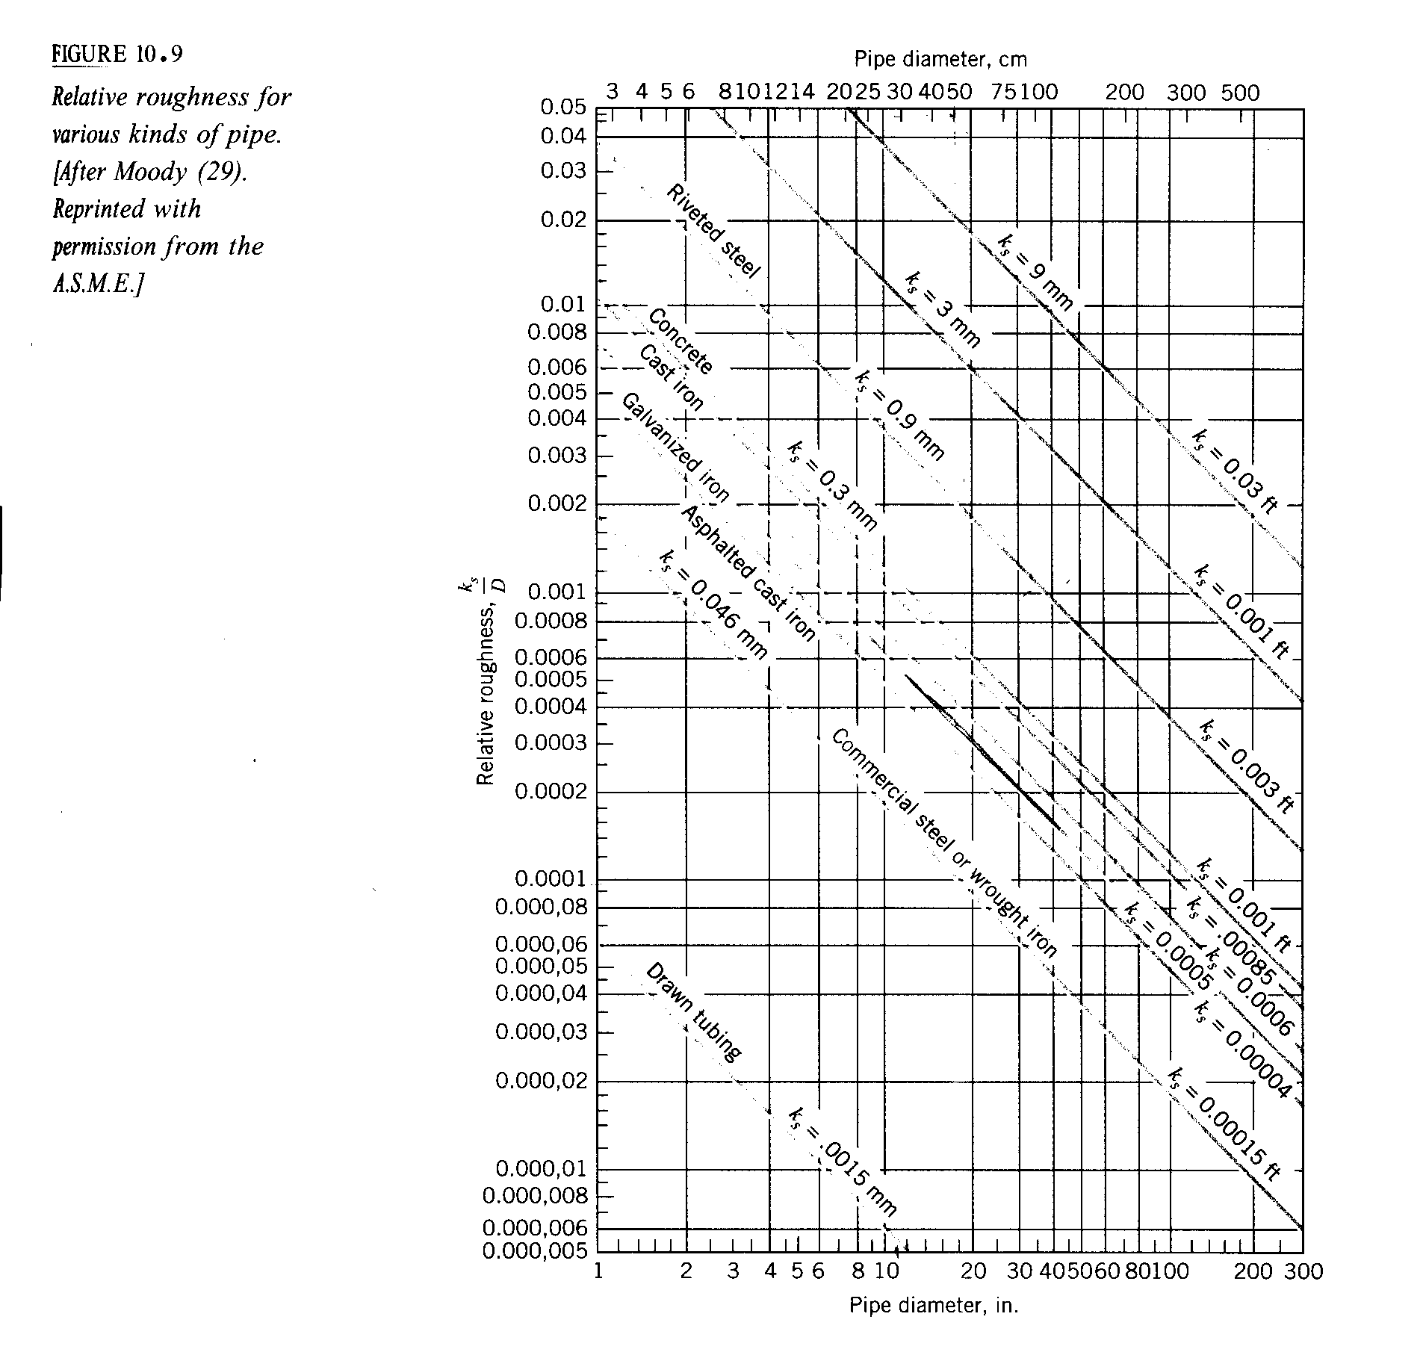

There are basically three types of problems involved with uniform flow in a single pipe:

- Determine the head loss, given the kind and size of pipe along with the flow rate, Q = A*V
- Determine the flow rate, given the head, kind, and size of pipe
- Determine the pipe diameter, given the type of pipe, head, and flow rate

- Determine the head loss
The first problem of head loss is solved readily by obtaining f from the Moody diagram, using values of Re and k_{s}/D computed from the given data. The head loss h_{f} is then computed from the Darcy-Weisbach equation.

f = f(Re_{D}, k_{s}/D)

= $−Δ\left(\frac{p}{γ}+z\right)$

Re_{D} = Re_{D}(V, D)

- Determine the flow rate
The second problem of flow rate is solved by trial, using a successive approximation procedure. This is because both Re and f(Re) depend on the unknown velocity, V. The solution is as follows:
  - solve for V using an assumed value for f and the Darcy-Weisbach equation
$$V={\left[\frac{2{\text{gh}}_{f}}{L/D}\right]}^{1/2}⋅f^{{−1}/2}$$

known from note sign
given data

  - using V compute Re
  - obtain a new value for f = f(Re, k_{s}/D) and reapeat as above until convergence

Or can use $\text{Re}=f^{1/2}=\frac{D^{3/2}}{ν}{\left(\frac{2{\text{gh}}_{f}}{L}\right)}^{1/2}$
scale on Moody Diagram

  - compute $\text{Re}f^{1/2}$ and k_{s}/D
  - read f
  - solve V from $h_{f}=f\frac{L}{D}\frac{V^{2}}{2g}$
  - Q = VA

- Determine the size of the pipe
The third problem of pipe size is solved by trial, using a successive approximation procedure. This is because h_{f}, f, and Q all depend on the unknown diameter D. The solution procedure is as follows:

  - solve for D using an assumed value for f and the Darcy-Weisbach equation along with the definition of Q
$$D={\left[\frac{8{\text{LQ}}^{2}}{π^{2}{\text{gh}}_{f}}\right]}^{1/5}⋅ f^{1/5}$$

known from
given data

  - using D compute Re and k_{s}/D

  - obtain a new value of f = f(Re, k_{s}/D) and reapeat as above until convergence

Flows at Pipe Inlets and Losses From Fittings

For real pipe systems in addition to friction head loss these are additional so called minor losses due to

- entrance and exit effects
can be large effect
- expansions and contractions
- bends, elbows, tees, and other fittings
- valves (open or partially closed)

For such complex geometries we must rely on experimental data to obtain a loss coefficient

$K=\frac{h_{m}}{\frac{V^{2}}{2g}}$ head loss due to minor losses

In general,

K = K(geometry, Re, ε/D)

dependence usually
not known

Loss coefficient data is supplied by manufacturers and also listed in handbooks. The data are for turbulent flow conditions but seldom given in terms of Re.

Modified Energy Equation to Include Minor Losses (where ):

$\frac{p_{1}}{γ}+z_{1}+\frac{1}{2g}α_{1}V_{1}^{2}+h_{p}=\frac{p_{2}}{γ}+z_{2}+\frac{1}{2g}α_{2}V_{2}^{2}+h_{t}+h_{f}+\sum{h_{m}}$ $h_{m}=K\frac{V^{2}}{2g}$

Note: Σh_{m} does not include pipe friction and e.g. in elbows and tees, this must be added to h_{f}.

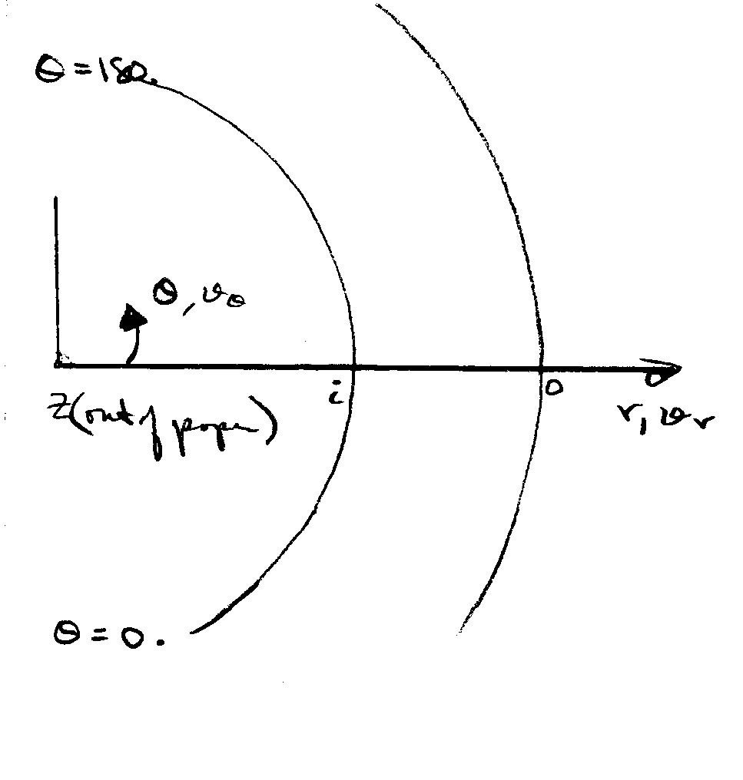
- Flow in a bend:
$$−\frac{1}{r}v_{θ}^{2}=−\frac{1}{ρ}\frac{∂p}{∂r}$$

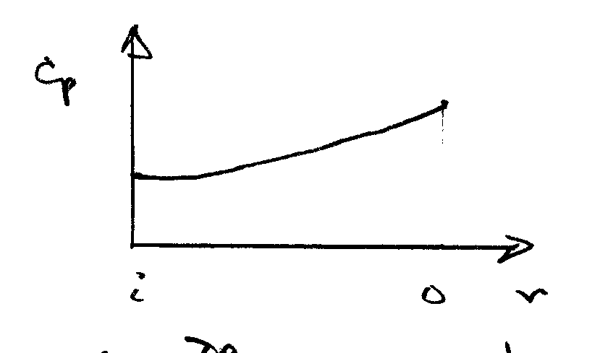
centrifugal acceleration

i.e. $\frac{∂p}{∂r}>0$ which is an adverse pressure gradient in r direction. The slower moving fluid near wall responds first and a swirling flow pattern results.

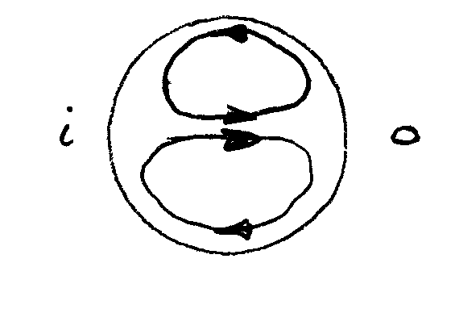
This swirling flow represents an
energy loss which must be added
to the h_{L}.

Also, flow separation can result due to adverse longitudinal pressure gradients which will result in additional losses.

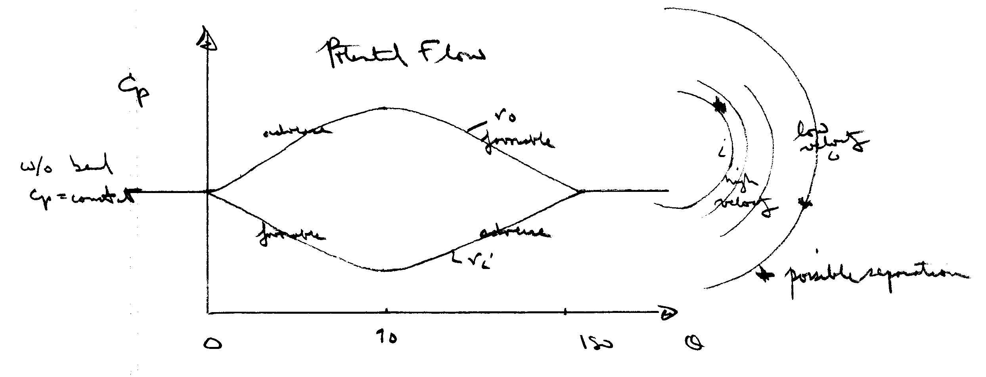

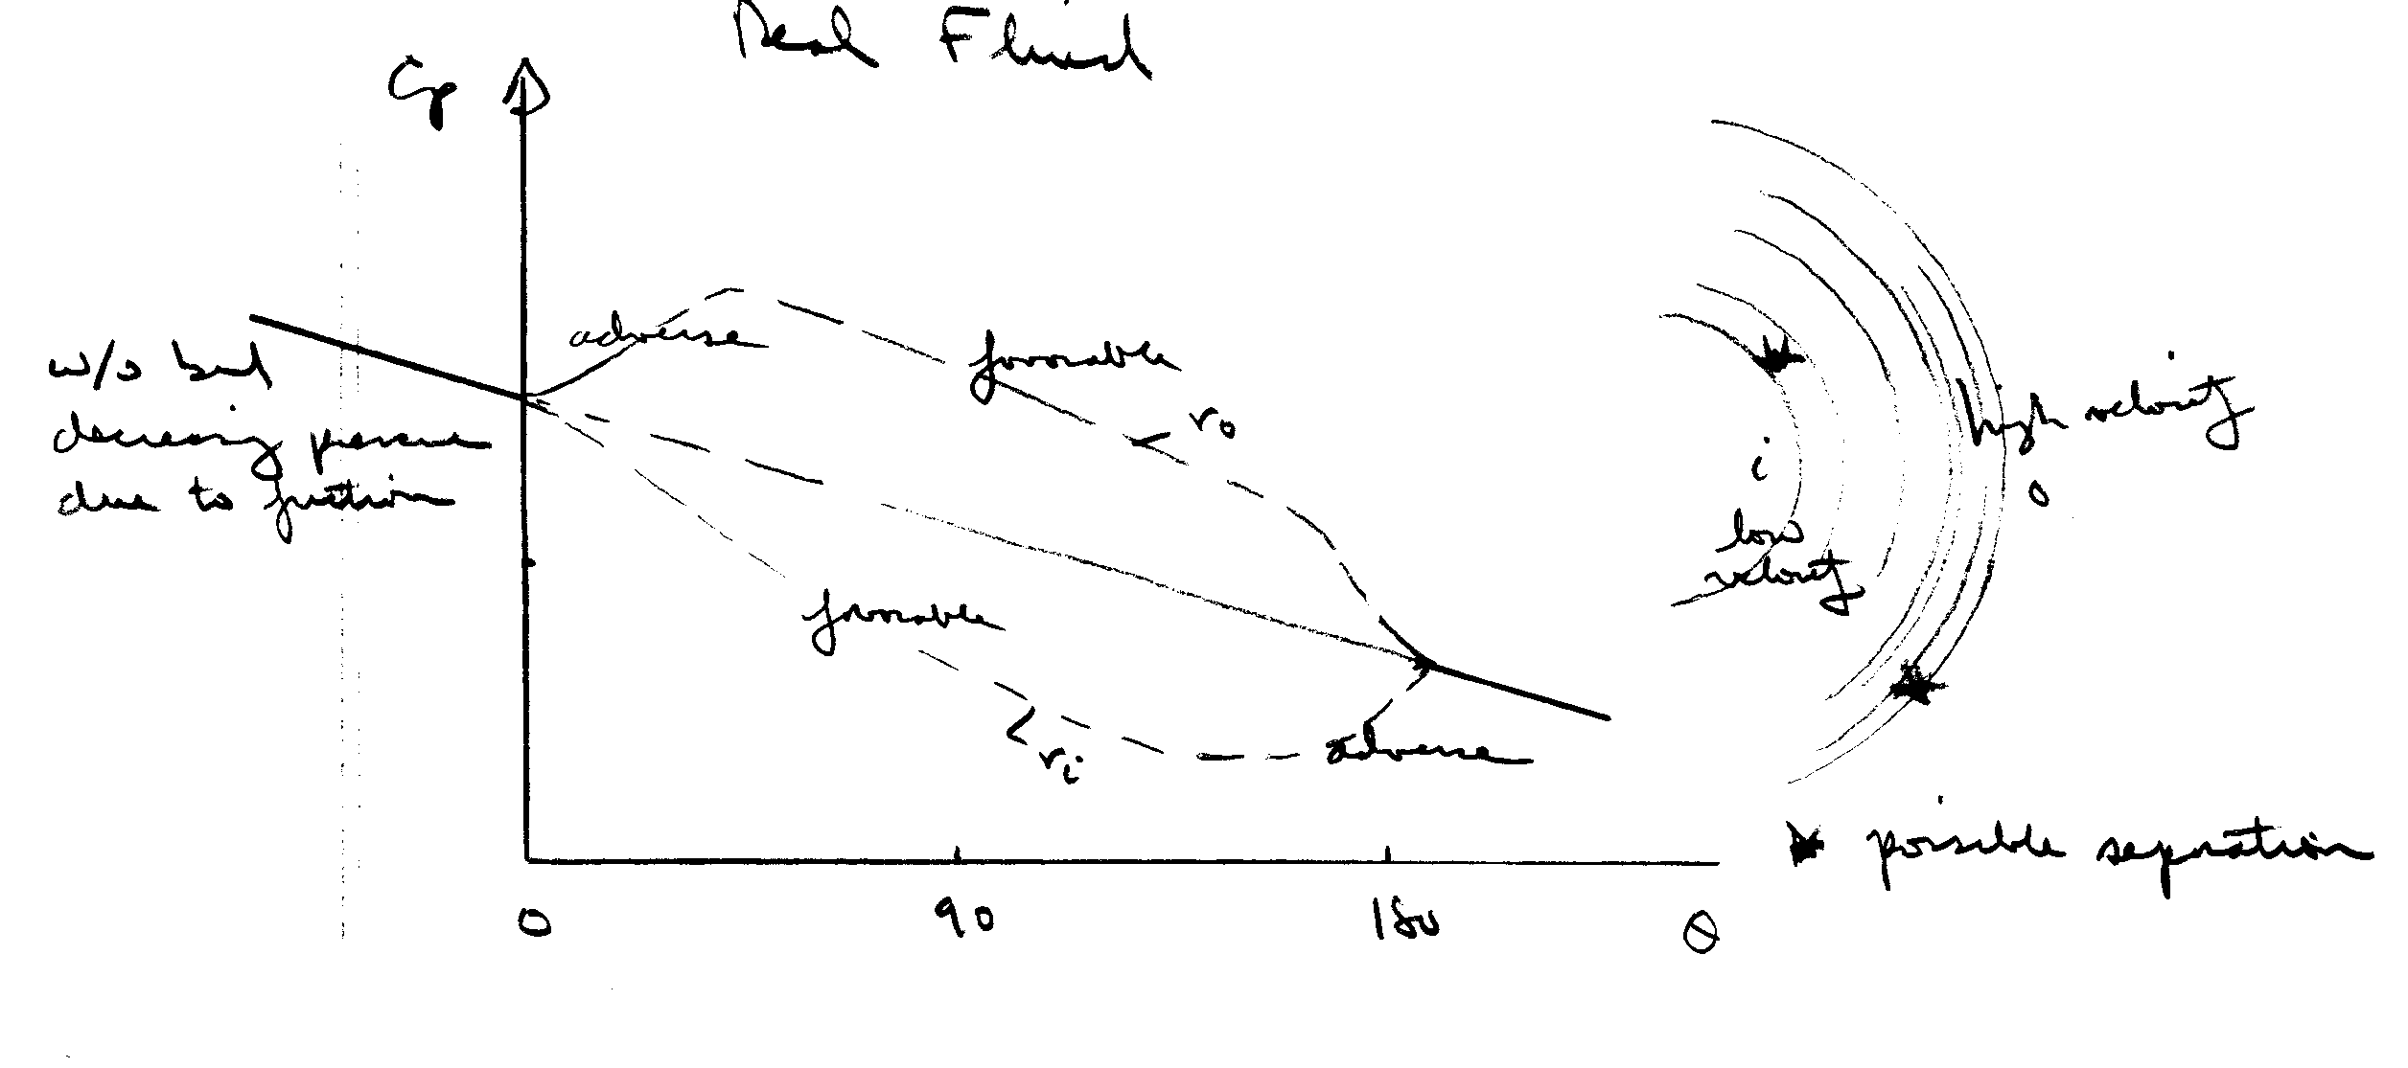

This shows potential flow is not a good approximate in internal flows (except possibly near entrance)

- Valves: enormous losses

- Entrances: depends on rounding of entrance

- Exit (to a large reservoir): K = 1
i.e., all velocity head is lost

- Contractions and Expansions
sudden or gradual
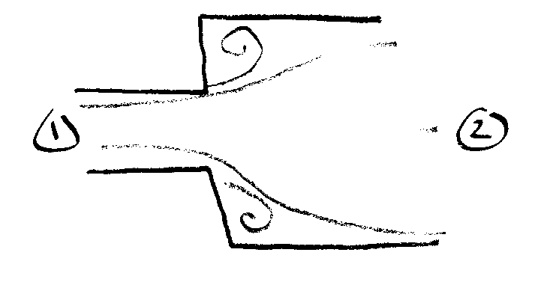
theory for expansion:
d
D
$h_{L}=\frac{{\left(V_{1}−V_{2}\right)}^{2}}{2g}$

from continuity, momentum, and energy
(assuming p = p₁ in separation pockets)
⇒ $K_{\text{SE}}={\left(1−\frac{d^{2}}{D^{2}}\right)}^{2}=\frac{h_{m}}{V_{1}^{2}2g}$

no theory for contraction:
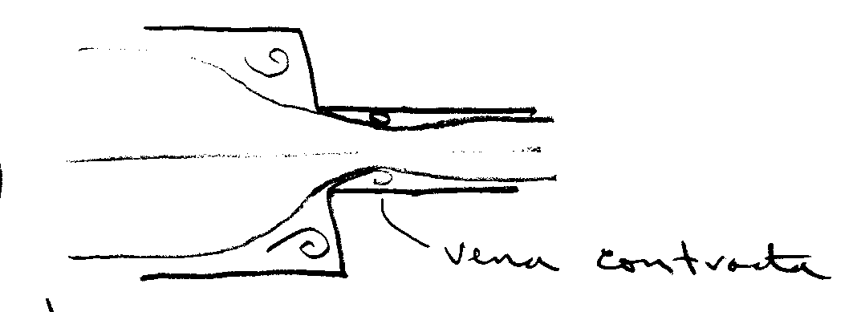
$K_{\text{SC}}=\text{.}\text{42}\left(1−\frac{d^{2}}{D^{2}}\right)$

from experiment
If the contraction or expansion is gradual the losses are quite different. A gradual expansion is called a diffuser. Diffusers are designed with the intent of raising the static pressure.

$C_{p}=\frac{p_{2}−p_{1}}{\frac{1}{2}{ρV}_{1}^{2}}$

$C_{p_{\text{ideal}}}=1−{\left(\frac{A_{1}}{A_{2}}\right)}^{2}$
Bernoulli and continuity equation

$K=\frac{h_{m}}{V^{2}2g}=C_{p_{\text{ideal}}}−C_{p}$ Energy equation

Actually very complex flow and

C_{p} = C_{p} (geometry, inlet flow conditions)

i.e., fully developed (long pipe) reduces C_{p}
thin boundary layer (short pipe) high C_{p}
(more uniform inlet profile)

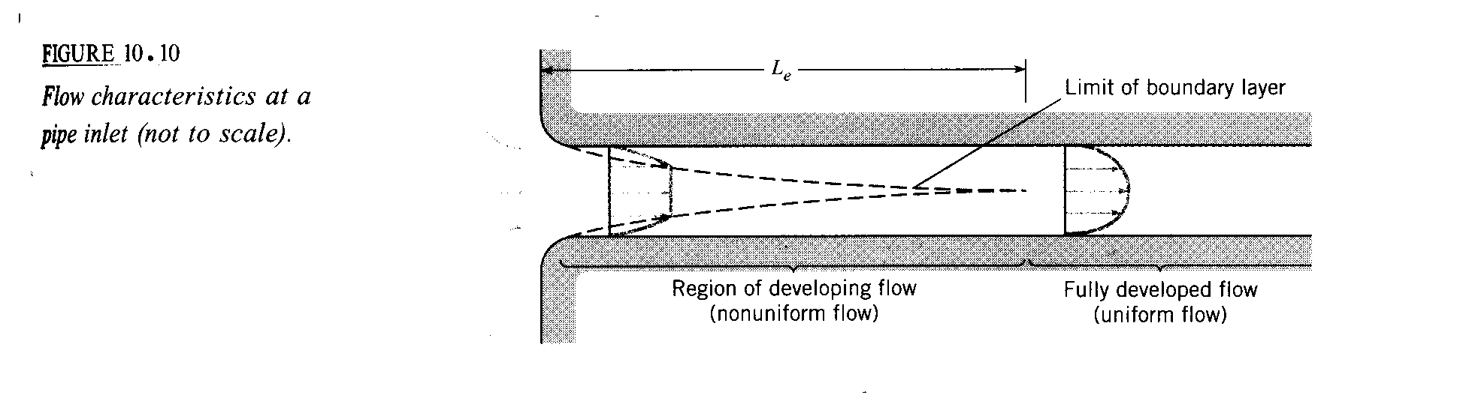

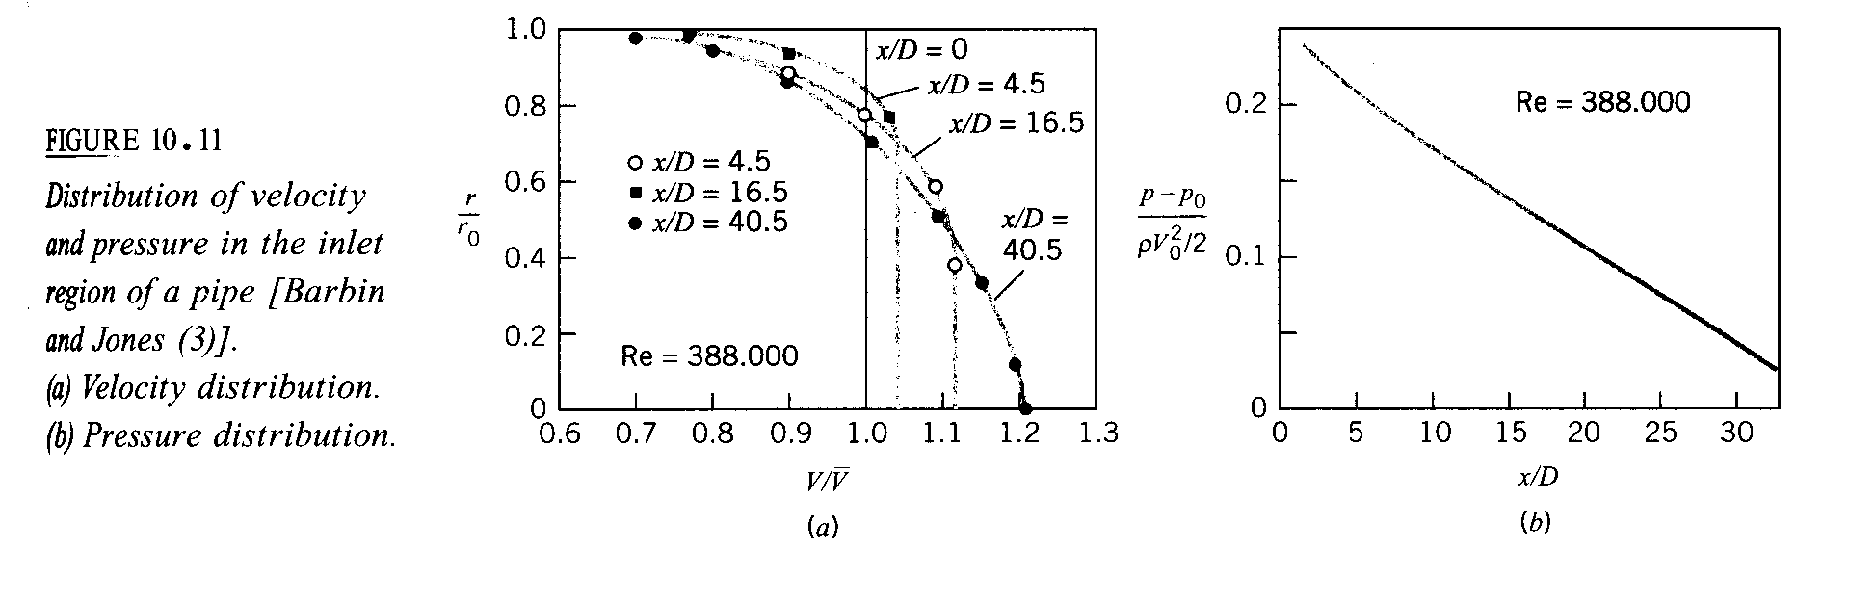

Turbulent flow

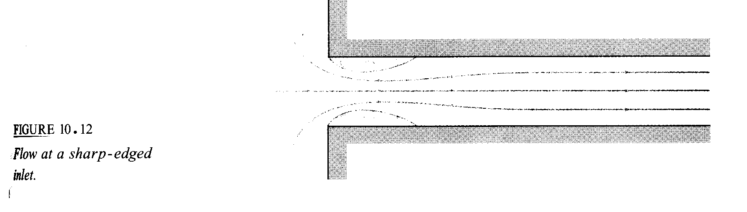

K = .5

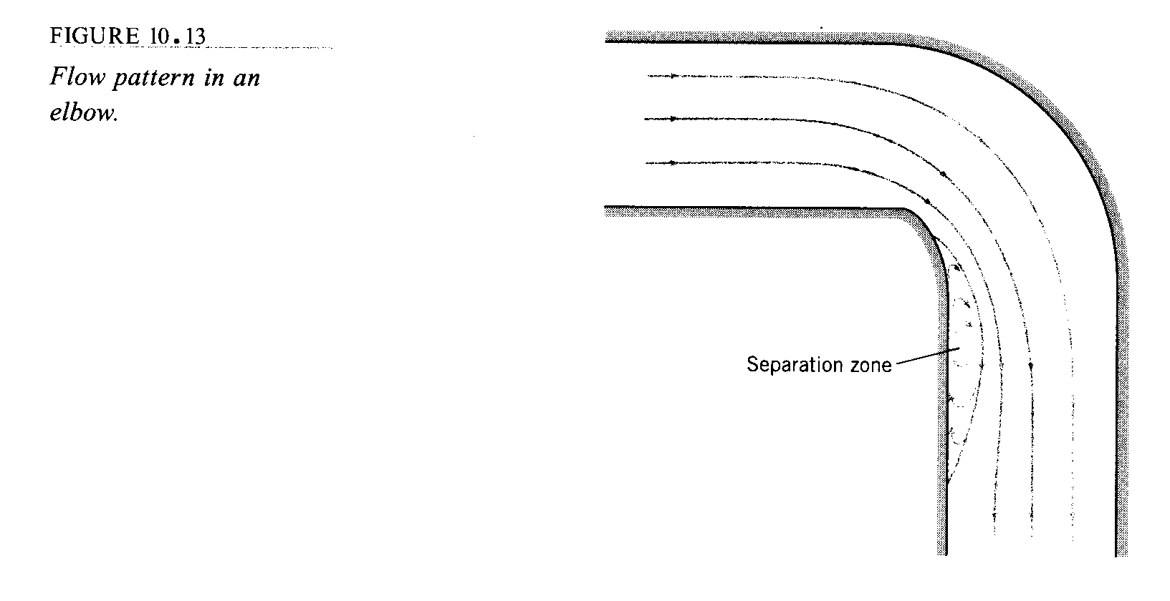

See textbook Table 8.2 for a table of the loss coefficients for pipe components
