Chapter 7 Dimensional Analysis and Modeling

**The Need for Dimensional Analysis**

Dimensional analysis is a process of formulating fluid mechanics problems in terms of nondimensional variables and parameters.

1. Reduction in Variables:

F = functional form

If F(A1, A2, …, An) = 0, Ai = dimensional

variables

Then f(Π1, Π2, … Πr < n) = 0 Πj = nondimensional

parameters

Thereby reduces number of = Πj (Ai)

experiments and/or simulations i.e., Πj consists of

required to determine f vs. F nondimensional

groupings of Ai’s

1. Helps in understanding physics
2. Useful in data analysis and modeling
3. Fundamental to concept of similarity and model testing

Enables scaling for different physical dimensions and fluid properties

**Dimensions and Equations**

Basic dimensions: F, L, and t or M, L, and t

F and M related by F = Ma = MLT-2

**Buckingham Π Theorem**

In a physical problem including n dimensional variables in which there are m dimensions, the variables can be arranged into r = n –  independent nondimensional parameters Πr (where usually  = m).

F(A1, A2, …, An) = 0

f(Π1, Π2, … Πr) = 0

Ai’s = dimensional variables required to formulate problem

(i = 1, n)

Πj’s = nondimensional parameters consisting of groupings

of Ai’s (j = 1, r)

F, f represents functional relationships between An’s and

Πr’s, respectively

 = rank of dimensional matrix

= m (i.e., number of dimensions) usually

**Dimensional Analysis**

Methods for determining Πi’s

1. Functional Relationship Method

Identify functional relationships F(Ai) and f(Πj)by first determining Ai’s and then evaluating Πj’s

a. Inspection intuition

b. Step-by-step Method text

c. Exponent Method class

1. Nondimensionalize governing differential equations and initial and boundary conditions

Select appropriate quantities for nondimensionalizing the GDE, IC, and BC e.g. for M, L, and t

Put GDE, IC, and BC in nondimensional form

Identify Πj’s

Exponent Method for Determining Πj’s

1. determine the n essential quantities
2. select  of the A quantities, with different dimensions, that contain among them the  dimensions, and use them as repeating variables together with one of the other A quantities to determine each Π.

# For example let A1, A2, and A3 contain M, L, and t (not necessarily in each one, but collectively); then the Πj parameters are formed as follows:

Determine exponents such that Πi’s are dimensionless

3 equations and 3 unknowns for each Πi



In these equations the exponents are determined so that each Π is dimensionless. This is accomplished by substituting the dimensions for each of the Ai in the equations and equating the sum of the exponents of M, L, and t each to zero. This produces three equations in three unknowns (x, y, t) for each Πparameter.

In using the above method, the designation of  = m as the number of basic dimensions needed to express the n variables dimensionally is not always correct. The correct value for  is the rank of the dimensional matrix, i.e., the next smaller square subgroup with a nonzero determinant.

Dimensional matrix = A1 ……… An

M a11 ……… a1n

L

aij = exponent of M, L, or t in Ai

t a31 ……… a3n

o ……… o

: :

: :

: :

o ……… o

n x n matrix

Rank of dimensional matrix equals size of next smaller sub-group with nonzero determinant

Example: Hydraulic jump (see section 15.2)

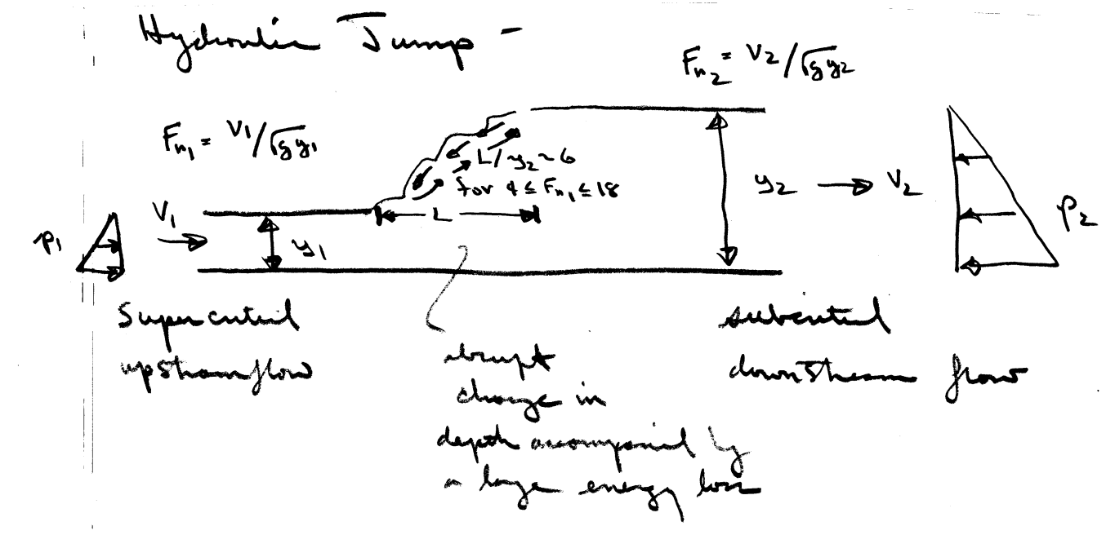

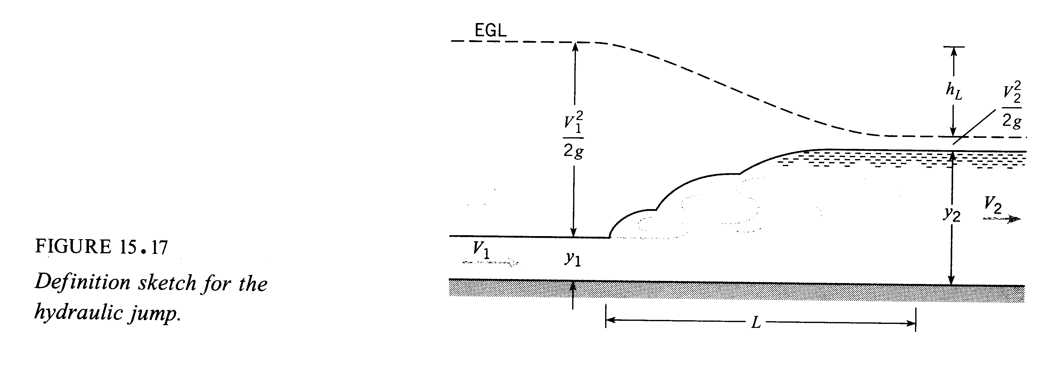

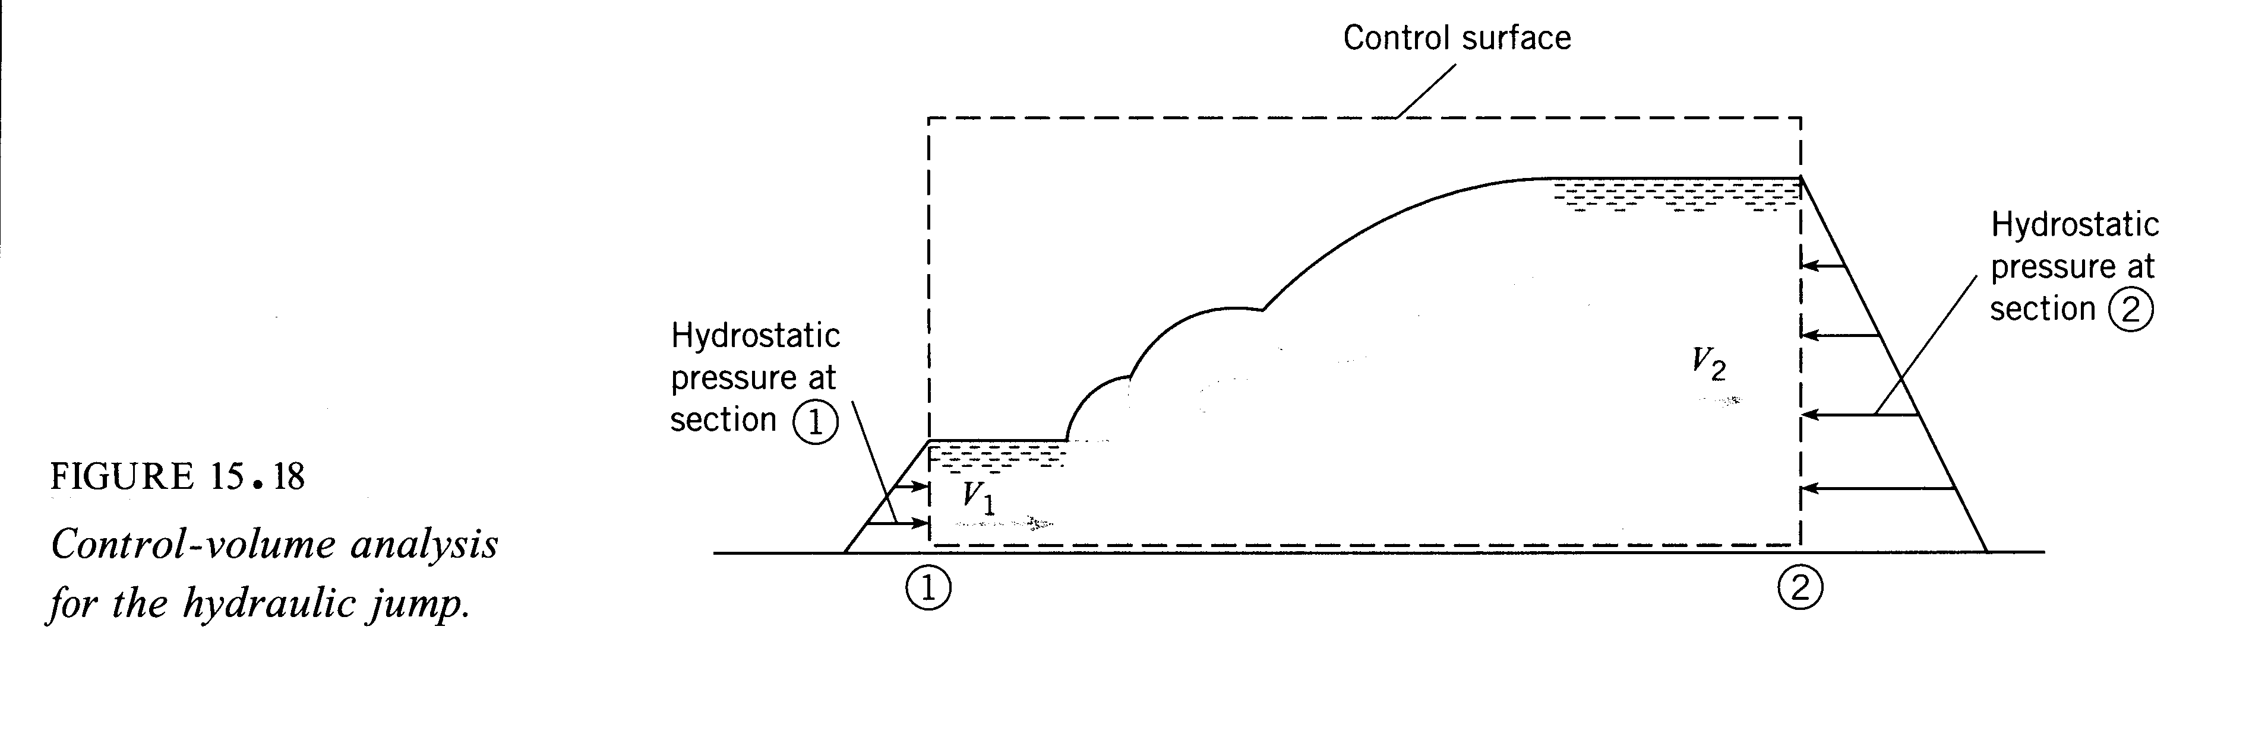

Say we assume that

V1 = V1(ρ, g, μ, y1, y2)

or V2 = V1y1/y2

Dimensional analysis is a procedure whereby the functional relationship can be expressed in terms of r nondimensional parameters in which r < n = number of variables. Such a reduction is significant since in an experimental or numerical investigation a reduced number of experiments or calculations is extremely beneficial

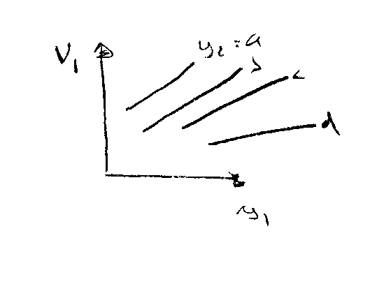

1. ρ, g fixed; vary μ

Represents many, many experiments

1. ρ, μ fixed; vary g
2. μ, g fixed; vary ρ

In general: F(A1, A2, …, An) = 0 dimensional form

f(Π1, Π2, … Πr) = 0 nondimensional form with reduced

or Π1 = Π1 (Π2, …, Πr) # of variables

It can be shown that



neglect μ (ρ drops out as will be shown)

thus only need one experiment to determine the functional relationship

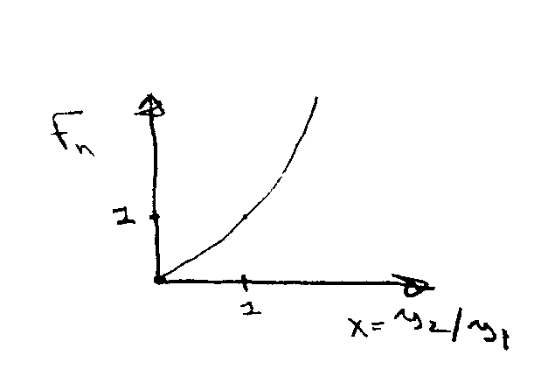 

x Fr

0 0

½ .61

1 1

2 1.7

5 3.9

For this particular application we can determine the functional relationship through the use of a control volume analysis: (neglecting μ and bottom friction)

x-momentum equation: 



Note: each term in equation must have some units: principle of dimensional homogeneity, i.e., in this case, force per unit width N/m



continuity equation: V1y1 = V2y2





pressure forces = inertial forces

due to gravity

now divide equation by 

 dimensionless equation

ratio of inertia forces/gravity forces = (Froude number)2

note: Fr = Fr(y2/y1) do not need to know both y2

and y1, only ratio to get Fr

Also, shows in an experiment it is not necessary to vary

γ, y1, y2, V1, and V2, but only Fr and y2/y1

Next, can get an estimate of hL from the energy equation (along free surface from 1→2)





≠ f(μ) due to assumptions made in deriving 1-D steady flow energy equations

Exponent method to determine Πj’s for Hydraulic jump

F(g,V1,y1,y2,ρ,μ) = 0 n = 6



m = 3 ⇒ r = n – m = 3

use V1, y1, ρ as

repeating variables

Assume  = m to avoid evaluating rank of 6 x 6 dimensional matrix

Π1 = V1x1 y1y1 ρz1 μ

= (LT-1)x1 (L)y1 (ML-3)z1 ML-1T-1

L x1 + y1 − 3z1 − 1 = 0 y1 = 3z1 + 1 − x1 = -1

T -x1  − 1 = 0 x1 = -1

M z1 + 1 = 0 z1 = -1

 or  = Reynolds number = Re

Π2 = V1x2 y1y2 ρz2 g

= (LT-1)x2 (L)y2 (ML-3)z2 LT-2

L x2 + y2 − 3z2 + 1 = 0 y2 = − 1 − x2 = 1

T -x2  − 2 = 0 x2 = -2

M z2 = 0

  = Froude number = Fr

Π3 = V1x3 y1y3 ρz3 y2

= (LT-1)x3 (L)y3 (ML-3)z3 L

L x3 + y3 − 3z3 + 1 = 0 y3 = − 1

T -x3 = 0

M -3z3 = 0

  = depth ratio

f(Π1, Π2, Π3) = 0

or, Π2 = Π2(Π1, Π3)

i.e., Fr = Fr(Re, y2/y1)

if we neglect μ then Re drops out



Note that dimensional analysis does not provide the actual functional relationship. Recall that previously we used control volume analysis to derive



the actual relationship between F vs. y2/y1

F = F(Re, Fr, y1/y2)

or Fr = Fr(Re, y1/y2)

dimensional matrix:

g V1 y1 y2 ρ μ

M 0 0 0 0 1 1

L 1 1 1 1 3 -1

Size of next smaller subgroup with nonzero determinant = 3 = rank of matrix

t -2 -1 0 0 0 -1

0 0 0 0 0 0

0 0 0 0 0 0

0 0 0 0 0 0

**Common Dimensionless Parameters for Fluid Flow Problems**

Most common physical quantities of importance in fluid flow problems are: (without heat transfer)

1 2 3 4 5 6 7 8

V, ρ, g, μ, σ, K, Δp, L

velocity density gravity viscosity surface compressibility pressure length

tension change

n = 8 m = 3 ⇒ 5 dimensionless parameters

$$F_{i}=Ma=ρL^{3}\frac{V^{2}}{L}$$

$$f_{i}={ρV^{2}}/L$$

1. Reynolds number =  

$$F_{ν}=τL^{2}=νVL$$

$$f_{v}={μV}/{L^{2}}$$

Re

Rcrit distinguishes among flow regions: laminar or turbulent

value varies depending upon flow situation

1. Froude number =  

$$F_{g}=γL^{3}$$

$$f_{g}=γ$$

Fr

### important parameter in free-surface flows

1. Weber number = 

$$F_{σ}=σL$$

$$f_{σ}=σ/{L^{2}}$$

We

important parameter at gas-liquid or liquid-liquid interfaces and when these surfaces are in contact with a boundary

1. Mach number = 

$$F_{c}=ρa^{2}L^{2}$$

$$f_{σ}={ρa^{2}}/L$$

# Ma

speed of sound in liquid

Paramount importance in high speed flow (V > c)

1. Pressure Coefficient =  

$$F_{p}=ΔpL^{2}$$

$$f_{p}={Δp}/L$$

Cp

(Euler Number)

## Nondimensionalization of the Basic Equation

It is very useful and instructive to nondimensionalize the basic equations and boundary conditions. Consider the situation for ρ and μ constant and for flow with a free surface

Continuity: 

Momentum: 

ρg = specific weight

Boundary Conditions:

1. fixed solid surface: 
2. inlet or outlet: V = Vo p = po
3. free surface:  

(z = η) surface tension

All variables are now nondimensionalized in terms of ρ and

U = reference velocity

L = reference length

 

 

All equations can be put in nondimensional form by making the substitution







and  etc.

Result: 



1)  Re-1

2)  

3)  

pressure coefficient

V = U

We-1

Fr-2

**Similarity and Model Testing**

Flow conditions for a model test are completely similar if all relevant dimensionless parameters have the same corresponding values for model and prototype

Πi model = Πi prototype i = 1, r = n -  (m)

Enables extrapolation from model to full scale

However, complete similarity usually not possible

Therefore, often it is necessary to use Re, or Fr, or Ma scaling, i.e., select most important Πand accommodate others as best possible

Types of Similarity:

1. Geometric Similarity (similar length scales):

A model and prototype are geometrically similar if and only if all body dimensions in all three coordinates have the same linear-scale ratios

α = Lm/Lp (α < 1)

1/10 or 1/50

1. Kinematic Similarity (similar length and time scales):

The motions of two systems are kinematically similar if homologous (same relative position) particles lie at homologous points at homologous times

1. Dynamic Similarity (similar length, time and force (or

mass) scales):

in addition to the requirements for kinematic similarity

the model and prototype forces must be in a constant

ratio

Model Testing in Water (with a free surface)

F(*D*, L, V, g, ρ, ν) = 0

⇒ n = 6 and m = 3 thus r = n – m = 3 pi terms

In a dimensionless form,

f(CD, Fr, Re) = 0

or CD = f(Fr, Re)

where

$C_{D}=\frac{D}{\frac{1}{2}ρV^{2}L^{2}}$

$Fr=\frac{V}{\sqrt{gL}}$

$Re=\frac{VL}{ν}$

If  or 

 Froude scaling

and Rem = Rep or 

  
Then,

${C_{D}}_{m}=C_{D_{p}}$ or $\frac{D_{m}}{ρ_{m}V_{m}^{2}L_{m}^{2}}=\frac{D_{p}}{ρ_{p}V_{p}^{2}L_{p}^{2}}$

However, impossible to achieve, since

if , 

For mercury 

Alternatively one could maintain Re similarity and obtain

Vm = Vp/α

But, if , ,

High speed testing is difficult and expensive.











But if , 

Impossible to achieve

## Model Testing in Air

F(*D*, L, V, ρ, ν, a) = 0

⇒ n = 6 and m = 3 thus r = n – m = 3 pi terms

In a dimensionless form,

f(CD, Re, Ma) = 0

or

CD = f(Re, Ma)

where

$C_{D}=\frac{D}{\frac{1}{2}ρV^{2}L^{2}}$

$Re=\frac{VL}{ν}$

$Ma=\frac{V}{a}$

If 

and 

Then,

${C_{D}}_{m}=C_{D_{p}}$ or $\frac{D_{m}}{ρ_{m}V_{m}^{2}L_{m}^{2}}=\frac{D_{p}}{ρ_{p}V_{p}^{2}L_{p}^{2}}$

1

However, 

again not possible

Therefore, in wind tunnel testing Re scaling is also violated

Model Studies w/o free surface



See text

High Re

Model Studies with free surface

In hydraulics model studies, Fr scaling used, but lack of We similarity can cause problems. Therefore, often models are distorted, i.e. vertical scale is increased by 10 or more compared to horizontal scale

Ship model testing:

CT = f(Re, Fr) = Cw(Fr) + Cv(Re)

Cwm = CTm − Cv

Based on flat plate of same surface area

Vm determined for Fr scaling

CTs = Cwm + Cv