Chapter 6 Momentum Analysis of Flow System

6.1 Momentum Equation

RTT with B = MV and β = V
$$\sum{\left[{\underline{F}}_{S}+{\underline{F}}_{B}\right]=\frac{d}{\text{dt}}\int_{\text{CV}}{ρ\underline{V}dV+\int_{\text{CS}}{\underline{V}ρ{\underline{V}}_{R}⋅\underline{\text{dA}}}}}$$
V = velocity referenced to an inertial frame (non-accelerating)
V_{R} = velocity referenced to control volume
F_{S} = surface forces + reaction forces (due to pressure and
viscous normal and shear stresses)
F_{B} = body force (due to gravity)

6.2 Applications of the Momentum Equation

Initial Setup and Signs
- Jet deflected by a plate or a vane
- Flow through a nozzle
- Forces on bends
- Problems involving non-uniform velocity distribution
- Motion of a rocket
- Force on rectangular sluice gate
- Water hammer

6.3 Moment of Momentum Equation

6.1 Derivation of the Basic Equation
General form for moving but
non-accelerating reference frame

Recall RTT: $\frac{{\text{dB}}_{\text{sys}}}{\text{dt}}=\frac{d}{\text{dt}}\int_{\text{CV}}{\text{βρ}dV}+\int_{\text{CS}}{\text{βρ}{\underline{V}}_{R}⋅\underline{\text{dA}}}$

V_{R}=velocity relative to CS=V – V_{S}=absolute – velocity CS
Subscript not shown in text but implied!
i.e., referenced to CV
small v in text and must be referenced to inertial reference frame
Let, B = MV = linear momentum
β = V

$$\frac{d(M\underline{V})}{\text{dt}}=\sum{\underline{F}}=\frac{d}{\text{dt}}\int_{\text{CV}}{\underline{V}ρdV}+\int_{\text{CS}}{\underline{V}ρ{\underline{V}}_{R}⋅\underline{\text{dA}}}$$
Must be relative to a non-accelerating inertial reference frame
Newton’s 2nd law
where ΣF = vector sum of all forces acting on the
control volume including both surface and
body forces
= ΣF_{S} + ΣF_{B}

ΣF_{S} = sum of all external surface forces acting at
the CS, i.e., pressure forces, forces
transmitted through solids, shear forces,etc.
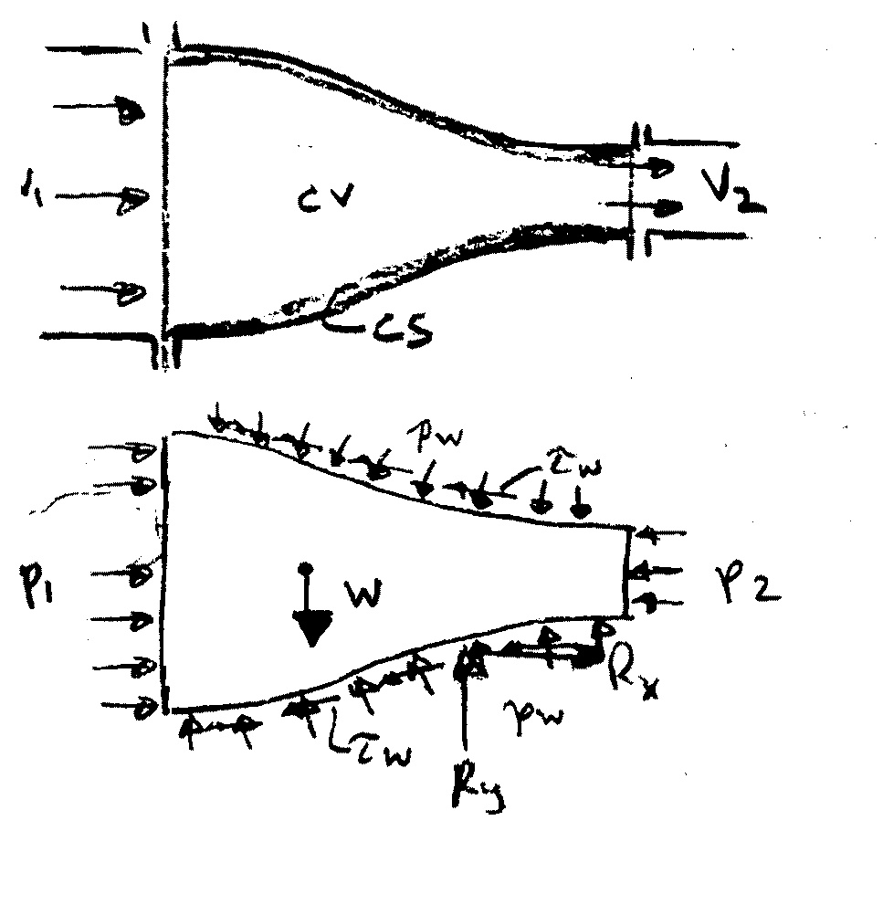
ΣF_{B} = sum of all external
body forces, i.e.,
gravity force

ΣF_{x} = p₁A₁ – p₂A₂ + R_{x}
ΣF_{y} = -W + R_{y}

R = resultant force on fluid
in CV due to p_{w} and τ_{w}
free body diagram
i.e., reaction force on fluid
Important Features (to be remembered)
- Vector equation to get component in any direction must
use dot product

x equation
$\sum{F_{x}=\frac{d}{\text{dt}}\int_{\text{CV}}{ρ\text{ud \{}V}}+\int_{\text{CS}}{ρu{\underline{V}}_{R}⋅\underline{\text{dA}}}$
Carefully define coordinate system with forces positive in positive direction of coordinate axes

y equation
$\sum{F_{y}=\frac{d}{\text{dt}}\int_{\text{CV}}{ρ\text{vd \{}V}}+\int_{\text{CS}}{ρv{\underline{V}}_{R}⋅\underline{\text{dA}}}$

z equation
$\sum{F_{z}=\frac{d}{\text{dt}}\int_{\text{CV}}{ρ\text{wd \{}V}}+\int_{\text{CS}}{ρw{\underline{V}}_{R}⋅\underline{\text{dA}}}$

- Carefully define control volume and be sure to include all external body and surface faces acting on it.
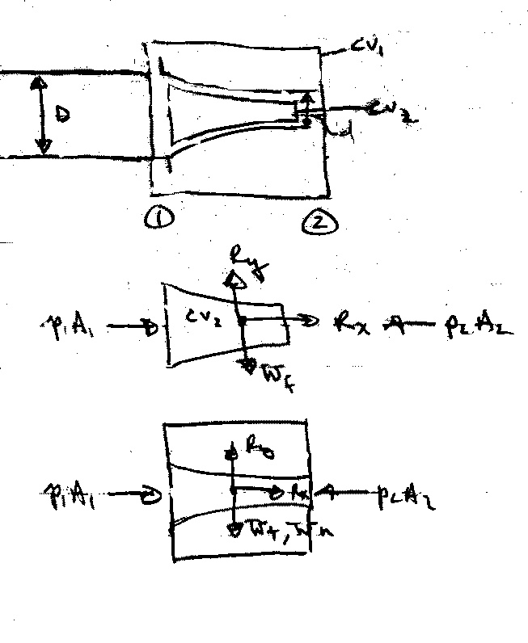
For example,

(R_{x},R_{y}) = reaction force on fluid

(R_{x},R_{y}) = reaction force on nozzle

- Velocity V must be referenced to a non-accelerating inertial reference frame. Sometimes it is advantageous to use a moving (at constant velocity) reference frame. Note V_{R} = V – V_{s} is always relative to CS.
Text uses small v
i.e., in these cases V used for B also referenced to CV (i.e., V = V_{R})
- Steady vs. Unsteady Flow

Steady flow ⇒ $\frac{d}{\text{dt}}\int_{\text{CV}}{ρ\underline{V}dV=0}$

- Uniform vs. Nonuniform Flow

$\int_{\text{CS}}{\underline{V}ρ{\underline{V}}_{R}⋅\underline{\text{dA}}}$ = change in flow of momentum across CS
= ΣVρV_{R}⋅A uniform flow across A

- F_{pres} = −$\int{p\underline{n}\text{dA}}$ $\int_{V}{∇\text{fd \{}V}=\int_{S}{f\underline{n}\text{ds}}$
f = constant, ∇f = 0
= 0 for p = constant and for a closed surface

i.e., always use gage pressure

- Pressure condition at a jet exit
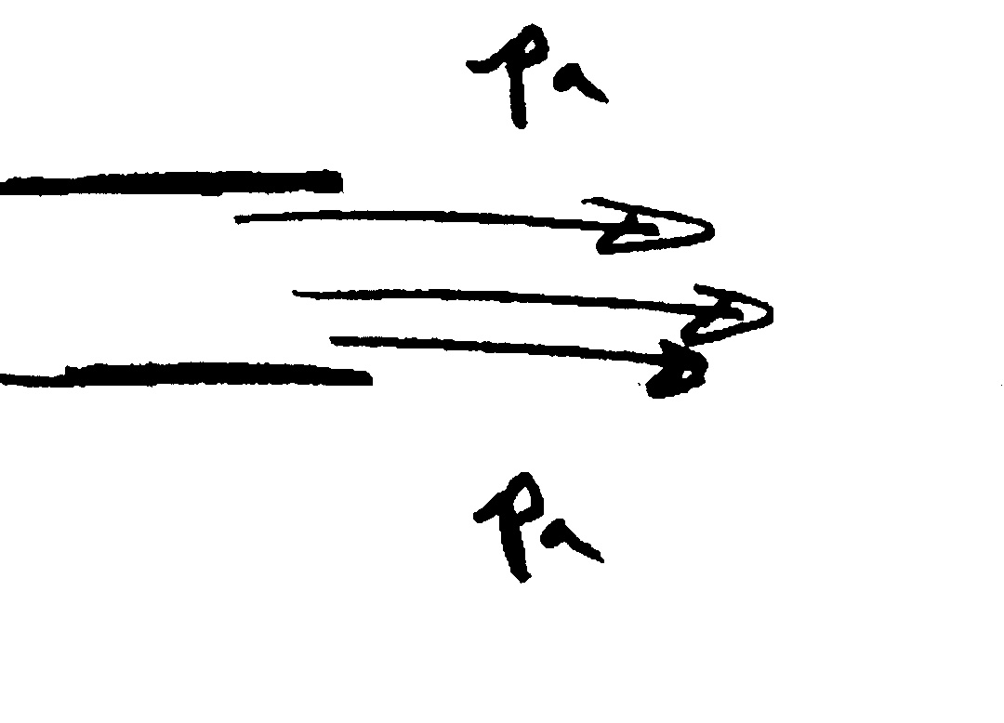
at an exit into the atmosphere jet pressure must be p_{a}

6.2 Application of the Momentum Equation
1. Jet deflected by a plate or vane

Consider a jet of water turned through a horizontal angle

CV and CS are for jet so that F_{x} and F_{y} are vane reactions forces on fluid

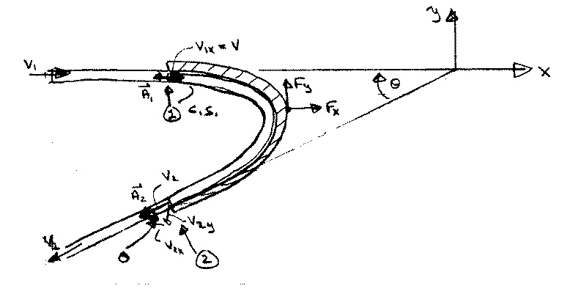
x-equation: $\sum{F_{x}=F_{x}=\frac{d}{\text{dt}}\int{ρ\text{ud \{}V}+\int_{\text{CS}}{ρu\underline{V}⋅\underline{\text{dA}}}}$
$F_{x}=\sum_{\text{CS}}{ρu\underline{V}⋅\underline{A}}$ steady flow

= ${ρV}_{1x}(−V_{1}A_{1})+{ρV}_{2x}(V_{2}A_{2})$

continuity equation: ρA₁V₁ = ρA₂V₂ = ρQ
for A₁ = A₂
V₁ = V₂

F_{x} = ρQ(V_{2x} – V_{1x})

y-equation: $\sum{F_{y}=F_{y}=\sum_{\text{CS}}{ρv\underline{V}⋅\underline{A}}}$
F_{y} = ρV_{1y}(– A₁V₁) + ρV_{2y}(– A₂V₂)
= ρQ(V_{2y} – V_{1y})

for above geometry only
where: V_{1x} = V₁ V_{2x} = -V₂cosθ V_{2y} = -V₂sinθ V_{1y} = 0
note: F_{x} and F_{y} are force on fluid
- F_{x} and -F_{y} are force on vane due to fluid
If the vane is moving with velocity V_{v}, then it is convenient to choose CV moving with the vane

i.e., V_{R} = V - V_{v} and V used for B also moving with vane

x-equation: $F_{x}=\int_{\text{CS}}{ρu{\underline{V}}_{R}⋅\underline{\text{dA}}}$

F_{x} = ρV_{1x}[-(V – V_{v})₁A₁] + ρV_{2x}[-(V – V_{v})₂A₂]

Continuity: 0 = $\int{ρ{\underline{V}}_{R}⋅\underline{\text{dA}}}$
i.e., ρ(V-V_{v})₁A₁ = ρ(V-V_{v})₂A₂ = ρ(V-V_{v})A
Q_{rel}
F_{x} = ρ(V-V_{v})A[V_{2x} – V_{1x}]
Q_{rel}

on fluid V_{2x} = (V – V_{v})_{2x}
For coordinate system moving with vane
V_{1x} = (V – V_{v})_{1x}

Power = -F_{x}V_{v} i.e., = 0 for V_{v} = 0

F_{y} = ρQ_{rel}(V_{2y} – V_{1y})

- Flow through a nozzle

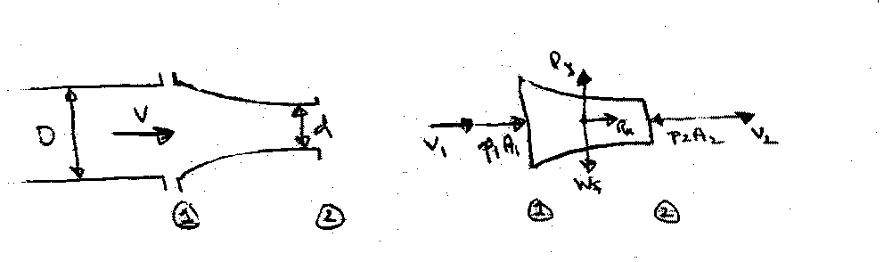
Consider a nozzle at the end of a pipe (or hose). What force is required to hold the nozzle in place?

CV = nozzle
and fluid
∴ (R_{x}, R_{y}) = force required to hold nozzle in place

Assume either the pipe velocity or pressure is known. Then, the unknown (velocity or pressure) and the exit velocity V₂ can be obtained from combined use of the continuity and Bernoulli equations.

Bernoulli: $p_{1}+{γz}_{1}+\frac{1}{2}{ρV}_{1}^{2}=p_{2}+{γz}_{2}+\frac{1}{2}{ρV}_{2}^{2}$ z₁=z₂
$p_{1}+\frac{1}{2}{ρV}_{1}^{2}=\frac{1}{2}{ρV}_{2}^{2}$

Continuity: A₁V₁ = A₂V₂ = Q
$V_{2}=\frac{A_{1}}{A_{2}}V_{1}={\left(\frac{D}{d}\right)}^{2}V_{1}$
$p_{1}+\frac{1}{2}{ρV}_{1}^{2}\left(1−{\left(\frac{D}{d}\right)}^{4}\right)=0$
Say p₁ known: $V_{1}={\left[\frac{−2p_{1}}{ρ\left(1−{\left(Dd\right)}^{4}\right)}\right]}^{1/2}$
To obtain the reaction force R_{x} apply momentum equation in x-direction

$\sum{F_{x}}=\frac{d}{\text{dt}}\int_{\text{CV}}{uρdV}+\int_{\text{CS}}{ρu\underline{V}⋅\underline{\text{dA}}}$
steady flow and uniform
flow over CS
=$\sum_{\text{CS}}{ρu\underline{V}⋅\underline{A}}$

R_{x} + p₁A₁ – p₂A₂ = ρV₁(-V₁A₁) + ρV₂(V₂A₂)
= ρQ(V₂ - V₁)
R_{x} = ρQ(V₂ - V₁) - p₁A₁

To obtain the reaction force R_{y} apply momentum equation in y-direction

$\sum{F_{y}=\sum_{\text{CS}}{ρv\underline{V}⋅\underline{A}=0}}$ since no flow in y-direction
R_{y} – W_{f} − W_{N} = 0 i.e., R_{y} = W_{f} + W_{N}

Numerical Example: Oil with S = .85 flows in pipe under pressure of 100 psi. Pipe diameter is 3” and nozzle tip diameter is 1”
$$ρ=\frac{Sγ}{g}=1\text{.}\text{65}$$
D/d = 3
Q = $\frac{π}{4}{\left(\frac{1}{\text{12}}\right)}^{2}V_{2}$
= .716 ft³/s

V₁ = 14.59 ft/s
V₂ = 131.3 ft/s

R_{x} = 141.48 – 706.86 = −569 lbf
R_{z} = 10 lbf

This is force on nozzle

3. Forces on Bends

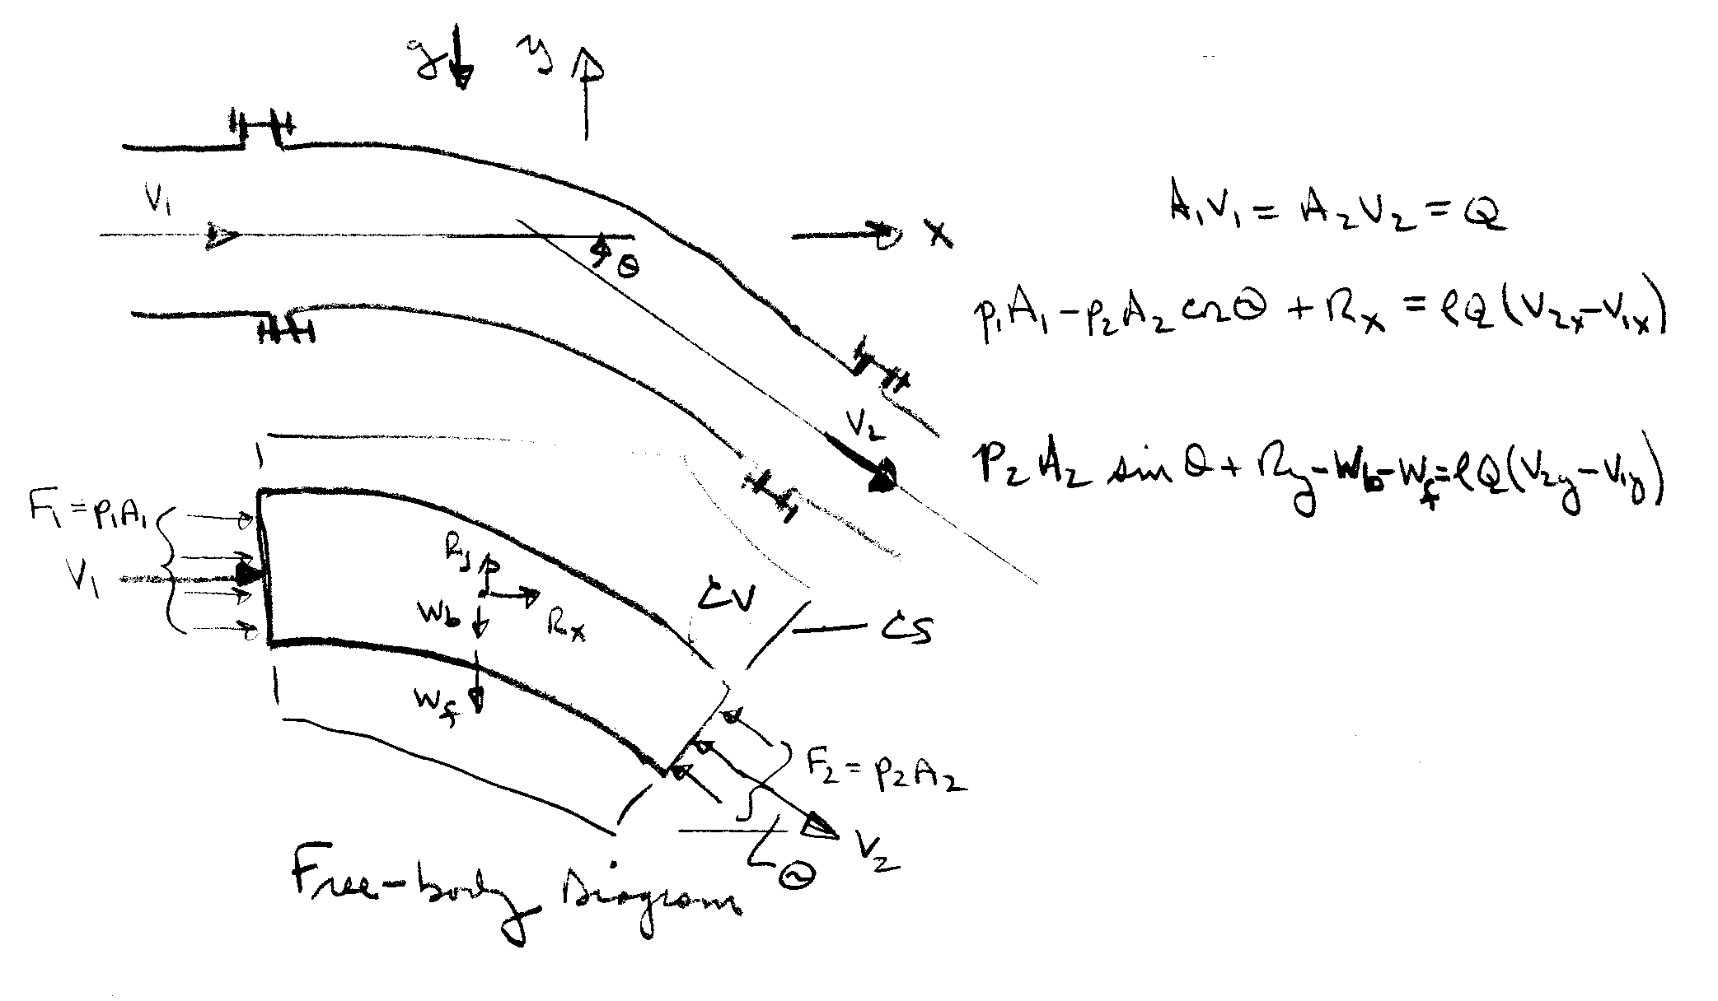
Consider the flow through a bend in a pipe. The flow is considered steady and uniform across the inlet and outlet sections. Of primary concern is the force required to hold the bend in place, i.e., the reaction forces R_{x} and R_{y} which can be determined by application of the momentum equation.

R_{x}, R_{y} = reaction force on
bend i.e., force
required to hold
bend in place

Continuity: $0=\sum{ρ\underline{V}⋅\underline{A}=−{ρV}_{1}A_{1}+{ρV}_{2}A_{2}}$
i.e., Q = constant = $V_{1}A_{1}=V_{2}A_{2}$

x-momentum: $\sum{F_{x}=\sum{ρu\underline{V}⋅\underline{A}}}$ $p_{1}A_{1}−p_{2}A_{2}\text{cos}θ+R_{x}={ρV}_{1x}\left(−V_{1}A_{1}\right)+{ρV}_{2x}\left(V_{2}A_{2}\right)$
= $ρQ\left(V_{2x}−V_{1x}\right)$

y-momentum: $\sum{F_{y}=\sum{ρv\underline{V}⋅\underline{A}}}$
$p_{2}A_{2}\text{sin}θ+R_{y}−w_{f}−w_{b}={ρV}_{1y}\left(−V_{1}A_{1}\right)+{ρV}_{2y}\left(V_{2}A_{2}\right)$ = $ρQ\left(V_{2y}−V_{1y}\right)$
4. Problems involving Nonuniform Velocity Distribution
See text pp. 192 − 194

5. Motion of a Rocket
See text pp. 194 − 198

6. Force on a rectangular sluice gate

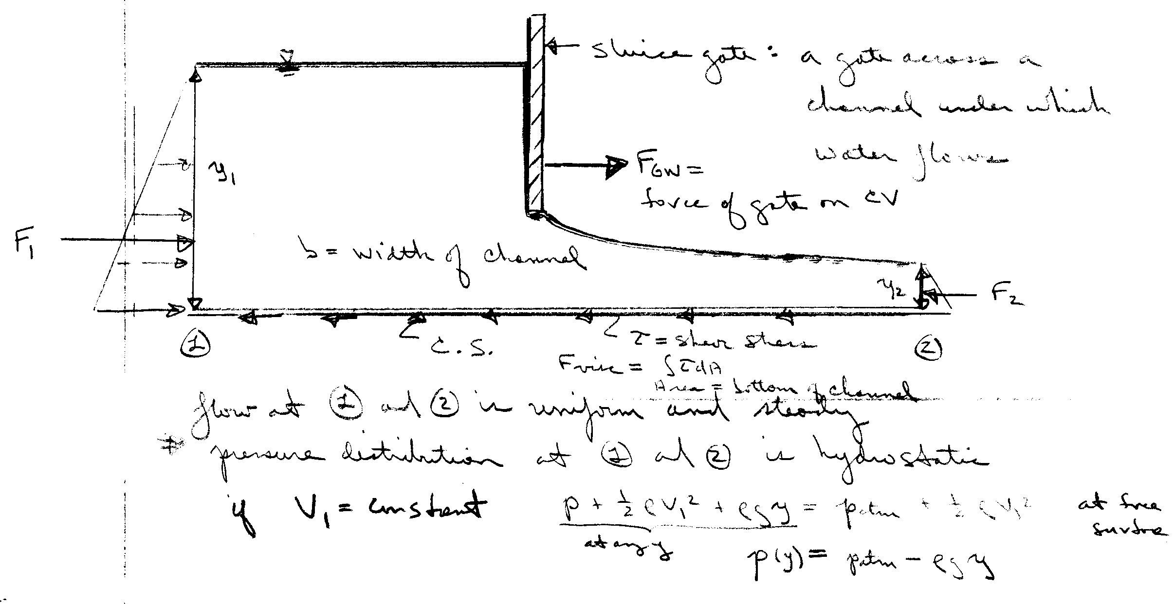
The force on the fluid due to the gate is calculated from the x-momentum equation:

$$\sum{F_{x}=\sum{ρu\underline{V}⋅\underline{A}}}$$

$$F_{1}+F_{\text{GW}}−F_{\text{visc}}−F_{2}={ρV}_{1}\left(−V_{1}A_{1}\right)+{ρV}_{2}\left(V_{2}A_{2}\right)$$
usually can be neglected
$$F_{\text{GW}}=F_{2}−F_{1}+ρQ\left(V_{2}−V_{1}\right)+F_{\text{visc}}$$
= $γ\frac{y_{2}}{2}⋅y_{2}b−γ\frac{y_{1}}{2}⋅y_{1}b+ρQ\left(V_{2}−V_{1}\right)$
$$F_{\text{GW}}=\frac{1}{2}bγ\left(y_{2}^{2}−y_{1}^{2}\right)+ρQ\left(V_{2}−V_{1}\right)$$
$$\begin{aligned}V_{1}=\frac{Q}{y_{1}b} \\ V_{2}=\frac{Q}{y_{2}b}\end{aligned}$$
$\frac{{ρQ}^{2}}{b}\left(\frac{1}{y_{2}}−\frac{1}{y_{1}}\right)$

- Water Hammer
See text pp. 198 − 204

6.3 Moment of Momentum Equation

See text pp. 248 − 259

