# Chapter 6 Differential Analysis of Fluid Flow

**Fluid Element Kinematics**

Fluid element motion consists of translation, linear deformation, rotation, and angular deformation.

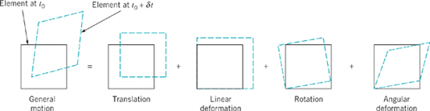

Types of motion and deformation for a fluid element.

Linear Motion and Deformation:

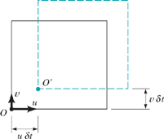

Translation of a fluid element

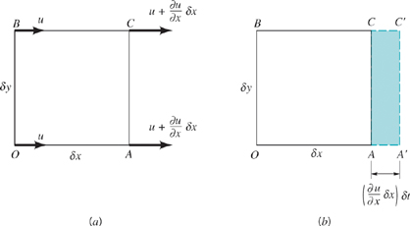

Linear deformation of a fluid element

Change in:



the rate at which the volume  is changing per unit volume due to the gradient ∂u/∂x is



If velocity gradients ∂v/∂y and ∂w/∂z are also present, then using a similar analysis it follows that, in the general case,



This rate of change of the volume per unit volume is called the volumetric dilatation rate.

Angular Motion and Deformation

For simplicity we will consider motion in the x–y plane, but the results can be readily extended to the more general case.

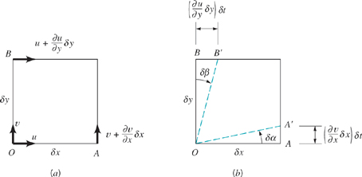

Angular motion and deformation of a fluid element

The angular velocity of line *OA*, ω*OA*, is



For small angles



so that



Note that if ∂*v*/∂*x* is positive, ω*OA* will be counterclockwise.

Similarly, the angular velocity of the line *OB* is



In this instance if ∂*u*/∂*y* is positive, ω*OB* will be clockwise.

The rotation, ω*z*, of the element about the *z* axis is defined as the average of the angular velocities ω*OA* and ω*OB* of the two mutually perpendicular lines *OA* and *OB*. Thus, if counterclockwise rotation is considered to be positive, it follows that



Rotation of the field element about the other two coordinate axes can be obtained in a similar manner:





The three components, ω*x*,ω*y*, and ω*z* can be combined to give the rotation vector, **ω**, in the form:



since





The vorticity, **ζ**, is defined as a vector that is twice the rotation vector; that is,



The use of the vorticity to describe the rotational characteristics of the fluid simply eliminates the (1/2) factor associated with the rotation vector. If , the flow is called irrotational.

In addition to the rotation associated with the derivatives ∂u/∂y and ∂v/∂x, these derivatives can cause the fluid element to undergo an angular deformation, which results in a change in shape of the element. The change in the original right angle formed by the lines OA and OB is termed the shearing strain, δγ,



The rate of change of δγ is called the rate of shearing strain or the rate of angular deformation:

$${\dot{γ}}_{xy}=\lim_{δt→0}{\frac{δγ}{δt}}=\lim_{δt→0}{\frac{δγ}{δt}}=\left[\frac{\left({∂v}/{∂x}\right)δt+\left({∂u}/{∂y}\right)δt}{δt}\right]=\frac{∂v}{∂x}+\frac{∂u}{∂y}$$

Similarly,

$${\dot{γ}}_{xz}=\frac{∂w}{∂x}+\frac{∂u}{∂z}$$

$${\dot{γ}}_{yz}=\frac{∂w}{∂y}+\frac{∂v}{∂z}$$

The rate of angular deformation is related to a corresponding shearing stress which causes the fluid element to change in shape.

**The Continuity Equation in Differential Form**

The governing equations can be expressed in both integral and differential form. Integral form is useful for large-scale control volume analysis, whereas the differential form is useful for relatively small-scale point analysis.

Application of RTT to a fixed elemental control volume yields the differential form of the governing equations. For example for conservation of mass



net outflow of mass = rate of decrease

across CS of mass within CV

Consider a cubical element oriented so that its sides are ⎢⎢to

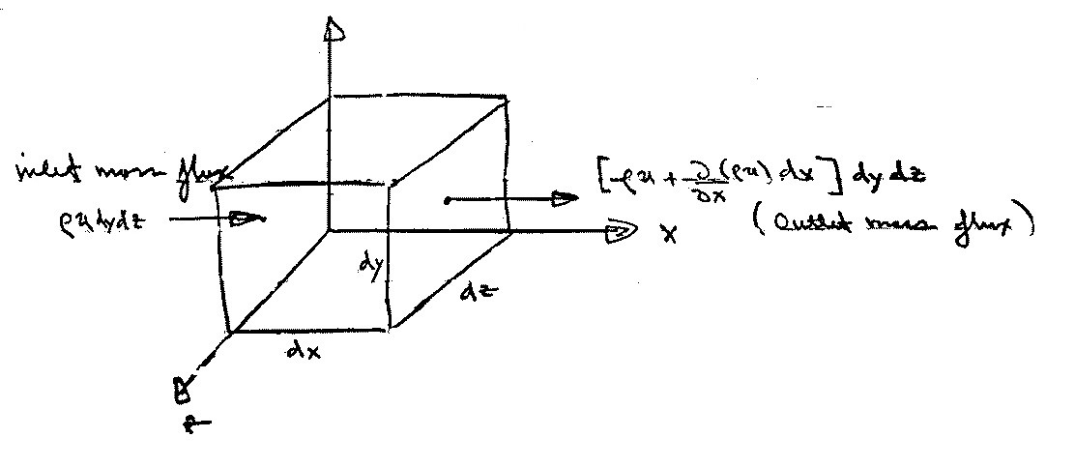the (x,y,z) axes



outlet mass flux

inlet mass flux

ρudydz

Taylor series expansion retaining only first order term

We assume that the element is infinitesimally small such that we can assume that the flow is approximately one dimensional through each face.

The mass flux terms occur on all six faces, three inlets, and three outlets. Consider the mass flux on the x faces



=

~~V~~

Similarly for the y and z faces



The total net mass outflux must balance the rate of decrease of mass within the CV which is



Combining the above expressions yields the desired result



per unit ~~V~~

differential form of continuity equations

d~~V~~



 

Nonlinear 1st order PDE; ( unless ρ = constant, then linear)

Relates V to satisfy kinematic condition of mass conservation

Simplifications:

1. Steady flow: 
2. ρ = constant: 

i.e.,  3D

 2D

The continuity equation in Cylindrical Polar Coordinates

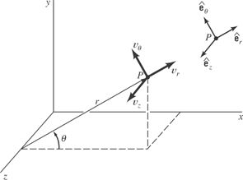

The velocity at some arbitrary point P can be expressed as



The continuity equation:



For steady, compressible flow



For incompressible fluids (for steady or unsteady flow)



The Stream Function

Steady, incompressible, plane, two-dimensional flow represents one of the simplest types of flow of practical importance. By plane, two-dimensional flow we mean that there are only two velocity components, such as u and v, when the flow is considered to be in the x–y plane. For this flow the continuity equation reduces to



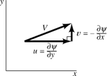

We still have two variables, u and v, to deal with, but they must be related in a special way as indicated. This equation suggests that if we define a function ψ(x, y), called the stream function, which relates the velocities as



then the continuity equation is identically satisfied:



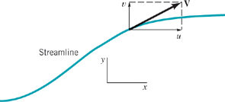

Velocity and velocity components along a streamline

Another particular advantage of using the stream function is related to the fact that lines along which ψ is constant are streamlines.The change in the value of ψ as we move from one point (x, y) to a nearby point (x + dx, y + dy) along a line of constant ψ is given by the relationship:



and, therefore, along a line of constant ψ



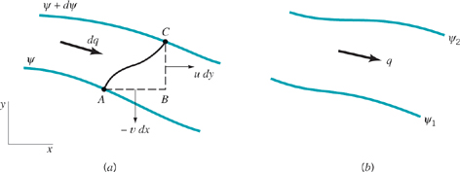

The flow between two streamlines

The actual numerical value associated with a particular streamline is not of particular significance, but the change in the value of ψ is related to the volume rate of flow. Let dq represent the volume rate of flow (per unit width perpendicular to the x–y plane) passing between the two streamlines.



Thus, the volume rate of flow, q, between two streamlines such as ψ1 and ψ2, can be determined by integrating to yield:



In cylindrical coordinates the continuity equation for incompressible, plane, two-dimensional flow reduces to



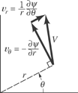

and the velocity components, vr and vθ, can be related to the stream function, ψ(r, θ), through the equations



**Navier-Stokes Equations**

Differential form of momentum equation can be derived by applying control volume form to elemental control volume

The differential equation of linear momentum: elemental fluid volume approach

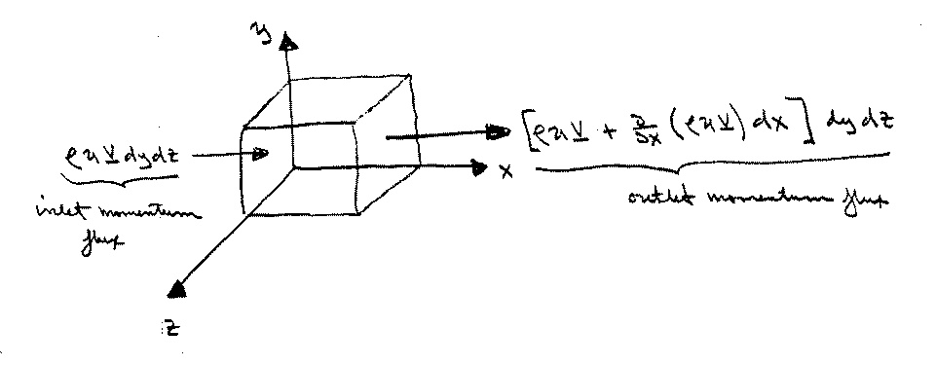

$$∑\underline{F}=\underset{(1)}{\underbrace{\frac{∂}{∂t}\int_{CV}{ρ\underline{V}dV}}}+\underset{(2)}{\underbrace{\int_{CS}{\underline{V}ρ\underline{V}⋅\hat{n}dA}}}$$

(1) = $\frac{∂}{∂t}\left(ρ\underline{V}\right)dxdydz=\left(\frac{∂ρ}{∂t}\underline{V}+ρ\frac{∂\underline{V}}{∂t}\right)dxdydz$

(2) = $\left[\underset{x-face}{\underbrace{\frac{∂}{∂x}\left(ρu\underline{V}\right)}}+\underset{y-face}{\underbrace{\frac{∂}{∂y}\left(ρv\underline{V}\right)}}+\underset{z-face}{\underbrace{\frac{∂}{∂z}\left(ρw\underline{V}\right)}}\right]dxdydz$

= $\left[ρu\frac{∂\underline{V}}{∂x}+\underline{V}\frac{∂ρu}{∂x}+ρv\frac{∂\underline{V}}{∂y}+\underline{V}\frac{∂ρv}{∂y}+ρw\frac{∂\underline{V}}{∂z}+\underline{V}\frac{∂ρw}{∂x}\right]dxdydz$

combining and making use of the continuity equation yields

$∑\underline{F}=\left[\underline{V}\left\{\underset{=0}{\underbrace{\frac{∂ρ}{∂t}+∇⋅\left(ρ\underline{V}\right)}}\right\}+ρ\left(\frac{∂\underline{V}}{∂t}+\underline{V}⋅∇\underline{V}\right)\right]dxdydz$

$∴ ∑\underline{F}=ρ\frac{D\underline{V}}{Dt}dxdydz$ or $∑\underline{f}=ρ\frac{D\underline{V}}{Dt}$

$\underline{V}⋅∇ =u\frac{∂}{∂x}+v\frac{∂}{∂y}+w\frac{∂}{∂z}$

$\frac{D}{Dt}=\frac{∂}{∂t}+\underline{V}⋅∇$

where $∑\underline{F}=∑{\underline{F}}_{body}+∑{\underline{F}}_{surface}$

$∑\underline{f}=∑{\underline{f}}_{body}+∑{\underline{f}}_{surface}$

Body forces are due to external fields such as gravity or magnetics. Here we only consider a gravitational field; that is,



and  for g↓ z↑

i.e., 

Surface forces are due to the stresses that act on the sides of the control surfaces

symmetric (σij = σji)

σij = - pδij + τij 2nd order tensor

δij = 1 i = j

δij = 0 i ≠ j

normal pressure viscous stress

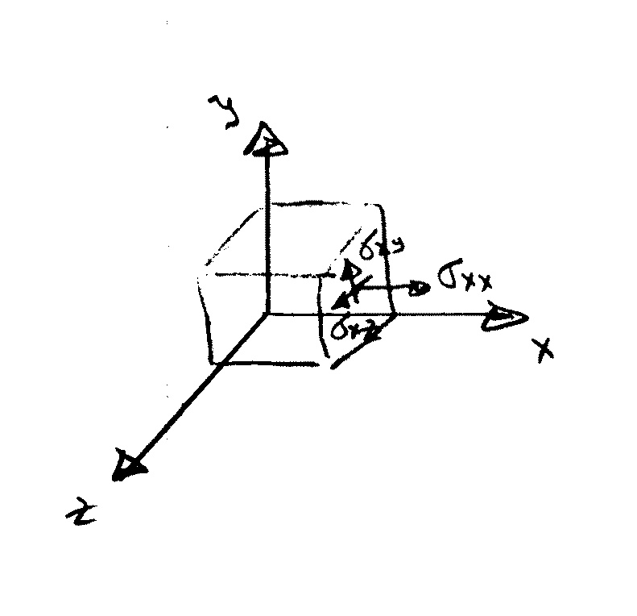

= -p+τxx τxy τxz

τyx -p+τyy τyz

τzx  τzy -p+τzz

As shown before for p alone it is not the stresses themselves that cause a net force but their gradients.

dFx,surf  = 

= 

This can be put in a more compact form by defining vector stress on x-face



and noting that

dFx,surf = 

fx,surf =  per unit volume

similarly for y and z

fy,surf =  

fz,surf =  

finally if we define

 then

 

Putting together the above results











inertia body

force force surface surface force

due to force due due to viscous

gravity to p shear and normal

stresses

For Newtonian fluid the shear stress is proportional to the rate of strain, which for incompressible flow can be written

$τ_{ij}=2με_{ij}=μ\left(\frac{∂u_{i}}{∂x_{j}}+\frac{∂u_{j}}{∂x_{i}}\right)$

where,

$μ$ = coefficient of viscosity

$ε_{ij}$ = rate of strain tensor

= $\left[\begin{matrix}\frac{∂u}{∂x} & \frac{1}{2}\left(\frac{∂v}{∂x}+\frac{∂u}{∂y}\right) & \frac{1}{2}\left(\frac{∂w}{∂x}+\frac{∂u}{∂z}\right) \\ \frac{1}{2}\left(\frac{∂u}{∂y}+\frac{∂v}{∂x}\right) & \frac{∂v}{∂y} & \frac{1}{2}\left(\frac{∂w}{∂y}+\frac{∂v}{∂z}\right) \\ \frac{1}{2}\left(\frac{∂u}{∂z}+\frac{∂w}{∂x}\right) & \frac{1}{2}\left(\frac{∂v}{∂z}+\frac{∂w}{∂y}\right) & \frac{∂w}{∂z}\end{matrix}\right]$

Ex) 1-D flow

$$τ=μ\frac{du}{dy}$$

$ρ\underline{a}=-ρg\hat{k}-∇p+∇⋅\left(τ_{ij}\right)$

where,

$∇⋅\left(τ_{ij}\right)=μ\frac{∂}{∂x_{j}}\left(\frac{∂u_{i}}{∂x_{j}}+\frac{∂u_{j}}{∂x_{i}}\right)=μ\left(\underset{∇^{2}\underline{V}}{\underbrace{\frac{∂^{2}u_{i}}{∂x_{j}^{2}}}}+\frac{∂}{∂x_{i}}\underset{=0}{\underbrace{\frac{∂u_{j}}{∂x_{j}}}}\right)$

$ρ\underline{a}=-ρg\hat{k}-∇p+μ∇^{2}\underline{V}$

$ρ\underline{a}=-∇\left(p+γz\right)+μ∇^{2}\underline{V}$ Navier-Stokes Equation

$∇⋅\underline{V}=0$ Continuity Equation

Four equations in four unknowns: V and p

Difficult to solve since 2nd order nonlinear PDE

x: $ρ\left[\frac{∂u}{∂t}+u\frac{∂u}{∂x}+v\frac{∂u}{∂y}+w\frac{∂u}{∂z}\right]=-\frac{∂p}{∂x}+μ\left[\frac{∂^{2}u}{∂x^{2}}+\frac{∂^{2}u}{∂y^{2}}+\frac{∂^{2}u}{∂z^{2}}\right]$

y: $ρ\left[\frac{∂v}{∂t}+u\frac{∂v}{∂x}+v\frac{∂v}{∂y}+w\frac{∂v}{∂z}\right]=-\frac{∂p}{∂y}+μ\left[\frac{∂^{2}v}{∂x^{2}}+\frac{∂^{2}v}{∂y^{2}}+\frac{∂^{2}v}{∂z^{2}}\right]$

z: $ρ\left[\frac{∂w}{∂t}+u\frac{∂w}{∂x}+v\frac{∂w}{∂y}+w\frac{∂w}{∂z}\right]=-\frac{∂p}{∂z}-ρg+μ\left[\frac{∂^{2}w}{∂x^{2}}+\frac{∂^{2}w}{∂y^{2}}+\frac{∂^{2}w}{∂z^{2}}\right]$



Navier-Stokes equations can also be written in other coordinate systems such as cylindrical, spherical, etc.

There are about 80 exact solutions for simple geometries. For practical geometries, the equations are reduced to algebraic form using finite differences and solved using computers.

Ex) Exact solution for laminar incompressible steady flow in a circular pipe

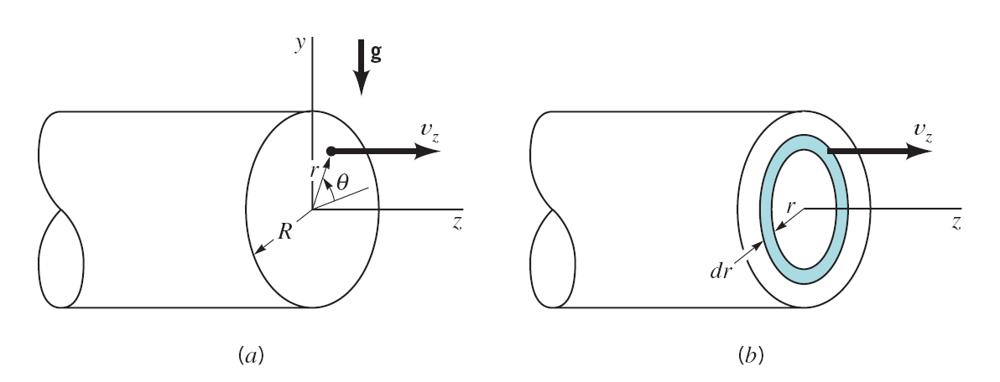

Use cylindrical coordinates with assumptions

$\frac{∂}{∂z}=0$: Fully-developed flow

$v_{θ}=0$: Flow is parallel to the wall

Continuity equation:

$\frac{1}{r}\frac{∂\left(rv_{r}\right)}{∂r}+\frac{1}{r}\frac{∂v_{θ}}{∂θ}+\frac{∂v_{z}}{∂z}=0$

$v_{r}=\frac{C}{r}$

B.C. $v_{r}\left(r=0\right)=0$ ⇒ $C=0$

i.e., $v_{r}=0$

Momentum equation:

$ρ\left(\frac{∂v_{r}}{∂t}+v_{r}\frac{∂v_{r}}{∂r}+\frac{v_{θ}}{r}\frac{∂v_{r}}{∂θ}-\frac{v_{θ}^{2}}{r}+v_{z}\frac{∂v_{r}}{∂z}\right)$

$=-\frac{∂p}{∂r}+ρg_{r}+μ\left[\frac{1}{r}\frac{∂}{∂r}\left(r\frac{∂v_{r}}{∂r}\right)-\frac{v_{r}}{r^{2}}+\frac{1}{r^{2}}\frac{∂^{2}v_{r}}{∂θ^{2}}-\frac{2}{r^{2}}\frac{∂v_{θ}}{∂θ}+\frac{∂^{2}v_{r}}{∂z^{2}}\right]$

$ρ\left(\frac{∂v_{θ}}{∂t}+v_{r}\frac{∂v_{θ}}{∂r}+\frac{v_{θ}}{r}\frac{∂v_{θ}}{∂θ}+\frac{v_{r}v_{θ}}{r}+v_{z}\frac{∂v_{θ}}{∂z}\right)$

$=-\frac{∂p}{∂θ}+ρg_{θ}+μ\left[\frac{1}{r}\frac{∂}{∂r}\left(r\frac{∂v_{θ}}{∂r}\right)-\frac{v_{θ}}{r^{2}}+\frac{1}{r^{2}}\frac{∂^{2}v_{θ}}{∂θ^{2}}+\frac{2}{r^{2}}\frac{∂v_{r}}{∂θ}+\frac{∂^{2}v_{θ}}{∂z^{2}}\right]$

$ρ\left(\frac{∂v_{z}}{∂t}+v_{r}\frac{∂z}{∂r}+\frac{v_{θ}}{r}\frac{∂v_{z}}{∂θ}+v_{z}\frac{∂v_{z}}{∂z}\right)$

$=-\frac{∂p}{∂z}+ρg_{z}+μ\left[\frac{1}{r}\frac{∂}{∂r}\left(r\frac{∂v_{z}}{∂r}\right)+\frac{1}{r^{2}}\frac{∂^{2}v_{z}}{∂θ^{2}}+\frac{∂^{2}v_{z}}{∂z^{2}}\right]$

or

$0=-ρg\sin{θ}-\frac{∂p}{∂r}$ (1)

$0=-ρg\cos{θ}-\frac{1}{r}\frac{∂p}{∂θ}$ (2)

$0=-\frac{∂p}{∂z}+μ\left[\frac{1}{r}\frac{∂}{∂r}\left(r\frac{∂v_{z}}{∂r}\right)\right]$ (3)

where,

$g_{r}=-g\sin{θ}$

$g_{θ}=-g\cos{θ}$

Equations (1) and (2) can be integrated to give

$$p=-ρg\left(r\sin{θ}\right)+f_{1}\left(z\right)=-ρgy+f_{1}\left(z\right)$$

⇒ pressure $p$ is hydrostatic and ${∂p}/{∂z}$ is not a function of $r$ or $θ$

Equation (3) can be written in the from

$$\frac{1}{r}\frac{∂}{∂r}\left(r\frac{∂v_{z}}{∂r}\right)=\frac{1}{μ}\frac{∂p}{∂z}$$

and integrated (using the fact that ${∂p}/{∂z}$ = constant) to give

$$r\frac{∂v_{z}}{∂r}=\frac{1}{2μ}\left(\frac{∂p}{∂z}\right)r^{2}+C_{1}$$

Integrating again we obtain

$$v_{z}=\frac{1}{4μ}\left(\frac{∂p}{∂z}\right)r^{2}+C_{1}\ln{r}+C_{2}$$

B.C.

$v_{z}\left(r=0\right)≠∞$ ⇒ $C_{1}=0$

$v_{z}\left(r=R\right)=0$ ⇒ $C_{2}=-\frac{1}{4μ}\left(\frac{∂p}{∂z}\right)R^{2}$

$$∴ v_{z}=\frac{1}{4μ}\left(\frac{∂p}{∂z}\right)\left(r^{2}-R^{2}\right)$$

⇒ at any cross section the velocity distribution is parabolic

1) Flow rate $Q$:

$$Q=\int_{0}^{R}{v_{z}dA}=2π\int_{0}^{R}{v_{z}rdr}=-\frac{πR^{4}}{8μ}\left(\frac{∂p}{∂z}\right)$$

where, $dA=\left(2πr\right)dr$

If the pressure drops $Δp$ over a length :

2) Mean velocity :

3) Maximum velocity $v_{max}$:

$$v_{max}=v_{z}\left(r=0\right)=-\frac{R^{2}}{4μ}\left(\frac{∂p}{∂z}\right)=\frac{R^{2}Δp}{4μl}=2V$$

⇒

$$\frac{v_{z}}{v_{max}}=1-{\left(\frac{r}{R}\right)}^{2}$$

**Differential Analysis of Fluid Flow**

We now discuss a couple of exact solutions to the Navier-Stokes equations. Although all known exact solutions (about 80) are for highly simplified geometries and flow conditions, they are very valuable as an aid to our understanding of the character of the NS equations and their solutions. Actually the examples to be discussed are for internal flow (Chapter 8) and open channel flow (Chapter 10), but they serve to underscore and display viscous flow. Finally, the derivations to follow utilize differential analysis. See the text for derivations using CV analysis.

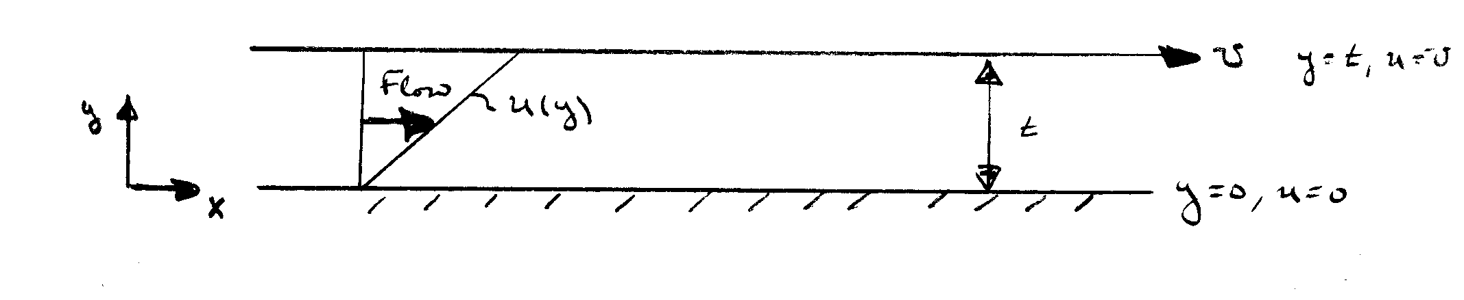Couette Flow

boundary conditions

First, consider flow due to the relative motion of two parallel plates

Continuity 

u = u(y)

v = o



Momentum 

or by CV continuity and momentum equations:



u1 = u2



= 0

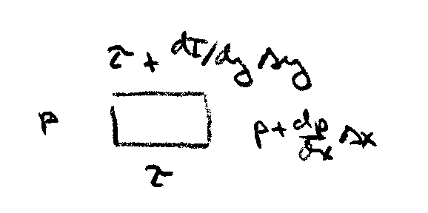



i.e. 



from momentum equation





u(0) = 0 ⇒ D = 0

u(t) = U ⇒ C = 



constant

Generalization for inclined flow with a constant pressure gradient

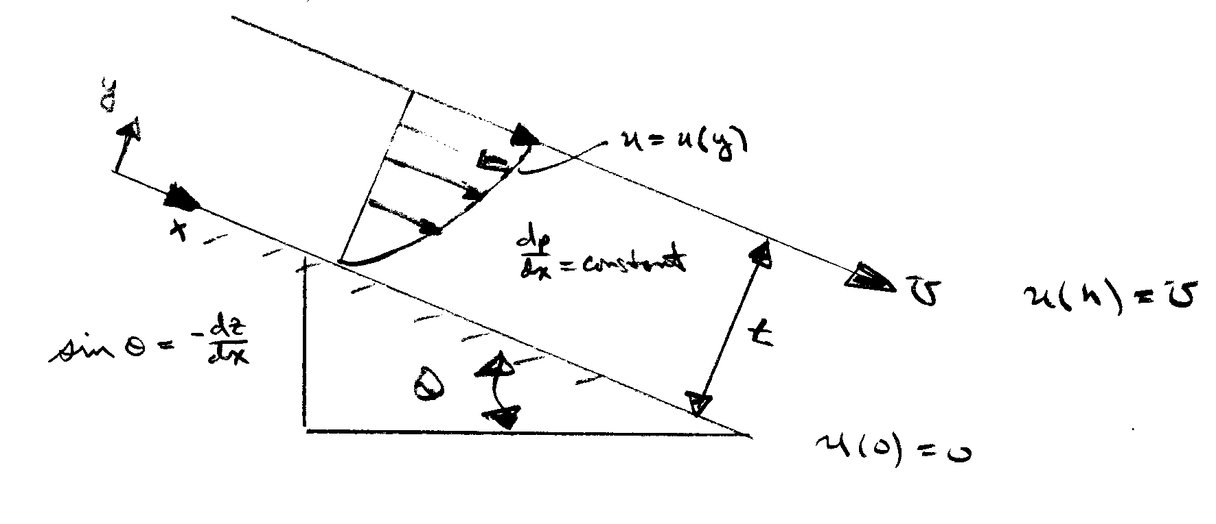

Continutity 

u = u(y)

v = o



Momentum 

i.e.,  h = p/γ +z = constant

plates horizontal 

plates vertical =-1

which can be integrated twice to yield





now apply boundary conditions to determine A and B

u(y = 0) = 0 ⇒ B = 0

u(y = t) = U





=

This equation can be put in non-dimensional form:



define: P = non-dimensional pressure gradient

=  

Y = y/t 

⇒ 

parabolic velocity profile

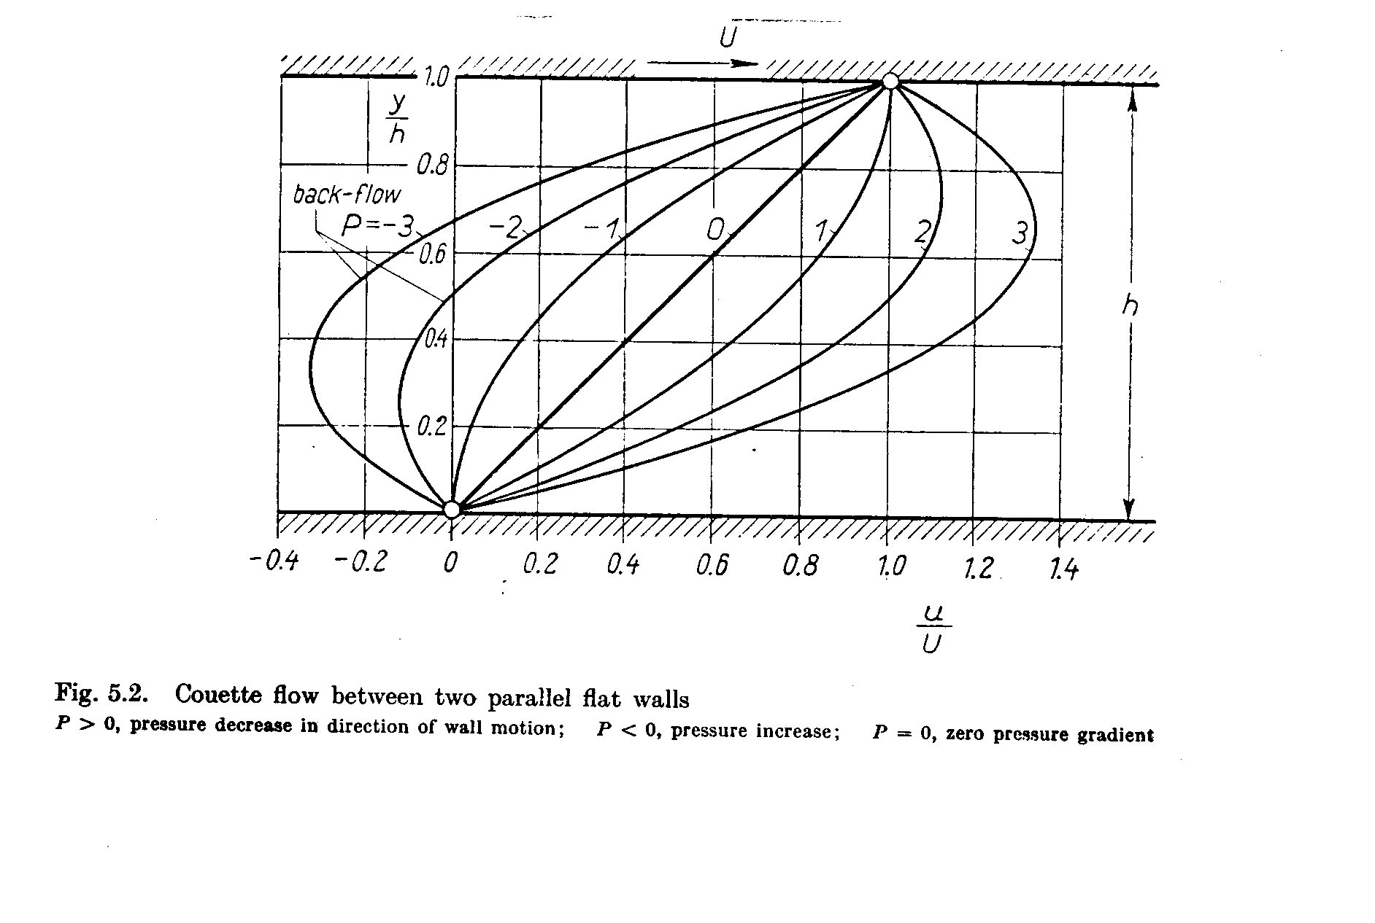





 =



For laminar flow  Recrit ~ 1000

The maximum velocity occurs at the value of y for which:

 

 @ umax

for U = 0, y = t/2



note: if U = 0: 

The shape of the velocity profile u(y) depends on P:

1. If P > 0, i.e., the pressure decreases in the

direction of flow (favorable pressure gradient) and the velocity is positive over the entire width



a) 

b) 

1. If P < 0, i.e.,  the pressure increases in the direction of flow (adverse pressure gradient) and the velocity over a portion of the width can become negative (backflow) near the stationary wall. In this case the dragging action of the faster layers exerted on the fluid particles near the stationary wall is insufficient to overcome the influence of the adverse pressure gradient.



 or 

1. If P = 0, i.e.,  the velocity profile is linear



a)  and θ = 0

Note: we derived this special case

b) 

For U = 0 the form  is not appropriate

u = UPY(1-Y)+UY

= 

Now let U = 0: 

3. Shear stress distribution

Non-dimensional velocity distribution



where  is the non-dimensional velocity,  
 is the non-dimensional pressure gradient  
 is the non-dimensional coordinate.

Shear stress



In order to see the effect of pressure gradient on shear stress using the non-dimensional velocity distribution, we define the non-dimensional shear stress:



Then









where  is a positive constant.

So the shear stress always varies linearly with across any section.

At the lower wall :



At the upper wall :



For favorable pressure gradient, the lower wall shear stress is always positive:

1. For small favorable pressure gradient :

 and 

2. For large favorable pressure gradient :

 and 



 

For adverse pressure gradient, the upper wall shear stress is always positive:

1. For small adverse pressure gradient :

 and 

2. For large adverse pressure gradient :

 and 



 

For , i.e., channel flow, the above non-dimensional form of velocity profile is not appropriate. Let’s use dimensional form:



Thus the fluid always flows in the direction of decreasing piezometric pressure or piezometric head because  and . So if  is negative, is positive; if  is positive, is negative.

Shear stress:



Since , the sign of shear stress  is always opposite to the sign of piezometric pressure gradient , and the magnitude of  is always maximum at both walls and zero at centerline of the channel.

For favorable pressure gradient, , 

For adverse pressure gradient, , 



 

Flow down an inclined plane

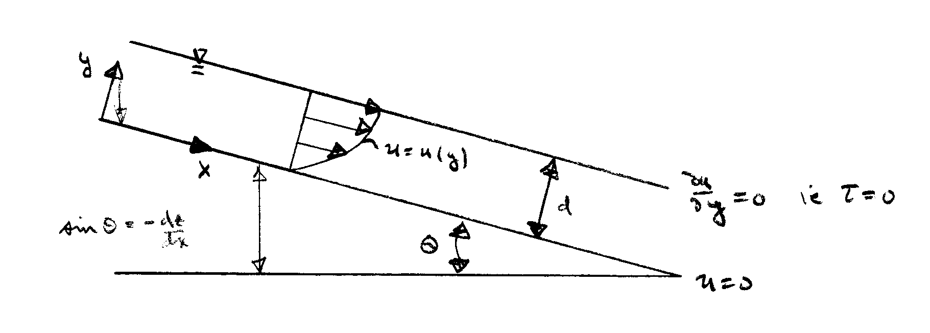uniform flow ⇒ velocity and depth do not

change in x-direction

Continuity 

x-momentum 

y-momentum hydrostatic pressure variation











u(0) = 0 ⇒ D = 0



=

u(y) =



discharge per unit width

= 



in terms of the slope So = tan θ ~ sin θ



Exp. show Recrit ~ 500, i.e., for Re > 500 the flow will become turbulent

  ~ 500





i.e., 

* p(d) > po

* if θ = 0 p = γ(d − y) + po

entire weight of fluid imposed

if θ = π/2 p = po

no pressure change through the fluid