Chapter 5 Mass, Bernoulli, and Energy Equations

5.1 Flow Rate and Conservation of Mass

- cross-sectional area oriented normal to velocity vector
(simple case where V ⊥ A)

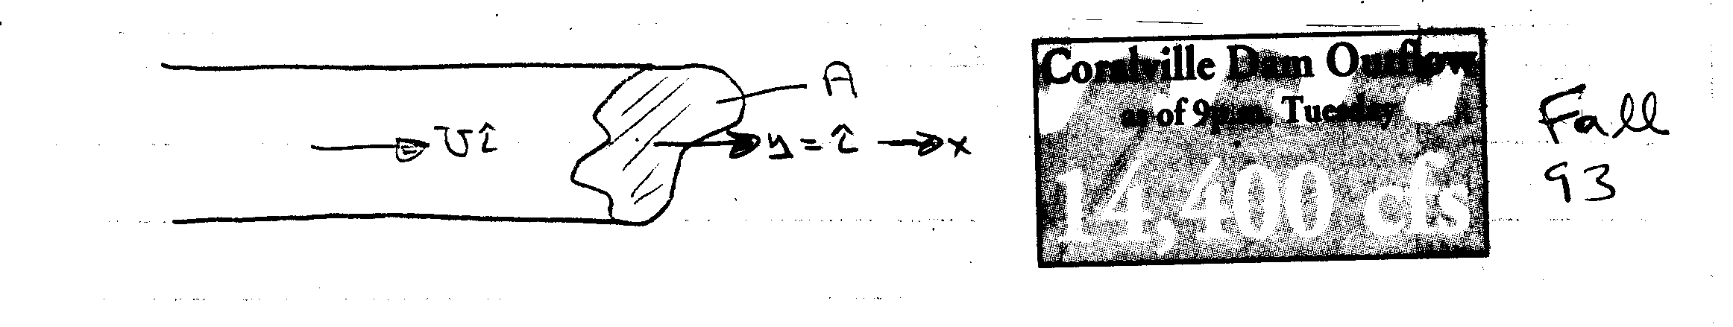
U = constant: Q = volume flux = UA [m/s × m² = m³/s]
U ≠ constant: Q = $\int_{A}{\text{UdA}}$
Similarly the mass flux = $\overset{˙}{m}=\int_{A}{ρ\text{UdA}}$

- general case
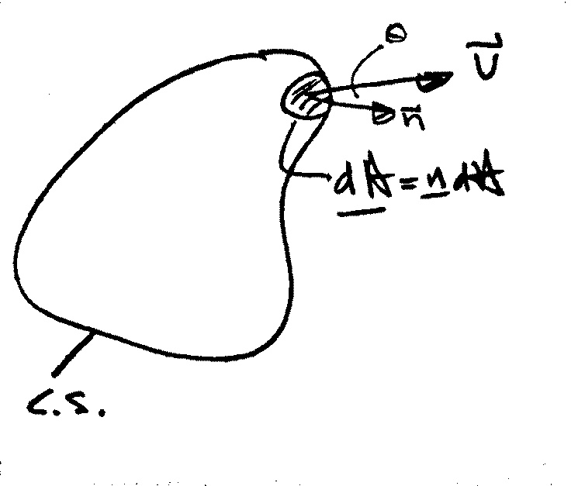

$\begin{aligned}Q=\int_{\text{CS}}{\underline{V}⋅\underline{n}\text{dA}} \\ =\int_{\text{CS}}{\left|\underline{V}\right|\text{cos}θ\text{dA}}\end{aligned}$
$$\overset{˙}{m}=\int_{\text{CS}}{ρ\left(\underline{V}⋅\underline{n}\right)\text{dA}}$$

average velocity: $\overline{V}=\frac{Q}{A}$

Example:
At low velocities the flow through a long circular tube, i.e. pipe, has a parabolic velocity distribution (actually paraboloid of revolution).
$$u=u_{\text{max}}\left(1−{\left(\frac{r}{R}\right)}^{2}\right)$$
i.e., centerline velocity
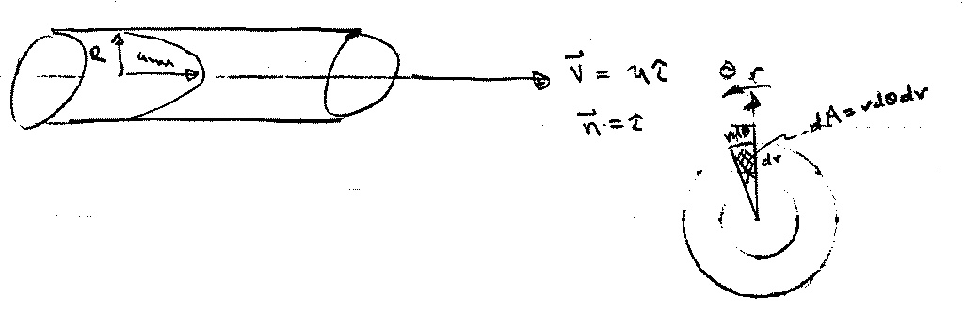

a) find Q and $\overline{V}$

$$Q=\int_{A}{\underline{V}⋅\underline{n}}\text{dA}=\int_{A}{\text{udA}}$$

$$\int_{A}{\text{udA}=\int_{0}^{2π}{\int_{0}^{R}{u(r)\text{rd}θ\text{dr}}}}$$
= $2π\int_{0}^{R}{u(r)\text{rdr}}$
dA = 2πrdr
u = u(r) and not θ ∴ $\int_{0}^{2π}{dθ=2π}$

Q = $2π\int_{0}^{R}{u_{\text{max}}\left(1−{\left(\frac{r}{R}\right)}^{2}\right)\text{rdr}}$ = $\frac{1}{2}u_{\text{max}}{πR}^{2}$
$$\overline{V}=\frac{1}{2}u_{\text{max}}$$

Continuity Equation

RTT can be used to obtain an integral relationship expressing conservation of mass by defining the extensive property B = M such that β = 1.

B = M = mass
β = dB/dM = 1

General Form of Continuity Equation

$$\frac{\text{dM}}{\text{dt}}=0=\frac{d}{\text{dt}}\int_{\text{CV}}{ρdV+\int_{\text{CS}}{ρ\underline{V}⋅\underline{\text{dA}}}}$$
or
$$\int_{\text{CS}}{ρ\underline{V}}⋅\underline{\text{dA}} = −\frac{d}{\text{dt}}\int_{\text{CV}}{ρdV}$$

net rate of outflow rate of decrease of
of mass across CS mass within CV

Simplifications:
- Steady flow: $−\frac{d}{\text{dt}}\int_{\text{CV}}{ρdV}=0$

- V = constant over discrete dA (flow sections):

$$\int_{\text{CS}}{ρ\underline{V}⋅\underline{\text{dA}}=\sum_{\text{CS}}{ρ\underline{V}⋅\underline{A}}}$$

- Incompressible fluid (ρ = constant)
conservation of volume

- Steady One-Dimensional Flow in a Conduit:
$$\sum_{\text{CS}}{ρ\underline{V}⋅\underline{A}=0}$$

−ρ₁V₁A₁ + ρ₂V₂A₂ = 0

for ρ = constant Q₁ = Q₂

Some useful definitions:

Mass flux $\overset{˙}{m}=\int_{A}{ρ\underline{V}⋅\underline{\text{dA}}}$

Volume flux $Q=\int_{A}{\underline{V}⋅\underline{\text{dA}}}$

Average Velocity $\overline{V}=Q/A$

Average Density $\overline{ρ}=\frac{1}{A}\int{ρ\text{dA}}$

Note: unless ρ = constant

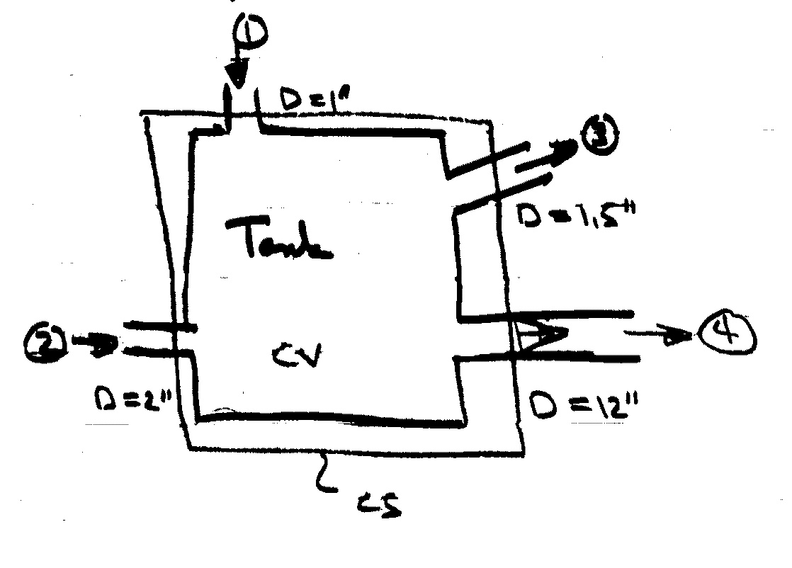
Example

*Steady flow
*V_{1,2,3} = 50 fps
*@  V varies linearly
from zero at wall to
V_{max} at pipe center
*find ${\overset{˙}{m}}_{4}$, Q₄, V_{max}
0 *water, ρ_{w} = 1.94 slug/ft³
$$\int_{\text{CS}}{ρ\underline{V}⋅\underline{\text{dA}}=0}=−\frac{d}{\text{dt}}\int_{\text{CV}}{ρdV}$$
$${\overset{˙}{m}}_{4}$$

i.e., -ρ₁V₁A₁ - ρ₂V₂A₂ + ρ₃V₃A₃ + ρ$\int_{A_{4}}{V_{4}{\text{dA}}_{4}}$= 0
ρ = const. = 1.94 lb-s² /ft⁴ = 1.94 slug/ft³

${\overset{˙}{m}}_{4}=ρ\int{V_{4}{\text{dA}}_{4}}$= ρV(A₁ + A₂ – A₃) V₁=V₂=V₃=V=50f/s
= $\frac{1\text{.}\text{94}}{\text{144}}×\text{50}×\frac{π}{4}\left(1^{2}+2^{2}−1\text{.}5^{2}\right)$
= 1.45 slugs/s

Q₄ = ${\overset{˙}{m}}_{4}/ρ=\text{.}\text{75}$ ft³/s

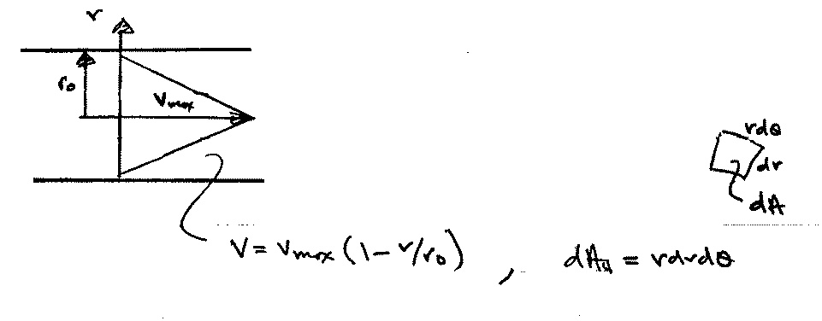
= $\int_{A_{4}}{V_{4}{\text{dA}}_{4}}$
velocity profile

Q₄ = $\int_{0}^{r_{o}}{\int_{0}^{2π}{V_{\text{max}}\left(1−\frac{r}{r_{o}}\right)\text{rd}θ\text{dr}}}$
dA₄
V₄ ≠ V₄(θ)

$\begin{aligned}=2π\int_{0}^{r_{o}}{V_{\text{max}}\left(1−\frac{r}{r_{o}}\right)\text{rdr}} \\ \\ =2{πV}_{\text{max}}\int_{0}^{r_{o}}{\left[r−\frac{r^{2}}{r_{o}}\right]}\text{dr} \\ \\ =2{πV}_{\text{max}}\left[\frac{r^{2}}{2}|_{0}^{r_{0}}−\frac{r^{3}}{3r_{o}}|_{0}^{r_{o}}\right] \\ \\ =2{πV}_{\text{max}}r_{o^{2}}\left[\frac{1}{2}−\frac{1}{3}\right]=\frac{1}{3}{πr}_{o^{2}}V_{\text{max}}\end{aligned}$
$${\overline{V}}_{4}=\frac{Q}{A}=\frac{\frac{1}{3}{πr}_{o}^{2}V_{\text{max}}}{{πr}_{o}^{2}}$$
= $\frac{1}{3}V_{\text{max}}$

V_{max} = $\frac{Q_{4}}{\frac{1}{3}{πr}_{o^{2}}}=2\text{.}\text{86}$fps
5.2 Mechanical Energy, Efficiency, Bernoulli Equations, Application, and Limitations

Assume irrotational, inviscid, and incompressible flow = ideal flow theory

Also, assume steady flow
Ω = ∇ × V = 0 ⇒ V = ∇ϕ irrotational

a = − ∇(p/ρ + gz), ∇ ⋅ V = 0 inviscid, incompressible
0
a = V ⋅∇V = ∇½V ⋅ V + V × (∇ × V) steady
= ∇½V² V² = V ⋅ V

$$∇\frac{1}{2}V^{2}=−∇\left(\frac{p}{ρ}+\text{gz}\right)$$

$$∇\left(\frac{1}{2}V^{2}+\frac{p}{ρ}+\text{gz}\right)=0$$

i.e., p + ½ρV² + γz = B = constant

p₁ + ½ρV₁² + γz₁ = p₂ + ½ρV₂² + γz₂

Also, from continuity and irrotational
∇ ⋅ V = 0 V = ∇ϕ = $\frac{∂ϕ}{∂x}\hat{i}+\frac{∂ϕ}{∂y}\hat{j}+\frac{∂ϕ}{∂z}\hat{k}$
∇ ⋅ ∇ϕ = 0 ϕ = velocity potential

∇²ϕ = 0 i.e., governing differential
equation for ϕ is Laplace equation
Application of Bernoulli’s Equation

Stagnation Tube
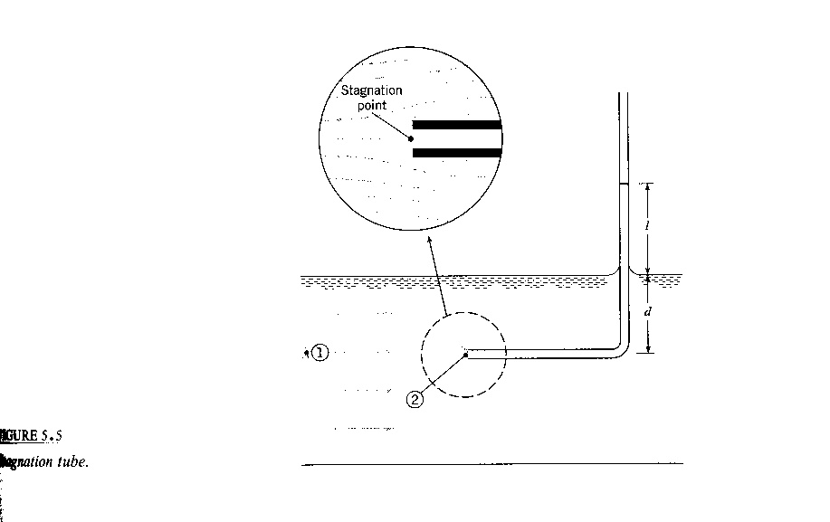

at  V = 0

$p_{1}+ρ\frac{V_{1}^{2}}{2}=p_{2}+ρ\frac{V_{2}^{2}}{2}$ z₁ = z₂

$V_{1}^{2}=\frac{2}{ρ}\left(p_{2}−p_{1}\right)$ $\begin{aligned}p_{1}=γd \\ p_{2}=γ\left(ℓ+d\right)\end{aligned}$
V₂ = 0
gage

= $\frac{2}{ρ}\left(γℓ\right)$
Limited by length of tube and need for free surface reference
$V_{1}=\sqrt{2gℓ}$
Pitot Tube
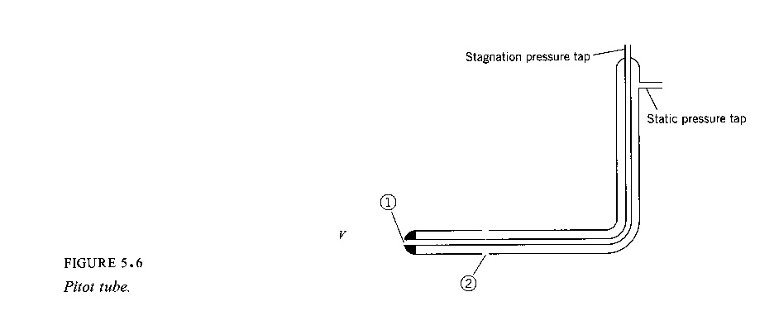

0
$$\frac{p_{1}}{γ}+\frac{V_{1}^{2}}{2g}+z_{1}=\frac{p_{2}}{γ}+\frac{V_{2}^{2}}{2g}+z_{2}$$
at  at 
$V_{2}={\left\{2g\left[\left(\frac{p_{1}}{γ}+z_{1}\right)−\left(\frac{p_{2}}{γ}+z_{2}\right)\right]\right\}}^{1/2}$ V₁ = 0

h₁ h₂
h = piezometric head
$V=V_{2}=\sqrt{2g\left(h_{1}−h_{2}\right)}$ h₁ – h₂ from manometer
or pressure gage

for gas flow $\frac{Δp}{γ}\text{>>}Δz$

$$V=\sqrt{\frac{2Δp}{ρ}}$$
5.3 Derivation of the Energy Equation

The First Law of Thermodynamics
The difference between the heat added to a system and the work done by a system depends only on the initial and final states of the system; that is, depends only on the change in energy E: principle of conservation of energy

ΔE = Q – W

ΔE = change in energy
Q = heat added to the system
W = work done by the system

E = E_{u} + E_{k} + E_{p} = total energy of the system
potential energy
kinetic energy
Internal energy due to molecular motion

The differential form of the first law of thermodynamics expresses the rate of change of E with respect to time

$\frac{\text{dE}}{\text{dt}}=\overset{˙}{Q}−\overset{˙}{W}$
rate of work being done by system

rate of heat transfer to system

Energy Equation for Fluid Flow
The energy equation for fluid flow is derived from Reynolds transport theorem with

B_{system} = E = total energy of the system (extensive property)

β = E/mass = e = energy per unit mass (intensive property)
= u + e_{k} + e_{p}

$$\frac{\text{dE}}{\text{dt}}=\frac{d}{\text{dt}}\int{ρ\text{ed \{}V}+\int{ρe\underline{V}⋅\underline{\text{dA}}}$$
$$\overset{˙}{Q}−\overset{˙}{W}=\frac{d}{\text{dt}}\int{ρ(u+e_{k}+e_{p})dV+}\int{ρ(u+e_{k}+e_{p})\underline{V}⋅\underline{\text{dA}}}$$

This can be put in a more useable form by noting the following:
$$e_{k}=\frac{\text{Total} \text{KE} \text{of} \text{mass} \text{with} \text{velocity} V}{\text{mass}}=\frac{Δ{{\text{MV}}^{2}}/2}{ΔM}=\frac{V^{2}}{2}$$
$$V^{2}=\left|\underline{V}\right|$$
$e_{p}=\frac{E_{p}}{ΔM}=\frac{γΔVz}{ρΔV}=\text{gz}$ (for E_{p} due to gravity only)

$$\overset{˙}{Q}−\overset{˙}{W}=\frac{d}{\text{dt}}\int{ρ\left(\frac{V^{2}}{2}+\text{gz}+u\right)dV+}\int{ρ\left(\frac{V^{2}}{2}+\text{gz}+u\right)\underline{V}⋅\underline{\text{dA}}}$$

rate of work rate of change flux of energy
done by system of energy in CV out of CV
(ie, across CS)
rate of heat
transfer to sysem
Rate of Work Components: $\overset{˙}{W}={\overset{˙}{W}}_{s}+{\overset{˙}{W}}_{f}$
For convenience of analysis, work is divided into shaft work W_{s} and flow work W_{f}

W_{f} = net work done on the surroundings as a result of
normal and tangential stresses acting at the control
surfaces
= W_{f pressure} + W_{f shear}

W_{s} = any other work transferred to the surroundings
usually in the form of a shaft which either takes
energy out of the system (turbine) or puts energy into
the system (pump)

Flow work due to pressure forces W_{f p} (for system)
Note: here $\underline{V}$ uniform over $\underline{A}$
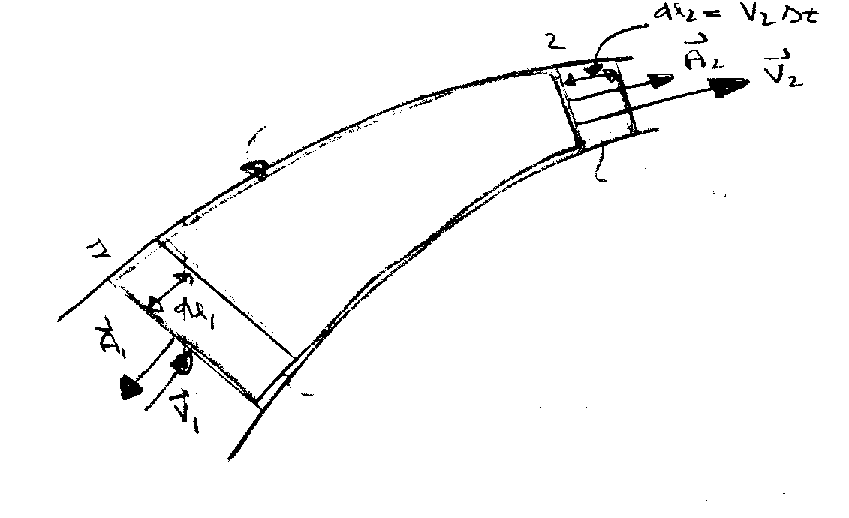
System at time t + Δt
System at time t
CS

CV

Work = force × distance
at 2 W₂ = p₂A₂ × V₂Δt
(on surroundings)
rate of work⇒ ${\overset{˙}{W}}_{2}=p_{2}A_{2}V_{2}=p_{2}{\underline{V}}_{2}⋅{\underline{A}}_{2}$

at 1 W₁ = −p₁A₁ × V₁Δt
neg. sign since pressure force on surrounding fluid acts in a direction opposite to the motion of the system boundary
${\overset{˙}{W}}_{1}=p_{1}{\underline{V}}_{1}⋅{\underline{A}}_{1}$

In general,

${\overset{˙}{W}}_{\text{fp}}=p\underline{V}⋅\underline{A}$

for more than one control surface and V not necessarily uniform over A:

${\overset{˙}{W}}_{\text{fp}}=\int{p\underline{V}⋅\underline{\text{dA}}}=\int{ρ\left(\frac{p}{ρ}\right)\underline{V}⋅\underline{\text{dA}}}$
${\overset{˙}{W}}_{f}={\overset{˙}{W}}_{\text{fp}}+{\overset{˙}{W}}_{\text{fshear}}$

Basic form of energy equation
$$\begin{aligned}\overset{˙}{Q}−{\overset{˙}{W}}_{s}−{\overset{˙}{W}}_{\text{fshear}}−\int{ρ\left(\frac{p}{ρ}\right)\underline{V}⋅\underline{\text{dA}}} \\ =\frac{d}{\text{dt}}\int{ρ\left(\frac{V^{2}}{2}+\text{gz}+u\right)dV}+\int{ρ\left(\frac{V^{2}}{2}+\text{gz}+u\right)\underline{V}⋅\underline{\text{dA}}}\end{aligned}$$
$\begin{aligned}\overset{˙}{Q}−{\overset{˙}{W}}_{s}−{\overset{˙}{W}}_{\text{fshear}}=\frac{d}{\text{dt}}\int{ρ\left(\frac{V^{2}}{2}+\text{gz}+u\right)dV} \\ +\int{ρ\left(\frac{V}{2}+\text{gz}+u+\frac{p}{ρ}\right)\underline{V}⋅\underline{\text{dA}}}\end{aligned}$ h=enthalpy

Usually this term can be eliminated by proper choice of CV, i.e. CS normal to flow lines. Also, at fixed boundaries the velocity is zero (no slip condition) and no shear stress flow work is done. Not included or discussed in text!

5.4 Simplified Forms of the Energy Equation

Energy Equation for Steady One-Dimensional Pipe Flow
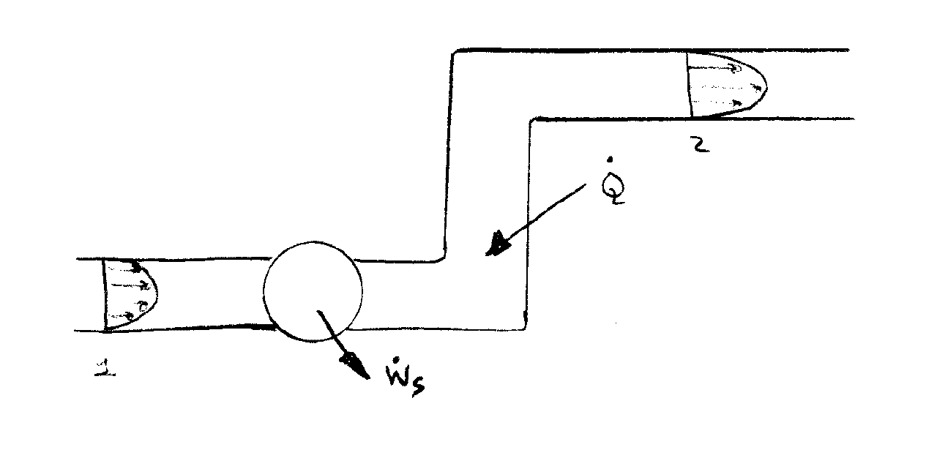
Consider flow through the pipe system as shown

Energy Equation (steady flow)
$$\overset{˙}{Q}−{\overset{˙}{W}}_{s}=\int{ρ\left(\frac{V^{2}}{2}+\text{gz}+\frac{p}{ρ}+u\right)\underline{V}⋅\underline{\text{dA}}}$$
$$\begin{aligned}\overset{˙}{Q}−{\overset{˙}{W}}_{s}+\int{\left(\frac{p_{1}}{ρ}+{\text{gz}}_{1}+u_{1}\right)ρ_{1}V_{1}A_{1}+\int{\frac{ρ_{1}V_{1}^{3}}{2}{\text{dA}}_{1}}} \\ =\int{\left(\frac{p_{2}}{ρ}+{\text{gz}}_{2}+u_{2}\right)ρ_{2}V_{2}A_{2}+\int{\frac{ρ_{2}V_{2}^{3}}{2}{\text{dA}}_{2}}}\end{aligned}$$

*Although the velocity varies across the flow sections the streamlines are assumed to be straight and parallel; consequently, there is no acceleration normal to the streamlines and the pressure is hydrostatically distributed, i.e., p/ρ +gz = constant.

*Furthermore, the internal energy u can be considered as constant across the flow sections, i.e. T = constant. These quantities can then be taken outside the integral sign to yield
$$\begin{aligned}\overset{˙}{Q}−{\overset{˙}{W}}_{s}+\left(\frac{p_{1}}{ρ}+{\text{gz}}_{1}+u_{1}\right)ρ\int{V_{1}{\text{dA}}_{1}}+ρ\int{\frac{V_{1}^{3}}{2}{\text{dA}}_{1}} \\ =\left(\frac{p_{2}}{ρ}+{\text{gz}}_{2}+u_{2}\right)ρ\int{V_{2}{\text{dA}}_{2}}+ρ\int{\frac{V_{2}^{3}}{2}{\text{dA}}_{2}}\end{aligned}$$

Recall that $Q=\int{\underline{V}⋅\underline{\text{dA}}}=\bar{V}A$
So that $ρ\int{\underline{V}⋅\underline{\text{dA}}}=ρ\bar{V}A=\overset{˙}{m}$ mass flow rate

Define: $ρ\int_{A}{\frac{V^{3}}{2}}\text{dA}=α\frac{ρ{\overline{V}}^{3}A}{2}=α\frac{{\overline{V}}^{2}}{2}\overset{˙}{m}$
K.E. flux K.E. flux for V=$\overline{V}$=constant across pipe

i.e., $α=\frac{1}{A}\int_{A}{{\left(\frac{V}{\overline{V}}\right)}^{3}\text{dA}}$ = kinetic energy correction factor

$\overset{˙}{Q}−\overset{˙}{W}+\left(\frac{p_{1}}{ρ}+{\text{gz}}_{1}+u_{1}+α_{1}\frac{{\overline{V}}_{1}^{2}}{2}\right)\overset{˙}{m}=\left(\frac{p_{2}}{ρ}+{\text{gz}}_{2}+u_{2}+α_{2}\frac{{\overline{V}}_{2}^{2}}{2}\right)\overset{˙}{m}$$\frac{1}{\overset{˙}{m}}\left(\overset{˙}{Q}−\overset{˙}{W}\right)+\frac{p_{1}}{ρ}+{\text{gz}}_{1}+u_{1}+α_{1}\frac{{\overline{V}}_{1}^{2}}{2}=\frac{p_{2}}{ρ}+{\text{gz}}_{2}+u_{2}+α_{2}\frac{{\overline{V}}_{2}^{2}}{2}$

note that: α = 1 if V is constant across the flow section
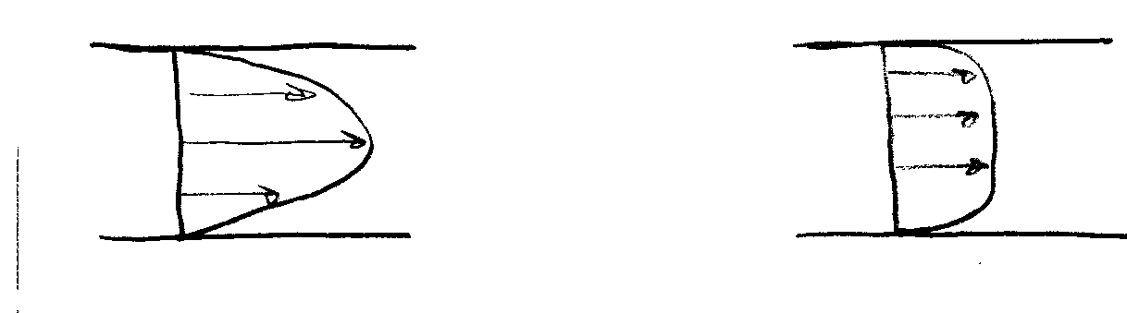
α > 1 if V is nonuniform

laminar flow α = 2 turbulent flow α = 1.05 ∼ 1 may
be used
Shaft Work
Shaft work is usually the result of a turbine or a pump in the flow system. When a fluid passes through a turbine, the fluid is doing shaft work on the surroundings; on the other hand, a pump does work on the fluid
${\overset{˙}{W}}_{s}={\overset{˙}{W}}_{t}−{\overset{˙}{W}}_{p}$ where ${\overset{˙}{W}}_{t}$ and ${\overset{˙}{W}}_{p}$ are
magnitudes of power $\left(\frac{\text{work}}{\text{time}}\right)$

Using this result in the energy equation and deviding by g results in

$$\frac{{\overset{˙}{W}}_{p}}{\overset{˙}{m}g}+\frac{p_{1}}{γ}+z_{1}+α_{1}\frac{{\bar{V}}_{1}^{2}}{2}=\frac{{\overset{˙}{W}}_{t}}{\overset{˙}{m}g}+\frac{p_{2}}{γ}+z_{2}+α_{2}\frac{{\bar{V}}_{2}^{2}}{2}+\frac{u_{2}−u_{1}}{g}−\frac{\overset{˙}{Q}}{\overset{˙}{m}g}$$
mechanical part thermal part

Note: each term has dimensions of length
Define the following:

$$h_{p}=\frac{{\overset{˙}{W}}_{p}}{\overset{˙}{m}g}=\frac{{\overset{˙}{W}}_{p}}{ρ\text{Qg}}=\frac{{\overset{˙}{W}}_{p}}{γQ}$$

$$h_{t}=\frac{{\overset{˙}{W}}_{t}}{\overset{˙}{m}g}$$

$$h_{L}=\frac{u_{2}−u_{1}}{g}−\frac{\overset{˙}{Q}}{\overset{˙}{m}g}=\text{head} \text{loss}$$
Head Loss
In a general fluid system a certain amount of mechanical energy is converted to thermal energy due to viscous action. This effect results in an increase in the fluid internal energy. Also, some heat will be generated through energy dissipation and be lost (i.e. -$\overset{˙}{Q}$). Therefore the term
from 2nd law
represents a loss in mechanical energy due to viscous stresses
$h_{L}=\frac{u_{2}−u_{1}}{g}−\frac{\overset{˙}{Q}}{g\overset{˙}{m}}>0$

Note that adding $\overset{˙}{Q}$ to system will not make h_{L} = 0 since this also increases Δu. It can be shown from 2nd law of thermodynamics that h_{L} > 0.

Drop ⎯ over $\bar{V}$ and understand that V in energy equation refers to average velocity.

Using the above definitions in the energy equation results in (steady 1-D incompressible flow)

$$\frac{p_{1}}{γ}+α_{1}\frac{V_{1}^{2}}{2g}+z_{1}+h_{p}=\frac{p_{2}}{γ}+α_{2}\frac{V_{2}^{2}}{2g}+z_{2}+h_{t}+h_{L}$$

form of energy equation used for this course!
Comparison of Energy Equation and Bernoulli Equation:

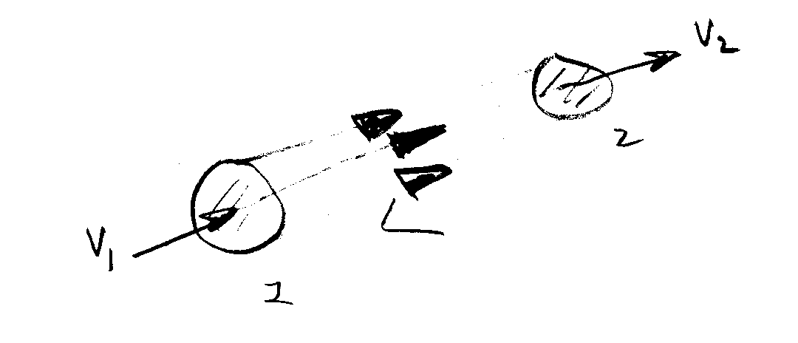
Apply energy equation to a stream tube without any shaft work
Infinitesimal stream tube ⇒ α₁=α₂=1

Energy eq : $\frac{p_{1}}{γ}+\frac{V_{1}^{2}}{2g}+z_{1}=\frac{p_{2}}{γ}+\frac{V_{2}^{2}}{2g}+z_{2}+h_{L}$

•If h_{L} = 0 (i.e., μ = 0) we get Bernoulli equation and conservation of mechanical energy along a streamline

•Therefore, energy equation for steady 1-D pipe flow can be interpreted as a modified Bernoulli equation to include viscous effects (h_{L}) and shaft work (h_{p} or h_{t})
5.5 Concept of Hydraulic and Energy Grade Lines

$$\frac{p_{1}}{γ}+α_{1}\frac{V_{1}^{2}}{2g}+z_{1}+h_{p}=\frac{p_{2}}{γ}+α_{2}\frac{V_{2}^{2}}{2g}+z_{2}+h_{t}+h_{L}$$
Define HGL = $\frac{p}{γ}+z$
point-by-point application is graphically displayed
EGL = $\frac{p}{γ}+z+α\frac{V^{2}}{2g}$

HGL corresponds to pressure tap measurement + z

EGL corresponds to stagnation tube measurement + z
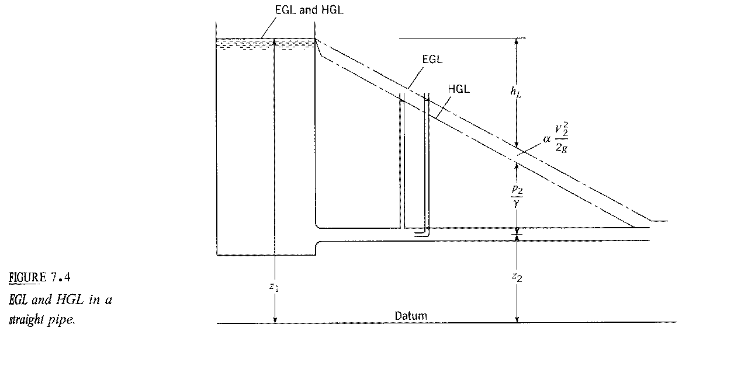
EGL = HGL if V = 0
h_{L} = $f\frac{L}{D}\frac{V^{2}}{2g}$
i.e., linear variation in L for D,
V, and f constant
EGL₁ = EGL₂ + h_{L}
for h_{p} = h_{t} = 0

f = friction factor
f = f(Re)

pressure tap: $\frac{p_{2}}{γ}=h$
h = height of fluid in
tap/tube
stagnation tube: $\frac{p_{2}}{γ}+α\frac{V_{2}^{2}}{2g}=h$

EGL₁ + h_{p} = EGL₂ + h_{t} + h_{L}
EGL₂ = EGL₁ + h_{p} − h_{t} − h_{L}
abrupt change due to h_{p} or h_{t}
$$f\frac{L}{D}\frac{V^{2}}{2g}$$
Helpful hints for drawing HGL and EGL

- EGL = HGL + αV²/2g = HGL for V = 0

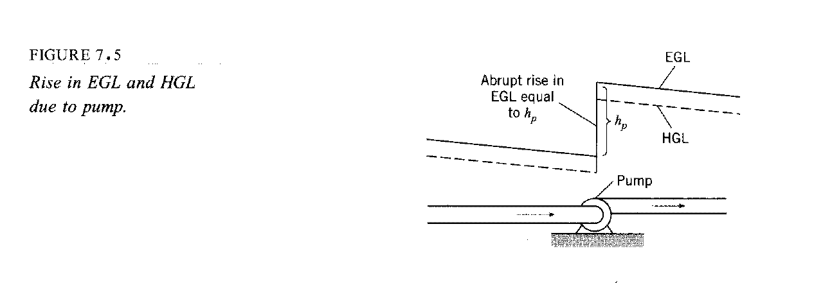
2.&3. $h_{L}=f\frac{L}{D}\frac{V^{2}}{2g}$ in pipe means EGL and HGL will slope
downward, except for abrupt changes due to h_{t} or h_{p}

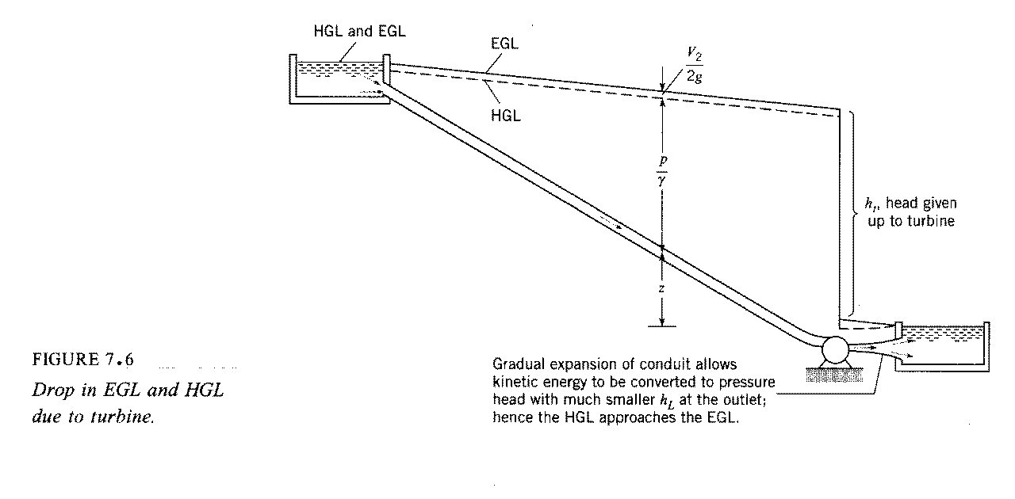
$$\frac{p_{1}}{γ}+z_{1}+\frac{V_{1}^{2}}{2g}=\frac{p_{2}}{γ}+z_{2}+\frac{V_{2}^{2}}{2g}+h_{L}$$
HGL₂ = EGL₁ - h_{L}
$h_{L}=\frac{V^{2}}{2g}$for abrupt expansion
4. p = 0 ⇒ HGL = z

5. for $h_{L}=f\frac{L}{D}\frac{V^{2}}{2g}$ = constant × L
i.e., linearly increased for increasing L with slope $\frac{f}{D}\frac{V^{2}}{2g}$

EGL/HGL slope downward

6. for change in D ⇒ change in V

i.e. V₁A₁ = V₂A₂
change in distance between HGL & EGL and slope
change due to change in h_{L}
$V_{1}\frac{{πD}_{1}^{2}}{4}=V_{2}\frac{{πD}_{2}^{2}}{4}$
⇒
$V_{1}D_{1}^{2}=V_{1}D_{2}^{2}$

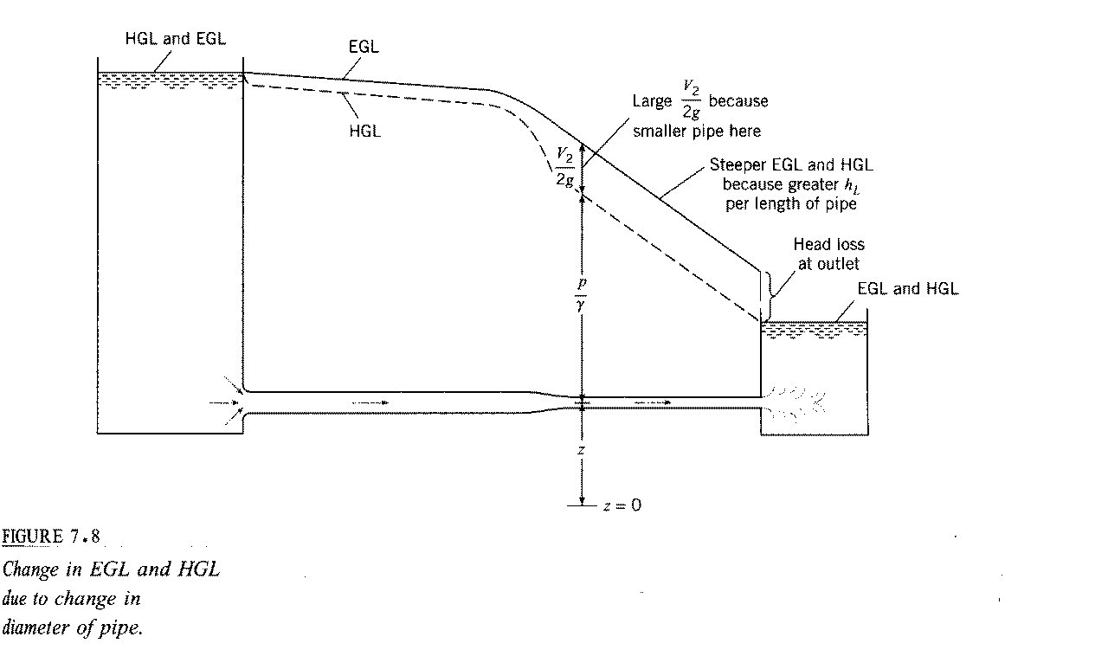
7. If HGL < z then p/γ < 0 i.e., cavitation possible

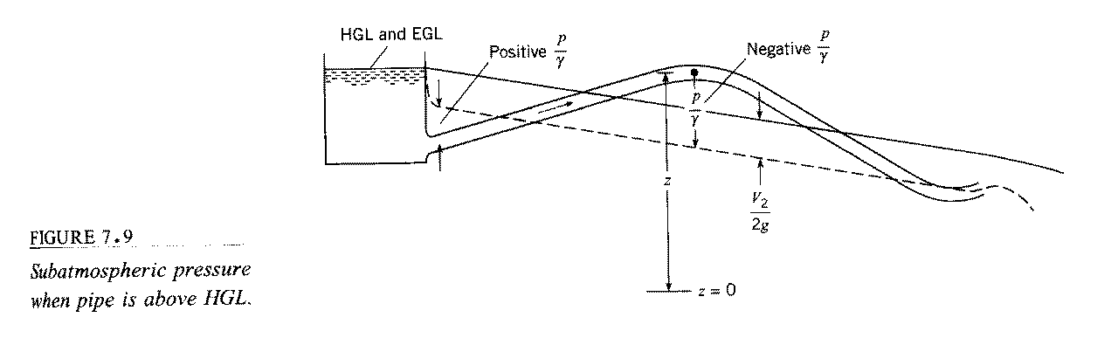

condition for cavitation:

$p=p_{\text{va}}=\text{2000}\frac{N}{m^{2}}$

gage pressure $p_{\text{va},g}=p_{A}−p_{\text{atm}}≈−p_{\text{atm}}=−\text{100},\text{000}\frac{N}{m^{2}}$

$\frac{p_{\text{va},g}}{γ}≈−\text{10}m$

9810 N/m³
Summary of the Energy Equation

The energy equation is derived from Reynolds Transport Theorem with

B = E = total energy of the system

β = e = E/M = energy per unit mass

= u + $\frac{1}{2}V^{2}$+gz

internal KE PE

$\frac{\text{dE}}{\text{dt}}=\frac{d}{\text{dt}}\int_{\text{CV}}{ρ\text{ed \{}V}+\int_{\text{CS}}{ρe\underline{V}⋅\underline{\text{dA}}}=\overset{˙}{Q}−\overset{˙}{W}$
heat add$\frac{p_{1}}{γ}+z_{1}+\frac{V_{1}^{2}}{2g}$ed
work done
from 1st Law of Thermodynamics

Neglected in text presentation
$$\overset{˙}{W}={\overset{˙}{W}}_{s}+{\overset{˙}{W}}_{p}+{\overset{˙}{W}}_{v}$$

shaft work done on or by system (pump or turbine)
pressure work done on CS
Viscous stress work on CS

${\overset{˙}{W}}_{p}=\int_{\text{CV}}{p\underline{V}⋅\underline{\text{dA}}=}\int_{\text{CS}}{ρ\left(p/ρ\right)\underline{V}⋅\underline{\text{dA}}}$

$${\overset{˙}{W}}_{s}={\overset{˙}{W}}_{t}−{\overset{˙}{W}}_{p}$$
$$\overset{˙}{Q}−{\overset{˙}{W}}_{t}+{\overset{˙}{W}}_{p}=\frac{d}{\text{dt}}\int_{\text{CV}}{ρ\text{ed \{}V}+\int_{\text{CS}}{ρ\left(e+p/e\right)\underline{V}⋅\underline{\text{dA}}}$$
$$e=u+\frac{1}{2}V^{2}+\text{gz}$$

For steady 1-D pipe flow (one inlet and one outlet):
- Streamlines are straight and parallel
⇒ p/ρ +gz = constant across CS

- T = constant ⇒ u = constant across CS

3) define $α=\frac{1}{A}\int_{\text{CS}}{{\left(\frac{V}{\overline{V}}\right)}^{3}\text{dA}}$ = KE correction factor

⇒ $\frac{ρ}{2}\int{V^{3}\text{dA}=α\frac{ρ{\overline{V}}^{3}}{2}A=α\frac{{\overline{V}}^{2}}{2}\overset{˙}{m}}$
mechanical energy
Thermal energy

$$\frac{p_{1}}{γ}+α_{1}\frac{V_{1}^{2}}{2g}+z_{1}+h_{p}=\frac{p_{2}}{γ}+α_{2}\frac{V_{2}^{2}}{2g}+z_{2}+h_{t}+h_{L}$$

Note: each term has
units of length

V is average velocity (vector dropped) and
corrected by α
$$h_{p}={\overset{˙}{W}}_{p}/\overset{˙}{m}g$$

$$h_{t}={\overset{˙}{W}}_{t}/\overset{˙}{m}g$$

$h_{L}=\frac{u_{2}−u_{1}}{g}−\frac{\overset{˙}{Q}}{\overset{˙}{m}g}=$ head loss
> 0 represents loss in mechanical energy due to viscosity
