Chapter 5 Mass, Momentum, and Energy Equations

Flow Rate and Conservation of Mass

- cross-sectional area oriented normal to velocity vector
(simple case where V ⊥ A)

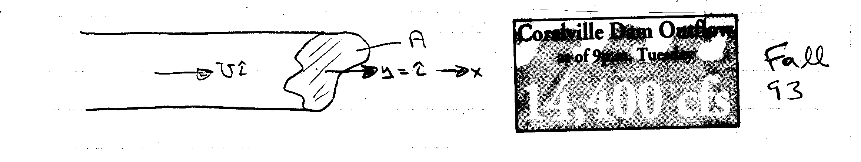
U = constant: Q = volume flux = UA [m/s × m² = m³/s]
U ≠ constant: Q = $\int_{A}{\text{UdA}}$
Similarly the mass flux = $\overset{˙}{m}=\int_{A}{ρ\text{UdA}}$

- general case
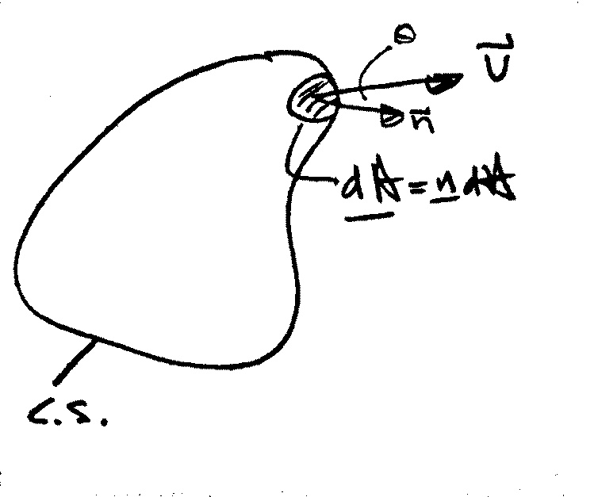

$\begin{aligned}Q=\int_{\text{CS}}{\underline{V}⋅\underline{n}\text{dA}} \\ =\int_{\text{CS}}{\left|\underline{V}\right|\text{cos}θ\text{dA}}\end{aligned}$
$$\overset{˙}{m}=\int_{\text{CS}}{ρ\left(\underline{V}⋅\underline{n}\right)\text{dA}}$$

average velocity: $\overline{V}=\frac{Q}{A}$

Example:
At low velocities the flow through a long circular tube, i.e. pipe, has a parabolic velocity distribution (actually paraboloid of revolution).
$$u=u_{\text{max}}\left(1−{\left(\frac{r}{R}\right)}^{2}\right)$$
i.e., centerline velocity
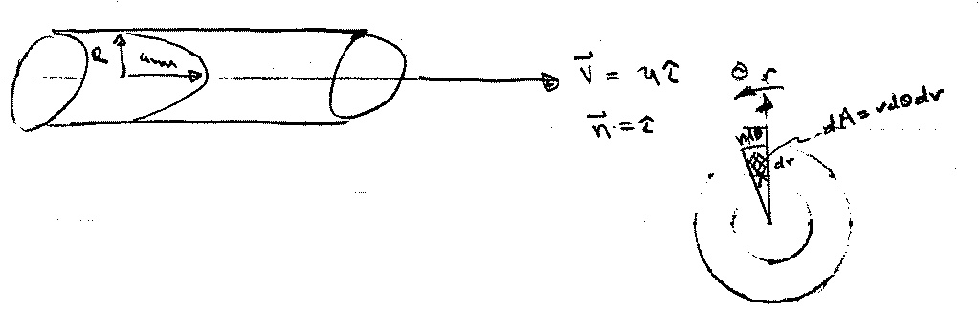

a) find Q and $\overline{V}$

$$Q=\int_{A}{\underline{V}⋅\underline{n}}\text{dA}=\int_{A}{\text{udA}}$$

$$\int_{A}{\text{udA}=\int_{0}^{2π}{\int_{0}^{R}{u(r)\text{rd}θ\text{dr}}}}$$
= $2π\int_{0}^{R}{u(r)\text{rdr}}$
dA = 2πrdr
u = u(r) and not θ ∴ $\int_{0}^{2π}{dθ=2π}$

Q = $2π\int_{0}^{R}{u_{\text{max}}\left(1−{\left(\frac{r}{R}\right)}^{2}\right)\text{rdr}}$ = $\frac{1}{2}u_{\text{max}}{πR}^{2}$
$$\overline{V}=\frac{1}{2}u_{\text{max}}$$

Continuity Equation

RTT can be used to obtain an integral relationship expressing conservation of mass by defining the extensive property B = M such that β = 1.

B = M = mass
β = dB/dM = 1

General Form of Continuity Equation

$$\frac{\text{dM}}{\text{dt}}=0=\frac{d}{\text{dt}}\int_{\text{CV}}{ρdV+\int_{\text{CS}}{ρ\underline{V}⋅\underline{\text{dA}}}}$$
or
$$\int_{\text{CS}}{ρ\underline{V}}⋅\underline{\text{dA}} = −\frac{d}{\text{dt}}\int_{\text{CV}}{ρdV}$$

net rate of outflow rate of decrease of
of mass across CS mass within CV

Simplifications:
- Steady flow: $−\frac{d}{\text{dt}}\int_{\text{CV}}{ρdV}=0$
- V = constant over discrete dA (flow sections):

$$\int_{\text{CS}}{ρ\underline{V}⋅\underline{\text{dA}}=\sum_{\text{CS}}{ρ\underline{V}⋅\underline{A}}}$$

- Incompressible fluid (ρ = constant)
conservation of volume

- Steady One-Dimensional Flow in a Conduit:
$$\sum_{\text{CS}}{ρ\underline{V}⋅\underline{A}=0}$$

−ρ₁V₁A₁ + ρ₂V₂A₂ = 0

for ρ = constant Q₁ = Q₂

Some useful definitions:

Mass flux $\overset{˙}{m}=\int_{A}{ρ\underline{V}⋅\underline{\text{dA}}}$

Volume flux $Q=\int_{A}{\underline{V}⋅\underline{\text{dA}}}$

Average Velocity $\overline{V}=Q/A$

Average Density $\overline{ρ}=\frac{1}{A}\int{ρ\text{dA}}$

Note: unless ρ = constant
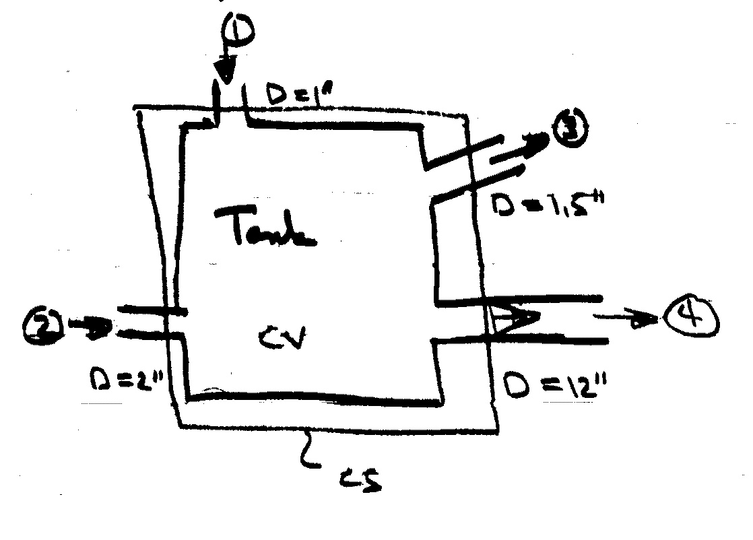
Example

*Steady flow
*V_{1,2,3} = 50 fps
*@  V varies linearly
from zero at wall to
V_{max} at pipe center
*find ${\overset{˙}{m}}_{4}$, Q₄, V_{max}
0 *water, ρ_{w} = 1.94 slug/ft³
$$\int_{\text{CS}}{ρ\underline{V}⋅\underline{\text{dA}}=0}=−\frac{d}{\text{dt}}\int_{\text{CV}}{ρdV}$$
$${\overset{˙}{m}}_{4}$$

i.e., -ρ₁V₁A₁ - ρ₂V₂A₂ + ρ₃V₃A₃ + ρ$\int_{A_{4}}{V_{4}{\text{dA}}_{4}}$= 0
ρ = const. = 1.94 lb-s² /ft⁴ = 1.94 slug/ft³

${\overset{˙}{m}}_{4}=ρ\int{V_{4}{\text{dA}}_{4}}$= ρV(A₁ + A₂ – A₃) V₁=V₂=V₃=V=50f/s
= $\frac{1\text{.}\text{94}}{\text{144}}×\text{50}×\frac{π}{4}\left(1^{2}+2^{2}−1\text{.}5^{2}\right)$
= 1.45 slugs/s
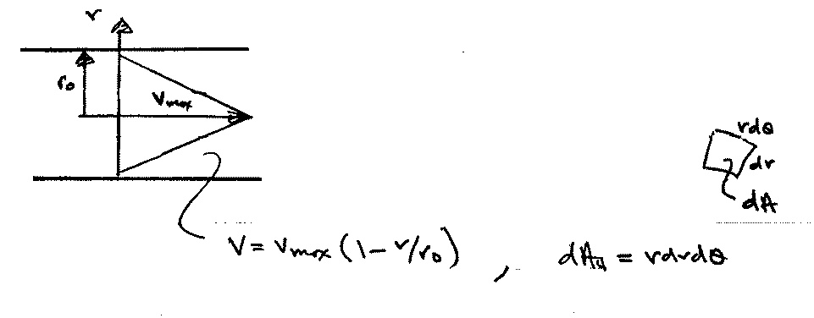

Q₄ = ${\overset{˙}{m}}_{4}/ρ=\text{.}\text{75}$ ft³/s

= $\int_{A_{4}}{V_{4}{\text{dA}}_{4}}$
velocity profile
Q₄ = $\int_{0}^{r_{o}}{\int_{0}^{2π}{V_{\text{max}}\left(1−\frac{r}{r_{o}}\right)\text{rd}θ\text{dr}}}$
dA₄
V₄ ≠ V₄(θ)

$\begin{aligned}=2π\int_{0}^{r_{o}}{V_{\text{max}}\left(1−\frac{r}{r_{o}}\right)\text{rdr}} \\ \\ =2{πV}_{\text{max}}\int_{0}^{r_{o}}{\left[r−\frac{r^{2}}{r_{o}}\right]}\text{dr} \\ \\ =2{πV}_{\text{max}}\left[\frac{r^{2}}{2}|_{0}^{r_{0}}−\frac{r^{3}}{3r_{o}}|_{0}^{r_{o}}\right] \\ \\ =2{πV}_{\text{max}}r_{o^{2}}\left[\frac{1}{2}−\frac{1}{3}\right]=\frac{1}{3}{πr}_{o^{2}}V_{\text{max}}\end{aligned}$
$${\overline{V}}_{4}=\frac{Q}{A}=\frac{\frac{1}{3}{πr}_{o}^{2}V_{\text{max}}}{{πr}_{o}^{2}}$$
= $\frac{1}{3}V_{\text{max}}$

V_{max} = $\frac{Q_{4}}{\frac{1}{3}{πr}_{o^{2}}}=2\text{.}\text{86}$fps
Momentum Equation

RTT with B = MV and β = V
$$\sum{\left[{\underline{F}}_{S}+{\underline{F}}_{B}\right]=\frac{d}{\text{dt}}\int_{\text{CV}}{ρ\underline{V}dV+\int_{\text{CS}}{\underline{V}ρ{\underline{V}}_{R}⋅\underline{\text{dA}}}}}$$
V = velocity referenced to an inertial frame (non-accelerating)
V_{R} = velocity referenced to control volume
F_{S} = surface forces + reaction forces (due to pressure and
viscous normal and shear stresses)
F_{B} = body force (due to gravity)

Applications of the Momentum Equation
Initial Setup and Signs
- Jet deflected by a plate or a vane
- Flow through a nozzle
- Forces on bends
- Problems involving non-uniform velocity distribution
- Motion of a rocket
- Force on rectangular sluice gate
- Water hammer
General form for moving but
non-accelerating reference frame
Derivation of the Basic Equation
Recall RTT: $\frac{{\text{dB}}_{\text{sys}}}{\text{dt}}=\frac{d}{\text{dt}}\int_{\text{CV}}{\text{βρ}dV}+\int_{\text{CS}}{\text{βρ}{\underline{V}}_{R}⋅\underline{\text{dA}}}$

V_{R}=velocity relative to CS=V – V_{S}=absolute – velocity CS
Subscript not shown in text but implied!
i.e., referenced to CV
Let, B = MV = linear momentum
V must be referenced to inertial reference frame
β = V
$$\frac{d(M\underline{V})}{\text{dt}}=\sum{\underline{F}}=\frac{d}{\text{dt}}\int_{\text{CV}}{\underline{V}ρdV}+\int_{\text{CS}}{\underline{V}ρ{\underline{V}}_{R}⋅\underline{\text{dA}}}$$
Must be relative to a non-accelerating inertial reference frame
Newton’s 2nd law
where ΣF = vector sum of all forces acting on the
control volume including both surface and
body forces
= ΣF_{S} + ΣF_{B}
ΣF_{S} = sum of all external surface forces acting at
the CS, i.e., pressure forces, forces
transmitted through solids, shear forces, etc.
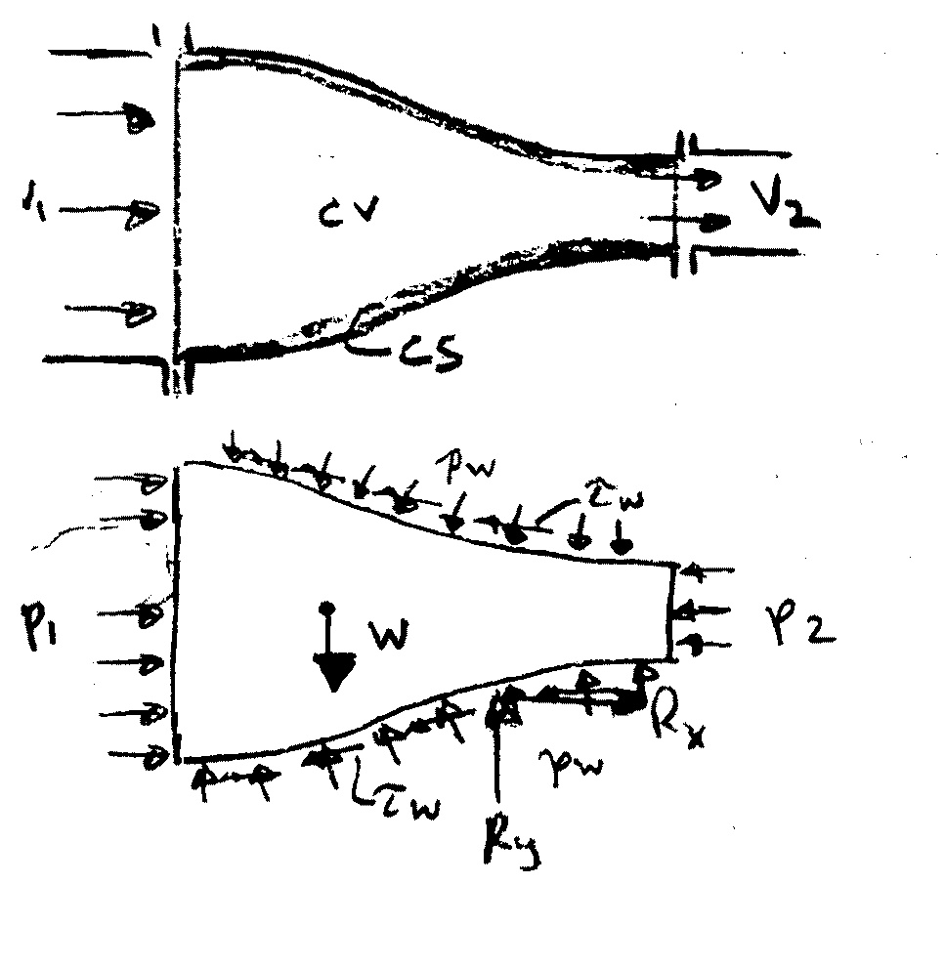
ΣF_{B} = sum of all external
body forces, i.e.,
gravity force

ΣF_{x} = p₁A₁ – p₂A₂ + R_{x}
ΣF_{y} = -W + R_{y}

R = resultant force on fluid
in CV due to p_{w} and τ_{w}
free body diagram
i.e., reaction force on fluid

Important Features (to be remembered)

- Vector equation to get component in any direction must use dot product
Carefully define coordinate system with forces positive in positive direction of coordinate axes
x equation
$\sum{F_{x}=\frac{d}{\text{dt}}\int_{\text{CV}}{ρ\text{ud \{}V}}+\int_{\text{CS}}{ρu{\underline{V}}_{R}⋅\underline{\text{dA}}}$
y equation
$\sum{F_{y}=\frac{d}{\text{dt}}\int_{\text{CV}}{ρ\text{vd \{}V}}+\int_{\text{CS}}{ρv{\underline{V}}_{R}⋅\underline{\text{dA}}}$

z equation
$\sum{F_{z}=\frac{d}{\text{dt}}\int_{\text{CV}}{ρ\text{wd \{}V}}+\int_{\text{CS}}{ρw{\underline{V}}_{R}⋅\underline{\text{dA}}}$

- Carefully define control volume and be sure to include all external body and surface faces acting on it.
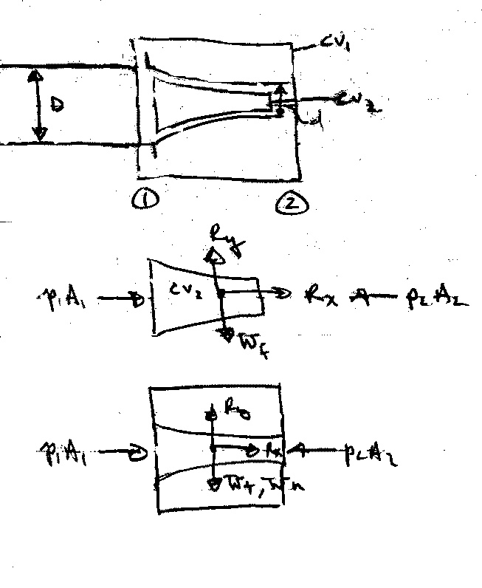
For example,

(R_{x},R_{y}) = reaction force on fluid

(R_{x},R_{y}) = reaction force on nozzle

- Velocity V must be referenced to a non-accelerating inertial reference frame. Sometimes it is advantageous to use a moving (at constant velocity) reference frame. Note V_{R} = V – V_{s} is always relative to CS.
i.e., in these cases V used for B also referenced to CV (i.e., V = V_{R})

- Steady vs. Unsteady Flow

Steady flow ⇒ $\frac{d}{\text{dt}}\int_{\text{CV}}{ρ\underline{V}dV=0}$

- Uniform vs. Nonuniform Flow

$\int_{\text{CS}}{\underline{V}ρ{\underline{V}}_{R}⋅\underline{\text{dA}}}$ = change in flow of momentum across CS
= ΣVρV_{R}⋅A uniform flow across A
- F_{pres} = −$\int{p\underline{n}\text{dA}}$ $\int_{V}{∇\text{fd \{}V}=\int_{S}{f\underline{n}\text{ds}}$
f = constant, ∇f = 0
= 0 for p = constant and for a closed surface

i.e., always use gage pressure

- Pressure condition at a jet exit
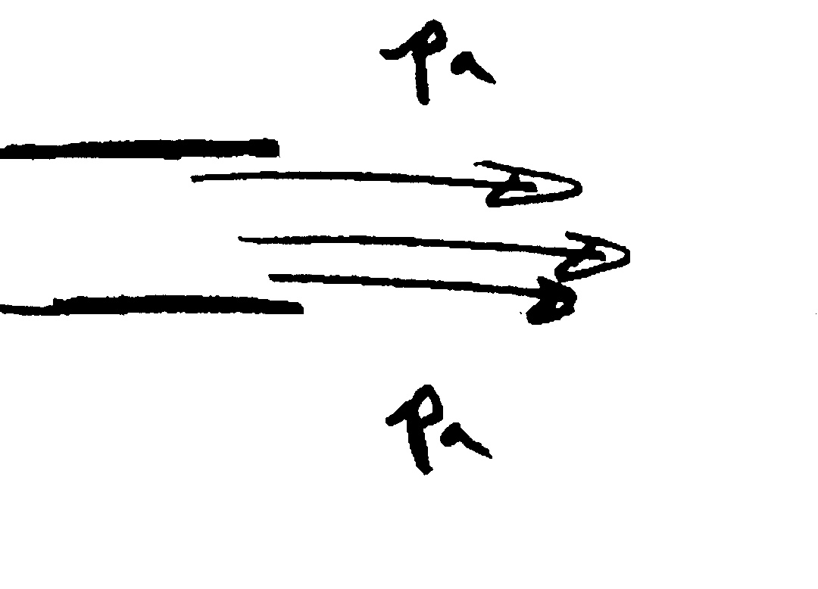
at an exit into the atmosphere jet pressure must be p_{a}

Application of the Momentum Equation
1. Jet deflected by a plate or vane

Consider a jet of water turned through a horizontal angle

CV and CS are for jet so that F_{x} and F_{y} are vane reactions forces on fluid
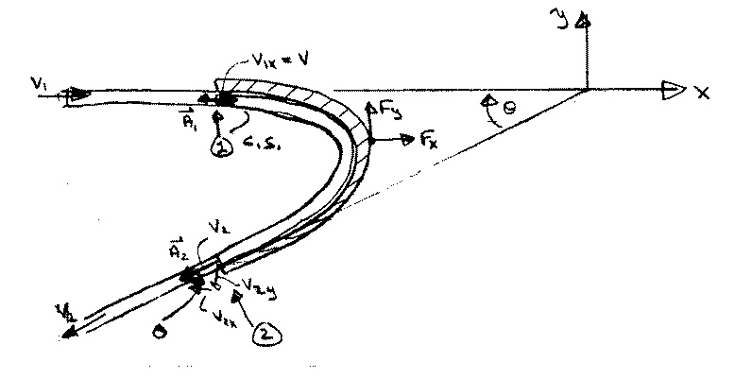

x-equation: $\sum{F_{x}=F_{x}=\frac{d}{\text{dt}}\int{ρ\text{ud \{}V}+\int_{\text{CS}}{ρu\underline{V}⋅\underline{\text{dA}}}}$
$F_{x}=\sum_{\text{CS}}{ρu\underline{V}⋅\underline{A}}$ steady flow

= ${ρV}_{1x}(−V_{1}A_{1})+{ρV}_{2x}(V_{2}A_{2})$

continuity equation: ρA₁V₁ = ρA₂V₂ = ρQ
for A₁ = A₂
V₁ = V₂

F_{x} = ρQ(V_{2x} – V_{1x})

y-equation: $\sum{F_{y}=F_{y}=\sum_{\text{CS}}{ρv\underline{V}⋅\underline{A}}}$
F_{y} = ρV_{1y}(– A₁V₁) + ρV_{2y}(– A₂V₂)
= ρQ(V_{2y} – V_{1y})

for above geometry only
where: V_{1x} = V₁ V_{2x} = -V₂cosθ V_{2y} = -V₂sinθ V_{1y} = 0
note: F_{x} and F_{y} are force on fluid
- F_{x} and -F_{y} are force on vane due to fluid

If the vane is moving with velocity V_{v}, then it is convenient to choose CV moving with the vane

i.e., V_{R} = V - V_{v} and V used for B also moving with vane

x-equation: $F_{x}=\int_{\text{CS}}{ρu{\underline{V}}_{R}⋅\underline{\text{dA}}}$

F_{x} = ρV_{1x}[-(V – V_{v})₁A₁] + ρV_{2x}[(V – V_{v})₂A₂]

Continuity: 0 = $\int{ρ{\underline{V}}_{R}⋅\underline{\text{dA}}}$
i.e., ρ(V-V_{v})₁A₁ = ρ(V-V_{v})₂A₂ = ρ(V-V_{v})A
Q_{rel}
F_{x} = ρ(V-V_{v})A[V_{2x} – V_{1x}]
Q_{rel}

on fluid V_{2x} = (V – V_{v})_{2x}
For coordinate system moving with vane
V_{1x} = (V – V_{v})_{1x}

Power = -F_{x}V_{v} i.e., = 0 for V_{v} = 0

F_{y} = ρQ_{rel}(V_{2y} – V_{1y})

- Flow through a nozzle

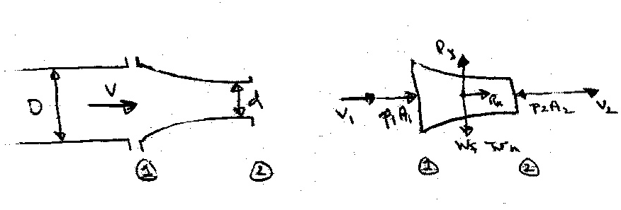
Consider a nozzle at the end of a pipe (or hose). What force is required to hold the nozzle in place?

CV = nozzle
and fluid
∴ (R_{x}, R_{y}) = force required to hold nozzle in place

Assume either the pipe velocity or pressure is known. Then, the unknown (velocity or pressure) and the exit velocity V₂ can be obtained from combined use of the continuity and Bernoulli equations.

Bernoulli: $p_{1}+{γz}_{1}+\frac{1}{2}{ρV}_{1}^{2}=p_{2}+{γz}_{2}+\frac{1}{2}{ρV}_{2}^{2}$ z₁=z₂
$p_{1}+\frac{1}{2}{ρV}_{1}^{2}=\frac{1}{2}{ρV}_{2}^{2}$

Continuity: A₁V₁ = A₂V₂ = Q
$V_{2}=\frac{A_{1}}{A_{2}}V_{1}={\left(\frac{D}{d}\right)}^{2}V_{1}$
$p_{1}+\frac{1}{2}{ρV}_{1}^{2}\left(1−{\left(\frac{D}{d}\right)}^{4}\right)=0$
Say p₁ known: $V_{1}={\left[\frac{−2p_{1}}{ρ\left(1−{\left(Dd\right)}^{4}\right)}\right]}^{1/2}$
To obtain the reaction force R_{x} apply momentum equation in x-direction

$\sum{F_{x}}=\frac{d}{\text{dt}}\int_{\text{CV}}{uρdV}+\int_{\text{CS}}{ρu\underline{V}⋅\underline{\text{dA}}}$
steady flow and uniform
flow over CS
=$\sum_{\text{CS}}{ρu\underline{V}⋅\underline{A}}$

R_{x} + p₁A₁ – p₂A₂ = ρV₁(-V₁A₁) + ρV₂(V₂A₂)
= ρQ(V₂ - V₁)
R_{x} = ρQ(V₂ - V₁) - p₁A₁

To obtain the reaction force R_{y} apply momentum equation in y-direction

$\sum{F_{y}=\sum_{\text{CS}}{ρv\underline{V}⋅\underline{A}=0}}$ since no flow in y-direction
R_{y} – W_{f} − W_{N} = 0 i.e., R_{y} = W_{f} + W_{N}

Numerical Example: Oil with S = .85 flows in pipe under pressure of 100 psi. Pipe diameter is 3” and nozzle tip diameter is 1”
$$ρ=\frac{Sγ}{g}=1\text{.}\text{65}$$
D/d = 3
Q = $\frac{π}{4}{\left(\frac{1}{\text{12}}\right)}^{2}V_{2}$
= .716 ft³/s

V₁ = 14.59 ft/s
V₂ = 131.3 ft/s

R_{x} = 141.48 – 706.86 = −569 lbf
R_{z} = 10 lbf

This is force on nozzle

3. Forces on Bends

Consider the flow through a bend in a pipe. The flow is considered steady and uniform across the inlet and outlet sections. Of primary concern is the force required to hold the bend in place, i.e., the reaction forces R_{x} and R_{y} which can be determined by application of the momentum equation.

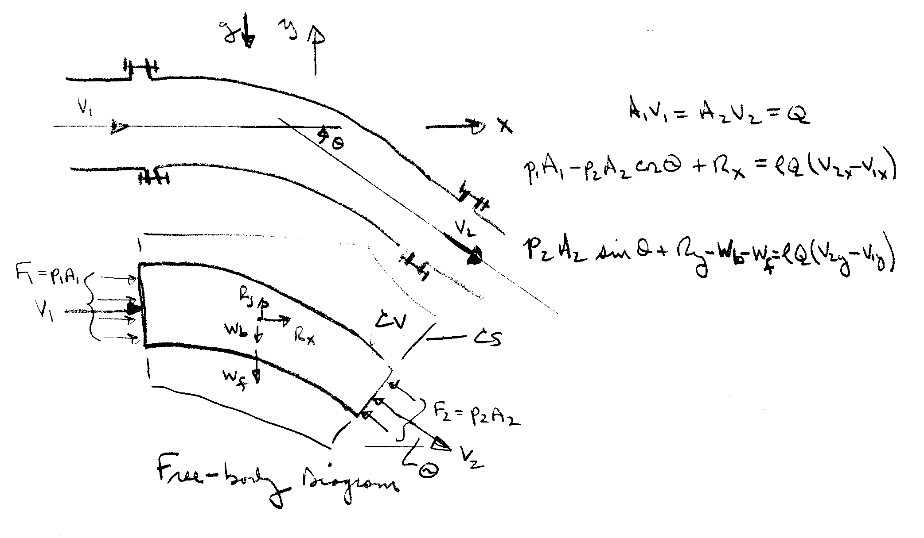

R_{x}, R_{y} = reaction force on
bend i.e., force
required to hold
bend in place

Continuity: $0=\sum{ρ\underline{V}⋅\underline{A}=−{ρV}_{1}A_{1}+{ρV}_{2}A_{2}}$
i.e., Q = constant = $V_{1}A_{1}=V_{2}A_{2}$

x-momentum: $\sum{F_{x}=\sum{ρu\underline{V}⋅\underline{A}}}$ $p_{1}A_{1}−p_{2}A_{2}\text{cos}θ+R_{x}={ρV}_{1x}\left(−V_{1}A_{1}\right)+{ρV}_{2x}\left(V_{2}A_{2}\right)$
= $ρQ\left(V_{2x}−V_{1x}\right)$

y-momentum: $\sum{F_{y}=\sum{ρv\underline{V}⋅\underline{A}}}$
$p_{2}A_{2}\text{sin}θ+R_{y}−w_{f}−w_{b}={ρV}_{1y}\left(−V_{1}A_{1}\right)+{ρV}_{2y}\left(V_{2}A_{2}\right)$ = $ρQ\left(V_{2y}−V_{1y}\right)$

4. Problems involving Nonuniform Velocity Distribution
See text pp. 215− 216
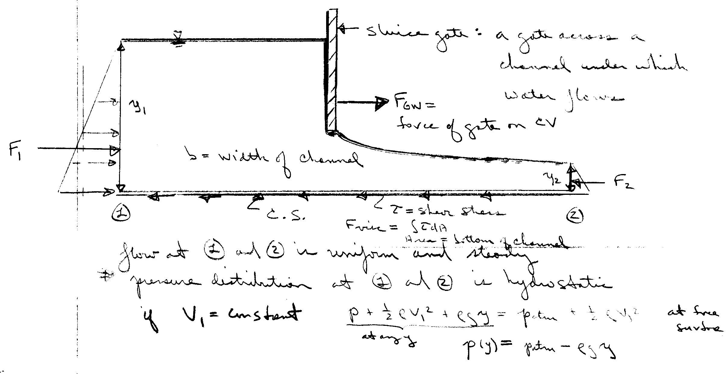
5. Force on a rectangular sluice gate
The force on the fluid due to the gate is calculated from the x-momentum equation:
$$\sum{F_{x}=\sum{ρu\underline{V}⋅\underline{A}}}$$

$$F_{1}+F_{\text{GW}}−F_{\text{visc}}−F_{2}={ρV}_{1}\left(−V_{1}A_{1}\right)+{ρV}_{2}\left(V_{2}A_{2}\right)$$
usually can be neglected
$$F_{\text{GW}}=F_{2}−F_{1}+ρQ\left(V_{2}−V_{1}\right)+F_{\text{visc}}$$
= $γ\frac{y_{2}}{2}⋅y_{2}b−γ\frac{y_{1}}{2}⋅y_{1}b+ρQ\left(V_{2}−V_{1}\right)$
$$F_{\text{GW}}=\frac{1}{2}bγ\left(y_{2}^{2}−y_{1}^{2}\right)+ρQ\left(V_{2}−V_{1}\right)$$
$$\begin{aligned}V_{1}=\frac{Q}{y_{1}b} \\ V_{2}=\frac{Q}{y_{2}b}\end{aligned}$$
$\frac{{ρQ}^{2}}{b}\left(\frac{1}{y_{2}}−\frac{1}{y_{1}}\right)$

Moment of Momentum Equation
See text pp. 221 − 229

Energy Equations

Derivation of the Energy Equation

The First Law of Thermodynamics
The difference between the heat added to a system and the work done by a system depends only on the initial and final states of the system; that is, depends only on the change in energy E: principle of conservation of energy

ΔE = Q – W

ΔE = change in energy
Q = heat added to the system
W = work done by the system

E = E_{u} + E_{k} + E_{p} = total energy of the system
potential energy
kinetic energy
Internal energy due to molecular motion

The differential form of the first law of thermodynamics expresses the rate of change of E with respect to time

$\frac{\text{dE}}{\text{dt}}=\overset{˙}{Q}−\overset{˙}{W}$
rate of work being done by system

rate of heat transfer to system
Energy Equation for Fluid Flow
The energy equation for fluid flow is derived from Reynolds transport theorem with

B_{system} = E = total energy of the system (extensive property)

β = E/mass = e = energy per unit mass (intensive property)
= + e_{k} + e_{p}

$$\frac{\text{dE}}{\text{dt}}=\frac{d}{\text{dt}}\int{ρ\text{ed \{}V}+\int{ρe\underline{V}⋅\underline{\text{dA}}}$$

This can be put in a more useable form by noting the following:
$$e_{k}=\frac{\text{Total} \text{KE} \text{of} \text{mass} \text{with} \text{velocity} V}{\text{mass}}=\frac{Δ{{\text{MV}}^{2}}/2}{ΔM}=\frac{V^{2}}{2}$$
$$V^{2}=\left|\underline{V}\right|$$
$e_{p}=\frac{E_{p}}{ΔM}=\frac{γΔVz}{ρΔV}=\text{gz}$ (for E_{p} due to gravity only)

rate of work rate of change flux of energy
done by system of energy in CV out of CV
(ie, across CS)
rate of heat
transfer to sysem
Rate of Work Components: $\overset{˙}{W}={\overset{˙}{W}}_{s}+{\overset{˙}{W}}_{f}$
For convenience of analysis, work is divided into shaft work W_{s} and flow work W_{f}

W_{f} = net work done on the surroundings as a result of
normal and tangential stresses acting at the control
surfaces
= W_{f pressure} + W_{f shear}

W_{s} = any other work transferred to the surroundings
usually in the form of a shaft which either takes
energy out of the system (turbine) or puts energy into
the system (pump)

Flow work due to pressure forces W_{f p} (for system)
Note: here $\underline{V}$ uniform over $\underline{A}$
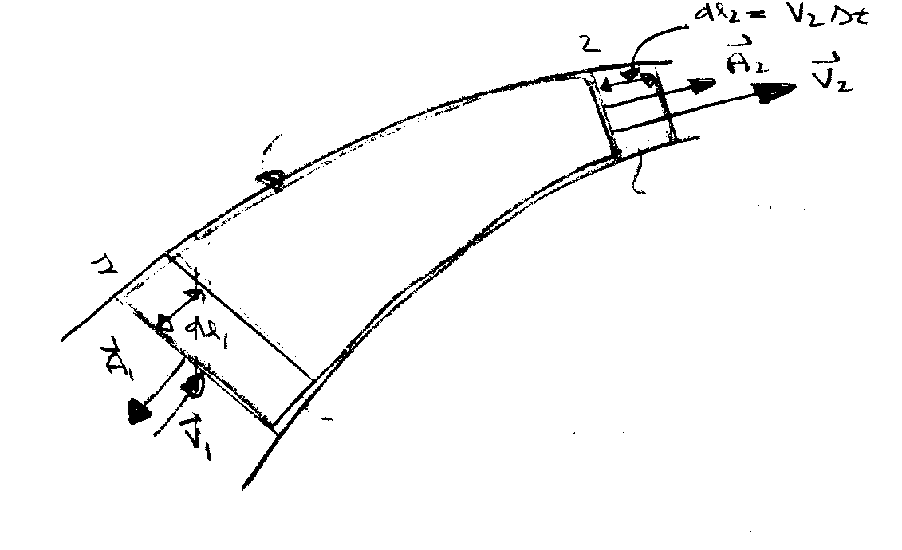
System at time t + Δt
System at time t
CS

CV

Work = force × distance
at 2 W₂ = p₂A₂ × V₂Δt
(on surroundings)
rate of work⇒ ${\overset{˙}{W}}_{2}=p_{2}A_{2}V_{2}=p_{2}{\underline{V}}_{2}⋅{\underline{A}}_{2}$

at 1 W₁ = −p₁A₁ × V₁Δt
neg. sign since pressure force on surrounding fluid acts in a direction opposite to the motion of the system boundary
${\overset{˙}{W}}_{1}=p_{1}{\underline{V}}_{1}⋅{\underline{A}}_{1}$
In general,

${\overset{˙}{W}}_{\text{fp}}=p\underline{V}⋅\underline{A}$

for more than one control surface and V not necessarily uniform over A:

${\overset{˙}{W}}_{\text{fp}}=\int{p\underline{V}⋅\underline{\text{dA}}}=\int{ρ\left(\frac{p}{ρ}\right)\underline{V}⋅\underline{\text{dA}}}$
${\overset{˙}{W}}_{f}={\overset{˙}{W}}_{\text{fp}}+{\overset{˙}{W}}_{\text{fshear}}$

Basic form of energy equation
h=enthalpy

Usually this term can be eliminated by proper choice of CV, i.e. CS normal to flow lines. Also, at fixed boundaries the velocity is zero (no slip condition) and no shear stress flow work is done. Not included or discussed in text!

Simplified Forms of the Energy Equation

Energy Equation for Steady One-Dimensional Pipe Flow

Consider flow through the pipe system as shown

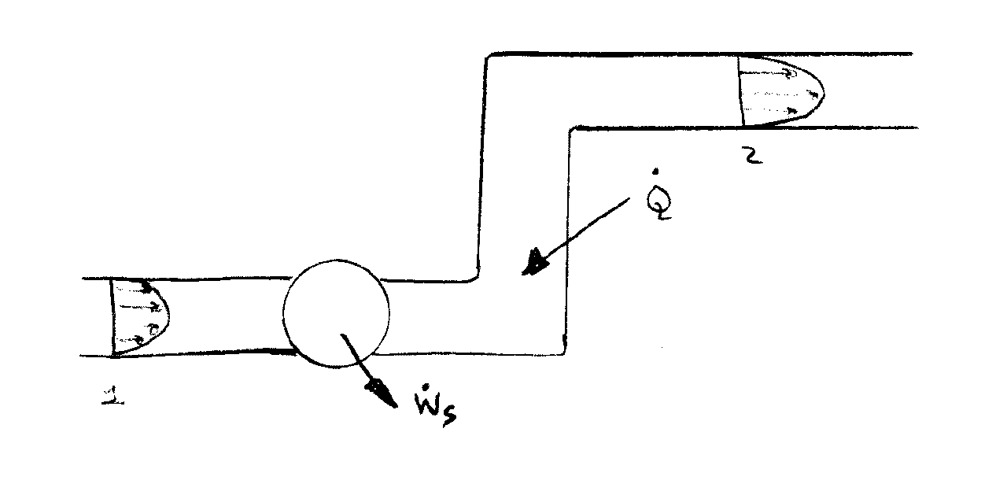

Energy Equation (steady flow)

*Although the velocity varies across the flow sections the streamlines are assumed to be straight and parallel; consequently, there is no acceleration normal to the streamlines and the pressure is hydrostatically distributed, i.e., p/ρ +gz = constant.

*Furthermore, the internal energy u can be considered as constant across the flow sections, i.e. T = constant. These quantities can then be taken outside the integral sign to yield

Recall that $Q=\int{\underline{V}⋅\underline{\text{dA}}}=\bar{V}A$
So that $ρ\int{\underline{V}⋅\underline{\text{dA}}}=ρ\bar{V}A=\overset{˙}{m}$ mass flow rate

Define: $ρ\int_{A}{\frac{V^{3}}{2}}\text{dA}=α\frac{ρ{\overline{V}}^{3}A}{2}=α\frac{{\overline{V}}^{2}}{2}\overset{˙}{m}$
K.E. flux K.E. flux for V=$\overline{V}$=constant across pipe
i.e., $α=\frac{1}{A}\int_{A}{{\left(\frac{V}{\overline{V}}\right)}^{3}\text{dA}}$ = kinetic energy correction factor

Nnote that: α = 1 if V is constant across the flow section
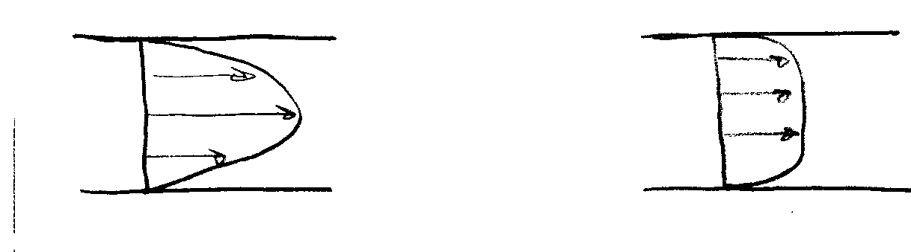
α > 1 if V is nonuniform

laminar flow α = 2 turbulent flow α = 1.05 ∼ 1 may be used
Shaft Work
Shaft work is usually the result of a turbine or a pump in the flow system. When a fluid passes through a turbine, the fluid is doing shaft work on the surroundings; on the other hand, a pump does work on the fluid
${\overset{˙}{W}}_{s}={\overset{˙}{W}}_{t}−{\overset{˙}{W}}_{p}$ where ${\overset{˙}{W}}_{t}$ and ${\overset{˙}{W}}_{p}$ are
magnitudes of power $\left(\frac{\text{work}}{\text{time}}\right)$
Using this result in the energy equation and deviding by g results in

mechanical part thermal part

Note: each term has dimensions of length
Define the following:

$$h_{p}=\frac{{\overset{˙}{W}}_{p}}{\overset{˙}{m}g}=\frac{{\overset{˙}{W}}_{p}}{ρ\text{Qg}}=\frac{{\overset{˙}{W}}_{p}}{γQ}$$

$$h_{t}=\frac{{\overset{˙}{W}}_{t}}{\overset{˙}{m}g}$$

Head Loss
In a general fluid system a certain amount of mechanical energy is converted to thermal energy due to viscous action. This effect results in an increase in the fluid internal energy. Also, some heat will be generated through energy dissipation and be lost (i.e. -$\overset{˙}{Q}$). Therefore the term
from 2nd law
represents a loss in mechanical energy due to viscous stresses

Note that adding $\overset{˙}{Q}$ to system will not make h_{L} = 0 since this also increases Δu. It can be shown from 2nd law of thermodynamics that h_{L} > 0.

Drop ⎯ over $\bar{V}$ and understand that V in energy equation refers to average velocity.

Using the above definitions in the energy equation results in (steady 1-D incompressible flow)

$$\frac{p_{1}}{γ}+α_{1}\frac{V_{1}^{2}}{2g}+z_{1}+h_{p}=\frac{p_{2}}{γ}+α_{2}\frac{V_{2}^{2}}{2g}+z_{2}+h_{t}+h_{L}$$

form of energy equation used for this course!

Comparison of Energy Equation and Bernoulli Equation

Apply energy equation to a stream tube without any shaft work
Infinitesimal stream tube ⇒ α₁=α₂=1
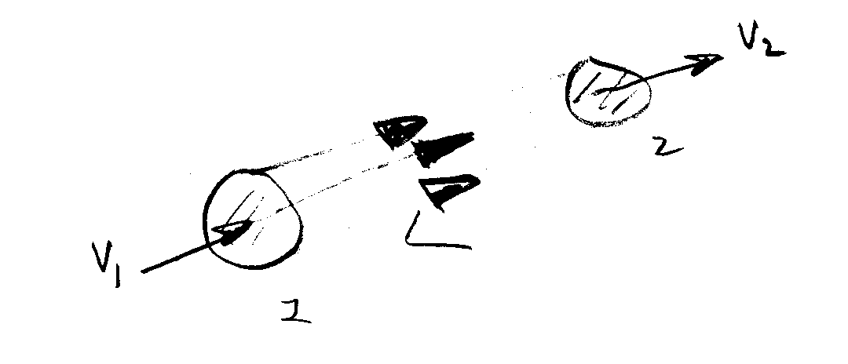

Energy eq : $\frac{p_{1}}{γ}+\frac{V_{1}^{2}}{2g}+z_{1}=\frac{p_{2}}{γ}+\frac{V_{2}^{2}}{2g}+z_{2}+h_{L}$

•If h_{L} = 0 (i.e., μ = 0) we get Bernoulli equation and conservation of mechanical energy along a streamline

•Therefore, energy equation for steady 1-D pipe flow can be interpreted as a modified Bernoulli equation to include viscous effects (h_{L}) and shaft work (h_{p} or h_{t})

Summary of the Energy Equation

The energy equation is derived from RTT with

B = E = total energy of the system

β = e = E/M = energy per unit mass

= + $\frac{1}{2}V^{2}$+gz

internal KE PE

$\frac{\text{dE}}{\text{dt}}=\frac{d}{\text{dt}}\int_{\text{CV}}{ρ\text{ed \{}V}+\int_{\text{CS}}{ρe\underline{V}⋅\underline{\text{dA}}}=\overset{˙}{Q}−\overset{˙}{W}$
heat add$\frac{p_{1}}{γ}+z_{1}+\frac{V_{1}^{2}}{2g}$ed
work done
from 1st Law of Thermodynamics

Neglected in text presentation
$$\overset{˙}{W}={\overset{˙}{W}}_{s}+{\overset{˙}{W}}_{p}+{\overset{˙}{W}}_{v}$$

shaft work done on or by system (pump or turbine)
pressure work done on CS
Viscous stress work on CS

${\overset{˙}{W}}_{p}=\int_{\text{CV}}{p\underline{V}⋅\underline{\text{dA}}=}\int_{\text{CS}}{ρ\left(p/ρ\right)\underline{V}⋅\underline{\text{dA}}}$

$${\overset{˙}{W}}_{s}={\overset{˙}{W}}_{t}−{\overset{˙}{W}}_{p}$$
$$\overset{˙}{Q}−{\overset{˙}{W}}_{t}+{\overset{˙}{W}}_{p}=\frac{d}{\text{dt}}\int_{\text{CV}}{ρ\text{ed \{}V}+\int_{\text{CS}}{ρ\left(e+p/e\right)\underline{V}⋅\underline{\text{dA}}}$$

For steady 1-D pipe flow (one inlet and one outlet):
- Streamlines are straight and parallel
⇒ p/ρ +gz = constant across CS
- T = constant ⇒ u = constant across CS

3) define $α=\frac{1}{A}\int_{\text{CS}}{{\left(\frac{V}{\overline{V}}\right)}^{3}\text{dA}}$ = KE correction factor

⇒ $\frac{ρ}{2}\int{V^{3}\text{dA}=α\frac{ρ{\overline{V}}^{3}}{2}A=α\frac{{\overline{V}}^{2}}{2}\overset{˙}{m}}$
mechanical energy
Thermal energy

$$\frac{p_{1}}{γ}+α_{1}\frac{V_{1}^{2}}{2g}+z_{1}+h_{p}=\frac{p_{2}}{γ}+α_{2}\frac{V_{2}^{2}}{2g}+z_{2}+h_{t}+h_{L}$$

Note: each term has
units of length

V is average velocity (vector dropped) and
corrected by α
$$h_{p}={\overset{˙}{W}}_{p}/\overset{˙}{m}g$$

$$h_{t}={\overset{˙}{W}}_{t}/\overset{˙}{m}g$$

head loss
> 0 represents loss in mechanical energy due to viscosity
Concept of Hydraulic and Energy Grade Lines

$$\frac{p_{1}}{γ}+α_{1}\frac{V_{1}^{2}}{2g}+z_{1}+h_{p}=\frac{p_{2}}{γ}+α_{2}\frac{V_{2}^{2}}{2g}+z_{2}+h_{t}+h_{L}$$
Define HGL = $\frac{p}{γ}+z$
point-by-point application is graphically displayed
EGL = $\frac{p}{γ}+z+α\frac{V^{2}}{2g}$

HGL corresponds to pressure tap measurement + z

EGL corresponds to stagnation tube measurement + z
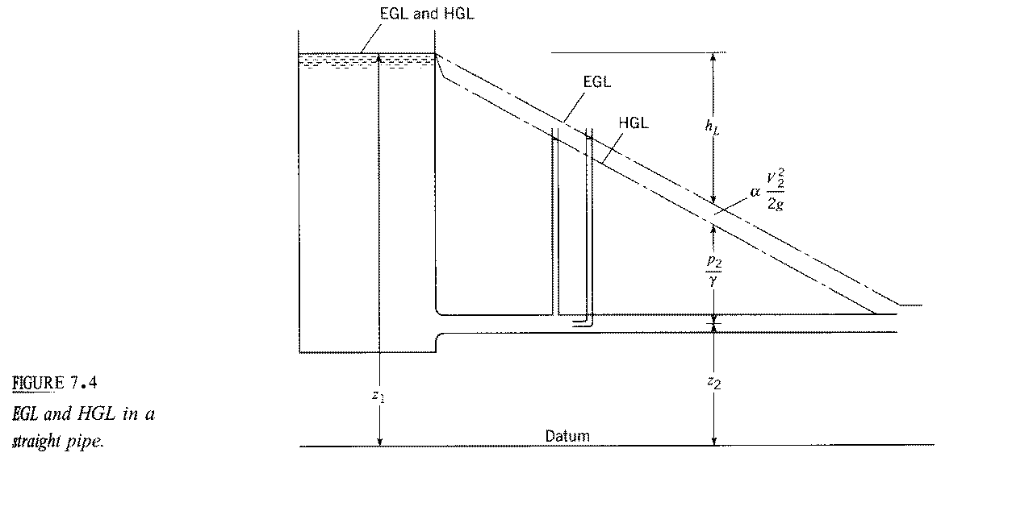
EGL = HGL if V = 0
h_{L} = $f\frac{L}{D}\frac{V^{2}}{2g}$
i.e., linear variation in L for D,
V, and f constant
EGL₁ = EGL₂ + h_{L}
for h_{p} = h_{t} = 0

f = friction factor
f = f(Re)

pressure tap: $\frac{p_{2}}{γ}=h$
h = height of fluid in
tap/tube
stagnation tube: $\frac{p_{2}}{γ}+α\frac{V_{2}^{2}}{2g}=h$

EGL₁ + h_{p} = EGL₂ + h_{t} + h_{L}
EGL₂ = EGL₁ + h_{p} − h_{t} − h_{L}
abrupt change due to h_{p} or h_{t}
$$f\frac{L}{D}\frac{V^{2}}{2g}$$

Helpful hints for drawing HGL and EGL

- EGL = HGL + αV²/2g = HGL for V = 0

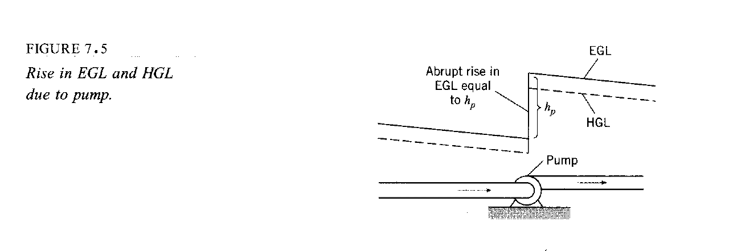
2.&3. $h_{L}=f\frac{L}{D}\frac{V^{2}}{2g}$ in pipe means EGL and HGL will slope
downward, except for abrupt changes due to h_{t} or h_{p}

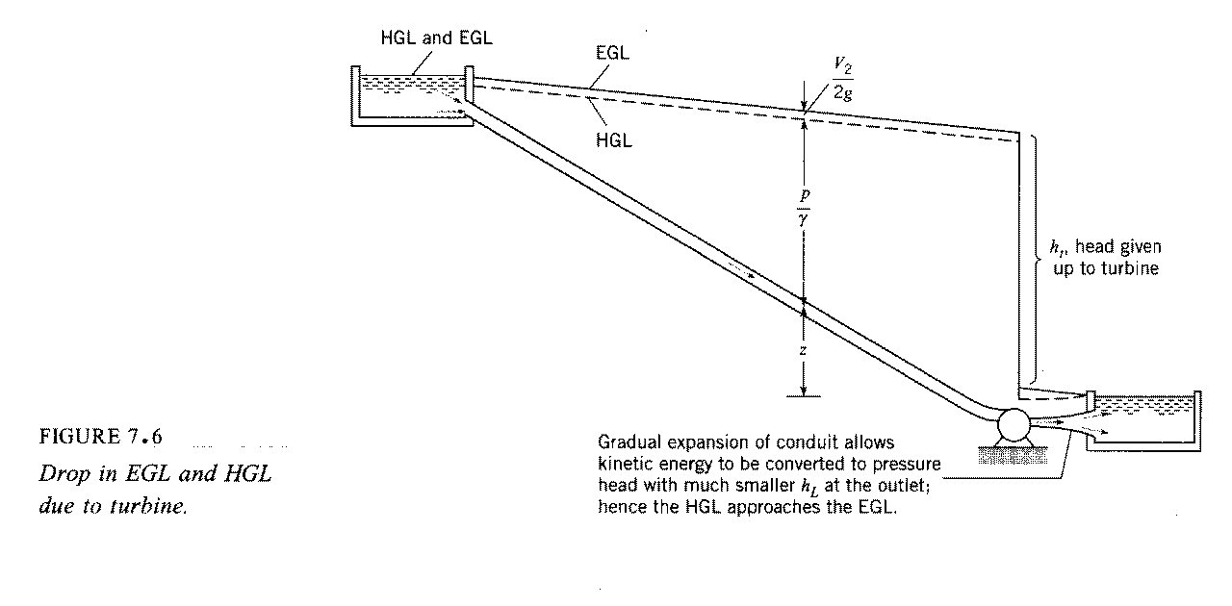
$$\frac{p_{1}}{γ}+z_{1}+\frac{V_{1}^{2}}{2g}=\frac{p_{2}}{γ}+z_{2}+\frac{V_{2}^{2}}{2g}+h_{L}$$
HGL₂ = EGL₁ - h_{L}
$h_{L}=\frac{V^{2}}{2g}$for abrupt expansion
4. p = 0 ⇒ HGL = z

5. for $h_{L}=f\frac{L}{D}\frac{V^{2}}{2g}$ = constant × L
i.e., linearly increased for increasing L with slope $\frac{f}{D}\frac{V^{2}}{2g}$

EGL/HGL slope downward

6. for change in D ⇒ change in V

i.e. V₁A₁ = V₂A₂
change in distance between HGL & EGL and slope
change due to change in h_{L}
$V_{1}\frac{{πD}_{1}^{2}}{4}=V_{2}\frac{{πD}_{2}^{2}}{4}$
⇒
$V_{1}D_{1}^{2}=V_{1}D_{2}^{2}$

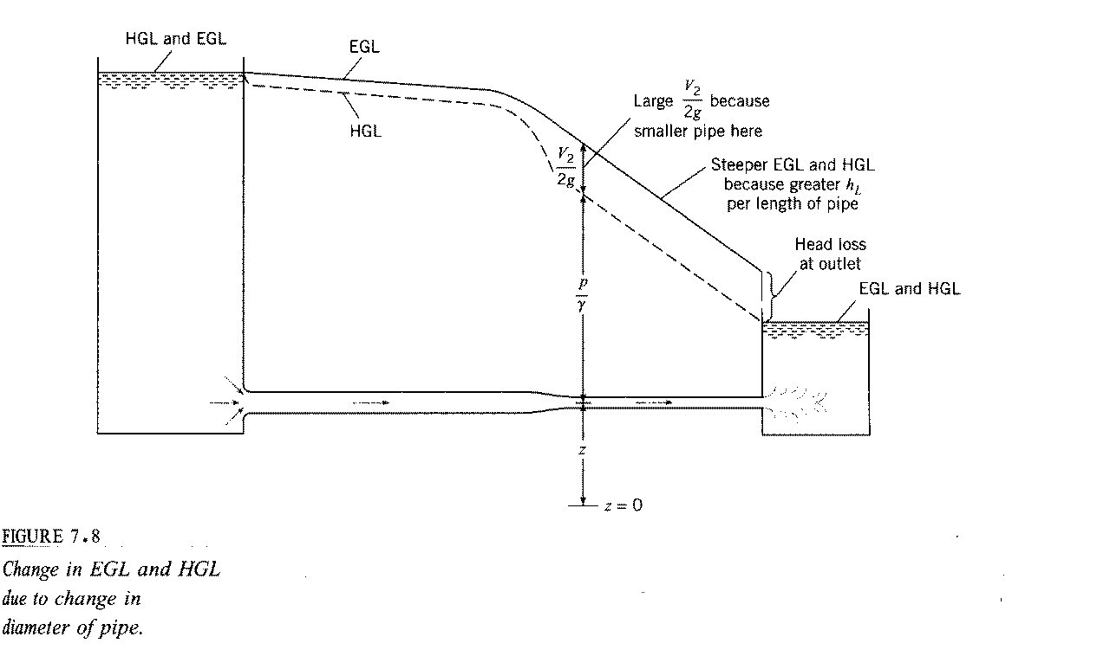
7. If HGL < z then p/γ < 0 i.e., cavitation possible

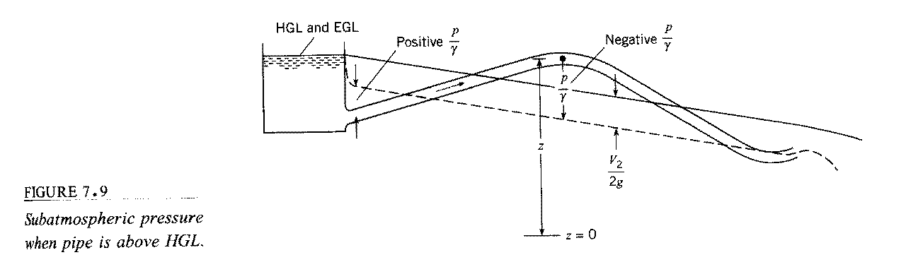

condition for cavitation:

$p=p_{\text{va}}=\text{2000}\frac{N}{m^{2}}$

gage pressure $p_{\text{va},g}=p_{A}−p_{\text{atm}}≈−p_{\text{atm}}=−\text{100},\text{000}\frac{N}{m^{2}}$

$\frac{p_{\text{va},g}}{γ}≈−\text{10}m$

9810 N/m³
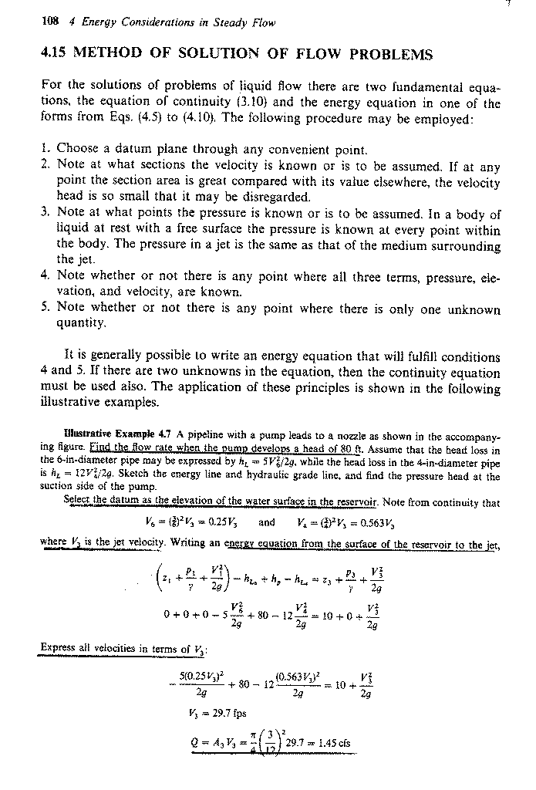
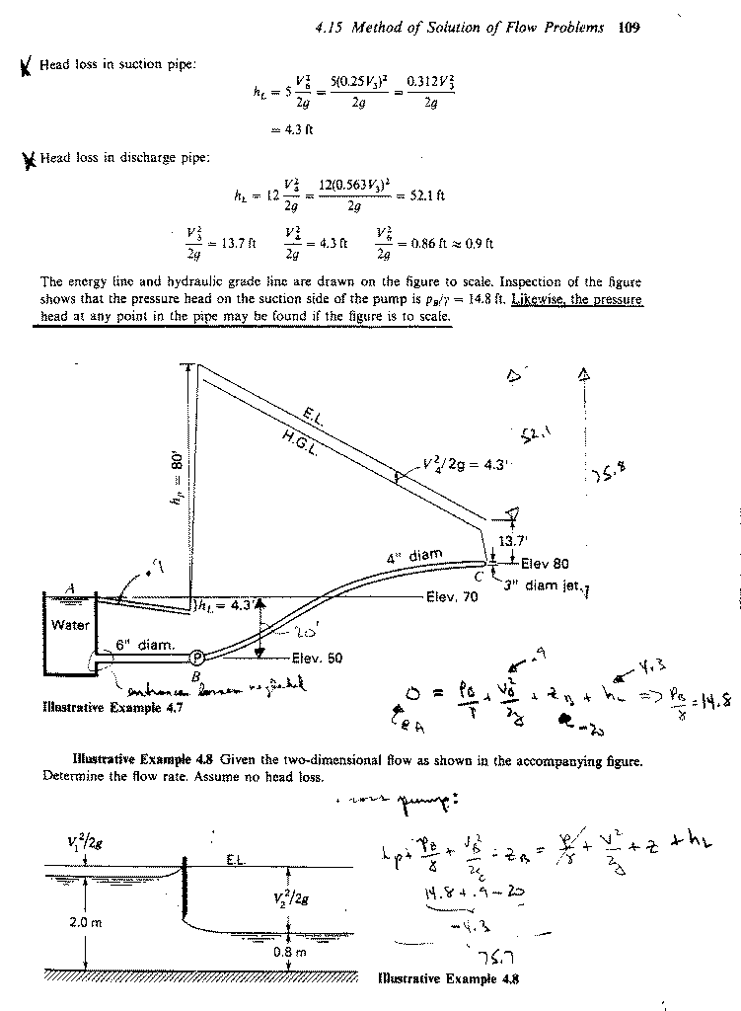
Application of the Energy, Momentum, and Continuity Equations in Combination

In general, when solving fluid mechanics problems, one should use all available equations in order to derive as much information as possible about the flow. For example, consistent with the approximation of the energy equation we can also apply the momentum and continuity equations

Energy:
$$\frac{p_{1}}{γ}+α_{1}\frac{V_{1}^{2}}{2g}+z_{1}+h_{p}=\frac{p_{2}}{γ}+α_{2}\frac{V_{2}^{2}}{2g}+z_{2}+h_{t}+h_{L}$$

Momentum:
one inlet and one outlet
ρ = constant
$\sum{F_{s}={ρV}_{2}^{2}A_{2}−{ρV}_{1}^{2}A_{1}=ρQ\left(V_{2}−V_{1}\right)}$

Continuity:
A₁V₁ = A₂V₂ = Q = constant
Abrupt Expansion
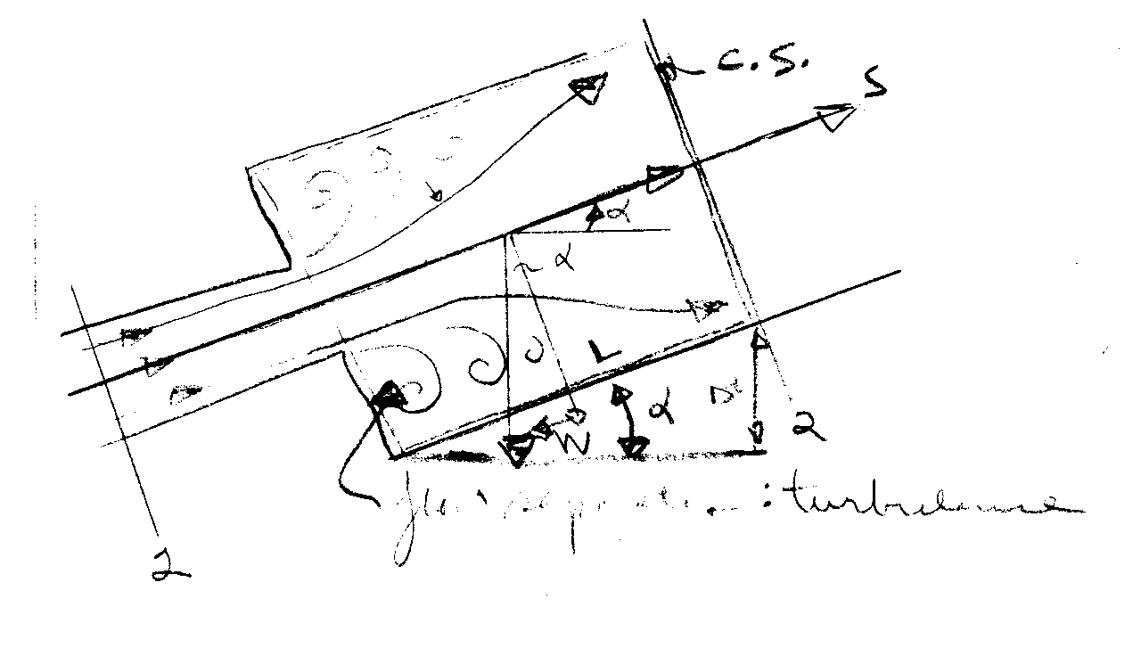
Consider the flow from a small pipe to a larger pipe. Would like to know h_{L} = h_{L}(V₁,V₂). Analytic solution to exact problem is extremely difficult due to the occurrence of flow separations and turbulence. However, if the assumption is made that the pressure in the separation region remains approximately constant and at the value at the point of separation, i.e, p₁, an approximate solution for h_{L} is possible:

Apply Energy Eq from 1-2 (α₁ = α₂ = 1)
$$\frac{p_{1}}{γ}+z_{1}+\frac{V_{1}^{2}}{2g}=\frac{p_{2}}{γ}+z_{2}+\frac{V_{2}^{2}}{2g}+h_{L}$$

Momentum eq. For CV shown (shear stress neglected)

$$\sum{F_{s}=p_{1}A_{2}−p_{2}A_{2}−W\text{sin}α=\sum{ρu\underline{V}⋅\underline{A}}}$$
=${ρV}_{1}(−V_{1}A_{1})+{ρV}_{2}(V_{2}A_{2})$
$${γA}_{2}L\frac{Δz}{L}$$
=${ρV}_{2}^{2}A_{2}−{ρV}_{1}^{2}A_{1}$

W sin α
next divide momentum equation by γA₂
$\frac{p_{1}}{γ}−\frac{p_{2}}{γ}−\left(z_{1}−z_{2}\right)=\frac{V_{2}^{2}}{g}−\frac{V_{1}^{2}}{g}\frac{A_{1}}{A_{2}}=\frac{V_{1}^{2}}{g}\frac{A_{1}}{A_{2}}\left(\frac{A_{1}}{A_{2}}−1\right)$
÷ γA₂

from energy equation
⇓
$\frac{V_{2}^{2}}{2g}−\frac{V_{1}^{2}}{2g}+h_{L}=\frac{V_{2}^{2}}{g}−\frac{V_{1}^{2}}{g}\frac{A_{1}}{A_{2}}$

$h_{L}=\frac{V_{2}^{2}}{2g}+\frac{V_{1}^{2}}{2g}\left(1−\frac{2A_{1}}{A_{2}}\right)$
continutity eq.
V₁A₁ = V₂A₂
$\frac{A_{1}}{A_{2}}=\frac{V_{2}}{V_{1}}$
$h_{L}=\frac{1}{2g}\left[V_{2}^{2}+V_{1}^{2}−2V_{1}^{2}\frac{A_{1}}{A_{2}}\right]$

−2V₁V₂

$h_{L}=\frac{1}{2g}{\left[V_{2}−V_{1}\right]}^{2}$

If ,
Forces on Transitions

Example 7-6
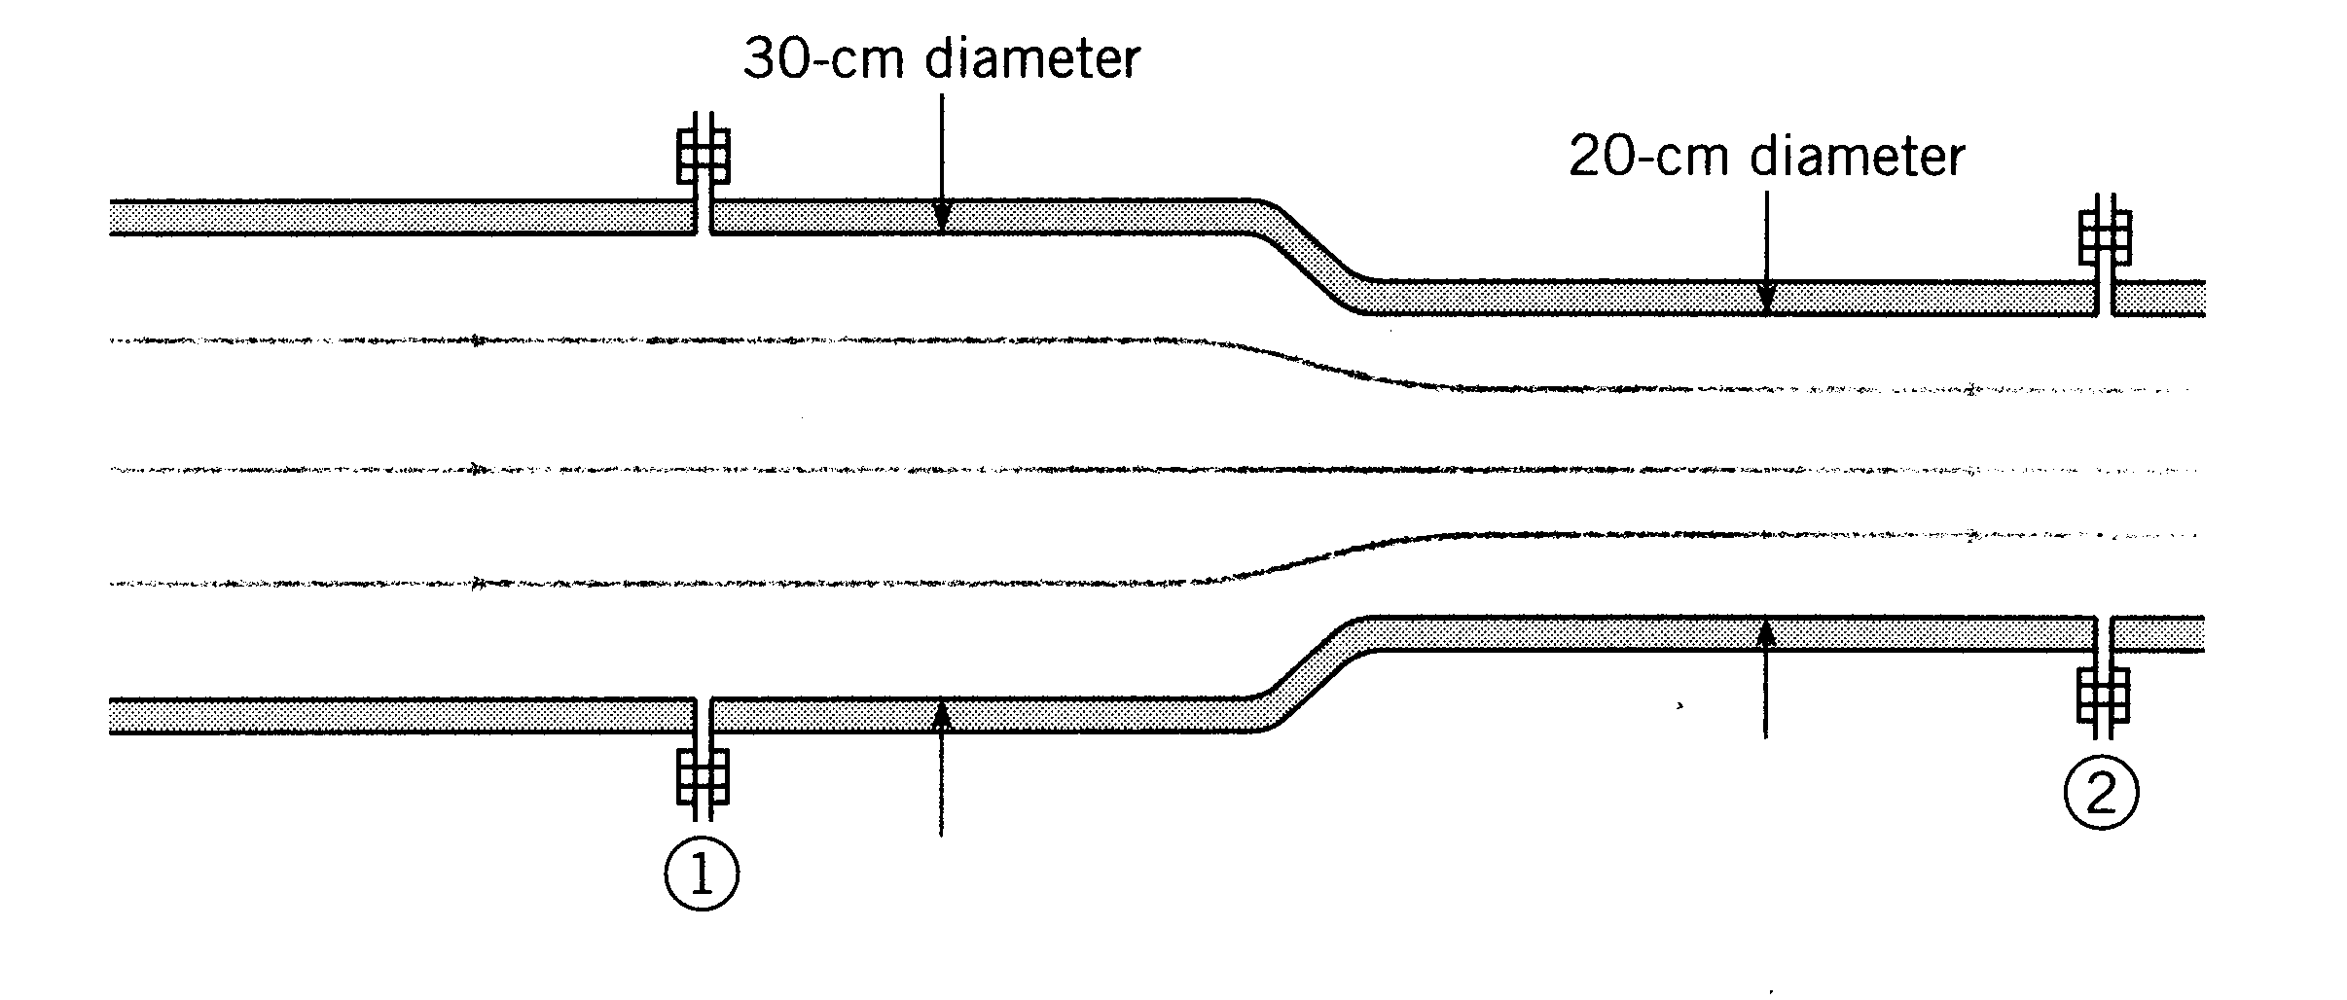
Q = .707 m³/s
head loss = $\text{.}1\frac{V_{2}^{2}}{2g}$
(empirical equation)

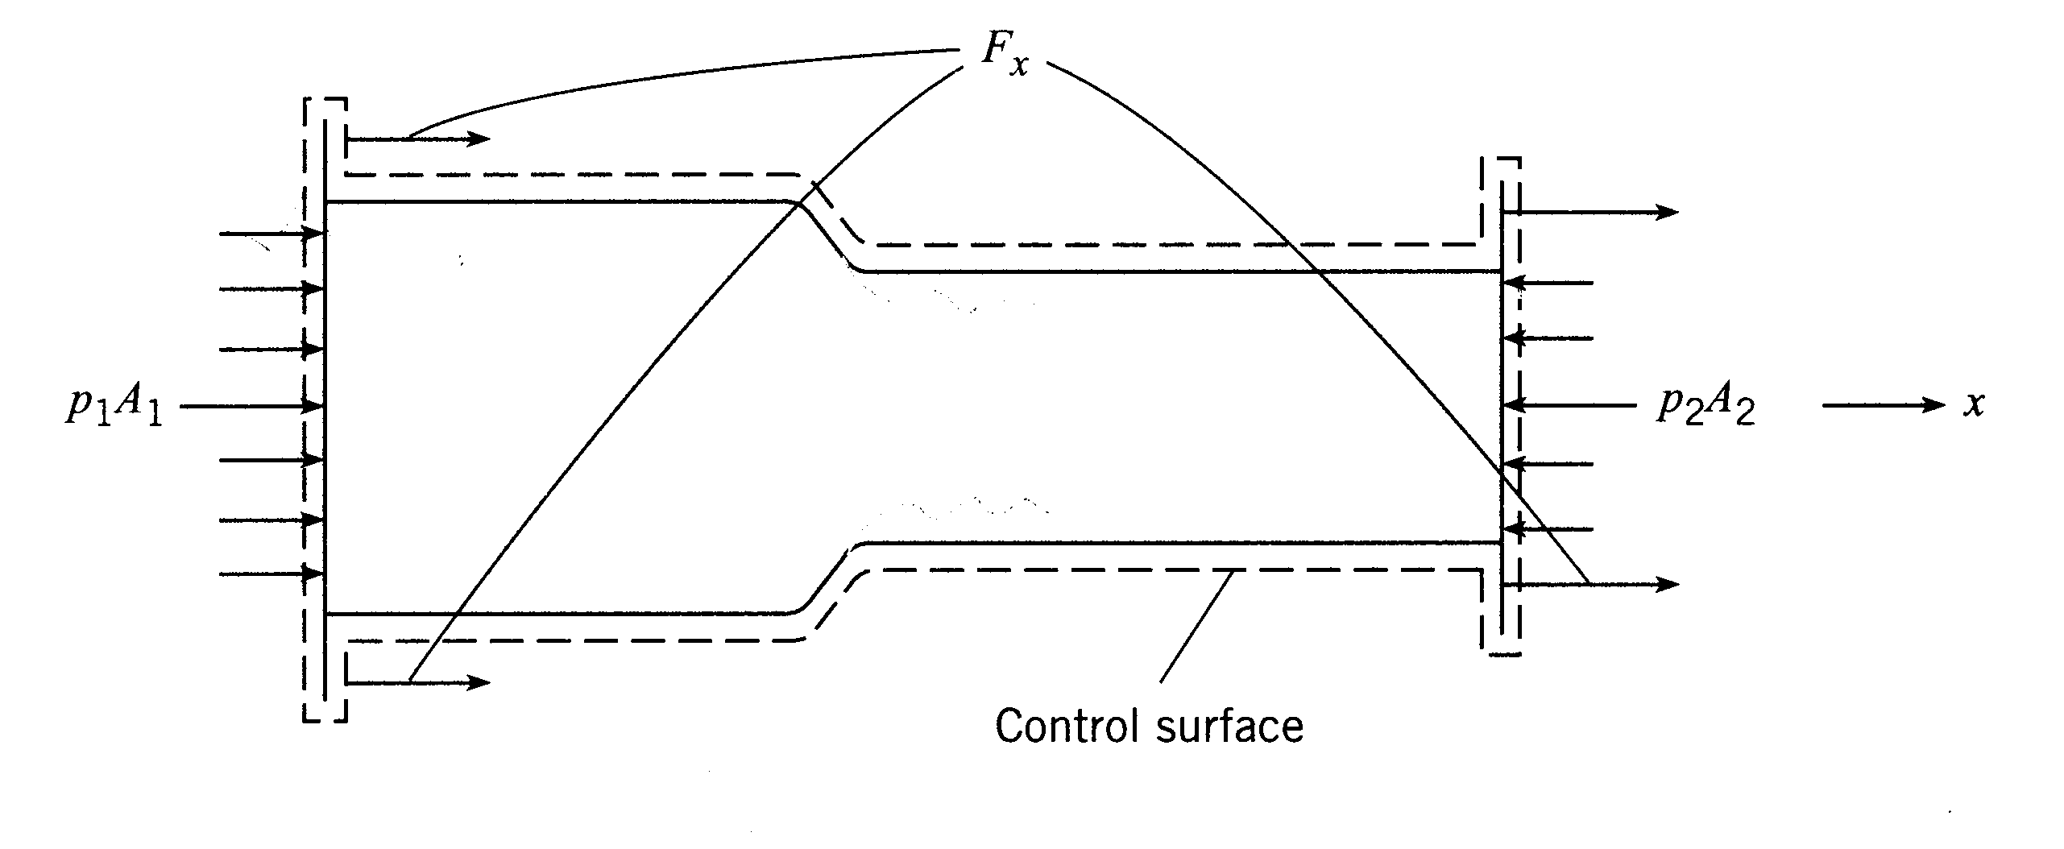
Fluid = water
p₁ = 250 kPa
D₁ = 30 cm
D₂ = 20 cm
F_{x} = ?

First apply momentum theorem

$$\sum{F_{x}=\sum{ρu\underline{V}⋅\underline{A}}}$$

F_{x} + p₁A₁ − p₂A₂ = ρV₁(−V₁A₁) + ρV₂(V₂A₂)

F_{x} = ρQ(V₂ − V₁) − p₁A₁ + p₂A₂

force required to hold transition in place

The only unknown in this equation is p₂, which can be obtained from the energy equation.

$\frac{p_{1}}{γ}+\frac{V_{1}^{2}}{2g}=\frac{p_{2}}{γ}+\frac{V_{2}^{2}}{2g}+h_{L}$ note: z₁ = z₂ and α = 1

$p_{2}=p_{1}−γ\left[\frac{V_{2}^{2}}{2g}−\frac{V_{1}^{2}}{2g}+h_{L}\right]$ drop in pressure

⇒$F_{x}=ρQ\left(V_{2}−V_{1}\right)+A_{2}\left[p_{1}−γ\left(\frac{V_{2}^{2}}{2g}−\frac{V_{1}^{2}}{2g}+h_{L}\right)\right]−p_{1}A_{1}$

p₂
(note: if p₂ = 0 same as nozzle)

In this equation,
continuity A₁V₁ = A₂V₂
$V_{2}=\frac{A_{1}}{A_{2}}V_{1}$
i.e. V₂ > V₁

V₁ = Q/A₁ = 10 m/s
V₂ = Q/A₂ = 22.5 m/s
$h_{L}=\text{.}1\frac{V_{2}^{2}}{2g}=2\text{.}\text{58}m$

F_{x} = −8.15 kN is negative x direction to hold
transition in place

