# Chapter 5 Finite Control Volume Analysis

**5.1 Continuity Equation**

RTT can be used to obtain an integral relationship expressing conservation of mass by defining the extensive property B = M such that β = 1.

B = M = mass

β = dB/dM = 1

General Form of Continuity Equation for moving and deforming CV,

$$\frac{dM}{dt}=0=\frac{d}{dt}\int_{CV}{ρdV}+\int_{CS}{ρ\underline{V_{R}}⋅\underline{dA}}$$

Or

$$\underset{\begin{aligned}Net rate of outflow \\ of mass across CS\end{aligned}}{\underbrace{\int_{CS}{ρ\underline{V_{R}}⋅\underline{dA}}}}=\underset{\begin{aligned}Rate of decrease of \\ mass within CV\end{aligned}}{\underbrace{-\frac{d}{dt}\int_{CV}{ρdV}}}$$

where, $\underline{V_{R}}=\underline{V}-\underline{V_{S}}$ is the relative velocity of fluid and $\underline{V_{S}}$ is the control surface velocity.

Simplifications for fixed CV (i.e, $\underline{V_{S}}$ =0):

1. Steady flow: $-\frac{d}{dt}\int_{CV}{ρdV}=0$
2. V = constant over discrete dA (flow sections):
$$\int_{CS}{ρ\underline{V}⋅\underline{dA}}=\sum_{CS}{\underline{V}⋅\underline{dA}}$$

3. Incompressible fluid (ρ = constant)

$$\int_{CS}{\underline{V}⋅\underline{dA}}=-\frac{d}{dt}\int_{CV}{dV}$$

i.e., conservation of volume

1. Steady One-Dimensional Flow in a Conduit:



−ρ1V1A1 + ρ2V2A2 = 0

for ρ = constant Q1 = Q2

Some useful definitions:

Mass flux 

Volume flux 

Average Velocity 

Average Density 

Note:  unless ρ = constant

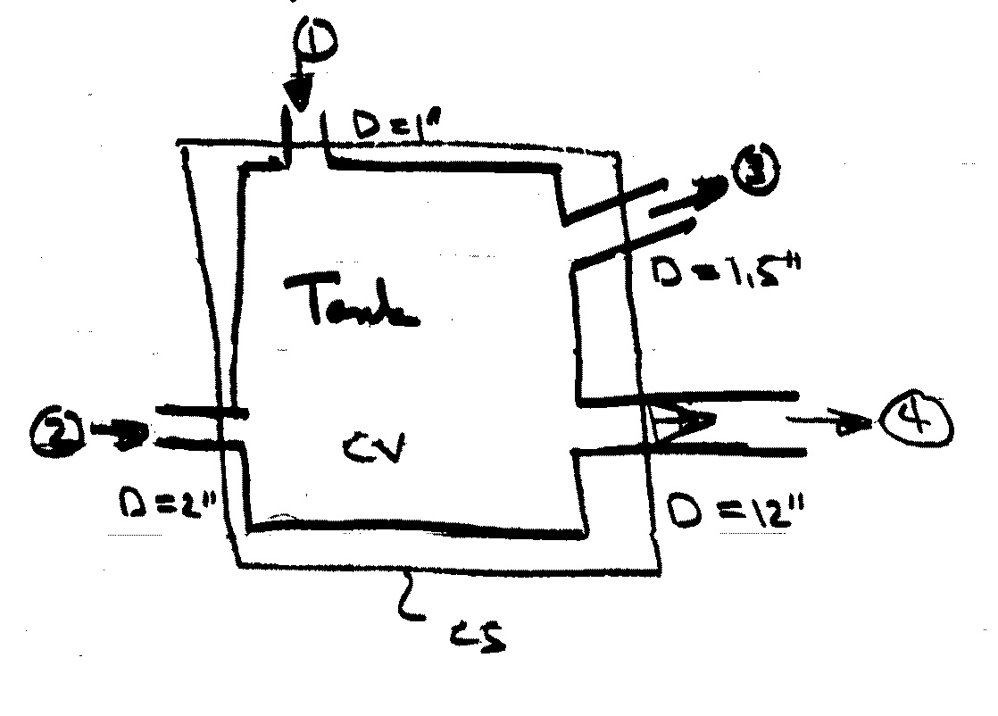Example

*Steady flow

*V1,2,3 = 50 fps

*At ④, V varies linearly

from zero at wall to

Vmax at pipe center

*find , Q4, Vmax

0 *water, ρw = 1.94 slug/ft3





i.e., -ρ1V1A1 - ρ2V2A2 + ρ3V3A3 + ρ= 0

ρ = const. = 1.94 lb-s2 /ft4 = 1.94 slug/ft3

= ρV(A1 + A2 – A3) V1=V2=V3=V=50f/s

= 

= 1.45 slugs/s

Q4 =  ft3/s

= 

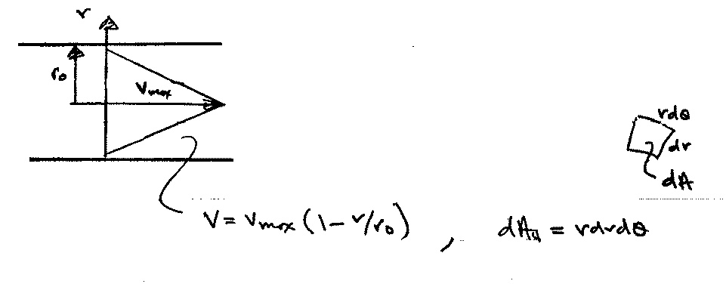velocity profile

Q4 = 

dA4

V4 ≠ V4(θ)





= 

Vmax = fps

**5.2 Momentum Equation**

Derivation of the Momentum Equation

Newton’s second law of motion for a system is

|  |  |  |
| --- | --- | --- |
| Time rate of change of the momentum of the system | = | Sum of external forces acting on the system |

Since momentum is mass times velocity, the momentum of a small particle of mass $ρdV$ is $\underline{V}ρdV$ and the momentum of the entire system is $\int_{sys}{\underline{V}ρdV}$. Thus,

$$\frac{D}{Dt}\int_{sys}{\underline{V}ρdV=\sum{{\underline{F}}_{sys}}}$$

Recall RTT:

$$\frac{DB_{sys}}{Dt}=\frac{d}{dt}\int_{CV}{βρdV}+\int_{CS}{βρ{\underline{V}}_{R}⋅\underline{dA}}$$

With $B_{sys}=M\underline{V}$ and $β=\frac{dB_{sys}}{dM}=\underline{V}$,

$$\frac{D}{Dt}\int_{sys}{\underline{V}ρdV=\frac{d}{dt}\int_{CV}{\underline{V}ρdV}+\int_{CS}{\underline{V}ρ{\underline{V}}_{R}⋅\underline{dA}}}$$

Thus, the Newton’s second law becomes

$$\underset{\begin{aligned}Rate of change \\ of momentum \\ in the CV\end{aligned}}{\underbrace{\frac{d}{dt}\int_{CV}{\underline{V}ρdV}}}+\underset{\begin{aligned}Net rate of flow \\ of momentum \\ through the CS\end{aligned}}{\underbrace{\int_{CS}{\underline{V}ρ{\underline{V}}_{R}⋅\underline{dA}}}}=\underset{\begin{aligned}Net external \\ force acting \\ on the CV\end{aligned}}{\underbrace{\sum{{\underline{F}}_{CV}}}}$$

where,

$\underline{V}$ is fluid velocity referenced to an inertial frame (non-accelerating)

${\underline{V}}_{S}$ is the velocity of CS referenced to the inertial frame

${\underline{V}}_{R}=\underline{V}-{\underline{V}}_{S}$ is the relative velocity referenced to CV

$\sum{{\underline{F}}_{CV}}=\sum{{\underline{F}}_{B}}+\sum{{\underline{F}}_{S}}$ is vector sum of all forces acting on the CV

${\underline{F}}_{B}$ is body force such as gravity that acts on the entire mass/volume of CV

${\underline{F}}_{S}$ is surface force such as normal (pressure and viscous) and tangential (viscous) stresses acting on the CS

e.g., Surface forces:

|  |  |
| --- | --- |
|  | $\underline{R}=R_{x}\hat{i}+R_{y}\hat{j}$ = resultant force on fluid in CV due to $p_{w}$ and $τ_{w}$, i.e. reaction force on fluid: $$R_{x}=\int_{A}{\left(-p_{w}\hat{n}+τ_{w}\hat{t}\right)⋅\hat{i}dA}$$ $$R_{y}=\int_{A}{\left(-p_{w}\hat{n}+τ_{w}\hat{t}\right)⋅jdA}$$ |
|  |  |

Note that, when CS cuts through solids, ${\underline{F}}_{S}$ may also include reaction force (or anchoring force).

e.g., the anchoring force $F_{B}$ required to hold nozzle when CS cuts through the bolts that are holding the nozzle/bend in place

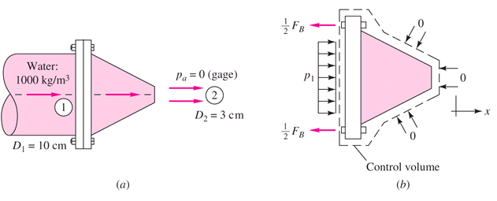

Important Features (to be remembered)

1. Vector equation to get component in any direction must use dot product

Carefully define coordinate system with forces positive in positive direction of coordinate axes

x equation



y equation



z equation



1. Carefully define control volume and be sure to include all external body and surface faces acting on it.

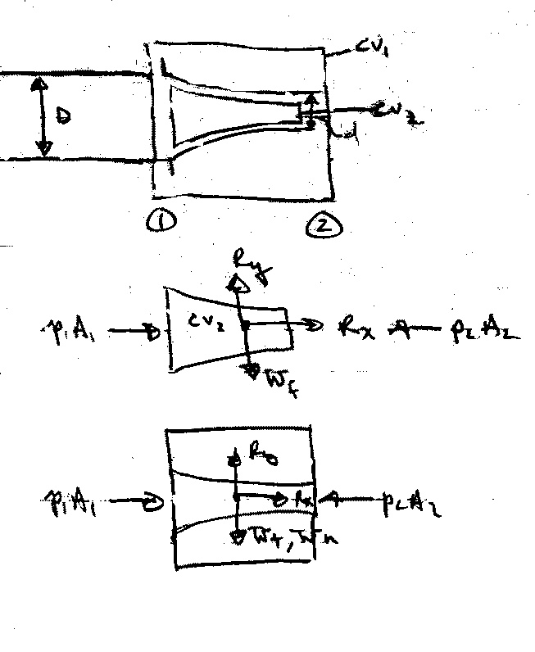For example,

(Rx,Ry) = reaction force on fluid

(Rx,Ry) = reaction force on nozzle

1. Velocity V and Vs must be referenced to a non-accelerating inertial reference frame. Sometimes it is advantageous to use a moving (at constant velocity) reference frame: relative inertial coordinate. Note VR = V – Vs is always relative to CS.
2. Steady vs. Unsteady Flow

Steady flow ⇒ 

1. Uniform vs. Nonuniform Flow

 = change in flow of momentum across CS

= ΣVρVR⋅A uniform flow across A

1. Fpres = − 

f = constant, ∇f = 0

= 0 for p = constant and for a closed surface

i.e., always use gage pressure

1. Pressure condition at a jet exit

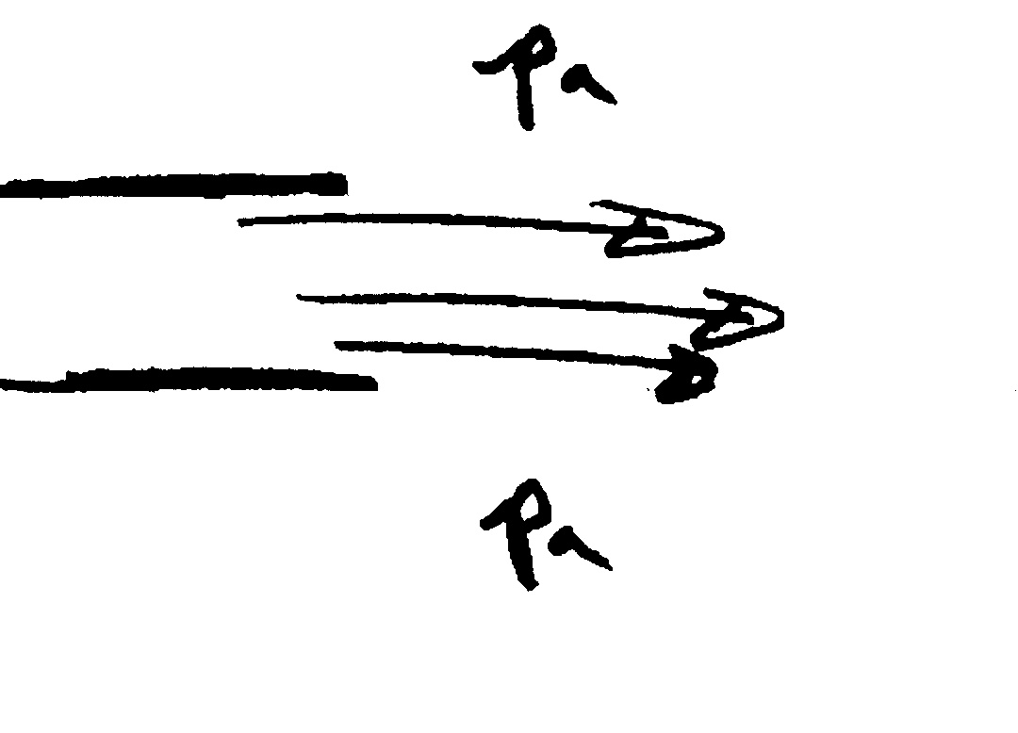

at an exit into the atmosphere jet pressure must be pa

Applications of the Momentum Equation

Initial Setup and Signs

1. Jet deflected by a plate or a vane
2. Flow through a nozzle
3. Forces on bends
4. Problems involving non-uniform velocity distribution
5. Motion of a rocket
6. Force on rectangular sluice gate
7. Water hammer
8. Steady and unsteady developing and fully developed pipe flow
9. Empting and filling tanks
10. Forces on transitions
11. Hydraulic jump
12. Boundary layer and bluff body drag
13. Rocket or jet propulsion
14. Propeller

1. Jet deflected by a plate or vane

Consider a jet of water turned through a horizontal angle

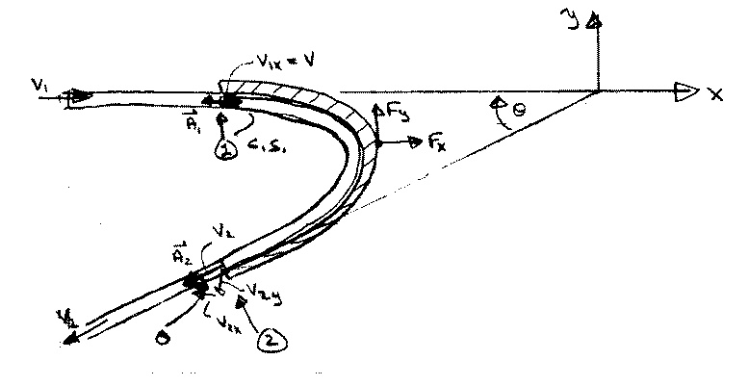

CV and CS are for jet so that Fx and Fy are vane reactions forces on fluid

x-equation: 

steady flow



= 

continuity equation: ρA1V1 = ρA2V2 = ρQ

for A1 = A2

V1 = V2

Fx = ρQ(V2x – V1x)

y-equation: 

Fy = ρV1y(– A1V1) + ρV2y(– A2V2)

= ρQ(V2y – V1y)

for above geometry only

where: V1x = V1 V2x = -V2cosθ V2y = -V2sinθ V1y = 0

note: Fx and Fy are force on fluid

- Fx and -Fy are force on vane due to fluid

If the vane is moving with velocity Vv, then it is convenient to choose CV moving with the vane

i.e., VR = V - Vv and V used for B also moving with vane

x-equation: 

Fx = ρV1x[-(V – Vv)1A1] + ρV2x[(V – Vv)2A2]

Continuity: 0 = 

i.e., ρ(V-Vv)1A1 = ρ(V-Vv)2A2 = ρ(V-Vv)A

Qrel

Fx = ρ(V-Vv)A[V2x – V1x]

Qrel

on fluid V2x = (V – Vv)2x

For coordinate system moving with vane

V1x = (V – Vv)1x

Power = -FxVv i.e., = 0 for Vv = 0

Fy = ρQrel(V2y – V1y)

1. Flow through a nozzle

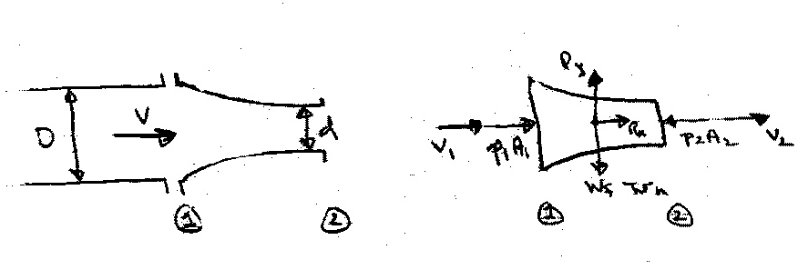Consider a nozzle at the end of a pipe (or hose). What force is required to hold the nozzle in place?

### CV = nozzle

and fluid

∴ (Rx, Ry) = force required to hold nozzle in place

Assume either the pipe velocity or pressure is known. Then, the unknown (velocity or pressure) and the exit velocity V2 can be obtained from combined use of the continuity and Bernoulli equations.

Bernoulli:  z1=z2



Continuity: A1V1 = A2V2 = Q





Say p1 known: 

To obtain the reaction force Rx apply momentum equation in x-direction



steady flow and uniform

flow over CS

=

Rx + p1A1 – p2A2 = ρV1(-V1A1) + ρV2(V2A2)

= ρQ(V2 - V1)

Rx = ρQ(V2 - V1) - p1A1

To obtain the reaction force Ry apply momentum equation in y-direction

 since no flow in y-direction

Ry – Wf − WN = 0 i.e., Ry = Wf + WN

Numerical Example: Oil with S = .85 flows in pipe under pressure of 100 psi. Pipe diameter is 3” and nozzle tip diameter is 1”



D/d = 3

Q = 

= .716 ft3/s

V1 = 14.59 ft/s

V2 = 131.3 ft/s

Rx = 141.48 – 706.86 = −569 lbf

Rz = 10 lbf

This is force on nozzle

3. Forces on Bends

Consider the flow through a bend in a pipe. The flow is considered steady and uniform across the inlet and outlet sections. Of primary concern is the force required to hold the bend in place, i.e., the reaction forces Rx and Ry which can be determined by application of the momentum equation.

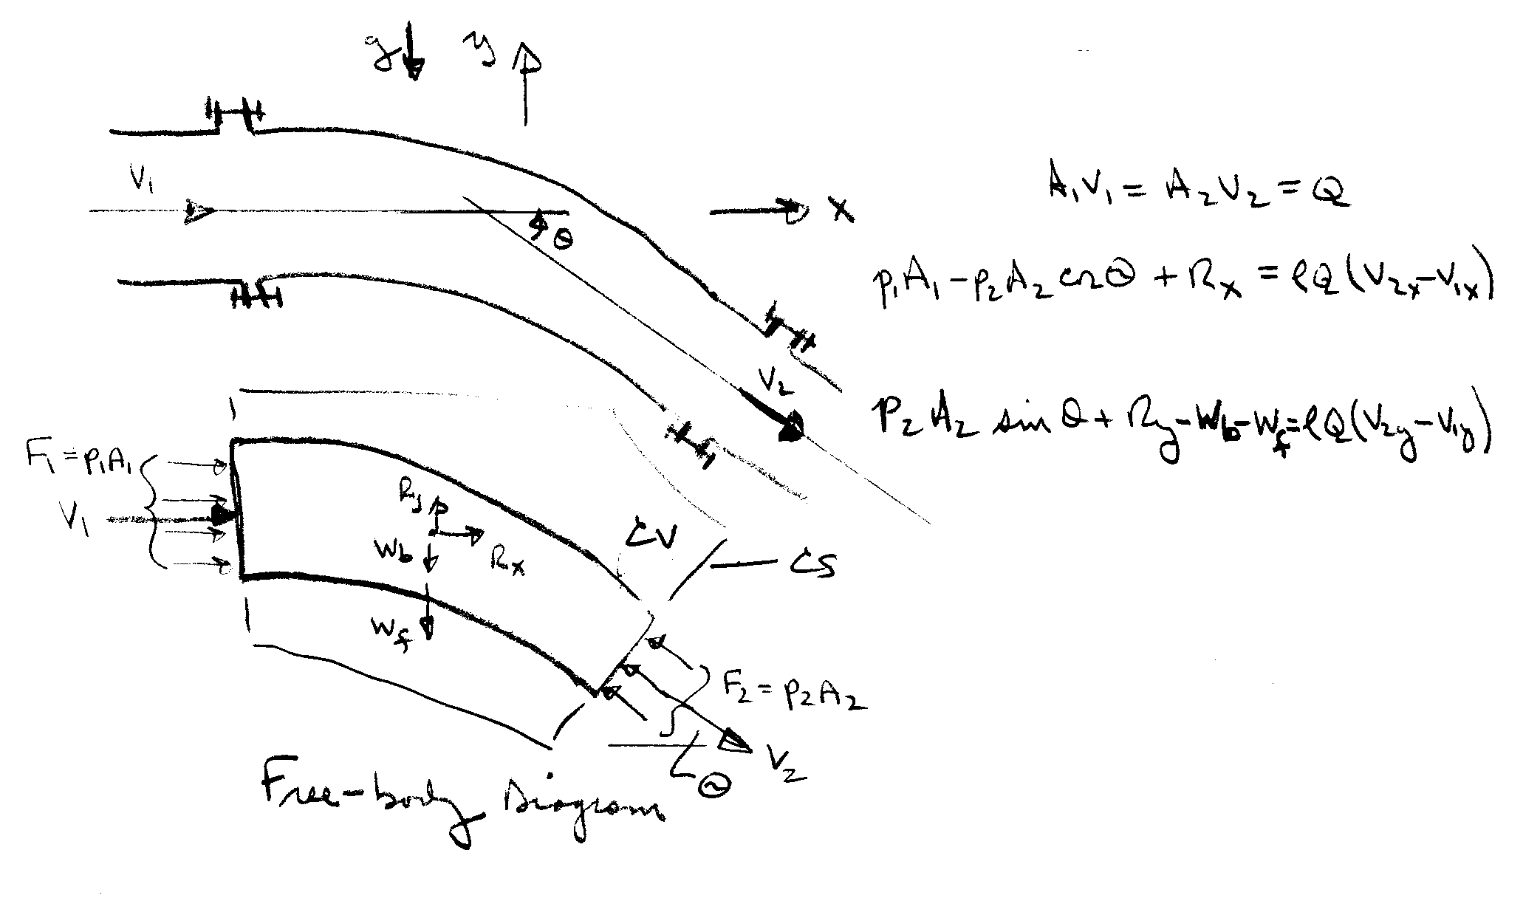

Rx, Ry = reaction force on

bend i.e., force

required to hold

bend in place

Continuity: 

i.e., Q = constant = 

x-momentum:  

= 

y-momentum: 

 = 

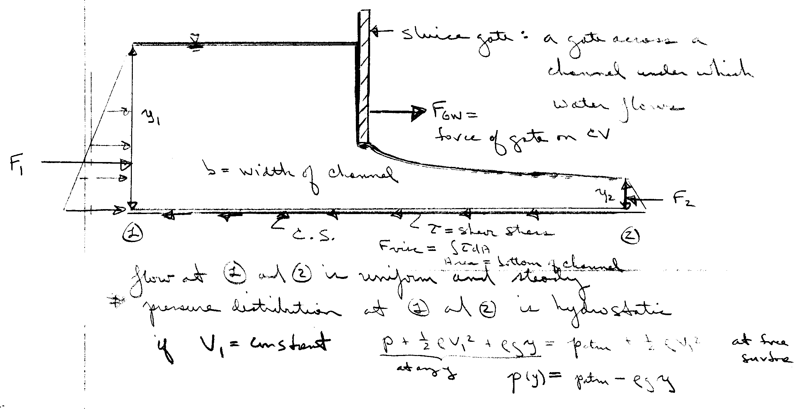4. Force on a rectangular sluice gate

The force on the fluid due to the gate is calculated from the x-momentum equation:





usually can be neglected



= 







5. Application of relative inertial coordinates for a moving but non-deforming control volume (CV)

The CV moves at a constant velocity  with respect to the absolute inertial coordinates. If  represents the velocity in the relative inertial coordinates that move together with the CV, then:



Reynolds transport theorem for an arbitrary moving deforming CV:



For a non-deforming CV moving at constant velocity, RTT for incompressible flow:



1) Conservation of mass

, and :



For steady flow:



2) Conservation of momentum

 and 



For steady flow with the use of continuity:





Example (use relative inertial coordinates):

Ex) A jet strikes a vane which moves to the right at constant velocity $V_{C}$ on a frictionless cart. Compute (a) the force $F_{x}$ required to restrain the cart and (b) the power $P$ delivered to the cart. Also find the cart velocity for which (c) the force $F_{x}$ is a maximum and (d) the power $P$ is a maximum.

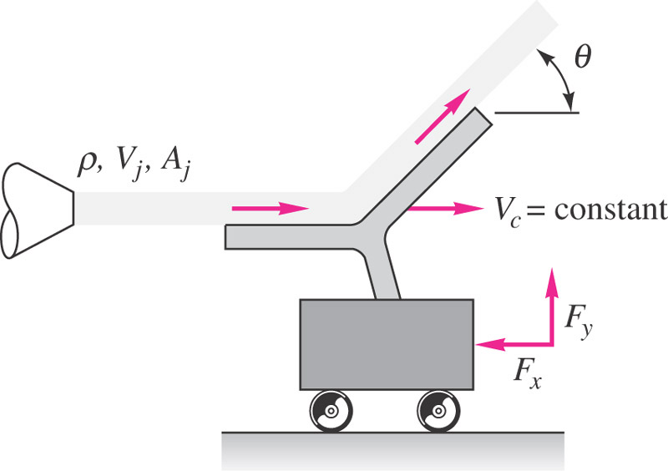

**Solution:**

Assume relative inertial coordinates with non-deforming CV i.e. CV moves at constant translational non-accelerating

$\underline{V_{CS}}=u_{CS}\hat{i}+v_{CS}\hat{j}+w_{CS}\hat{k}=V_{C}\hat{i}$

then  . Also assume steady flow $\underline{V}≠\underline{V}\left(t\right)$ with $ρ=constant$ and neglect gravity effect.

Continuity:



Bernoulli without gravity:





Since 



Momentum:

$$∑\underline{F}=ρ\int_{CS}{\underline{V_{R}} \underline{V_{R}}⋅\underline{n}dA}$$

$$\sum{F_{x}=-F_{x}=ρ\int_{CS}{V_{Rx}\underline{V_{R}}⋅\underline{n}dA}}$$

$$-F_{x}=ρV_{R_{x}1}\left(-V_{R1}A_{1}\right)+ρV_{R_{x}2}\left(V_{R2}A_{2}\right)$$

$$0=ρ\int_{CS}{\underline{V_{R}}⋅\underline{n}dA}$$

$$-ρV_{R1}A_{1}+ρV_{R2}A_{2}=0$$

$$V_{R1}A_{1}=V_{R2}A_{2}=\underset{V_{R1}=V_{R_{x}1}=V_{j}-V_{C}}{\underbrace{\left(V_{j}-V_{C}\right)}A_{j}}$$

$$-F_{x}=ρ\left(V_{j}-V_{C}\right)\left[-\left(V_{j}-V_{C}\right)A_{j}\right]+ρ\left(V_{j}-V_{C}\right)\cos{θ}\left(V_{j}-V_{C}\right)A_{j}$$

$$F_{x}=ρ{\left(V_{j}-V_{C}\right)}^{2}A_{j}\left[1-\cos{θ}\right]$$

$$Power=V_{C}F_{x}=V_{C}ρ{\left(V_{j}-V_{C}\right)}^{2}A_{j}\left(1-\cos{θ}\right)$$

$${F_{x}}_{max}=ρV_{j}^{2}A_{j}\left(1-\cos{θ}\right), V_{C}=0$$

$$P_{max}⇒\frac{dP}{dV_{C}}=0$$

$$P=V_{C}ρ\left(V_{j}^{2}-2V_{C}V_{j}+V_{C}^{2}\right)A_{j}\left(1-\cos{θ}\right)$$

$$=ρ\left(V_{j}^{2}V_{C}-2V_{C}^{2}V_{j}+V_{C}^{3}\right)A_{j}\left(1-\cos{θ}\right)$$

$$\frac{dP}{dV_{C}}=ρ\left(V_{j}^{2}-4V_{C}V_{j}+3V_{C}^{2}\right)A_{j}\left(1-\cos{θ}\right)=0$$

$$3V_{C}^{2}-4V_{j}V_{C}+V_{j}^{2}=0$$

$$V_{C}=\frac{+4V_{j}±\sqrt{16V_{j}^{2}-12V_{j}^{2}}}{6}=\frac{4V_{j}±2V_{j}}{6}$$

$$V_{C}=\frac{V_{j}}{3}$$

$$P_{max}=\frac{V_{j}}{3}ρ{\left(\frac{2V_{j}}{3}\right)}^{2}A_{j}\left(1-\cos{θ}\right)$$

$$=\frac{4}{27}V_{j}^{3}ρA_{j}\left(1-\cos{θ}\right)$$

**5.3 Energy Equation**

Derivation of the Energy Equation

The First Law of Thermodynamics

The difference between the heat added to a system and the work done by a system depends only on the initial and final states of the system; that is, depends only on the change in energy E: principle of conservation of energy

ΔE = Q – W

ΔE = change in energy

Q = heat added to the system

W = work done by the system

E = Eu + Ek + Ep = total energy of the system

potential energy

kinetic energy

Internal energy due to molecular motion

The differential form of the first law of thermodynamics expresses the rate of change of E with respect to time



rate of work being done by system

rate of heat transfer to system

Energy Equation for Fluid Flow

The energy equation for fluid flow is derived from Reynolds transport theorem with

Bsystem = E = total energy of the system (extensive property)

β = E/mass = e = energy per unit mass (intensive property)

=  + ek + ep





This can be put in a more useable form by noting the following:





 (for Ep due to gravity only)



rate of work rate of change flux of energy

done by system of energy in CV out of CV

(ie, across CS)

rate of heat

transfer to sysem

Rate of Work Components: 

For convenience of analysis, work is divided into shaft work Ws and flow work Wf

Wf = net work done on the surroundings as a result of

normal and tangential stresses acting at the control

surfaces

= Wf pressure + Wf shear

Ws = any other work transferred to the surroundings

usually in the form of a shaft which either takes

energy out of the system (turbine) or puts energy into

the system (pump)

Flow work due to pressure forces Wf p  (for system)

Note: here  uniform over 

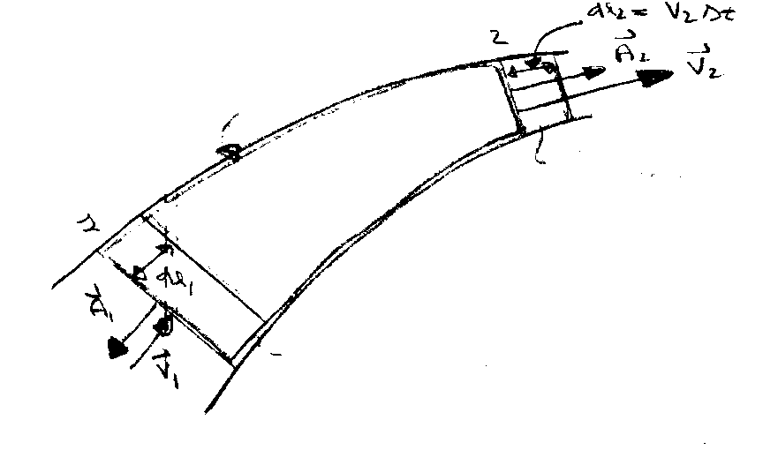

System at time t + Δt

System at time t

CS

CV

Work = force × distance

at 2 W2 = p2A2 × V2Δt

(on surroundings)

rate of work⇒ 

at 1 W1 = −p1A1 × V1Δt

neg. sign since pressure force on surrounding fluid acts in a direction opposite to the motion of the system boundary



In general,



for more than one control surface and V not necessarily uniform over A:





### Basic form of energy equation



 h=enthalpy

#### Usually this term can be eliminated by proper choice of CV, i.e. CS normal to flow lines. Also, at fixed boundaries the velocity is zero (no slip condition) and no shear stress flow work is done. Not included or discussed in text!

**Simplified Forms of the Energy Equation**

Energy Equation for Steady One-Dimensional Pipe Flow

Consider flow through the pipe system as shown

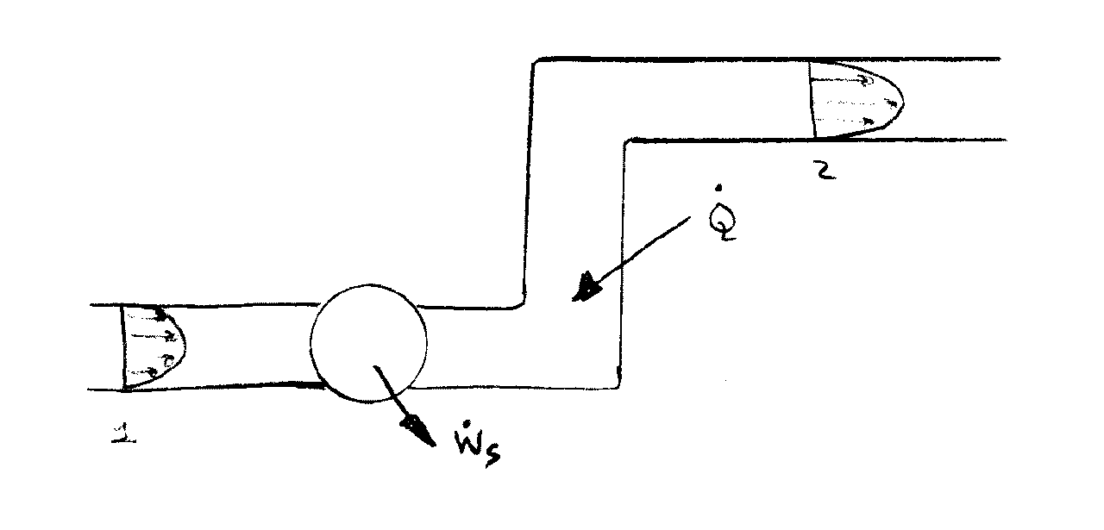

Energy Equation (steady flow)





*Although the velocity varies across the flow sections the streamlines are assumed to be straight and parallel; consequently, there is no acceleration normal to the streamlines and the pressure is hydrostatically distributed, i.e., p/ρ +gz = constant.

*Furthermore, the internal energy u can be considered as constant across the flow sections, i.e. T = constant. These quantities can then be taken outside the integral sign to yield



Recall that 

So that  mass flow rate

Define: 

K.E. flux K.E. flux for V==constant across pipe

i.e.,  = kinetic energy correction factor



Note that: α = 1 if V is constant across the flow section

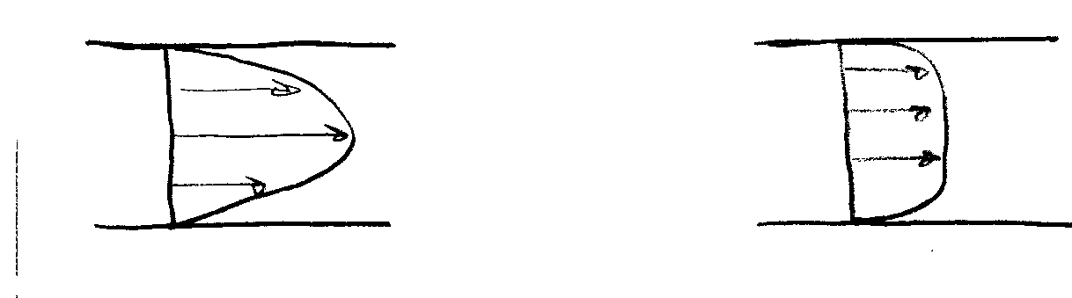α > 1 if V is nonuniform

laminar flow α = 2 turbulent flow α = 1.05 ~ 1 may be used

Shaft Work

Shaft work is usually the result of a turbine or a pump in the flow system. When a fluid passes through a turbine, the fluid is doing shaft work on the surroundings; on the other hand, a pump does work on the fluid

 where  and  are

magnitudes of power 

Using this result in the energy equation and deviding by g results in



mechanical part thermal part

Note: each term has dimensions of length

Define the following:







Head Loss

In a general fluid system a certain amount of mechanical energy is converted to thermal energy due to viscous action. This effect results in an increase in the fluid internal energy. Also, some heat will be generated through energy dissipation and be lost (i.e. -). Therefore the term

from 2nd law

represents a loss in mechanical energy due to viscous stresses



Note that adding  to system will not make hL = 0 since this also increases Δu. It can be shown from 2nd law of thermodynamics that hL > 0.

Drop ⎯ over  and understand that V in energy equation refers to average velocity.

Using the above definitions in the energy equation results in (steady 1-D incompressible flow)



form of energy equation used for this course!

Comparison of Energy Equation and Bernoulli Equation

Apply energy equation to a stream tube without any shaft work

Infinitesimal stream tube ⇒ α1=α2=1

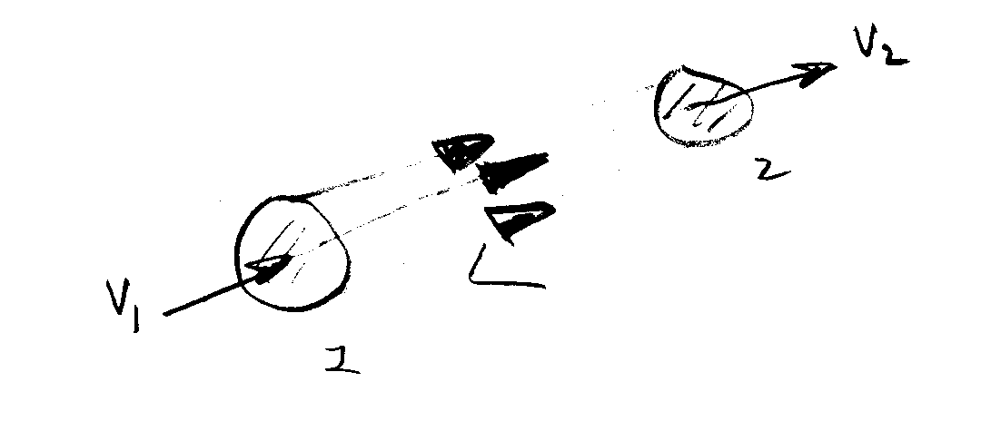

Energy eq : 

•If hL = 0 (i.e., μ = 0) we get Bernoulli equation and conservation of mechanical energy along a streamline

•Therefore, energy equation for steady 1-D pipe flow can be interpreted as a modified Bernoulli equation to include viscous effects (hL) and shaft work (hp or ht)

Summary of the Energy Equation

The energy equation is derived from RTT with

B = E = total energy of the system

β = e = E/M = energy per unit mass

=  + +gz

internal KE PE



from 1st Law of Thermodynamics

work done

heat added

##### Neglected in text presentation



pressure work done on CS

shaft work done on or by system (pump or turbine)

Viscous stress work on CS









For steady 1-D pipe flow (one inlet and one outlet):

1. Streamlines are straight and parallel

⇒ p/ρ +gz = constant across CS

1. T = constant ⇒ u = constant across CS

3) define  = KE correction factor

⇒ 

mechanical energy

Thermal energy



# Note: each term has

units of length

V is average velocity (vector dropped) and

corrected by α





 head loss

> 0 represents loss in mechanical energy due to viscosity**Concept of Hydraulic and Energy Grade Lines**



Define HGL = 

point-by-point application is graphically displayed

EGL = 

# HGL corresponds to pressure tap measurement + z

# EGL corresponds to stagnation tube measurement + z

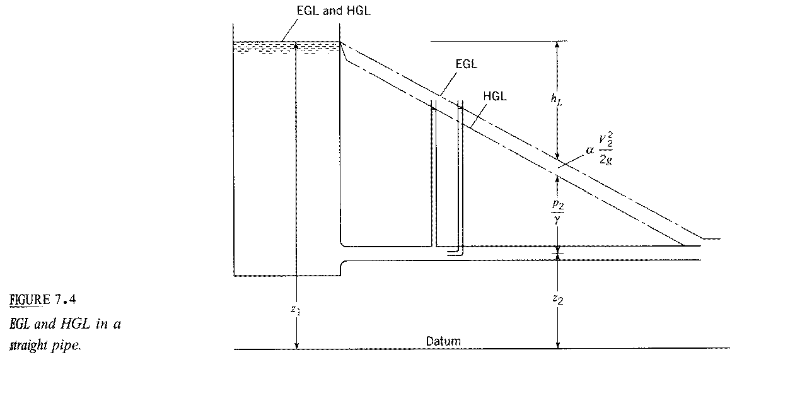

EGL1 = EGL2 + hL

for hp = ht = 0

hL = 

i.e., linear variation in L for D,

V, and f constant

EGL = HGL if V = 0

f = friction factor

f = f(Re)

pressure tap: 

h = height of fluid in

tap/tube

stagnation tube: 

EGL1 + hp = EGL2 + ht + hL

EGL2 = EGL1 + hp − ht − hL



abrupt change due to hp or ht

Helpful hints for drawing HGL and EGL

1. EGL = HGL + αV2/2g = HGL for V = 0

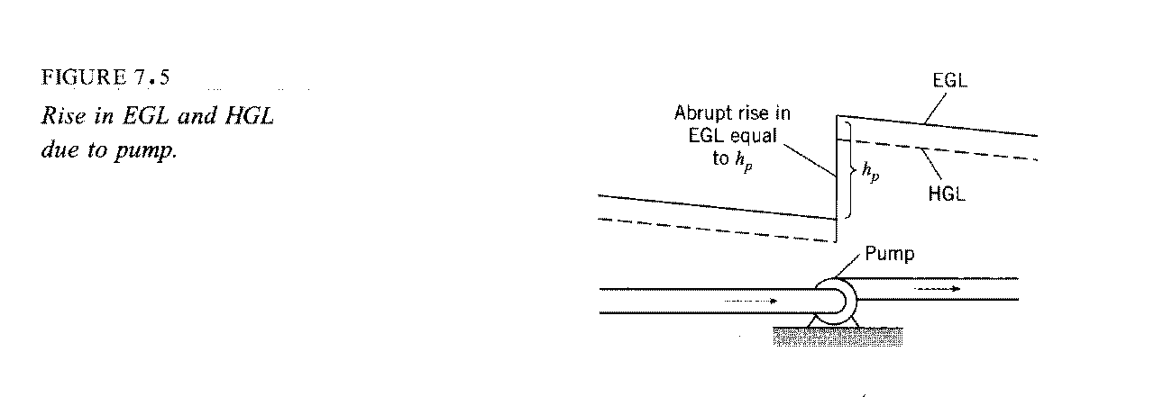2.&3.  in pipe means EGL and HGL will slope

downward, except for abrupt changes due to ht or hp

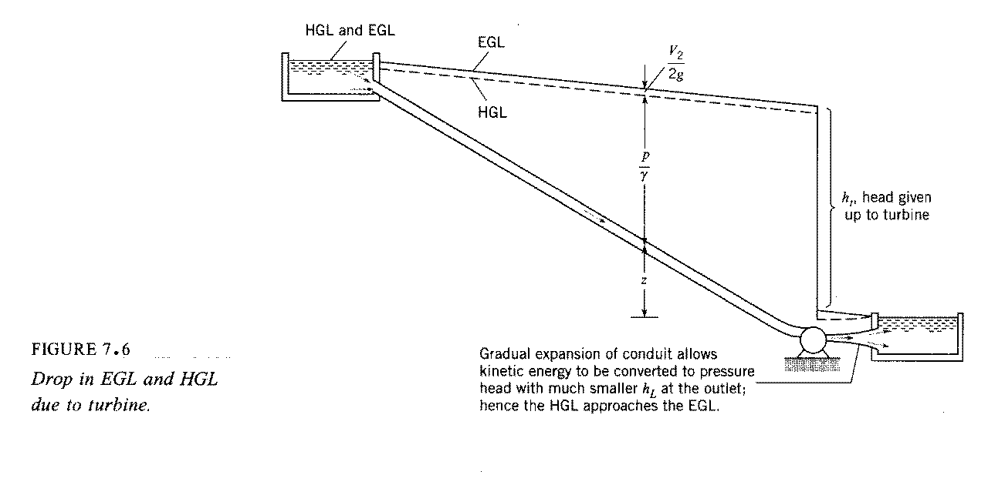4. p = 0 ⇒ HGL = z



HGL2 = EGL1 - hL

for abrupt expansion

5. for  = constant × L

i.e., linearly increased for increasing L with slope 

EGL/HGL slope downward

6. for change in D ⇒ change in V

i.e. V1A1 = V2A2

change in distance between HGL & EGL and slope

change due to change in hL



⇒



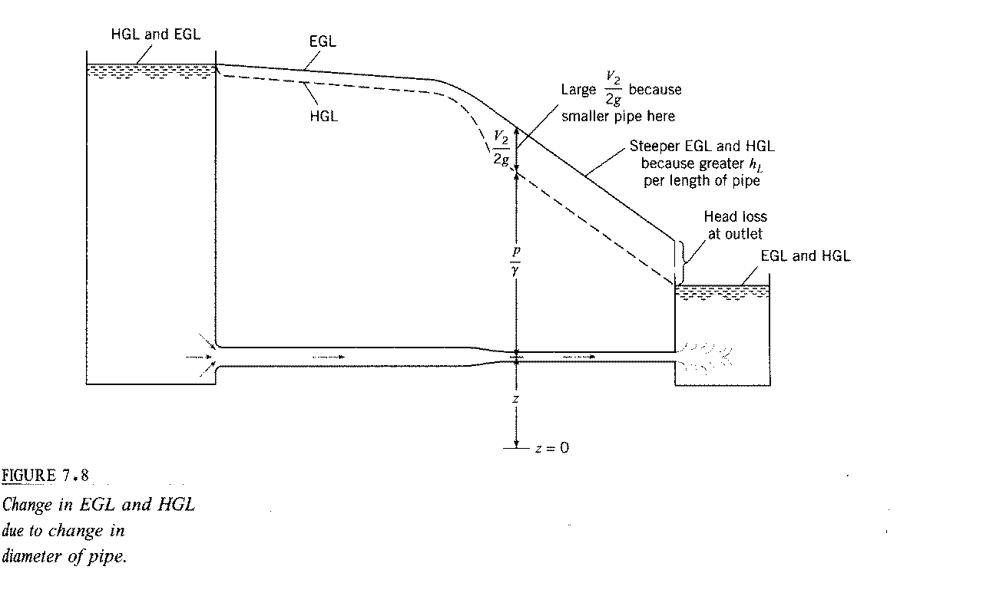

7. If HGL < z then p/γ < 0 i.e., cavitation possible

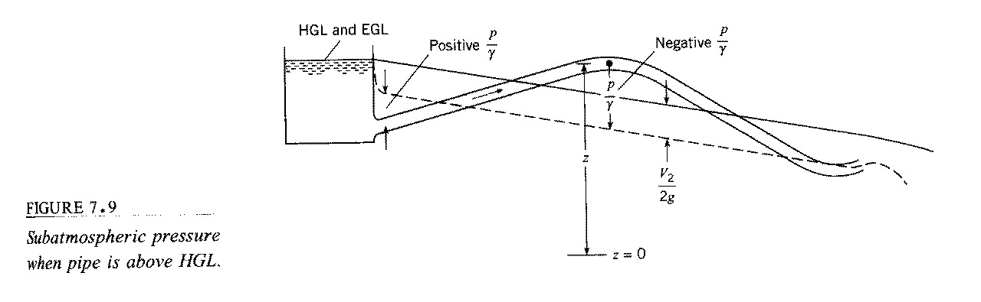

condition for cavitation:



gage pressure 



9810 N/m3

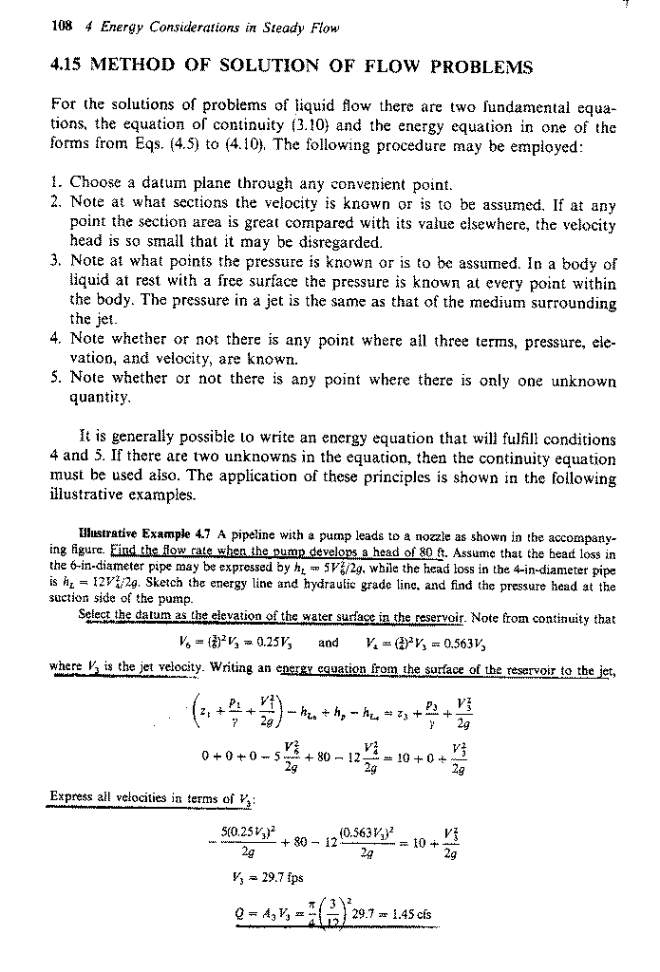

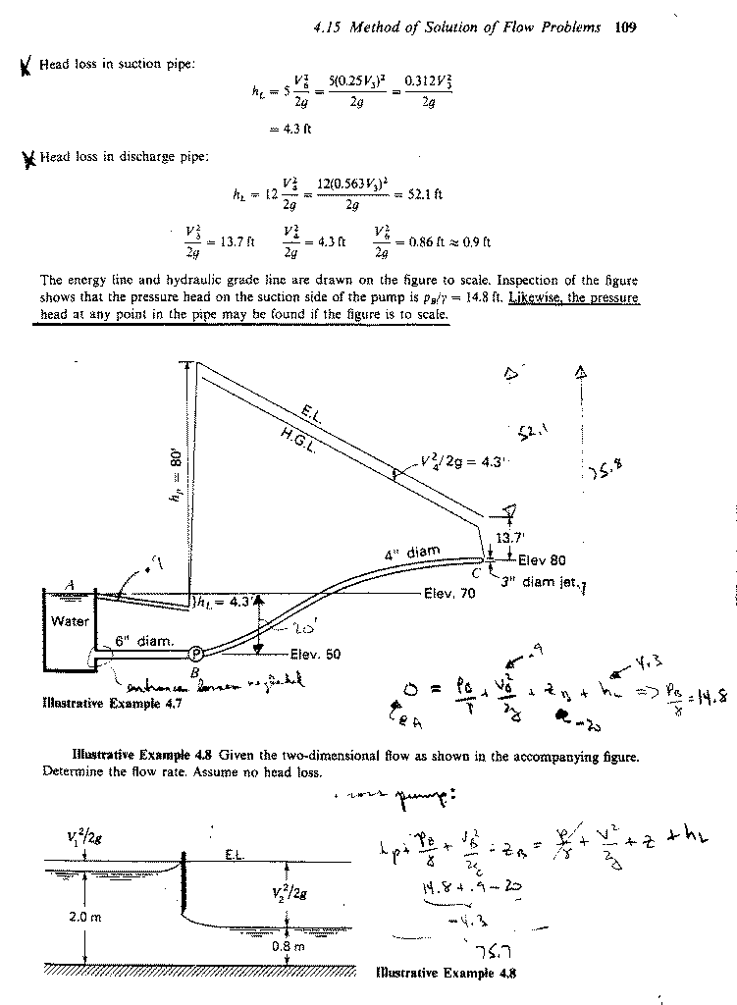**Application of the Energy, Momentum, and Continuity Equations in Combination**

In general, when solving fluid mechanics problems, one should use all available equations in order to derive as much information as possible about the flow. For example, consistent with the approximation of the energy equation we can also apply the momentum and continuity equations

Energy:



Momentum:

one inlet and one outlet

ρ = constant



Continuity:

A1V1 = A2V2 = Q = constant

Abrupt Expansion

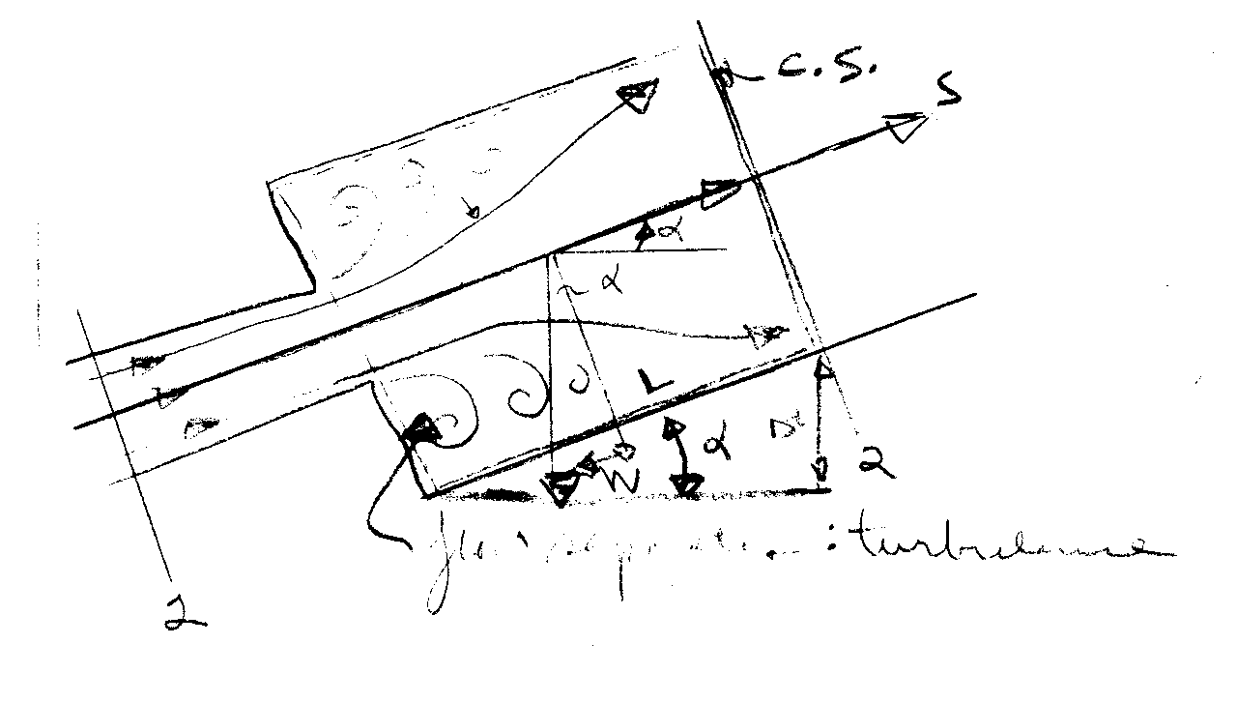Consider the flow from a small pipe to a larger pipe. Would like to know hL = hL(V1,V2). Analytic solution to exact problem is extremely difficult due to the occurrence of flow separations and turbulence. However, if the assumption is made that the pressure in the separation region remains approximately constant and at the value at the point of separation, i.e, p1, an approximate solution for hL is possible:

Apply Energy Eq from 1-2 (α1 = α2 = 1)



Momentum eq. For CV shown (shear stress neglected)



=



=

W sin α

next divide momentum equation by γA2



÷ γA2

from energy equation

⇓





continutity eq.

V1A1 = V2A2





−2V1V2



If V2 << V1,



Forces on Transitions

Example 7-6

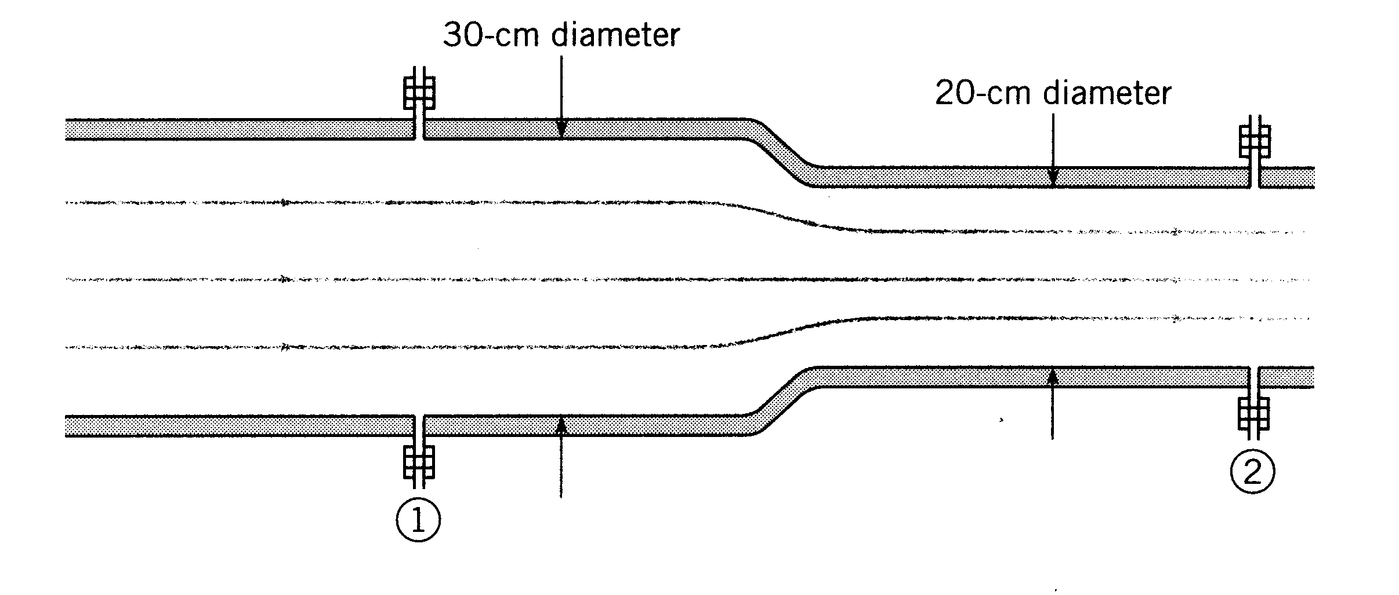Q = .707 m3/s

head loss = 

(empirical equation)

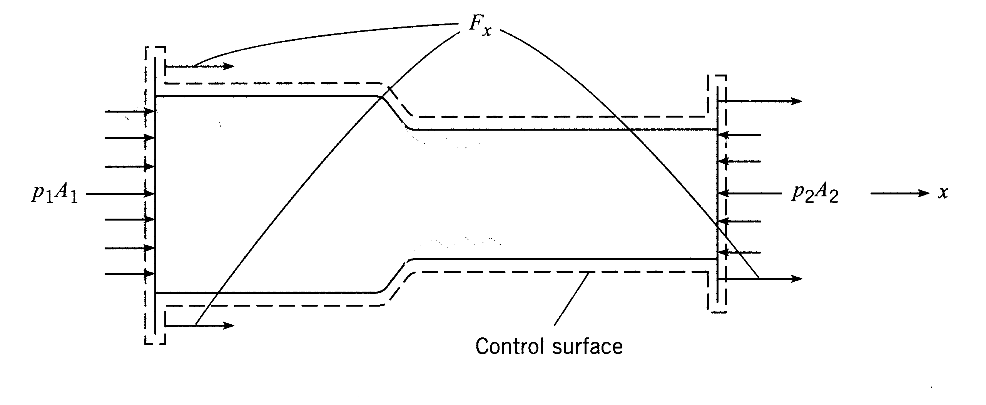

Fluid = water

p1 = 250 kPa

D1 = 30 cm

D2 = 20 cm

Fx = ?

First apply momentum theorem



Fx + p1A1 − p2A2 = ρV1(−V1A1) + ρV2(V2A2)

Fx = ρQ(V2 − V1) − p1A1 + p2A2

force required to hold transition in place

The only unknown in this equation is p2, which can be obtained from the energy equation.

 note: z1 = z2 and α = 1

 drop in pressure

⇒

p2

(note: if p2 = 0 same as nozzle)

In this equation,

continuity A1V1 = A2V2



i.e. V2 > V1

V1 = Q/A1 = 10 m/s

V2 = Q/A2 = 22.5 m/s



Fx = −8.15 kN is negative x direction to hold

transition in place