4.5 Separation, Vortices, Turbulence,
and Flow Classification

We will take this opportunity and expand on the material provided in the text to give a general discussion of fluid flow classifications and terminology.

- One-, Two-, and Three-dimensional Flow
1D: V = $u(y)\hat{i}$

2D: V = $u(x,y)\hat{i}+v(x,y)\hat{j}$

3D: V = V(x) = $u(x,y,z)\hat{i}+v(x,y,z)\hat{j}+w(x,y,z)\hat{k}$

- Steady vs. Unsteady Flow
V = V(x,t) unsteady flow

V = V(x) steady flow

- Incompressible and Compressible Flow
$\frac{Dρ}{\text{Dt}}=0$ ⇒ incompressible flow

representative velocity
Ma = $\frac{V}{c}$
speed of sound in fluid

Ma < .3 incompressible

Ma > .3 compressible

Ma = 1 sonic (commercial aircraft Ma∼.8)

Ma > 1 supersonic

Ma is the most important nondimensional parameter for compressible flow (Chapter 8 Dimensional Analysis)

- Viscous and Inviscid Flows
Inviscid flow: neglect μ, which simplifies analysis but
(μ = 0) must decide when this is a good
approximation (D’ Alembert paradox body in steady motion C_{D} = 0!)
Viscous flow: retain μ, i.e., “Real-Flow Theory” more
(μ ≠ 0) complex analysis, but often no choice

- Rotational vs. Irrotational Flow
Ω = ∇ × V ≠ 0 rotational flow

Ω = 0 irrotational flow

Generation of vorticity usually is the result of viscosity ∴ viscous flows are always rotational, whereas inviscid flows are usually irrotational. Inviscid, irrotational, incompressible flow is referred to as ideal-flow theory.

- Laminar vs. Turbulent Viscous Flows
Laminar flow = smooth orderly motion composed of thin sheets (i.e., laminas) gliding smoothly over each other

Turbulent flow = disorderly high frequency fluctuations superimposed on main motion. Fluctuations are visible as eddies which continuously mix, i.e., combine and disintegrate (average size is referred to as the scale of turbulence).
Re - decomposition
$u=\overline{u}+u^{'}(t)$

mean turbulent fluctuation
motion

usually $u^{'}$∼(.01-.1)$\overline{u}$, but influence is as if μ increased by 100-10,000 or more.

Example: Pipe Flow (Chapter 10 = Flow in Conduits)
Laminar flow:
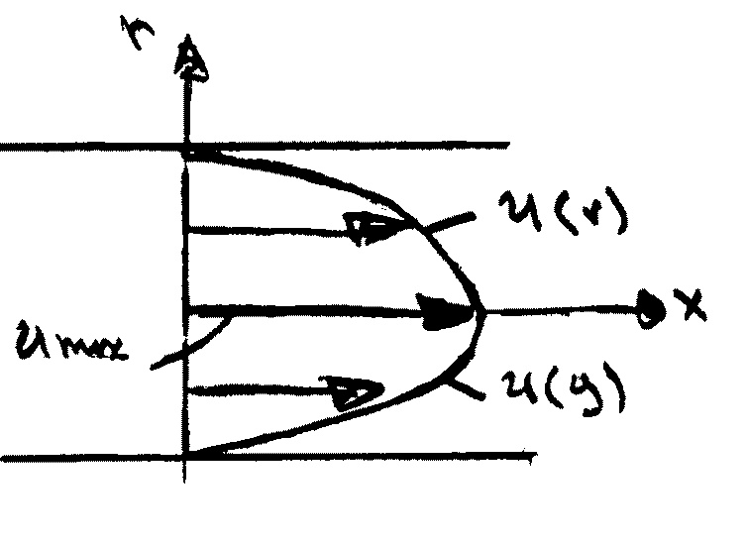
$$u(r)=\frac{R^{2}−r^{2}}{4μ}\left(−\frac{\text{dp}}{\text{dx}}\right)$$
u(y),velocity profile in a paraboloid

Turbulent flow: fuller profile due to turbulent mixing extremely complex fluid motion that defies closed form analysis.

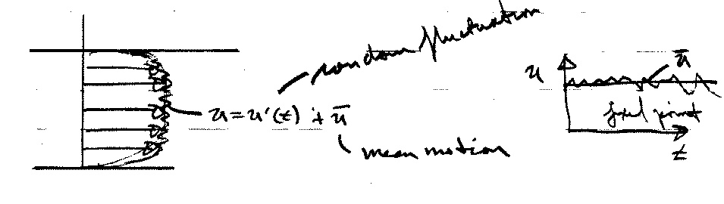

Turbulent flow is the most important area of motion fluid dynamics research.

The most important nondimensional number for describing fluid motion is the Reynolds number (Chapter 8)

V = characteristic velocity
D = characteristic length
Re = $\frac{\text{VD}ρ}{μ}=\frac{\text{VD}}{ν}$
For pipe flow
V = $\overline{V}$ = average velocity
D = pipe diameter

Re < 2000 laminar flow
Re > 2000 turbulent flow

Also depends on roughness, free-stream turbulence, etc.

- Internal vs. External Flows
Internal flows = completely wall bounded;
Usually requires viscous analysis, except near entrance (Chapter 10)

External flows = unbounded; i.e., at some distance from body or wall flow is uniform (Chapter 9, Surface Resistance)

External Flow exhibits flow-field regions such that both inviscid and viscous analysis can be used depending on the body shape and Re.

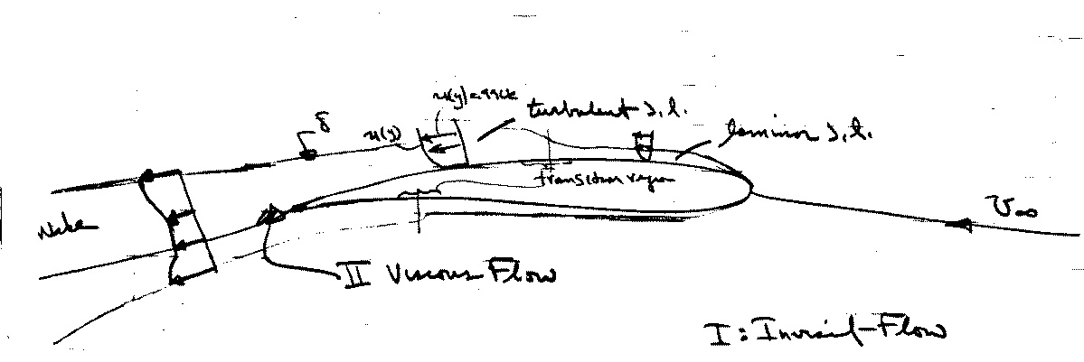
Flow Field Regions (high Re flows)
$$\text{Re}=\frac{\text{Vc}}{ν}=\frac{\text{inertia} \text{force}}{\text{viscous} \text{force}}$$

Important features:
- low Re viscous effects important throughout entire fluid domain: creeping motion
- high Re flow about streamlined body viscous effects confined to narrow region: boundary layer and wake
- high Re flow about bluff bodies: in regions of adverse pressure gradient flow is susceptible to separation and viscous-inviscid interaction is important

8. Separated vs. Unseparated Flow

Flow remains attached
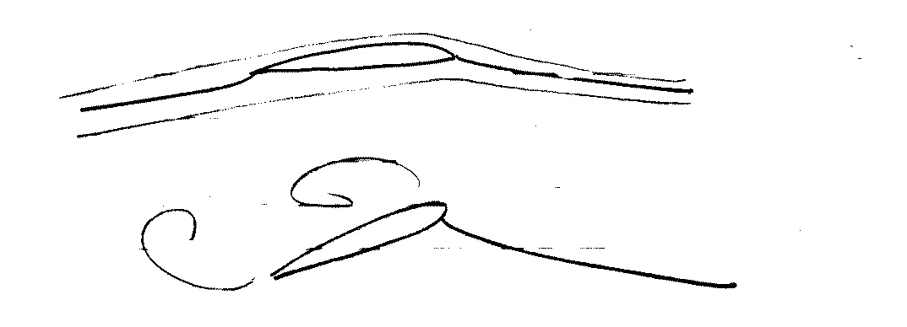
Streamlined body w/o separation

Bluff body Flow separates and creates
the region of reverse
flow, i.e. separation

4.6 Basic Control-Volume Approach and RTT

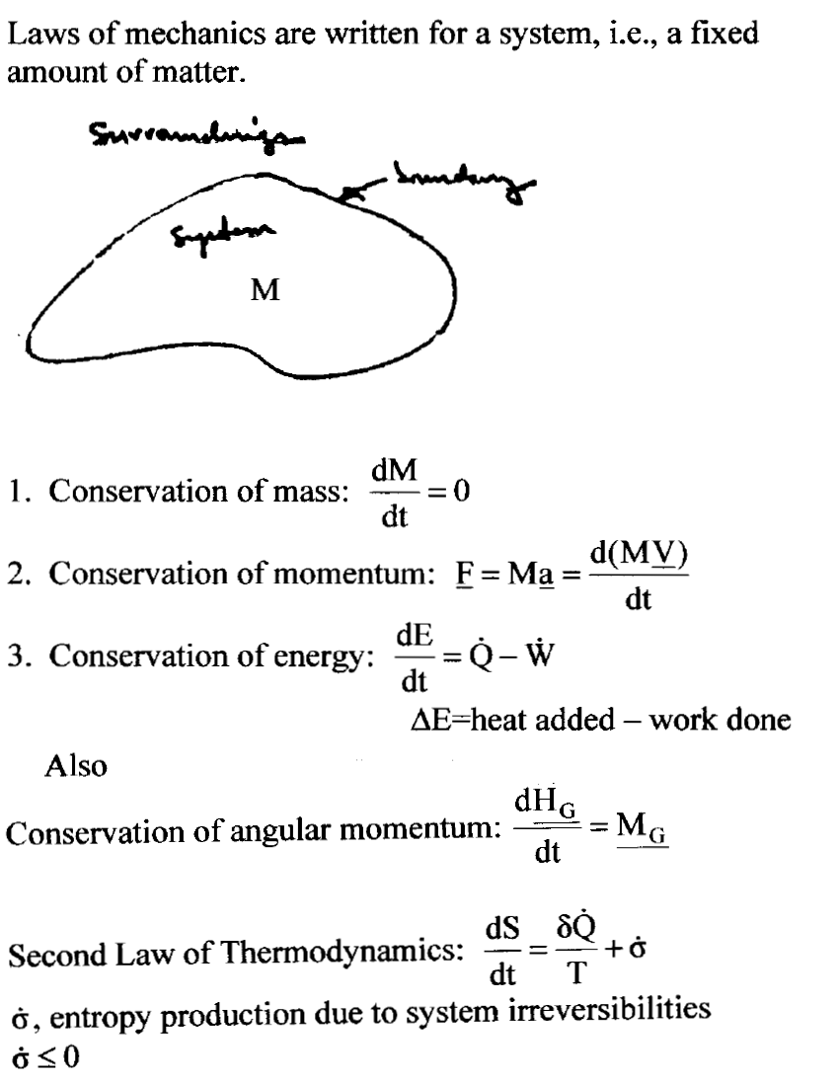
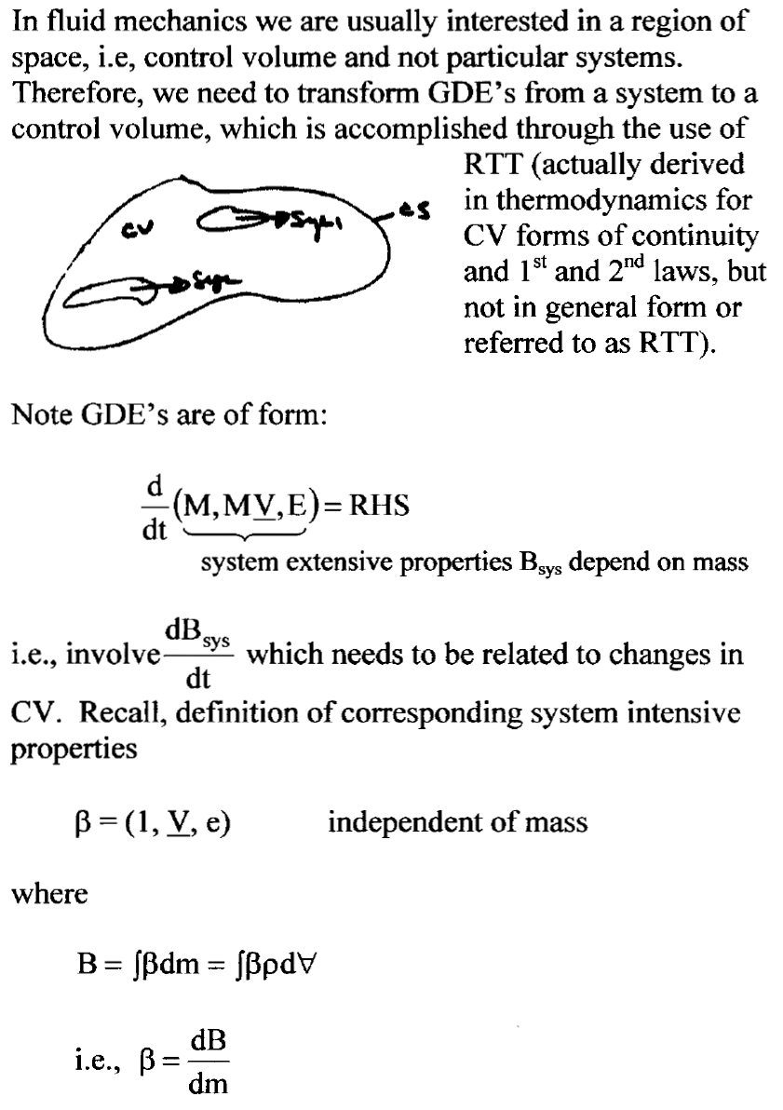
Reynolds Transport Theorem (RTT)

Need relationship between $\frac{d}{\text{dt}}\left(B_{\text{sys}}\right)$ and changes in $B_{\text{cv}}=\int_{\text{CV}}{β \text{dm}}=\int_{\text{CV}}{\text{βρ} d∀}$.
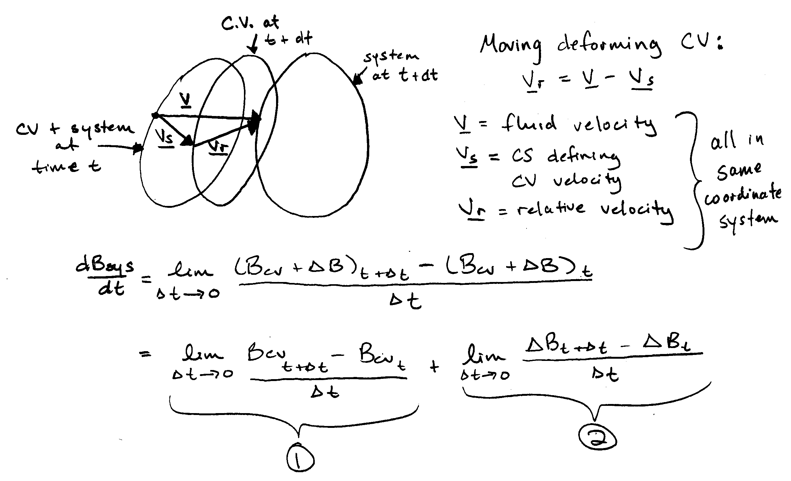
1 = time rate of change of B in CV =$\frac{{\text{dB}}_{\text{cv}}}{\text{dt}}=\frac{d}{\text{dt}}\int_{\text{CV}}{\text{βρ} d∀}$

2 = net outflux of B from CV across CS =
$\int_{\text{CS}}{\text{βρ}}{\underline{v}}_{R}⋅\underline{n} \text{DA}$
$$\frac{{\text{dB}}_{\text{SYS}}}{\text{dt}}=\frac{d}{\text{dt}}\int_{\text{CV}}{\text{βρ} d∀}+\int_{\text{CS}}{\text{βρ}}{\underline{v}}_{R}⋅\underline{n} \text{dA}$$

General form RTT for moving deforming control volume

Special Cases:

1) Non-deforming CV moving at constant velocity

$$\frac{{\text{dB}}_{\text{SYS}}}{\text{dt}}=\int_{\text{CV}}{\frac{∂}{∂t}\left(\text{βρ}\right) d∀}+\int_{\text{CS}}{\text{βρ}}{\underline{v}}_{R}⋅\underline{n} \text{dA}$$

2) Fixed CV

$$\frac{{\text{dB}}_{\text{SYS}}}{\text{dt}}=\int_{\text{CV}}{\frac{∂}{∂t}\left(\text{βρ}\right) d∀}+\int_{\text{CS}}{\text{βρ}}\underline{v}⋅\underline{n} \text{dA}$$

Greens Theorem:

$$\frac{{\text{dB}}_{\text{SYS}}}{\text{dt}}=\int_{\text{CV}}{\left[\frac{∂}{∂t}\left(\text{βρ}\right)+∇⋅\left(\text{βρ}\underline{v}\right)\right]} d∀$$

Since CV fixed and arbitrary $\underset{d∀→0}{\text{lim}}$gives differential eq.

3) Steady Flow: $\frac{∂}{∂t}=0$

4) Uniform flow across discrete CS (steady or unsteady)

$\int_{\text{CS}}{\text{βρ} \underline{v}⋅\underline{n} \text{dA}}=\sum_{\text{CS}}{\text{βρ} \underline{v}⋅\underline{n} \text{dA}}$ (- inlet, + outlet)
Continuity Equation:

B = M = mass of system
β = L

$\frac{\text{dM}}{\text{dt}}=0$ by definition, system = fixed amount of mass

Integral Form:

$$\frac{\text{dM}}{\text{dt}}=0=\frac{d}{\text{dt}}\int_{\text{CV}}{ρ d∀}+\int_{\text{CS}}{ρ {\underline{v}}_{R}⋅\underline{n}} \text{dA}$$

$$−\frac{d}{\text{dt}}\int_{\text{CV}}{ρ d∀}=\int_{\text{CS}}{ρ {\underline{v}}_{R}⋅\underline{n}} \text{dA}$$

Rate of decrease of mass in CV = net rate of mass outflow across CS

Note simplifications for non-deforming CV, fixed CV, steady flow, and uniform flow across discrete CS

Incompressible Fluid: ρ = constant

$$−\frac{d}{\text{dt}}\int_{\text{CV}}{d∀}=\int_{\text{CS}}{{\underline{v}}_{R}⋅\underline{n}} \text{dA}$$

“conservation of volume”
Differential Form:

$$\frac{∂ρ}{∂t}+∇⋅\left(ρ\underline{v}\right)=0$$
$$\begin{aligned}M=ρ d∀ \\ \text{dM}=ρ d∀+∀ dρ=0 \\ −\frac{d∀}{∀}=\frac{dρ}{ρ} \\ \frac{1}{ρ}\frac{Dρ}{\text{Dt}}=−\frac{1}{∀}\frac{D∀}{\text{Dt}}\end{aligned}$$

$$\frac{∂ρ}{∂t}+ρ ∇⋅\underline{v}+\underline{v}⋅∇ρ=0$$

$$\frac{Dρ}{\text{Dt}}+ρ ∇⋅\underline{v}=0$$

$$\frac{1}{ρ}\frac{Dρ}{\text{Dt}}underbracealignl\underset{\text{per} \text{unit} ρ}{\underbrace{\begin{aligned}\text{rate} \text{of} \text{change} ρ\end{aligned}}}+∇⋅\underline{v}underbracealignl\underset{\frac{∂u}{∂x}+\frac{∂v}{∂y}+\frac{∂w}{∂z}underbracealignl\underset{\text{per} \text{unit} ∀}{\underbrace{\begin{aligned}\text{rate} \text{of} \text{change} ∀\end{aligned}}}}{\underbrace{\begin{aligned}\end{aligned}}}=0$$

Called the continuity equation since the implication is that ρ and v are continuous functions of x.

Incompressible Fluid: ρ = constant

$\begin{aligned}∇⋅\underline{v}=0 \\ \frac{∂u}{∂x}+\frac{∂v}{∂y}+\frac{∂w}{∂z}=0\end{aligned}$

