Chapter 4: Fluids Kinematics

  - Velocity and Description Methods

Primary dependent variable is fluid velocity vector
V = V ( r ); where r is the position vector
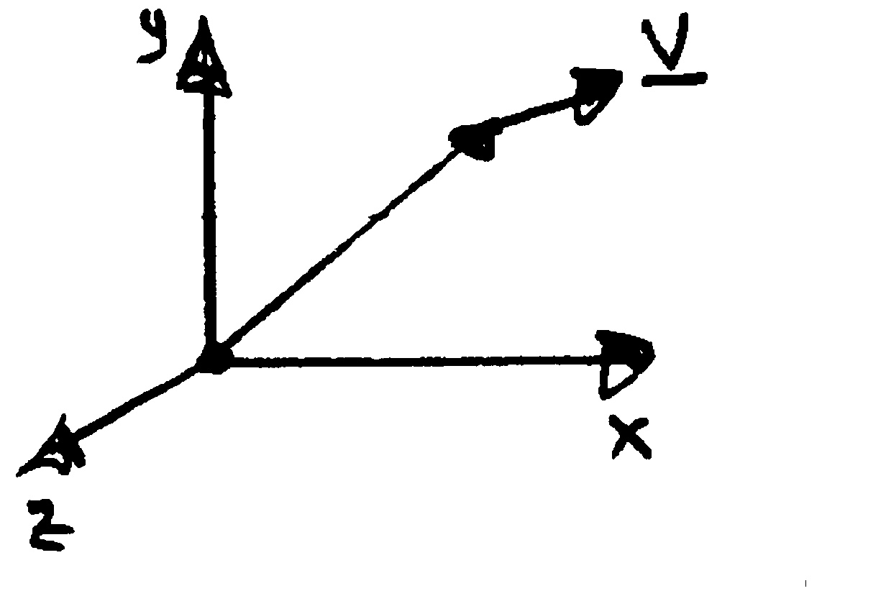
If V is known then pressure and forces can be determined using techniques to be discussed in subsequent chapters.
$$\underline{r}=x\hat{i}+y\hat{j}+z\hat{k}$$
$$\underline{V}=(\underline{r},t)=u\hat{i}+v\hat{j}+w\hat{k}$$
x
r

Consideration of the velocity field alone is referred to as flow field kinematics in distinction from flow field dynamics (force considerations).

Fluid mechanics and especially flow kinematics is a geometric subject and if one has a good understanding of the flow geometry then one knows a great deal about the solution to a fluid mechanics problem.

Consider a simple flow situation, such as an airfoil in a wind tunnel:
U = constant
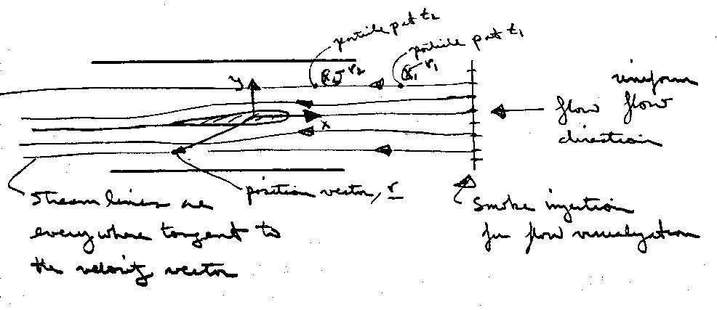

Velocity: Lagrangian and Eulerian Viewpoints

There are two approaches to analyzing the velocity field: Lagrangian and Eulerian

Lagrangian: keep track of individual fluids particles (i.e., solve F = Ma for each particle)

Say particle p is at position r₁(t₁) and at position r₂(t₂) then,
$\underline{V_{p}}=\underset{Δt→0}{\text{lim}}\frac{\underline{r_{2}}−\underline{r_{1}}}{t_{2}−t_{1}}=\frac{\text{dx}}{\text{dt}}\hat{i}+\frac{\text{dy}}{\text{dt}}\hat{j}+\frac{\text{dz}}{\text{dt}}\hat{k}$

= $u_{p}\hat{i}+v_{p}\hat{j}+w_{p}\hat{k}$

Of course the motion of one particle is insufficient to describe the flow field, so the motion of all particles must be considered simultaneously which would be a very difficult task. Also, spatial gradients are not given directly. Thus, the Lagrangian approach is only used in special circumstances.

Eulerian: focus attention on a fixed point in space
$\underline{x}=x\hat{i}+y\hat{j}+z\hat{k}$

In general,

$\underline{V}=\underline{V}(\underline{x},t)=u\hat{i}+v\hat{j}+w\hat{k}$

velocity components
where,
u = u(x,y,z,t), v = v(x,y,z,t), w = w(x,y,z,t)

This approach is by far the most useful since we are usually interested in the flow field in some region and not the history of individual particles.
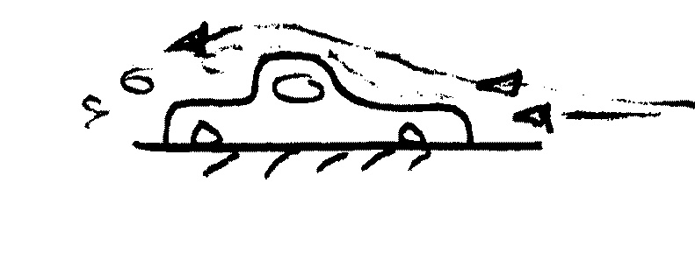
However, must transform F = Ma from system to CV (recall Reynolds Transport Theorem (RTT) & CV analysis from thermodynamics)
Ex. Flow around a car

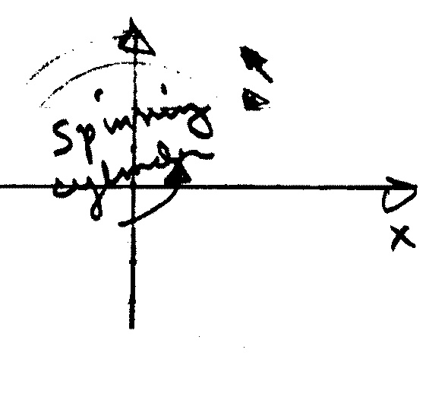
V can be expressed in any coordinate system; e.g., polar or spherical coordinates. Recall that such coordinates are called orthogonal curvilinear coordinates. The coordinate system is selected such that it is convenient for describing the problem at hand (boundary geometry or streamlines).
$$\underline{V}=v_{r}{\hat{e}}_{r}+v_{θ}{\hat{e}}_{θ}$$
$$\begin{aligned}x=r\text{cos}θ \\ y=r\text{sin}θ \\ \hat{e_{r}}=\text{cos}θ \hat{i}+\text{sin}θ \hat{j} \\ {\hat{e}}_{θ}=−\text{sin}θ \hat{i}+\text{cos}θ \hat{j}\end{aligned}$$

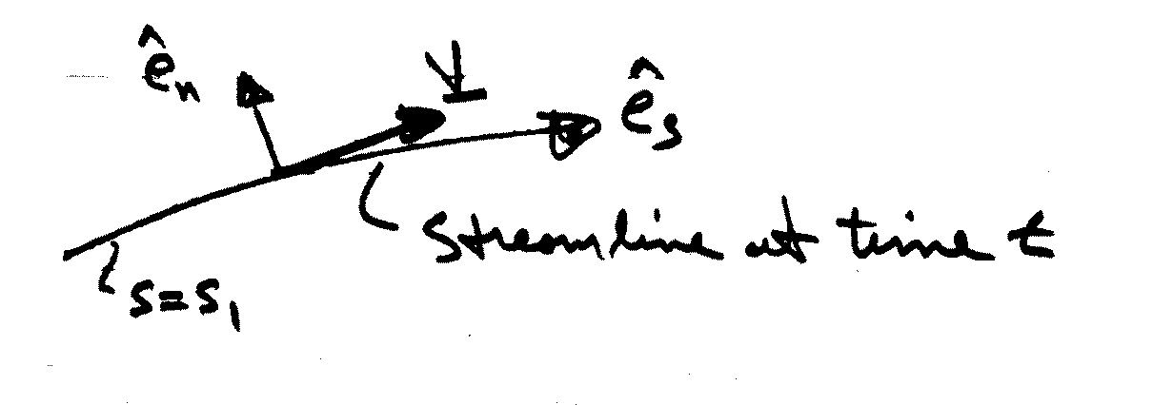
Undoubtedly, the most convenient coordinate system is streamline coordinates:
$$\underline{V}(s,t)=v_{s}(s,t){\hat{e}}_{s}(s,t)$$

However, usually V not known a priori and even if known streamlines maybe difficult to generate/determine.
4.2 Flow Visualization and Plots of Fluid Flow Data
See textbook for:
Streamlines and Streamtubes
Pathlines
Streaklines
Timelines
Refractive flow visualization techniques
Surface flow visualization techniques

Profile plots
Vector plots
Contour plots

4.3 Acceleration Field and Material Derivative

The acceleration of a fluid particle is the rate of change of its velocity.

In the Lagrangian approach the velocity of a fluid particle is a function of time only since we have described its motion in terms of its position vector.

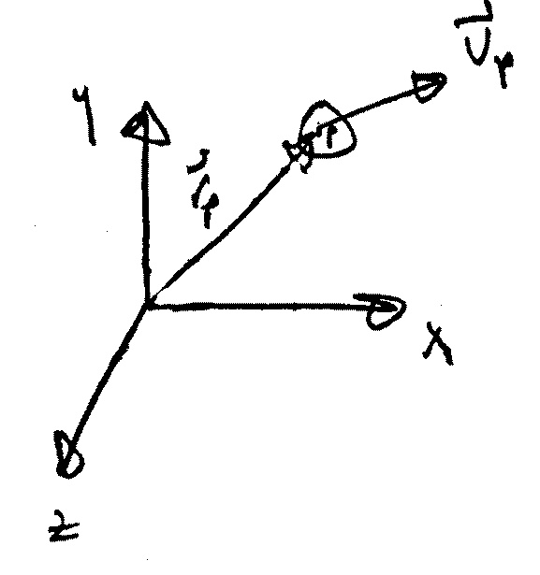
$$\begin{aligned}{\underline{r}}_{p}=x_{p}(t)\hat{i}+y_{p}(t)\hat{j}+z_{p}(t)\hat{k} \\ {\underline{V}}_{p}=\frac{dr_{p}}{\text{dt}}=u_{p}\hat{i}+v_{p}\hat{j}+w_{p}\hat{k} \\ {\underline{a}}_{p}=\frac{dv_{p}}{\text{dt}}=\frac{d^{2}r_{p}}{{\text{dt}}^{2}}=a_{x}\hat{i}+a_{y}\hat{j}+a_{z}\hat{k} \\ a_{x}=\frac{{\text{du}}_{p}}{\text{dt}} a_{y}=\frac{{\text{dv}}_{p}}{\text{dt}} a_{z}=\frac{{\text{dw}}_{p}}{\text{dt}}\end{aligned}$$
In the Eulerian approach the velocity is a function of both space and time; consequently,
$$\underline{V}=u(x,y,z,t)\hat{i}+v(x,y,z,t)\hat{j}+w(x,y,z,t)\hat{k}$$
x,y,z are f(t)
since we must follow the particle in evaluating du/dt

$$\underline{a}=\frac{dV}{\text{dt}}=\frac{\text{du}}{\text{dt}}\hat{i}+\frac{\text{dv}}{\text{dt}}\hat{j}+\frac{\text{dw}}{\text{dt}}\hat{k}=a_{x}\hat{i}+a_{y}\hat{j}+a_{z}\hat{k}$$

$$a_{x}=\frac{\text{du}}{\text{dt}}=\frac{∂u}{∂t}+\frac{∂u}{∂x}\frac{∂x}{∂t}+\frac{∂u}{∂y}\frac{∂y}{∂t}+\frac{∂u}{∂z}\frac{∂z}{∂t}=\frac{∂u}{∂t}+u\frac{∂u}{∂x}+v\frac{∂u}{∂y}+w\frac{∂u}{∂z}$$
called substantial derivative $\frac{\text{Du}}{\text{Dt}}$
Similarly for a_{y} & a_{z},

$\begin{aligned}a_{y}=\frac{\text{Dv}}{\text{Dt}}=\frac{∂v}{∂t}+u\frac{∂v}{∂x}+v\frac{∂v}{∂y}+w\frac{∂v}{∂z} \\ a_{z}=\frac{\text{Dw}}{\text{Dt}}=\frac{∂w}{∂t}+u\frac{∂w}{∂x}+v\frac{∂w}{∂y}+w\frac{∂w}{∂z}\end{aligned}$

In vector notation this can be written concisely
$$\frac{D\underline{V}}{\text{Dt}}=\frac{∂\underline{V}}{∂t}+\underline{V}⋅∇\underline{V}$$

$∇=\frac{∂}{∂x}\hat{i}+\frac{∂}{∂y}\hat{j}+\frac{∂}{∂z}\hat{k}$ gradient operator

First term, $\frac{∂\underline{V}}{∂t}$, called local or temporal acceleration results from velocity changes with respect to time at a given point. Local acceleration results when the flow is unsteady.

Second term,$\underline{V}⋅∇\underline{V}$, called convective acceleration because it is associated with spatial gradients of velocity in the flow field. Convective acceleration results when the flow is non-uniform, that is, if the velocity changes along a streamline.

The convective acceleration terms are nonlinear which causes mathematical difficulties in flow analysis; also, even in steady flow the convective acceleration can be large if spatial gradients of velocity are large.
Example: Flow through a converging nozzle can be approximated by a one dimensional velocity distribution
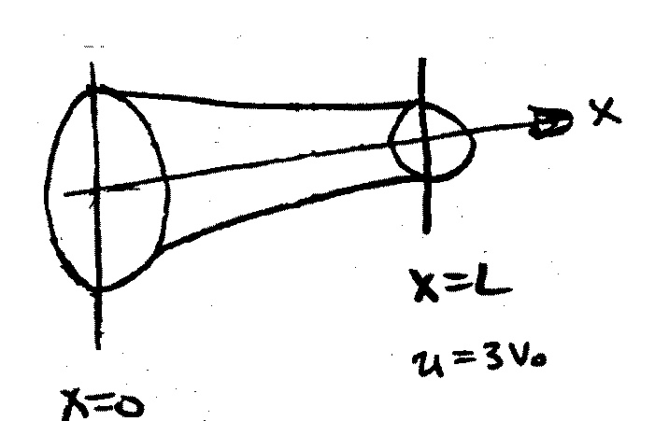
u = u(x). For the nozzle shown, assume that the velocity varies linearly from u = V_{o} at the entrance to u = 3V_{o} at the exit. Compute the acceleration $\frac{D\underline{V}}{\text{Dt}}$ as a function of x. Evaluate $\frac{D\underline{V}}{\text{Dt}}$ at the entrance and exit if V_{o} = 10 ft/s and
y
L =1 ft.
u = V_{o}

u(x) = mx + b
u(0) = b = V_{o}
m = $\frac{Δu}{Δx}=\frac{3V_{o}−V_{o}}{L}=\frac{2V_{o}}{L}$

We have $\underline{V}=u(x)\hat{i}$, $\frac{\text{Du}}{\text{Dt}}=u\frac{∂u}{∂x}=a_{x}$

$u(x)=\frac{2V_{o}}{L}\left(x\right)+V_{o}=V_{o}\left(\frac{2x}{L}+1\right)$
Assume linear variation between inlet and exit

$\frac{∂u}{∂x}=\frac{2V_{0}}{L}⇒$ $a_{x}=\frac{2V_{o}^{2}}{L}\left(\frac{2x}{L}+1\right)$

@ x = 0 a_{x} = 200 ft/s²

@ x = L a_{x} = 600 ft/s²

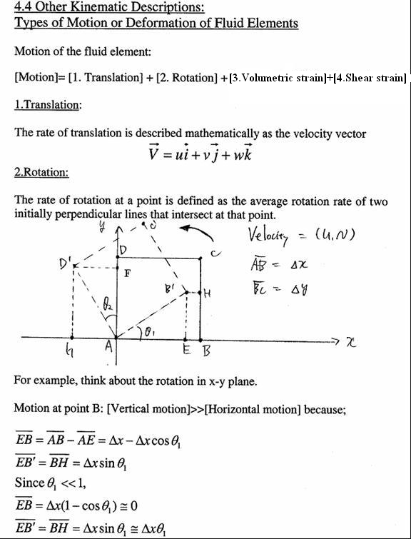

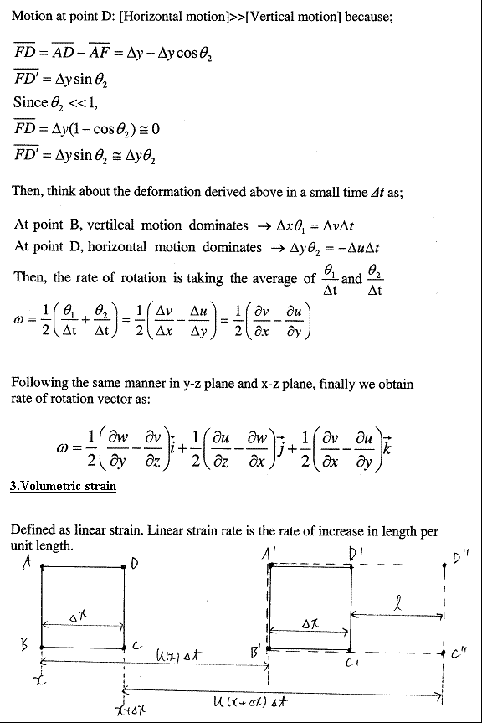
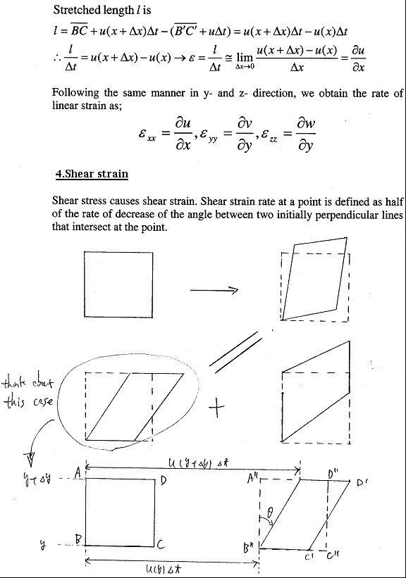

Example problem: Deformation rate of fluid element

Consider the steady, two-dimensional velocity field given by
$$\vec{V}=(u,v)=(0\text{.}5+0\text{.}8x)\vec{i}+(1\text{.}5−0\text{.}8y)\vec{j}$$
Calculate the kinematic properties such as;
- Rate of translation
- Rate of rotation
- Rate of linear strain
- Rate of shear strain

Solution:

(a) Rate of translation:
, ,

(b) Rate of rotation:

(c) Rate of linear strain:
, ,

(d) Rate of shear strain:

Rotation and Vorticity

Ω = fluid vorticity = 2 × angular velocity = 2ω

= ∇ × V i.e., curl V

= $\begin{aligned} \hat{i} \hat{j} \hat{k} \\ \\ \frac{∂}{∂x} \frac{∂}{∂y} \frac{∂}{∂z} \\ \\ u v w\end{aligned}$ =$\left(\frac{∂w}{∂y}−\frac{∂v}{∂z}\right)\hat{i}+\left(\frac{∂u}{∂z}−\frac{∂w}{∂x}\right)\hat{j}+\left(\frac{∂v}{∂x}−\frac{∂u}{∂y}\right)\hat{k}$

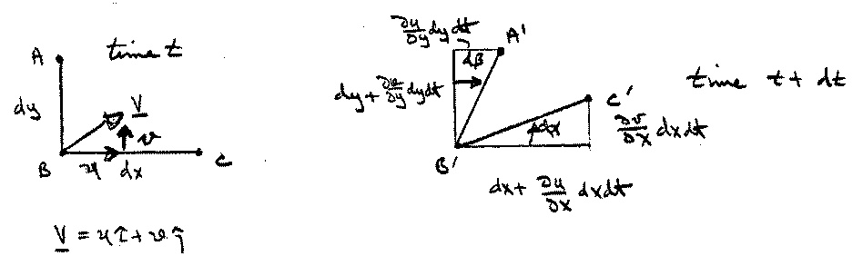
To show that this definition is correct consider two lines in the fluid

Angular velocity about z axis = average rate of rotation +

$\begin{aligned}ω_{z}=\frac{1}{2}\left(\frac{dα}{\text{dt}}−\frac{dβ}{\text{dt}}\right) \\ \\ dα={\text{tan}}^{−1}\frac{\frac{∂v}{∂x}\text{dxdt}}{\text{dx}+\frac{∂u}{∂x}\text{dxdt}}\end{aligned}$

$\underset{\text{dt}→0}{\text{lim}}=\frac{∂v}{∂x}\text{dt}$ i.e., $\frac{dα}{\text{dt}}=\frac{∂v}{∂x}$
$dβ={\text{tan}}^{−1}\frac{\frac{∂u}{∂y}\text{dydt}}{\text{dy}+\frac{∂v}{∂y}\text{dydt}}$
$\underset{\text{dt}→0}{\text{lim}}=\frac{∂u}{∂y}\text{dt}$ i.e., $\frac{dβ}{\text{dt}}=\frac{∂u}{∂y}$

similarly, $\begin{aligned}ω_{z}=\frac{1}{2}\left(\frac{∂v}{∂x}−\frac{∂u}{∂y}\right) \\ ω_{x}=\frac{1}{2}\left(\frac{∂w}{∂y}−\frac{∂v}{∂z}\right) \\ ω_{y}=\frac{1}{2}\left(\frac{∂u}{∂z}−\frac{∂w}{∂x}\right)\end{aligned}$

i.e., Ω = 2ω
Example problem: Calculation of Vorticity

Consider the following steady, three-dimensional velocity field
Calculate the vorticity vector as a function of space

Solution:

Vorticity vector in Cartesian coordinates:

For , ,

