3.4 Hydrostatic Forces on Plane Surfaces

For a static fluid, the shear stress is zero and the only stress is the normal stress, i.e., pressure p. Recall that p is a scalar, which when in contact with a solid surface exerts a normal force towards the surface.
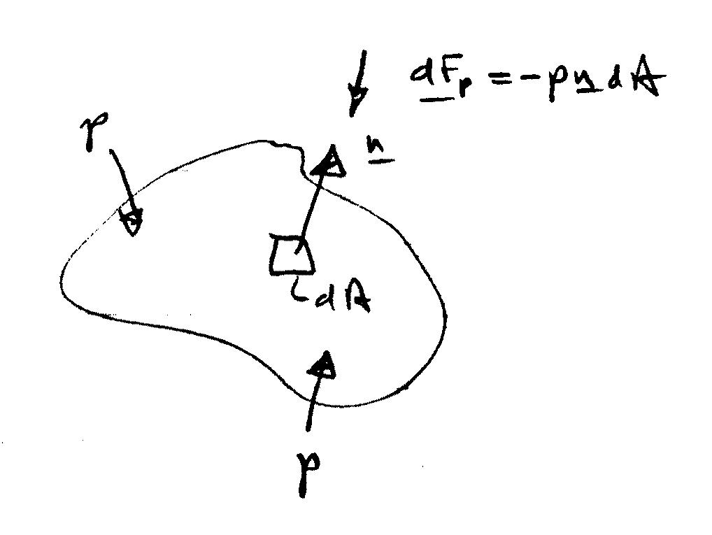

$$\underline{F_{p}}=−\int_{A}{p\underline{n}\text{dA}}$$

For a plane surface n = constant such that we can separately consider the magnitude and line of action of F_{p}.

$$\left|{\underline{F}}_{p}\right|=F=\int_{A}{\text{pdA}}$$

Line of action is towards and normal to A through the center of pressure (x_{cp}, y_{cp}).

Unless otherwise stated, throughout the chapter assume p_{atm} acts at liquid surface. Also, we will use gage pressure so that p = 0 at the liquid surface.

Horizontal Surfaces
horizontal surface with area A
p = constant

F

$$F=\int{\text{pdA}=\text{pA}}$$

Line of action is through centroid of A,
i.e., (x_{cp}, y_{cp}) = $(\overline{x}, \overline{y})$

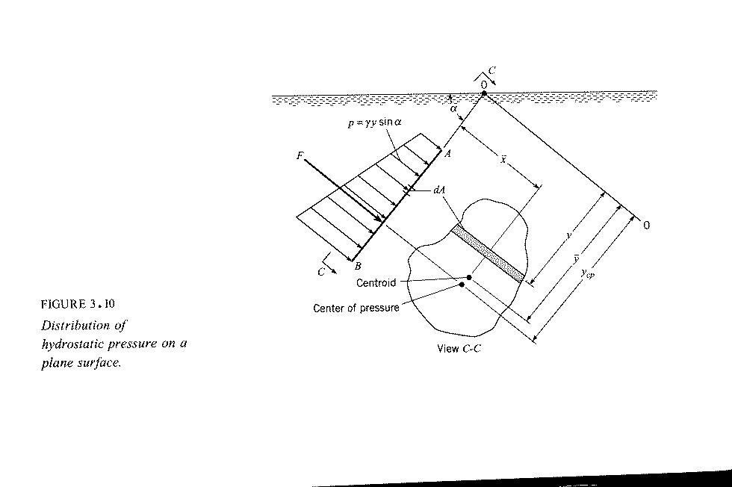
Inclined Surfaces

g
z
F
dF = pdA = γy sin α dA
(x,y) = centroid of A
(x_{cp},y_{cp}) = center of pressure
y
x
γ and sin α are constants

$$\overline{y}=\frac{1}{A}\int{\text{ydA}}$$

1st moment of area
p
$$F=\int_{A}{\text{pdA}}=γ\text{sin}α\int_{A}{\text{ydA}}$$
$$\overline{y}A$$

$$F=γ\text{sin}α\overline{ y }A$$
$$\overline{p}$$
= pressure at centroid of A
$$F=\overline{p}A$$

Magnitude of resultant hydrostatic force on plane surface is product of pressure at centroid of area and area of surface.

Center of Pressure

Center of pressure is in general below centroid since pressure increases with depth. Center of pressure is determined by equating the moments of the resultant and distributed forces about any arbitrary axis.

Determine y_{cp} by taking moments about horizontal axis 0-0

y_{cp}F = $\int_{A}{y}$dF
$\int_{A}{y \text{pdA}}$
$$\int_{A}{y(γy\text{sin}α)\text{dA}}$$
= $γ\text{sin}α\int_{A}{y^{2}\text{dA}}$

I_{o} = 2nd moment of area about 0-0
= moment of inertia

transfer equation: $I_{o}={\overline{y}}^{2}A+\overline{I}$
= moment of inertia with respect to horizontal
centroidal axis

$$\begin{aligned}y_{\text{cp}}F=γ\text{sin}α ({\overline{y}}^{2}A+\overline{I}) \\ \\ y_{\text{cp}}(\overline{p}A)=γ\text{sin}α ({\overline{y}}^{2}A+\overline{I}) \\ \\ y_{\text{cp}}γ\text{sin}α \overline{y}A=γ\text{sin}α ({\overline{y}}^{2}A+\overline{I}) \\ \end{aligned}$$
$y_{\text{cp}}\overline{y}A={\overline{y}}^{2}A+\overline{I}$

y_{cp} is below centroid by ${\overline{I}}/{\overline{y}}A$

y_{cp} → $\overline{y}$ for large $\overline{y}$

For p_{o} ≠ 0, y must be measured from an equivalent free surface located p_{o}/γ above $\overline{y}$.

Determine x_{cp} by taking moment about y axis

x_{cp}F = $\int_{A}{\text{xdF}}$
$\int_{A}{\text{xpdA}}$

$x_{\text{cp}}\overline{y}A=\int_{A}{\text{xydA}}$
I_{xy} = product of inertia
= ${\overline{I}}_{\text{xy}}+\overline{x}\overline{y}A$ transfer equation

$x_{\text{cp}}\overline{y}A={\overline{I}}_{\text{xy}}+\overline{x}\overline{y}A$
$$x_{\text{cp}}=\frac{{\overline{I}}_{\text{xy}}}{\overline{y}A}+\overline{x}$$

For plane surfaces with symmetry about an axis normal to 0-0, ${\overline{I}}_{\text{xy}}=0$ and x_{cp} = $\overline{x}$.

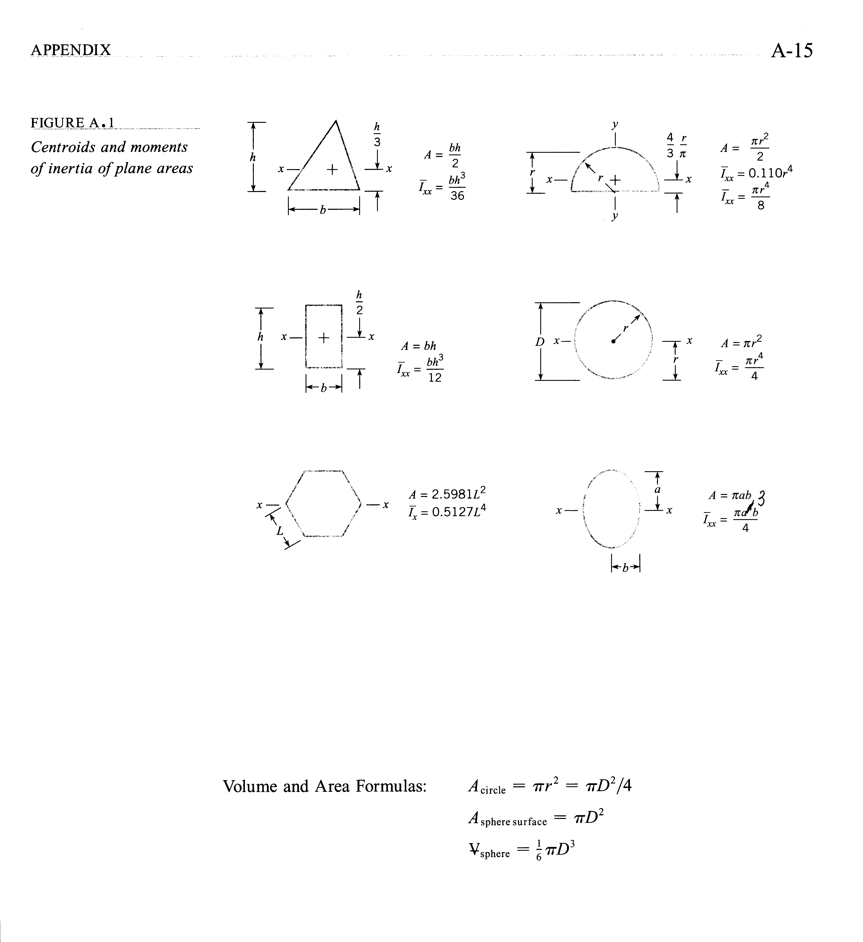
3.5 Hydrostatic Forces on Curved Surfaces
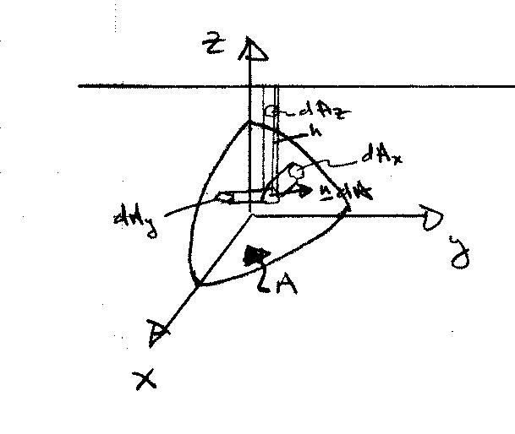
Free surface

$$\underline{F}=−\int_{A}{p\underline{n}\text{dA}}$$
p = γh

h = distance below free surface

Horizontal Components (x and y components)
$F_{x}=\underline{F}⋅\hat{i}=−\int_{A}{p\underline{n}⋅\hat{i}\text{dA}}$
dA_{x} = projection of ndA onto plane ⊥ to x-direction
$=−\int_{A_{x}}{{\text{pdA}}_{x}}$

$F_{y}=\underline{F}⋅\hat{j}=−\int_{A_{y}}{{\text{pdA}}_{y}}$ ${\text{dA}}_{y}=\underline{n}⋅\hat{j}\text{dA}$
= projection ndA
onto plane ⊥ to
y-direction

Therefore, the horizontal components can be determined by some methods developed for submerged plane surfaces.

The horizontal component of force acting on a curved surface is equal to the force acting on a vertical projection of that surface including both magnitude and line of action.

Vertical Components

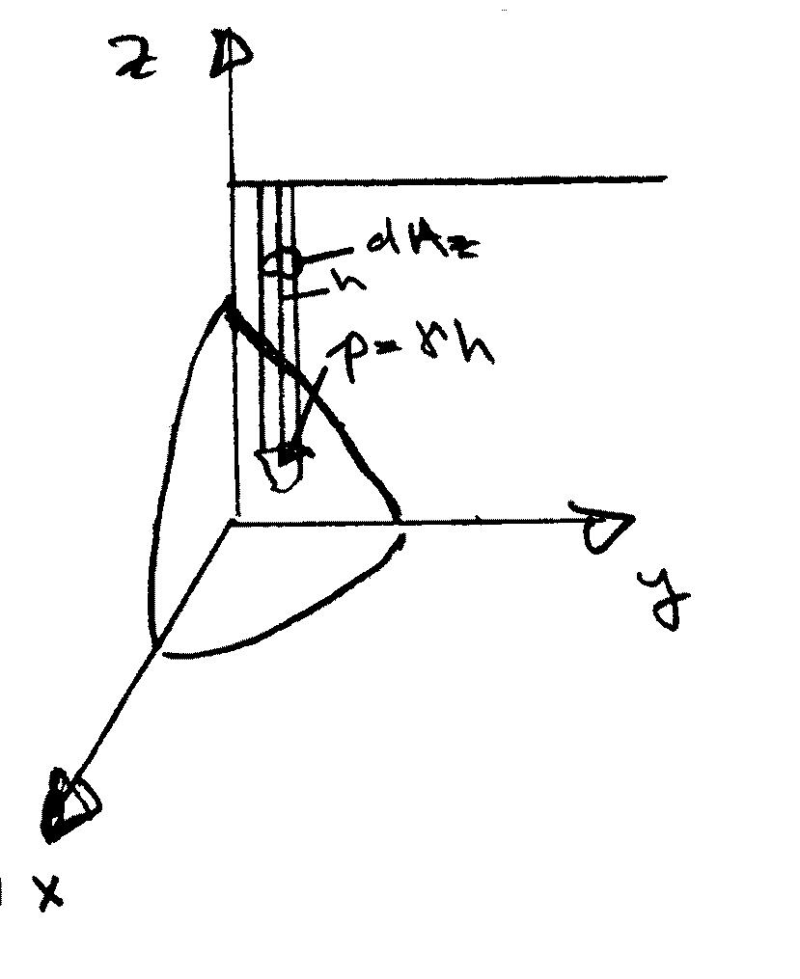
$F_{z}=\underline{F}⋅\hat{k}=−\int_{A}{p\underline{n}⋅\hat{k}\text{dA}}$
=$−\int_{A_{z}}{{\text{pdA}}_{z}}$ p = γh
h=distance
below free
surface

=$γ\int_{A_{z}}{{\text{hdA}}_{z}=γV}$
= weight of
fluid above
surface A

The vertical component of force acting on a curved surface is equal to the net weight of the column of fluid above the curved surface with line of action through the centroid of that fluid volume.

Example: Drum Gate
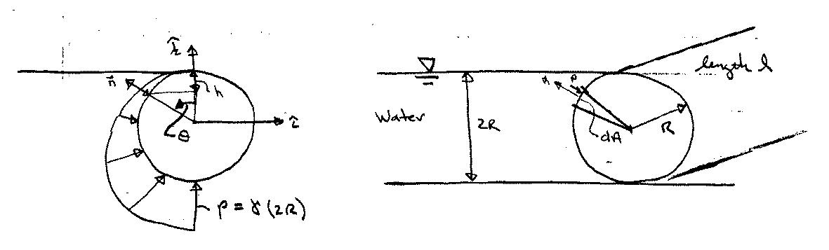

Pressure Diagram
p = γh = γR(1-cosθ)
$$\underline{n}=−\text{sin}θ \hat{i}+\text{cos}θ \hat{k}$$
dA = Rdθ
$$\underline{F}=−\int_{0}^{π}{γR(1−\text{cos}θ)(−\text{sin}θ \hat{i}+\text{cos}θ \hat{k})ℓ\text{Rd}θ}$$
p n dA

$$\underline{F}⋅\hat{i}=F_{x}\text{=+}γ ℓ R^{2}\int_{0}^{π}{(1−\text{cos}θ)\text{sin}θdθ}$$
= $γ ℓ R^{2}[−\text{cos}θ+\frac{1}{4}\text{cos}2θ|_{0}^{π}=2{γℓR}^{2}$
= (γR)(2R) ⇒ same force as that on projection of
$\overline{p}$ A area onto vertical plane
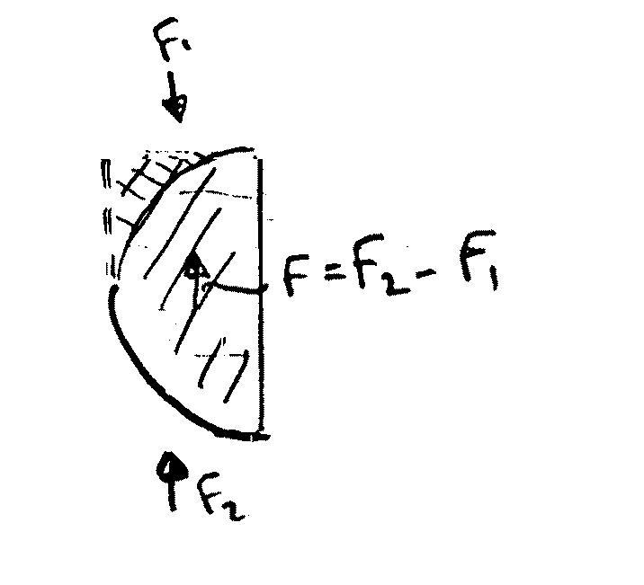
$$F_{z}=−γ ℓ R^{2}\int_{0}^{π}{(1−\text{cos}θ)\text{cos}θdθ}$$
=$−γ ℓ R^{2}[\text{sin}θ−\frac{θ}{2}−\frac{\text{sin}2θ}{4}|_{0}^{π}$
= $γ ℓ R^{2}\frac{π}{2}=γ ℓ\left(\frac{{πR}^{2}}{2}\right)=γV$
⇒ net weight of water above surface
3.6 Buoyancy

Archimedes Principle

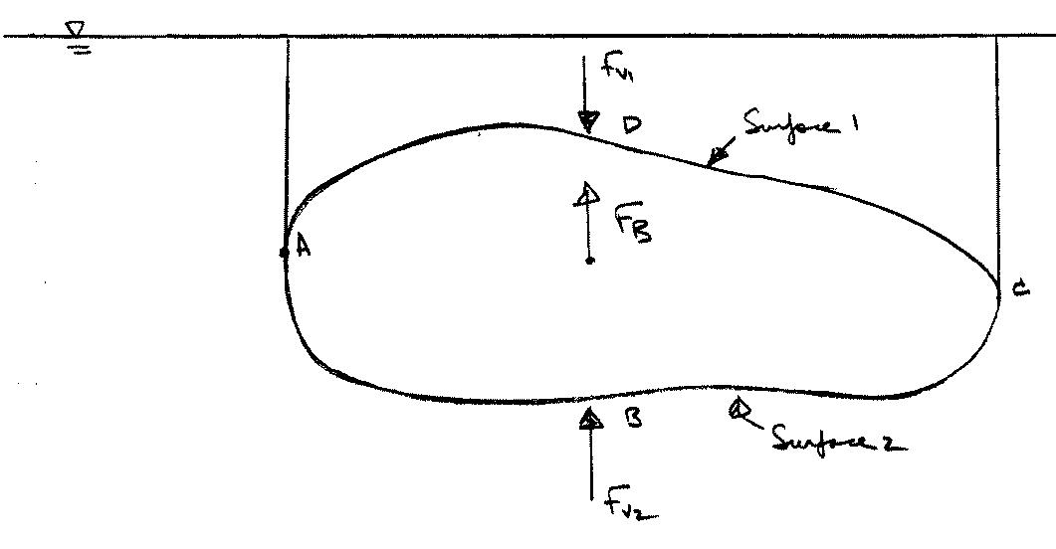
F_{B} = F_{v2} – F_{v1}

= fluid weight above Surface 2 (ABC)
- fluid weight above Surface 1 (ADC)

= fluid weight equivalent to body volume V

F_{B} = ρgV V = submerged volume

Line of action is through centroid of V = center of buoyancy

Net Horizontal forces are zero since
F_{BAD} = F_{BCD}

Hydrometry

A hydrometer uses the buoyancy principle to determine specific weights of liquids.
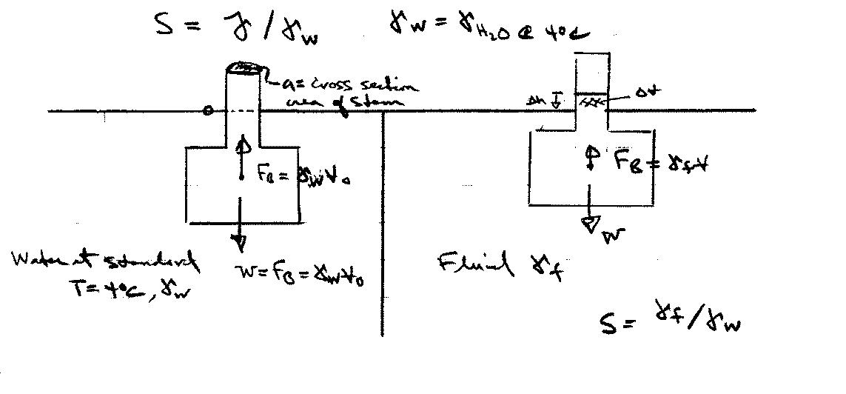
Stem

Bulb

W = mg = γ_{f}V = Sγ_{w}V

W = γ_{w}V _{o} = Sγ_{w}(V_{o} − ΔV) = Sγ_{w}(V_{o} − aΔh)
γ_{f}
V
a = cross section area stem
V_{o}/S = V_{o} − aΔh aΔh = V_{o} – V_{o}/S
Δh = $\frac{V_{o}}{a}⋅\left(1−\frac{1}{S}\right)$=Δh(S)

Δh = $\frac{V_{o}}{a}⋅\frac{S−1}{S}$ calibrate scale using fluids of known S

S = $\frac{V_{o}}{V_{0}−aΔh}$

Example (apparent weight)

King Hero ordered a new crown to be made from pure gold. When he received the crown he suspected that other metals had been used in its construction. Archimedes discovered that the crown required a force of 4.7# to suspend it when immersed in water, and that it displaced 18.9 in³ of water. He concluded that the crown was not pure gold. Do you agree?
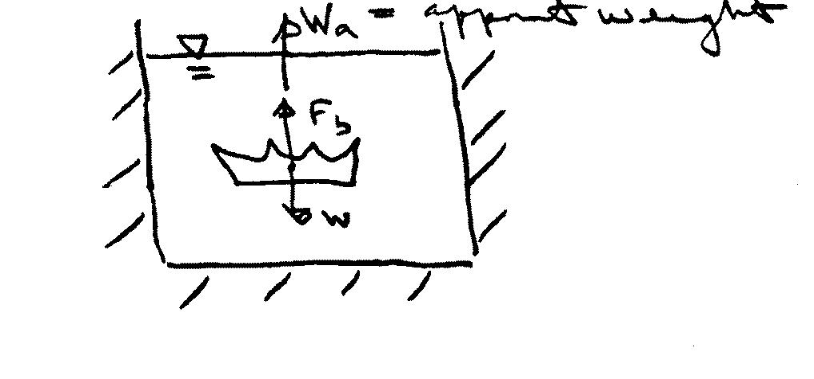

∑F_{vert} = 0 = W_{a} + F_{b} – W = 0 ⇒ W_{a} = W – F_{b} = (γ_{c} - γ_{w})V
W=γ_{c}V, F_{b} = γ_{w}V
or γ_{c} = $\frac{W_{a}}{V}+γ_{w}=\frac{W_{a}+γ_{w}V}{V}$

$$γ_{c}=\frac{4\text{.}7+\text{62}\text{.}4×\text{18}\text{.}9/{\text{1728}}}{\text{18}\text{.}9/{\text{1728}}} = \text{492}\text{.}1 = ρ_{c}g$$

⇒ ρ_{c} = 15.3 slugs/ft³

∼ ρ_{steel} and since gold is heavier than steel the crown
can not be pure gold
3.7 Stability of Immersed and Floating Bodies

Here we’ll consider transverse stability. In actual applications both transverse and longitudinal stability are important.

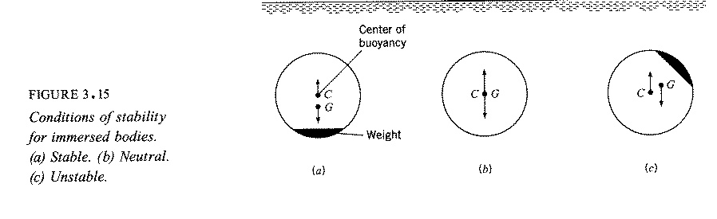
Immersed Bodies

Static equilibrium requires: $\sum{F_{v}=0 \text{and} \sum{M}=0}$

∑M = 0 requires that the centers of gravity and buoyancy coincide, i.e., C = G and body is neutrally stable

If C is above G, then the body is stable (righting moment when heeled)

If G is above C, then the body is unstable (heeling moment when heeled)

Floating Bodies

For a floating body the situation is slightly more complicated since the center of buoyancy will generally shift when the body is rotated depending upon the shape of the body and the position in which it is floating.

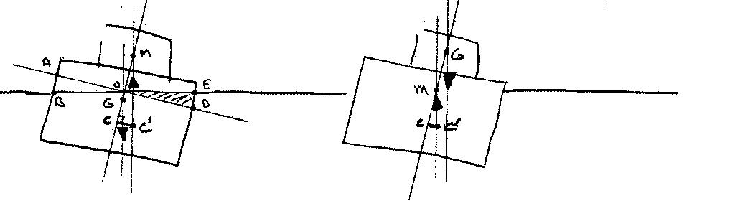
Positive $\overline{\text{GM}}$ Negative $\overline{\text{GM}}$

The center of buoyancy (centroid of the displaced volume) shifts laterally to the right for the case shown because part of the original buoyant volume AOB is transferred to a new buoyant volume EOD.

The point of intersection of the lines of action of the buoyant force before and after heel is called the metacenter M and the distance GM is called the metacentric height. If GM is positive, that is, if M is above G, then the ship is stable; however, if GM is negative, the ship is unstable.

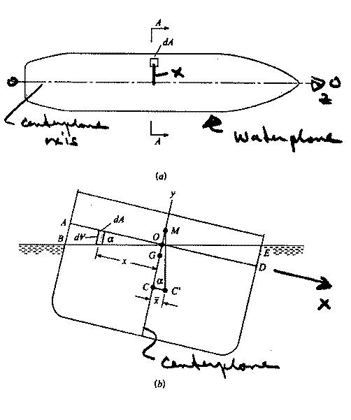
Floating Bodies

α = small heel angle
$\overline{x}=CC^{'}$ = lateral displacement
of C
C = center of buoyancy
i.e., centroid of displaced
volume V

Solve for GM: find $\overline{x}$ using
(1) basic definition for centroid of V; and
(2) trigonometry
Fig. 3.17

(1) Basic definition of centroid of volume V

$\overline{x}V=\int{\text{xd \{}V}=\sum{x_{i}ΔV_{i}}$ moment about centerplane

$\overline{x}V$ = moment V before heel – moment of V_{AOB}
+ moment of V_{EOD}
= 0 due to symmetry of
original V about y axis
i.e., ship centerplane

tan α = y/x
dV = ydA = x tan α dA
$$\overline{x}V=\text{tan}α\int{x^{2}\text{dA}}$$
ship waterplane area

moment of inertia of ship waterplane
about z axis O-O; i.e., I_{OO}

I_{OO} = moment of inertia of waterplane
area about centerplane axis

(2) Trigonometry
$$\begin{aligned}\overline{x}V=\text{tan}{αI}_{\text{OO}} \\ CC^{'}=\overline{x}=\frac{\text{tan}{αI}_{\text{OO}}}{V}=\text{CM}\text{tan}α\end{aligned}$$

CM = I_{OO} / V

GM = CM – CG

GM = $\frac{I_{\text{OO}}}{V}−\text{CG}$

GM > 0 Stable

GM < 0 Unstable

3.8 Fluids in Rigid-Body Motion

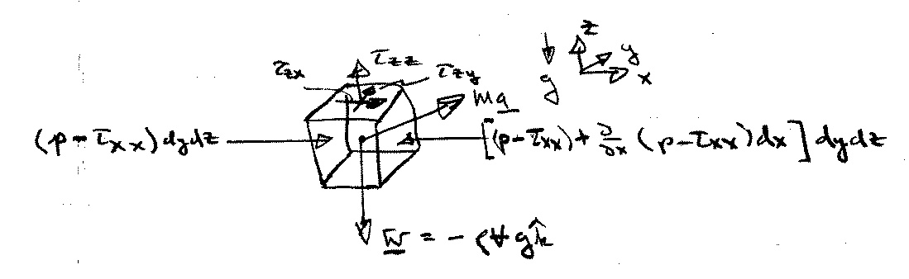
For fluids in motion, the pressure variation is no longer hydrostatic and is determined from application of Newton’s 2nd Law to a fluid element.
τ_{ij} = viscous stresses net surface force in X direction
p = pressure
$$X_{\text{net}}=\left(−\frac{∂p}{∂x}+\frac{∂τ_{\text{xx}}}{∂x}+\frac{∂τ_{\text{yx}}}{∂y}+\frac{∂τ_{\text{zx}}}{∂z}\right)V$$
Ma = inertia force
W = weight (body force)

Newton’s 2nd Law pressure viscous

Ma = ∑F = F_{B} + F_{S}

per unit (÷ V) ρa = f_{b} + f_{s}
volume
a = $\frac{D\underline{V}}{\text{Dt}}=\frac{∂\underline{V}}{∂t}+\underline{V}⋅∇\underline{V}$
f_{s} = body force = $−ρg\hat{k}$

f_{s} = surface force = f_{p} + f_{v}
f_{p} = surface force due to p = −∇p
f_{v} = surface force due to viscous stresses τ_{ij}
$$ρ\frac{D\underline{V}}{\text{Dt}}={\underline{f}}_{b}+{\underline{f}}_{p}+{\underline{f}}_{v}$$
Neglected in this chapter and included later in Section 6.4 when deriving complete Navier-Stokes equations

$$ρ\frac{D\underline{V}}{\text{Dt}}=−ρg\hat{k}−∇p$$

inertia force = body force due + surface force due to
to gravity pressure gradients

x: $ρ\frac{\text{Du}}{\text{Dt}}=−\frac{∂p}{∂x}$
Note: for V = 0
$\begin{aligned}∇p=−ρg\hat{k} \\ \frac{∂p}{∂x}=\frac{∂p}{∂y}=0 \\ \frac{∂p}{∂z}=−ρg=−γ\end{aligned}$

$ρ\left[\frac{∂u}{∂t}+u\frac{∂u}{∂x}+v\frac{∂u}{∂y}+w\frac{∂u}{∂z}\right]=−\frac{∂p}{∂x}$

y: $ρ\frac{\text{Dv}}{\text{Dt}}=−\frac{∂p}{∂y}$

$ρ\left[\frac{∂v}{∂t}+u\frac{∂v}{∂x}+v\frac{∂v}{∂y}+w\frac{∂v}{∂z}\right]=−\frac{∂p}{∂y}$

z: $ρ\frac{\text{Dw}}{\text{Dt}}=−ρg−\frac{∂p}{∂z}=−\frac{∂}{∂z}\left(p+γz\right)$

$ρ\left[\frac{∂w}{∂t}+u\frac{∂w}{∂x}+v\frac{∂w}{∂y}+w\frac{∂w}{∂z}\right]=−\frac{∂p}{∂z}\left(p+γz\right)$

or ρa = −∇(p + γz) Euler’s equation for inviscid flow

∇ ⋅ V = 0 Continuity equation for
incompressible flow

4 equations in four unknowns V and p

Examples of Pressure Variation From Acceleration

Uniform Linear Acceleration:
$$\begin{aligned}ρ\underline{a}=−ρg\hat{k}−∇p \\ ∇p=−ρ\left(\underline{a}+g\hat{k}\right)=ρ\left(\underline{g}−\underline{a}\right) \underline{g}=−g\hat{k}\end{aligned}$$
$$∇p=−ρ\left[a_{x}\hat{i}+\left(g+a_{z}\right)\hat{k}\right] \underline{a}=a_{x}\hat{i}+a_{z}\hat{k}$$
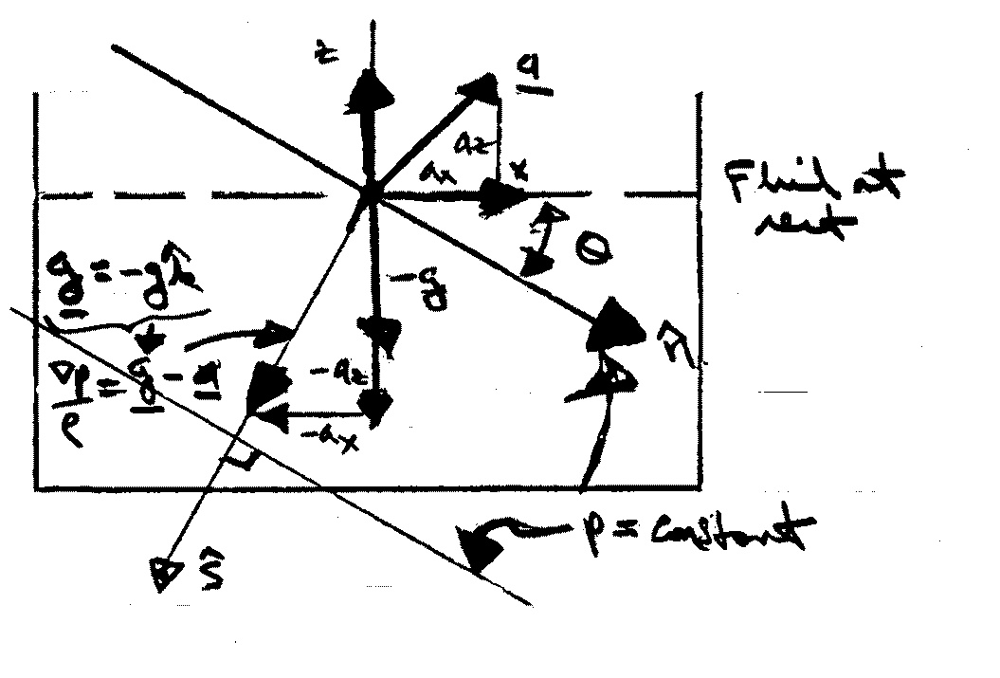
$$\frac{∂p}{∂x}=−{ρa}_{x} \frac{∂p}{∂z}=−ρ\left(g+a_{z}\right)$$
$\hat{s}$= unit vector in direction of ∇p
=∇p /⏐∇p⏐
=$\frac{−\left[a_{x}\hat{i}+\left(g+a_{z}\right)\hat{k}\right]}{ {\left[a_{x}^{2}+{\left(g+a_{z}\right)}^{2}\right]}^{1/2}}$

$\hat{n}$ = unit vector in direction of p = constant
= $\hat{s}×\hat{j}$ ijkijk
⊥ to ∇p
by definition lines of constant p are normal to ∇p
= $\frac{−a_{x}\hat{k}+(g+a_{z})\hat{i}}{ {\left[a_{x}^{2}+(g+a_{z})^{2}\right]}^{1/2}}$

θ = tan⁻¹ a_{x} / (g + a_{z}) = angle between $\hat{n}$ and x
$\frac{\text{dp}}{\text{ds}}=∇p⋅\hat{s}=ρ{\left[a_{x}^{2}+{\left(g+a_{z}\right)}^{2}\right]}^{1/2}$ > ρg

G
p = ρGs + constant ⇒ p_{gage} = ρGs
Rigid Body Rotation:

Consider a cylindrical tank of liquid rotating at a constant rate $\underline{Ω}=Ω\hat{k}$ Ω = ω in text
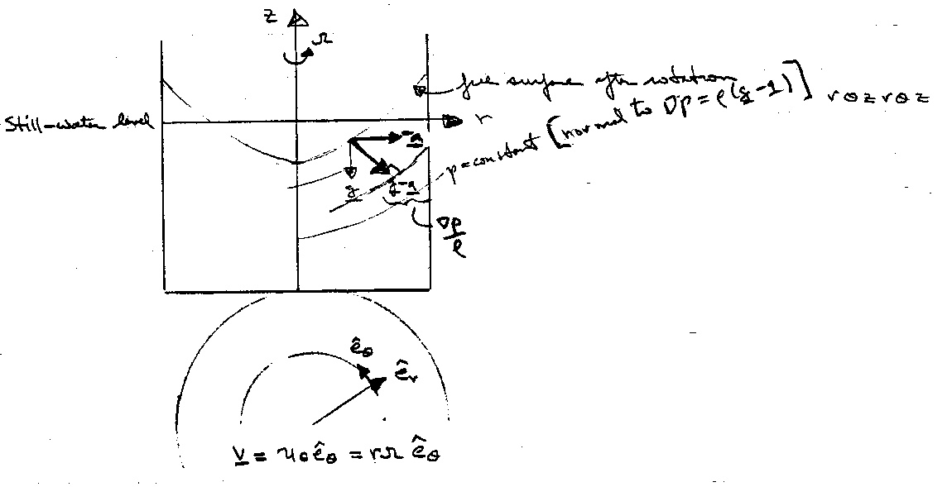

$\underline{a}=\underline{Ω}×\left(\underline{Ω}×r_{o}\right)$
centripetal acceleration

= $−rΩ^{2}{\hat{e}}_{r}$
= $−\frac{V^{2}}{r}{\hat{e}}_{r}$

$∇p=ρ(\underline{g}−\underline{a})$ $∇=\frac{∂}{∂r}{\hat{e}}_{r}+\frac{1}{r}\frac{∂}{∂θ}{\hat{e}}_{θ}+\frac{∂}{∂z}{\hat{e}}_{z}$
= $−ρg\hat{k}+ρrΩ^{2}{\hat{e}}_{r}$ grad in cylindrical coordinates

i.e., $\frac{∂p}{∂r}=ρrΩ^{2}$ $\frac{∂p}{∂z}=−ρg$ $\frac{∂p}{∂θ}=0$
C (r)
along path of a = 0 pressure distribution is hydrostatic
and p = $\frac{ρ}{2}r^{2}Ω^{2}+f(z)+c$
p_{z} = -ρg
p = -ρgz + C(r) + c

p = $\frac{ρ}{2}r^{2}Ω^{2}−ρ\text{gz}$ + constant $\frac{p}{γ}+z−\frac{V^{2}}{2g}=$constant
V = rΩ
The constant is determined by specifying the pressure at one point; say, p = p_{o} at (r, z) = (0, 0)

p = p_{o} − ρgz + $\frac{1}{2}$r²Ω²

Note: pressure is linear in z and parabolic in r

Curves of constant pressure are given by

z = $\frac{p_{1}−p_{o}}{ρg}+\frac{r^{2}Ω^{2}}{2g}=a+{\text{br}}^{2}$

which are paraboloids of revolution, concave upward, with their minimum point on the axis of rotation

Free surface is found by requiring volume of liquid to be constant (before and after rotation)

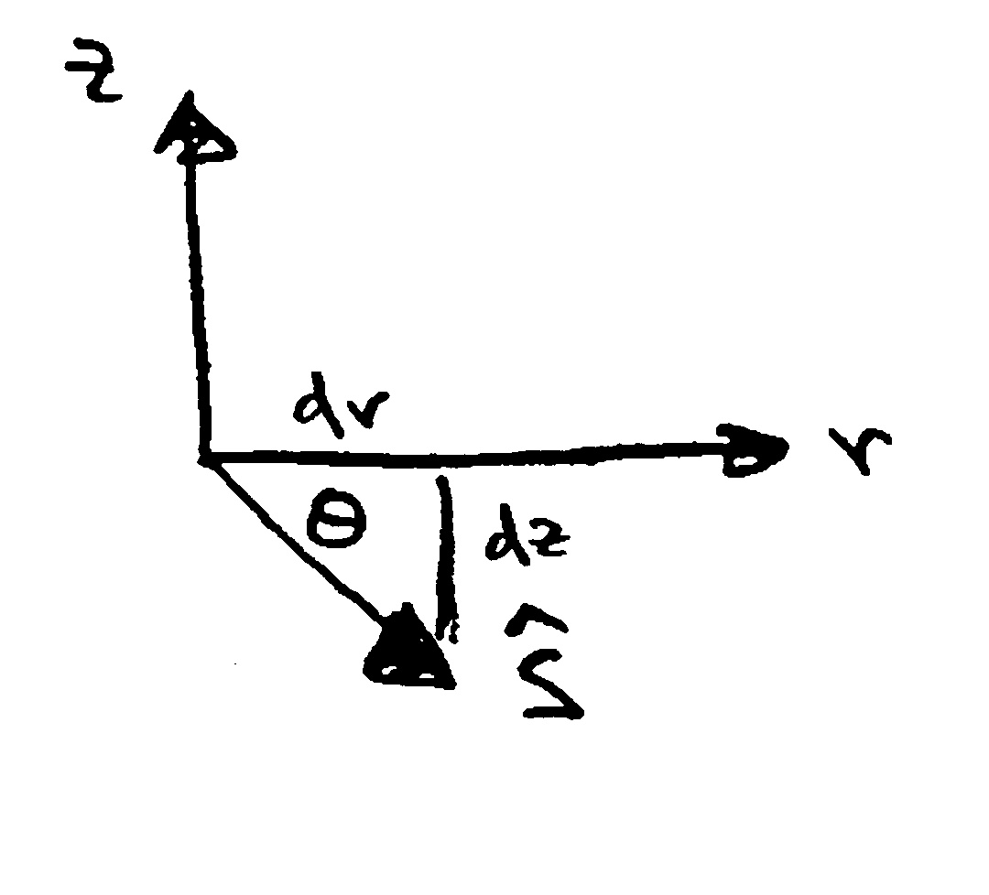
The unit vector in the direction of ∇p is
$\hat{s}=\frac{−ρg\hat{k}+ρrΩ^{2}{\hat{e}}_{r}}{ {\left[{\left(ρg\right)}^{2}+{\left(ρrΩ^{2}\right)}^{2}\right]}^{1/2}}$

$\text{tan}θ=\frac{\text{dz}}{\text{dr}}=−\frac{g}{rΩ^{2}}$ slope of $\hat{s}$

i.e., r = C₁exp$\left(−\frac{Ω^{2}z}{g}\right)$ equation of ∇p surfaces
