Chapter 3 Bernoulli Equation

Derivation of Bernoulli Equation

Streamline Coordinates:
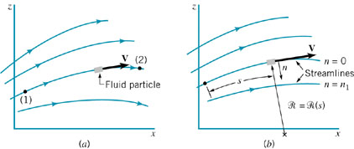
(a) Flow in the x–z plane.
(b) Flow in terms of streamline and normal coordinates.

Streamlines are the lines that are tangent to the velocity vectors throughout the flow field. For many situations it is easiest to describe the flow in terms of the “streamline” coordinates (s, n) based on the streamlines. The particle motion is described in terms of its distance, , along the streamline from some convenient origin and the local radius of curvature of the streamline, .
Speed:
Streamwise acceleration:
Normal acceleration:

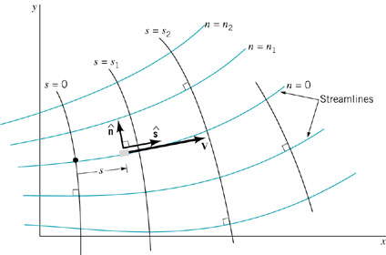
Streamline coordinate system for two-dimensional flow.

The velocity is always tangent to the s direction:

For steady, two-dimensional flow the acceleration for a given fluid particle (material derivative D/Dt) is:
Steady flow:
Definition velocity:

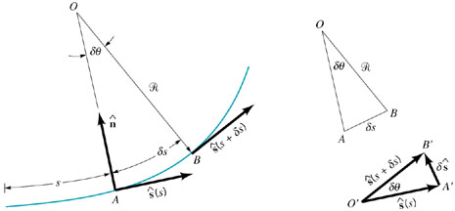
Relationship between the unit vector along the streamline, ŝ, and the radius of curvature of the streamline,

The quantity ∂ŝ/∂s represents the limit as δs → 0 of the change in the unit vector along the streamline, δŝ, per change in distance along the streamline, δs. The magnitude of ŝ is constant (|ŝ| = 1; it is a unit vector), but its direction is variable if the streamlines are curved. From Fig. 4.9 it is seen that the magnitude of ∂ŝ/∂s is equal to the inverse of the radius of curvature of the streamline, , at the point in question. This follows because the two triangles shown (AOB and A′O′B′) are similar triangles so that δs/ = |δŝ|/|ŝ| = |δŝ|, or |δŝ/δs| = 1/. Similarly, in the limit δs → 0, the direction of δŝ/δs is seen to be normal to the streamline. That is,
So we have
i.e.,
,
Newton's Second Law
According to Newton's second law of motion, the net force acting on the fluid particle under consideration must equal its mass times its acceleration,

Assumptions used in the derivation:
(1) Inviscid
(2) Incompressible
(3) Steady
(4) Conservative body force

To determine the forces necessary to produce a given flow (or conversely, what flow results from a given set of forces), we consider the free-body diagram of a small fluid particle:
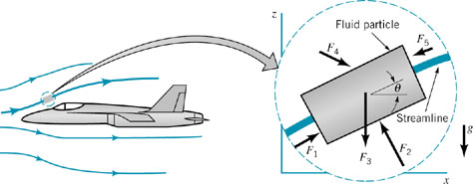

F = ma along a Streamline
The component of Newton's second law along the streamline direction, s, can be written as
The component of the weight force in the direction of the streamline:
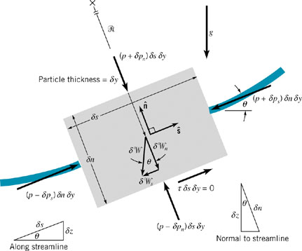
Free-body diagram of a fluid particle for which
the important forces are those due to pressure and gravity.

1st-order Taylor series expansion for the pressure field:
The net pressure force on the particle in the streamline direction:
The net force acting in the streamline direction on the particle is
Noting that and , the above equation can be rearranged and integrated:
(along a streamline)
For constant acceleration of gravity:
(along a streamline)
For steady, inviscid, and incompressible flow, we have the celebrated Bernoulli equation:
(along a streamline)

F = ma Normal to a Streamline
The component of Newton's second law along the normal direction, n, can be written as
The component of the weight (gravity force) in the normal direction:
1st-order Taylor series expansion for the pressure field:
The net pressure force on the particle in the streamline normal direction:
The net force acting in the normal direction on the particle is
Noting that , we obtain the equation of motion along the normal direction:
Since if s is constant, integrate across the streamline:
(across the streamline)
For steady, inviscid, and incompressible flow, we have:
(across the streamline)

Physical Interpretation
Integration of the equation of motion to give the Bernoulli equation actually corresponds to the work-energy principle often used in the study of dynamics. With certain assumptions, a statement of the work-energy principle may be written as follows: The work done on a particle by all forces acting on the particle is equal to the change of the kinetic energy of the particle. The Bernoulli equation is a mathematical statement of this principle. In fact, an alternate method of deriving the Bernoulli equation is to use the first and second laws of thermodynamics (the energy and entropy equations), rather than Newton's second law. With the appropriate restrictions, the general energy equation reduces to the Bernoulli equation.
An alternate but equivalent form of the Bernoulli equation
(along a streamline)
Pressure head:
Velocity head:
Elevation head:
The Bernoulli equation states that the sum of the pressure head, the velocity head, and the elevation head is constant along a streamline.

Static, Stagnation, Dynamic, and Total Pressure
(along a streamline)
Static pressure:
Dynamic pressure:
Hydrostatic pressure:

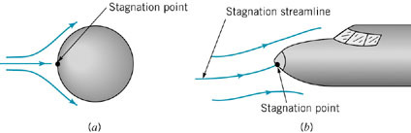
Stagnation points on bodies in flowing fluids.

Stagnation pressure:(assume elevation effects negligible)
Total pressure: (along a streamline)
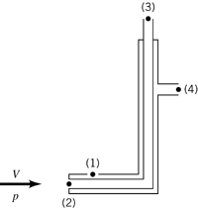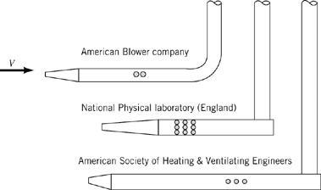
The Pitot-static tube and typical Pitot-static tube designs.
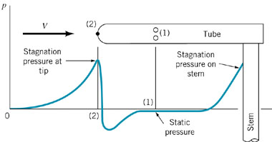
Typical pressure distribution along a Pitot-static tube.

Applications of Bernoulli Equation

Stagnation Tube
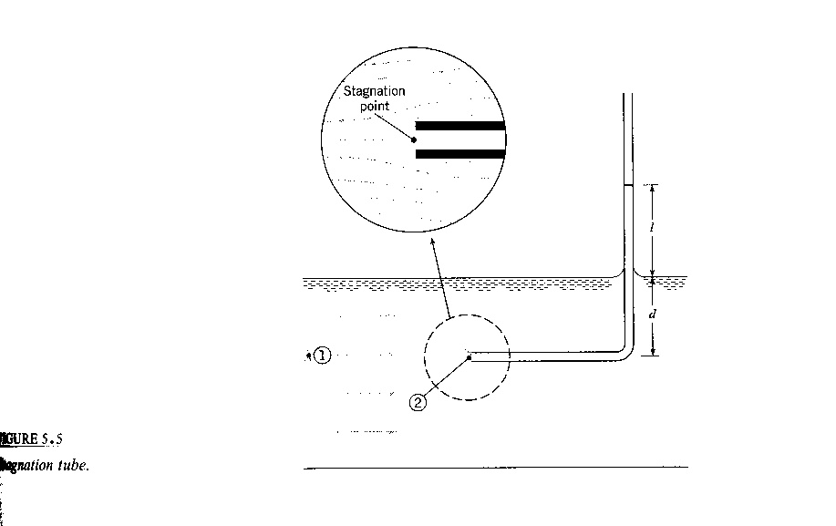

$p_{1}+ρ\frac{V_{1}^{2}}{2}=p_{2}+ρ\frac{V_{2}^{2}}{2}$ z₁ = z₂

$V_{1}^{2}=\frac{2}{ρ}\left(p_{2}−p_{1}\right)$ $\begin{aligned}p_{1}=γd \\ p_{2}=γ\left(ℓ+d\right)\end{aligned}$
V₂ = 0
gage
= $\frac{2}{ρ}\left(γℓ\right)$
Limited by length of tube and need for free surface reference
$V_{1}=\sqrt{2gℓ}$

Pitot Tube
0
$$\frac{p_{1}}{γ}+\frac{V_{1}^{2}}{2g}+z_{1}=\frac{p_{2}}{γ}+\frac{V_{2}^{2}}{2g}+z_{2}$$
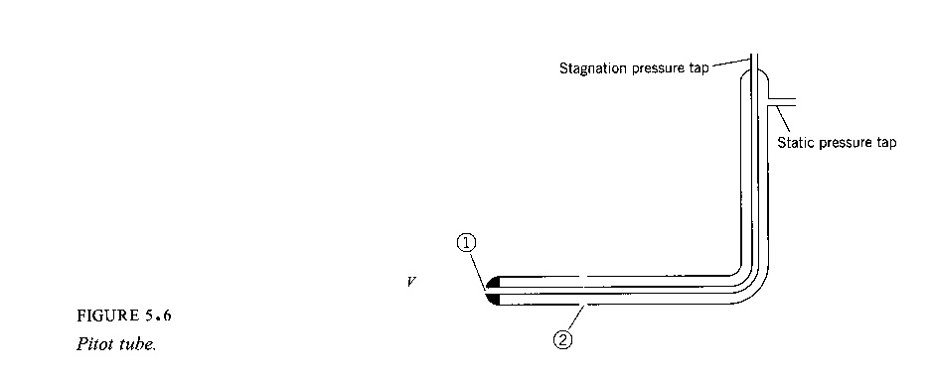

$V_{2}={\left\{2g\left[\left(\frac{p_{1}}{γ}+z_{1}\right)−\left(\frac{p_{2}}{γ}+z_{2}\right)\right]\right\}}^{1/2}$ V₁ = 0

h₁ h₂
h = piezometric head
$V=V_{2}=\sqrt{2g\left(h_{1}−h_{2}\right)}$ h₁ – h₂ from manometer
or pressure gage
for gas flow $\frac{Δp}{γ}\text{>>}Δz$

$$V=\sqrt{\frac{2Δp}{ρ}}$$

Free Jets
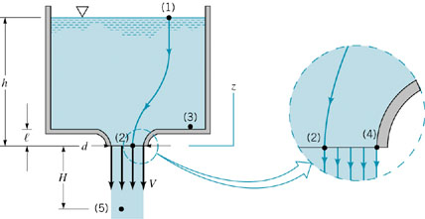
Vertical flow from a tank
Application of Bernoulli Equation between points (1) and (2) on the streamline shown gives
Since, , , , , we have:
Bernoulli equation between points (1) and (5) gives
Simplified form of the continuity equation
Obtained from the following intuitive arguments:
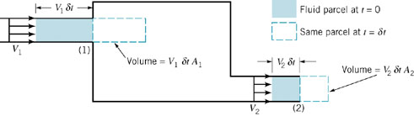
Steady flow into and out of a tank.
Volume flowrate:
Mass flowrate:
Conservation of mass requires
For incompressible flow , we have

Volume Rate of flow (flowrate, discharge)

- cross-sectional area oriented normal to velocity vector
(simple case where V ⊥ A)

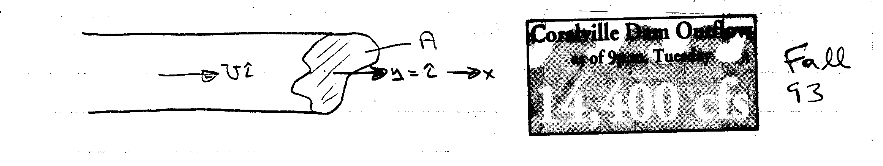
U = constant: Q = volume flux = UA [m/s × m² = m³/s]
U ≠ constant: Q = $\int_{A}{\text{UdA}}$

Similarly the mass flux = $\overset{˙}{m}=\int_{A}{ρ\text{UdA}}$
- general case
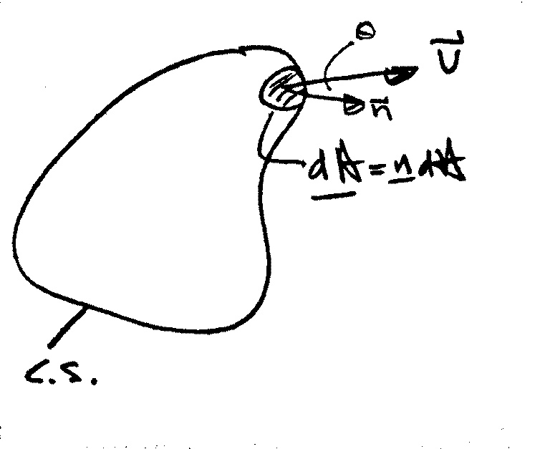

$\begin{aligned}Q=\int_{\text{CS}}{\underline{V}⋅\underline{n}\text{dA}} \\ =\int_{\text{CS}}{\left|\underline{V}\right|\text{cos}θ\text{dA}}\end{aligned}$
$$\overset{˙}{m}=\int_{\text{CS}}{ρ\left(\underline{V}⋅\underline{n}\right)\text{dA}}$$
average velocity: $\overline{V}=\frac{Q}{A}$

Example:
At low velocities the flow through a long circular tube, i.e. pipe, has a parabolic velocity distribution (actually paraboloid of revolution).
$$u=u_{\text{max}}\left(1−{\left(\frac{r}{R}\right)}^{2}\right)$$
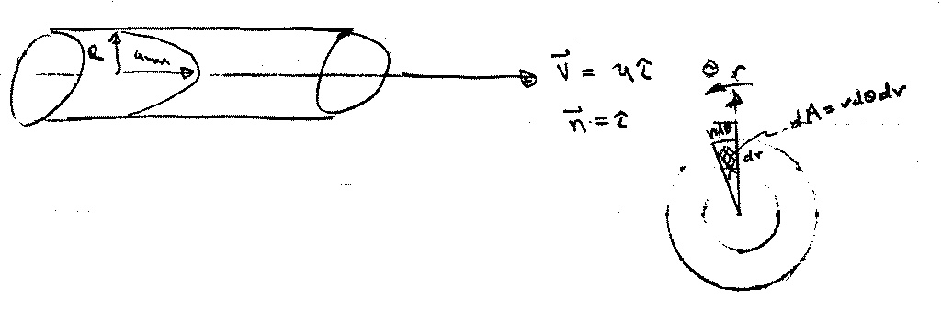
i.e., centerline velocity

a) find Q and $\overline{V}$

$$Q=\int_{A}{\underline{V}⋅\underline{n}}\text{dA}=\int_{A}{\text{udA}}$$

$$\int_{A}{\text{udA}=\int_{0}^{2π}{\int_{0}^{R}{u(r)\text{rd}θ\text{dr}}}}$$
= $2π\int_{0}^{R}{u(r)\text{rdr}}$
dA = 2πrdr
u = u(r) and not θ ∴ $\int_{0}^{2π}{dθ=2π}$

Q = $2π\int_{0}^{R}{u_{\text{max}}\left(1−{\left(\frac{r}{R}\right)}^{2}\right)\text{rdr}}$ = $\frac{1}{2}u_{\text{max}}{πR}^{2}$
$$\overline{V}=\frac{1}{2}u_{\text{max}}$$

Flowrate Measurement
Various flow meters are governed by the Bernoulli and continuity equations.
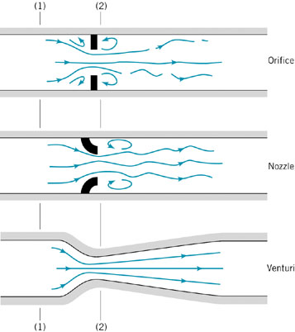
Typical devices for measuring flowrate in pipes
Three commonly used types of flow meters are illustrated: the orifice meter, the nozzle meter, and the Venturi meter. The operation of each is based on the same physical principles—an increase in velocity causes a decrease in pressure. The difference between them is a matter of cost, accuracy, and how closely their actual operation obeys the idealized flow assumptions.

We assume the flow is horizontal (z₁ = z₂), steady, inviscid, and incompressible between points (1) and (2). The Bernoulli equation becomes:
If we assume the velocity profiles are uniform at sections (1) and (2), the continuity equation can be written as:
where A₂ is the small (A₂ < A₁) flow area at section (2). Combination of these two equations results in the following theoretical flowrate

Other flow meters based on the Bernoulli equation are used to measure flowrates in open channels such as flumes and irrigation ditches. Two of these devices, the sluice gate and the sharp-crested weir, are discussed below under the assumption of steady, inviscid, incompressible flow.
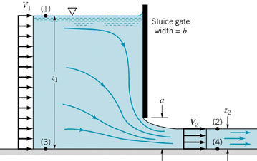
Sluice gate geometry
We apply the Bernoulli and continuity equations between points on the free surfaces at (1) and (2) to give:
and
With the fact that :
In the limit of :

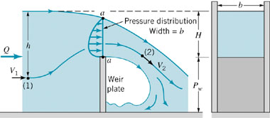
Rectangular, sharp-crested weir geometry

For such devices the flowrate of liquid over the top of the weir plate is dependent on the weir height, P_{w}, the width of the channel, b, and the head, H, of the water above the top of the weir. Between points (1) and (2) the pressure and gravitational fields cause the fluid to accelerate from velocity V₁ to velocity V₂. At (1) the pressure is p₁ = γh, while at (2) the pressure is essentially atmospheric, p₂ = 0. Across the curved streamlines directly above the top of the weir plate (section a–a), the pressure changes from atmospheric on the top surface to some maximum value within the fluid stream and then to atmospheric again at the bottom surface.

For now, we will take a very simple approach and assume that the weir flow is similar in many respects to an orifice-type flow with a free streamline. In this instance we would expect the average velocity across the top of the weir to be proportional to and the flow area for this rectangular weir to be proportional to Hb. Hence, it follows that

Energy grade line (EGL) and hydraulic grade line (HGL)

In this chapter, we neglect losses and/or minor losses , and energy input or output by pumps or turbines:

Define HGL = $\frac{p}{γ}+z$
point-by-point application is graphically displayed
EGL =

HGL corresponds to pressure tap measurement + z

EGL corresponds to stagnation tube measurement + z
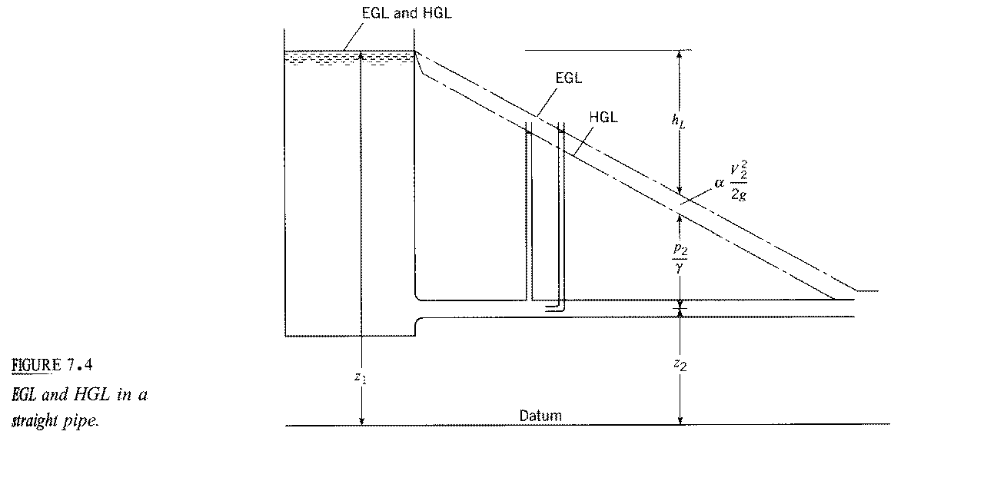
EGL = HGL if V = 0
h_{L} = $f\frac{L}{D}\frac{V^{2}}{2g}$
i.e., linear variation in L for D,
V, and f constant
EGL₁ = EGL₂ + h_{L}
for h_{p} = h_{t} = 0

f = friction factor
f = f(Re)

pressure tap: $\frac{p_{2}}{γ}=h$
h = height of fluid in
tap/tube
stagnation tube:

Helpful hints for drawing HGL and EGL

1. EGL = HGL + V²/2g = HGL for V = 0

2. p = 0 ⇒ HGL = z
3. for change in D ⇒ change in V

i.e. V₁A₁ = V₂A₂
change in distance between HGL & EGL and slope
change due to change in h_{L}
$V_{1}\frac{{πD}_{1}^{2}}{4}=V_{2}\frac{{πD}_{2}^{2}}{4}$
⇒
$V_{1}D_{1}^{2}=V_{1}D_{2}^{2}$

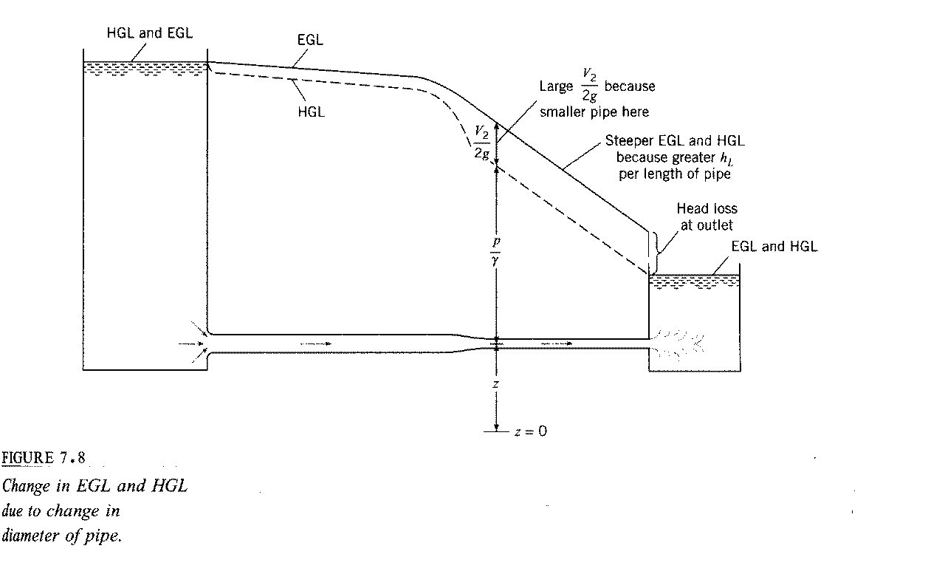
4. If HGL < z then p/γ < 0 i.e., cavitation possible
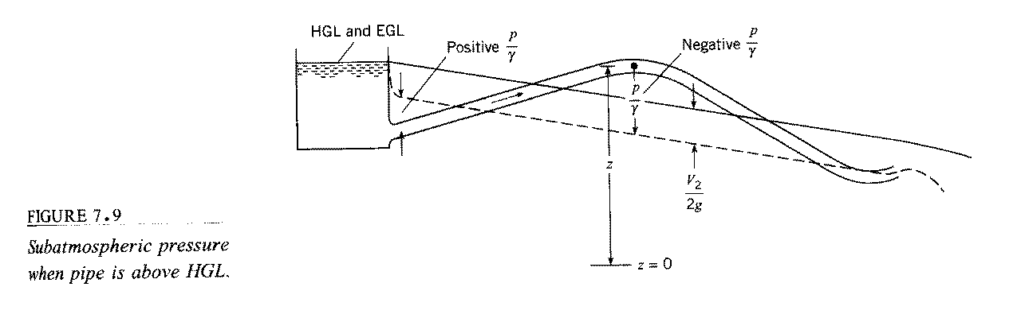
condition for cavitation:

$p=p_{\text{va}}=\text{2000}\frac{N}{m^{2}}$
gage pressure

$\frac{p_{\text{va},g}}{γ}≈−\text{10}m$

9810 N/m³

Limitations of Bernoulli Equation

Assumptions used in the derivation Bernoulli Equation:
(1) Inviscid
(2) Incompressible
(3) Steady
(4) Conservative body force

1. Compressibility Effects:
The Bernoulli equation can be modified for compressible flows. A simple, although specialized, case of compressible flow occurs when the temperature of a perfect gas remains constant along the streamline—isothermal flow. Thus, we consider p = ρRT, where T is constant. (In general, p, ρ, and T will vary.). An equation similar to the Bernoulli equation can be obtained for isentropic flow of a perfect gas. For steady, inviscid, isothermal flow, Bernoulli equation becomes
The constant of integration is easily evaluated if z₁, p₁, and V₁ are known at some location on the streamline. The result is

2. Unsteady Effects:
The Bernoulli equation can be modified for unsteady flows. With the inclusion of the unsteady effect (∂V/∂t ≠ 0) the following is obtained:
(along a streamline)
For incompressible flow this can be easily integrated between points (1) and (2) to give
(along a streamline)

3. Rotational Effects
Care must be used in applying the Bernoulli equation across streamlines. If the flow is “irrotational” (i.e., the fluid particles do not “spin” as they move), it is appropriate to use the Bernoulli equation across streamlines. However, if the flow is “rotational” (fluid particles “spin”), use of the Bernoulli equation is restricted to flow along a streamline.

4. Other Restrictions
Another restriction on the Bernoulli equation is that the flow is inviscid. The Bernoulli equation is actually a first integral of Newton's second law along a streamline. This general integration was possible because, in the absence of viscous effects, the fluid system considered was a conservative system. The total energy of the system remains constant. If viscous effects are important the system is nonconservative and energy losses occur. A more detailed analysis is needed for these cases.

The Bernoulli equation is not valid for flows that involve pumps or turbines. The final basic restriction on use of the Bernoulli equation is that there are no mechanical devices (pumps or turbines) in the system between the two points along the streamline for which the equation is applied. These devices represent sources or sinks of energy. Since the Bernoulli equation is actually one form of the energy equation, it must be altered to include pumps or turbines, if these are present.

