# Chapter 3 Bernoulli Equation

## 3.1 Flow Patterns: Streamlines, Pathlines, Streaklines

1. A ***streamline $ψ\left(\underline{x},t\right)$*** is a line that is everywhere tangent to the velocity vector at a given instant.

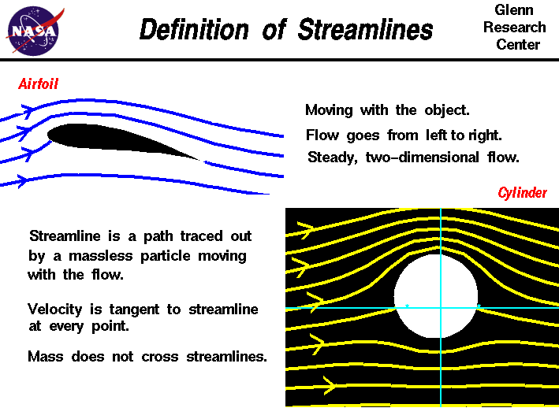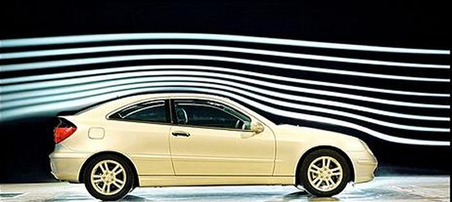

Examples of streamlines around an airfoil (left) and a car (right)

1. A ***pathline*** is the actual path traveled by a given fluid particle.



An illustration of pathline (left) and an example of pathlines, motion of water induced by surface waves (right)

1. A ***streakline*** is the locus of particles which have earlier passed through a particular point.

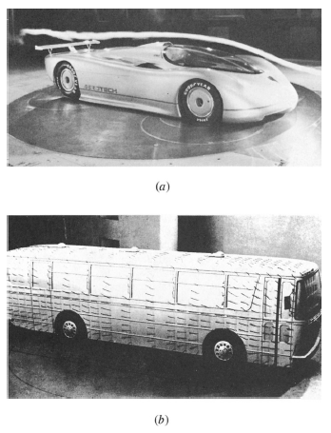

An illustration of streakline (left) and an example of streaklines, flow past a full-sized streamlined vehicle in the GM aerodynamics laboratory wind tunnel, and 18-ft by 34-ft test section facilility by a 4000-hp, 43-ft-diameter fan (right)

Note:

1. For steady flow, all 3 coincide.
2. For unsteady flow, $ψ\left(t\right)$ pattern changes with time, whereas pathlines and streaklines are generated as the passage of time

Streamline:

By definition we must have $\underline{V}×d\underline{r}=0$ which upon expansion yields the equation of the streamlines for a given time $t=t_{1}$

$$\frac{dx}{u}=\frac{dy}{v}=\frac{dz}{w}=ds$$

where $s$ = integration parameter. So if ($u$, $v$, $w$) know, integrate with respect to $s$ for $t=t_{1}$ with I.C. ($x_{0}$, $y_{0}$, $z_{0}$, $t_{1}$) at $s=0$ and then eliminate $s$.

Pathline:

The path line is defined by integration of the relationship between velocity and displacement.

$$\frac{dx}{dt}=u \frac{dy}{dt}=v \frac{dz}{dt}=w$$

Integrate $u$, $v$, $w$ with respect to $t$ using I.C. ($x_{0}$, $y_{0}$, $z_{0}$, $t_{0}$) then eliminate $t$.

Streakline:

To find the streakline, use the integrated result for the pathline retaining time as a parameter. Now, find the integration constant which causes the pathline to pass through ($x_{0}$, $y_{0}$, $z_{0}$) for a sequence of time $ξ<t$. Then eliminate $ξ$.

## 3.2 Streamline Coordinates

Equations of fluid mechanics can be expressed in different coordinate systems, which are chosen for convenience, e.g., application of boundary conditions: Cartesian ($x$, $y$, $z$) or orthogonal curvilinear (e.g., $r$, $θ$, $z$) or non-orthogonal curvilinear. A natural coordinate system is streamline coordinates ($s$, $n$, $l$); however, difficult to use since solution to flow problem ($\underline{V}$) must be known to solve for steamlines.

For streamline coordinates, since $\underline{V}$ is tangent to $s$ there is only one velocity component.

$$\underline{V}\left(\underline{x},t\right)=v_{s}\left(\underline{x},t\right)\hat{s}+v_{n}\left(\underline{x},t\right)\hat{n}$$

where $v_{n}=0$ by definition.

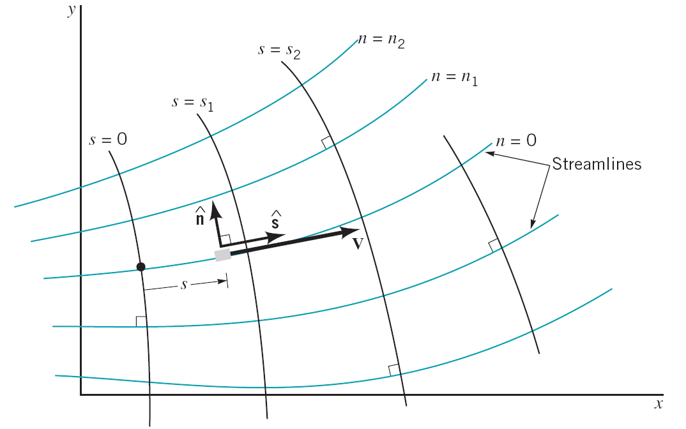

Figure 4.8 Streamline coordinate system for two-dimensional flow.

The acceleration is

$$\underline{a}=\frac{D\underline{V}}{Dt}=\frac{∂\underline{V}}{∂t}+\left(\underline{V}⋅∇\right)\underline{V}$$

where,

$$∇=\frac{∂}{∂s}\hat{s}+\frac{∂}{∂n}\hat{n}; \underline{V}⋅∇=v_{s}\frac{∂}{∂s}$$

$$\underline{a}=a_{s}\hat{s}+a_{n}\hat{n}=\frac{∂\underline{V}}{∂t}+v_{s}\frac{∂\underline{V}}{∂s}$$

$$=\left[\frac{∂v_{s}}{∂t}\hat{s}+v_{s}\frac{∂\hat{s}}{∂t}\right]+v_{s}\left[\frac{∂v_{s}}{∂s}\hat{s}+v_{s}\frac{∂\hat{s}}{∂s}\right]$$

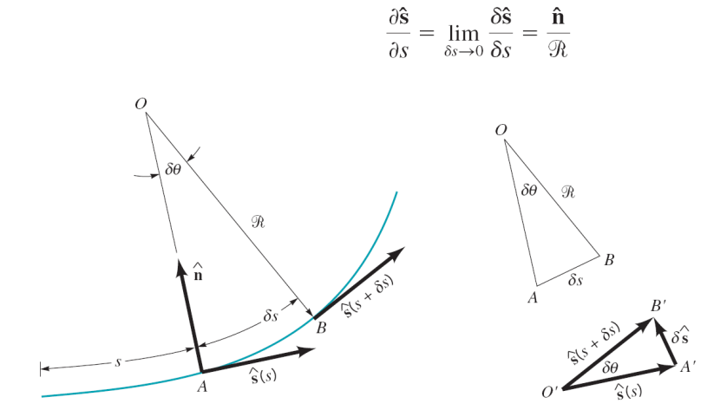

Figure 4.9 Relationship between the unit vector along the streamline, $\hat{s}$, and the radius of curvature of the streamline, $R$

Space increment

$$\hat{s}+\frac{∂\hat{s}}{∂s}ds$$

$$\frac{∂θ}{∂s}ds\hat{n}$$

$$dθ$$

$$\hat{s}$$

Normal to $\hat{s}$

$$ds=Rdθ$$

$$\hat{s}+\frac{∂θ}{∂s}ds\hat{n}=\hat{s}+\frac{∂\hat{s}}{∂s}ds$$

$$\frac{∂\hat{s}}{∂s}=\frac{\hat{n}}{R}$$

Time increment

$$\hat{s}+\frac{∂\hat{s}}{∂t}dt$$

$$\frac{∂θ}{∂t}dt\hat{n}$$

$$dθ$$

$$\hat{s}$$

$$\hat{s}+\frac{∂θ}{∂t}dt\hat{n}=\hat{s}+\frac{∂\hat{s}}{∂t}dt$$

$$\frac{∂\hat{s}}{∂t}=\frac{∂θ}{∂t}\hat{n} are chosen for convenience, e.g.,GM aerodyn$$

$$\underline{a}=\left(\frac{∂v_{s}}{∂t}+v_{s}\frac{∂v_{s}}{∂s}\right)\hat{s}+\left(\underset{{∂v_{n}}/{∂t}}{\underbrace{v_{s}\frac{∂θ}{∂t}}}+\frac{v_{s}^{2}}{R}\right)\hat{n}$$

or

$$a_{s}=\frac{∂v_{s}}{∂t}+v_{s}\frac{∂v_{s}}{∂s}, a_{n}=\frac{∂v_{n}}{∂t}+\frac{v_{s}^{2}}{R}$$

where,

$\frac{∂v_{s}}{∂t}$ = local $a_{s}$ in $\hat{s}$ direction

$\frac{∂v_{n}}{∂t}$ = local $a_{n}$ in $\hat{n}$ direction

$v_{s}\frac{∂v_{s}}{∂s}$ = convective $a_{s}$ due to spatial gradient of $\underline{V}$

i.e. convergence /divergence $ψ$

$\frac{v_{s}^{2}}{R}$ = convective $a_{n}$ due to curvature of : centrifugal accerleration

## 3.3 Bernoulli Equation

Consider the small fluid particle of size $δs$ by $δn$ in the plane of the figure and $δy$ normal to the figure as shown in the free-body diagram below. For steady flow, the components of Newton’s second law along the streamline and normal directions can be written as following:

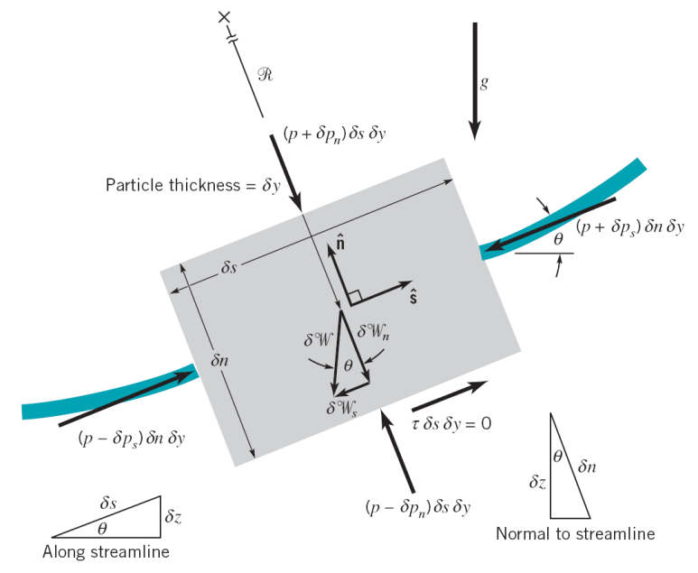

1) Along a streamline

$δm⋅a_{s}=∑δF_{s}=δW_{s}+δF_{ps}$

where,

$δm⋅a_{s}=\left(ρδV\right)⋅\left(v_{s}\frac{∂v_{s}}{∂s}\right)$

$δW_{s}=-γδV\sin{θ}$

$δF_{ps}=\left(p-δp_{s}\right)δnδy-\left(p+δp_{s}\right)δnδy=-2δp_{s}δnδy$

$=-\frac{∂p}{∂s}δV$

$δp_{s}=\frac{∂p}{∂s}\frac{δs}{2}$

1st order Taylor Series

Thus,

$\left(ρδV\right)⋅\left(v_{s}\frac{∂v_{s}}{∂s}\right)=-\frac{∂p}{∂s}δV-γδV\sin{θ}$

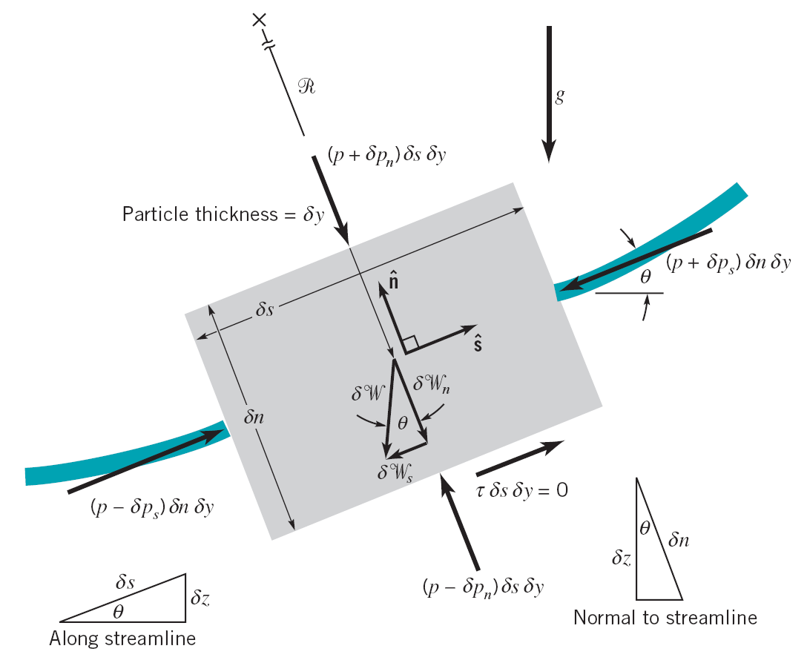 $ρ\left(v_{s}\frac{∂v_{s}}{∂s}\right)=-\frac{∂p}{∂s}-γ\sin{θ}$

$$\sin{θ}=\frac{dz}{ds}$$

$=-\frac{∂}{∂s}\left(p+γz\right)$

→ change in speed due to $\frac{∂p}{∂s}$ and $\frac{∂z}{∂s}$ (i.e. along )

2) Normal to a streamline

$δm⋅a_{n}=∑δF_{n}=δW_{n}+δF_{pn}$

where,

$δm⋅a_{n}=\left(ρδV\right)⋅\left(\frac{v_{s}^{2}}{R}\right)$

$δW_{n}=-γδV\cos{θ}$

$δF_{pn}=\left(p-δp_{n}\right)δsδy-\left(p+δp_{n}\right)δsδy=-2δp_{n}δsδy$

$δp_{n}=\frac{∂p}{∂n}\frac{δn}{2}$

1st order Taylor Series

$=-\frac{∂p}{∂n}δV$

Thus,



$\left(ρδV\right)⋅\left(\frac{v_{s}^{2}}{R}\right)=-\frac{∂p}{∂n}δV-γδV\cos{θ}$

$$\cos{θ}=\frac{dz}{dn}$$

$ρ\frac{v_{s}^{2}}{R}=-\frac{∂p}{∂n}-γ\cos{θ}$

$=-\frac{∂}{∂n}\left(p+γz\right)$

→ streamline curvature is due to $\frac{∂p}{∂n}$ and $\frac{∂z}{∂n}$ (i.e. $W$ along $\hat{n}$)

In a vector form:

$ρ\underline{a}=-∇\left(p+γz\right)$ (Euler equation)

or $ρ\left(v_{s}\frac{∂v_{s}}{∂s}\hat{s}+\frac{v_{s}^{2}}{R}\hat{n}\right)=-\left(\frac{∂}{∂s}\hat{s}+\frac{∂}{∂n}\hat{n}\right)\left(p+γz\right)$

Steady flow, $ρ$ = constant, $\hat{s}$ equation

$ρv_{s}\frac{∂v_{s}}{∂s}=-\frac{∂}{∂s}\left(p+γz\right)$

$\frac{∂}{∂s}\left[\frac{v_{s}^{2}}{2}+\frac{p}{ρ}+gz\right]=0$

$$∴ \underset{Bernoulli equation}{\underbrace{\frac{v_{s}^{2}}{2}+\frac{p}{ρ}+gz=constant}}$$

Steady flow, $ρ$ = constant, $\hat{n}$ equation

$ρ\frac{v_{s}^{2}}{R}=-\frac{∂}{∂n}\left(p+γz\right)$

$$∴ \int{\frac{v_{s}^{2}}{R}dn}+\frac{p}{ρ}+gz=constant$$

For curved streamlines $p+γz$ (= constant for static fluid) decreases in the $\hat{n}$ direction, i.e. towards the local center of curvature.

It should be emphasized that the Bernoulli equation is restricted to the following:

* inviscid flow
* steady flow
* incompressible flow
* flow along a streamline

Note that if in addition to the flow being inviscid it is also irrotational, i.e. rotation of fluid = $\underline{ω}$ = vorticity = $∇×\underline{V}$ = 0, the Bernoulli constant is same for all $ψ$, as will be shown later.

## 3.4 Physical interpretation of Bernoulli equation

Integration of the equation of motion to give the Bernoulli equation actually corresponds to the work-energy principle often used in the study of dynamics. This principle results from a general integration of the equations of motion for an object in a very similar to that done for the fluid particle. With certain assumptions, a statement of the work-energy principle may be written as follows:

The work done on a particle by all forces acting on the particle is equal to the change of the kinetic energy of the particle.

The Bernoulli equation is a mathematical statement of this principle.

In fact, an alternate method of deriving the Bernoulli equation is to use the first and second laws of thermodynamics (the energy and entropy equations), rather than Newton’s second law. With the approach restrictions, the general energy equation reduces to the Bernoulli equation.

An alternate but equivalent form of the Bernoulli equation is

$$\frac{p}{γ}+\frac{V^{2}}{2g}+z=constant$$

along a streamline.

Pressure head: $\frac{p}{γ}$

Velocity head: $\frac{V^{2}}{2g}$

Elevation head: $z$

The Bernoulli equation states that the sum of the pressure head, the velocity head, and the elevation head is constant along a streamline.

## 3.5 Static, Stagnation, Dynamic, and Total Pressure

$$p+\frac{1}{2}ρV^{2}+γz=p_{T}=constant$$

along a streamline.

Static pressure: $p$

Dynamic pressure: $\frac{1}{2}ρV^{2}$

Hydrostatic pressure: $γz$

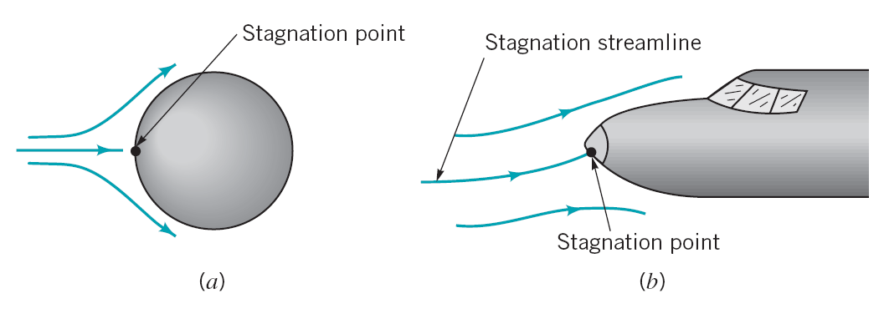

Stagnation points on bodies in flowing fluids.

Stagnation pressure: $p+\frac{1}{2}ρV^{2}$ (assuming elevation effects are negligible)

Total pressure: $p_{T}=p+\frac{1}{2}ρV^{2}+γz$ (along a streamline)

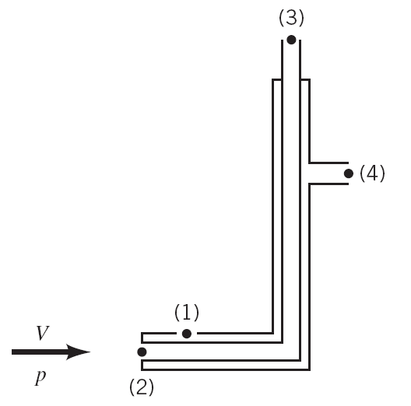 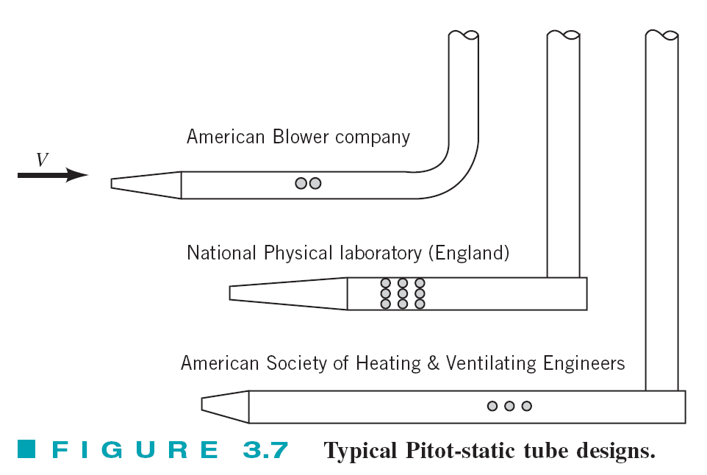

The Pitot-static tube (left) and typical Pitot-static tube designs (right).

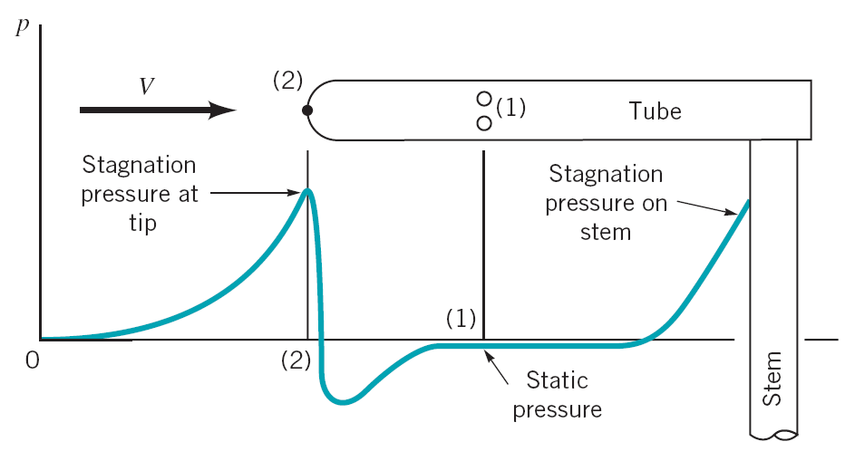

Typical pressure distribution along a Pitot-static tube.

## 3.6 Applications of Bernoulli Equation

### 1) Stagnation Tube

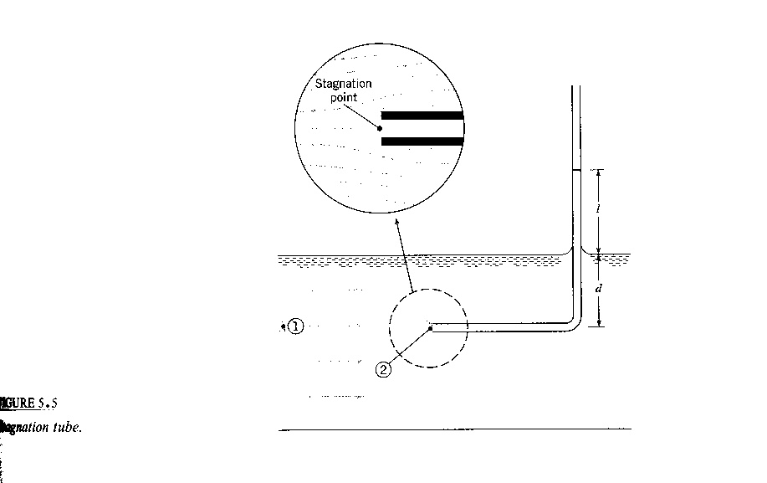

$$p_{1}+ρ\frac{V_{1}^{2}}{2}=p_{2}+ρ\frac{V_{2}^{2}}{2}$$

$$V_{1}^{2}=\frac{2}{ρ}\left(p_{2}-p_{1}\right)$$

$$=\frac{2}{ρ}\left(γl\right)$$

$$V_{1}=\sqrt{2gl}$$

$$z_{1}=z_{2}$$

$$p_{1}=γd, V_{2}=0$$

$$p_{2}=γ\left(l+d\right) gage$$

Limited by length of tube and need for free surface reference

### 2) Pitot Tube

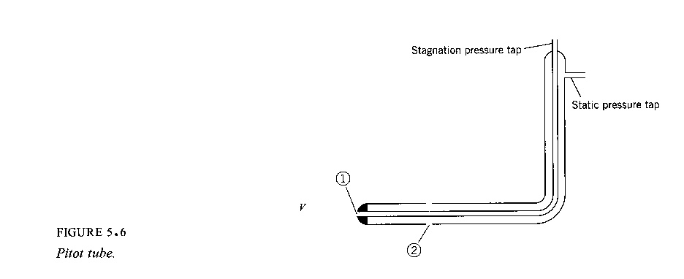

$$\frac{p_{1}}{γ}+\frac{V_{1}^{2}}{2g}+z_{1}=\frac{p_{2}}{γ}+\frac{V_{2}^{2}}{2g}+z_{2}$$

$$V_{2}={\left\{2g\left[\left(\underset{h_{1}}{\underbrace{\frac{p_{1}}{γ}+z_{1}}}\right)-\left(\underset{h_{2}}{\underbrace{\frac{p_{2}}{γ}+z_{2}}}\right)\right]\right\}}^{\frac{1}{2}}$$

where, $V_{1}=0$ and $h$ = piezometric head

$$V=V_{2}=\sqrt{2g\left(h_{1}-h_{2}\right)}$$

$h_{1}-h_{2}$ from manometer or pressure gage

For gas flow ${Δp}/γ≫Δz$

$$V=\sqrt{\frac{2Δp}{ρ}}$$

### 3) Free Jets

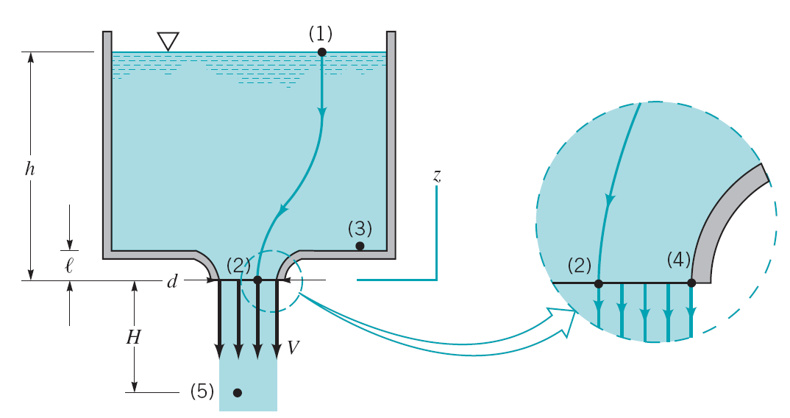

Vertical flow from a tank

Application of Bernoulli equation between points (1) and (2) on the streamline shown gives

$$p_{1}+\frac{1}{2}ρV_{1}^{2}+γz_{1}=p_{2}+\frac{1}{2}ρV_{2}^{2}+γz_{2}$$

Since $z_{1}=h$, $z_{2}=0$, $V_{1}≈0$, $p_{1}=0$, $p_{2}=0$, we have

$$γh=\frac{1}{2}ρV_{2}^{2}$$

$$V_{2}=\sqrt{2\frac{γh}{ρ}}=\sqrt{2gh}$$

Bernoulli equation between points (1) and (5) gives

$$V_{5}=\sqrt{2g\left(h+H\right)}$$

### 4) Simplified form of the continuity equation

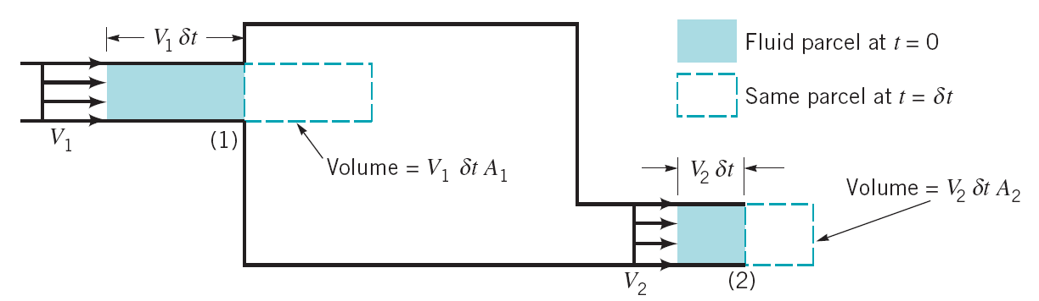

Steady flow into and out of a tank

Obtained from the following intuitive arguments:

Volume flow rate: $Q=VA$

Mass flow rate: $\dot{m}=ρQ=ρVA$

Conservation of mass requires

$$ρ_{1}V_{1}A_{1}=ρ_{2}V_{2}A_{2}$$

For incompressible flow $ρ_{1}=ρ_{2}$, we have

$$V_{1}A_{1}=V_{2}A_{2}$$

or

$$Q_{1}=Q_{2}$$

### 5) Volume Rate of Flow (flowrate, discharge)

#### 1. Cross-sectional area oriented normal to velocity vector

(simple case where $V⊥A)$

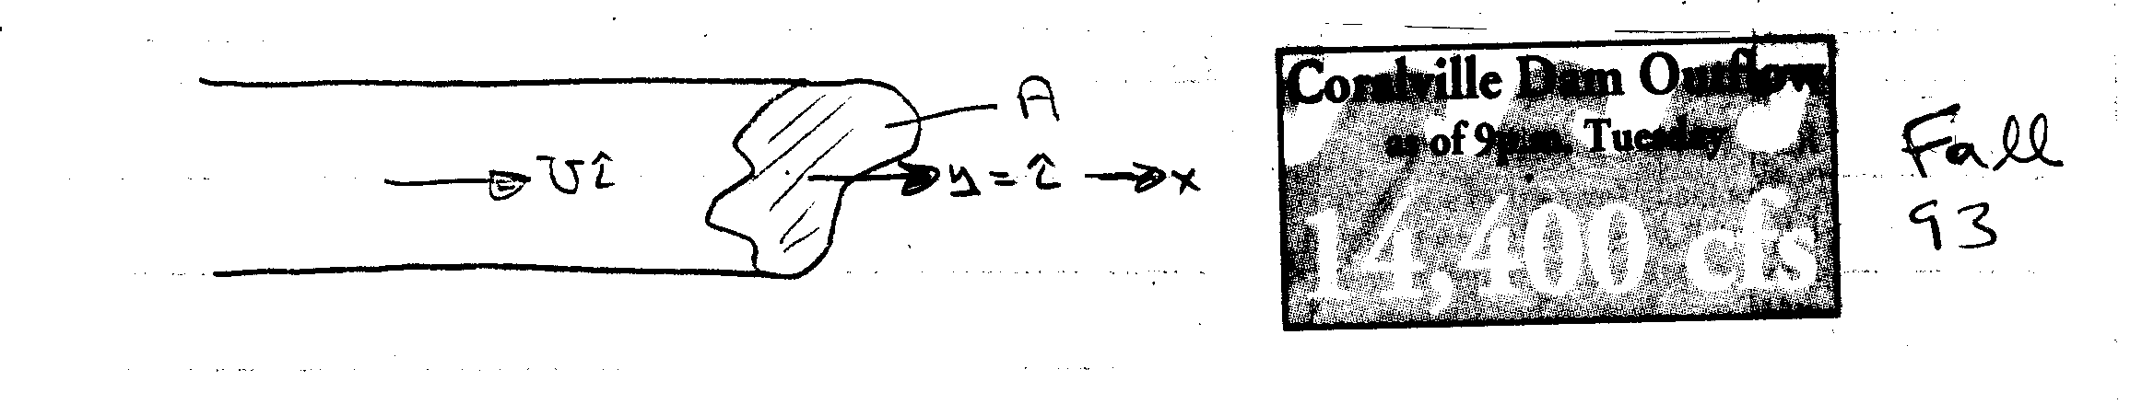

$U$ = constant: $Q$ = volume flux = [m/s × m2 = m3/s]

constant: $Q=\int_{A}{UdA}$

Similarly the mass flux = $\dot{m}=\int_{A}{ρUdA}$

#### 2. General case

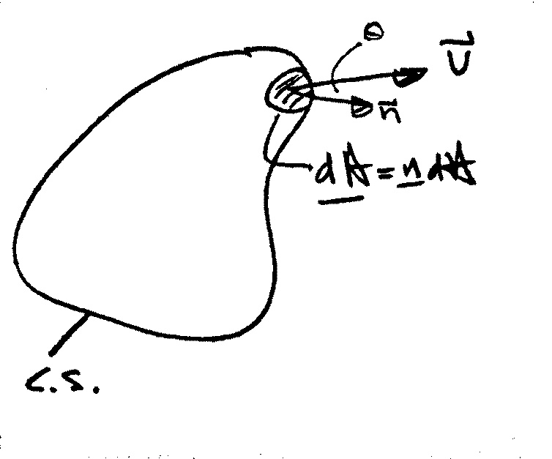

$$Q=\int_{CS}{\underline{V}⋅\underline{n}dA}$$

$$=\int_{CS}{\left|\underline{V}\right|\cos{θ}dA}$$

$$\dot{m}=\int_{CS}{ρ\left(\underline{V}⋅\underline{n}\right)dA}$$

Average velocity:

$$\overline{V}=\frac{Q}{A}$$

Example:

At low velocities the flow through a long circular tube, i.e. pipe, has a parabolic velocity distribution (actually paraboloid of revolution).

$$u=u_{max}\left(1-{\left(\frac{r}{R}\right)}^{2}\right)$$

where, $u_{max}$ = centerline velocity

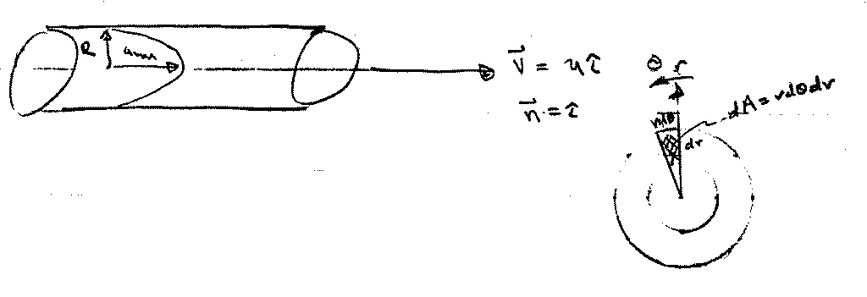

a) find $Q$ and $\overline{V}$

$$Q=\int_{A}{\underline{V}⋅\underline{n}}dA=\int_{A}{udA}$$

$$\int_{A}{udA}=\int_{0}^{2π}{\int_{0}^{R}{u\left(r\right)rdθdr}}$$

$$=2π\int_{0}^{R}{u\left(r\right)rdr}$$

where, $dA=2πrdr$, $u=u\left(r\right)$ and not $θ$, $∴ \int_{0}^{2π}{dθ}=2π$

$$Q=2π\int_{0}^{R}{u_{max}\left(1-{\left(\frac{r}{R}\right)}^{2}\right)rdr}=\frac{1}{2}u_{max}πR^{2}$$

$$\overline{V}=\frac{Q}{A}=\frac{u_{max}}{2}$$

### 6) Flowrate measurement

Various flow meters are governed by the Bernoulli and continuity equations.

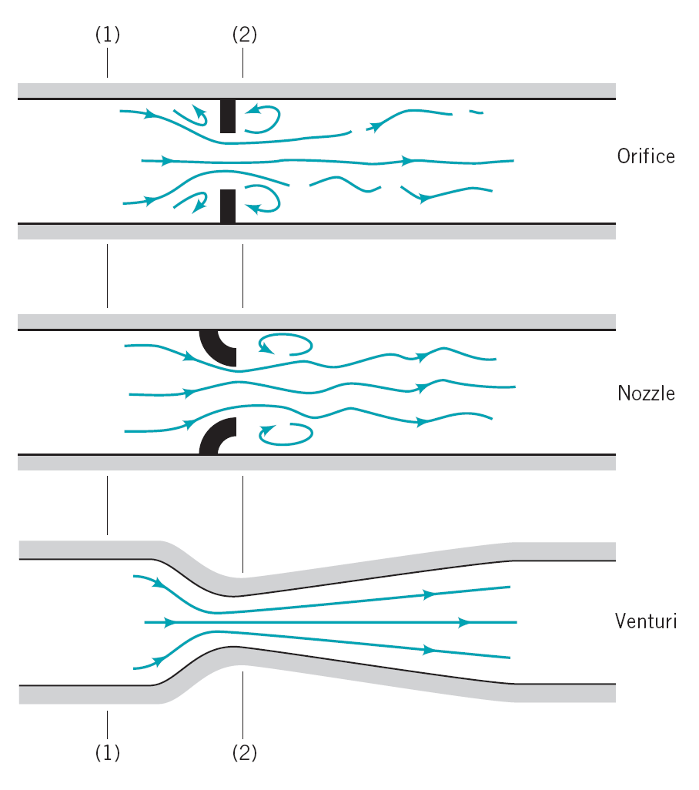

Typical devices for measuring flowrate in pipes.

Three commonly used types of flow meters are illustrated: the orifice meter, the nozzle meter, and the Venturi meter. The operation of each is based on the same physical principles—an increase in velocity causes a decrease in pressure. The difference between them is a matter of cost, accuracy, and how closely their actual operation obeys the idealized flow assumptions.

We assume the flow is horizontal ($z_{1}=z_{2}$), steady, inviscid, and incompressible between points (1) and (2). The Bernoulli equation becomes:

$$p_{1}+\frac{1}{2}ρV_{1}^{2}=p_{2}+\frac{1}{2}ρV_{2}^{2}$$

If we assume the velocity profiles are uniform at sections (1) and (2), the continuity equation can be written as:

$$Q=V_{1}A_{1}=V_{2}A_{2}$$

where $A_{2}$ is the small ($A_{2}<A_{1}$) flow area at section (2). Combination of these two equations results in the following theoretical flowrate

$$Q=A_{2}\sqrt{\frac{2\left(p_{1}-p_{2}\right)}{ρ\left[1-{\left({A_{2}}/{A_{1}}\right)}^{2}\right]}}$$

assumed *vena contracta* = 0, i.e., no viscous effects. Otherwise,

$$Q=C_{C}A_{C}\sqrt{\frac{2\left(p_{1}-p_{2}\right)}{ρ\left[1-{\left({A_{2}}/{A_{1}}\right)}^{2}\right]}}$$

where $C_{C}$ = contraction coefficient

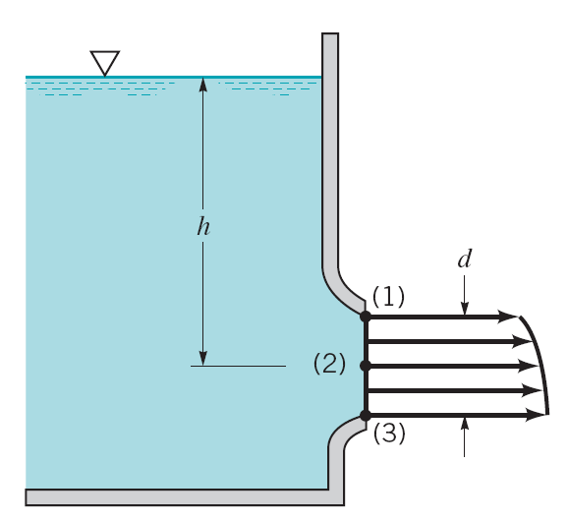 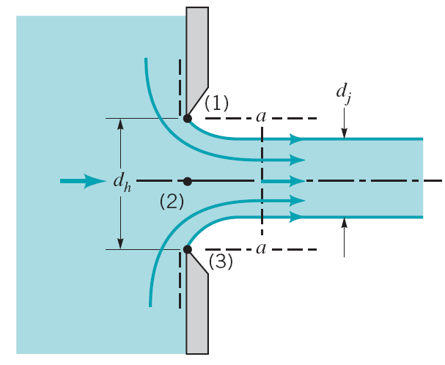

A smooth, well-contoured nozzle (left) and a sharp corner (right)

The velocity profile of the left nozzle is not uniform due to differences in elevation, but in general $d≪h$ and we can safely use the centerline velocity, $V_{2}$, as a reasonable “average velocity.”

For the right nozzle with a sharp corner, $d_{j}$ will be less than $d_{h}$. This phenomenon, called a ***vena contracta*** effect, is a result of the inability of the fluid to turn the sharp 90° corner.

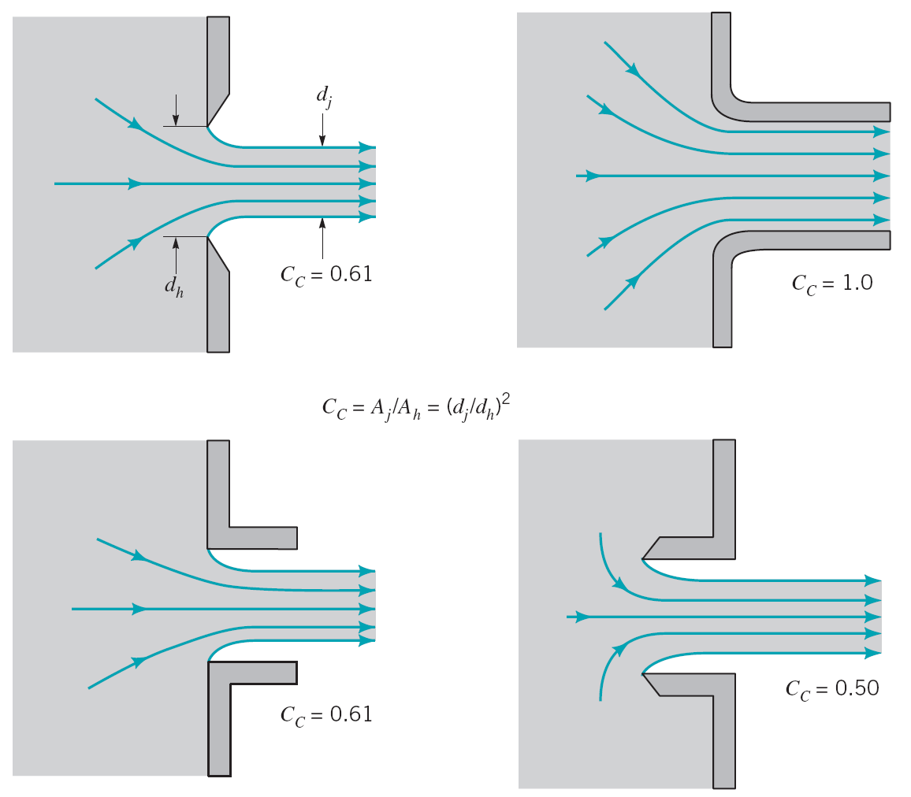

Figure 3.14 Typical flow patterns and contraction coefficients

The vena contracta effect is a function of the geometry of the outlet. Some typical configurations are shown in Fig. 3.14 along with typical values of the experimentally obtained contraction coefficient, $C_{C}={A_{j}}/{A_{h}}$, where $A_{j}$ and $A_{h}$ are the areas of the jet a the vena contracta and the area of the hole, respectively.

Other flow meters based on the Bernoulli equation are used to measure flowrates in open channels such as flumes and irrigation ditches. Two of these devices, the sluice gate and the sharp-crested weir, are discussed below under the assumption of steady, inviscid, incompressible flow.

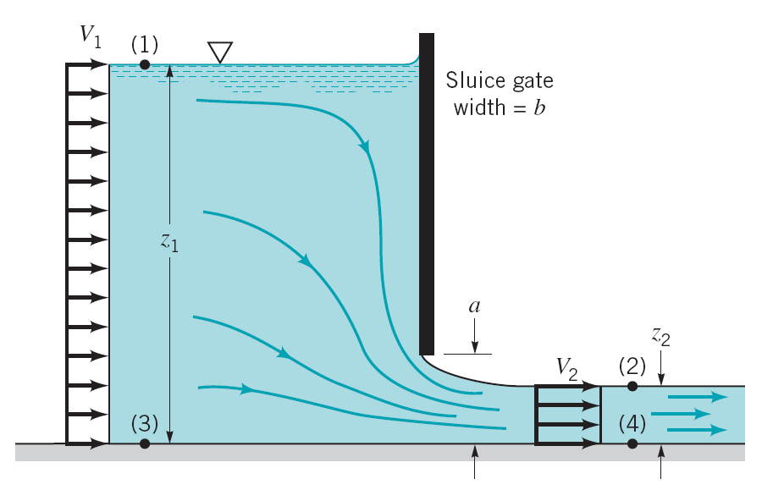

Sluice gate geometry

We apply the Bernoulli and continuity equations between points on the free surfaces at (1) and (2) to give:

$$p_{1}+\frac{1}{2}ρV_{1}^{2}+γz_{1}=p_{2}+\frac{1}{2}ρV_{2}^{2}+γz_{2}$$

and

$$Q=V_{1}A_{1}=bV_{1}z_{1}=V_{2}A_{2}=bV_{2}z_{2}$$

With the fact that $p_{1}=p_{2}=0$:

$$Q=z_{2}b\sqrt{\frac{2g\left(z_{1}-z_{2}\right)}{1-{\left({z_{2}}/{z_{1}}\right)}^{2}}}$$

In the limit of $z_{1}≫z_{2}$:

$$Q=z_{2}b\sqrt{2gz_{1}}$$

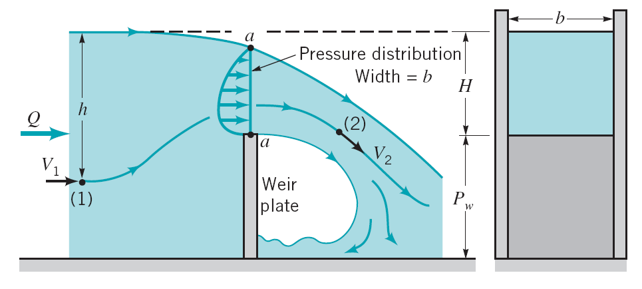

Rectangular, sharp-crested weir geometry

For such devices the flowrate of liquid over the top of the weir plate is dependent on the weir height, $P_{w}$, the width of the channel, $b$, and the head, $H$, of the water above the top of the weir. Between points (1) and (2) the pressure and gravitational fields cause the fluid to accelerate from velocity $V_{1}$ to velocity $V_{2}$. At (1) the pressure is $p_{1}=γh$, while at (2) the pressure is essentially atmospheric, $p_{2}=0$. Across the curved streamlines directly above the top of the weir plate (section *a*–*a*), the pressure changes from atmospheric on the top surface to some maximum value within the fluid stream and then to atmospheric again at the bottom surface.

For now, we will take a very simple approach and assume that the weir flow is similar in many respects to an orifice-type flow with a free streamline. In this instance we would expect the average velocity across the top of the weir to be proportional to $\sqrt{2gH}$ and the flow area for this rectangular weir to be proportional to $Hb$. Hence, it follows that

$$Q=C_{1}Hb\sqrt{2gH}=C_{1}b\sqrt{2g}H^{\frac{3}{2}}$$

## 3.7 Energy grade line (EGL) and hydraulic grade line (HGL)

In this chapter, we neglect losses and/or minor losses, and energy input or output by pumps or turbines:

$h_{L}=0$, $h_{p}=0$, $h_{t}=0$

$$\frac{p_{1}}{γ}+\frac{V_{1}^{2}}{2g}+z_{1}=\frac{p_{2}}{γ}+\frac{V_{2}^{2}}{2g}+z_{2}$$

Define

$\left.\begin{aligned}HGL=\frac{p}{γ}+z \\ EGL=\frac{p}{γ}+z+\frac{V^{2}}{2g}\end{aligned}\right\}$ point-by point application is graphically displayed

HGL corresponds to pressure tap measurement + $z$

EGL corresponds to stagnation tube measurement + $z$

$EGL=HGL$ if $V=0$

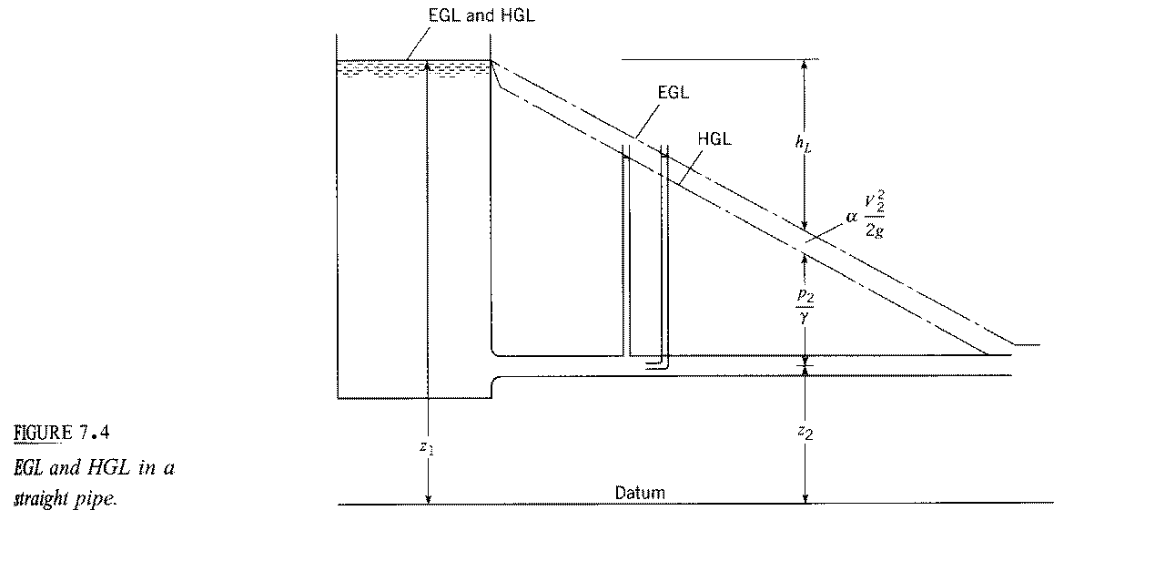

$h_{L}=f\frac{L}{D}\frac{V^{2}}{2g}$

i.e., linear variation in $L$ for $D$, $V$, and $f$ constant

$f$ = friction factor

$f$ = $f\left(Re\right)$

$$EGL_{1}=EGL_{2}+h_{L}$$

for $h_{p}=h_{t}=0$

Pressure tap: $\frac{p_{2}}{γ}=h$

Stagnation tube: $\frac{p_{2}}{γ}+\frac{V_{2}^{2}}{2g}=h$

Helpful hints for drawing and

1. for

2.

3. for change in $D$ $⇒$ change in $V$

i.e.

$\left.\begin{aligned}V_{1}A_{1}=V_{2}A_{2} \\ V_{1}\frac{πD_{1}^{2}}{4}=V_{2}\frac{πD_{2}^{2}}{4} \\ V_{1}D_{1}^{2}=V_{2}D_{2}^{2}\end{aligned}\right\}⇒$

Change in distance between $HGL$& $EGL$ and slope change due to change in

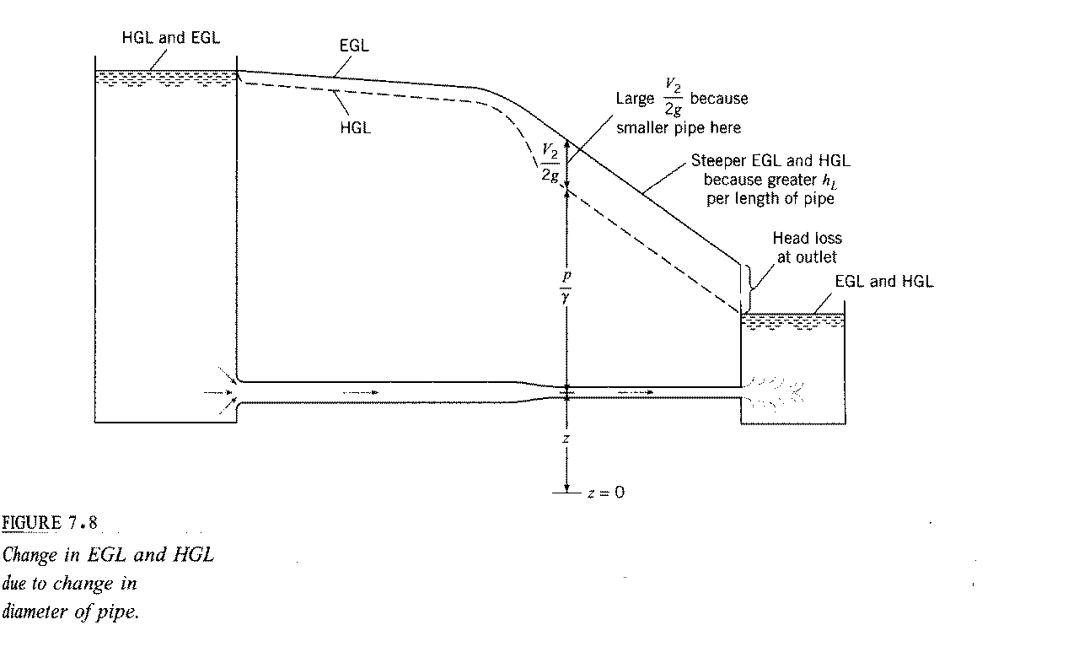

4. If then $p/γ<0$ i.e., cavitation possible

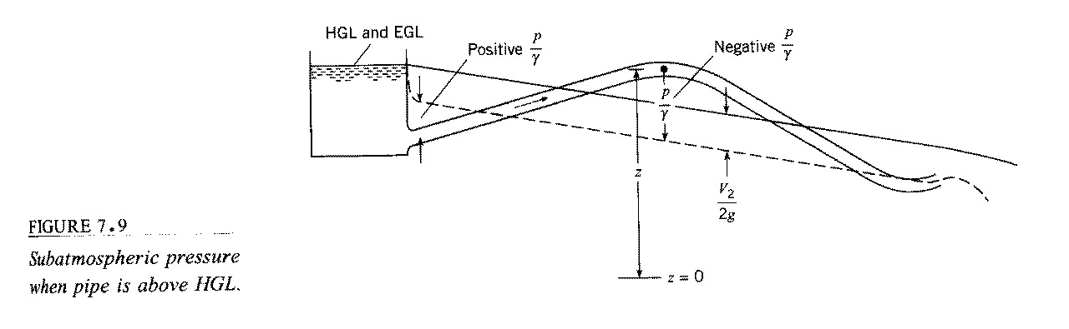

Condition for cavitation:

$$p=p_{va}=2000N/{m^{2}}$$

Gage pressure $p_{va,g}=p_{va}-p_{atm}≈-p_{atm}=-100,000N/{m^{2}}$

$$\frac{p_{va,g}}{γ}≈-10m$$

where $γ=9810N/{m^{2}}$

## 3.9 Limitations of Bernoulli Equation

Assumptions used in the derivation Bernoulli Equation:

1. Inviscid
2. Incompressible
3. Steady
4. Conservative body force

### 1) Compressibility Effects:

The Bernoulli equation can be modified for compressible flows. A simple, although specialized, case of compressible flow occurs when the temperature of a perfect gas remains constant along the streamline—isothermal flow. Thus, we consider $p=ρRT$, where $T$ is constant (In general, $p$, $ρ$, and $T$ will vary). An equation similar to the Bernoulli equation can be obtained for isentropic flow of a perfect gas. For steady, inviscid, isothermal flow, Bernoulli equation becomes

$$RT\int{\frac{dp}{p}}+\frac{1}{2}V^{2}+gz=const$$

The constant of integration is easily evaluated if $z_{1}$, $p_{1}$, and $V_{1}$ are known at some location on the streamline. The result is

$$\frac{V_{1}^{2}}{2g}+z_{1}+\frac{RT}{g}\ln\left(\frac{p_{1}}{p_{2}}\right)=\frac{V_{2}^{2}}{2g}+z_{2}$$

### 2) Unsteady Effects:

The Bernoulli equation can be modified for unsteady flows. With the inclusion of the unsteady effect (${∂V}/{∂t}≠0$) the following is obtained:

$ρ\frac{∂V}{∂t}ds+dp+\frac{1}{2}ρd\left(V^{2}\right)+γdz=0$ (along a streamline)

For incompressible flow this can be easily integrated between points (1) and (2) to give

$p_{1}+\frac{1}{2}ρV_{1}^{2}+γz_{1}=ρ\int_{s_{1}}^{s_{2}}{\frac{∂V}{∂t }ds}+p_{2}+\frac{1}{2}ρV_{2}^{2}+γz_{2}$ (along a streamline)

### 3) Rotational Effects

Care must be used in applying the Bernoulli equation across streamlines. If the flow is “irrotational” (i.e., the fluid particles do not “spin” as they move), it is appropriate to use the Bernoulli equation across streamlines. However, if the flow is “rotational” (fluid particles “spin”), use of the Bernoulli equation is restricted to flow along a streamline.

### 4) Other Restrictions

Another restriction on the Bernoulli equation is that the flow is inviscid. The Bernoulli equation is actually a first integral of Newton's second law along a streamline. This general integration was possible because, in the absence of viscous effects, the fluid system considered was a conservative system. The total energy of the system remains constant. If viscous effects are important the system is nonconservative and energy losses occur. A more detailed analysis is needed for these cases.

The Bernoulli equation is not valid for flows that involve pumps or turbines. The final basic restriction on use of the Bernoulli equation is that there are no mechanical devices (pumps or turbines) in the system between the two points along the streamline for which the equation is applied. These devices represent sources or sinks of energy. Since the Bernoulli equation is actually one form of the energy equation, it must be altered to include pumps or turbines, if these are present.