Chapter 3: Pressure and Fluid Statics

3.1 Pressure

For a static fluid, the only stress is the normal stress since by definition a fluid subjected to a shear stress must deform and undergo motion. Normal stresses are referred to as pressure p.

For the general case, the stress on a fluid element or at a point is a tensor
τ_{ij} = stress tensor

= τ_{xx} τ_{xy} τ_{xz}
τ_{yx} τ_{yy} τ_{yz}
τ_{zx} τ_{zy} τ_{zz}
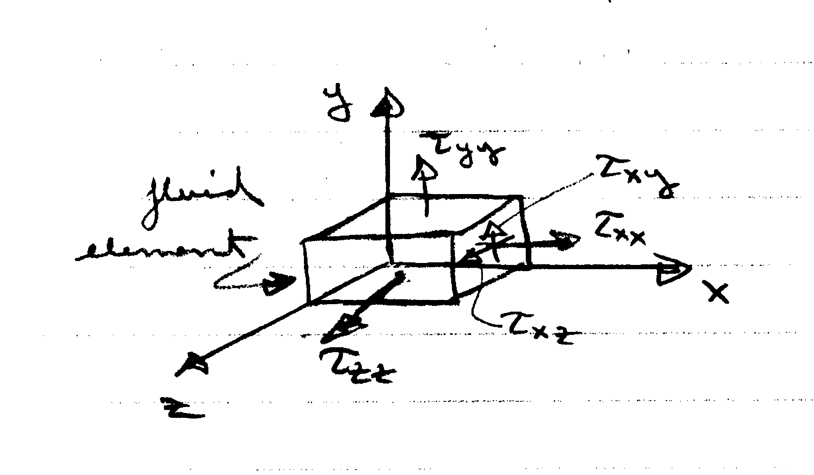

i = force
j = direction
For a static fluid,
τ_{ij} = 0 i≠j shear stresses = 0

τ_{ii} = −p = τ_{xx} = τ_{yy} = τ_{zz} i = j normal stresses = p

Also shows that p is isotropic, one value at a point which is independent of direction, a scalar.

Definition of Pressure:

N/m² = Pa (Pascal)
F = normal force acting over A

As already noted, p is a scalar, which can be easily demonstrated by considering the equilibrium of forces on a wedge-shaped fluid element

Geometry
ΔA = Δ Δy
Δx = Δcosα
Δz = Δsinα

W = mg
= ρVg
= γV
V = ½ ΔxΔzΔy

ΣF_{x} = 0
p_{n}ΔA sin α - p_{x}ΔA sin α = 0
p_{n} = p_{x}

ΣF_{z} = 0
-p_{n}ΔA cos α + p_{z}ΔA cos α - W = 0
$W=\frac{γ}{2}(Δℓ\text{cos}α)(Δℓ\text{sin}α)Δy$
Δx
Δz
$$−p_{n}+p_{z}−\frac{g}{2}Dl\text{sin}α=0$$
$p_{n}=p_{z}\text{for}Dl→0$
i.e., p_{n} = p_{x} = p_{y} = p_{z}

p is single valued at a point and independent of direction since arbitrary and independent p_{n} of

A body/surface in contact with a static fluid experiences a force due to p
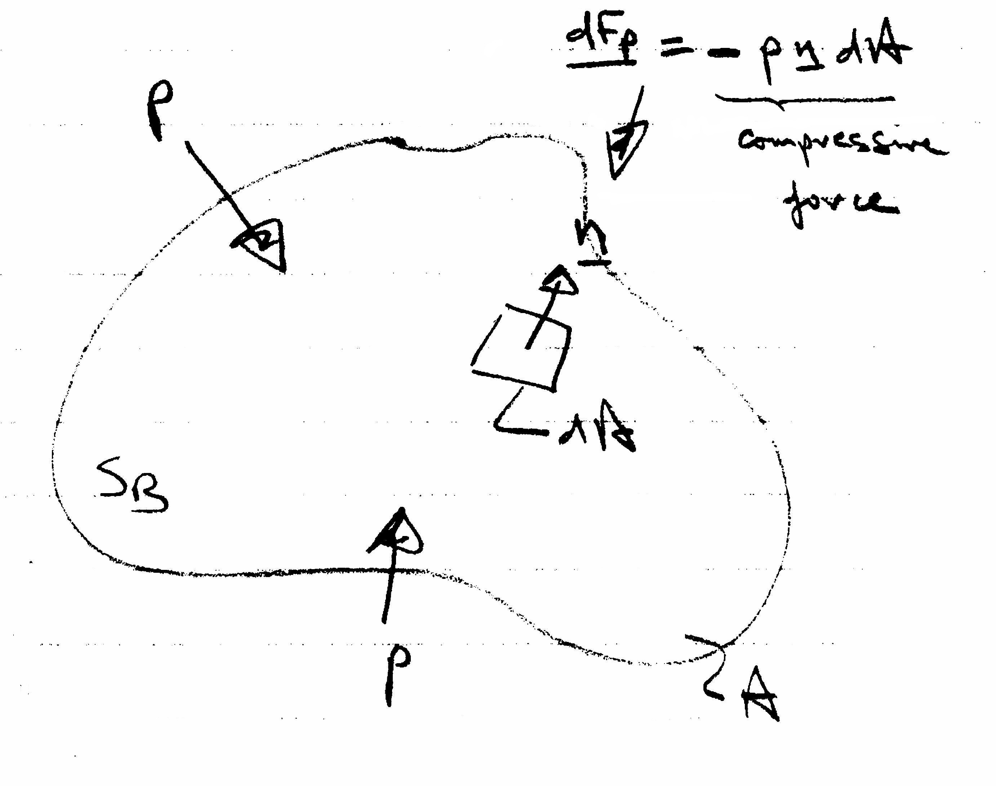
$${\underline{F}}_{p}=−\int_{S_{B}}{p\underline{n}\text{dA}}$$

Note: if p = constant, F_{p} = 0 for a closed body

Scalar form of Green's Theorem:
f = constant ⇒∇f = 0

Pressure Transmission

Pascal's law: in a closed system, a pressure change produced at one point in the system is transmitted throughout the entire system.

Absolute Pressure, Gage Pressure, and Vacuum

p_{A} < p_{a}
p_{g} < 0
p_{g} > 0
p_{A} > p_{a}
p_{a} = atmospheric
pressure =
101.325 kPa
p_{A} = 0 = absolute
zero

For p_{A}>p_{a}, p_{g} = p_{A} – p_{a} = gage pressure

For p_{A}<p_{a}, p_{vac} = -p_{g} = p_{a} – p_{A} = vacuum pressure

3.2 Pressure Variation with Elevation

Basic Differential Equation

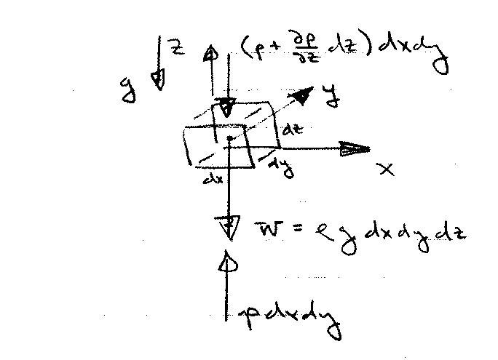
For a static fluid, pressure varies only with elevation within the fluid. This can be shown by consideration of equilibrium of forces on a fluid element
1st order Taylor series estimate for pressure variation over dz

Newton's law (momentum principle) applied to a static fluid
ΣF = ma = 0 for a static fluid
i.e., ΣF_{x} = ΣF_{y} = ΣF_{z} = 0

ΣF_{z} = 0
$\frac{¶p}{¶z}\text{=-}ρg\text{=-}g$
Basic equation for pressure variation with elevation
$\begin{aligned}\sum{F_{y}=0} \\ \text{pdxdz}−(p+\frac{∂p}{∂y}\text{dy})\text{dxdz}=0 \\ \frac{∂p}{∂y}=0\end{aligned}$ $\begin{aligned}\sum{F_{x}=0} \\ \text{pdydz}−(p+\frac{∂p}{∂x}\text{dx})\text{dydz}=0 \\ \frac{∂p}{∂x}=0\end{aligned}$

For a static fluid, the pressure only varies with elevation z and is constant in horizontal xy planes.

The basic equation for pressure variation with elevation can be integrated depending on whether ρ = constant or ρ = ρ(z), i.e., whether the fluid is incompressible (liquid or low-speed gas) or compressible (high-speed gas) since
g ∼ constant

Pressure Variation for a Uniform-Density Fluid
$\frac{¶p}{¶z}\text{=-}ρg\text{=-}g$
Z
g
ρ = constant for liquid
Alternate forms:
constant
constant piezometric pressure
gage
increase linearly with depth
decrease linearly with height
i.e.,
constant piezometric head
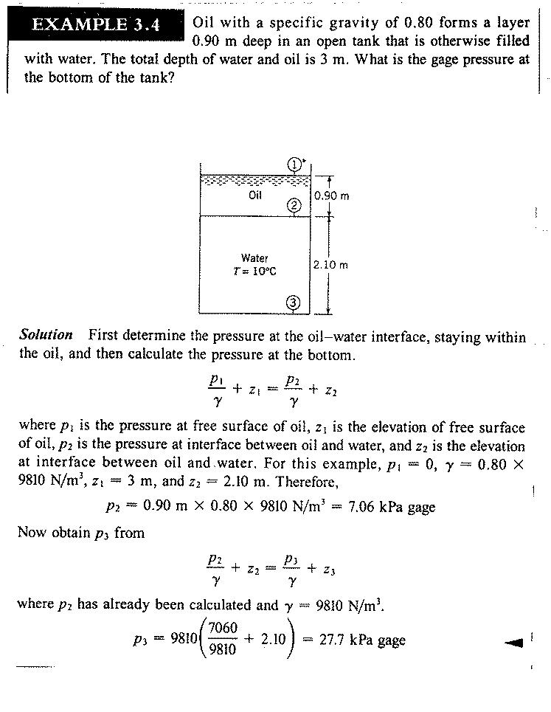
7.06
27.7
Pressure Variation for Compressible Fluids:

Basic equation for pressure variation with elevation

$$\frac{\text{dp}}{\text{dz}}=−γ=−γ(p,z)=ρg$$
Pressure variation equation can be integrated for γ(p,z) known. For example, here we solve for the pressure in the atmosphere assuming ρ(p,T) given from ideal gas law, T(z) known, and g ≠ g(z).
dry air
p = ρRT R = gas constant = 287 J/kg ⋅°K
p,T in absolute scale

$\frac{\text{dp}}{\text{dz}}=−\frac{\text{pg}}{\text{RT}}$

$\frac{\text{dp}}{p}=\frac{−g}{R}\frac{\text{dz}}{T(z)}$ which can be integrated for T(z) known

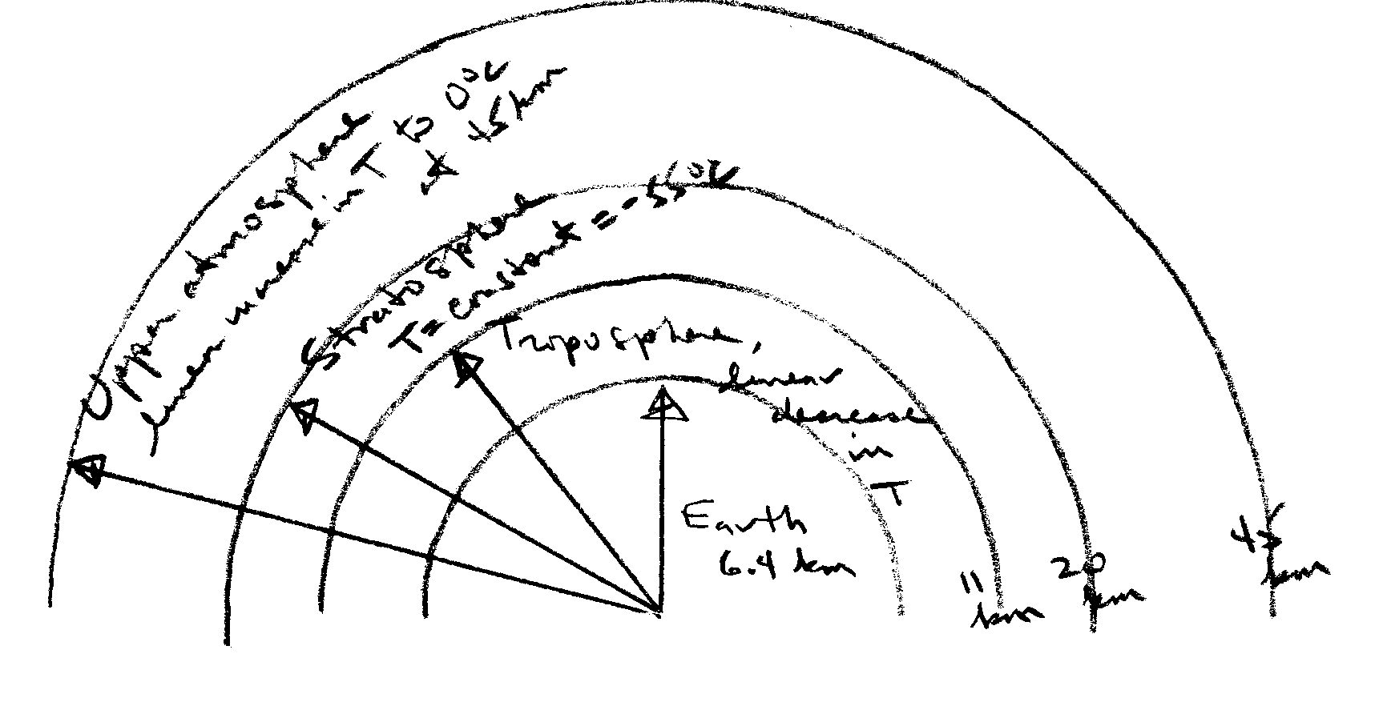

Pressure Variation in the Troposphere

T = T_{o} − α(z – z_{o}) linear decrease

T_{o} = T(z_{o}) where p = p_{o}(z_{o}) known
α = lapse rate = 6.5 °K/km

$\frac{\text{dp}}{p}=−\frac{g}{R}\frac{\text{dz}}{[T_{o}−α(z−z_{o})]}$ $\begin{aligned}z'=T_{o}−α(z−z_{o}) \\ \text{dz}'=α\text{dz}\end{aligned}$

$$\text{ln}p=\frac{g}{αR}\text{ln}[T_{o}−α(z−z_{o})] + \text{constant}$$
z_{o} = earth surface
= 0

p_{o} = 101.3 kPa

T = 15°C

α = 6.5 °K/km
use reference condition

$$\text{ln}p_{o}=\frac{g}{αR}\text{ln}T_{o} + \text{constant}$$

solve for constant

$$\begin{aligned}\text{ln}\frac{p}{p_{o}}=\frac{g}{αR}\text{ln}\frac{T_{o}−α(z−z_{o})}{T_{o}} \\ \\ \frac{p}{p_{o}}={\left[\frac{T_{o}−α(z−z_{o})}{T_{o}}\right]}^{g/αR}\end{aligned}$$

i.e., p decreases for increasing z

Pressure Variation in the Stratosphere

T = T_{s} = −55°C

$\text{ln}p=−\frac{g}{{\text{RT}}_{s}}z + \text{constant}$

use reference condition to find constant

$\begin{aligned}\frac{p}{p_{o}}=e^{−(z−z_{0})g/{{\text{RT}}_{s}}} \\ \\ p=p_{o}\text{exp}[−(z−z_{o})g/{{\text{RT}}_{s}}]\end{aligned}$

i.e., p decreases exponentially for increasing z.

3.3 Pressure Measurements

Pressure is an important variable in fluid mechanics and many instruments have been devised for its measurement. Many devices are based on hydrostatics such as barometers and manometers, i.e., determine pressure through measurement of a column (or columns) of a liquid using the pressure variation with elevation equation for an incompressible fluid.
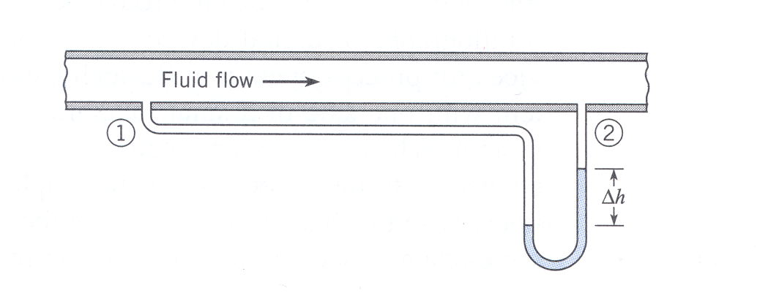
Differential manometer

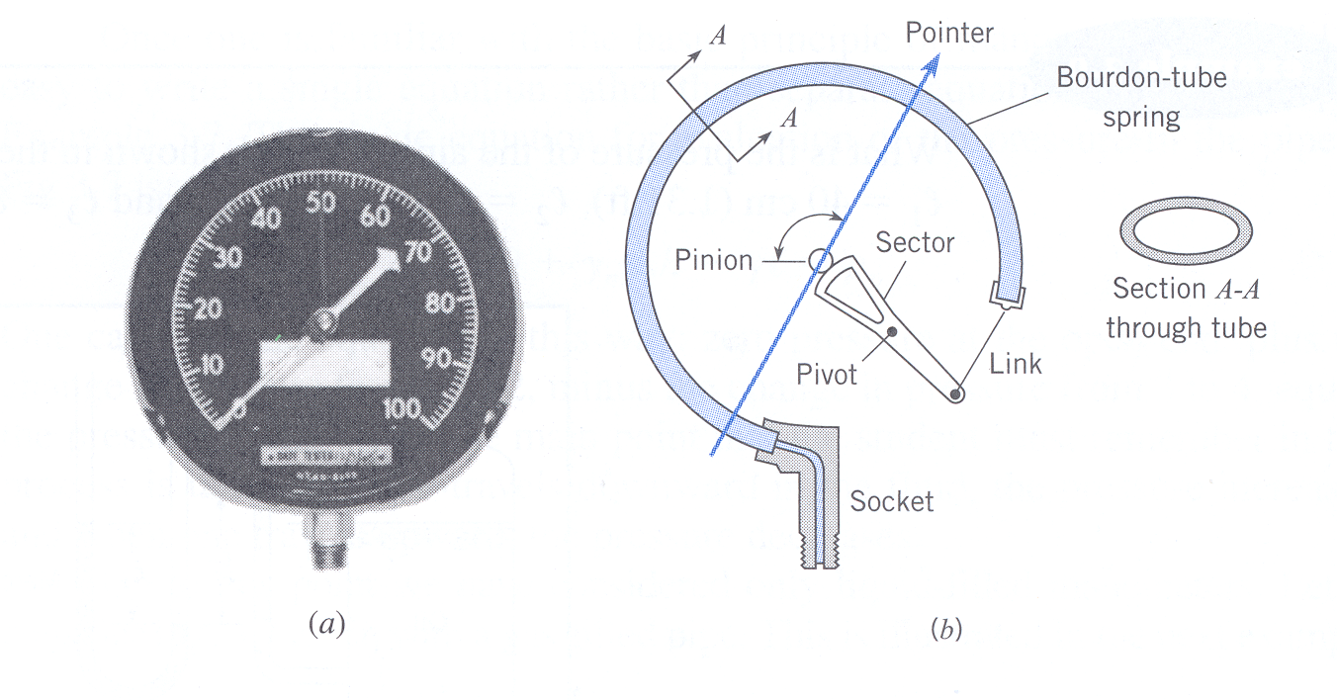
More modern devices include Bourdon-Tube Gage (mechanical device based on deflection of a spring) and pressure transducers (based on deflection of a flexible diaphragm/membrane). The deflection can be monitored by a strain gage such that voltage output is ∝ Δp across diaphragm, which enables electronic data acquisition with computers.

Bourdon-Tube Gage

In this course we will use both manometers and pressure transducers in EFD labs 2 and 3.

Manometry
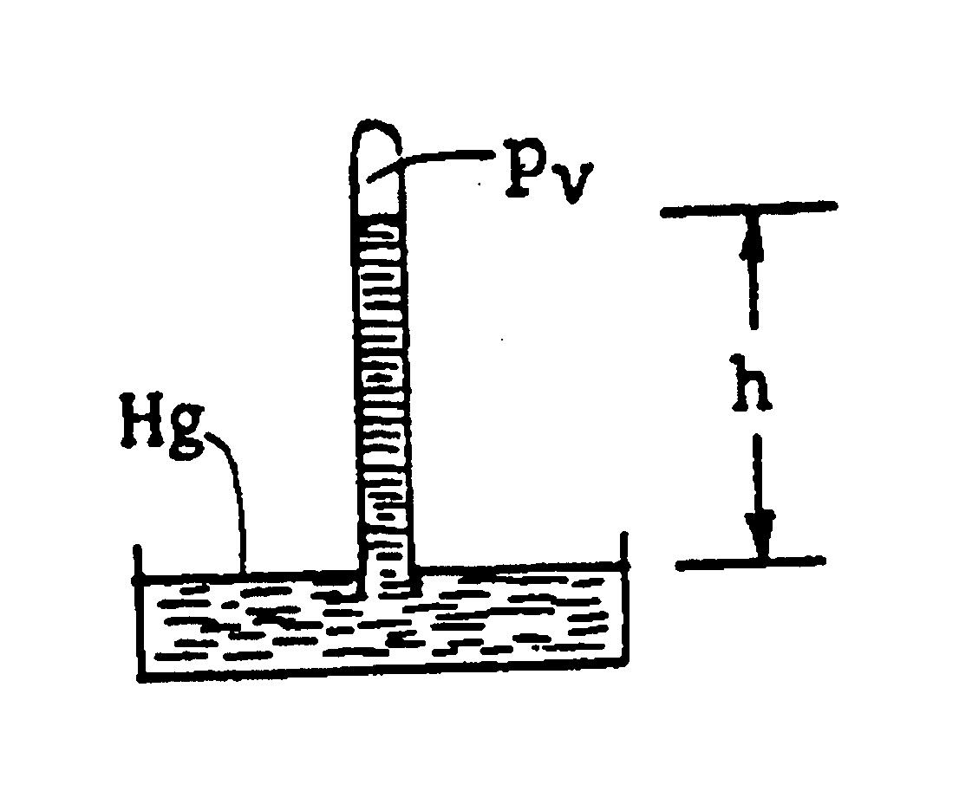
- Barometer

p_{v} + γ_{Hg}h = p_{atm}

p_{atm} = γ_{Hg}h p_{v} ∼ 0 i.e., vapor pressure Hg
nearly zero at normal T
h ∼ 76 cm
∴ p_{atm} ∼ 101 kPa (or 14.6 psia)

Note: p_{atm} is relative to absolute zero, i.e., absolute pressure. p_{atm} = p_{atm}(location, weather)

Consider why water barometer is impractical
$γ_{\text{Hg}}h_{\text{Hg}}=γ_{H_{2}O}h_{H_{2}O}$

$$h_{H_{2}O}=\frac{γ_{\text{Hg}}}{γ_{H_{2}O}}h_{\text{Hg}}=S_{\text{Hg}}h_{\text{Hg}}=\text{13}\text{.}6 × \text{76}= \text{1033}\text{.}6 \text{cm}=\text{34} \text{ft}\text{.}$$
- Piezometer
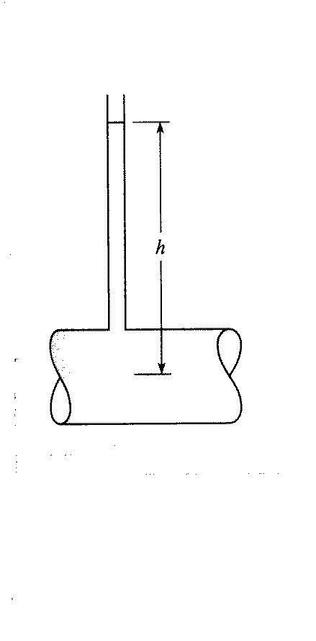
p_{atm}

p_{atm} + γh = p_{pipe} = p absolute

p = γh gage

Simple but impractical for large p and vacuum pressures (i.e., p_{abs} < p_{atm}). Also for small p and small d, due to large surface tension effects, could be corrected using , but accuracy may be problem if
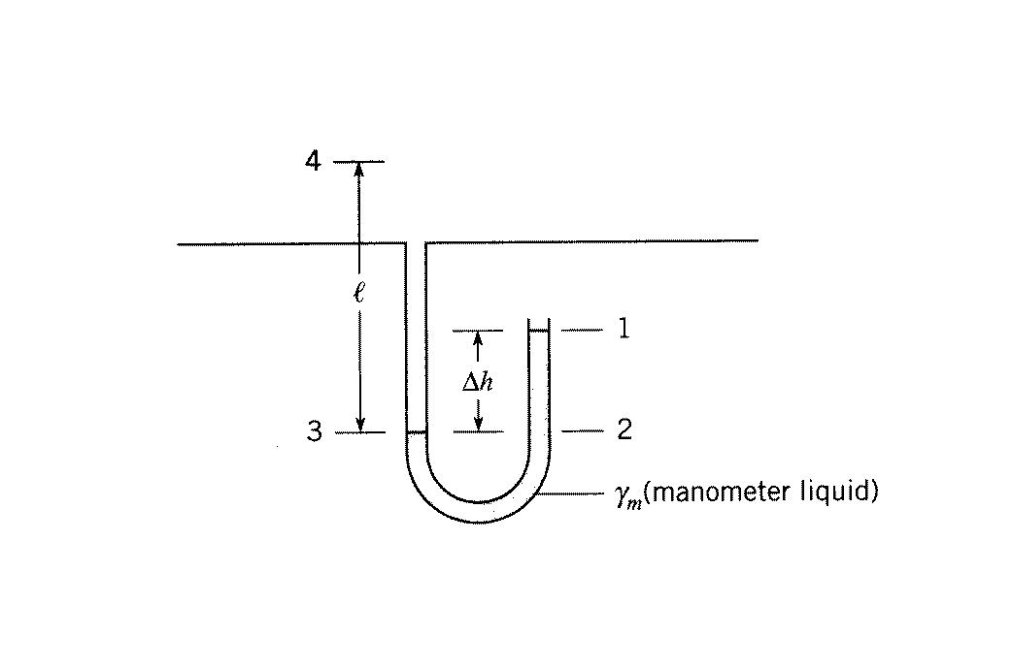
3. U-tube or differential manometer
γ

p_{atm}

p₁ + γ_{m}Δh − γl = p₄ p₁ = p_{atm}
p₄ = γ_{m}Δh − γl gage
= γ_{w}[S_{m}Δh − S l]
for gases S << S_{m} and can be neglected, i.e., can neglect Δp in gas compared to Δp in liquid in determining p₄ = p_{pipe}.
Example:
Air at 20 °C is in pipe with a water manometer. For given conditions compute gage pressure in pipe.
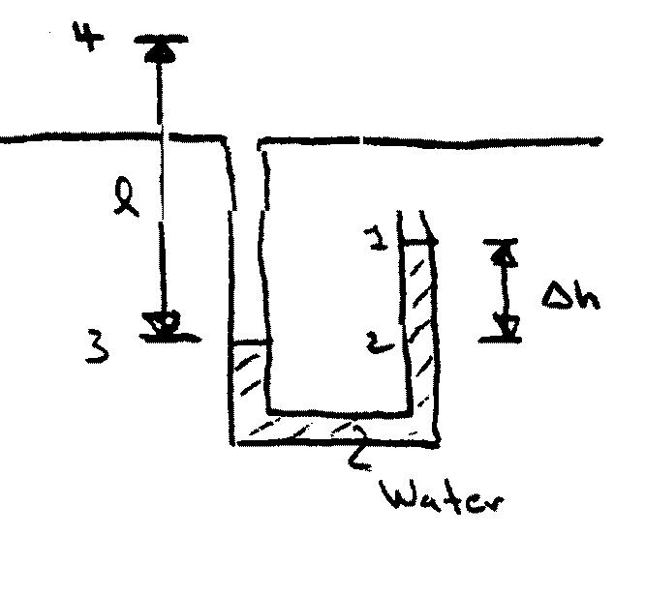
γ_{air}
l = 140 cm
Δh = 70 cm

p₄ = ? gage (i.e., p₁ = 0)
Pressure same at 2&3 since same elevation & Pascal’s law: in closed system pressure change produce at one part transmitted throughout entire system

p₁ + γΔh = p₃ step-by-step method
p₃ - γ_{air}l = p₄
γΔh

p₁ + γΔh - γ_{air}l = p₄ complete circuit method
γΔh - γ_{air}l = p₄ gage

γ_{water}(20°C) = 9790 N/m³ ⇒ p₃ = γΔh = 6853 Pa [N/m²]
γ_{air} = ρg
p_{abs}
or could use Table A.3
$$ρ=\frac{p}{\text{RT}}=\frac{\left(p_{3}+p_{\text{atm}}\right)}{R\left(°C+\text{273}\right)}=\frac{\text{6853}+\text{101300}}{\text{287}(\text{20}+\text{273})}=1\text{.}\text{286} {\text{kg}}/{m^{3}}$$
°K
γ_{air} = 1.286 × 9.81m/s² = 12.62 N/m³

note γ_{air} << γ_{water}
p₄ = p₃ - γ_{air}l = 6853 – 12.62 × 1.4 = 6835 Pa
17.668
if neglect effect of air column p₄ = 6853 Pa
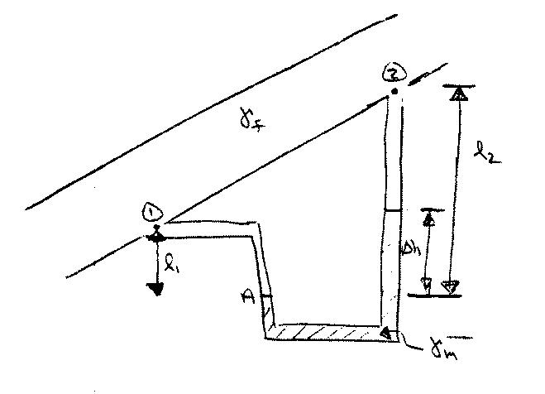
A differential manometer determines the difference in pressures at two points ①and ② when the actual pressure at any point in the system cannot be determined.

$$\left(\frac{p_{1}}{γ_{f}}+ℓ_{1}\right)−\left(\frac{p_{2}}{γ_{f}}+ℓ_{2}\right)=\left(\frac{γ_{m}}{γ_{f}}−1\right)Δh$$
difference in piezometric head

if fluid is a gas γ_{f} << γ_{m} : p₁ – p₂ = γ_{m}Δh

if fluid is liquid & pipe horizontal = :
p₁ – p₂ = (γ_{m} - γ_{f}) Δh

