Chapter 2: Pressure and Fluid Statics

Pressure

For a static fluid, the only stress is the normal stress since by definition a fluid subjected to a shear stress must deform and undergo motion. Normal stresses are referred to as pressure p.

For the general case, the stress on a fluid element or at a point is a tensor
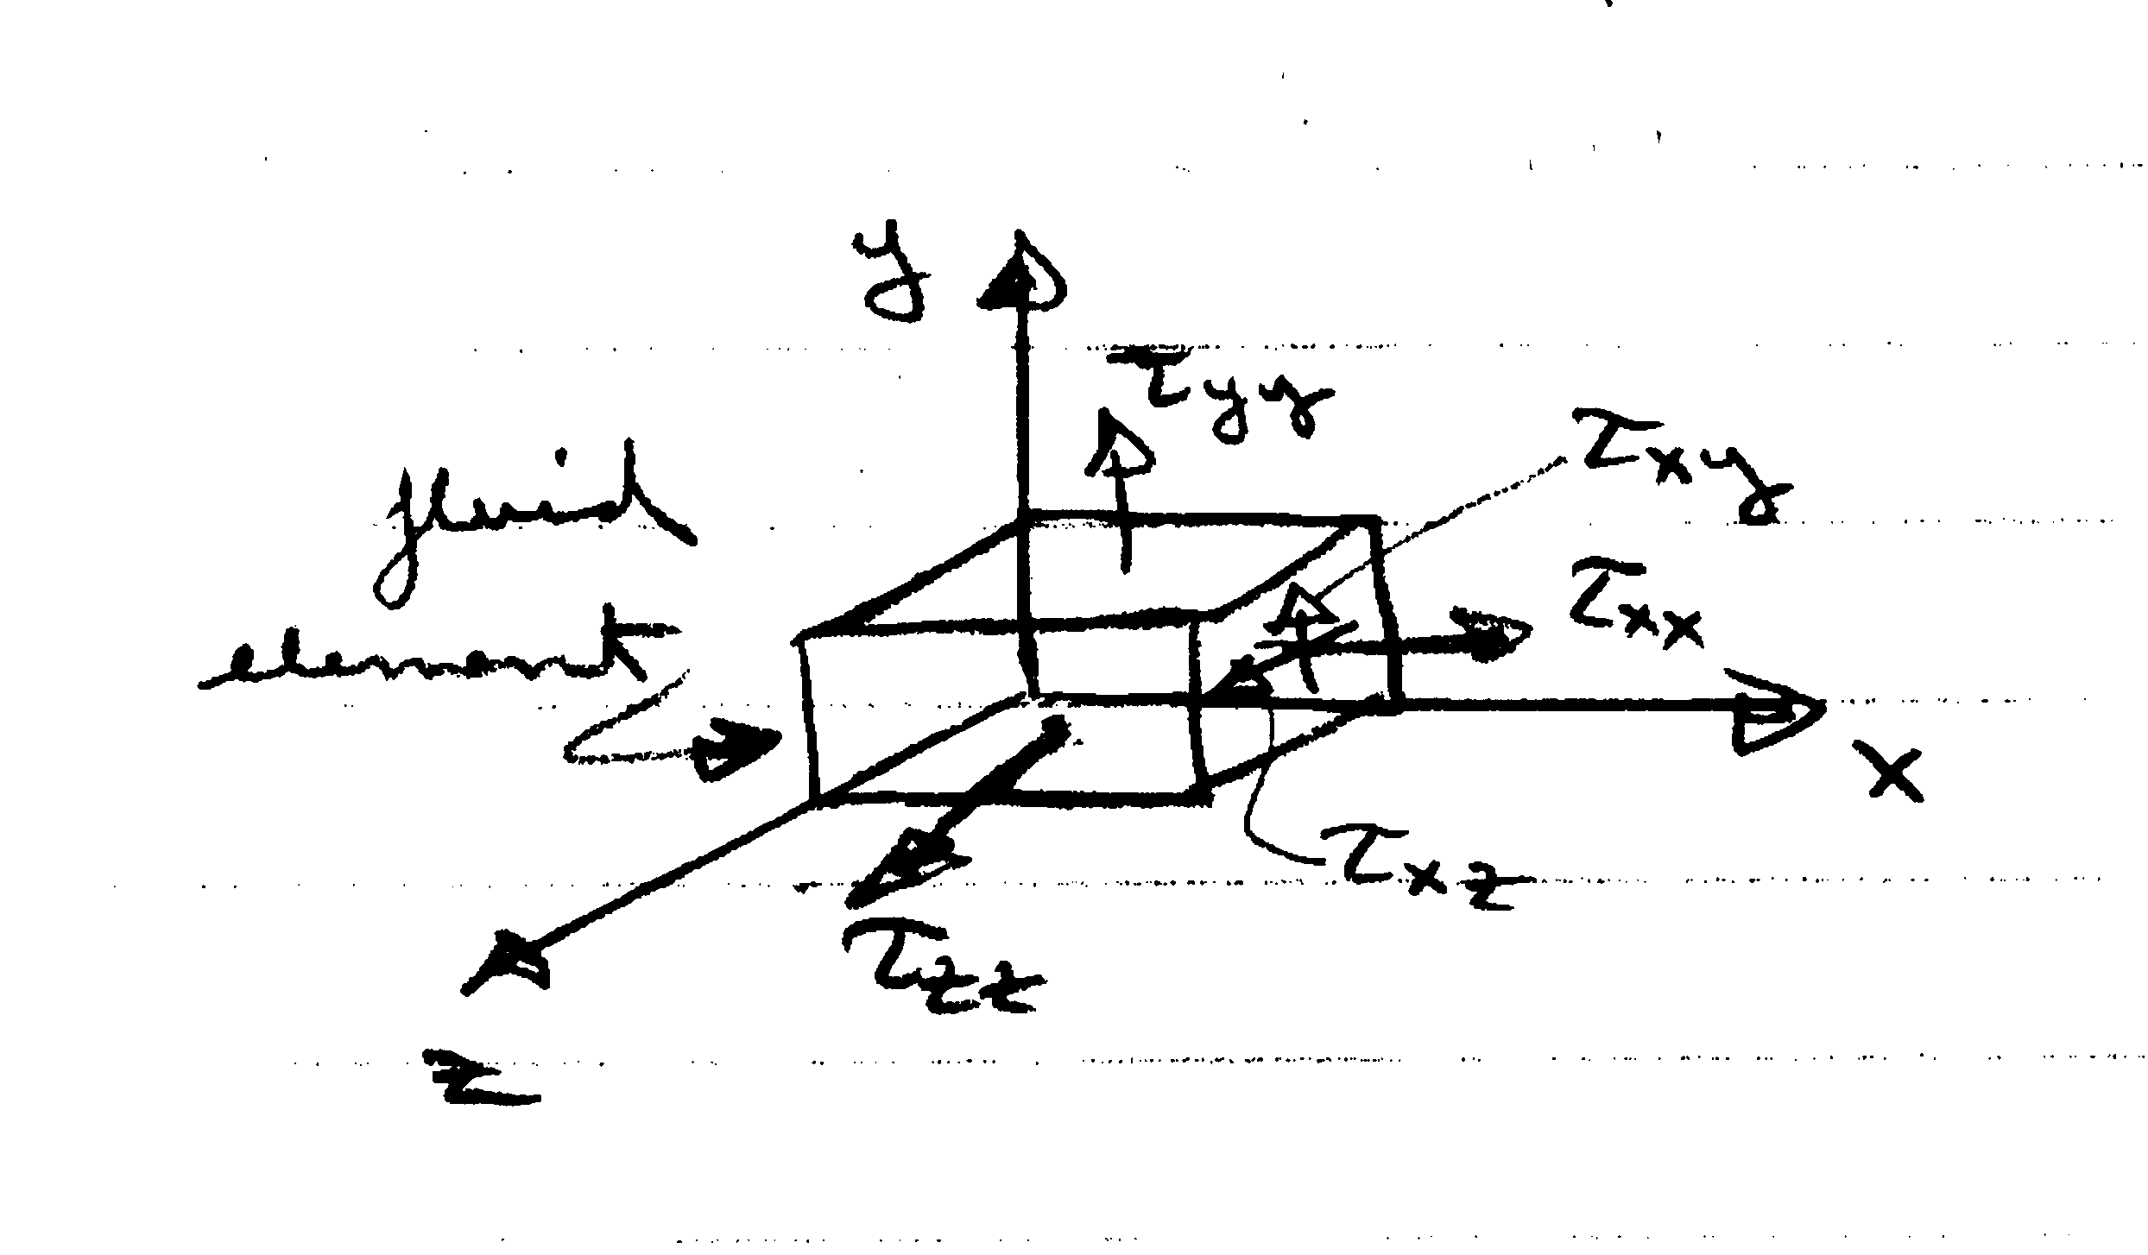
τ_{ij} = stress tensor*
= τ_{xx} τ_{xy} τ_{xz}
τ_{yx} τ_{yy} τ_{yz}
τ_{zx} τ_{zy} τ_{zz}
*Tensor: A mathematical object analogus to but more general than a vector, represented by an array of components that are functions of the coordinates of a space (Oxford)

i = face
j = direction

For a static fluid,
τ_{ij} = 0 i≠j shear stresses = 0

τ_{ii} = −p = τ_{xx} = τ_{yy} = τ_{zz} i = j normal stresses =-p

Also shows that p is isotropic, one value at a point which is independent of direction, a scalar.

Definition of Pressure:

N/m² = Pa (Pascal)
F = normal force acting over A

As already noted, p is a scalar, which can be easily demonstrated by considering the equilibrium of forces on a wedge-shaped fluid element
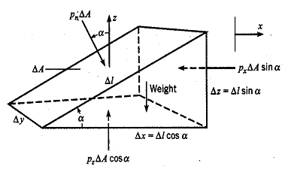

Geometry
ΔA = Δ Δy
Δx = Δcosα
Δz = Δsinα

ΣF_{x} = 0

W = mg
= ρVg
= γV
V = ½ ΔxΔzΔy
p_{n}ΔA sin α - p_{x}ΔA sin α = 0
p_{n} = p_{x}

ΣF_{z} = 0
-p_{n}ΔA cos α + p_{z}ΔA cos α - W = 0
$W=\frac{γ}{2}(Δℓ\text{cos}α)(Δℓ\text{sin}α)Δy$
Δx
Δz

$$−p_{n}ΔℓΔy\text{cos}α+p_{z}ΔℓΔy\text{cos}α−\frac{γ}{2}{Δℓ}^{2}\text{cos}α\text{sin}αΔy=0$$

$$−p_{n}+p_{z}−\frac{g}{2}Dl\text{sin}α=0$$
$p_{n}=p_{z}\text{for}Dl→0$
i.e., p_{n} = p_{x} = p_{y} = p_{z}

p is single valued at a point and independent of direction.

A body/surface in contact with a static fluid experiences a force due to p
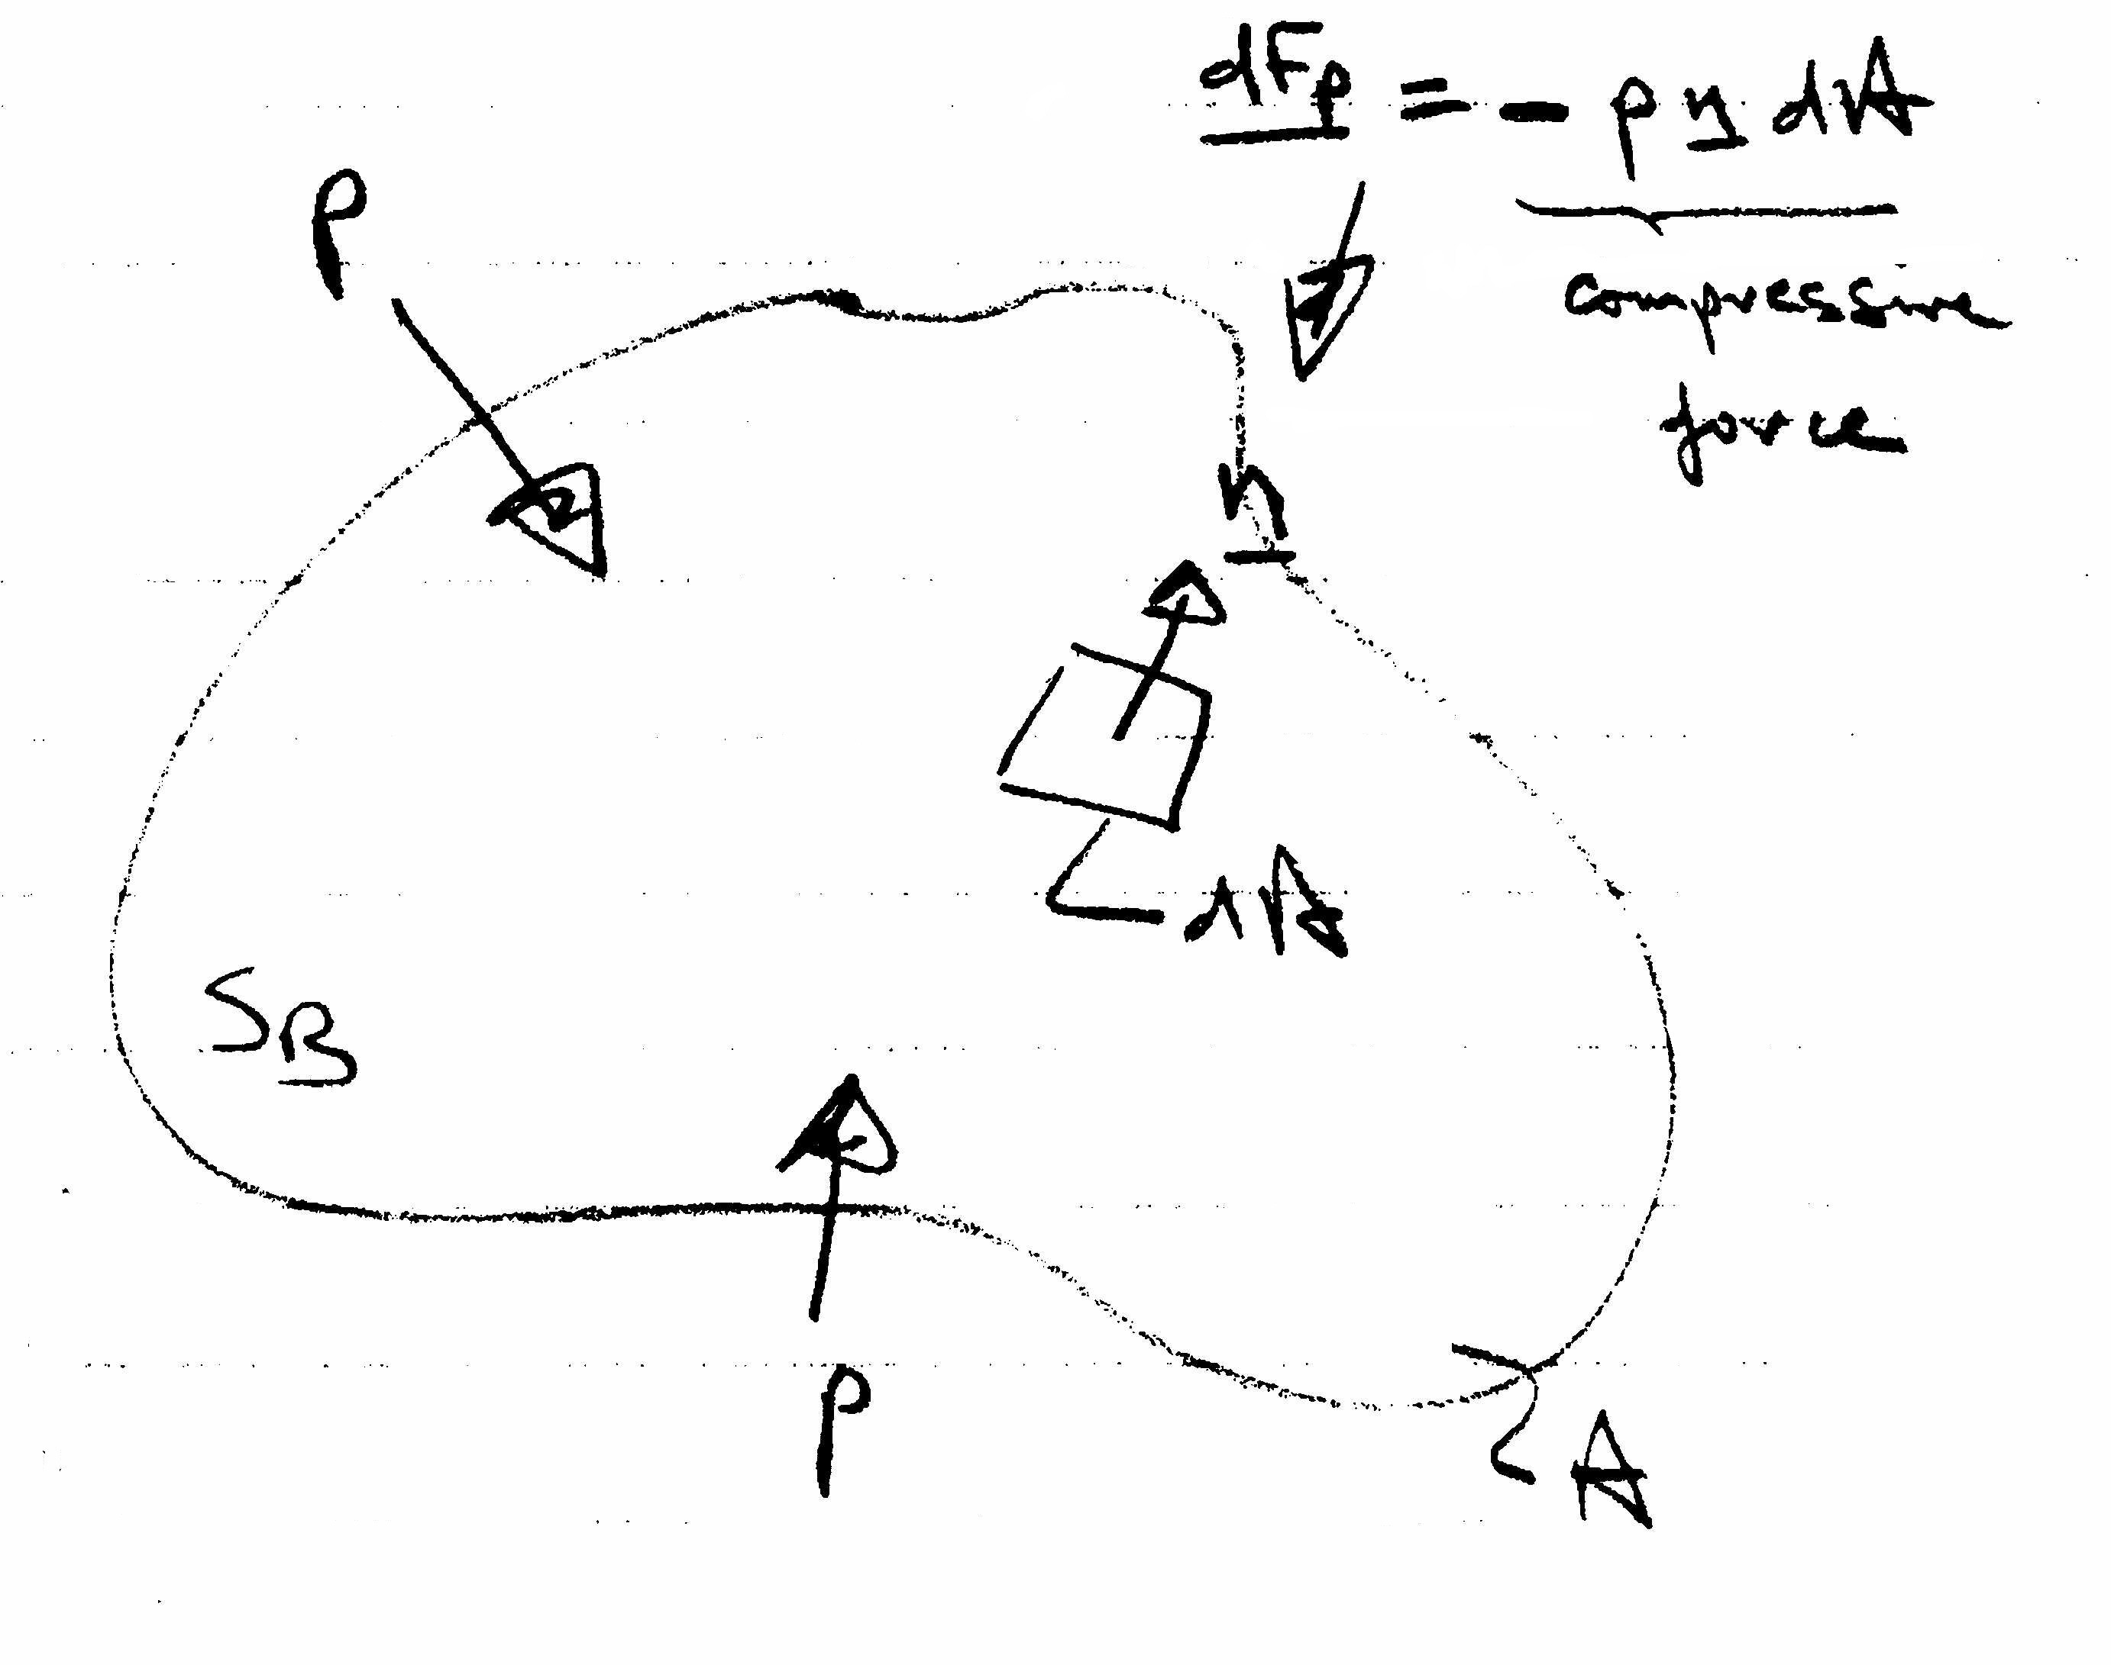
$${\underline{F}}_{p}=−\int_{S_{B}}{p\underline{n}\text{dA}}$$

Note: if p = constant, F_{p} = 0 for a closed body.

Scalar form of Green's Theorem:
f = constant ⇒∇f = 0

Pressure Transmission

Pascal's law: in a closed system, a pressure change produced at one point in the system is transmitted throughout the entire system.

Absolute Pressure, Gage Pressure, and Vacuum

p_{A} < p_{a}
p_{g} < 0
p_{g} > 0
p_{A} > p_{a}
p_{a} = atmospheric
pressure =
101.325 kPa
p_{A} = 0 = absolute
zero

For p_{A}>p_{a}, p_{g} = p_{A} – p_{a} = gage pressure

For p_{A}<p_{a}, p_{vac} = -p_{g} = p_{a} – p_{A} = vacuum pressure

Pressure Variation with Elevation

Basic Differential Equation

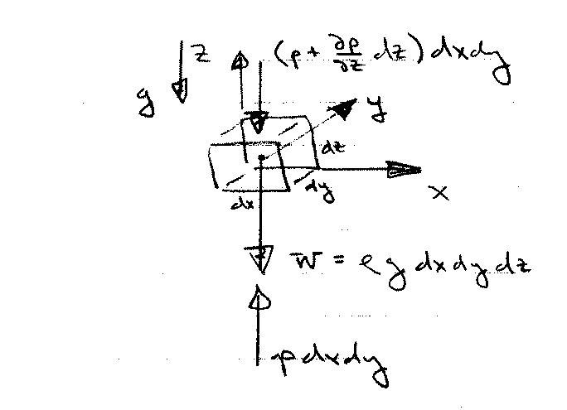
For a static fluid, pressure varies only with elevation within the fluid. This can be shown by consideration of equilibrium of forces on a fluid element
1st order Taylor series estimate for pressure variation over dz

Newton's law (momentum principle) applied to a static fluid
ΣF = ma = 0 for a static fluid
i.e., ΣF_{x} = ΣF_{y} = ΣF_{z} = 0

ΣF_{z} = 0
$\text{pdxdy}−(p+\frac{¶p}{¶z}\text{dz})\text{dxdy}−ρ\text{gdxdydz}=0$ $\frac{¶p}{¶z}\text{=-}ρg\text{=-}g$
Basic equation for pressure variation with elevation
$\begin{aligned}\sum{F_{y}=0} \\ \text{pdxdz}−(p+\frac{∂p}{∂y}\text{dy})\text{dxdz}=0 \\ \frac{∂p}{∂y}=0\end{aligned}$ $\begin{aligned}\sum{F_{x}=0} \\ \text{pdydz}−(p+\frac{∂p}{∂x}\text{dx})\text{dydz}=0 \\ \frac{∂p}{∂x}=0\end{aligned}$

For a static fluid, the pressure only varies with elevation z and is constant in horizontal xy planes.

The basic equation for pressure variation with elevation can be integrated depending on whether ρ = constant or ρ = ρ(z), i.e., whether the fluid is incompressible (liquid or low-speed gas) or compressible (high-speed gas) since
g ∼ constant

Pressure Variation for a Uniform-Density Fluid
$\frac{¶p}{¶z}\text{=-}ρg\text{=-}g$
Z
g
ρ = constant for liquid
Alternate forms:
constant
constant piezometric pressure
gage
increase linearly with depth
decrease linearly with height
i.e.,
constant piezometric head
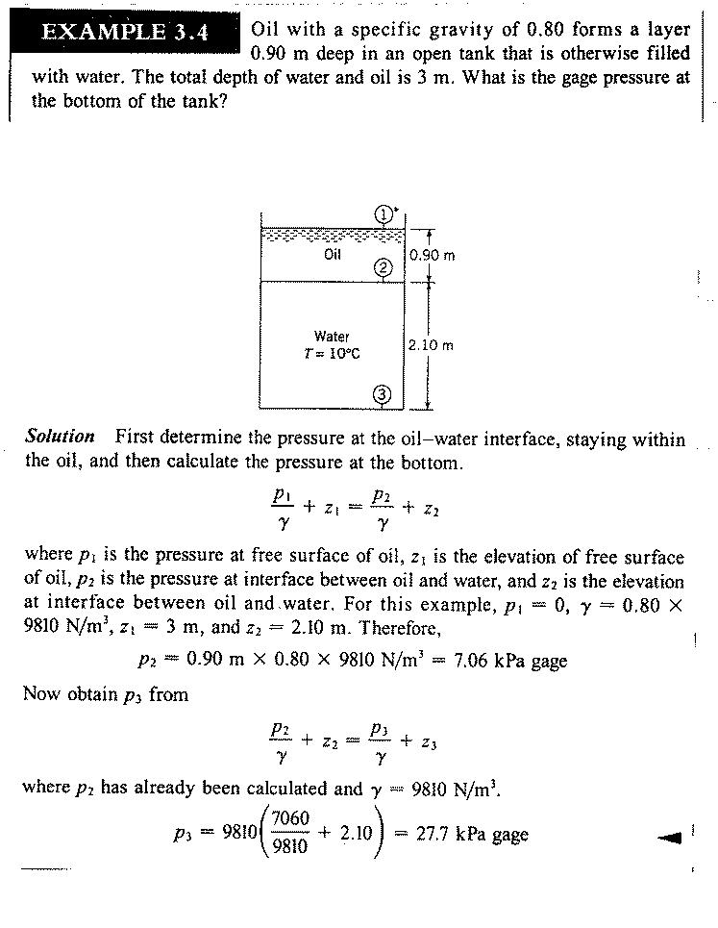
7.06
27.7
Pressure Variation for Compressible Fluids:

Basic equation for pressure variation with elevation

Pressure variation equation can be integrated for γ(p,z) known. For example, here we solve for the pressure in the atmosphere assuming ρ(p,T) given from ideal gas law, T(z) known, and g ≠ g(z).
dry air
p = ρRT R = gas constant = 287 J/kg ⋅°K
p,T in absolute scale

$\frac{\text{dp}}{\text{dz}}=−\frac{\text{pg}}{\text{RT}}$

$\frac{\text{dp}}{p}=\frac{−g}{R}\frac{\text{dz}}{T(z)}$ which can be integrated for T(z) known

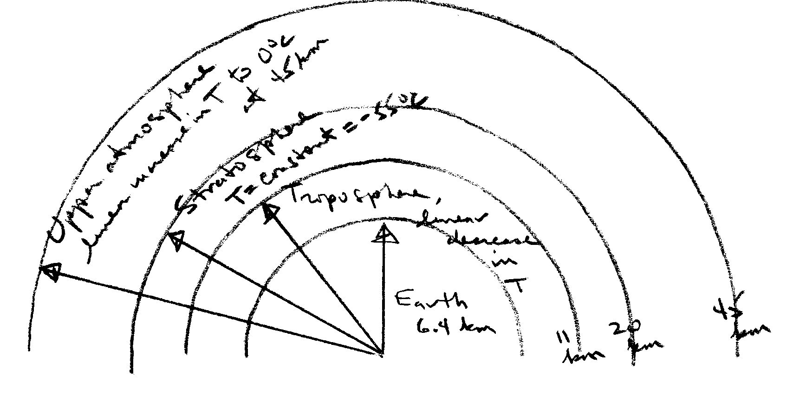

Pressure Variation in the Troposphere

T = T_{o} − α(z – z_{o}) linear decrease

T_{o} = T(z_{o}) where p = p_{o}(z_{o}) known
α = lapse rate = 6.5 °K/km

$\frac{\text{dp}}{p}=−\frac{g}{R}\frac{\text{dz}}{[T_{o}−α(z−z_{o})]}$ $\begin{aligned}z'=T_{o}−α(z−z_{o}) \\ \text{dz}'=α\text{dz}\end{aligned}$

$$\text{ln}p=\frac{g}{αR}\text{ln}[T_{o}−α(z−z_{o})] + \text{constant}$$
z_{o} = earth surface
= 0

p_{o} = 101.3 kPa

T = 15°C

α = 6.5 °K/km
use reference condition

$$\text{ln}p_{o}=\frac{g}{αR}\text{ln}T_{o} + \text{constant}$$

solve for constant

$$\begin{aligned}\text{ln}\frac{p}{p_{o}}=\frac{g}{αR}\text{ln}\frac{T_{o}−α(z−z_{o})}{T_{o}} \\ \\ \frac{p}{p_{o}}={\left[\frac{T_{o}−α(z−z_{o})}{T_{o}}\right]}^{g/αR}\end{aligned}$$

i.e., p decreases for increasing z

Pressure Variation in the Stratosphere

T = T_{s} = −55°C

$\frac{\text{dp}}{p}\text{=-}\frac{g}{R}\frac{\text{dz}}{T_{s}}$
$\text{ln}p=−\frac{g}{{\text{RT}}_{s}}z + \text{constant}$

use reference condition to find constant

$\begin{aligned}\frac{p}{p_{o}}=e^{−(z−z_{0})g/{{\text{RT}}_{s}}} \\ \\ p=p_{o}\text{exp}[−(z−z_{o})g/{{\text{RT}}_{s}}]\end{aligned}$

i.e., p decreases exponentially for increasing z.

Pressure Measurements

Pressure is an important variable in fluid mechanics and many instruments have been devised for its measurement. Many devices are based on hydrostatics such as barometers and manometers, i.e., determine pressure through measurement of a column (or columns) of a liquid using the pressure variation with elevation equation for an incompressible fluid.
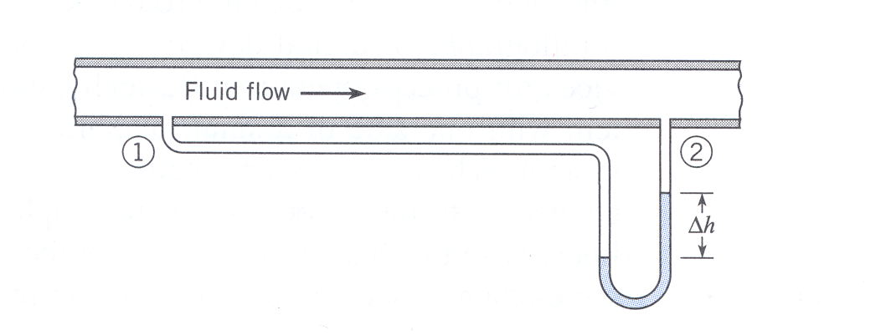
Differential manometer

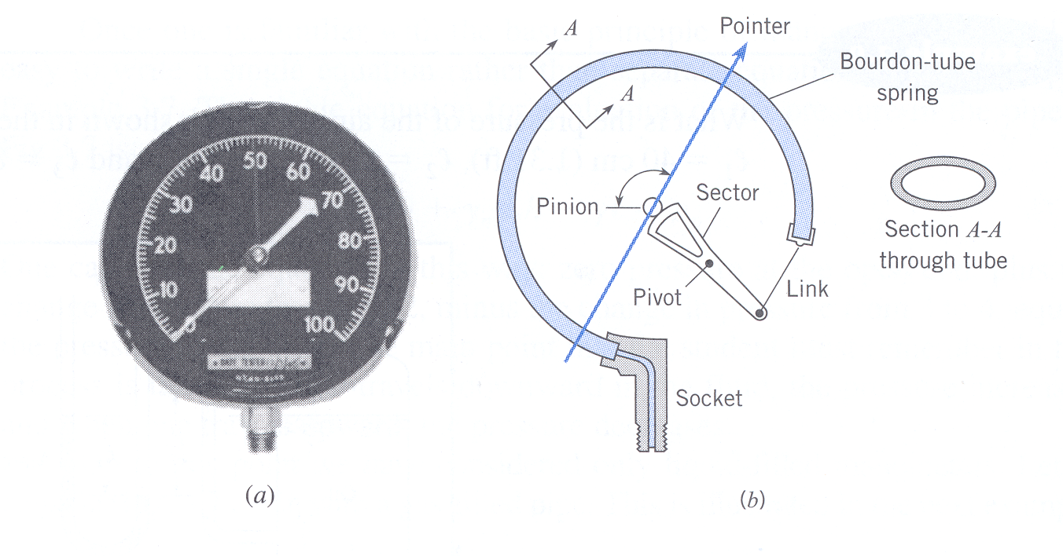
More modern devices include Bourdon-Tube Gage (mechanical device based on deflection of a spring) and pressure transducers (based on deflection of a flexible diaphragm/membrane). The deflection can be monitored by a strain gage such that voltage output is ∝ Δp across diaphragm, which enables electronic data acquisition with computers.

Bourdon-Tube Gage

In this course we will use both manometers and pressure transducers in EFD labs 2 and 3.

Manometry
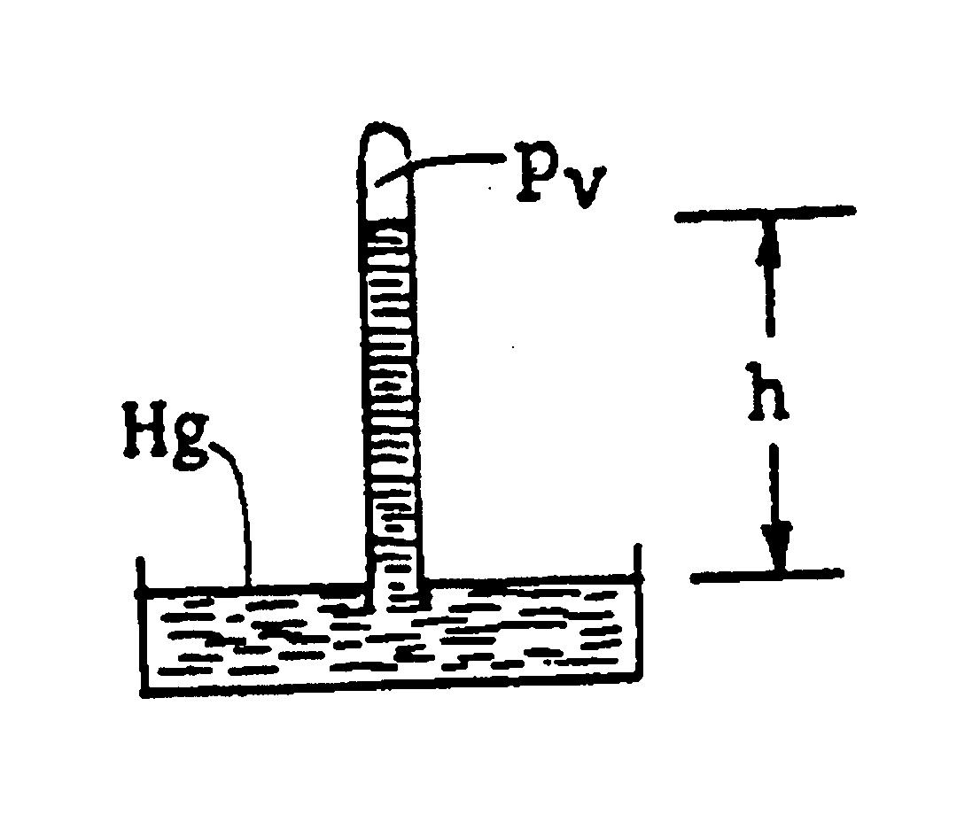
- Barometer

p_{v} + γ_{Hg}h = p_{atm} γ_{Hg} = 13.6 kN/m³

p_{atm} = γ_{Hg}h p_{v} ∼ 0 i.e., vapor pressure Hg
nearly zero at normal T
h ∼ 76 cm
∴ p_{atm} ∼ 101 kPa (or 14.6 psia)

Note: p_{atm} is relative to absolute zero, i.e., absolute pressure. p_{atm} = p_{atm}(location, weather)

Consider why water barometer is impractical
$γ_{\text{Hg}}h_{\text{Hg}}=γ_{H_{2}O}h_{H_{2}O}$ γ_{H2O} = 9.80 kN/m³

$$h_{H_{2}O}=\frac{γ_{\text{Hg}}}{γ_{H_{2}O}}h_{\text{Hg}}=S_{\text{Hg}}h_{\text{Hg}}=\text{13}\text{.}6 × \text{77}= \text{1047}\text{.}2 \text{cm}=\text{34} \text{ft}\text{.}$$
- Piezometer
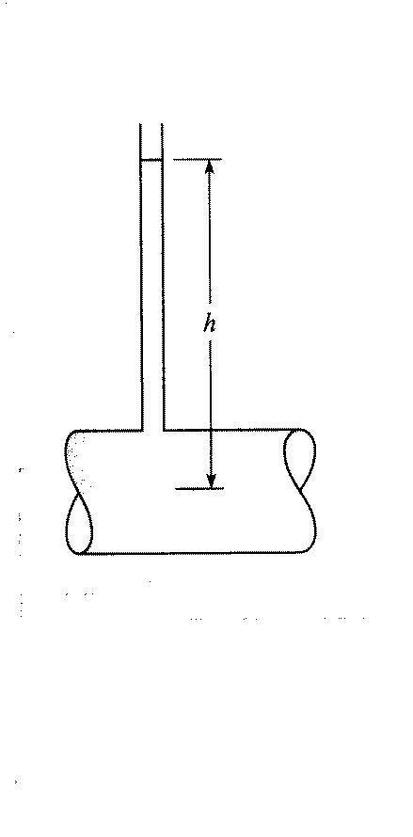
p_{atm}

p_{atm} + γh = p_{pipe} = p absolute

p = γh gage

Simple but impractical for large p and vacuum pressures (i.e., p_{abs} < p_{atm}). Also for small p and small d, due to large surface tension effects, which could be corrected using , but accuracy may be problem if p/γ ≈ Δh.
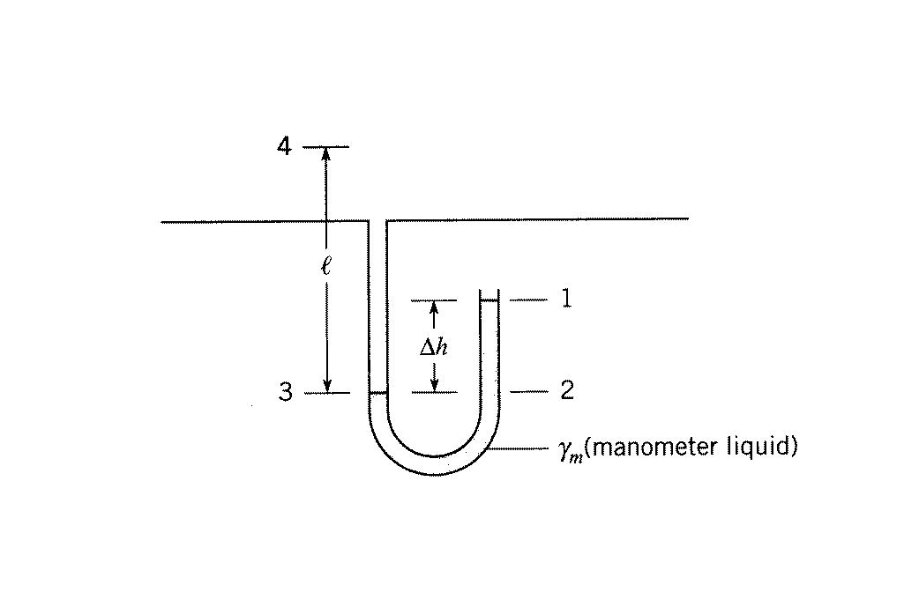
3. U-tube or differential manometer
γ

p_{atm}

p₁ + γ_{m}Δh − γl = p₄ p₁ = p_{atm}
p₄ = γ_{m}Δh − γl gage
= γ_{w}[S_{m}Δh − S l]
for gases S << S_{m} and can be neglected, i.e., can neglect Δp in gas compared to Δp in liquid in determining p₄ = p_{pipe}.

Example:
Air at 20 °C is in pipe with a water manometer. For given conditions compute gage pressure in pipe.
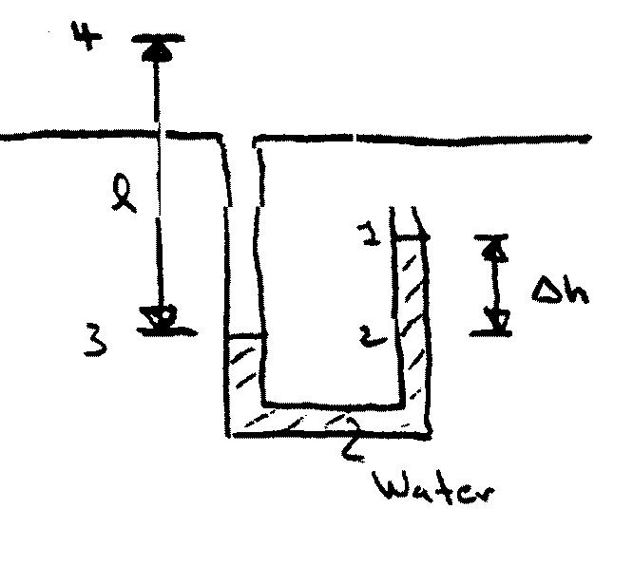
γ_{air}
l = 140 cm
Δh = 70 cm

p₄ = ? gage (i.e., p₁ = 0)
Pressure same at 2&3 since same elevation & Pascal’s law: in closed system pressure change produce at one part transmitted throughout entire system

p₁ + γΔh = p₃ step-by-step method
p₃ - γ_{air}l = p₄
γΔh

p₁ + γΔh - γ_{air}l = p₄ complete circuit method
γΔh - γ_{air}l = p₄ gage

γ_{water}(20°C) = 9790 N/m³ ⇒ p₃ = γΔh = 6853 Pa [N/m²]
γ_{air} = ρg
p_{abs}
$$ρ=\frac{p}{\text{RT}}=\frac{\left(p_{3}+p_{\text{atm}}\right)}{R\left(°C+\text{273}\right)}=\frac{\text{6853}+\text{101300}}{\text{287}(\text{20}+\text{273})}=1\text{.}\text{286} {\text{kg}}/{m^{3}}$$
°K
γ_{air} = 1.286 × 9.81m/s² = 12.62 N/m³

note γ_{air} << γ_{water}
p₄ = p₃ - γ_{air}l = 6853 – 12.62 × 1.4 = 6835 Pa
17.668
if neglect effect of air column p₄ = 6853 Pa
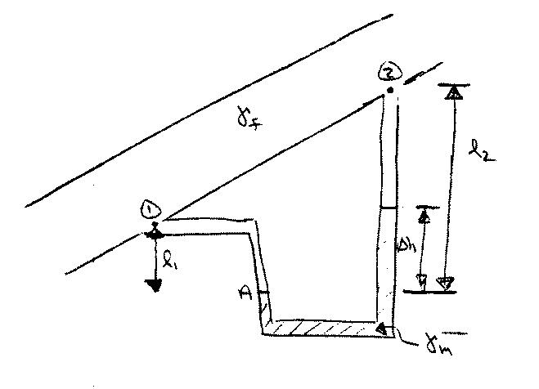
A differential manometer determines the difference in pressures at two points ①and ② when the actual pressure at any point in the system cannot be determined.

$$\left(\frac{p_{1}}{γ_{f}}+ℓ_{1}\right)−\left(\frac{p_{2}}{γ_{f}}+ℓ_{2}\right)=\left(\frac{γ_{m}}{γ_{f}}−1\right)Δh$$
difference in piezometric head

if fluid is a gas γ_{f} << γ_{m} : p₁ – p₂ = γ_{m}Δh

if fluid is liquid & pipe horizontal = :
p₁ – p₂ = (γ_{m} - γ_{f}) Δh
Hydrostatic Forces on Plane Surfaces

For a static fluid, the shear stress is zero and the only stress is the normal stress, i.e., pressure p. Recall that p is a scalar, which when in contact with a solid surface exerts a normal force towards the surface.
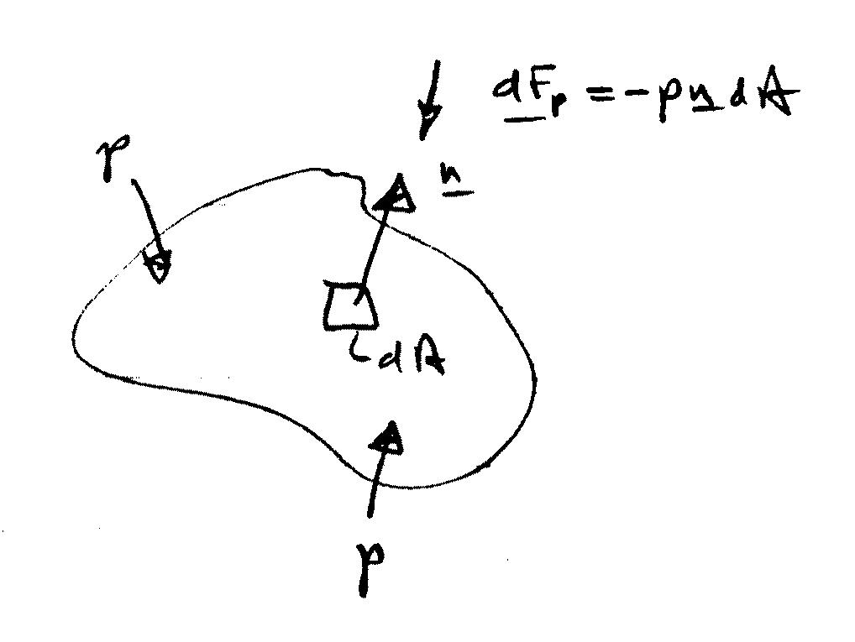

$$\underline{F_{p}}=−\int_{A}{p\underline{n}\text{dA}}$$

For a plane surface n = constant such that we can separately consider the magnitude and line of action of F_{p}.

$$\left|{\underline{F}}_{p}\right|=F=\int_{A}{\text{pdA}}$$

Line of action is towards and normal to A through the center of pressure (x_{cp}, y_{cp}).

Unless otherwise stated, throughout the chapter assume p_{atm} acts at liquid surface. Also, we will use gage pressure so that p = 0 at the liquid surface.

Horizontal Surfaces
horizontal surface with area A
p = constant

F

$$F=\int{\text{pdA}=\text{pA}}$$

Line of action is through centroid of A,
i.e., (x_{cp}, y_{cp}) = $(\overline{x}, \overline{y})$

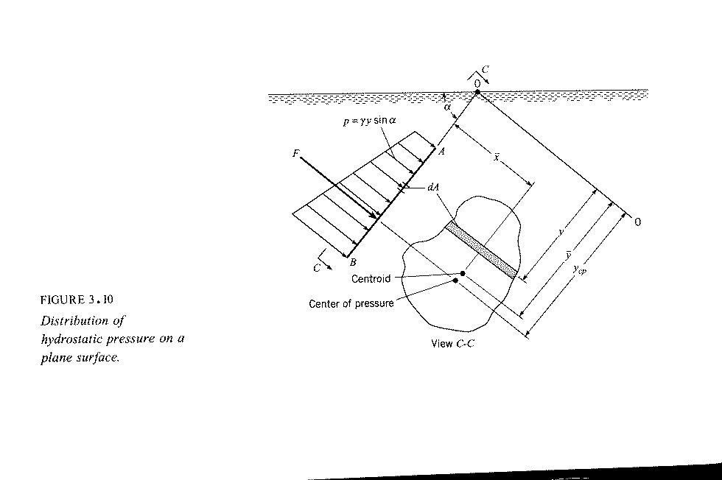
Inclined Surfaces
g
z
F
(x,y) = centroid of A
(x_{cp},y_{cp}) = center of pressure
y
x

p – p₀ = -γ(z – z₀) where p₀ = 0 & z₀ = 0
p = -γz and y⋅sinα = -z
p = γy⋅sinα

dF = pdA = γy sin α dA
γ and sin α are constants

$$\overline{y}=\frac{1}{A}\int{\text{ydA}}$$

1st moment of area
p

$$F=\int_{A}{\text{pdA}}=γ\text{sin}α\int_{A}{\text{ydA}}$$
$$\overline{y}A$$

$$F=γ\text{sin}α\overline{ y }A$$
$\overline{p}$= pressure at centroid of A

$$F=\overline{p}A$$

Magnitude of resultant hydrostatic force on plane surface is product of pressure at centroid of area and area of surface.

Center of Pressure

Center of pressure is in general below centroid since pressure increases with depth. Center of pressure is determined by equating the moments of the resultant and distributed forces about any arbitrary axis.

Determine y_{cp} by taking moments about horizontal axis 0-0

y_{cp}F = $\int_{A}{y}$dF
$\int_{A}{y \text{pdA}}$
$$\int_{A}{y(γy\text{sin}α)\text{dA}}$$
= $γ\text{sin}α\int_{A}{y^{2}\text{dA}}$

I_{o} = 2nd moment of area about 0-0
= moment of inertia
transfer equation: $I_{o}={\overline{y}}^{2}A+\overline{I}$
= moment of inertia with respect to horizontal
centroidal axis

$$\begin{aligned}y_{\text{cp}}F=γ\text{sin}α ({\overline{y}}^{2}A+\overline{I}) \\ \\ y_{\text{cp}}(\overline{p}A)=γ\text{sin}α ({\overline{y}}^{2}A+\overline{I}) \\ \\ y_{\text{cp}}γ\text{sin}α \overline{y}A=γ\text{sin}α ({\overline{y}}^{2}A+\overline{I}) \\ \end{aligned}$$
$y_{\text{cp}}\overline{y}A={\overline{y}}^{2}A+\overline{I}$

y_{cp} is below centroid by ${\overline{I}}/{\overline{y}}A$

y_{cp} → $\overline{y}$ for large $\overline{y}$

For p_{o} ≠ 0, y must be measured from an equivalent free surface located p_{o}/γ above $\overline{y}$.
Determine x_{cp} by taking moment about y axis

x_{cp}F = $\int_{A}{\text{xdF}}$
$\int_{A}{\text{xpdA}}$

$x_{\text{cp}}\overline{y}A=\int_{A}{\text{xydA}}$
I_{xy} = product of inertia
= ${\overline{I}}_{\text{xy}}+\overline{x}\overline{y}A$ transfer equation

$x_{\text{cp}}\overline{y}A={\overline{I}}_{\text{xy}}+\overline{x}\overline{y}A$
$$x_{\text{cp}}=\frac{{\overline{I}}_{\text{xy}}}{\overline{y}A}+\overline{x}$$

For plane surfaces with symmetry about an axis normal to 0-0, ${\overline{I}}_{\text{xy}}=0$ and x_{cp} = $\overline{x}$.

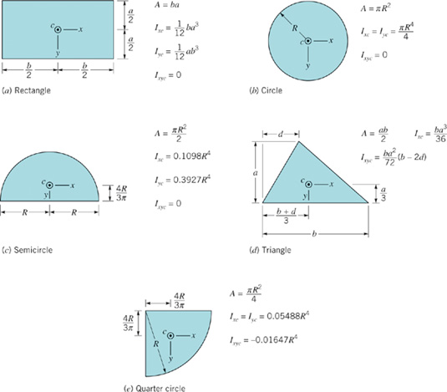
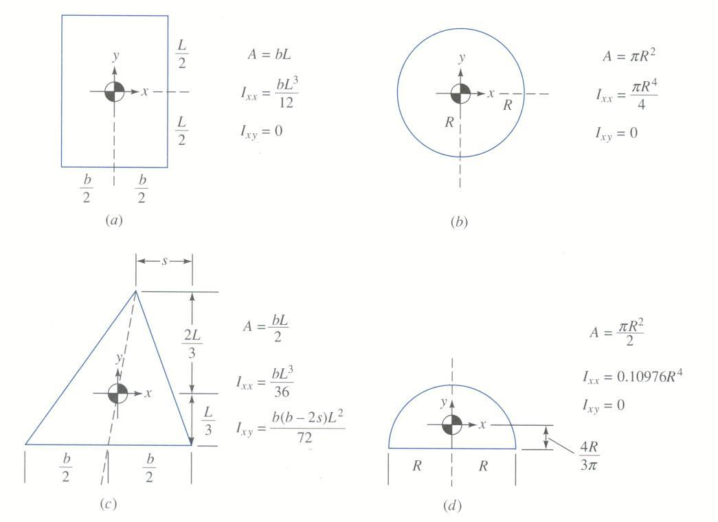
Hydrostatic Forces on Curved Surfaces
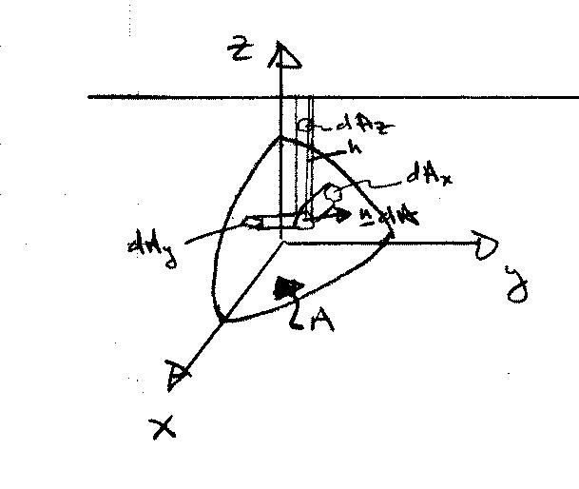
Free surface

$$\underline{F}=−\int_{A}{p\underline{n}\text{dA}}$$
p = γh

h = distance below free surface

Horizontal Components (x and y components)
$F_{x}=\underline{F}⋅\hat{i}=−\int_{A}{p\underline{n}⋅\hat{i}\text{dA}}$
dA_{x} = projection of ndA onto vertical plane to x-direction
$=−\int_{A_{x}}{{\text{pdA}}_{x}}$

$F_{y}=\underline{F}⋅\hat{j}=−\int_{A_{y}}{{\text{pdA}}_{y}}$ ${\text{dA}}_{y}=\underline{n}⋅\hat{j}\text{dA}$
= projection ndA
onto vertical plane to
y-direction

Therefore, the horizontal components can be determined by some methods developed for submerged plane surfaces.

The horizontal component of force acting on a curved surface is equal to the force acting on a vertical projection of that surface including both magnitude and line of action.

Vertical Components

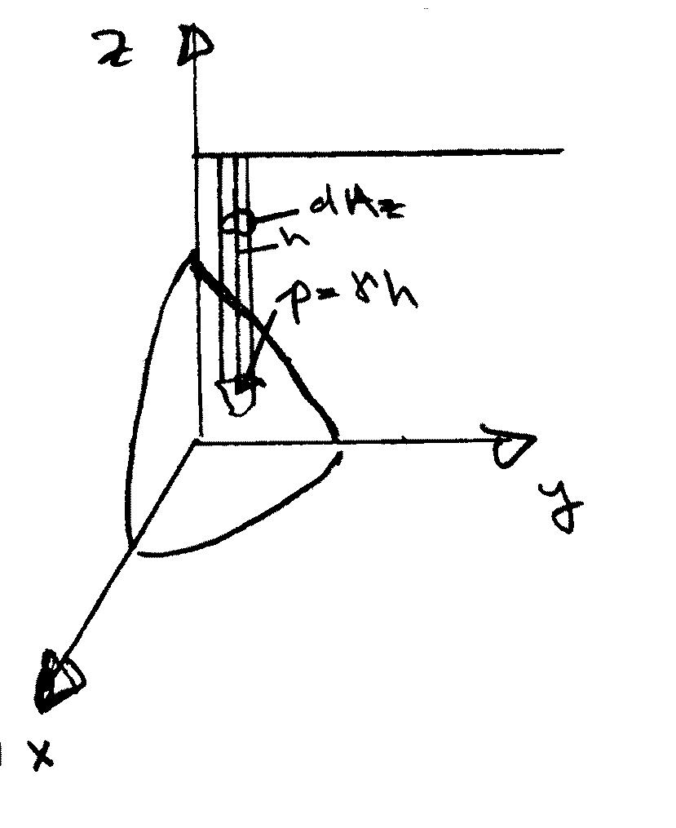
$F_{z}=\underline{F}⋅\hat{k}=−\int_{A}{p\underline{n}⋅\hat{k}\text{dA}}$
=$−\int_{A_{z}}{{\text{pdA}}_{z}}$ p = γh
h=distance
below free
surface

=$γ\int_{A_{z}}{{\text{hdA}}_{z}=γV}$
= weight of
fluid above
surface A

The vertical component of force acting on a curved surface is equal to the net weight of the column of fluid above the curved surface with line of action through the centroid of that fluid volume.

Example: Drum Gate
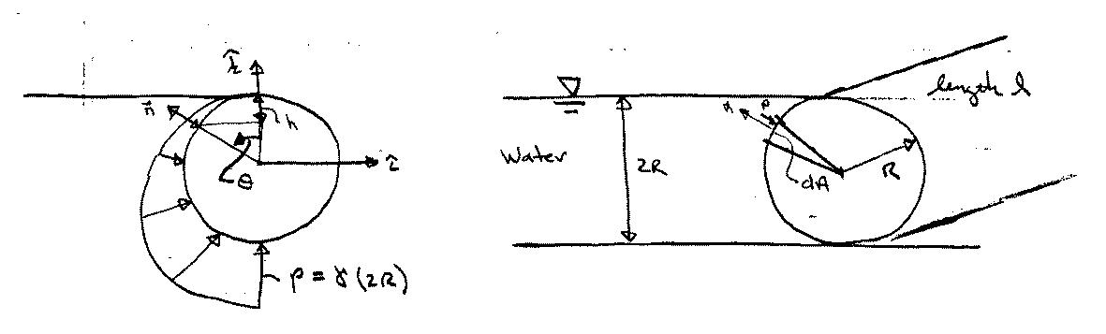

Pressure Diagram
p = γh = γR(1-cosθ)
$$\underline{n}=−\text{sin}θ \hat{i}+\text{cos}θ \hat{k}$$
dA = Rdθ : Area p acts over (Note: Rdθ = arc length)
$$\underline{F}=−\int_{0}^{π}{γR(1−\text{cos}θ)(−\text{sin}θ \hat{i}+\text{cos}θ \hat{k})ℓ\text{Rd}θ}$$
p n dA
$$\underline{F}⋅\hat{i}=F_{x}\text{=+}γ ℓ R^{2}\int_{0}^{π}{(1−\text{cos}θ)\text{sin}θdθ}$$
= $γ ℓ R^{2}[−\text{cos}θ+\frac{1}{4}\text{cos}2θ|_{0}^{π}=2{γℓR}^{2}$
= (γR)(2R) ⇒ same force as that on projection of
$\overline{p}$ A area onto vertical plane
$$F_{z}=−γ ℓ R^{2}\int_{0}^{π}{(1−\text{cos}θ)\text{cos}θdθ}$$
=$−γ ℓ R^{2}[\text{sin}θ−\frac{θ}{2}−\frac{\text{sin}2θ}{4}|_{0}^{π}$
= $γ ℓ R^{2}\frac{π}{2}=γ ℓ\left(\frac{{πR}^{2}}{2}\right)=γV$
⇒ net weight of water above surface

Another approach:

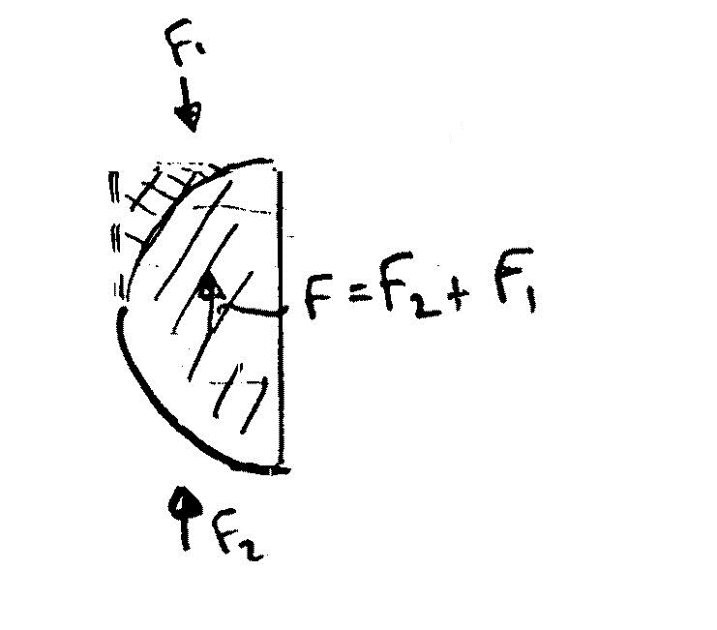
$$\begin{aligned}F_{1}=−γ ℓ \left[R^{2}−\frac{1}{4}{πR}^{2}\right] \\ −γ {ℓR}^{2}\left[1−\frac{π}{4}\right]\end{aligned}$$

$$F_{2}=γ ℓ \frac{{πR}^{2}}{2}−F_{1}$$

$$\begin{aligned}F=F_{2}+F_{1} \\ \frac{γ {ℓπR}^{2}}{2}\end{aligned}$$

Buoyancy

Archimedes Principle

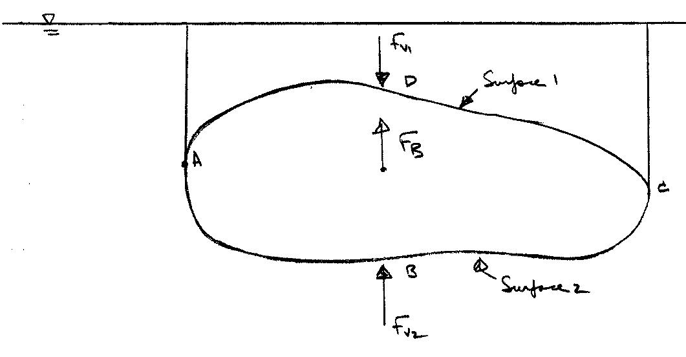
F_{B} = F_{v2} – F_{v1}

= fluid weight above Surface 2 (ABC)
- fluid weight above Surface 1 (ADC)

= fluid weight equivalent to body volume V

F_{B} = ρgV V = submerged volume

Line of action is through centroid of V = center of buoyancy

Net Horizontal forces are zero since
F_{BAD} = F_{BCD}

Hydrometry

A hydrometer uses the buoyancy principle to determine specific weights of liquids.
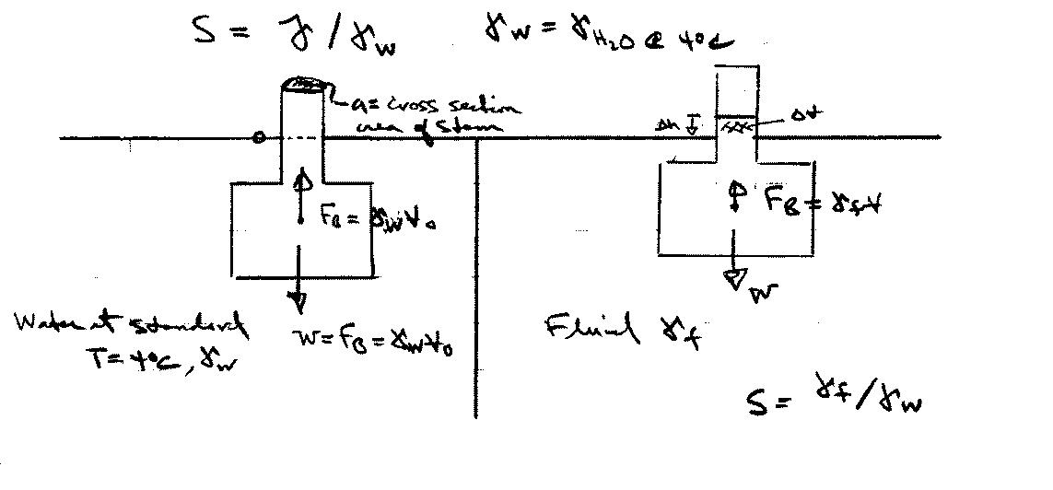
Stem

Bulb

F_{B} = γ_{w}V _{o}
W = mg = γ_{f}V = Sγ_{w}V = Sγ_{w}(V_{o} − ΔV) = Sγ_{w}(V_{o} − aΔh)
γ_{f} V
a = cross section area stem
F_{B} = W at equilibrium: Δh = stem height above waterline
γ_{w}V _{o} = Sγ_{w}(V_{o} − aΔh)
V_{o}/S = V_{o} − aΔh
aΔh = V_{o} – V_{o}/S

Δh = $\frac{V_{o}}{a}⋅\left(1−\frac{1}{S}\right)$=Δh(S); Calibrate scale using fluids of known S
S = $\frac{V_{o}}{V_{0}−aΔh}$= S(Δh); Convert scale to directly read S

Example (apparent weight)

King Hiero ordered a new crown to be made from pure gold. When he received the crown he suspected that other metals had been used in its construction. Archimedes discovered that the crown required a force of 4.7# to suspend it when immersed in water, and that it displaced 18.9 in³ of water. He concluded that the crown was not pure gold. Do you agree?
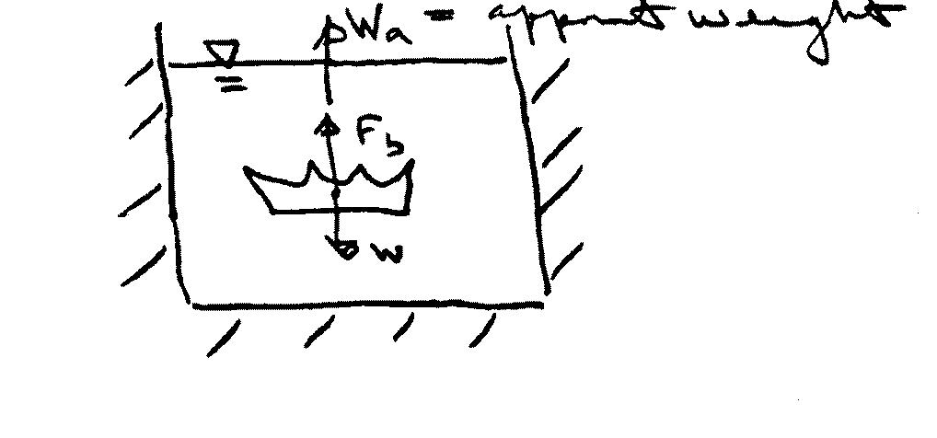

∑F_{vert} = 0 = W_{a} + F_{b} – W = 0 ⇒ W_{a} = W – F_{b} = (γ_{c} - γ_{w})V
W=γ_{c}V, F_{b} = γ_{w}V
or γ_{c} = $\frac{W_{a}}{V}+γ_{w}=\frac{W_{a}+γ_{w}V}{V}$

$$γ_{c}=\frac{4\text{.}7+\text{62}\text{.}4×\text{18}\text{.}9/{\text{1728}}}{\text{18}\text{.}9/{\text{1728}}} = \text{492}\text{.}1 = ρ_{c}g$$

⇒ ρ_{c} = 15.3 slugs/ft³

∼ ρ_{steel} and since gold is heavier than steel the crown
can not be pure gold
Stability of Immersed and Floating Bodies

Here we’ll consider transverse stability. In actual applications both transverse and longitudinal stability are important.

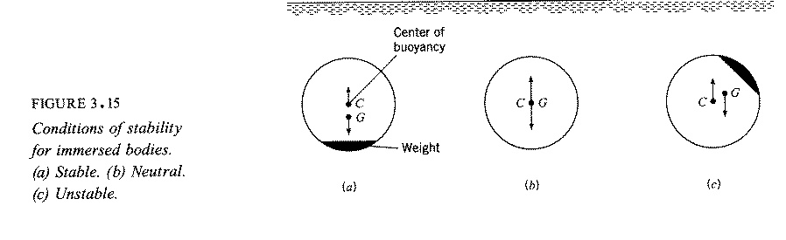
Immersed Bodies
Stable
Neutral
Unstable

Static equilibrium requires: $\sum{F_{v}=0 \text{and} \sum{M}=0}$

∑M = 0 requires that the centers of gravity and buoyancy coincide, i.e., C = G and body is neutrally stable

If C is above G, then the body is stable (righting moment when heeled)

If G is above C, then the body is unstable (heeling moment when heeled)

Floating Bodies

For a floating body the situation is slightly more complicated since the center of buoyancy will generally shift when the body is rotated depending upon the shape of the body and the position in which it is floating.

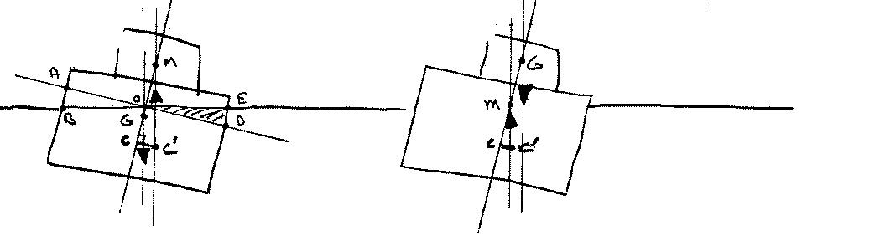
Positive $\overline{\text{GM}}$ Negative $\overline{\text{GM}}$

The center of buoyancy (centroid of the displaced volume) shifts laterally to the right for the case shown because part of the original buoyant volume AOB is transferred to a new buoyant volume EOD.

The point of intersection of the lines of action of the buoyant force before and after heel is called the metacenter M and the distance GM is called the metacentric height. If GM is positive, that is, if M is above G, then the ship is stable; however, if GM is negative, the ship is unstable.

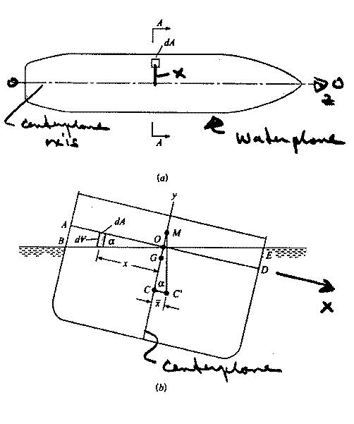
Floating Bodies

α = small heel angle
$\overline{x}=CC^{'}$ = lateral displacement
of C
C = center of buoyancy
i.e., centroid of displaced
volume V

Solve for GM: find $\overline{x}$ using
(1) basic definition for centroid of V; and
(2) trigonometry
Fig. 3.17

(1) Basic definition of centroid of volume V

$\overline{x}V=\int{\text{xd \{}V}=\sum{x_{i}ΔV_{i}}$ moment about centerplane

$\overline{x}V$ = moment V before heel – moment of V_{AOB}
+ moment of V_{EOD}
= 0 due to symmetry of
original V about y axis
i.e., ship centerplane

tan α = y/x
dV = ydA = x tan α dA
$$\overline{x}V=\text{tan}α\int{x^{2}\text{dA}}$$
ship waterplane area

moment of inertia of ship waterplane
about z axis O-O; i.e., I_{OO}

I_{OO} = moment of inertia of waterplane
area about centerplane axis

(2) Trigonometry
$$\begin{aligned}\overline{x}V=\text{tan}{αI}_{\text{OO}} \\ CC^{'}=\overline{x}=\frac{\text{tan}{αI}_{\text{OO}}}{V}=\text{CM}\text{tan}α\end{aligned}$$

CM = I_{OO} / V

GM = CM – CG

GM = $\frac{I_{\text{OO}}}{V}−\text{CG}$

GM > 0 Stable

GM < 0 Unstable

Fluids in Rigid-Body Motion

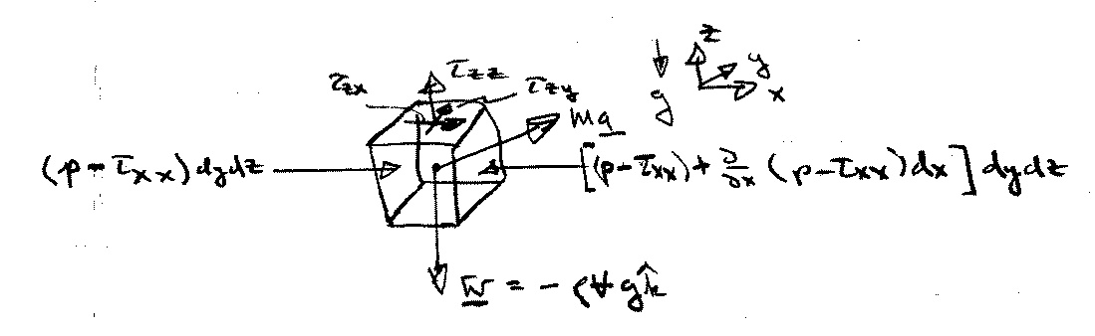
For fluids in motion, the pressure variation is no longer hydrostatic and is determined from application of Newton’s 2nd Law to a fluid element.
τ_{ij} = viscous stresses net surface force in X direction
p = pressure
$$X_{\text{net}}=\left(−\frac{∂p}{∂x}+\frac{∂τ_{\text{xx}}}{∂x}+\frac{∂τ_{\text{yx}}}{∂y}+\frac{∂τ_{\text{zx}}}{∂z}\right)V$$
Ma = inertia force
W = weight (body force)

Newton’s 2nd Law pressure viscous

Ma = ∑F = F_{B} + F_{S}

per unit volume (÷ V) ρa = f_{b} + f_{s}

The acceleration of fluid particle
a = $\frac{D\underline{V}}{\text{Dt}}=\frac{∂\underline{V}}{∂t}+\underline{V}⋅∇\underline{V}$
f_{b} = body force = $−ρg\hat{k}$
f_{s} = surface force = f_{p} + f_{v}
f_{p} = surface force due to p = −∇p
f_{v} = surface force due to viscous stresses τ_{ij}
Neglected in this chapter and included later in Chapter 6 when deriving complete Navier-Stokes equations

inertia force = body force due + surface force due to
to gravity pressure gradients

Where for general fluid motion, i.e. relative motion between fluid particles:
substantial derivative
x: $ρ\frac{\text{Du}}{\text{Dt}}=−\frac{∂p}{∂x}$
$ρ\left[\frac{∂u}{∂t}+u\frac{∂u}{∂x}+v\frac{∂u}{∂y}+w\frac{∂u}{∂z}\right]=−\frac{∂p}{∂x}$

y: $ρ\frac{\text{Dv}}{\text{Dt}}=−\frac{∂p}{∂y}$
$ρ\left[\frac{∂v}{∂t}+u\frac{∂v}{∂x}+v\frac{∂v}{∂y}+w\frac{∂v}{∂z}\right]=−\frac{∂p}{∂y}$

z: $ρ\frac{\text{Dw}}{\text{Dt}}=−ρg−\frac{∂p}{∂z}=−\frac{∂}{∂z}\left(p+γz\right)$
Note: for V = 0
$\begin{aligned}∇p=−ρg\hat{k} \\ \frac{∂p}{∂x}=\frac{∂p}{∂y}=0 \\ \frac{∂p}{∂z}=−ρg=−γ\end{aligned}$
$ρ\left[\frac{∂w}{∂t}+u\frac{∂w}{∂x}+v\frac{∂w}{∂y}+w\frac{∂w}{∂z}\right]=−\frac{∂}{∂z}\left(p+γz\right)$

But in this chapter rigid body motion, i.e., no
relative motion between fluid particles

ρa = −∇(p + γz) Euler’s equation for inviscid flow

∇⋅V = 0 Continuity equation for
incompressible flow (See Chapter 6)

4 equations in four unknowns V and p

For rigid body translation:
For rigid body rotating:

If , the motion equation reduces to hydrostatic equation:

Examples of Pressure Variation From Acceleration

Uniform Linear Acceleration:
$$\begin{aligned}ρ\underline{a}=−ρg\hat{k}−∇p \\ ∇p=−ρ\left(\underline{a}+g\hat{k}\right)=ρ\left(\underline{g}−\underline{a}\right) \underline{g}=−g\hat{k}\end{aligned}$$
$$∇p=−ρ\left[a_{x}\hat{i}+\left(g+a_{z}\right)\hat{k}\right] \underline{a}=a_{x}\hat{i}+a_{z}\hat{k}$$
$$\frac{∂p}{∂x}=−{ρa}_{x} \frac{∂p}{∂z}=−ρ\left(g+a_{z}\right)$$

1. p increase in +x
2. p decrease in +x

$\frac{∂p}{∂z}=−ρ\left(g+a_{z}\right)$
1. p decrease in +z
2. and p decrease in +z but slower than g
3. and p increase in +z
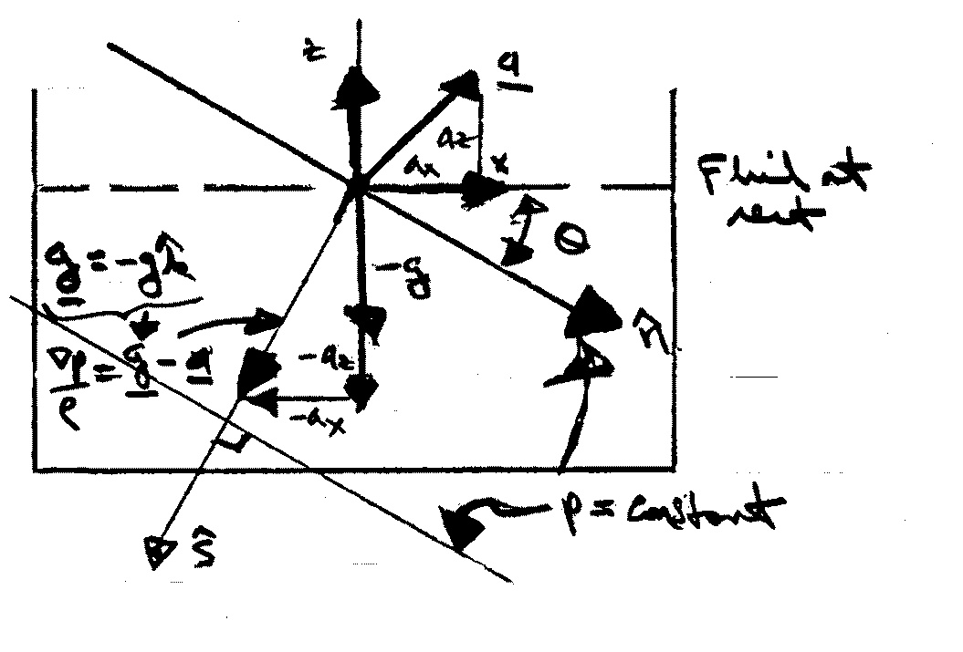
$\hat{s}$= unit vector in direction of ∇p
=∇p /⏐∇p⏐
=$\frac{−\left[a_{x}\hat{i}+\left(g+a_{z}\right)\hat{k}\right]}{ {\left[a_{x}^{2}+{\left(g+a_{z}\right)}^{2}\right]}^{1/2}}$

$\hat{n}$ = unit vector in direction of p = constant
= $\hat{s}×\hat{j}$ ijkijk
⊥ to ∇p
by definition lines of constant p are normal to ∇p
= $\frac{−a_{x}\hat{k}+(g+a_{z})\hat{i}}{ {\left[a_{x}^{2}+(g+a_{z})^{2}\right]}^{1/2}}$

θ = tan⁻¹ a_{x} / (g + a_{z}) = angle between $\hat{n}$ and x
$\frac{\text{dp}}{\text{ds}}=∇p⋅\hat{s}=ρ{\left[a_{x}^{2}+{\left(g+a_{z}\right)}^{2}\right]}^{1/2}$ > ρg

G
p = ρGs + constant ⇒ p_{gage} = ρGs
Rigid Body Rotation:

Consider a cylindrical tank of liquid rotating at a constant rate $\underline{Ω}=Ω\hat{k}$
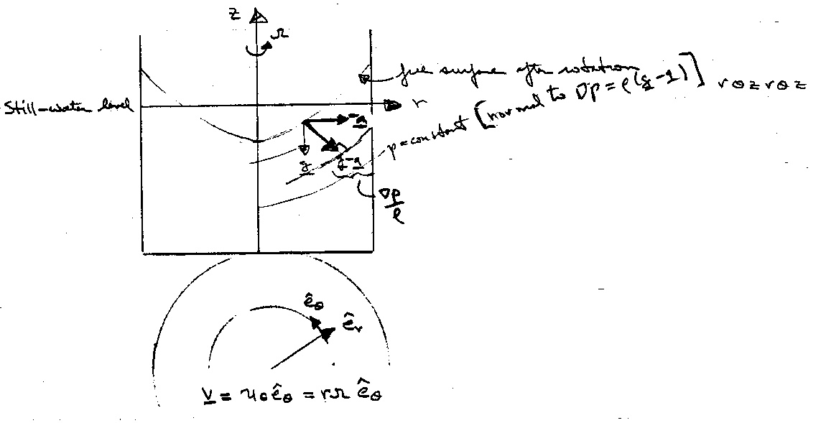

$\underline{a}=\underline{Ω}×\left(\underline{Ω}×r_{o}\right)$
centripetal acceleration

= $−rΩ^{2}{\hat{e}}_{r}$
= $−\frac{V^{2}}{r}{\hat{e}}_{r}$
$∇p=ρ(\underline{g}−\underline{a})$ $∇=\frac{∂}{∂r}{\hat{e}}_{r}+\frac{1}{r}\frac{∂}{∂θ}{\hat{e}}_{θ}+\frac{∂}{∂z}{\hat{e}}_{z}$
= $−ρg\hat{k}+ρrΩ^{2}{\hat{e}}_{r}$ grad in cylindrical coordinates

i.e., $\frac{∂p}{∂r}=ρrΩ^{2}$ $\frac{∂p}{∂z}=−ρg$ $\frac{∂p}{∂θ}=0$
C (r)
pressure distribution is hydrostatic in z direction
and p = $\frac{ρ}{2}r^{2}Ω^{2}+f(z)+c$
p_{z} = -ρg
p = -ρgz + C(r) + c

p = $\frac{ρ}{2}r^{2}Ω^{2}−ρ\text{gz}$ + constant $\frac{p}{γ}+z−\frac{V^{2}}{2g}=$constant
V = rΩ
The constant is determined by specifying the pressure at one point; say, p = p_{o} at (r, z) = (0, 0)

p = p_{o} − ρgz + $\frac{1}{2}$r²Ω²ρ
Note: pressure is linear in z and parabolic in r

Curves of constant pressure are given by

z = $\frac{p_{0}−p}{ρg}+\frac{r^{2}Ω^{2}}{2g}=a+{\text{br}}^{2}$

which are paraboloids of revolution, concave upward, with their minimum point on the axis of rotation

Free surface is found by requiring volume of liquid to be constant (before and after rotation)

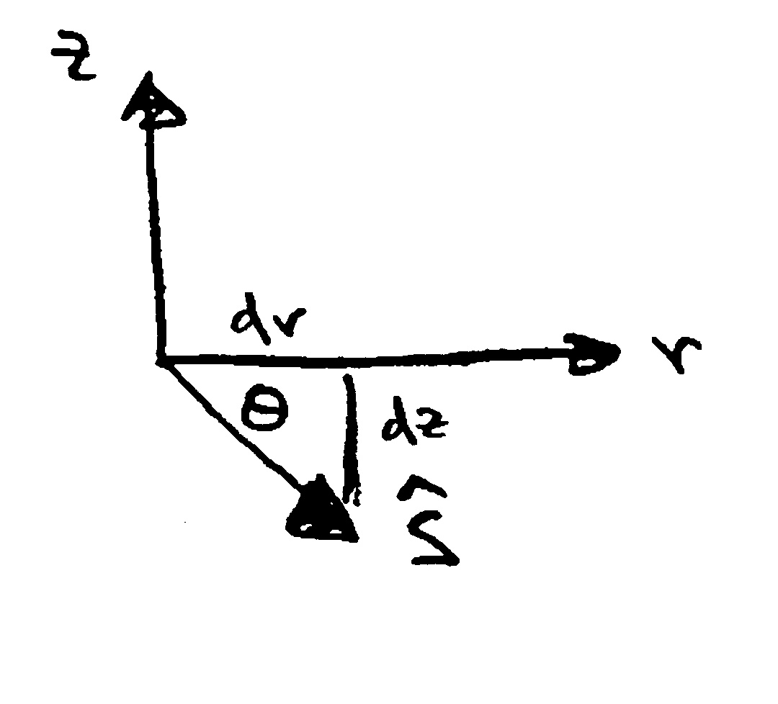
The unit vector in the direction of ∇p is
$\hat{s}=\frac{−ρg\hat{k}+ρrΩ^{2}{\hat{e}}_{r}}{ {\left[{\left(ρg\right)}^{2}+{\left(ρrΩ^{2}\right)}^{2}\right]}^{1/2}}$

$\text{tan}θ=\frac{\text{dz}}{\text{dr}}=−\frac{g}{rΩ^{2}}$ slope of $\hat{s}$

i.e., r = C₁exp$\left(−\frac{Ω^{2}z}{g}\right)$ equation of ∇p surfaces
