Chapter 11: Drag and Lift

11.1 Basic Considerations

Recall separation of drag components into form and skin-friction

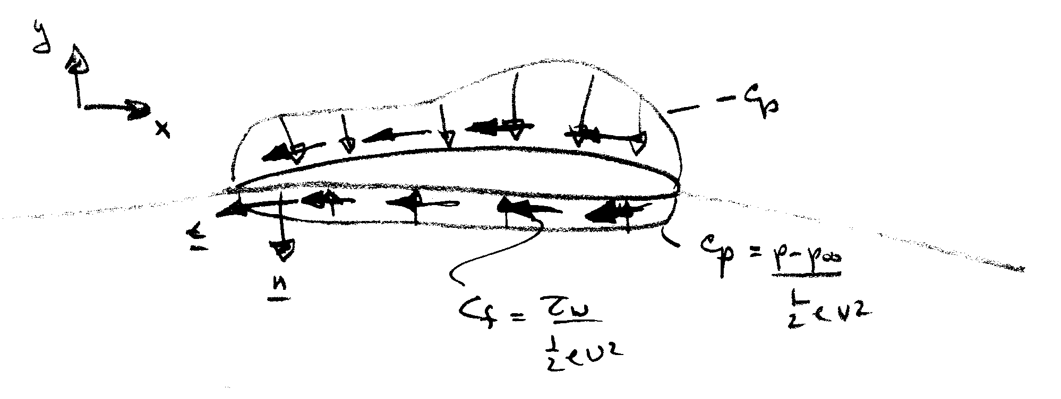
$$C_{D}=\frac{1}{\frac{1}{2}{ρV}^{2}A}\left\{\int_{S}{\left(p−p_{∞}\right)\underline{n}⋅\hat{i}\text{dA}}+\int_{S}{τ_{w}\underline{t}⋅\hat{i}\text{dA}}\right\}$$
C_{Dp} C_{f}

$$C_{L}=\frac{1}{\frac{1}{2}{ρV}^{2}A}\left\{\int_{S}{\left(p−p_{∞}\right)}\underline{n}⋅\hat{j}\text{dA}\right\}$$

$\frac{t}{c}$ << 1 C_{f} > > C_{Dp} streamlined body

$\frac{t}{c}$ ∼ 1 C_{Dp} > > C_{f} bluff body

Streamlining: One way to reduce the drag

Make a body streamlined:

→ reduce the flow separation→reduce the pressure drag
→ increase the surface area → increase the friction drag

→ Trade-off relationship between pressure drag and friction drag

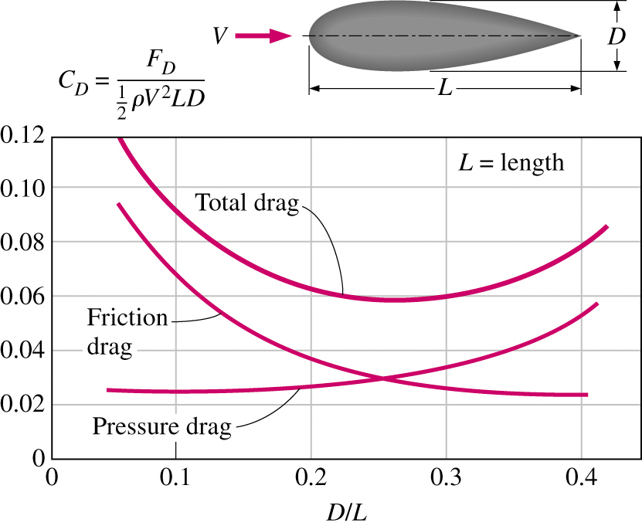
Trade-off relationship between pressure drag and friction drag

Benefit of streamlining: reducing vibration and noise
11.2 Drag of 2-D Bodies

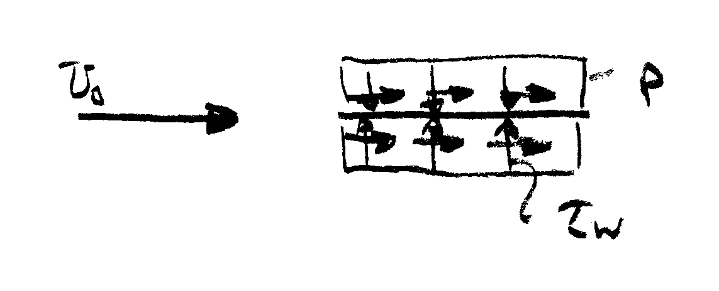
First consider a flat plate both parallel and normal to the flow

$$C_{\text{Dp}}=\frac{1}{\frac{1}{2}{ρV}^{2}A}\int_{S}{\left(p−p_{∞}\right)\underline{n}⋅\hat{i}}=0$$

$$C_{f}=\frac{1}{\frac{1}{2}{ρV}^{2}A}\int_{S}{τ_{w}\underline{t}⋅\hat{i}\text{dA}}$$

= $\frac{1\text{.}\text{33}}{{\text{Re}}_{L}^{1/2}}$ laminar flow

= $\frac{\text{.}\text{074}}{{\text{Re}}_{L}^{1/5}}$ turbulent flow
flow pattern
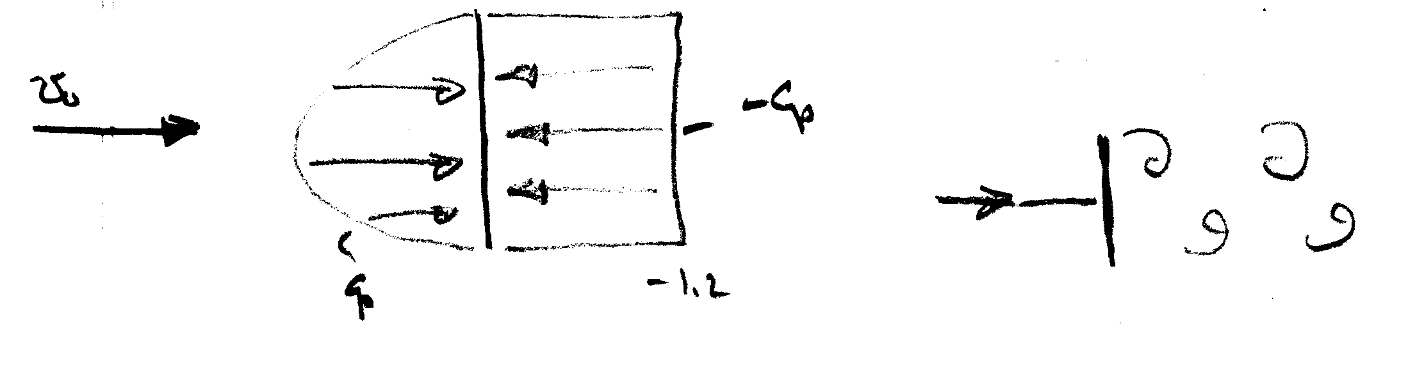

vortex wake
typical of bluff body flow

where C_{p} based on experimental data

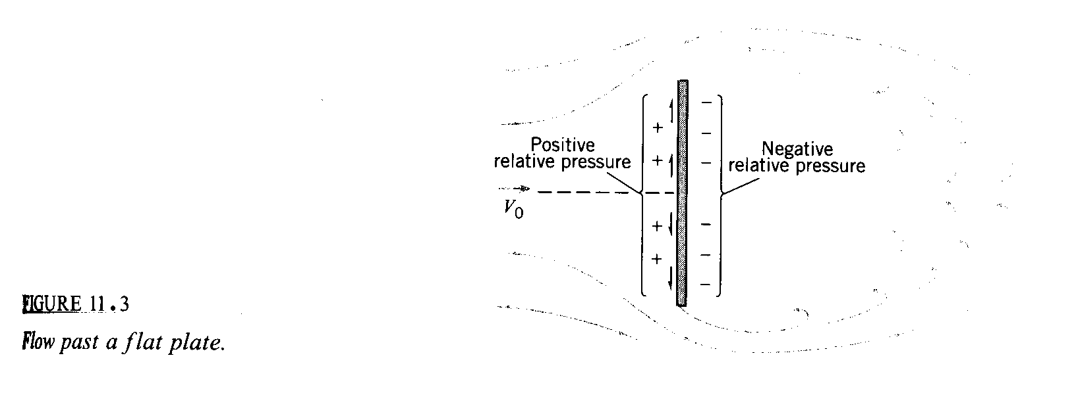

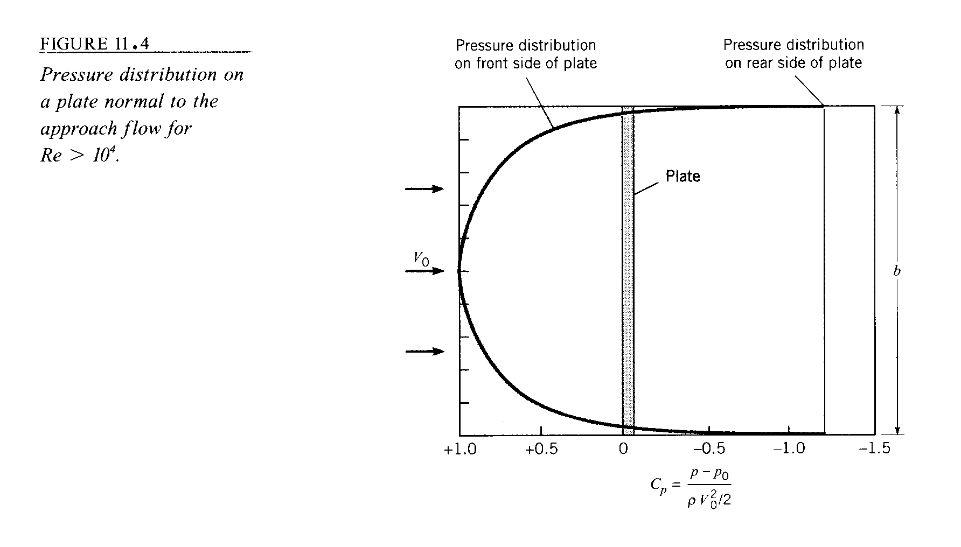

$$C_{\text{Dp}}=\frac{1}{\frac{1}{2}{ρV}^{2}A}\int_{S}{\left(p−p_{∞}\right)\underline{n}⋅\hat{i}\text{dA}}$$

= $\frac{1}{A}\int_{S}{C_{p}\text{dA}}$

= 2 using numerical integration of experimental data

C_{f} = 0

For bluff body flow experimental data used for c_{D}.

In general, Drag = f(V, L, ρ, μ, c, t, ε, T, etc.)
from dimensional analysis

c/L

$$C_{D}=\frac{\text{Drag}}{\frac{1}{2}{ρV}^{2}A}=f\left(\text{Re,} \text{Ar}, \frac{t}{L}, \frac{ε}{L}, T, \text{etc}\text{.}\right)$$

scale factor

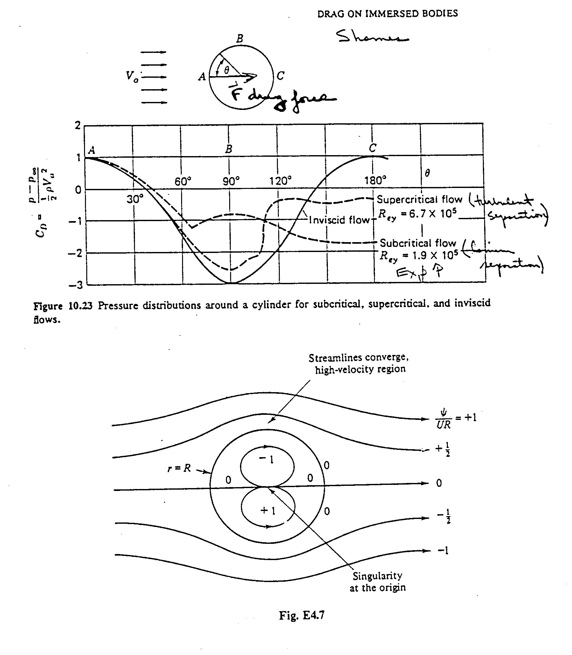
Potential Flow Solution: $ψ=−U_{∞}\left(r−\frac{a^{2}}{r}\right)\text{sin}θ$
$$\begin{aligned}u_{r}=\frac{1}{r}\frac{∂ψ}{∂θ} \\ \\ u_{θ}=−\frac{∂ψ}{∂r}\end{aligned}$$
$p+\frac{1}{2}{ρV}^{2}=p_{∞}+\frac{1}{2}{ρU}_{∞}^{2}$

$C_{p}=\frac{p−p_{∞}}{\frac{1}{2}{ρU}_{∞}^{2}}=1−\frac{u_{r}^{2}+u_{θ}^{2}}{U_{∞}^{2}}$
$C_{p}\left(r=a\right)=1−4{\text{sin}}^{2}θ$ surface pressure
Flow Separation

Flow separation:
→The fluid stream detaches itself from the surface of the body at
sufficiently high velocities. Only appeared in viscous flow!!

Flow separation forms the region called ‘separated region’

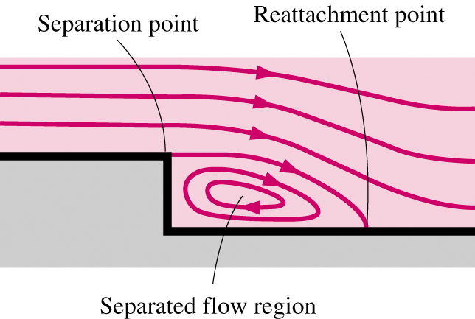

Inside the separation region:
→low-pressure, existence of recirculating/backflows
→viscous and rotational effects are the most significant!

Important physics related to flow separation:
→’Stall’ for airplane (Recall the movie you saw at CFD-PreLab2!)
→Vortex shedding
(Recall your work at CFD-Lab2, AOA=16°! What did you see in your velocity-vector plot at the trailing edge of the air foil?)

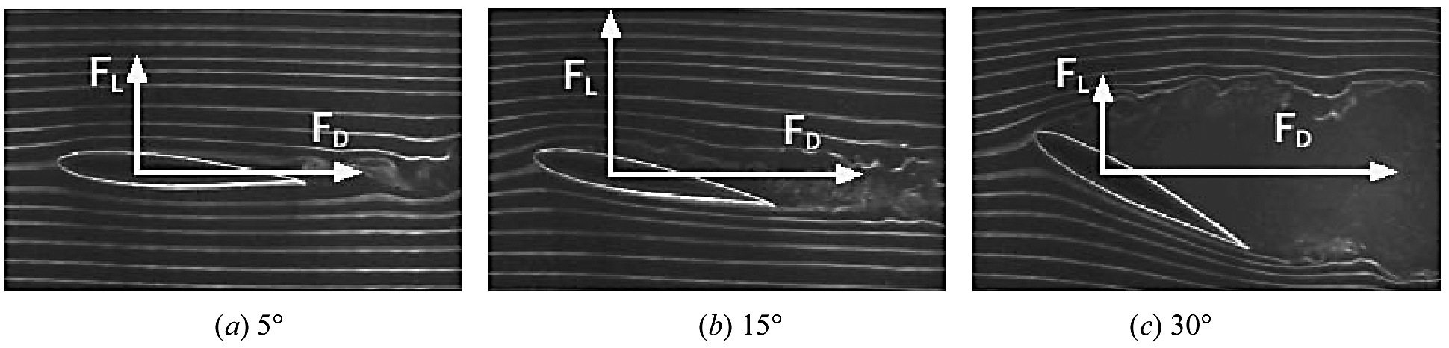

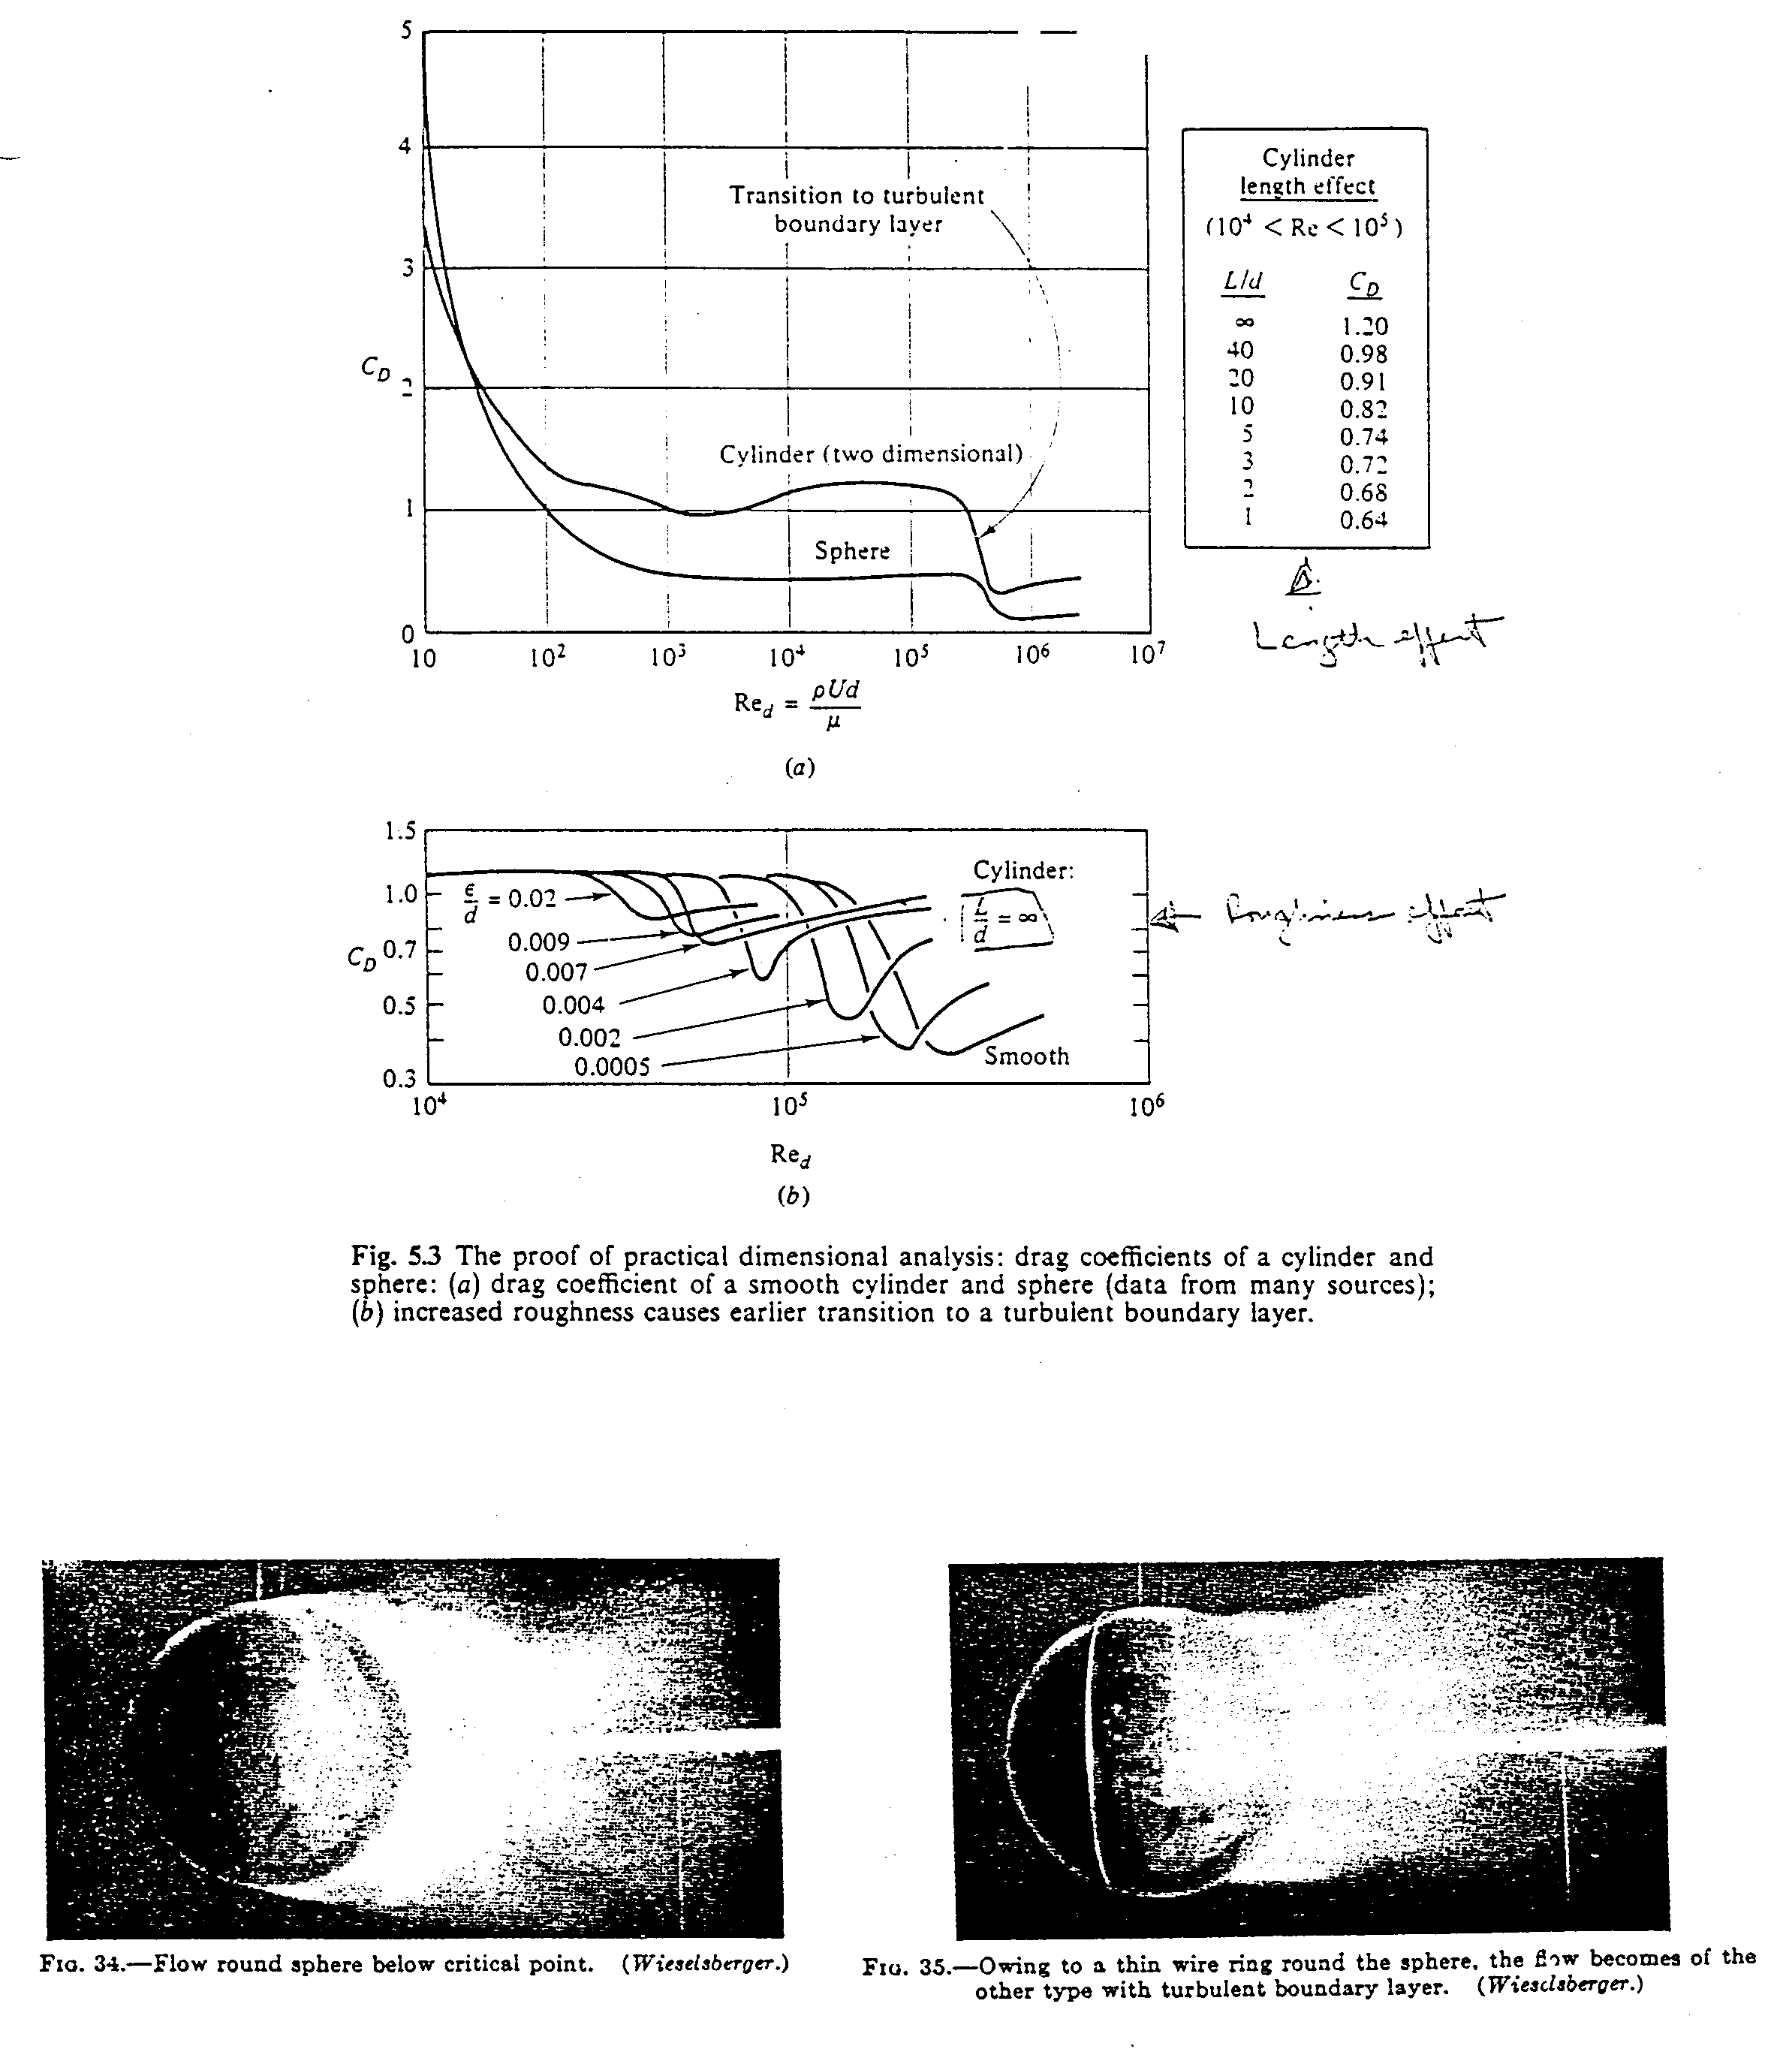
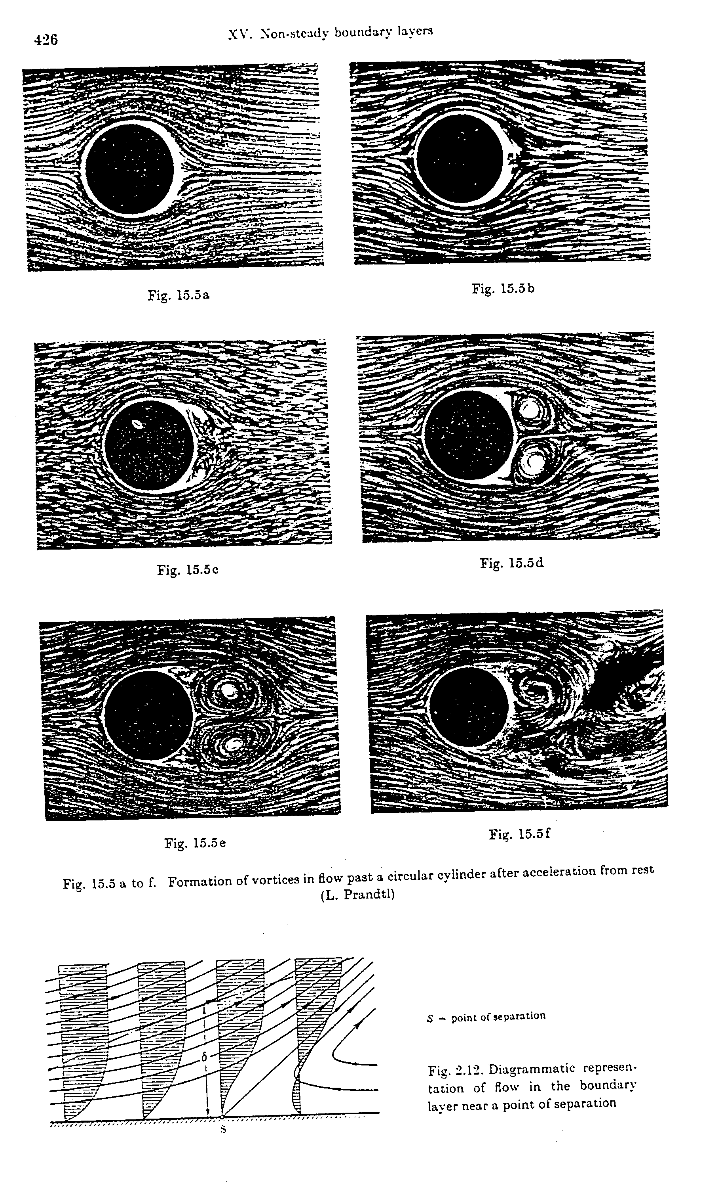
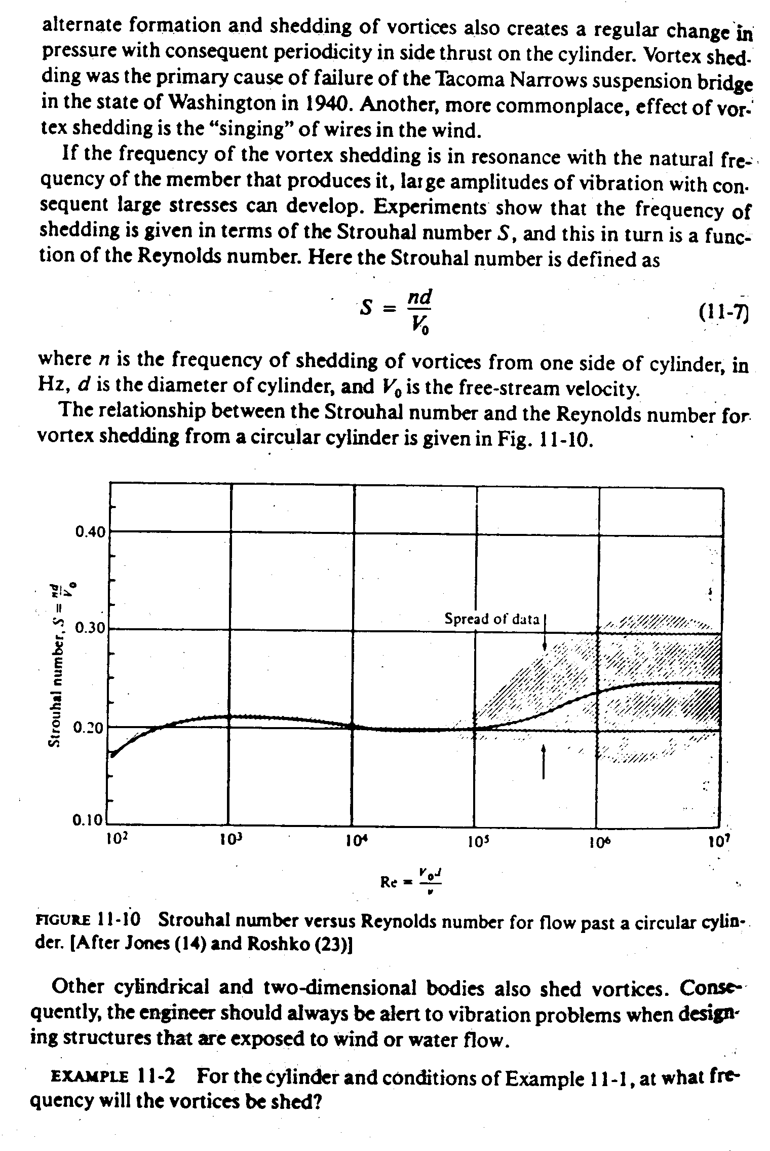
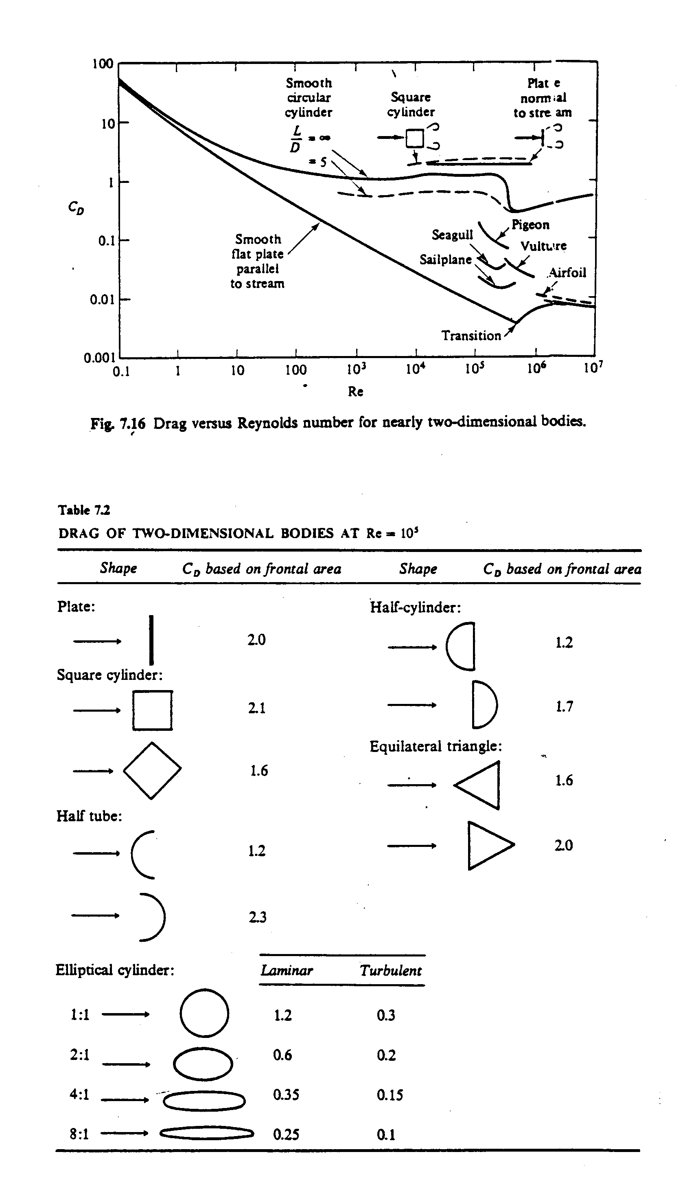
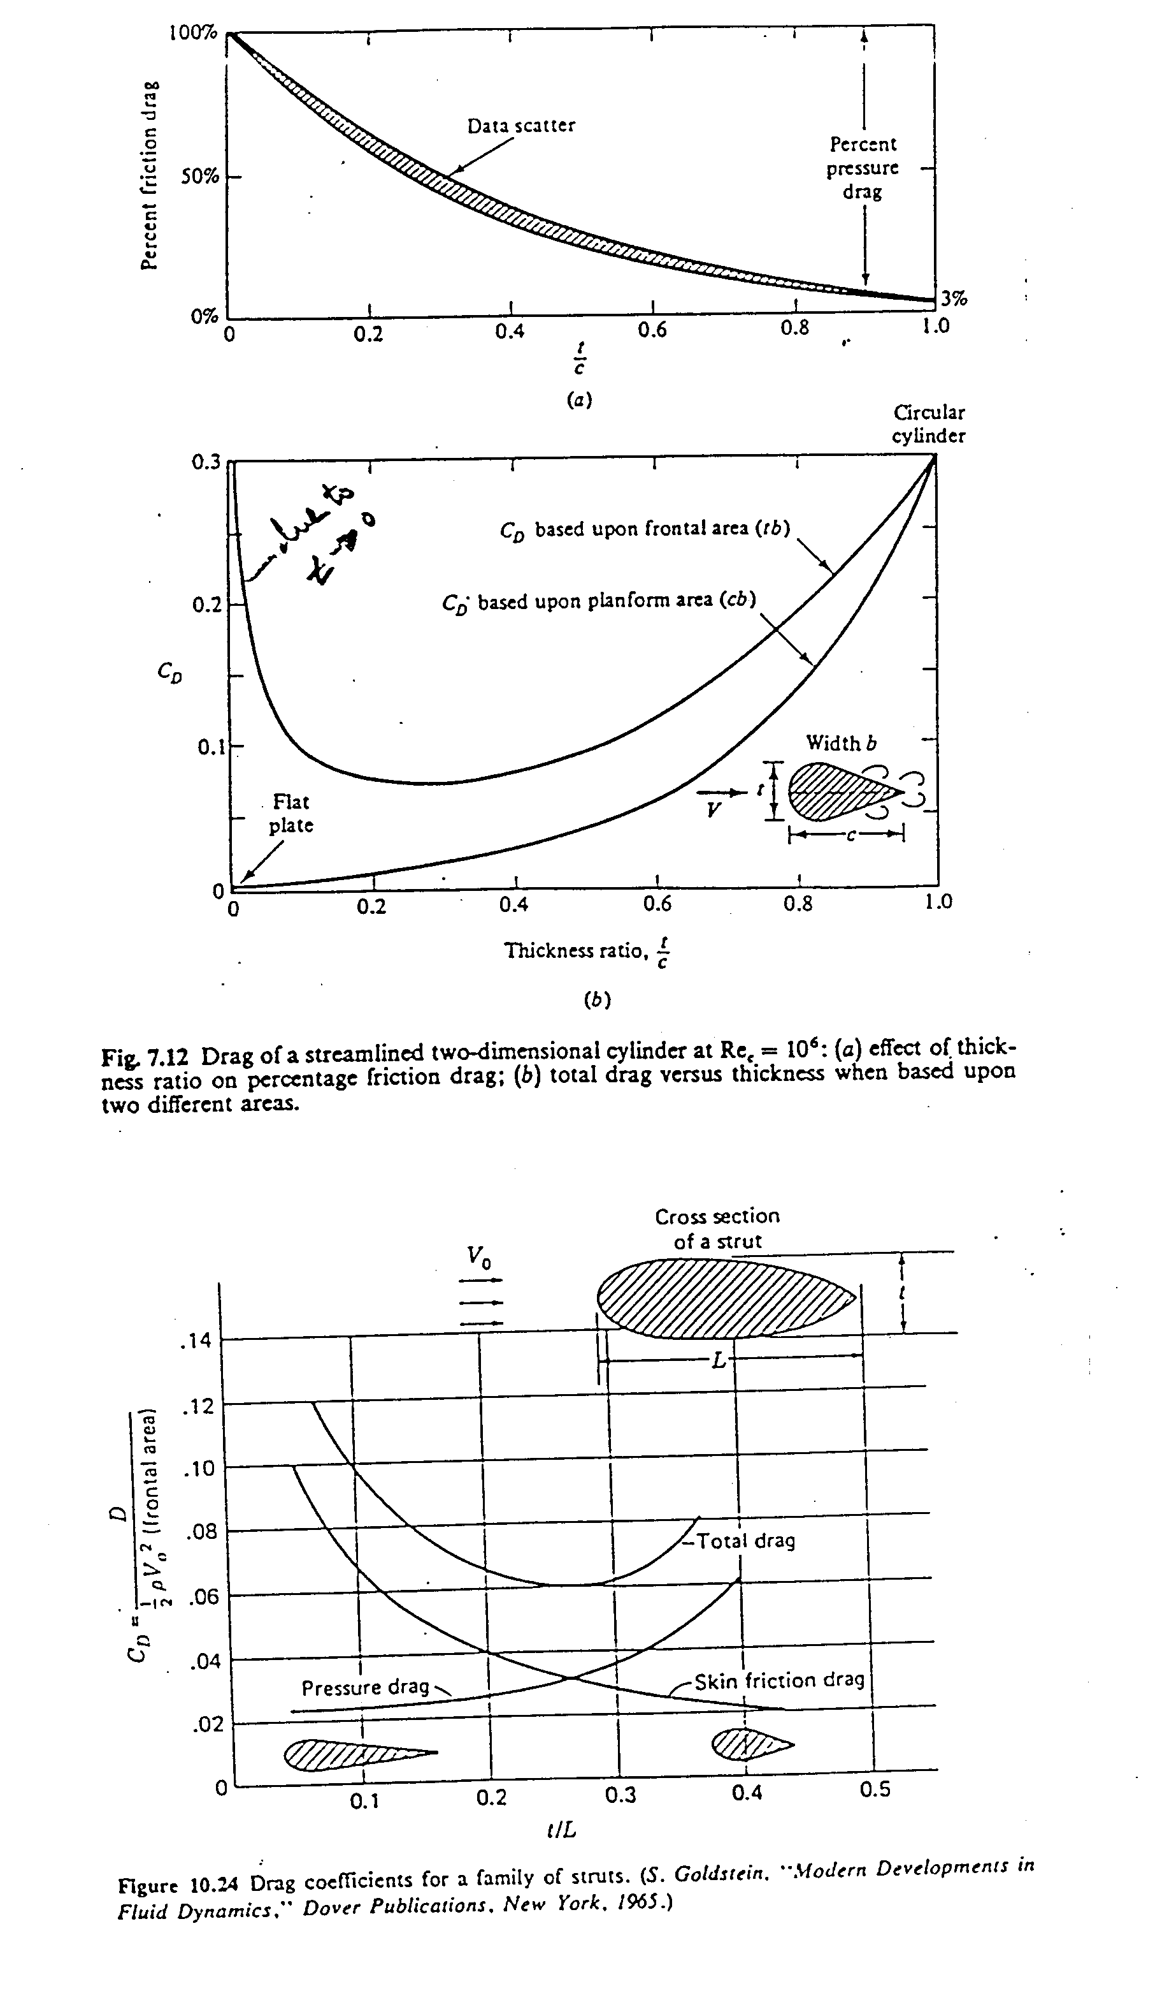
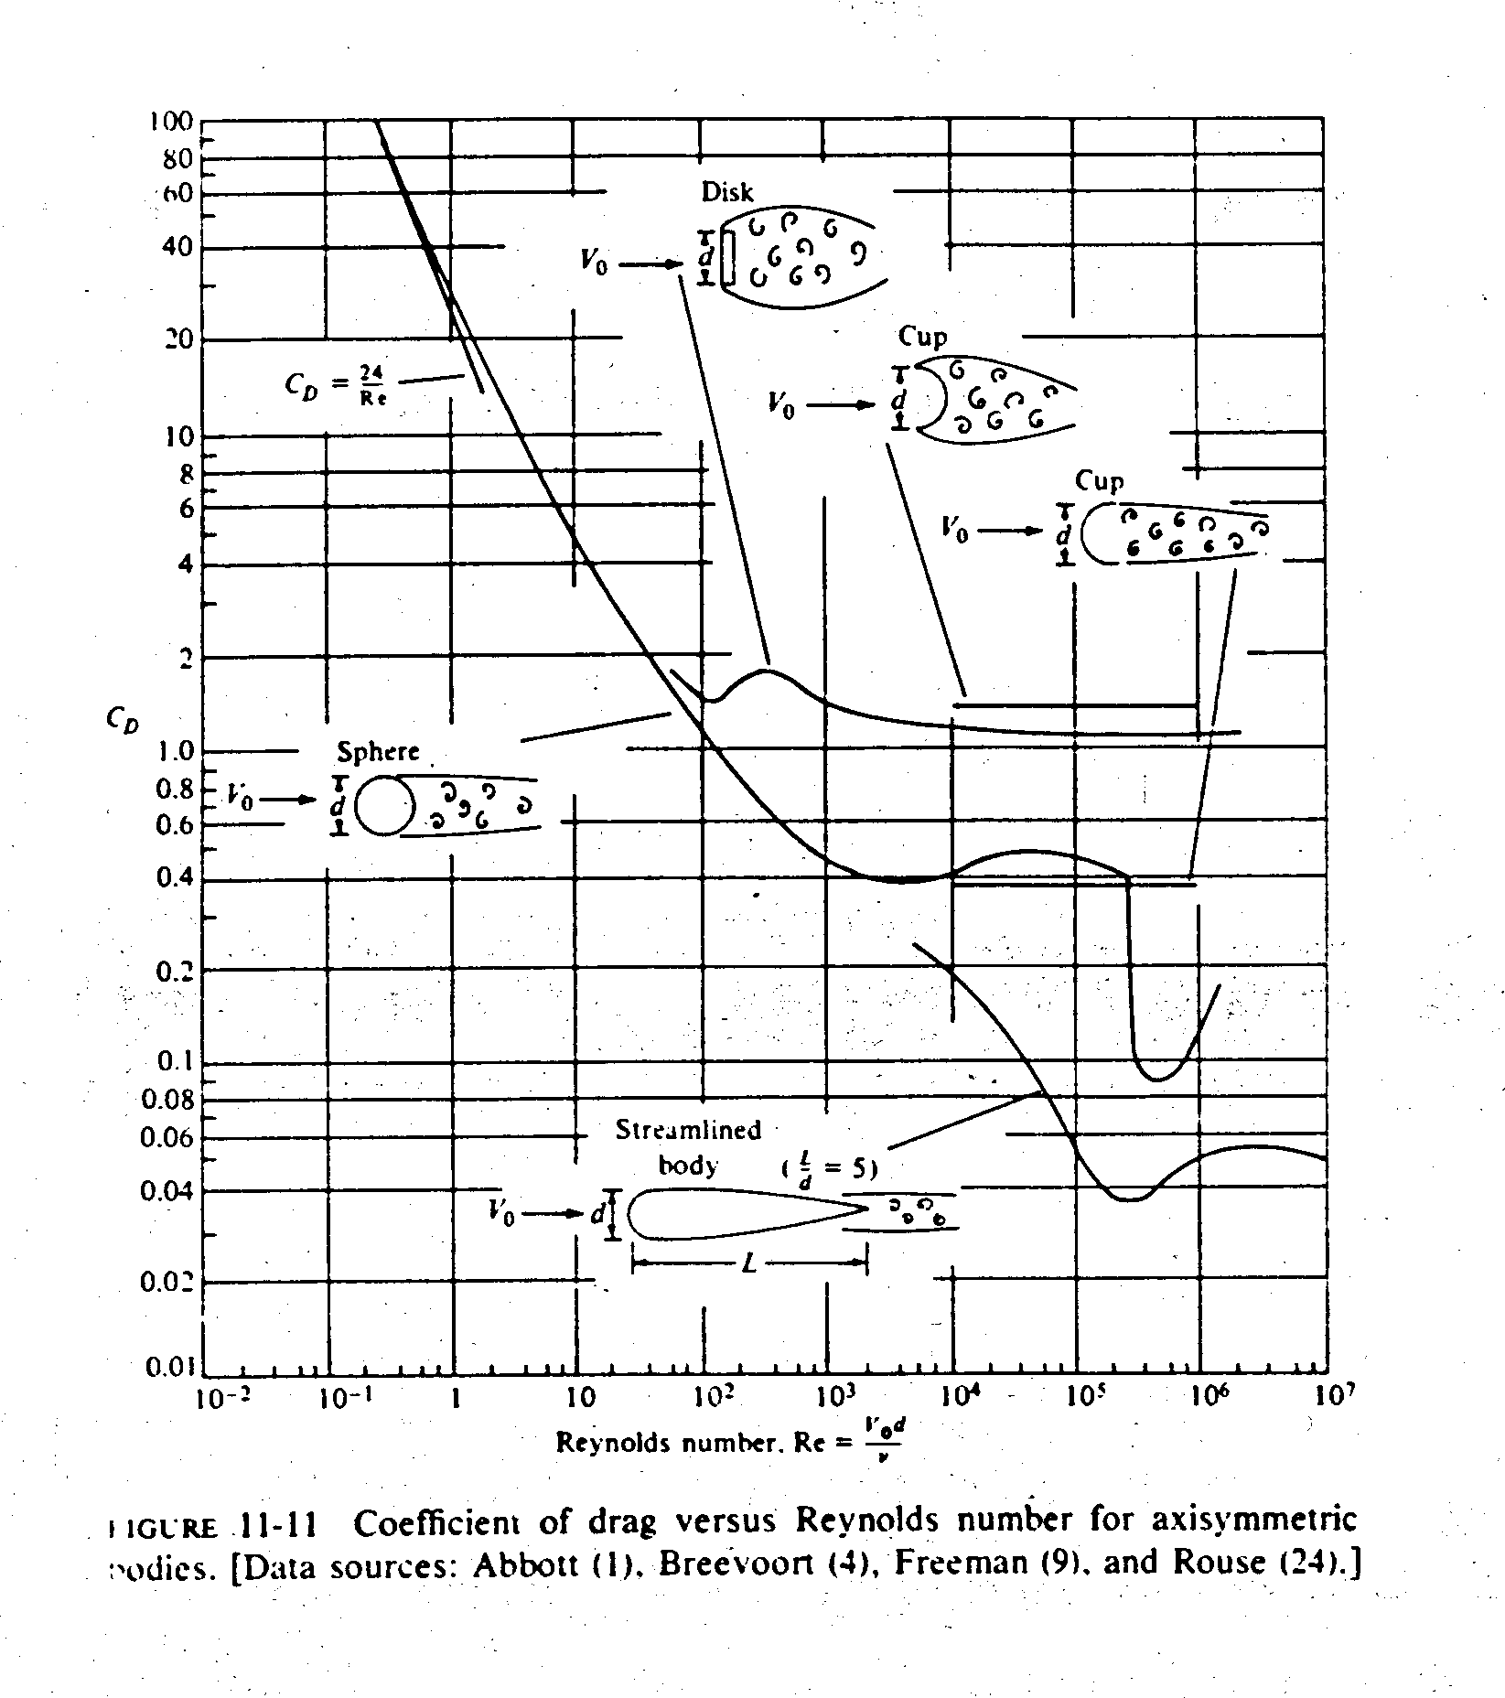

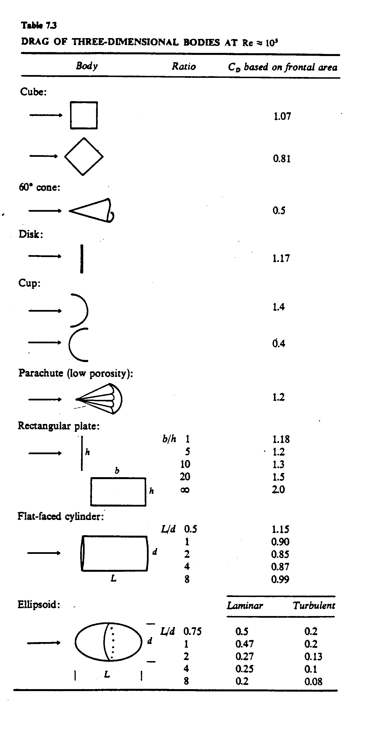
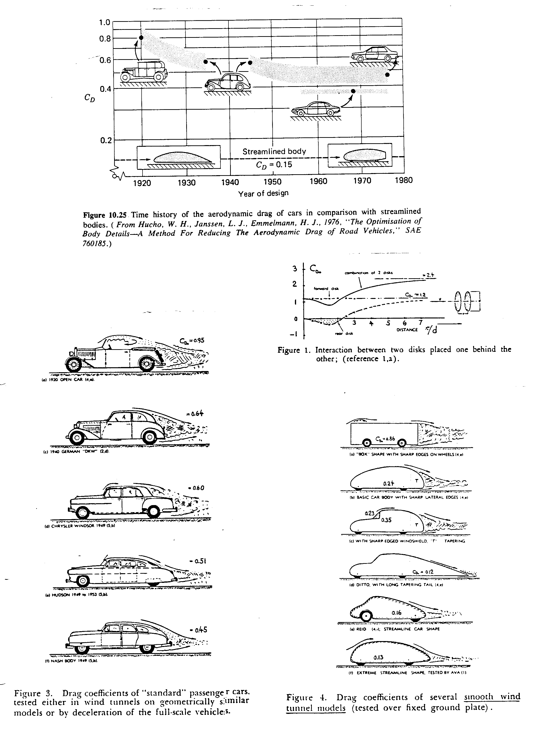

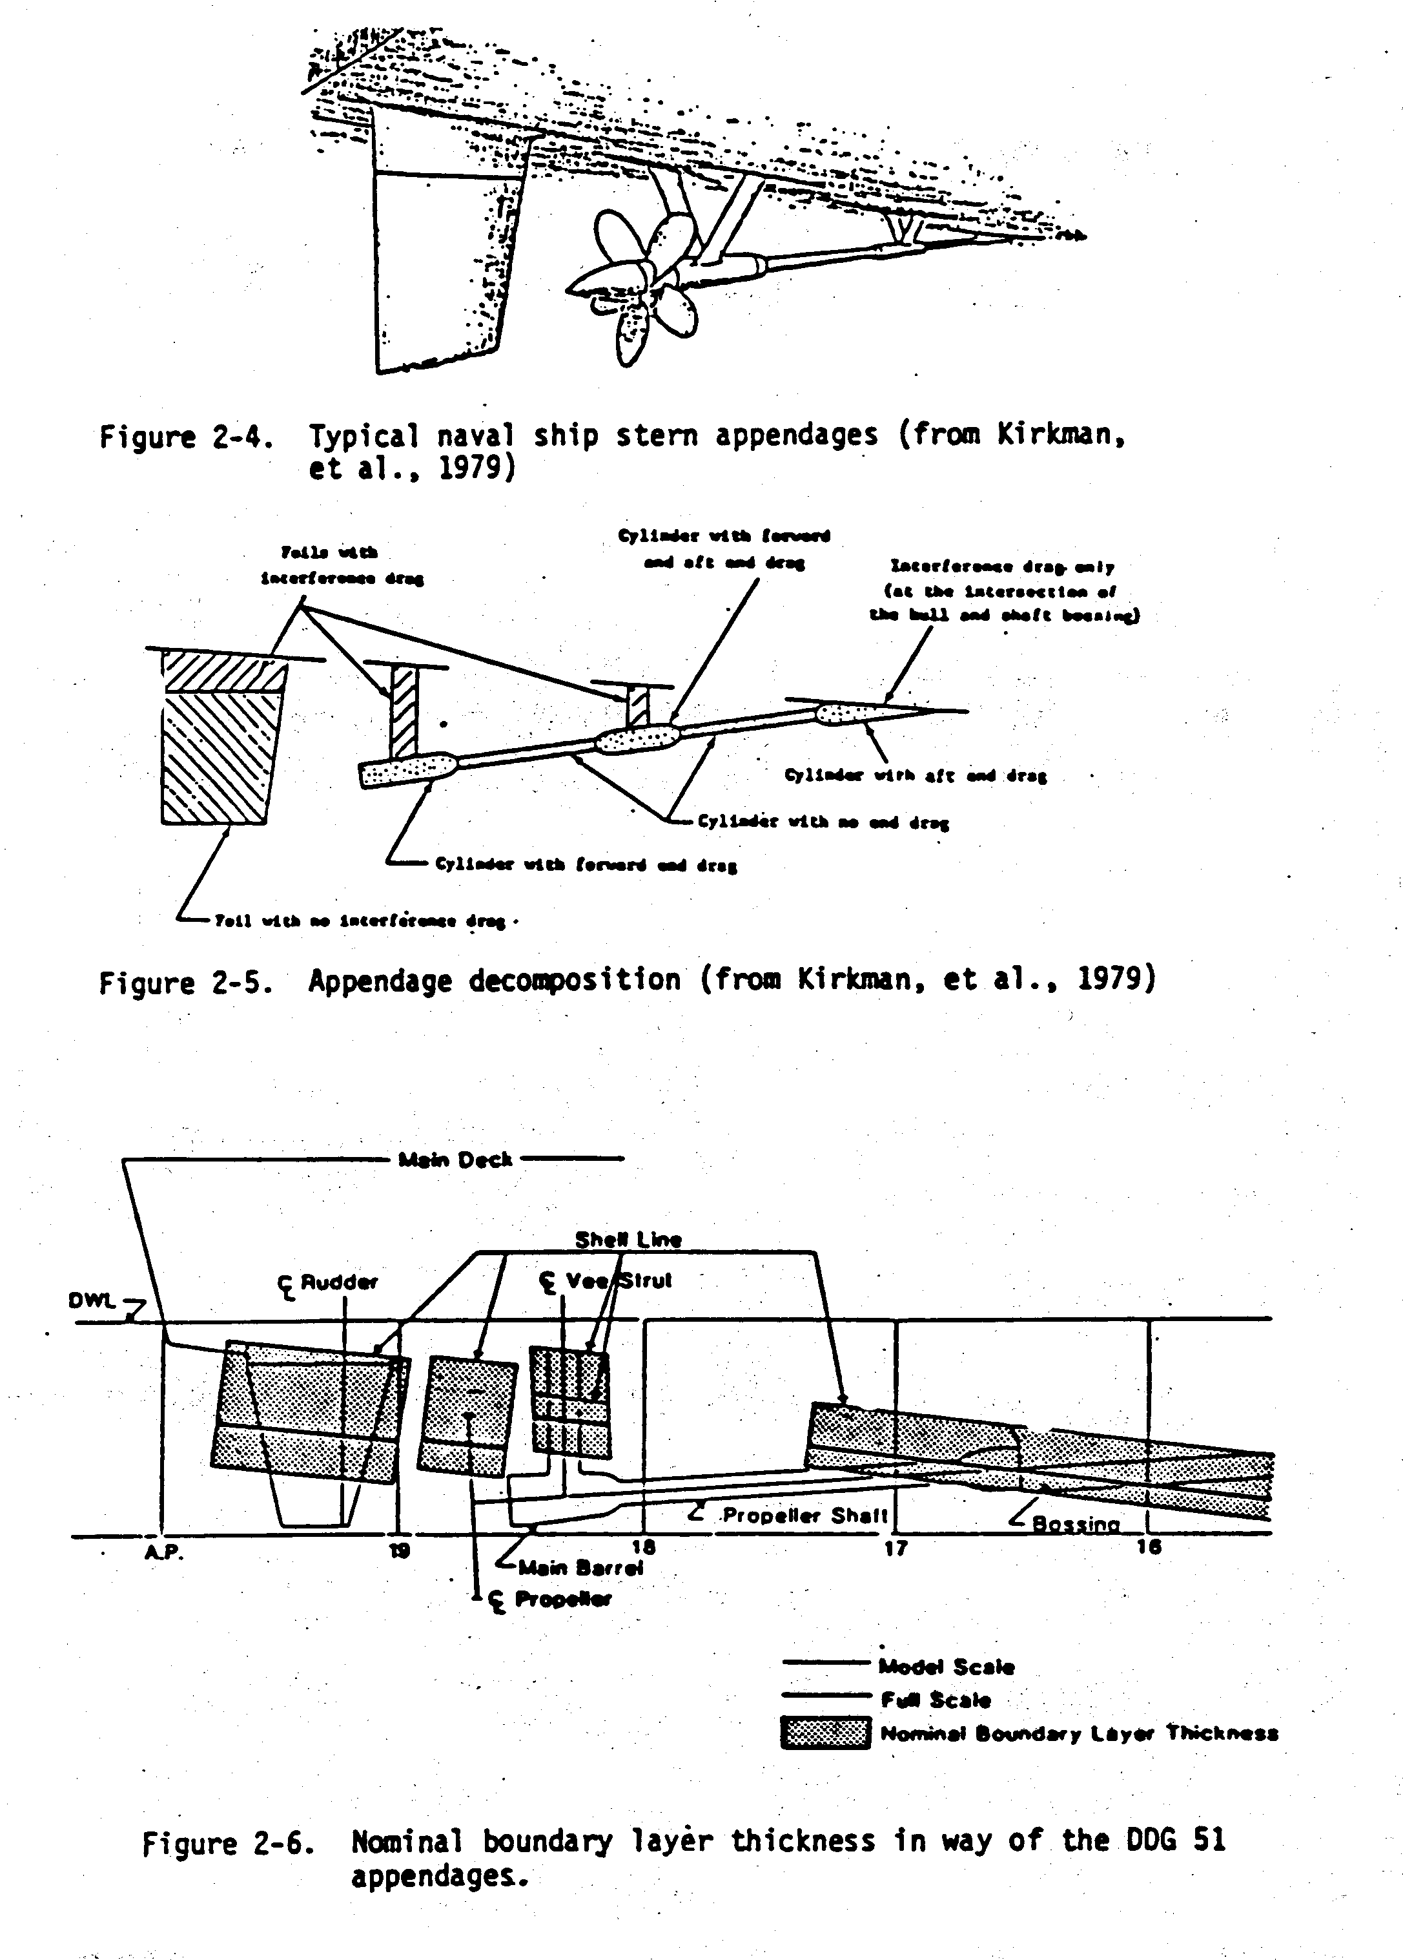

Magnus effect: Lift generation by spinning

Breaking the symmetry causes the lift!
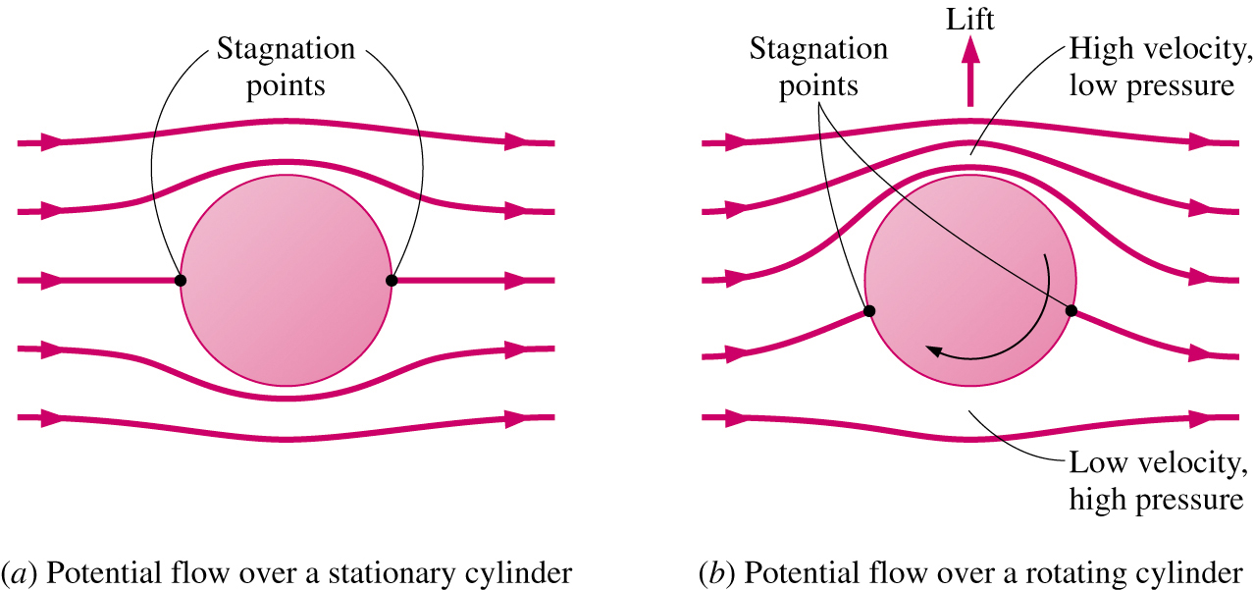

Effect of the rate of rotation on the lift and drag coefficients of a smooth sphere:
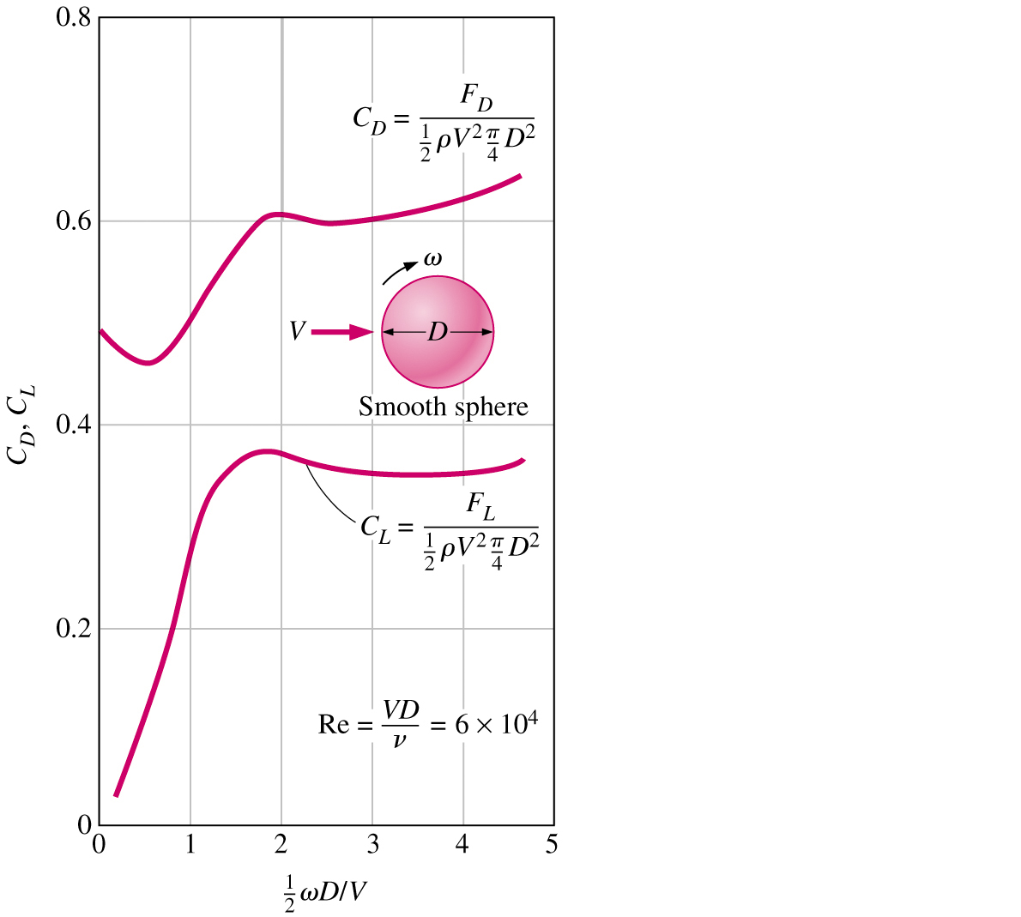
Lift acting on the airfoil

Lift force: the component of the net force (viscous+pressure) that is perpendicular to the flow direction

Variation of the lift-to-drag ratio with angle of attack:
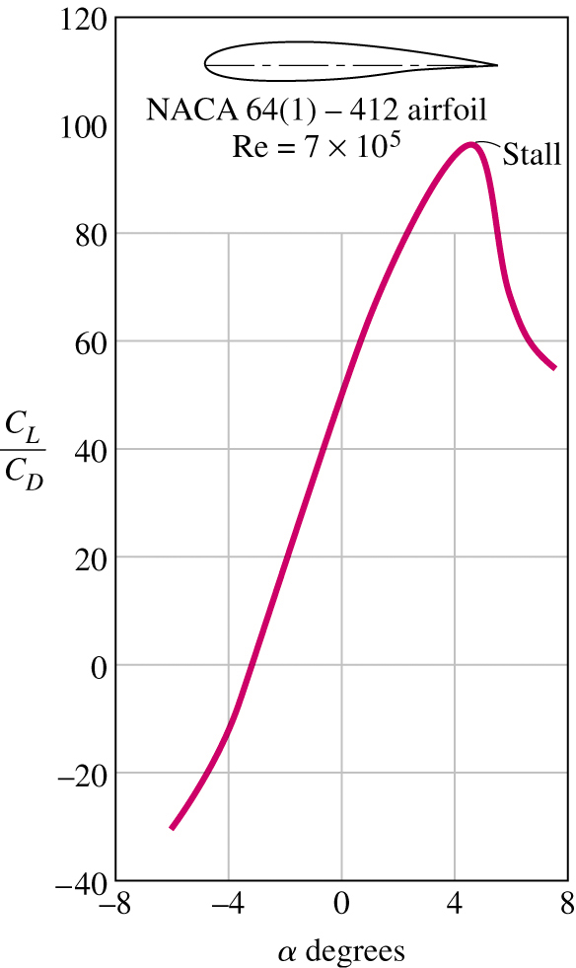
The minimum flight velocity:
→Total weight W of the aircraft be equal to the lift

$$W=F_{L}=\frac{1}{2}C_{L\text{,max}}{ρV}_{\text{min}}^{2}A→V_{\text{min}}=\sqrt{\frac{2W}{{ρC}_{L\text{,max}}A}}$$
11.3 Effect of Compressibility on Drag: C_{D} = C_{D}(Re, Ma)

$$\text{Ma}=\frac{U_{∞}}{a}$$
speed of sound = rate at which infinitesimal
disturbances are propagated from their source into undisturbed medium
< 0.3 flow is incompressible,
i.e., ρ ∼ constant
Ma < 1 subsonic
Ma ∼ 1 transonic (=1 sonic flow)
Ma > 1 supersonic
Ma >> 1 hypersonic

C_{D} increases for Ma ∼ 1 due to shock waves and wave drag

Ma_{critical}(sphere) ∼ .6

Ma_{critical}(slender bodies) ∼ 1

For U > a: upstream flow is not warned of approaching
disturbance which results in the formation of shock waves across which flow properties and streamlines change discontinuously

