Chapter 10 Approximate Solutions of the NS Equations

10.1 The Creeping Flow Approximation
See Textbook P476

10.2 Approximation for Inviscid Regions of Flow
See Textbook P481

10.3 The Irrotational Flow Approximation
See Textbook P485

10.4 Qualitative Description of the Boundary Layer

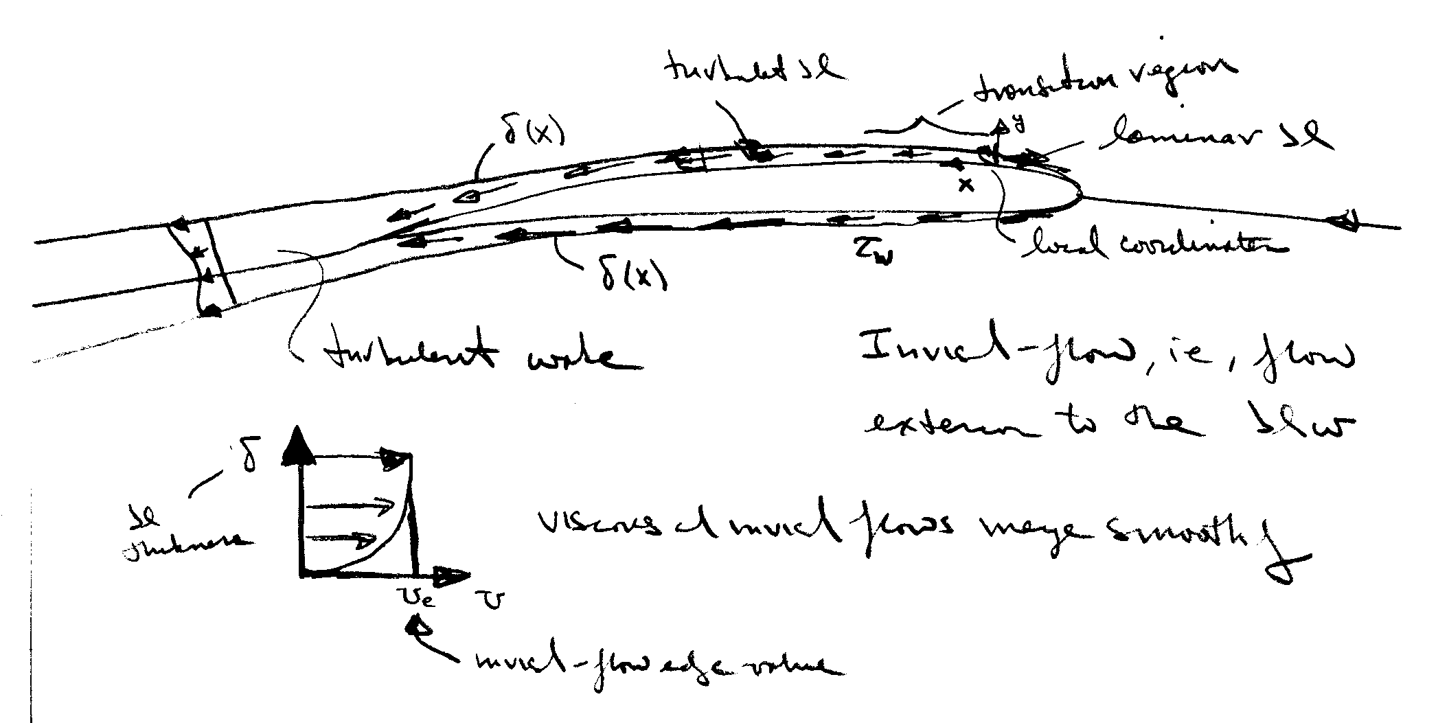
Recall our previous description of the flow-field regions for high Re flow about slender bodies

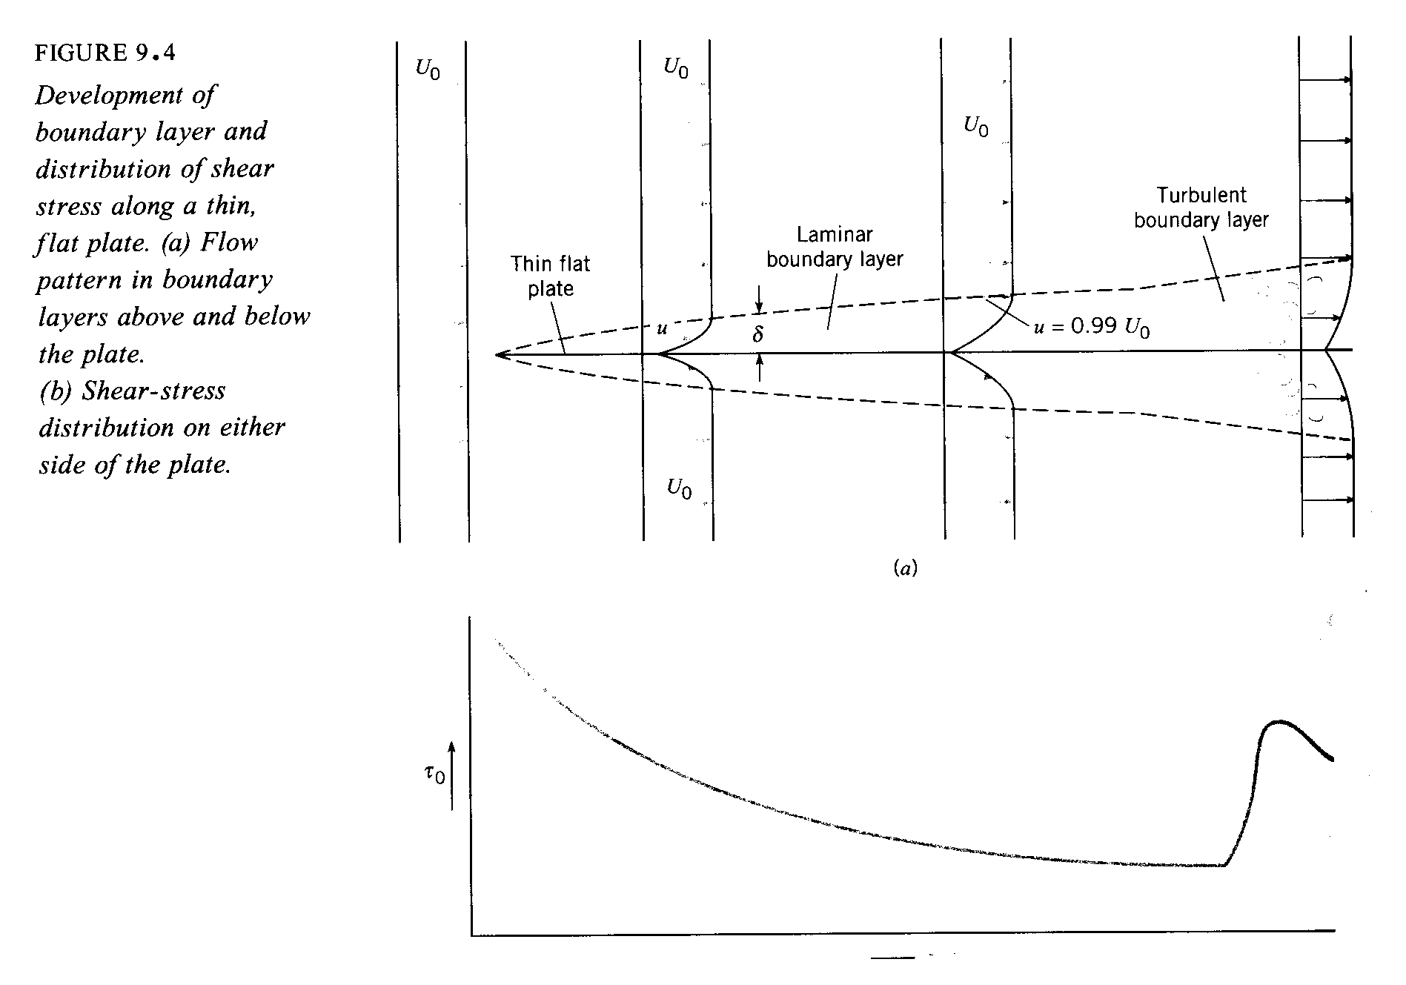

τ_{w} = shear stress

τ_{w} ∝ rate of strain (velocity gradient)

=$μ\frac{∂u}{∂y}|_{y=0}$

large near the surface where
fluid undergoes large changes to satisfy the no-slip condition

Boundary layer theory is a simplified form of the complete NS equations and provides τ_{w} as well as a means of estimating C_{form}. Formally, boundary-layer theory represents the asymptotic form of the Navier-Stokes equations for high Re flow about slender bodies. As mentioned before, the NS equations are 2nd order nonlinear PDE and their solutions represent a formidable challenge. Thus, simplified forms have proven to be very useful.

Near the turn of the century (1904), Prandtl put forth boundary-layer theory, which resolved D’Alembert’s paradox. As mentioned previously, boundary-layer theory represents the asymptotic form of the NS equations for high Re flow about slender bodies. The latter requirement is necessary since the theory is restricted to unseparated flow. In fact, the boundary-layer equations are singular at separation, and thus, provide no information at or beyond separation. However, the requirements of the theory are met in many practical situations and the theory has many times over proven to be invaluable to modern engineering.

The assumptions of the theory are as follows:

Variable order of magnitude
u U O(1)
v δ<<L O(ε) ε = δ/L
$\frac{∂}{∂x}$ L O(1)
$\frac{∂}{∂y}$ 1/δ O(ε⁻¹)
ν δ² ε²
The theory assumes that viscous effects are confined to a thin layer close to the surface within which there is a dominant flow direction (x) such that u ∼ U and v << u. However, gradients across δ are very large in order to satisfy the no slip condition.

Next, we apply the above order of magnitude estimates to the NS equations.
$u\frac{∂u}{∂x}+v\frac{∂u}{∂y}=−\frac{∂p}{∂x}+μ\left(\frac{∂^{2}u}{∂x^{2}}+\frac{∂^{2}u}{∂y^{2}}\right)$
1 1 ε ε⁻¹ ε² 1 ε⁻²

$u\frac{∂v}{∂x}+v\frac{∂v}{∂y}=−\frac{∂p}{∂y}+μ\left(\frac{∂^{2}v}{∂x^{2}}+\frac{∂^{2}v}{∂x^{2}}\right)$
elliptic
1 ε ε 1 ε² 1 ε⁻¹

$\frac{∂u}{∂x}+\frac{∂v}{∂y}=0$
- 1

Retaining terms of O(1) only results in the celebrated boundary-layer equations
$u\frac{∂u}{∂x}+v\frac{∂u}{∂y}=−\frac{∂p}{∂x}+μ\frac{∂^{2}u}{∂y^{2}}$
parabolic
$\frac{∂p}{∂y}=0$
$$\frac{∂u}{∂x}+\frac{∂v}{∂y}=0$$
Some important aspects of the boundary-layer equations:
- the y-momentum equation reduces to

$$\frac{∂p}{∂y}=0$$

i.e., p = p_{e} = constant across the boundary layer
edge value, i.e., inviscid flow value!
from the Bernoulli equation:
$p_{e}+\frac{1}{2}{ρU}_{e}^{2}=$constant
i.e., $\frac{∂p_{e}}{∂x}=−{ρU}_{e}\frac{∂U_{e}}{∂x}$

Thus, the boundary-layer equations are solved subject to a specified inviscid pressure distribution

- continuity equation is unaffected

- Although NS equations are fully elliptic, the boundary-layer equations are parabolic and can be solved using marching techniques

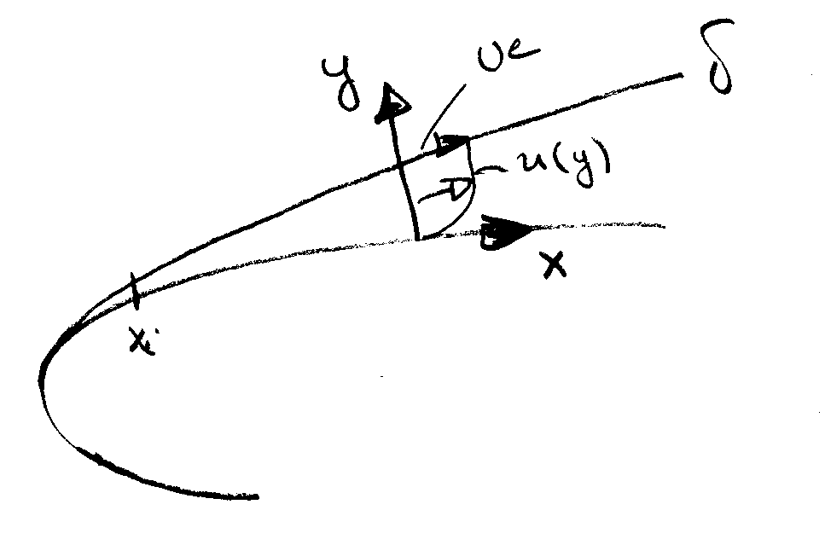
- Boundary conditions

u = v = 0 y = 0

u = U_{e} y = δ

+ appropriate initial conditions @ x_{i}
There are quite a few analytic solutions to the boundary-layer equations. Also numerical techniques are available for arbitrary geometries, including both two- and three-dimensional flows. Here, as an example, we consider the simple, but extremely important case of the boundary layer development over a flat plate.

10.5 Quantitative Relations for the Laminar Boundary Layer

Laminar boundary-layer over a flat plate: Blasius solution (1908) student of Prandtl
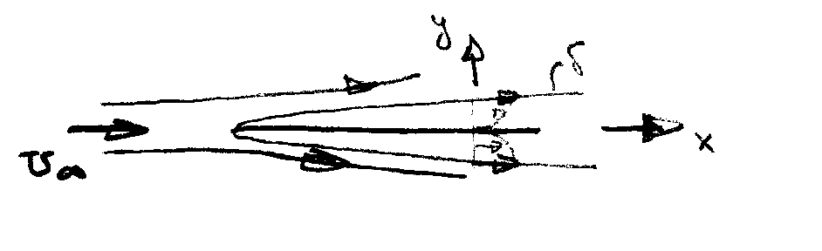
$\frac{∂u}{∂x}+\frac{∂v}{∂y}=0$
Note: $\frac{∂p}{∂x}$ = 0 for a flat plate
$u\frac{∂u}{∂x}+v\frac{∂u}{∂y}=ν\frac{∂^{2}u}{∂y^{2}}$

u = v = 0 @ y = 0 u = U∞ @ y = δ

We now introduce a dimensionless transverse coordinate and a stream function, i.e.,

$η=y\sqrt{\frac{U_{∞}}{νx}}∝\frac{y}{δ}$

$ψ=\sqrt{ν{\text{xU}}_{∞}}f\left(η\right)$
$u=\frac{∂ψ}{∂y}=\frac{∂ψ}{∂η}\frac{∂η}{∂y}=U_{∞}f^{'}\left(η\right)$ $f^{'}=u/{U_{∞}}$

$v=−\frac{∂ψ}{∂x}=\frac{1}{2}\sqrt{\frac{{νU}_{∞}}{x}}\left(ηf^{'}−f\right)$

substitution into the boundary-layer equations yields

$ff^{''}+2f^{'''}=0$ Blasius Equation

$f=f^{'}=0$ @ η = 0 $f^{'}=1$ @ η = 1

The Blasius equation is a 3rd order ODE which can be solved by standard methods (Runge-Kutta). Also, series solutions are possible. Interestingly, although simple in appearance no analytic solution has yet been found. Finally, it should be recognized that the Blasius solution is a similarity solution, i.e., the non-dimensional velocity profile f′ vs. η is independent of x. That is, by suitably scaling all the velocity profiles have neatly collapsed onto a single curve.

Now, lets consider the characteristics of the Blasius solution:
$\frac{u}{U_{∞}}$ vs. y

$\frac{v}{U_{∞}}\sqrt{\frac{U_{∞}}{V}}$ vs. y
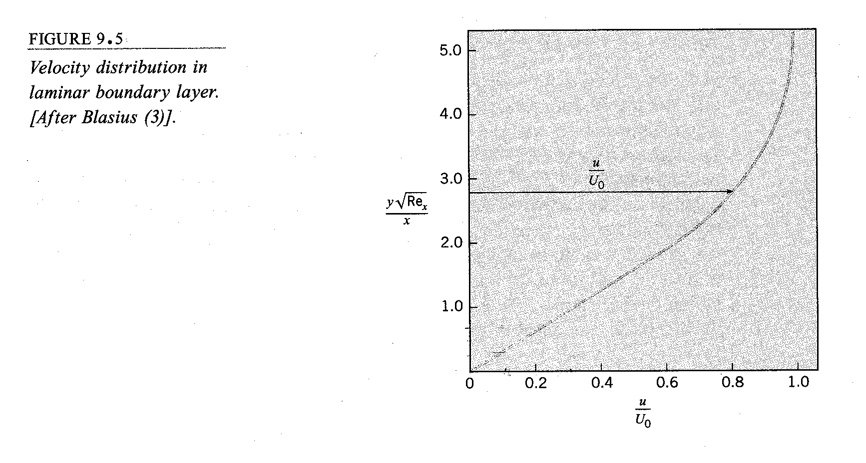
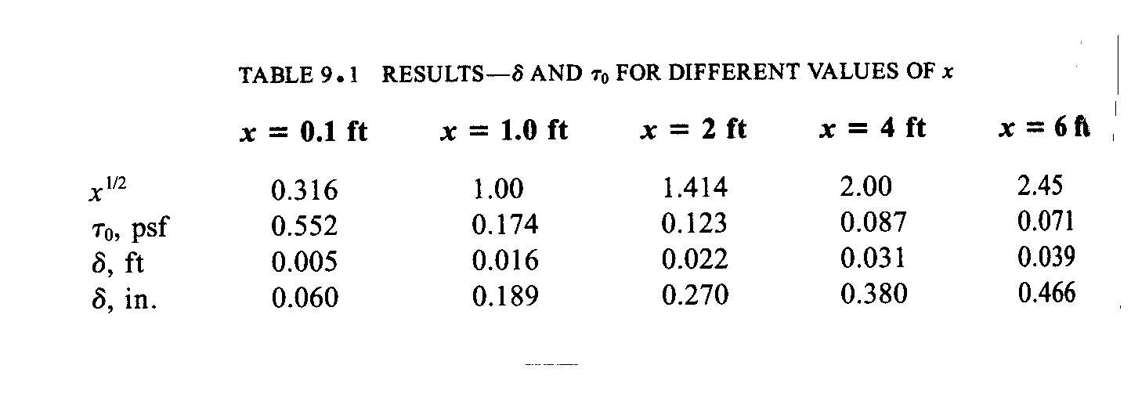

$δ=\frac{5x}{\sqrt{\text{Re}}}$ value of y where u/U∞ = .99

$${\text{Re}}_{x}=\frac{U_{∞}x}{ν}$$

$τ_{w}=\frac{{μU}_{∞}f^{''}(0)}{\sqrt{2{νx}/{U_{∞}}}}$

i.e., $c_{f}=\frac{2τ_{w}}{{ρU}_{∞}^{2}}=\frac{0\text{.}\text{664}}{\sqrt{{\text{Re}}_{x}}}=\frac{θ}{x}$ see below

$C_{f}=\frac{1}{L}\int_{0}^{L}{c_{f}\text{dx}=2c_{f}(L)}$
=$\frac{1\text{.}\text{328}}{\sqrt{{\text{Re}}_{L}}}$

$\frac{U_{∞}L}{ν}$
Other:
$δ^{}=\int_{0}^{δ}{\left(1−\frac{u}{U_{∞}}\right)\text{dy}=1\text{.}\text{7208}\frac{x}{\sqrt{{\text{Re}}_{x}}}}$ displacement thickness

measure of displacement of inviscid flow to due boundary layer

$θ=\int_{0}^{δ}{\left(1−\frac{u}{U_{∞}}\right)\frac{u}{U_{∞}}\text{dy}=0\text{.}\text{664}\frac{x}{\sqrt{{\text{Re}}_{x}}}}$ momentum thickness

measure of loss of momentum due to boundary layer

H = shape parameter = $\frac{δ^{}}{θ}$=2.5916
10.6 Quantitative Relations for the Turbulent Boundary
Layer

Description of Turbulent Flow
V and p are random functions of time in a turbulent flow
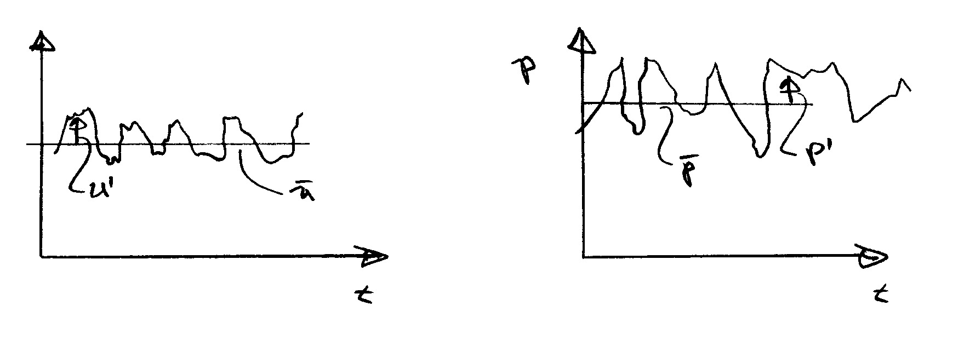
The mathematical complexity of turbulence entirely precludes any exact analysis. A statistical theory is well developed; however, it is both beyond the scope of this course and not generally useful as a predictive tool. Since the time of Reynolds (1883) turbulent flows have been analyzed by considering the mean (time averaged) motion and the influence of turbulence on it; that is, we separate the velocity and pressure fields into mean and fluctuating components

$u=\overline{u}+u^{'}$ $p=\overline{p}+p^{'}$
$v=\overline{v}+v^{'}$ and for compressible flow
$w=\overline{w}+w^{'}$ $ρ=\overline{ρ}+ρ^{'} \text{and} T=\overline{T}+T^{'}$

where (for example)
and t₁sufficiently large that the average is independent of time
$\overline{u}=\frac{1}{t_{1}}\int_{t_{0}}^{t_{0}+t_{1}}{\text{udt}}$

Thus by definition $\overline{u^{'}}=0$, etc. Also, note the following rules which apply to two dependent variables f and g

$\overline{\overline{f}}=\overline{f}$ $\overline{f+g}=\overline{f}+\overline{g}$

$\overline{\overline{f}⋅g}=\overline{f}⋅\overline{g}$

$\overline{\frac{∂f}{∂s}}=\frac{∂\overline{f}}{∂s}$ $\overline{\int{\text{fds}}}=\int{\overline{f}\text{ds}}$
f = (u, v, w, p)
s = (x, y, z, t)

The most important influence of turbulence on the mean motion is an increase in the fluid stress due to what are called the apparent stresses. Also known as Reynolds stresses:

$$τ_{\text{ij}}^{'}=−ρ\overline{u_{i}^{'}u_{j}^{'}}$$

$−ρ\overline{u^{}}$ $−ρ\overline{u^{'}v^{'}}$ $−ρ\overline{u^{'}w^{'}}$
Symmetric 2nd order tensor
= $−ρ\overline{u^{'}v^{'}}$ $−ρ\overline{v^{}}$ $−ρ\overline{v^{'}w^{'}}$
$−ρ\overline{u^{'}w^{'}}$ $−ρ\overline{v^{'}w^{'}}$ $−ρ\overline{w^{}}$

The mean-flow equations for turbulent flow are derived by substituting $\underline{V}=\underline{\overline{V}}+\underline{V^{'}}$ into the Navier-Stokes equations and averaging. The resulting equations, which are called the Reynolds-averaged Navier-Stokes (RANS) equations are:

Continuity $∇⋅\underline{V}=0 i\text{.}e\text{.} ∇⋅\underline{\overline{V}}=0 \text{and} ∇⋅\underline{V^{'}}=0$

Momentum $ρ\frac{D\overline{V}}{\text{Dt}}+ρ\frac{∂}{∂x_{j}}\left(\overline{u_{i}^{'}u_{j}^{'}}\right)=−ρg\hat{k}−∇\overline{p}+μ∇^{2}\overline{\underline{V}}$
or $ρ\frac{D\overline{V}}{\text{Dt}}=−ρg\hat{k}−∇\overline{p}+∇⋅τ_{\text{ij}}$
u₁ = u x₁ = x
u₂ = v x₂ = y
u₃ = w x₃ = z

$τ_{\text{ij}}=μ\left[\frac{∂u_{i}}{∂x_{j}}+\frac{∂u_{j}}{∂x_{i}}\right]−ρ\overline{u_{i}^{'}u_{j}^{'}}$
Comments: $τ_{\text{ij}}^{'}$
- equations are for the mean flow
- differ from laminar equations by Reynolds stress terms = $\overline{u_{i}^{'}u_{j}^{'}}$
- influence of turbulence is to transport momentum from one point to another in a similar manner as viscosity
- since $\overline{u_{i}^{'}u_{j}^{'}}$ are unknown, the problem is indeterminate: the central problem of turbulent flow analysis is closure!

4 equations and 4 + 6 = 10 unknowns
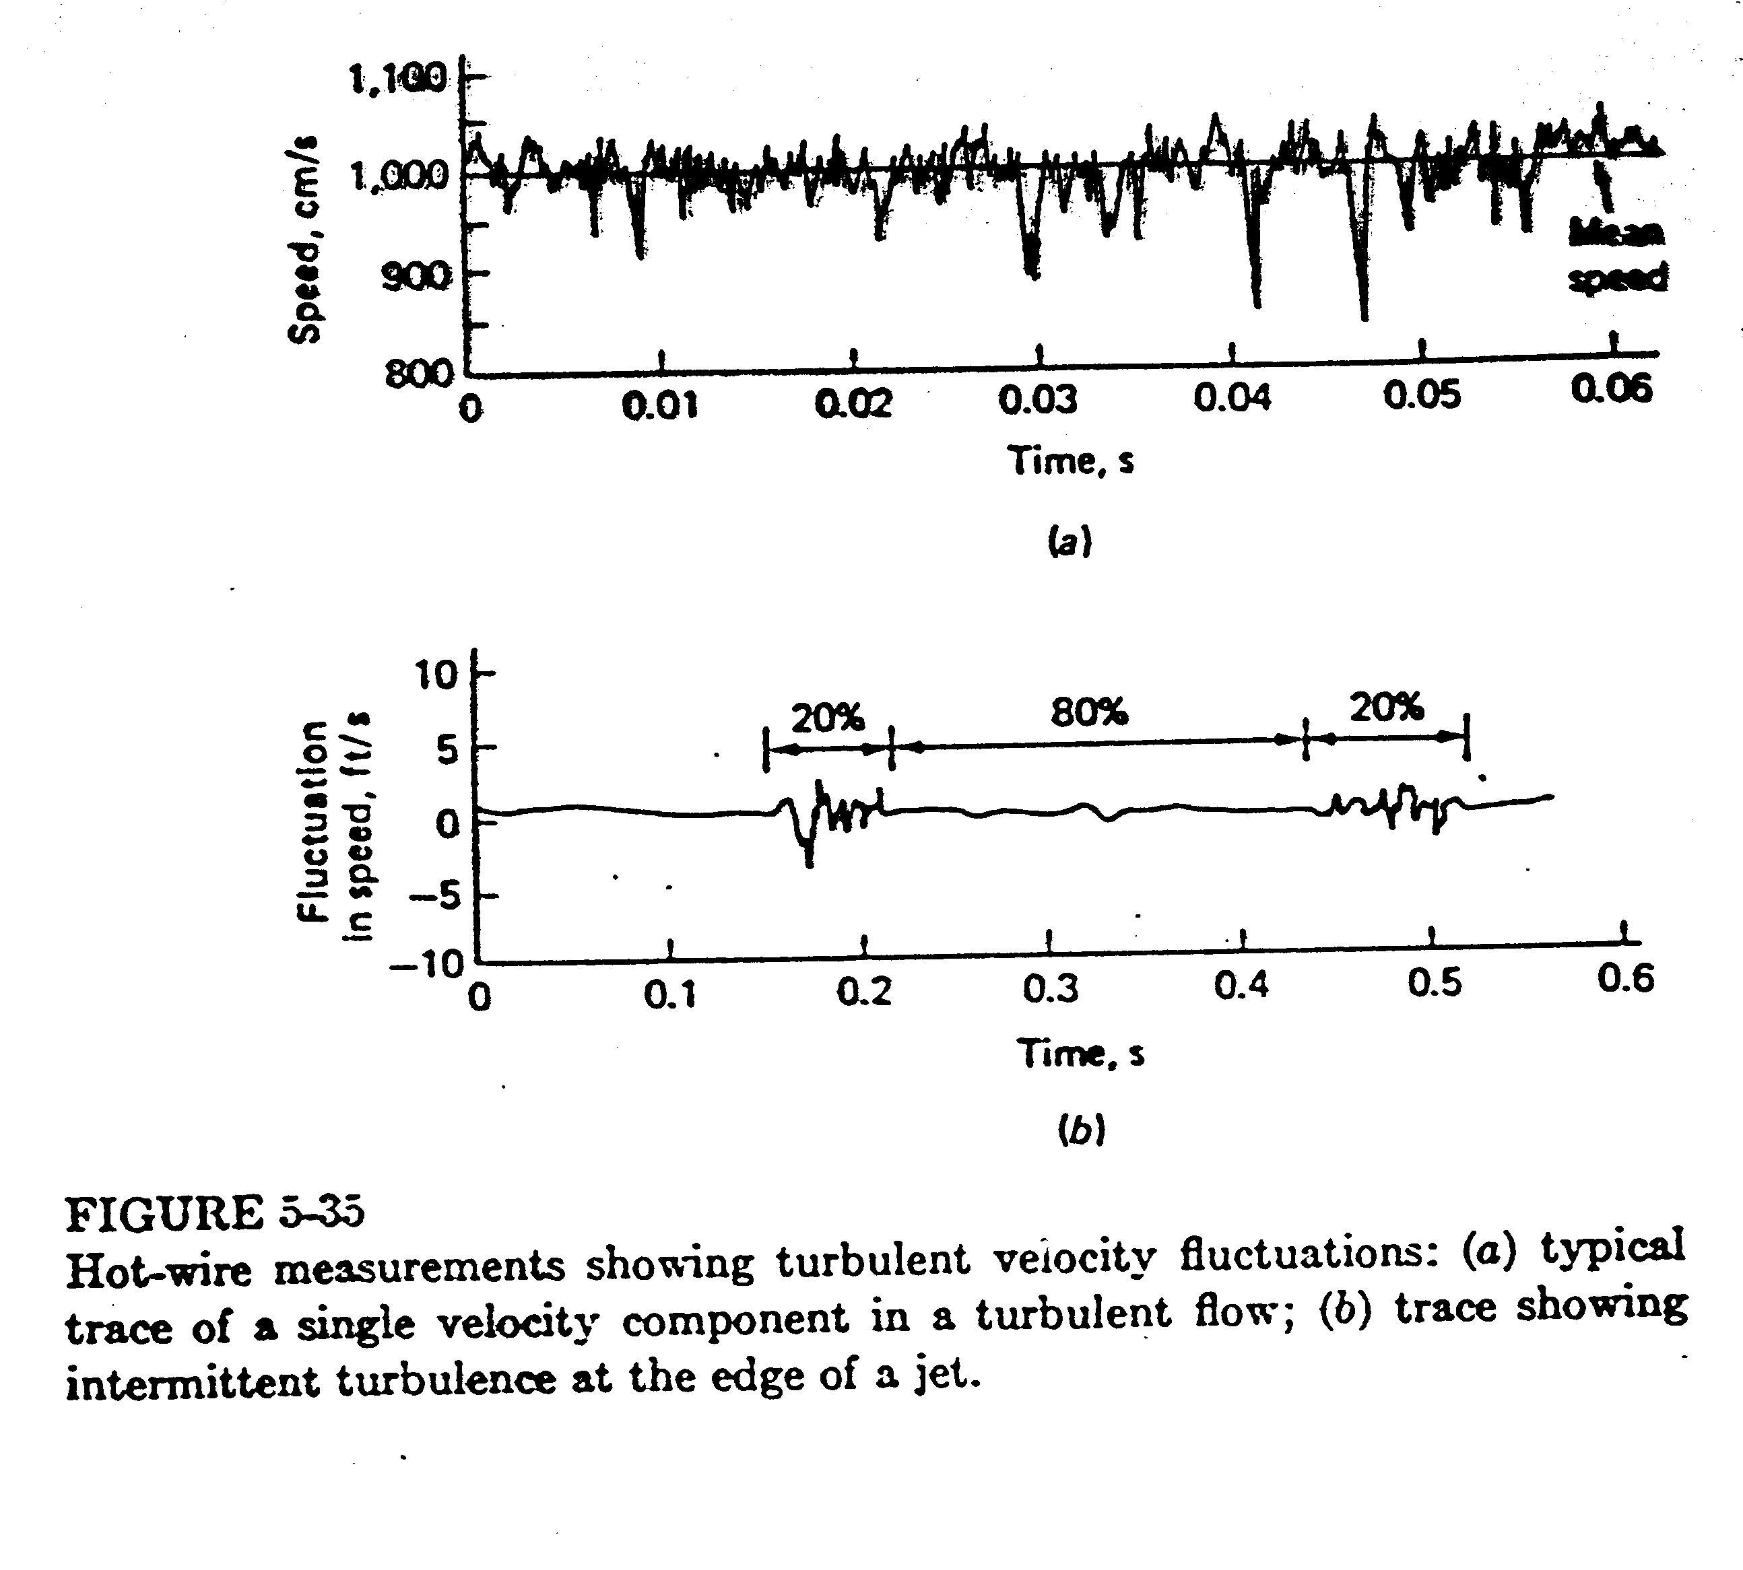
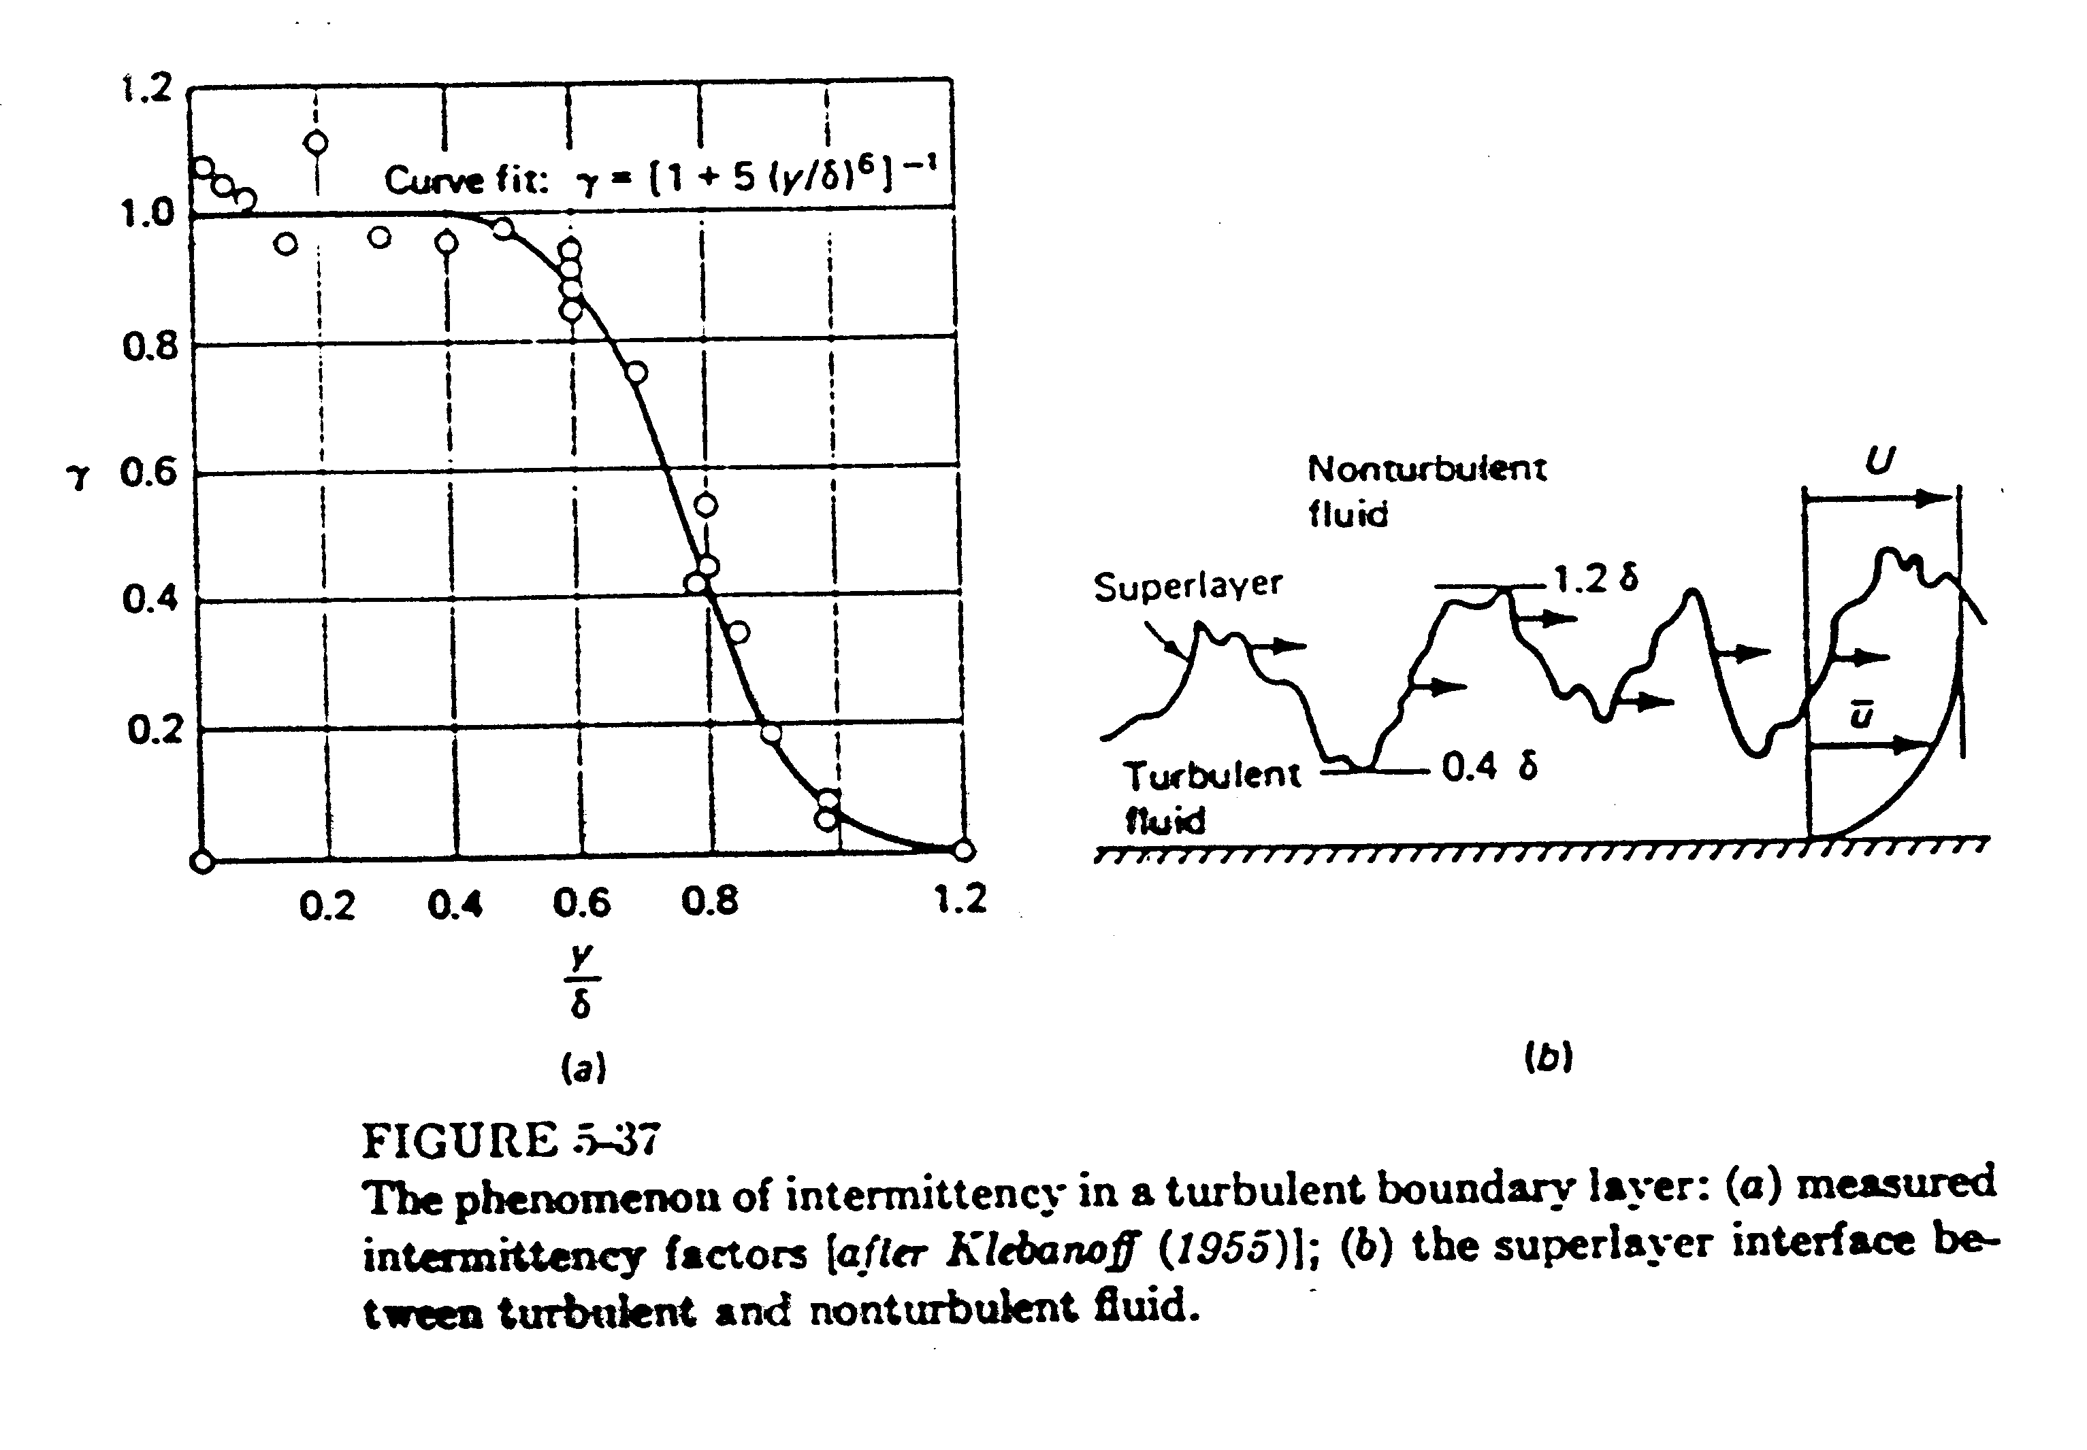
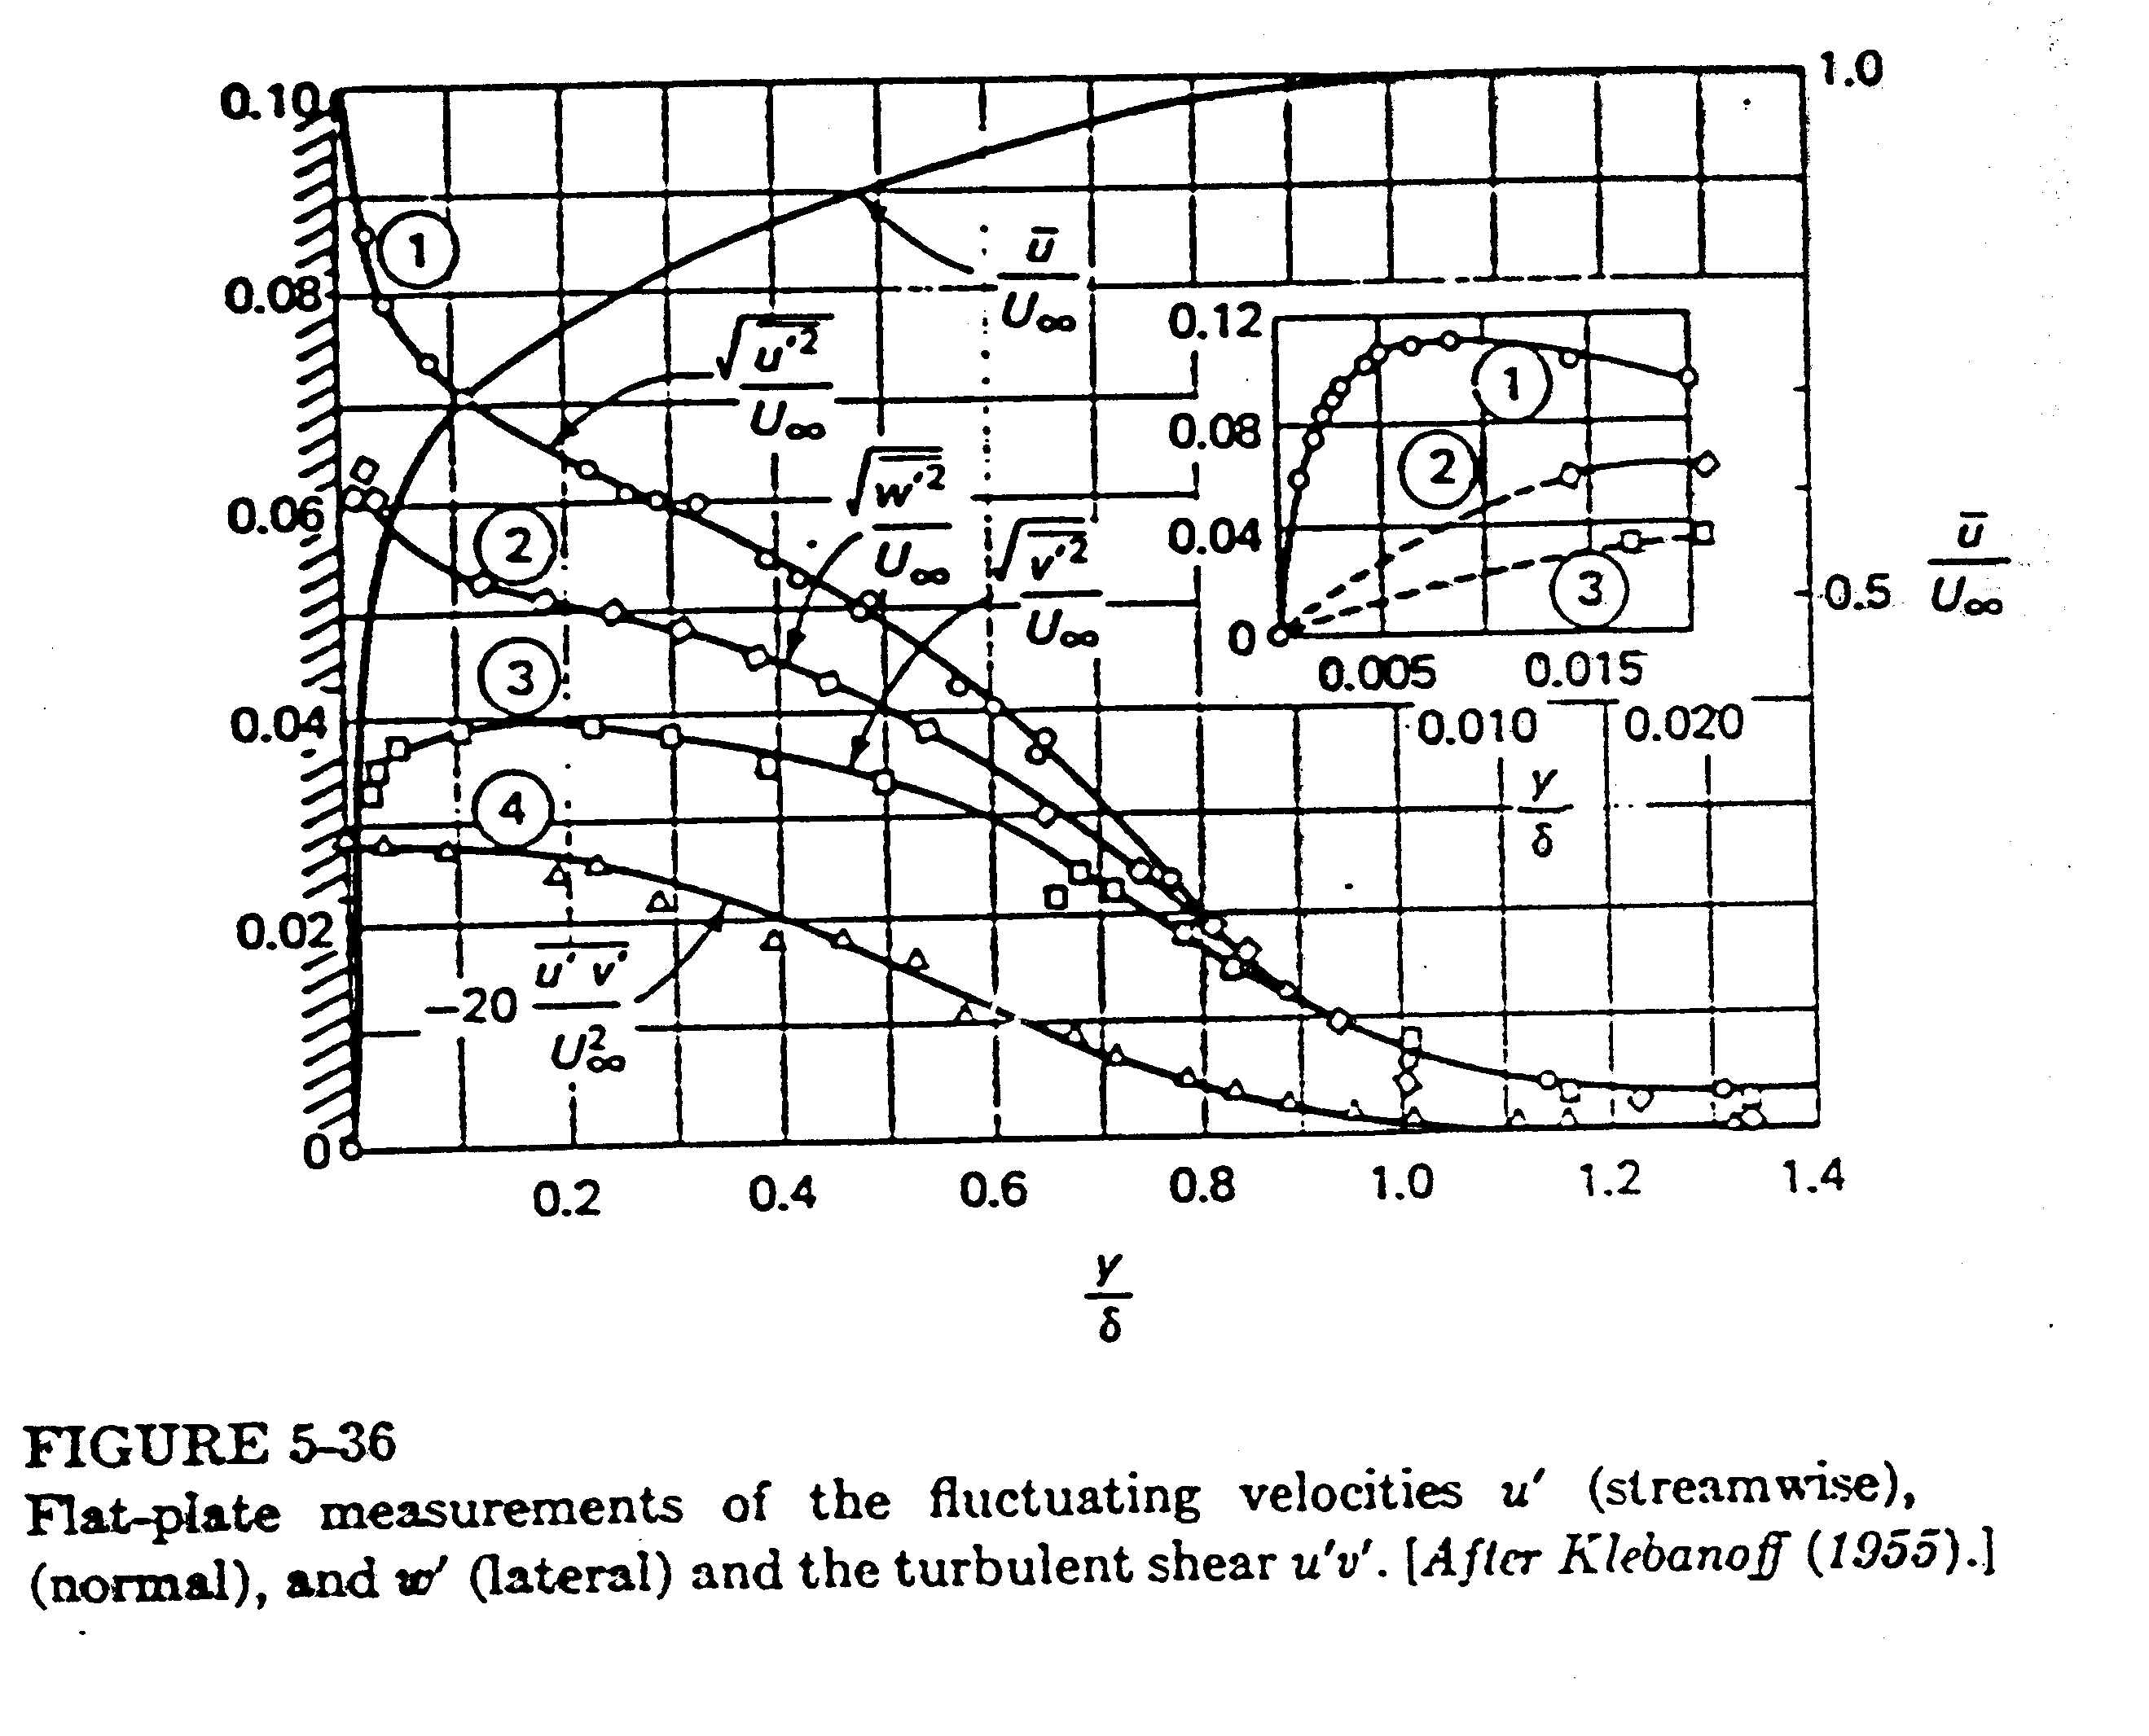

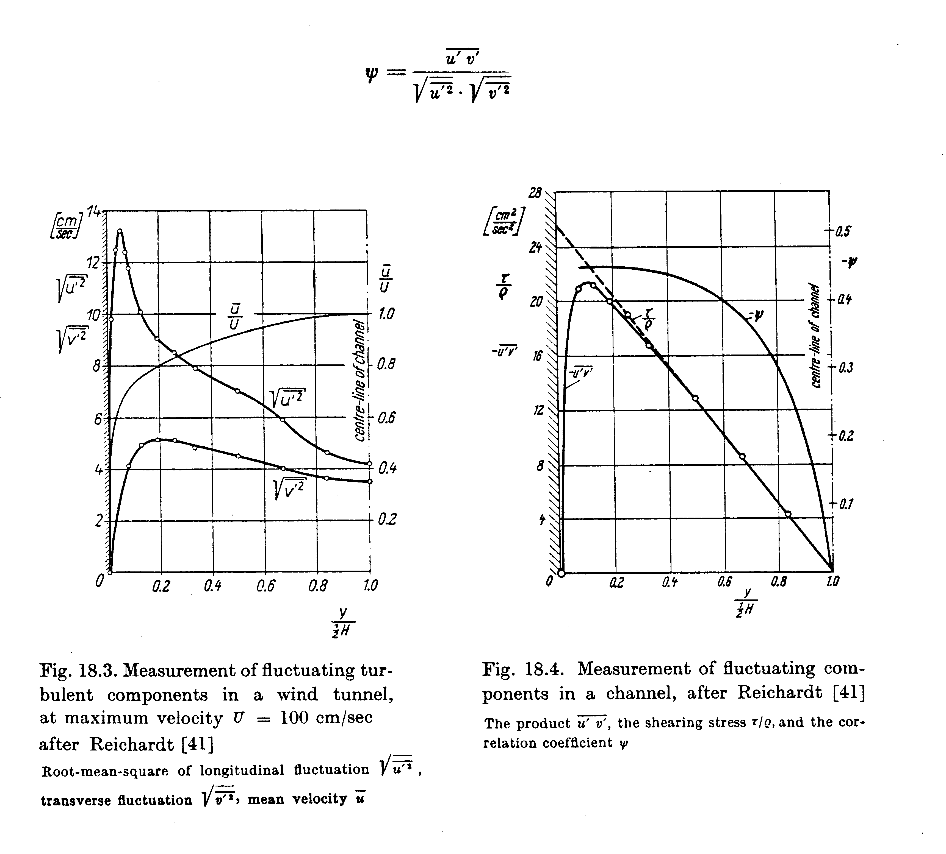

2-D Boundary-layer Form of RANS equations
$$\frac{∂u}{∂x}+\frac{∂v}{∂y}=0$$

$$u\frac{∂u}{∂x}+v\frac{∂u}{∂y}=−\frac{∂}{∂x}\left(\frac{p_{e}}{ρ}\right)+ν\frac{∂^{2}u}{∂y^{2}}−\frac{∂}{∂y}\left(\overline{u^{'}v^{'}}\right)$$
requires modeling

Turbulence Modeling
Closure of the turbulent RANS equations require the determination of $−ρ\overline{u^{'}v^{'}}$, etc. Historically, two approaches were developed: (a) eddy viscosity theories in which the Reynolds stresses are modeled directly as a function of local geometry and flow conditions; and (b) mean-flow velocity profile correlations which model the mean-flow profile itself. The modern approaches, which are beyond the scope of this class, involve the solution for transport PDE’s for the Reynolds stresses which are solved in conjunction with the momentum equations.

- eddy-viscosity: theories
(mainly used with differential methods)
$−ρ\overline{u^{'}v^{'}}=μ_{t}\frac{∂\overline{u}}{∂y}$
In analogy with the laminar viscous stress, i.e., τ_{t} ∝ mean-flow rate of strain
The problem is reduced to modeling μ_{t}, i.e.,
μ_{t} = μ_{t}(x, flow at hand)

Various levels of sophistication presently exist in modeling μ_{t}
$$μ_{t}={ρV}_{t}L_{t}$$
turbulent length scale
where V_{t} and L_{t} are based an large scale turbulent motion
turbulent velocity scale

The total stress is
$τ_{\text{total}}=\left(μ+μ_{t}\right)\frac{∂\overline{u}}{∂y}$
molecular viscosity
eddy viscosity
(for high Re flow μ_{t} >> μ)

Mixing-length theory (Prandtl, 1920)
based on kinetic theory of gases
$−ρ\overline{u^{'}v^{'}}=cρ\sqrt{{\overline{u^{'}}}^{2}}\sqrt{{\overline{v^{'}}}^{2}}$

$\sqrt{{\overline{u^{'}}}^{2}}=ℓ_{1}\frac{∂\overline{u}}{∂y}$
$ℓ_{1} \text{and} ℓ_{2}$are mixing lengths which are analogous to molecular mean free path, but much larger

$\sqrt{{\overline{v^{'}}}^{2}}=ℓ_{2}\frac{∂\overline{u}}{∂y}$

⇒ $−ρ\overline{u^{'}v^{'}}={ρℓ}^{2}\left|\frac{∂\overline{u}}{∂y}\right|\frac{∂\overline{u}}{∂y}$
distance across shear layer
Known as a zero equation model since no additional PDE’s are solved, only an algebraic relation
$ℓ=ℓ\left(y\right)$

= f(boundary layer, jet, wake, etc.)
Although mixing-length theory has provided a very useful tool for engineering analysis, it lacks generality. Therefore, more general methods have been developed.

One and two equation models

$μ_{t}=\frac{{Cρk}^{2}}{ε}$

C = constant

k² = turbulent kinetic energy
= $\overline{u^{}}=\overline{u^{}+v^{}+w^{}}$

ε = turbulent dissipation rate

Governing PDE’s are derived for k and ε which contain terms that require additional modeling. Although more general then the zero-equation models, the k-ε model also has definite limitation; therefore, recent work involves the solution of PDE’s for the Reynolds stresses themselves. Difficulty is that these contain triple correlations that are very difficult to model.

- mean-flow velocity profile correlations
(mainly used with integral methods)
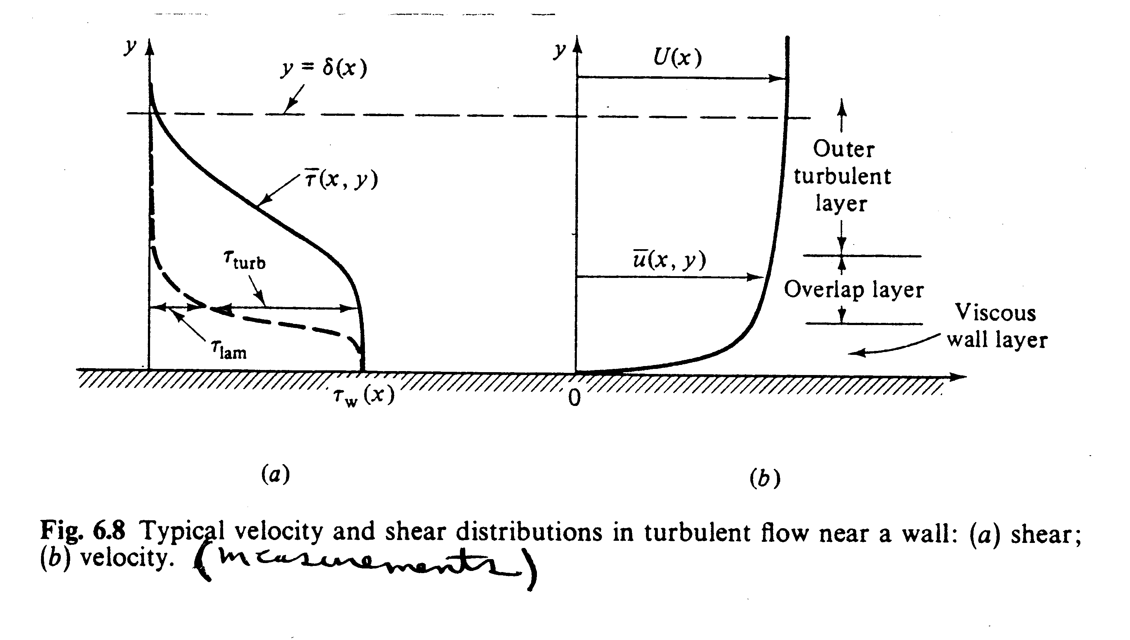
As an alternative to modeling the Reynolds stresses one can model mean flow profile directly. For simple 2-D flows this approach is quite food and will be used in this course. For complex and 3-D flows generally not successful. Consider the shape of turbulent velocity profiles.

Note that very near the wall τ_{laminar} must dominate since
$−ρ\overline{u_{i}u_{j}}$= 0 at the wall (y = 0) and in the outer part turbulent stress will dominate. This leads to the three layer concept:

Inner layer: viscous stress dominates

Outer layer: turbulent stress dominates

Overlap layer: both types of stress important

- Inner layer (Prandtl, 1930)

u = f(μ, τ_{w}, ρ, y) note: not f(δ)
From dimensional analysis
$u^{+}=f\left(y^{+}\right)$ law-of-the-wall

u⁺ = y⁺

where: $u^{+}=\frac{u}{u^{}}$

u* = friction velocity = $\sqrt{{τ_{w}}/ρ}$

$y^{+}=\frac{{\text{yu}}^{}}{ν}$

very near the wall:
τ ∼ τ_{w} ∼ constant = $μ\frac{\text{du}}{\text{dy}}$ ⇒ $u=\text{cy}$ or u⁺ = y⁺

- Outer layer (Karmen, 1933)

$${\left(U_{e}−u\right)}_{\text{outer}}=g\left(δ,τ_{w},ρ,y\right)$$
note: independent of μ and actually also depends on $\frac{\text{dp}}{\text{dx}}$

$\frac{U_{e}−u}{u^{}}=f\left(\frac{y}{δ}\right)$ velocity defect law
From dimensional analysis
- Overlap layer (Milliken, 1937)
In order for the inner and outer layers to merge smooth

$\frac{u}{u^{}}=\frac{1}{κ}\text{ln}y^{+}+B$ log-law

.41 5
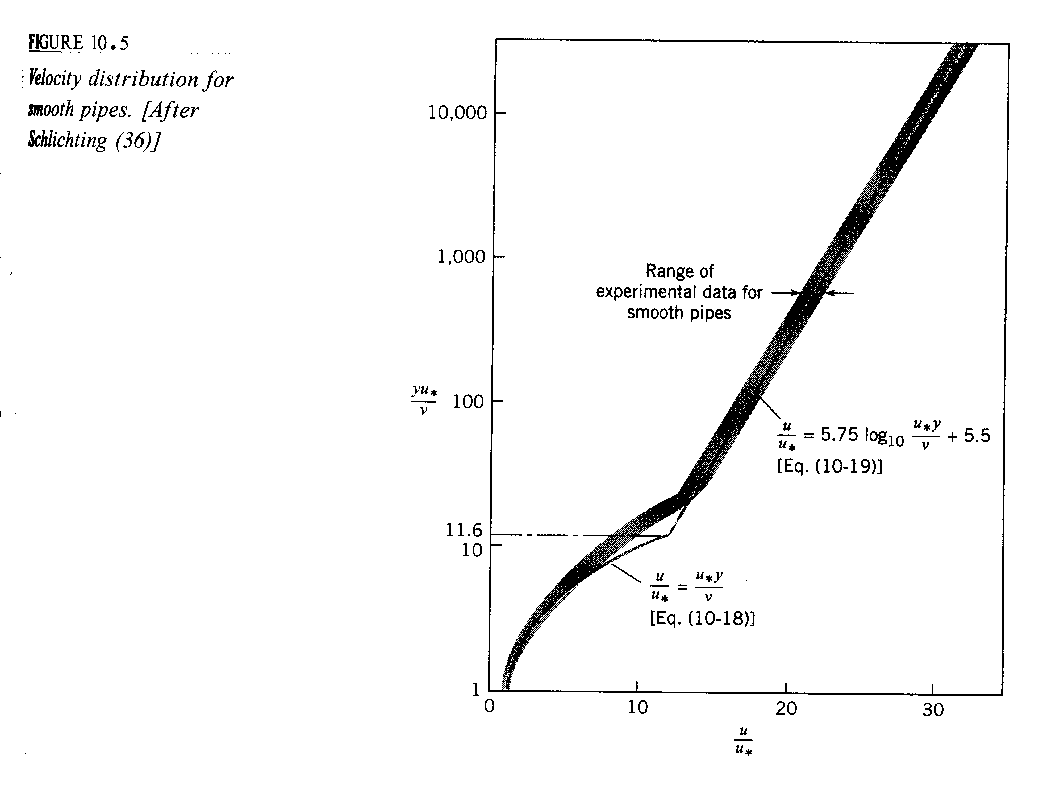
κ and B from experiments and independent of dp/dx

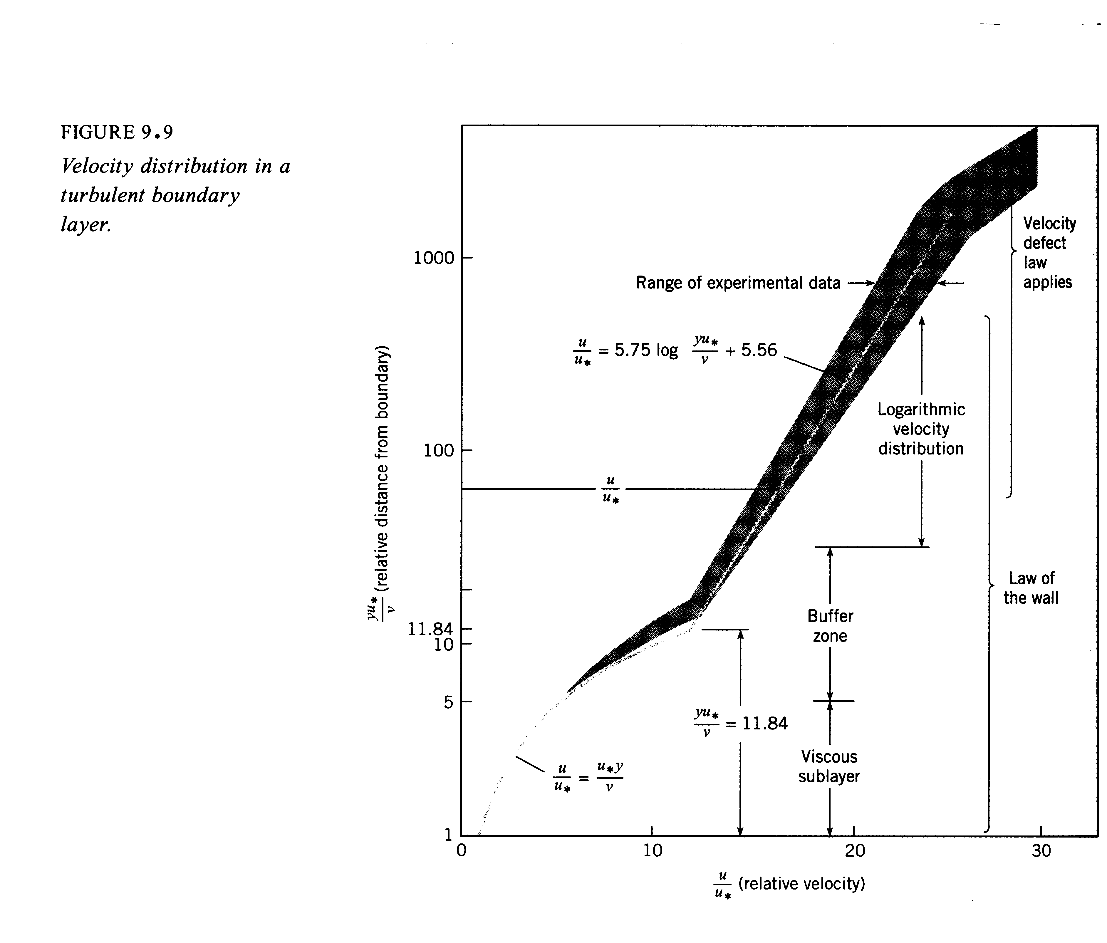
Note that the y⁺ scale is logarithmic and thus the inner law only extends over a very small portion of δ

Inner law region < .2δ

And the log law encompasses most of the boundary-layer. Thus as an approximation one can simply assume
$$\begin{aligned}u^{+}=\sqrt{{τ_{w}}/ρ} \\ y^{+}=\frac{{\text{yu}}^{}}{ν}\end{aligned}$$
$\frac{u}{u^{}}=\frac{1}{κ}\text{ln}y+B$

is valid all across the shear layer. This is the approach used in this course for turbulent flow analysis. The approach is a good approximation for simple and 2-D flows (pipe and flat plate), but does not work for complex and 3-D flows.

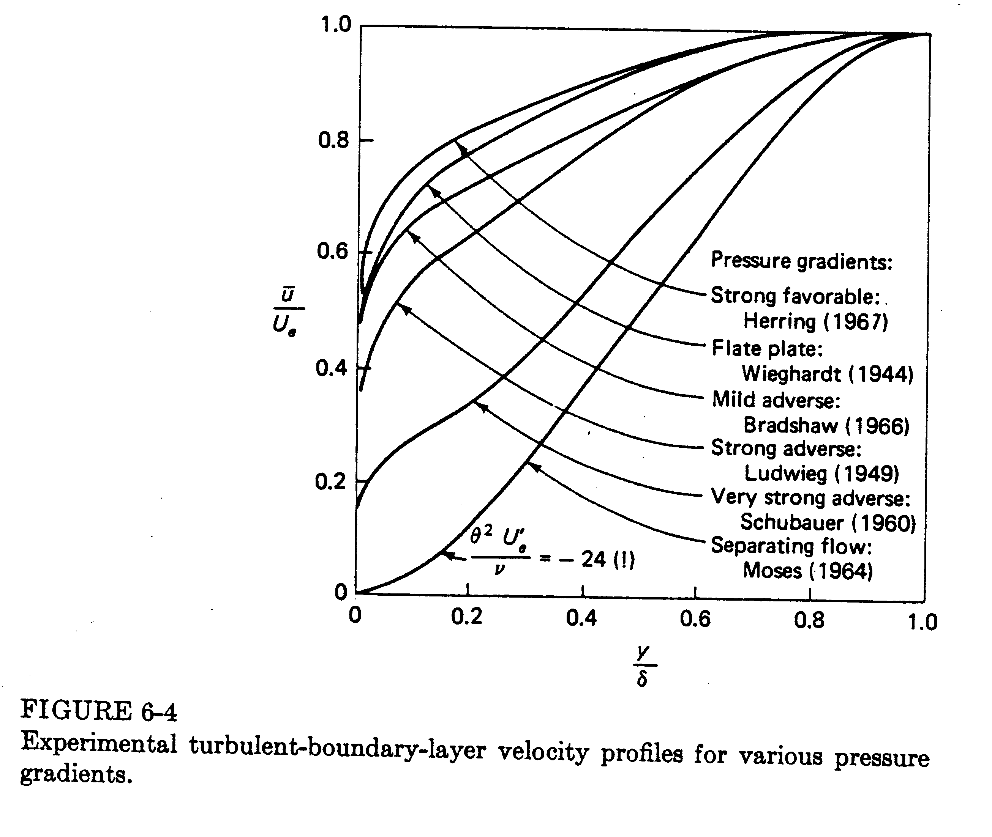
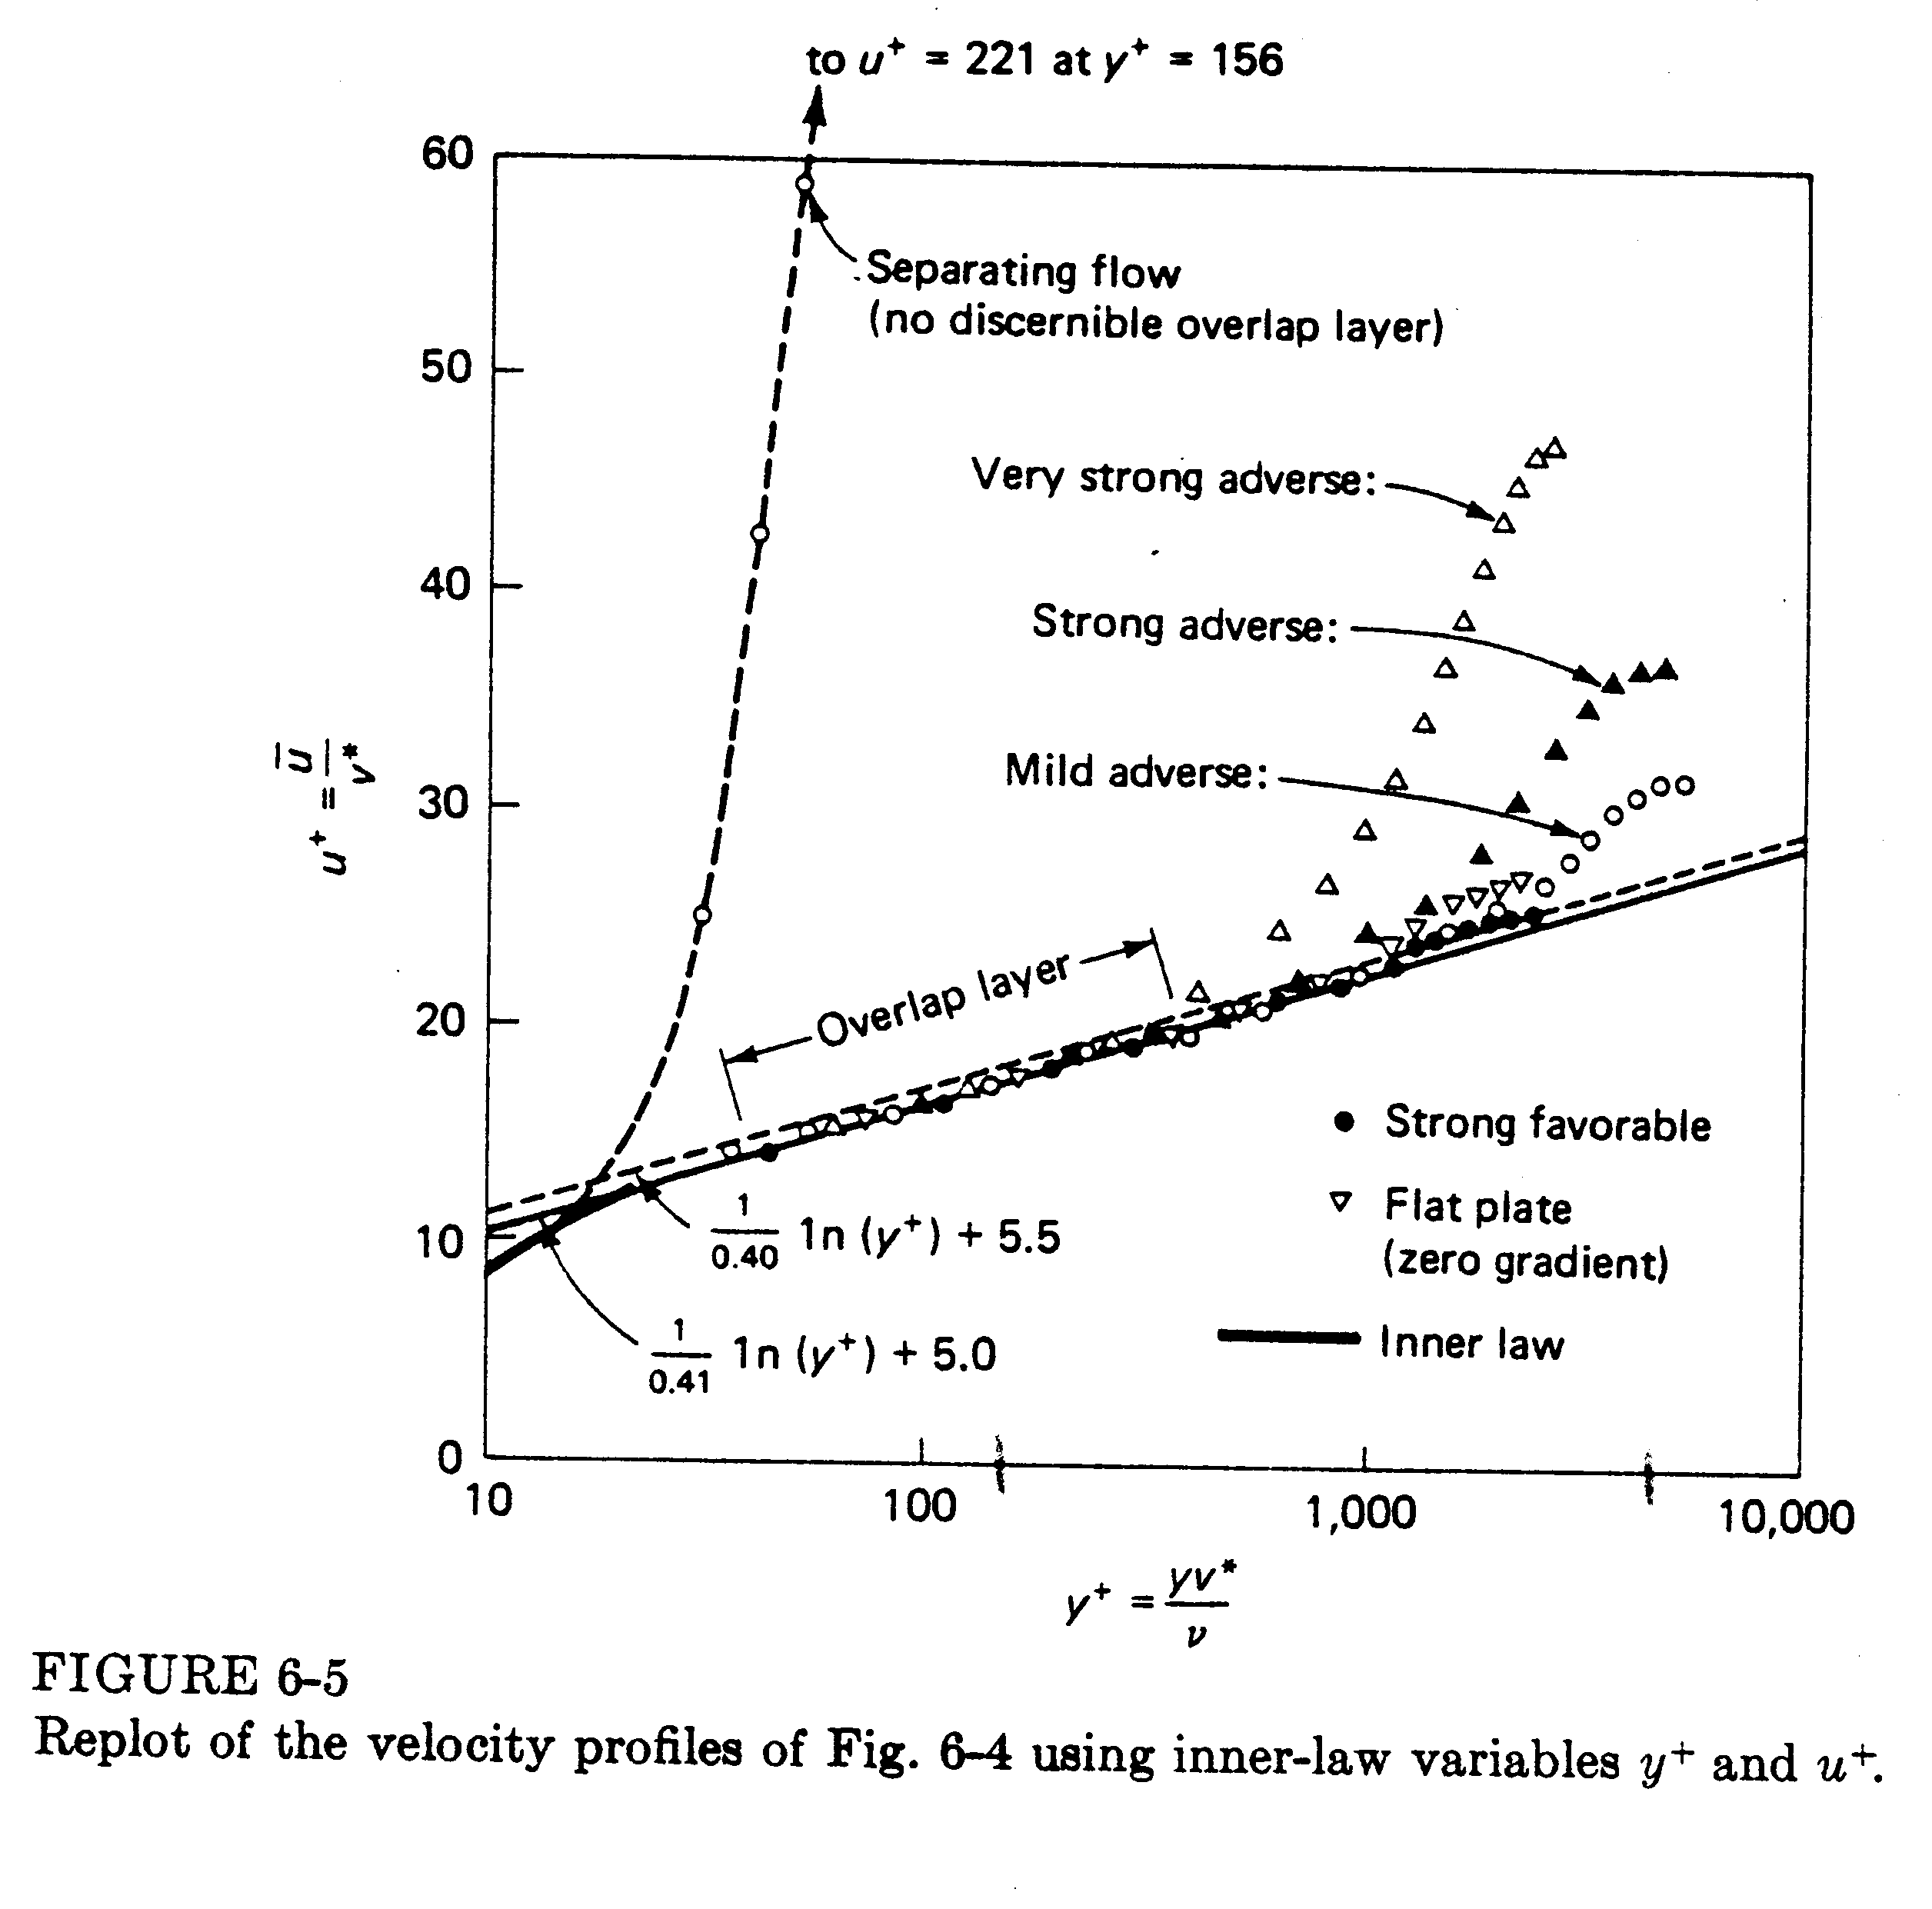
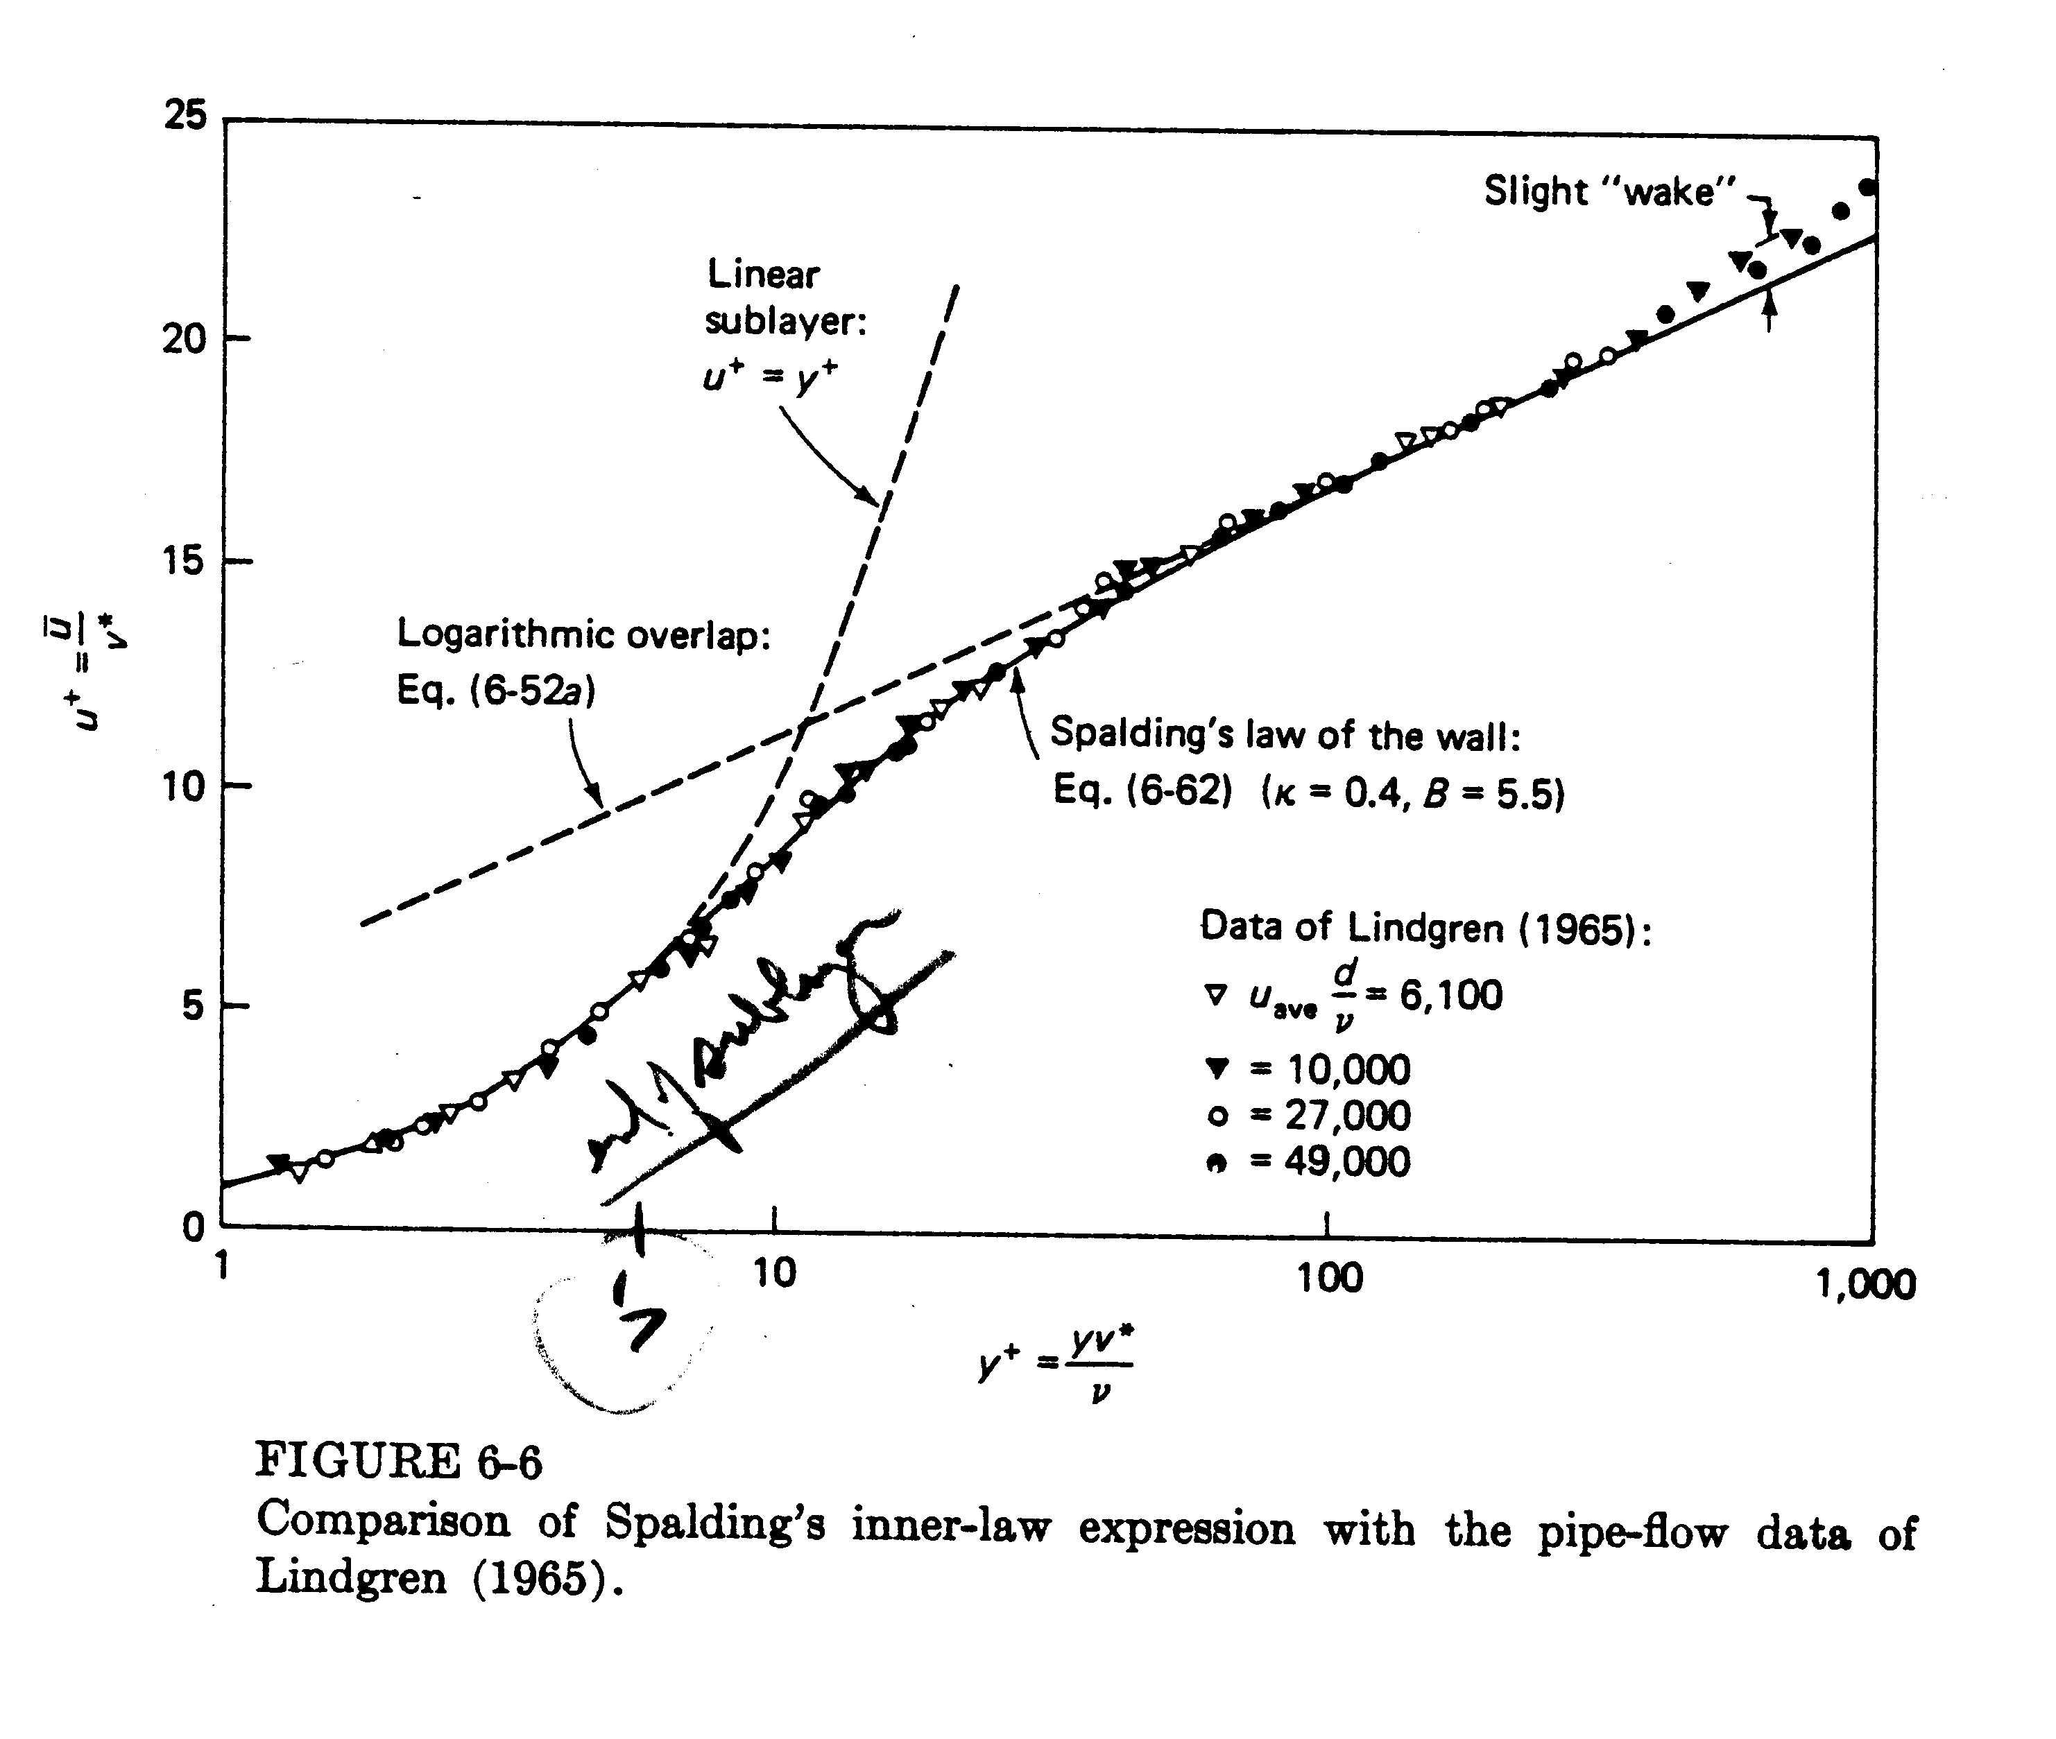
Momentum Integral Analysis

Background: History and Modern Approach: FD

To obtain general momentum integral relation which is valid for both laminar and turbulent flow
For flat plate or δ for general case
$$\int_{y=0}^{∞}{\left(\text{momentum} \text{equation} + (u−v) \text{continuity}\right)}\text{dy}$$

$\frac{τ_{w}}{{ρU}^{2}}=\frac{1}{2}c_{f}=\frac{dθ}{\text{dx}}+\left(2+H\right)\frac{θ}{U}\frac{\text{dU}}{\text{dx}}$ $−\frac{\text{dp}}{\text{dx}}=ρU\frac{\text{dU}}{\text{dx}}$
flat plate equation $\frac{\text{dU}}{\text{dx}}=0$

$θ=\int_{0}^{δ}{\frac{u}{U}\left(1−\frac{u}{U}\right)\text{dy}}$ momentum thickness

$H=\frac{δ^{}}{θ}$ shape parameter

$δ^{}=\int_{0}^{δ}{\left(1−\frac{u}{U}\right)}\text{dy}$ displacement thickness

Can also be derived by CV analysis as shown next for flat plate boundary layer.

Momentum Equation Applied to the Boundary Layer

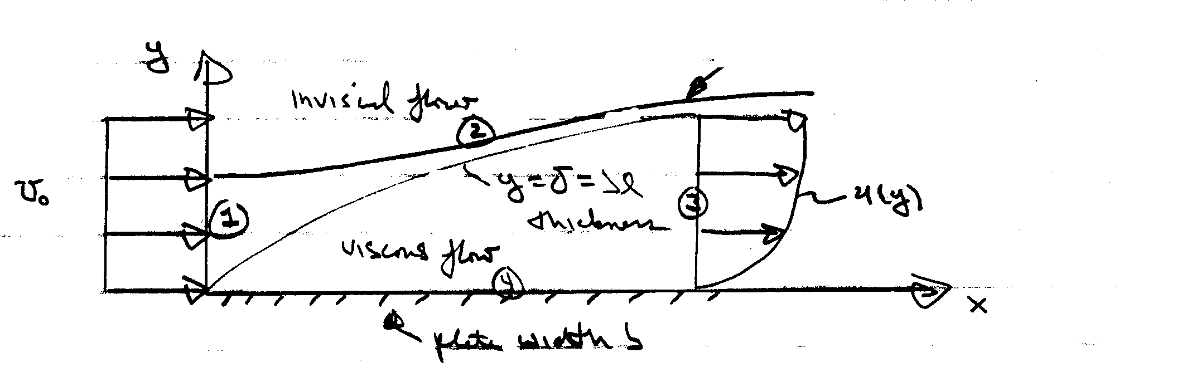
y = h + δ*= streamline
starts in uniform flow
merges with δ at 3

Steady
ρ = constant
neglect g
v << u = u_{o} ⇒ p = constant
i.e., -∇p = 0

CV = 1, 2, 3, 4

$−D=\text{drag}=b\int_{0}^{x}{τ_{w}\text{dx}}$ pressure force = 0 for v << U_{o}
force on CV wall shear stress u ∼ U_{o}

$$\sum{F_{x}=−D=ρ\int_{1}{u\left(\underline{V}⋅\underline{\text{dA}}\right)}}+ρ\int_{3}{u\left(\underline{V}⋅\underline{\text{dA}}\right)}$$

=$ρ\left(−U_{o}^{2}\text{bh}\right)+ρb\int_{3}{u^{2}\text{dy}}$

$$D(x)={ρU}_{o}^{2}\text{bh}−ρb\int_{0}^{δ}{u^{2}\text{dy}}$$

next eliminate h using continuity

$\begin{aligned}0=ρ\int_{1}{\underline{V}⋅\underline{\text{dA}}}+ρ\int_{3}{\underline{V}⋅\underline{\text{dA}}} \\ {ρU}_{o}\text{bh}=ρb\int_{0}^{δ}{\text{udy}} \\ U_{o}h=\int_{0}^{δ}{\text{udy}}\end{aligned}$
depends on u(y)

$D\left(x\right)=ρ{\text{bU}}_{o}\int_{0}^{δ}{\text{udy}}−ρb\int_{0}^{δ}{u^{2}\text{dy}}$

=$ρb\int_{0}^{δ}{u\left(U_{o}−u\right)\text{dy}}$

$C_{D}=\frac{D}{\frac{1}{2}{ρU}_{o}^{2}\text{bL}}=\frac{2}{L}\int_{0}^{δ}{\frac{u}{U_{o}}\left(1−\frac{u}{U_{o}}\right)\text{dy}}$
θ = momentum thickness

$C_{D}=\frac{2θ}{L}$

$C_{D}=\frac{D}{\frac{1}{2}{ρU}_{o}^{2}A}=\frac{b\int_{0}^{x}{τ_{w}\text{dx}}}{\frac{1}{2}{ρU}_{o}^{2}\text{bL}}=\frac{2θ}{L}$

$\int_{0}^{x}{\frac{τ_{w}}{\frac{1}{2}{ρU}_{o}^{2}}\left(x\right)\text{dx}=2θ\left(x\right)}$

$\frac{1}{2}\left(\frac{τ_{w}}{\frac{1}{2}{ρU}_{o}^{2}}\right)=\frac{dθ}{\text{dx}}$

$\frac{c_{f}}{2}=\frac{dθ}{\text{dx}}$ c_{f} = local skin friction coefficient

momentum integral relation for
flat plate boundary layer

$θ=\int_{0}^{δ}{\frac{u}{u_{o}}\left(1−\frac{u}{u_{o}}\right)\text{dy}}$

Approximate solution for a laminar boundary-layer

Assume cubic polynomial for u(y)

$$\frac{u}{U_{∞}}=A+\text{By}+{\text{Cy}}^{2}+{\text{Dy}}^{3}$$

$u=\frac{∂^{2}u}{∂y^{2}}=0$ y = 0 A = 0 B = $\frac{3}{2}δ$
$u=U_{∞}; \frac{∂u}{∂y}=0$ y = δ C = 0 D = $−\frac{1}{2}δ^{3}$

$$u_{y}=U\left(\frac{3}{2δ}+\frac{3}{2}\frac{y^{2}}{δ}\right)|_{y=0}=\frac{U3}{2δ}$$
i.e., $\frac{u}{U}=\frac{3}{2}\frac{y}{δ}+\frac{1}{2}{\left(\frac{y}{δ}\right)}^{3}$

$\frac{τ_{w}}{{ρU}^{2}}=\frac{1}{2}c_{f}=\frac{dθ}{\text{dx}}$ momentum integral equation for $\frac{\text{dp}}{\text{dx}}=0$

$\frac{1}{{ρU}^{2}}\left[μU\frac{3}{2δ}\right]=\text{.}\text{139}\frac{dδ}{\text{dx}}$ $θ=\int_{0}^{δ}{\frac{u}{U}\left(1−\frac{u}{U}\right)}\text{dy}$

$τ_{w}=μ\frac{\text{du}}{\text{dy}}$

Compare with
Exact Blassius
i.e., $δ=\frac{4\text{.}\text{65}x}{\sqrt{{\text{Re}}_{x}}}$ $\frac{5x}{\sqrt{{\text{Re}}_{x}}}$ 7% ↓

$τ_{w}=\frac{\text{.}\text{323}{ρV}^{2}}{\sqrt{{\text{Re}}_{x}}}$ $\frac{\text{.}\text{332}{ρU}^{2}}{\sqrt{{\text{Re}}_{x}}}$ 3%↓

$c_{f}=\frac{\text{.}\text{646}}{\sqrt{{\text{Re}}_{x}}}$ $\frac{\text{.}\text{664}}{\sqrt{{\text{Re}}_{x}}}$

$C_{f}=\frac{1\text{.}\text{29}}{\sqrt{{\text{Re}}_{L}}}$ $\frac{1\text{.}\text{33}}{\sqrt{{\text{Re}}_{L}}}$

$$C_{f}=\frac{1}{\frac{1}{2}{ρU}^{2}\text{bL}}\int_{0}^{L}{τ_{w}\left(x\right)\text{dx}}$$
span length

total skin-friction drag coefficient
Approximate solution Turbulent Boundary-Layer

Re_{t} ∼ 3 X 10⁶ for a flat plate boundary layer
Re_{crit} ∼ 500,000
$\frac{c_{f}}{2}=\frac{dθ}{\text{dx}}$

as was done for the approximate laminar flat plate boundary-layer analysis, solve by expressing c_{f} = c_{f} (δ) and θ = θ(δ) and integrate, i.e.

assume log-law valid across entire turbulent boundary-layer

$\frac{u}{u^{}}=\frac{1}{κ}\text{ln}\frac{{\text{yu}}^{}}{ν}+B$
neglect laminar sub layer and velocity defect region

at y = δ, u = U

$$\frac{U}{u^{}}=\frac{1}{κ}\text{ln}\frac{{δu}^{}}{ν}+B$$
${\text{Re}}_{δ}{\left(\frac{c_{f}}{2}\right)}^{1/2}$

or ${\left(\frac{2}{c_{f}}\right)}^{1/2}=2\text{.}\text{44}\text{ln}\left[{\text{Re}}_{δ}{\left(\frac{c_{f}}{2}\right)}^{1/2}\right]+5$
c_{f} (δ)

$c_{f}≃\text{.}\text{02}{\text{Re}}_{δ^{{−1}/6}}$ power-law fit
Next, evaluate
$\frac{dθ}{\text{dx}}=\frac{d}{\text{dx}}\int_{0}^{δ}{\frac{u}{U}\left(1−\frac{u}{U}\right)\text{dy}}$

can use log-law or more simply a power law fit
$$\frac{u}{U}={\left(\frac{y}{δ}\right)}^{1/7}$$

Note: can not be used to obtain c_{f} (δ) since τ_{w} → ∞

$$θ=\frac{7}{\text{72}}δ=θ\left(δ\right)$$

⇒ $τ_{w}=c_{f}\frac{1}{2}{ρU}^{2}={ρU}^{2}\frac{dθ}{\text{dx}}=\frac{7}{\text{72}}{ρU}^{2}\frac{dδ}{\text{dx}}$

$${\text{Re}}_{δ^{{−1}/6}}=9\text{.}\text{72}\frac{dδ}{\text{dx}}$$

or $\frac{δ}{x}=\text{.}\text{16}{\text{Re}}_{x}^{{−1}/7}$
i.e., much faster growth rate than laminar boundary layer

$δ∝x^{6/7}$ almost linear

$$c_{f}=\frac{\text{.}\text{027}}{{\text{Re}}_{x}^{1/7}}$$

$$C_{f}=\frac{\text{.}\text{031}}{{\text{Re}}_{L}^{1/7}}=\frac{7}{6}C_{f}\left(L\right)$$
Alternate forms given in text depending on experimental information and power-law fit used, etc. (i.e., dependent on Re range.)

Some additional relations given in texts for larger Re are as follows:
Total shear-stress coefficient
$C_{f}=\frac{\text{.}\text{455}}{{\left({\text{log}}_{\text{10}}{\text{Re}}_{L}\right)}^{2\text{.}\text{58}}}\frac{−\text{1700}}{{\text{Re}}_{L}}$ Re > 10⁷

$\frac{δ}{L}=c_{f}\left(\text{.}\text{98}{\text{logRe}}_{L}−\text{.}\text{732}\right)$
Local
shear-stress coefficient
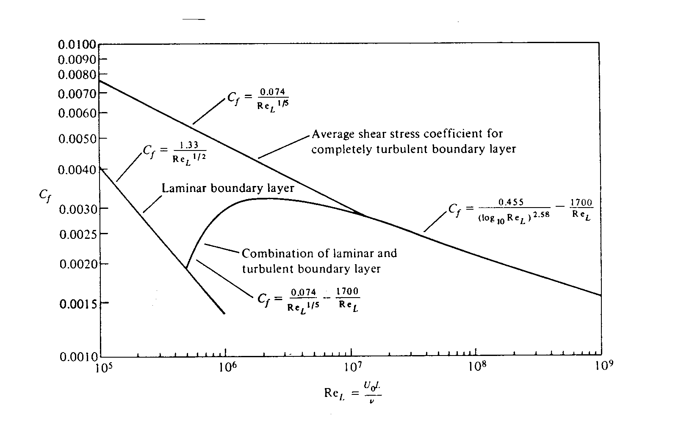
$c_{f}={\left(2{\text{logRe}}_{x}−\text{.}\text{65}\right)}^{−2\text{.}3}$

Finally, a composite formula that takes into account both the initial laminar boundary-layer (with translation at
Re_{CR} = 500,000) and subsequent turbulent boundary layer is $C_{f}=\frac{\text{.}\text{074}}{{\text{Re}}_{L}^{1/5}}−\frac{\text{1700}}{{\text{Re}}_{L}}$ 10⁵ < Re < 10⁷

