57:020

Fluid Mechanics

Class Notes

Fall 2007

Prepared by:

Professor Fred Stern

Typed by: Stephanie Schrader (Fall 1999)

Corrected by: Jun Shao (Fall 2003, Fall 2005)

Corrected by: Jun Shao, Tao Xing (Fall 2006)
Corrected by: Hyunse Yoon (Fall 2007)

CHAPTER 1: INTRODUCTION AND BASIC CONCEPTS
Fluids and the no-slip condition
Fluid mechanics is the science and technology of fluids either at rest (fluid statics) or in motion (fluid dynamics) and their effects on boundaries such as solid surfaces or interfaces with other fluids.
Definition of a fluid: A substance that deforms continuously when subjected to a shear stress
Consider a fluid between two parallel plates, which is subjected to a shear stress due to the impulsive motion of the upper plate
No slip condition: no relative motion between fluid and boundary, i.e., fluid in contact with lower plate is stationary, whereas fluid in contact with upper plate moves at speed U.
Fluid
Element

τ
τ
u=U
u=0
t=0
t=Δt
Fluid deforms, i.e., undergoes rate of strain $\overset{˙}{θ}$ due to shear stress τ

Newtonian fluid: $τ∝\overset{˙}{θ} = \text{rate} \text{of} \text{strain}$
$τ = μ \overset{˙}{θ}$
μ = coefficient of viscosity

Such behavior is different from solids, which resist shear by static deformation (up to elastic limit of material)
τ
τ

Solid

γ
t=0
t=Δt
Elastic solid: τ ∝ γ = strain
τ = G γ

G = shear modulus

Both liquids and gases behave as fluids

Liquids:
Closely spaced molecules with large intermolecular forces
Retain volume and take shape of container
liquid
container

Gases:
Widely spaced molecules with small intermolecular forces Take volume and shape of container
gas

Recall p-v-T diagram from thermodynamics:
single phase, two phase, triple point (point at which solid, liquid, and vapor are all in equilibrium), critical point (maximum pressure at which liquid and vapor are both in equilibrium).

Liquids, gases, and two-phase liquid-vapor behave as fluids.

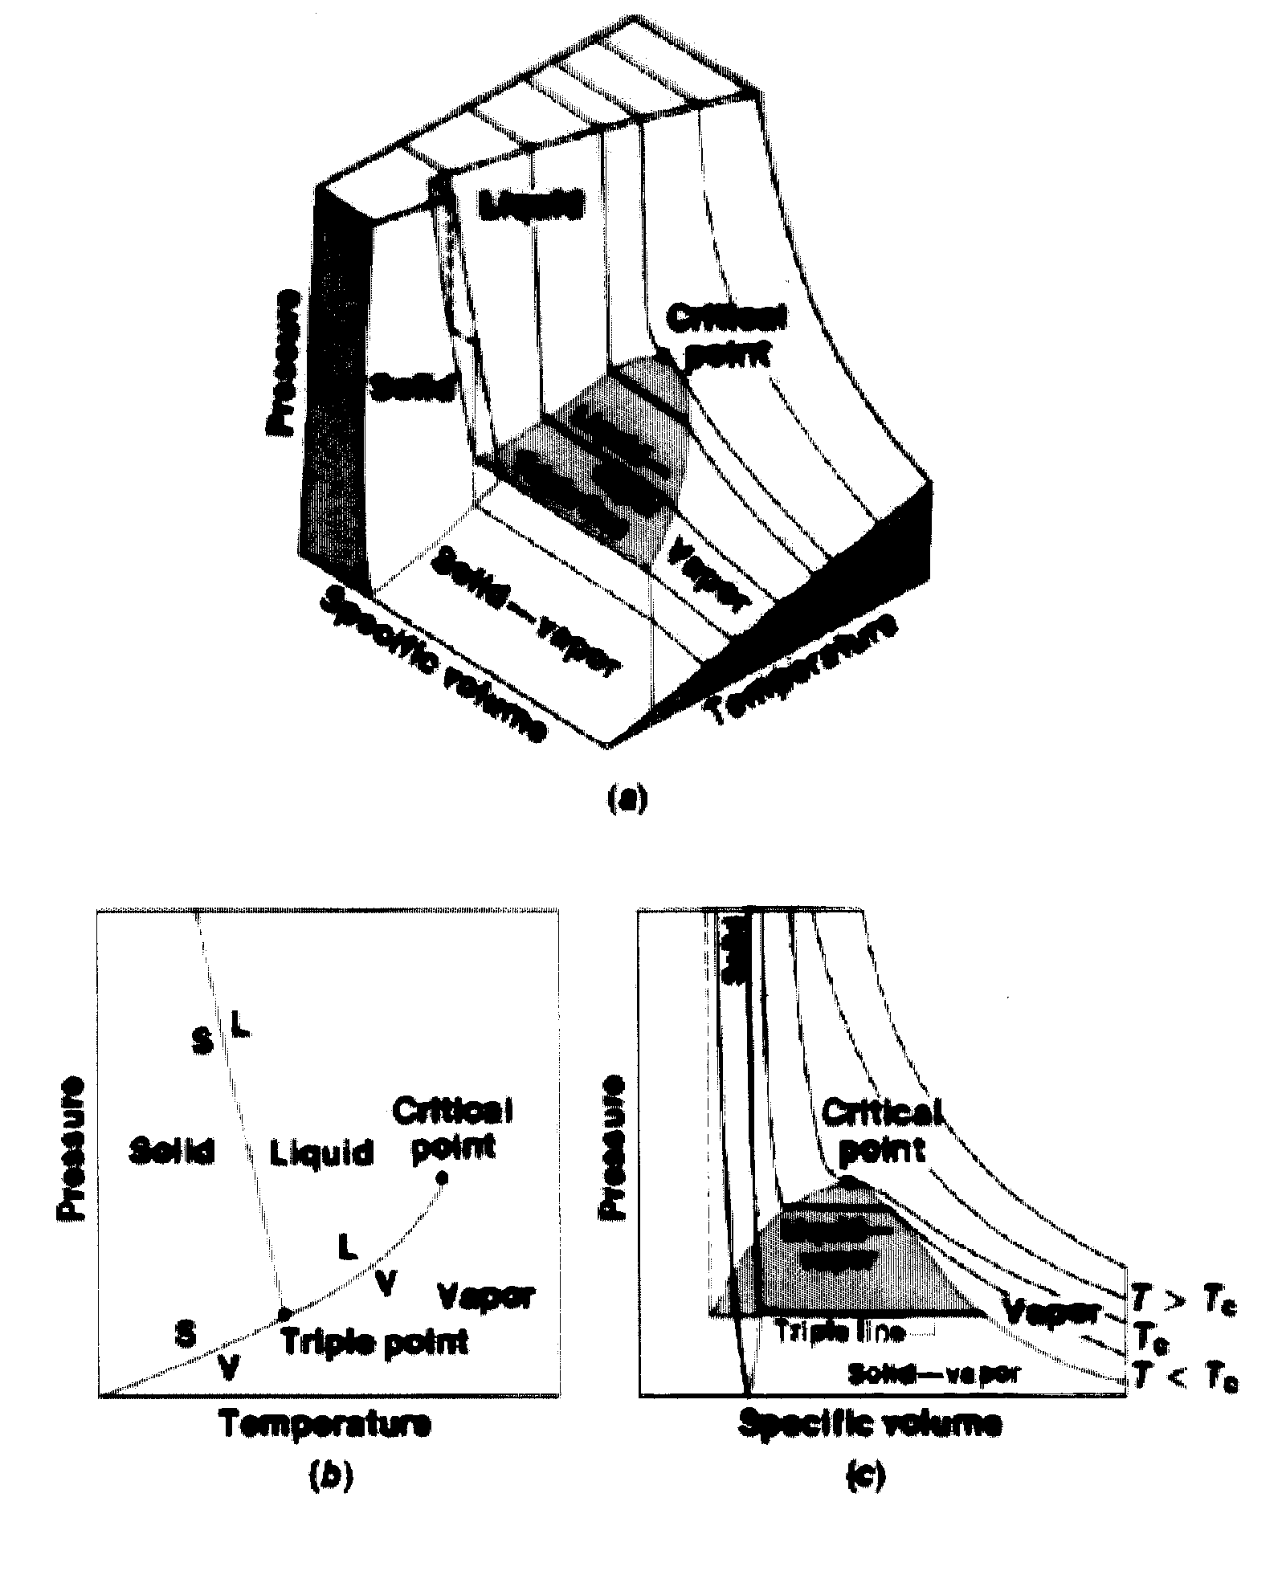
Continuum Hypothesis

In this course, the assumption is made that the fluid behaves as a continuum, i.e., the number of molecules within the smallest region of interest (a point) are sufficient that all fluid properties are point functions (single valued at a point).

For example:
Consider definition of density ρ of a fluid
x = position vector
t = time
$$ρ\left(\underline{x},t\right)=\frac{\text{lim}}{δV→δV^{}}\frac{δm}{δV}$$

δV* = limiting volume below which molecular variations may be important and above which macroscopic variations may be important

δV* ≈ 10⁻⁹ mm³ for all liquids and for gases at atmospheric pressure

10⁻⁹ mm³ air (at standard conditions, 20°C and 1 atm) contains 3x10⁷ molecules such that δM/δV = constant = ρ

Note that typical “smallest” measurement volumes are about 10⁻³ – 10⁰ mm³ >> δV* and that the “scale” of macroscopic variations are very problem dependent

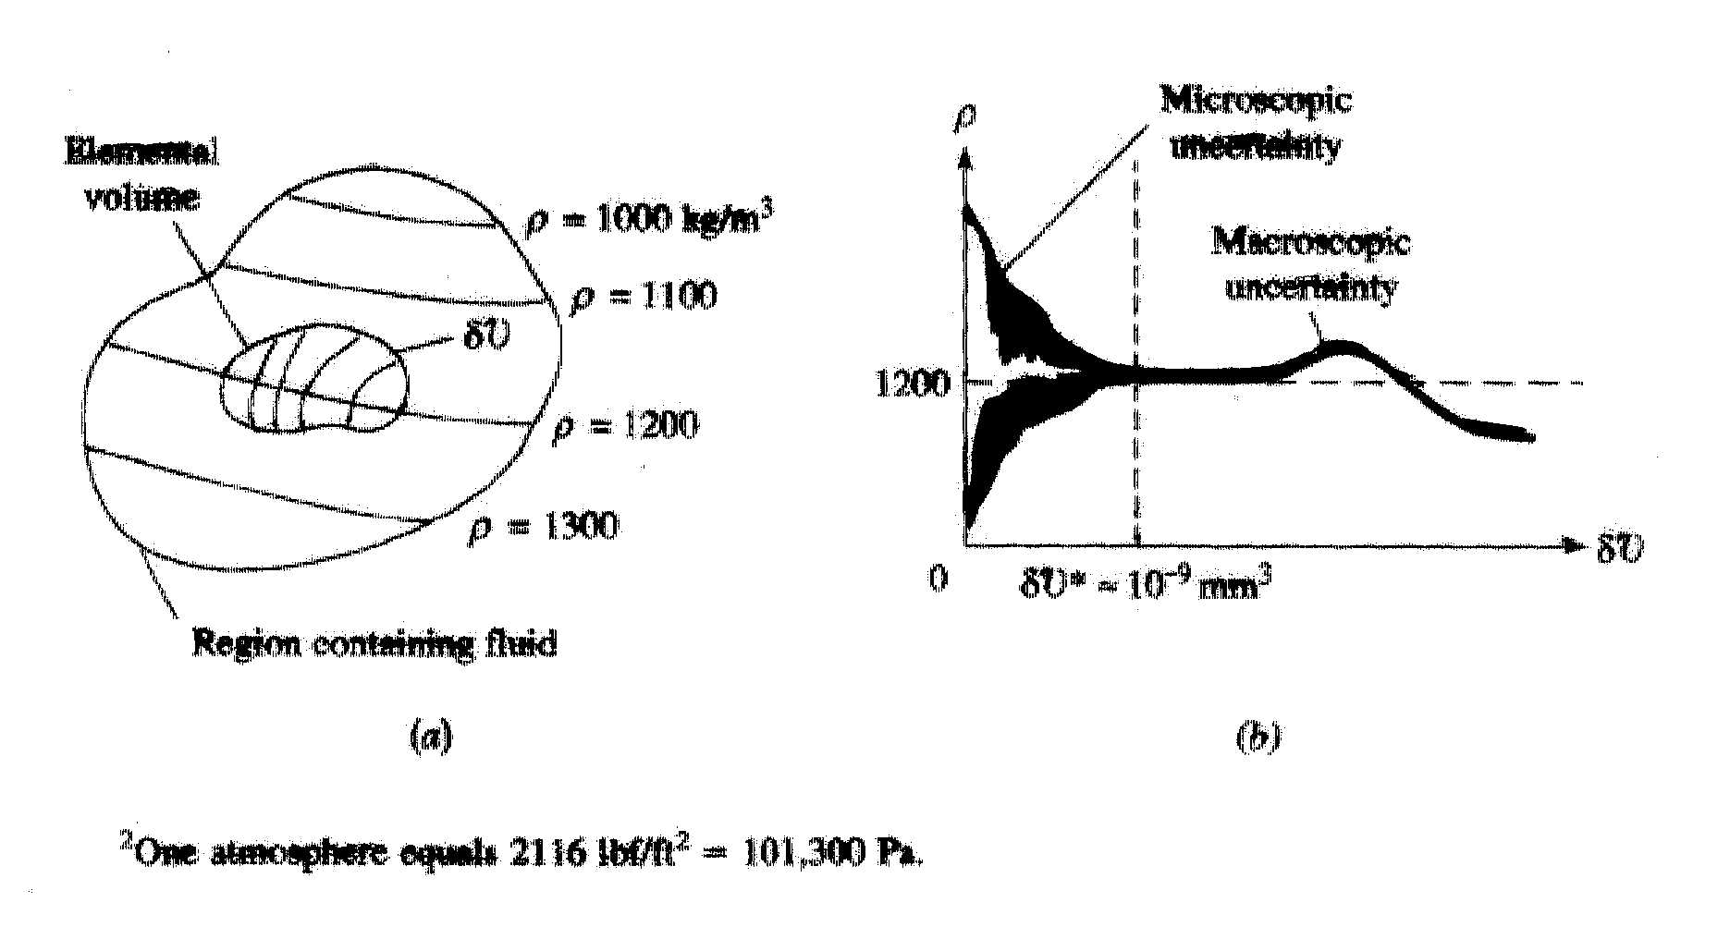

Exception: rarefied gas flow

Properties of Fluids
Fluids are characterized by their properties such as viscosity μ and density ρ, which we have already discussed with reference to definition of shear stress $τ = μ\overset{˙}{θ}$ and the continuum hypothesis.

Properties can be both dimensional (i.e., expressed in either SI or BG units) or non-dimensional.

Figure B.1 Dynamic (absolute) viscosity of common fluids as a function of temperature.
Figure B.2 Kinematic viscosity of common fluids (at atmospheric pressure) as a function of temperature.
Table B.1 Physical Properties of Water (BG Units)
Table B.2 Physical Properties of Water (SI Units)
Table B.3 Physical Properties of Air at Standard Atmospheric Pressure (BG Units)
Table B.4 Physical Properties of Air at Standard Atmospheric Pressure (SI Units)
Table 1.5 Approximate Physical Properties of Some Common Liquids (BG Units)
Table 1.6 Approximate Physical Properties of Some Common Liquids (SI Units)
Table 1.7 Approximate Physical Properties of Some Common Gases at Standard Atmospheric Pressure (BG Units)
Table 1.8 Approximate Physical Properties of Some Common Gases at Standard Atmospheric Pressure (SI Units)
Basic Units

System International and British Gravitational Systems

Primary Units | SI | BG
Mass M | kg | slug=32.2lbm
Length L | m | ft
Time t | s | s
Temperature T | °C (°K) | °F (°R)

Temperature Conversion:
°K = °C + 273
°R = °F + 460

°K and °R are absolute scales, i.e., 0 at absolute zero. Freezing point of water is at 0°C and 32°F.

Secondary  (derived) units | Dimension | SI | BG
velocity $\underline{V}$ | L/t | m/s | ft/s
acceleration $\underline{a}$ | L/t² | m/s² | ft/s²
force $\underline{F}$ | ML/t² | N (kg⋅m/s²) | lbf
pressure p | F/L² | Pa (N/m²) | lbf/ft²
density ρ | M/L³ | kg/m³ | slug/ft³
internal energy u | FL/M | J/kg (N⋅m/kg) | BTU/lbm

Table 1.3 Conversion Factors from BG and EE Units to SI Units.
Table 1.4 Conversion Factors from SI Units to BG and EE Units.

Weight and Mass

$\underline{F}=m\underline{a}$ Newton’s second law (valid for both solids
and fluids)
Weight = force on object due to gravity

W = mg g = 9.81 m/s²
= 32.2 ft/s²

SI: W (N) = m (kg) ⋅ 9.81 m/s²

BG: W (lbf) = $\frac{m\left(\text{lbm}\right)}{g_{c}}$⋅32.2 ft/s² =m(slug) ⋅ 32.2ft/ s²
$g_{c} = \text{32}\text{.}2\frac{\text{lbm}⋅\text{ft}}{s^{2}⋅\text{lbf}} = \text{32}\text{.}2\frac{\text{lbm}}{\text{slug}}$, i.e., 1 slug = 32.2 lbm

1N = 1kg ⋅ 1m/s²
1lbf = 1 slug ⋅ 1ft/s²

System; Extensive and Intensive Properties

System = fixed amount of matter
= mass m

Therefore, by definition
$\frac{d(m)}{\text{dt}} = 0$

Properties are further distinguished as being either extensive or intensive.

Extensive properties: depend on total mass of system,
e.g., m and W (upper case letters)
Intensive properties: independent of amount of mass of
system, e.g., p (force/area, lower case letters) and ρ (mass/volume)

Properties Involving the Mass or Weight of the Fluid

Specific Weight, γ = gravitational force, i.e., weight per
unit volume $V$
= W/$V$
= mg/$V$
= ρg N/m³
(Note that specific properties are extensive properties per unit mass or volume)
Mass Density ρ = mass per unit volume
= m/$V$ kg/m³
T = 4°C
Specific Gravity S = ratio of γ_{liquid} to γ_{water} at standard = γ/γ_{water, 4°C} dimensionless
(or γ_{air} at standard conditions for gases)

γ_{water, 4°C} = 9810 N/m³ for T = 4°C and atmospheric pressure
Variation in Density

gases: ρ = ρ (gas, T, p) equation of state (p-v-T)
= p/RT ideal gas

R = R (gas)
R (air) = 287.05 N⋅m/kg⋅°K

liquids: ρ ∼ constant

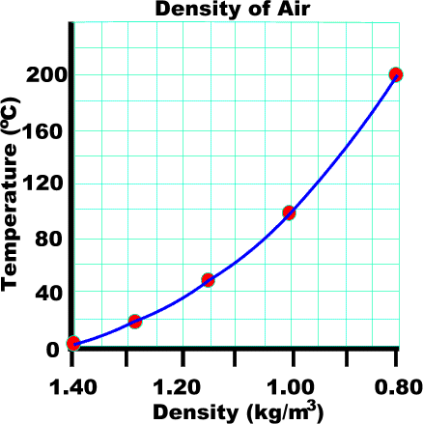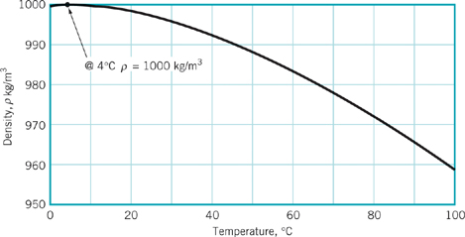
Water

Liquid and temperature | Density (kg/m³) | Density (slugs/ft³)
Water 20ºC (68ºF) | 998 | 1.94
Ethyl alcohol 20ºC (68ºF) | 799 | 1.55
Glycerine 20ºC (68ºF) | 1,260 | 2.45
Kerosene 20ºC (68ºF) | 814 | 1.58
Mercury 20ºC (68ºF) | 13,350 | 26.3
Sea water 10ºC at 3.3% salinity | 1,026 | 1.99
SAE 10W 38ºC(100ºF) | 870 | 1.69
SAE 10W-30 38ºC(100ºF) | 880 | 1.71
SAE 30 38ºC(100ºF) | 880 | 1.71

For greater accuracy can also use p-v-T diagram

ρ = ρ (liquid, T, p)

T↑ ρ↓
p↑ ρ↑

Properties Involving the Flow of Heat

For flows involving heat transfer such as gas dynamics additional thermodynamic properties are important, e.g.

specific heats c_{p} and c_{v} J/kg⋅°K
specific internal energy u J/kg
specific enthalpy h = u + p/ρ J/kg

Viscosity

Recall definition of a fluid (substance that deforms continuously when subjected to a shear stress) and Newtonian fluid shear / rate-of-strain relationship ($τ = μ\overset{˙}{θ}$).

Reconsider flow between fixed and moving parallel plates
(Couette flow)

δuδt=distance fluid particle travels in time δt
δθ
δf=fluid element
δf at t
δf at δt
u=U
u=0
u(y)=velocity profile

δy
y
h

Newtonian fluid: $τ = μ\overset{˙}{θ} = μ\frac{\text{δθ}}{\text{δt}}$
$\text{tan} \text{δθ} = \frac{\text{δuδt}}{\text{δy}} \text{or} \text{δθ} = \frac{\text{δuδt}}{\text{δy}}$ for small δθ

therefore $δ\overset{˙}{θ}= \frac{δu}{δy}$ i.e., $\overset{˙}{θ} = \frac{du}{dy}$ = velocity gradient

and $τ = μ\frac{\text{du}}{\text{dy}}$

Exact solution for Couette flow is a linear velocity profile

$u(y) = \frac{U}{h}y$ Note: u(0) = 0 and u(h) = U
i.e., satisfies no-slip
boundary condition

$τ = μ\frac{U}{h}$= constant

where

U/h = velocity gradient = rate of strain

μ = coefficient of viscosity = proportionality constant for
Newtonian fluid

$$μ=\frac{τ}{\frac{\text{du}}{\text{dy}}}=\frac{N/m^{2}}{\frac{m}{s}/m}=\frac{\text{Ns}}{m^{2}}$$
$ν=\frac{μ}{ρ}=\frac{m^{2}}{s}$ = kinematic viscosity

μ = μ(fluid;T,p) = μ(gas/liquid;T)

gas and liquid μ↑ p↑, but smal Δμ
gas: μ↑ T↑
Due to structural differences, more molecular activity, decreased cohesive forces for gases
liquid: μ↓ T↑

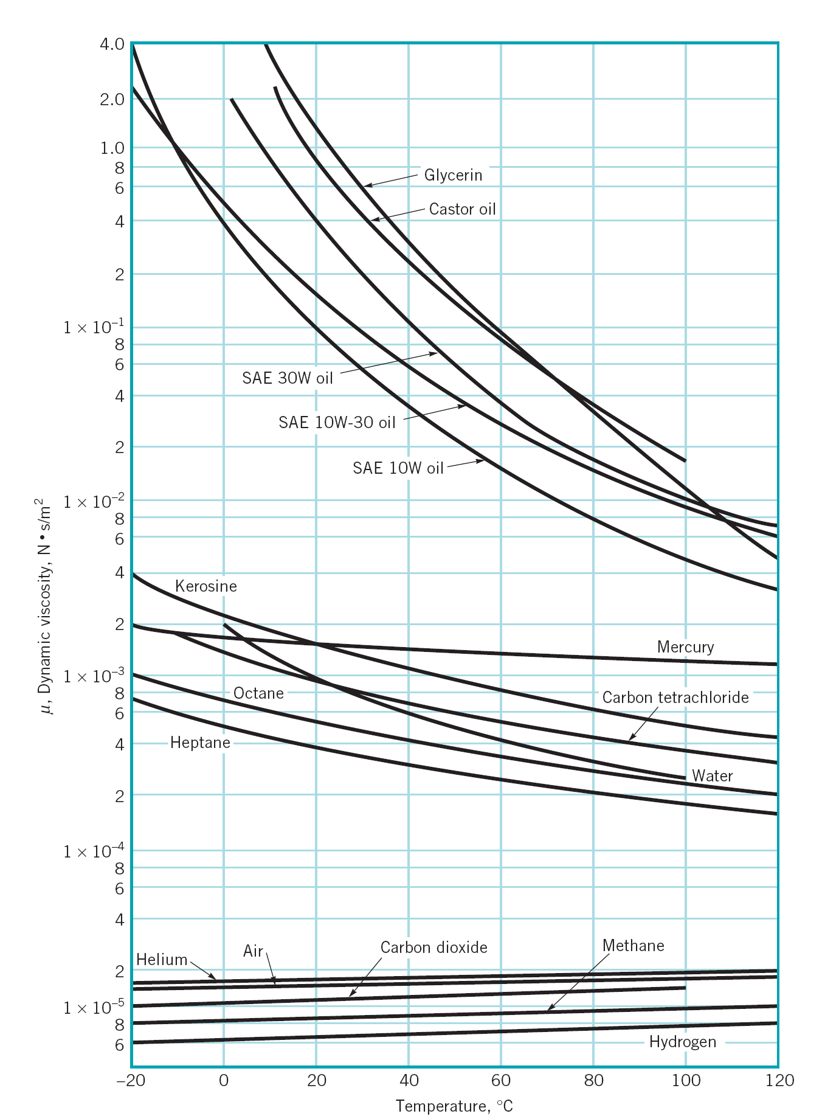

Newtonian vs. Non-Newtonian Fluids

Dilatant: τ ↑ dV/dy ↑
Newtonian: τ ∝ dV/dy
Pseudo plastic: τ ↓ dV/dy ↑

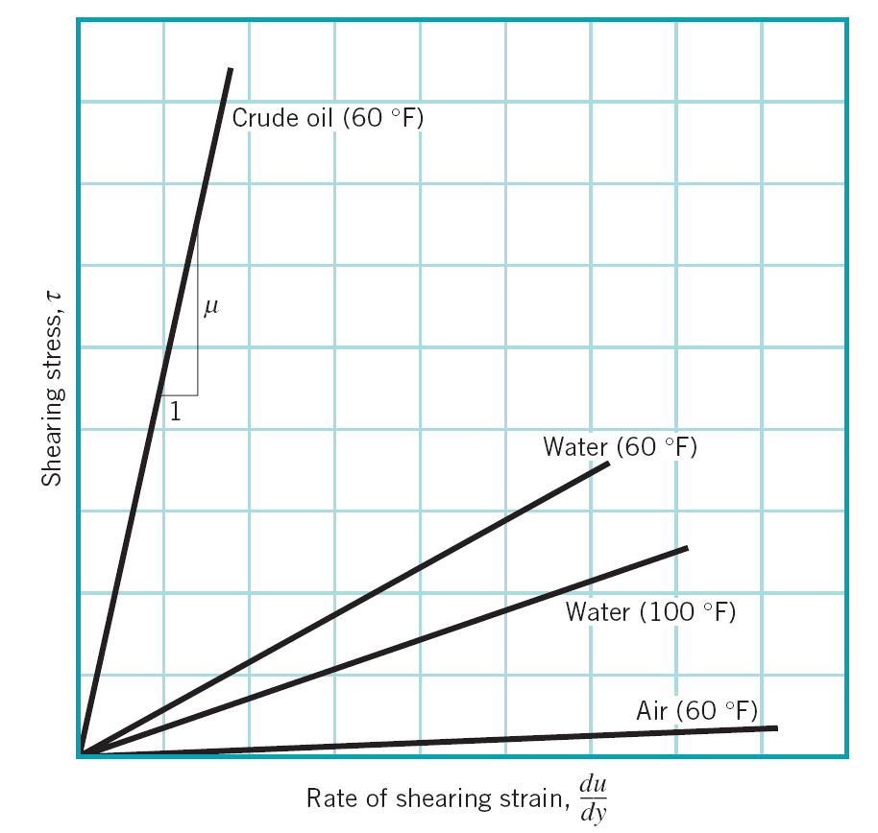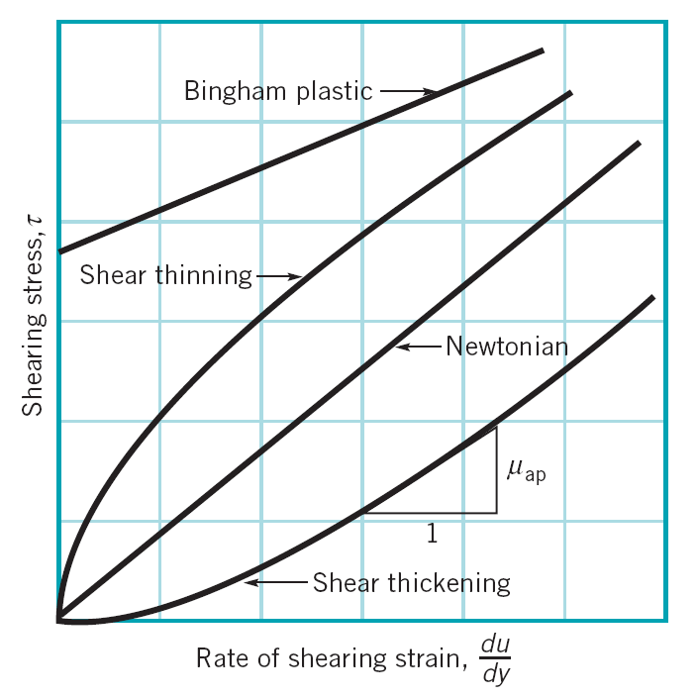

$$τ∝\frac{\text{dV}}{\text{dy}}$$
μ = slope

$$τ∝{\left(\frac{\text{dV}}{\text{dy}}\right)}^{n}$$

n > 1 slope increases with increasing τ
(shear thickening)

n < 1 slope decreases with increasing τ
(shear thinning)
Ex) blood, paint, liquid plastic

Elasticity (i.e., compressibility)

Increasing/decreasing pressure corresponds to contraction/expansion of a fluid. The amount of deformation is called elasticity.

$\text{dp}=−E_{v}\frac{dV}{V}$ $\text{dp}>0⇒\frac{dV}{V}<0\text{}$
∴ minus sign used

$E_{V}=−\frac{\text{dp}}{dV/V}=\frac{\text{dp}}{dρ/ρ}=\frac{N}{m^{2}}$ $E_{V}=ρ\frac{\text{dp}}{dρ}$
Alternate form: m = ρ$V$
dm = ρd$V$ + $V$dρ = 0 (by definition)

$−\frac{dV}{V}=\frac{dρ}{ρ}$
Liquids are in general incompressible, e.g.
E_{v} = 2.2 GN/m ² water
i.e. Δ$V$ = 0.05% for Δp = 1MN/m²
(G=Giga=10⁹ M=Mega=10⁶ k=kilo=10³)

Gases are in general compressible, e.g. for ideal gas at T = constant (isothermal)
$\frac{\text{dp}}{dρ}=\text{RT}$

$E_{v}=ρ\text{RT}=p$
Vapor Pressure and Cavitation

When the pressure of a liquid falls below the vapor pressure it evaporates, i.e., changes to a gas. If the pressure drop is due to temperature effects alone, the process is called boiling. If the pressure drop is due to fluid velocity, the process is called cavitation. Cavitation is common in regions of high velocity, i.e., low p such as on turbine blades and marine propellers.
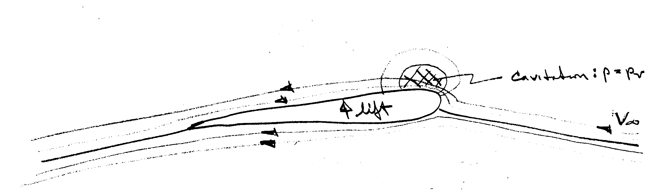
high V low p
(suction side)
isobars
streamlines around lifting surface (i.e. lines tangent to velocity vector)
low V high p
(pressure side)
Cavitation number = $\frac{p−p_{v}}{\frac{1}{2}{ρV}_{∞}^{2}}$

< 0 implies cavitation
Surface Tension and Capillary Effects

Two non-mixing fluids (e.g., a liquid and a gas) will form an interface. The molecules below the interface act on each other with forces equal in all directions, whereas the molecules near the surface act on each other with increased forces due to the absence of neighbors. That is, the interface acts like a stretched membrane

Interface
WATER
Near surface forces are increased due to absence of neighbors such that surface is in tension σ per unit length
Away from interface molecular forces are equal in all directions
AIR
F_{σ}
F_{σ} = surface tension force
F_{σ}

σ_{air/water} = 0.073 N/m
line force with direction normal to the cut
=length of cut through the interface

Effects of surface tension:

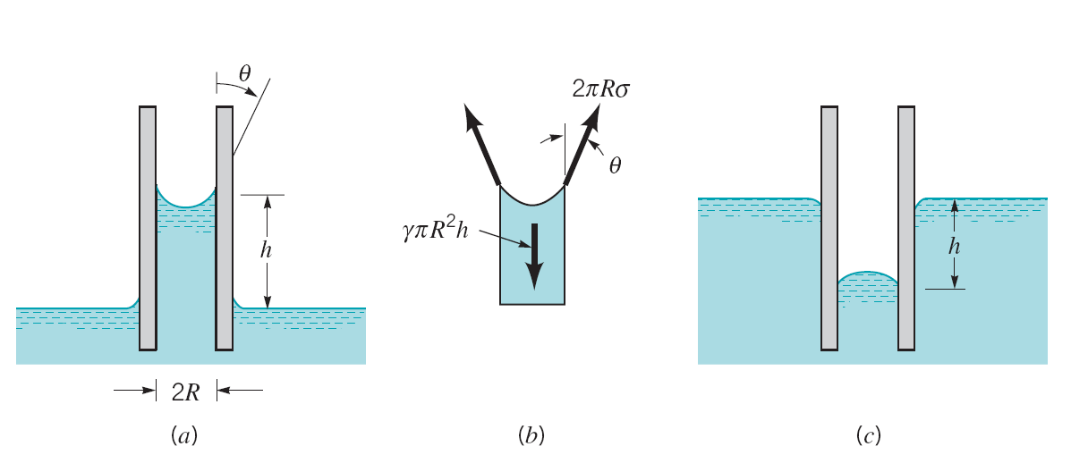
θ < 90º
wetting
θ > 90º
non-wetting

1. Capillary action in small tube $Δh=4σ/γd$
2. Pressure difference across curved interface
Δp = σ/R R = radius of curvature
3. Transformation of liquid jet into droplets
4. Binding of wetted granular material such as sand

Example

θ
F_{σ}
F_{σ}

Δh
d
water
reservoir
θ= contact angle
Fluid attaches to solid with contact angle θ due to surface tension effect and wetty properties

capillary tube d = 1.6mm = 0.0016m
, L=length of contact line between fluid & solid

water reservoir at 20° C, σ = 0.073 N/m, γ = 9790 N/m³

Δh = ?
ΣF_{z} = 0
F_{σ,z} - W = 0
σπd cosθ - ρgV = 0 θ ∼ 0° ⇒ cosθ = 1
ρg = γ
$\text{σπ}d−γΔh\frac{{πd}^{2}}{4}=0$ $V=\text{Δh}\frac{{\text{πd}}^{2}}{4}$
=Volume of fluid above reservoir

$Δh=\frac{4σ}{γd}=\text{18}\text{.}6\text{}\text{mm}$
A brief history of fluid mechanics
See text book section 1.10.

Fluid Mechanics and Flow Classification

Hydrodynamics: flow of fluids for which density is constant such as liquids and low-speed gases. If in addition fluid properties are constant, temperature and heat transfer effects are uncoupled such that they can be treated separately.

Examples: hydraulics, low-speed aerodynamics, ship hydrodynamics, liquid and low-speed gas pipe systems

Gas Dynamics: flow of fluids for which density is variable such as high-speed gases. Temperature and heat transfer effects are coupled and must be treated concurrently.

Examples: high-speed aerodynamics, gas turbines,
high-speed gas pipe systems, upper atmosphere

