# 57:020

# Fluid Mechanics

# Class Notes

### Fall 2015

# Prepared by:

# Professor Fred Stern

# Typed by: Stephanie Schrader (Fall 1999)

# Corrected by: Jun Shao (Fall 2003, Fall 2005)

# Corrected by: Jun Shao, Tao Xing (Fall 2006)

Corrected by: Hyunse Yoon (Fall 2007 ~ Fall 2015)

Corrected by: Timur Kent Dogan (Fall 2014) **CHAPTER 1: INTRODUCTION AND BASIC CONCEPTS**

**Fluids and the no-slip condition**

Fluid mechanics is the science and technology of fluids either at rest (fluid statics) or in motion (fluid dynamics) and their effects on boundaries such as solid surfaces or interfaces with other fluids.

Definition of a fluid: A substance that deforms continuously when subjected to a shear stress

Consider a fluid between two parallel plates, which is subjected to a shear stress due to the impulsive motion of the upper plate

No slip condition: no relative motion between fluid and boundary, i.e., fluid in contact with lower plate is stationary, whereas fluid in contact with upper plate moves at speed *U*.

Fluid

## Element

*τ*

*τ*



*u=U*

*u*=0

*t*=0

*t=Δt*

Fluid deforms, i.e., undergoes rate of strain  due to shear stress *τ*

Newtonian fluid: 



*μ* = coefficient of viscosity

Such behavior is different from solids, which resist shear by static deformation (up to elastic limit of material)

τ

*τ*

## Solid

γ

*t*=0

*t=Δt*

Elastic solid: *τ* ∝ *γ* = strain

*τ* = *G* γ

*G* = shear modulus

Both liquids and gases behave as fluids

Liquids:

Closely spaced molecules with large intermolecular forces

Retain volume and take shape of container

**liquid**

container

Gases:

Widely spaced molecules with small intermolecular forces Take volume and shape of container

**gas**

Recall *p-v-T* diagram from thermodynamics:

single phase, two phase, triple point (point at which solid, liquid, and vapor are all in equilibrium), critical point (maximum pressure at which liquid and vapor are both in equilibrium).

Liquids, gases, and two-phase liquid-vapor behave as fluids.

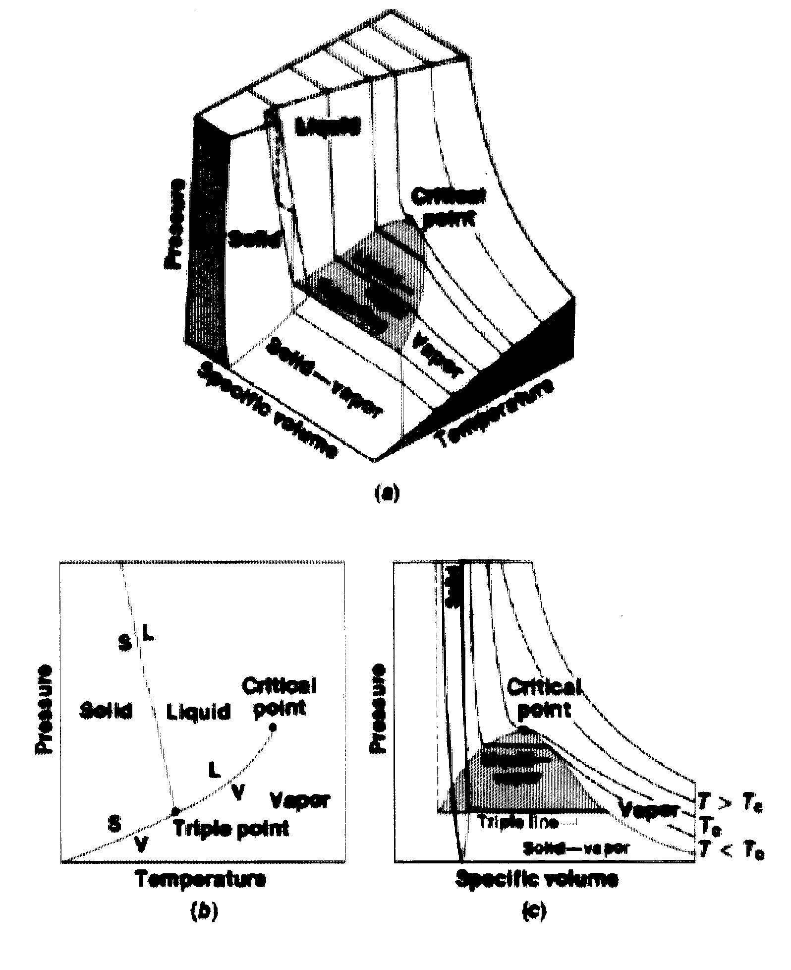

**Continuum Hypothesis**

In this course, the assumption is made that the fluid behaves as a continuum, i.e., the number of molecules within the smallest region of interest (a point) are sufficient that all fluid properties are point functions (single valued at a point).

For example:

Consider definition of density ρ of a fluid

x= position vector 

t = time



δ~~V~~* = limiting volume below which molecular variations may be important and above which macroscopic variations may be important

δ~~V~~* ≈ 10-9 mm3 (or length scale of l* ≈ 10-6 m) for all liquids and for gases at atmospheric pressure

10-9 mm3 air (at standard conditions, 20°C and 1 atm) contains 3x107 molecules such that δM/δ~~V~~ = constant = ρ

Note that typical “smallest” measurement volumes are about 10-3 – 100 mm3 >> δ~~V~~* and that the “scale” of macroscopic variations are very problem dependent

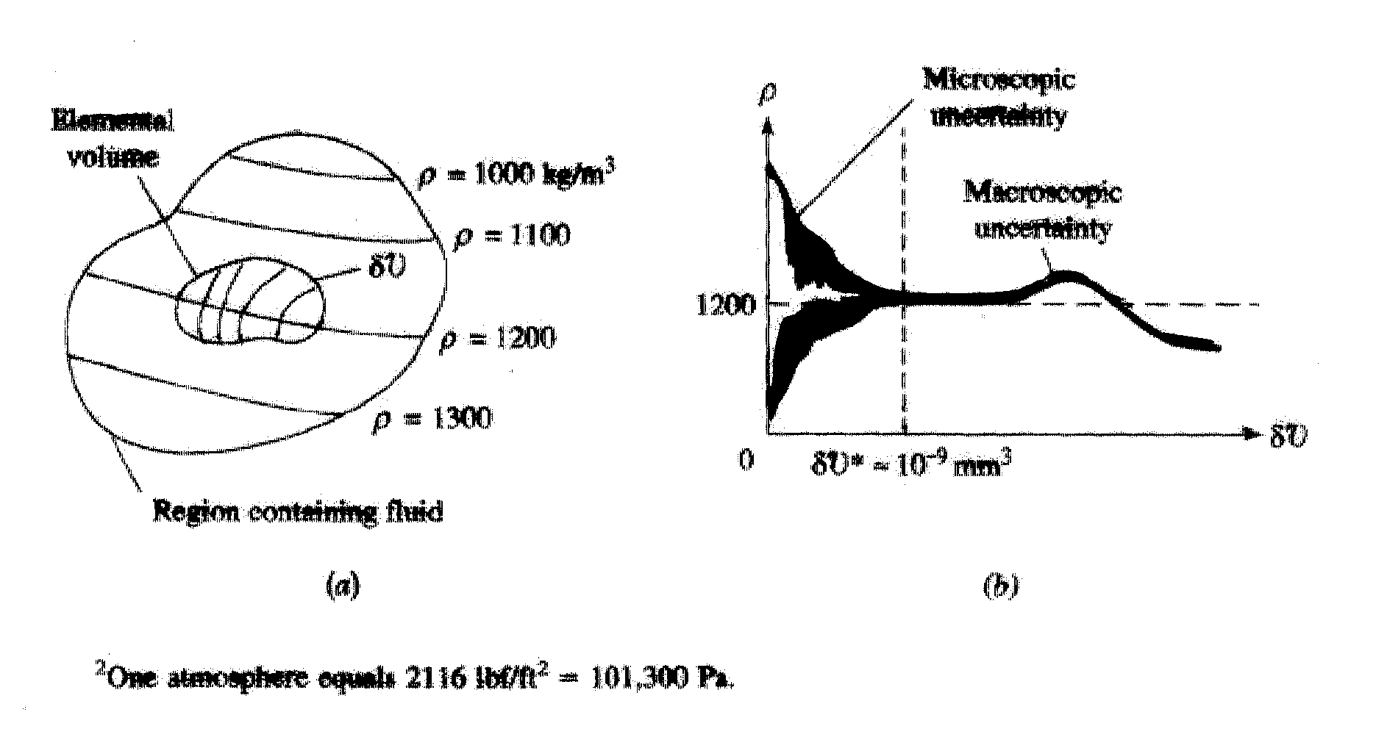

Exception: rarefied gas flow

δ∀* defines a point in the fluid, i.e., a fluid particle or infinitesimal material element used for deriving governing differential equations of fluid dynamics and at which all fluid properties are point functions:

l* =10-6 m >> molecular length scales

λ = mean free path = 6×10-8 m

tλ = 10-10 s = time between collisions

l* = 10-6 m <<fluid length scales l = 10-4 m

For laminar flow: lmax ≈ smallest geometry scales of the flow

Umax < U transition to turbulent flow

For turbulent flow: lmax and Umax determined by Kolmogorov scales at which viscous dissipation takes place, which for typical ship/airplane,

η ≈ 2×10-5 m (ship)/2.3×10-5 m (airplane)

uη ≈ 0.05 m/s (ship)/1.64 m/s (airplane)

tη ≈ 4×10-4 s (ship)/1.4×10-5 s (airplane)

**Properties of Fluids**

Fluids are characterized by their properties such as viscosity *μ* and density *ρ*, which we have already discussed with reference to definition of shear stress  and the continuum hypothesis.

1. ***Kinematic***: Linear ($\underline{V}$) and angular (${\underline{ω}}/2$) velocity, rate of strain ($ε_{ij}$), Vorticity ($\underline{ω}$), and acceleration ($\underline{a}$)
2. ***Transport***: Viscosity ($μ$), thermal conductivity ($k$), and mass diffusivity ($D$)
3. ***Thermodynamic***: Pressure ($p$), density ($ρ$), temperature ($T$), internal energy ($\hat{u}$), enthalpy ($h=\hat{u}+p/ρ$), specific heat ($C_{v}$, $C_{p}$, $γ={C_{p}}/{C_{v}}$, etc.)
4. ***Miscellaneous***: Surface tension ($σ$), vapor pressure ($p_{v}$), etc.

Properties can be both dimensional (i.e., expressed in either SI or BG units) or non-dimensional:

Figure B.1 Dynamic (absolute) viscosity of common fluids as a function of temperature.

Figure B.2 Kinematic viscosity of common fluids (at atmospheric pressure) as a function of temperature.

Table B.1 Physical Properties of Water (BG Units)

Table B.2 Physical Properties of Water (SI Units)

Table B.3 Physical Properties of Air at Standard Atmospheric Pressure (BG Units)

Table B.4 Physical Properties of Air at Standard Atmospheric Pressure (SI Units)

Table 1.5 Approximate Physical Properties of Some Common Liquids (BG Units)

Table 1.6 Approximate Physical Properties of Some Common Liquids (SI Units)

Table 1.7 Approximate Physical Properties of Some Common Gases at Standard Atmospheric Pressure (BG Units)

Table 1.8 Approximate Physical Properties of Some Common Gases at Standard Atmospheric Pressure (SI Units)

**Basic Units**

System International and British Gravitational Systems

|  |  |  |
| --- | --- | --- |
| Primary Units | SI | BG |
| Mass *M* | kg | slug=32.2lbm |
| Length *L* | m | ft |
| Time *t* | s | s |
| Temperature *T* | °C (°K) | °F (°R) |

Temperature Conversion:

°K = °C + 273

°R = °F + 460

°K and °R are absolute scales, i.e., 0 at absolute zero. Freezing point of water is at 0°C and 32°F.

|  |  |  |  |
| --- | --- | --- | --- |
| Secondary  (derived) units | Dimension | SI | BG |
| velocity | L/t | m/s | ft/s |
| acceleration | L/t2 | m/s2 | ft/s2 |
| force | ML/t2 | N (kg⋅m/s2) | lbf |
| pressure *p* | F/L2 | Pa (N/m2) | lbf/ft2 |
| density ** | M/L3 | kg/m3 | slug/ft3 |
| internal energy u | FL/M | J/kg (N⋅m/kg) | BTU/lbm |

Table 1.3 Conversion Factors from BG and EE Units to SI Units.

Table 1.4 Conversion Factors from SI Units to BG and EE Units.

**Weight and Mass**

 Newton’s second law (valid for both solids

and fluids)

Weight = force on object due to gravity

W = *mg* *g* = 9.81 m/s2

= 32.2 ft/s2

SI: W (N) = *m* (kg) ⋅ 9.81 m/s2

BG: W (lbf) = *m*(slug) ⋅ 32.2ft/ s2

EE: W (lbf) =⋅32.2 ft/s2

, i.e., 1 slug = 32.2 lbm

1 N = 1 kg ⋅ 1 m/s2

1 lbf = 1 slug ⋅ 1 ft/s2

**System; Extensive and Intensive Properties**

System = fixed amount of matter

= mass *m*

Therefore, by definition



Properties are further distinguished as being either extensive or intensive.

Extensive properties: depend on total mass of system,

e.g., *m* and W

Intensive properties: independent of amount of mass of

system, e.g., *p* (force/area) and *ρ* (mass/volume)

**Properties Involving the Mass or Weight of the Fluid**

Specific Weight, γ = gravitational force (i.e., weight) per unit volume 

= W/

= *mg*/

= *ρg* N/m3

(Note that specific properties are extensive properties per unit mass or volume)

Mass Density *ρ* = mass per unit volume

= *m*/ kg/m3

*T* = 4°C

Specific Gravity S = ratio of γliquid to γwater at standard = γ/γwater, 4°C dimensionless

(or γair at standard conditions for gases)

γwater, 4°C = 9810 N/m3 for *T* = 4°C and atmospheric pressure

γair = 12.01 N/m3 at standard atmosphere (T = 15°C and p = 101.33 kPa)

**Variation in Density**

gases: *ρ* = *ρ* (gas, *T*, *p*) equation of state (*p-v-T*)

= *p*/*RT* ideal gas

*R* = *R* (gas)

e.g. *R* (air) = 287.05 N⋅m/kg⋅°K

*ρ* (air) = 1.225 kg/m3 at Standard Atmosphere

(*T* = 15°C and *p* = 101.33 kPa)

liquids: *ρ* ~ constant

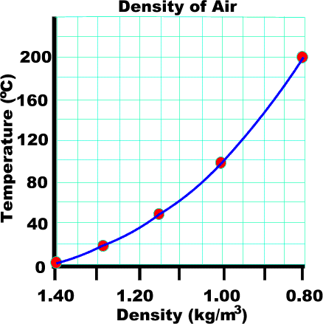 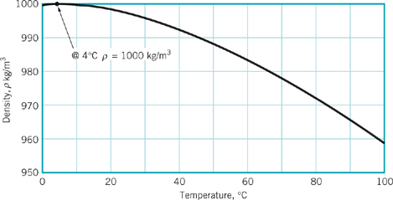

**Water**

Note: For a change in temperature from 0 to 100°C, density changes about 29% for air while only about 4% for water.

|  |  |  |
| --- | --- | --- |
| Liquid and temperature | Density  (kg/m3) | Density  (slugs/ft3) |
| Water 20oC (68oF) | 998 | 1.94 |
| Ethyl alcohol 20oC (68oF) | 799 | 1.55 |
| Glycerine 20oC (68oF) | 1,260 | 2.45 |
| Kerosene 20oC (68oF) | 814 | 1.58 |
| Mercury 20oC (68oF) | 13,350 | 26.3 |
| Sea water 10oC at 3.3% salinity | 1,026 | 1.99 |
| SAE 10W 38oC(100oF) | 870 | 1.69 |
| SAE 10W-30 8oC(100oF) | 880 | 1.71 |
| SAE 30 38oC(100oF) | 880 | 1.71 |

# For greater accuracy can also use p-v-T diagram

*ρ* = *ρ* (liquid, *T*, *p*)

*T*🡩 *ρ*🡫

*p*🡩 *ρ*🡩

**Properties Involving the Flow of Heat**

For flows involving heat transfer such as gas dynamics additional thermodynamic properties are important, e.g.

specific heats *cp* and *cv*J/kg⋅°K

specific internal energy *û* J/kg

specific enthalpy *h = û + p/ρ* J/kg

**Viscosity**

# Recall definition of a fluid (substance that deforms continuously when subjected to a shear stress) and Newtonian fluid shear / rate-of-strain relationship: .

# Reconsider flow between fixed and moving parallel plates

(Couette flow)

δuδt=distance fluid particle travels in time δt

δθ

δf=fluid element

δf at t

δf at δt

u=U

u=0

u(y)=velocity profile



δy

y

h

Newtonian fluid: 

 for small *δθ*

therefore  i.e.,  = velocity gradient

and 

Exact solution for Couette flow is a linear velocity profile

 Note: *u*(0) = 0 and *u*(h) = *U*

i.e., satisfies no-slip

boundary condition

= constant

where

*U*/h = velocity gradient = rate of strain

*μ*= coefficient of viscosity = proportionality constant for

Newtonian fluid



 = kinematic viscosity

*μ* = *μ*(fluid;*T,p*) = *μ*(gas/liquid;*T*)

gas and liquid *μ*🡩 *p*🡩, but small Δ*μ*

gas: *μ*🡩 *T*🡩

**Due to structural differences, more molecular activity for gases, decreased cohesive forces for liquids**

liquid: *μ*🡫 *T*🡩

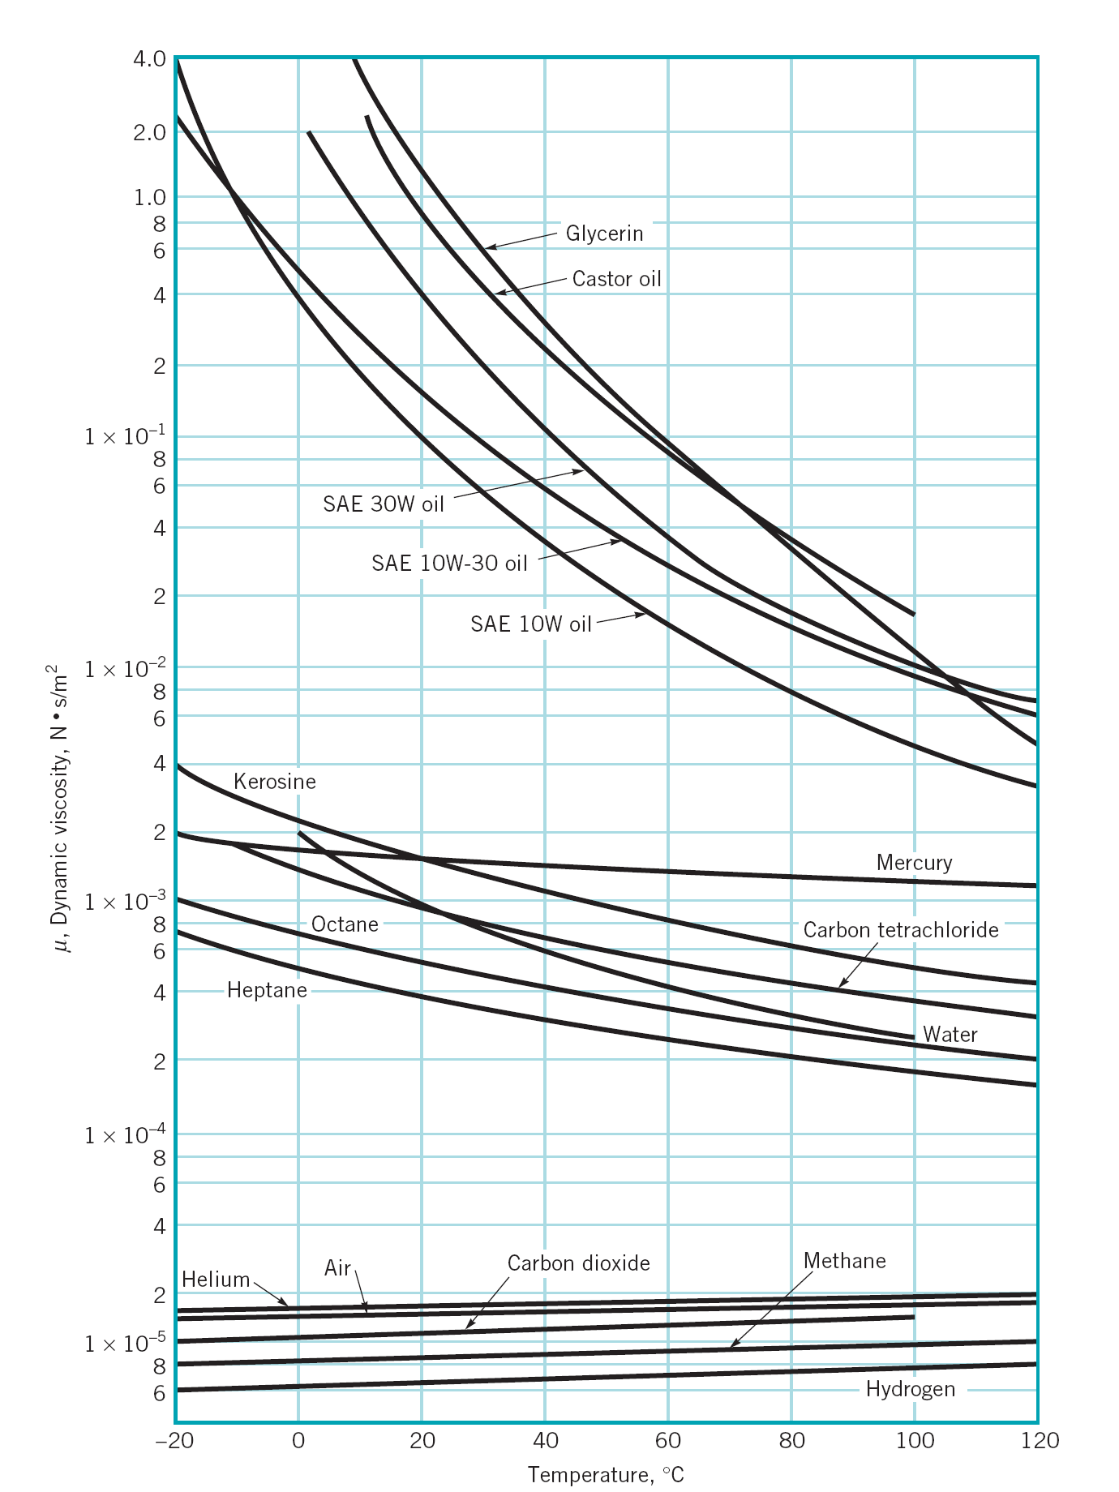

**Newtonian vs. Non-Newtonian Fluids**

# Dilatant (Shear thickening): *  *🡩 *du/dy* 🡩

Newtonian: **  ∝ *du/dy*

Pseudo plastic (Shear thinning): *  *🡫 *du/dy* 🡩

Bingham plastic: Requires τ before becomes fluid

Example: toothpaste, mayonnaise

|  |  |
| --- | --- |
| Newtonian Fluids | Non-Newtonian Fluids |
|  |  |
| $$τ∝\frac{du}{dy}$$ | $$τ∝{\left(\frac{du}{dy}\right)}^{n}$$ |
| *μ* = slope | *n* > 1 (shear thickening) Slope increases with increasing τ; ex) cornstarch, quick-sand  *n* < 1 (shear thinning) Slope decreases with increasing τ;  ex) blood, paint, liquid plastic |

**Elasticity (i.e., compressibility)**

Increasing/decreasing pressure corresponds to contraction/expansion of a fluid. The amount of deformation is called elasticity.

$dp=-E_{v}\frac{dV}{V}$ $dp>0$ ⇒ $\frac{dV}{V}<0$

Increase pressure, decrease volume. ∴ minus sign used

and by definition, $m=ρV$

$dm=ρdV+Vdρ=0$

$-\frac{dV}{V}=\frac{dρ}{ρ}$

Thus,

$$E_{v}=-\frac{dp}{{dV}/V}=\frac{dp}{{dρ}/ρ}=ρ\frac{dp}{dρ} \left[N/{m^{2}}\right]$$

Liquids are in general incompressible, e.g.

= 2.2 GN/m2 water

i.e. = 0.05% for *p* = 1MN/m2

(G=Giga=109 M=Mega=106 k=kilo=103)

Gases are in general compressible, e.g. for ideal gas (i.e., $p=ρRT$) at *T* = constant (isothermal)





**Vapor Pressure and Cavitation**

When the pressure of a liquid falls below the vapor pressure it evaporates, i.e., changes to a gas. If the pressure drop is due to temperature effects alone, the process is called boiling. If the pressure drop is due to fluid velocity, the process is called cavitation. Cavitation is common in regions of high velocity, i.e., low p such as on turbine blades and marine propellers.

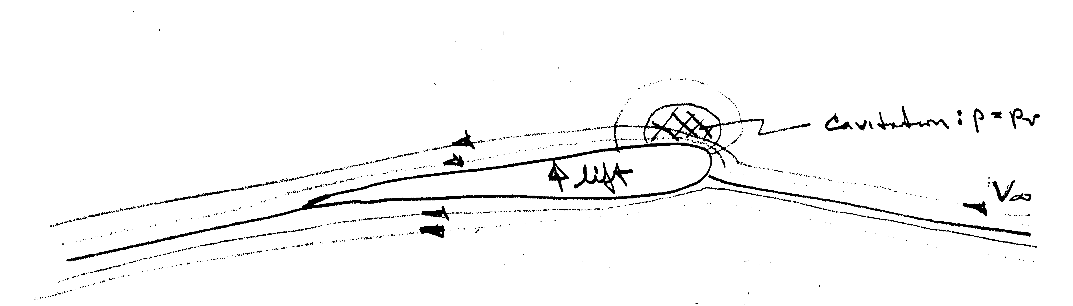

high V low p

(suction side)

isobars

streamlines around lifting surface (i.e. lines tangent to velocity vector)

low V high p

(pressure side)

Cavitation number, $C_{a}$ = 

$C_{a}$ < 0 implies cavitation

**Surface Tension and Capillary Effects**

At the interface of two immiscible fluids (e.g., a liquid and a gas), forces develop to cause the surface to behave as if it were a stretched membrane. Molecules in the interior attract each other equally, whereas molecules along the surface are subject to a net force due to the absence of neighbor molecules. The intensity of the molecular attraction per unit length along any line in the surface is call the surface tension and is designated by the Greek symbol $σ$.

Interface

#### WATER

Near surface forces are increased due to absence of neighbors such that surface is in tension σ per unit length

Away from interface molecular forces are equal in all directions

#### AIR

# *Fσ*

# *Fσ* = surface tension force

*Fσ*

σair/water = 0.073 N/m

line force with direction normal to the cut

=length of cut through the interface

Effects of surface tension:

Contact angle:

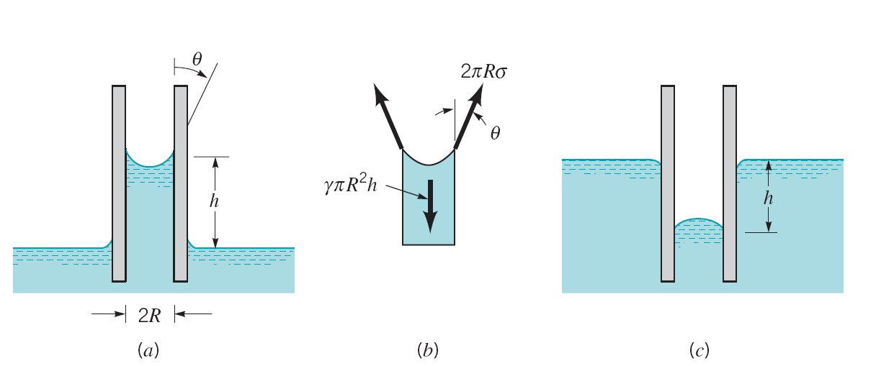

θ < 90o, Wetting

e.g., Water, θ ≈ 0°

θ > 90o, Non-wetting

e.g., Mercury, θ≈130°

1. Capillary action in small tube



2. Pressure difference across curved interface

*p* = /R R = radius of curvature

3. Transformation of liquid jet into droplets

4. Binding of wetted granular material such as sand

5. Capillary waves: surface tension acts as restoring force resulting in interfacial waves called capillary waves

Capillary tube

θ

###### *F*σ

##### *F*σ

Δ*h*

*d*

water

reservoir

*θ*= **contact angle**

Fluid attaches to solid with contact angle θ due to surface tension effect and wetty properties

**Example:**

Capillary tube *d* = 1.6mm = 0.0016m

, *L*=length of contact line between fluid & solid (i.e., *L* = π*D* = circumference)

water reservoir at 20° C, σ = 0.073 N/m, γ = 9790 N/m3

*h* = ?

*F*z = 0

*F*σ,z - W = 0

*d* cos** - *g*~~V~~ = 0 ** ~ 0° ⇒ cos** = 1

*g* = 

 

=Volume of fluid above reservoir



Pressure jump across curved interfaces



(a) Cylindrical interface

Force Balance:

2*σL* = 2 *RL⋅*(*p*i – *p*o)

Δ*p* = *σ*/*R*

*p*i > *p*o, i.e. pressure is larger on concave vs. convex side of interface

(b) Spherical interface (Droplets)

π⋅2*Rσ* = π*R*2Δ*p* → Δ*p* = 2*σ*/*R*

(c) General interface

Δ*p* = *σ*(*R*1-1 + *R*2-1)

*R*1,2 = principal radii of curvature

**A brief history of fluid mechanics**

See textbook section 1.10. (page 27)

**Fluid Mechanics and Flow Classification**

Hydrodynamics: flow of fluids for which density is constant such as liquids and low-speed gases. If in addition fluid properties are constant, temperature and heat transfer effects are uncoupled such that they can be treated separately.

Examples: hydraulics, low-speed aerodynamics, ship hydrodynamics, liquid and low-speed gas pipe systems

Gas Dynamics: flow of fluids for which density is variable such as high-speed gases. Temperature and heat transfer effects are coupled and must be treated concurrently.

Examples: high-speed aerodynamics, gas turbines,

high-speed gas pipe systems, upper atmosphere