**Review problems for Exam 3, 057:020-Fall 2007**

Friction factor and head loss

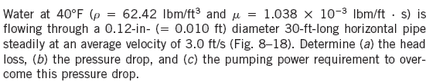

Minor loss

10-91-prob.tif10-91-Fig.tif.tif

Boundary layer

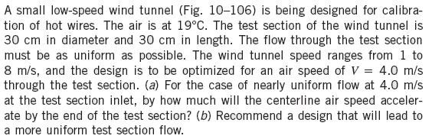

Drag force

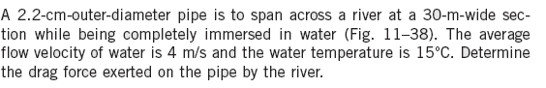



Dimensional Analysis

