1. A fire hose nozzle has a diameter of 1.125in. According to some fire codes, the nozzle must be capable of delivering at least 250 gal/min. If the nozzle is attached to a 3-in.-diameter hose, what pressure must be maintained just upstream of the nozzle to deliver this flowrate?
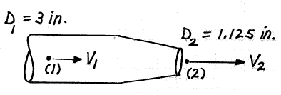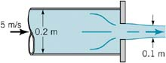
Figure 1 (for Problem 1) Figure 2 (for Problem 2)
2. The exit plane of a 0.20-m-diameter pipe is partially blocked by a plate with a hole in it that produces a 0.10-m-diameter stream as shown in the Figure. The water velocity in the pipe is 5 m/s. Gravity and viscous effects are negligible. Determine the force needed to hold the plate against the pipe.

3. The wave resistance of a model of a ship at 1/16 length scale ratio is 12N at a speed of 3 m/s. What are the corresponding velocity and wave resistance of the prototype? Assume both the model and the prototype are to operate in fresh water. The ship model tests are made according to Froude-number criterion , and wave resistance scales to the third power of the length scale.

4. A water turbine is connected to a reservoir as shown. The flow rate is . What power can be delivered by the turbine if its efficiency is 80%? The pipe material is commercial steel and the loss coefficient for the pipe entrance is 0.5.
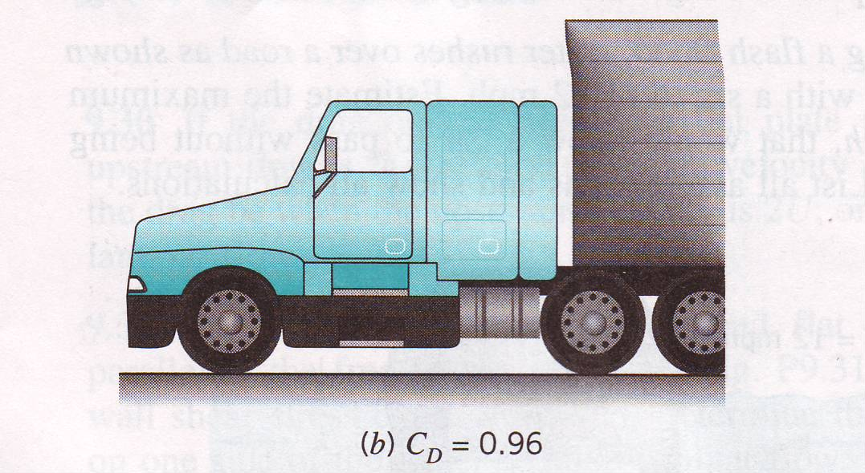
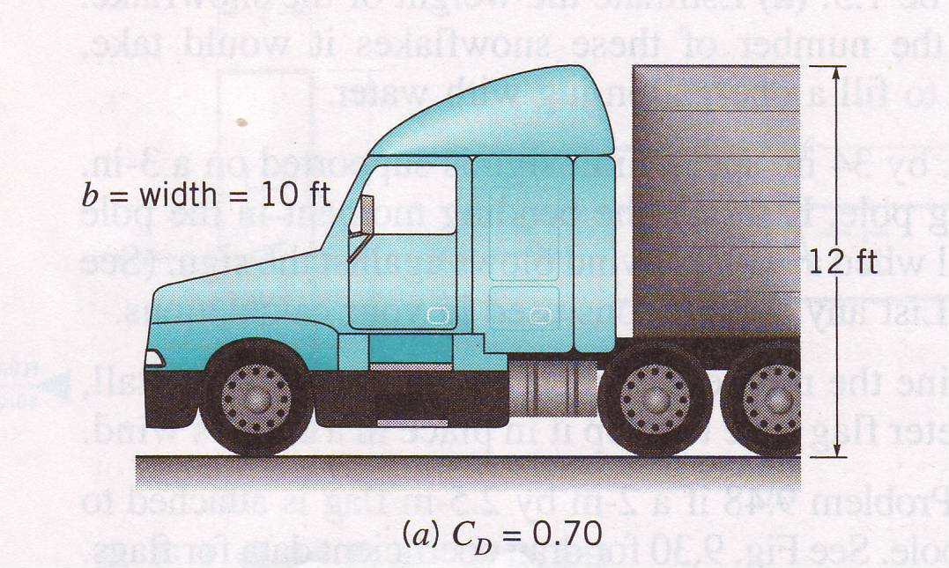

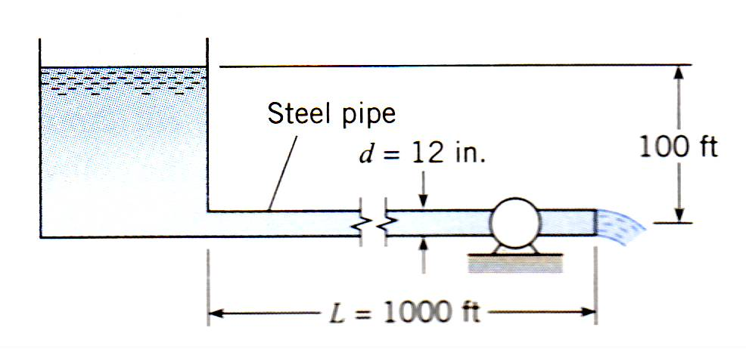
Figure 4 (for Problem 4) Figure 6 (for Problem 6)
5. Air flows parallel to a smooth, thin, flat plate at 15.5ft/s. The plate is 10.6ft long. Determine whether the boundary layer on the plate is most likely laminar, turbulent, or somewhere in between (transitional). The critical Reynolds number is . Compute the boundary layer thickness at the end of the plate for two cases: (a) the boundary layer is laminar everywhere, and (b) the boundary layer is turbulent everywhere.

6. The aerodynamic drag on a truck can be reduced by the use of appropriate air deflectors. A reduction in drag coefficient from C_{D}=0.96 to C_{D}=0.70 corresponds to a reduction of how many horsepower needed at a highway speed of 65 mph?

