**Review problems for Exam 2, 057:020-Fall 2007**

Momentum Conservation



Energy Equation and HGL/EGL

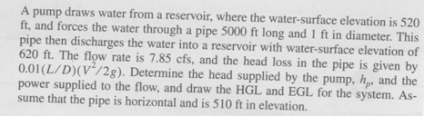

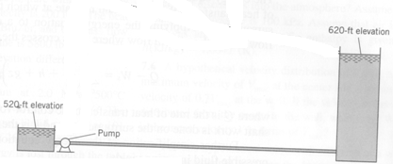

Differential Analysis of Fluid Flow



Dimensional Analysis 1



Dimensional Analysis 2

