|  |  |
| --- | --- |
| NAME |  |
| Student ID |  |

*Known:* Water flows horizontally through a 1 inch inner diameter pipe over a length of 30 feet. Water has the following properties: υ=1.21×10-5  ft2/s and ρ=1.94 slug/ft3. The equivalent roughness of the pipe, ε=0.0001ft.

*Find:* Part 1: Determine the friction factor and the pressure drop if the average velocity is 0.2 ft/second.

Part 2: Determine the friction factor and the pressure drop if the average velocity is 1 ft/second.

*Assumptions:* 1) The flow is fully developed. 2) No change in elevation. 3) There are no bends or contractions.

Equations:

*Re = VD/υ*

$\frac{1}{\sqrt{f_{turb}}}=-2 log⁡\left(\frac{ε/D}{3.7}+ \frac{2.51}{Re\sqrt{f_{turb}}}\right)$

*flam=64/Re*

*hL= f $\frac{lV^{2}}{2Dg}$*

$$\frac{p_{1}}{γ}+ α_{1}\frac{{V_{1}}^{2}}{2g}+ z_{1}=\frac{p_{2}}{γ}+ α_{2}\frac{{V_{2}}^{2}}{2g}+ z_{2}+h_{L}$$

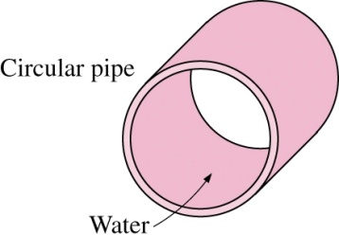

D = 1 in

*l* = 30 ft

*Solution:*

*Part 1:*

*Re = VD/ υ = (0.2 ft/s) (1/12 ft) / (0.0000121 ft2/s) = 1,377*

* *Laminar flow*

*flam = 64/Re = 64 / 1,377 = 0.0464*

$$\frac{p_{1}}{γ}+ α_{1}\frac{{V_{1}}^{2}}{2g}+ z_{1}=\frac{p_{2}}{γ}+ α_{2}\frac{{V_{2}}^{2}}{2g}+ z_{2}+h_{L}$$

$$\frac{p_{1}}{γ}=\frac{p_{2}}{γ}+ h_{L}$$

$$\frac{p_{1}-p_{2}}{γ}= h_{L}$$

$$p_{1}-p_{2}= γh_{L}$$

$∆p= γh_{L}=ρg$*f $\frac{lV^{2}}{2Dg}$ = $f\frac{ρlV^{2}}{2D}$ = $0.0464×\frac{1.94\frac{slug}{{ft}^{3}} × 30 ft × 0.2 \frac{ft}{s}}{2 × \left(1/{12}\right)ft }$ = 0.649 $\frac{lb}{{ft}^{2}}$ = 0.0045 $\frac{lb}{{in}^{2}}$*

*Part 2:*

*Re = VD/ υ = (1 ft/s) (1/12 ft) / (0.0000121 ft2/s) = 6887*

* *Turbulent flow*
* *Go to Moody diagram or Colebrook friction factor equation*

ε/D = 0.0001ft / (1/12 ft) = 0.0012

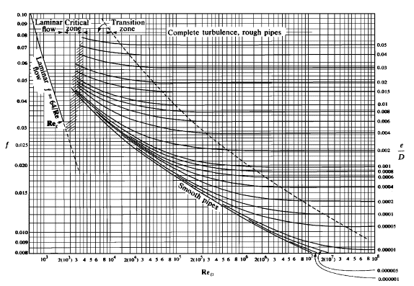

*fturb ~ 0.035*

$∆p= γh_{L}=ρg$*f $\frac{lV^{2}}{2Dg}$ = $f\frac{ρlV^{2}}{2D}$ = $0.035×\frac{1.94\frac{slug}{{ft}^{3}} × 30 ft × 1 \frac{ft}{s}}{2 × \left(1/{12}\right)ft }$ = 12.2 $\frac{lb}{{ft}^{2}}$ = 0.0850 $\frac{lb}{{in}^{2}}$*