NAME
Student ID

Known: Water flows horizontally through a 1 inch inner diameter pipe over a length of 30 feet. Water has the following properties: υ=1.21×10⁻⁵ ft²/s and ρ=1.94 slug/ft³. The equivalent roughness of the pipe, ε=0.0001ft.
Find: Part 1: Determine the friction factor and the pressure drop if the average velocity is 0.2 ft/second.
Part 2: Determine the friction factor and the pressure drop if the average velocity is 1 ft/second.

Assumptions: 1) The flow is fully developed. 2) No change in elevation. 3) There are no bends or contractions.
Equations:
Re = VD/υ
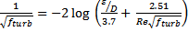
f_{lam}=64/Re
h_{L}= f
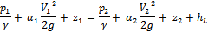

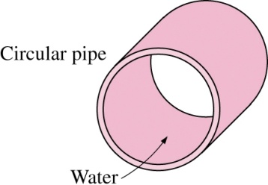
l = 30 ft
D = 1 in
Solution:

Part 1:
Re = VD/ υ = (0.2 ft/s) (1/12 ft) / (0.0000121 ft²/s) = 1,377
- Laminar flow
f_{lam} = 64/Re = 64 / 1,377 = 0.0464

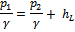

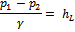
f == 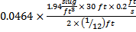= 0.649 = 0.0045

Part 2:
Re = VD/ υ = (1 ft/s) (1/12 ft) / (0.0000121 ft²/s) = 6887
- Turbulent flow
- Go to Moody diagram or Colebrook friction factor equation
ε/D = 0.0001ft / (1/12 ft) = 0.0012

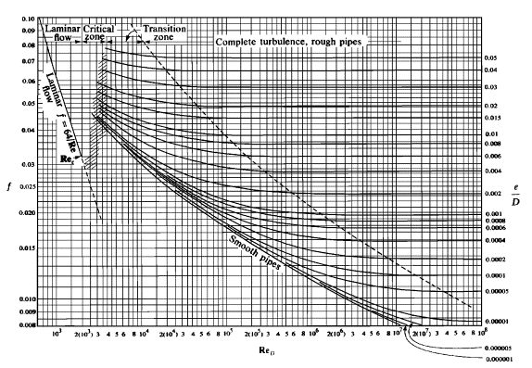

f_{turb} ~ 0.035
f == 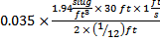= 12.2 = 0.0850

