57:020 Mechanics of Fluids & Transfer Processes
Exercise Notes for Fluid Property TM
Measurement of Density and Kinematic Viscosity
Marian Muste, Surajeet Ghosh and Fred Stern

1. Purpose
To provide Hands-on experience with table-top facility and simple measurement systems for fluid property (density and kinematic viscosity) measurement, including comparison with manufacturer values and rigorous implementation of standard EFD uncertainty analysis.

2. Experimental Design
Common methods used for determining viscosity are the rotating-concentric-cylinder method (Engler viscosimeter) and the capillary-flow method (Saybolt viscosimeter). In the present experiment we measure the kinematic viscosity through its effect on a falling object in still fluid (figure1). The maximum velocity attained by an object in free fall (terminal velocity) is inversely proportional to the viscosity of the fluid through which it is falling. When terminal velocity is attained, the body experiences no acceleration and so the forces acting on the body are in equilibrium.

Figure 1. Schematic of the experimental setup

The forces acting on the body are, the gravitational force,
$F_{g}\text{ = mg = }ρ_{\text{sphere}}π\frac{D^{3}}{6}\text{ g}$ (1)
The force due to buoyancy,
$F_{b}\text{ = }ρ_{\text{fluid}}π\frac{D^{3}}{6}\text{ g}$ (2)
and, the resistance of the fluid to the motion of the body, similar to friction. For Re = VD/ν << 1 (Re is the Reynolds number), the drag force on a sphere is described by the Stokes expression
$F_{d}\text{ = 3 }ρ_{\text{fluid}}πν\text{ V D}$ (3)
where, D is the sphere diameter, ρ_{fluid} is the density of the fluid, ρ_{sphere} is the density of the falling sphere, ν is the kinematic viscosity of the fluid, F_{d}, F_{b}, and F_{g}, denote the drag, buoyancy, and weight forces, respectively, V is the velocity of the sphere through the fluid (in this case, the terminal velocity), and g is the acceleration due to gravity (White 1994).
Once terminal velocity is achieved, a summation of the vertical forces must balance. This gives:
$ν\text{ = }{(D}^{2}\text{ g }({ρ_{\text{sphere}}}/{ρ_{\text{fluid}}}\text{ - 1})\text{ t})/{\text{18 }}λ$ (4)
where, t is the time for the sphere to fall the vertical distance λ.
Using equation (4) for two different materials, namely, teflon and steel spheres, the following relationship for the density of the fluid is obtained, where subscripts s and t refer to the steel and teflon spheres, respectively.
$ρ_{\text{fluid}}\text{ = }{(D}_{t}^{2}t_{t}ρ_{t}\text{ - }D_{s}^{2}t_{s}ρ_{s})/{D_{t}^{2}}t_{t}\text{ - }D_{s}^{2}t_{s}$ (5)
In this experiment, we will drop spheres (Steel and Teflon) of different densities and diameters through a long transparent cylinder filled with glycerin (Figure 1). Two horizontal lines are marked on the vertical cylinder. The distance between the two lines is long enough for the sphere to achieve the terminal velocity. We will measure the time required for the sphere to fall through the distance. The measurement system includes:
- A transparent cylinder (beaker) containing glycerin.
- A scale to measure the distance the sphere has fallen.
- Teflon and steel spheres of different diameters
- Stopwatch to measure fall time
- Micrometer to measure sphere diameter
- Thermometer to measure room temperature

An excel sheet is provided as Lab1_Data_Reduction_Sheet to facilitate data acquisition, data reduction and uncertainty analysis.

3. Experimental Process
The diagram of the experimental process is provided in Figure 2.

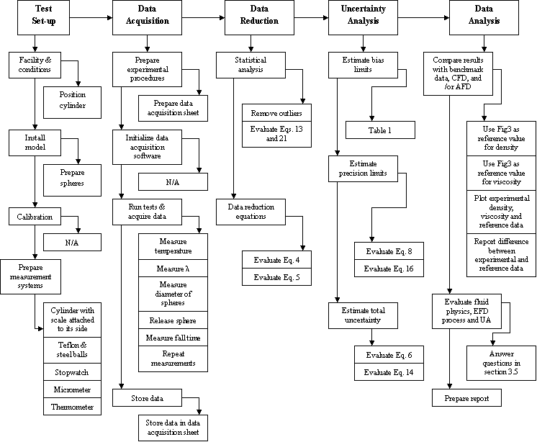

Figure 2. Diagram of the EFD process

3.1 Test setup
Before starting the experiment verify the vertical position for the cylinder and open the cylinder lid. Prepare 10 Teflon and 10 Steel spheres and make sure that the spheres are clean. Test the functionality of the stopwatch, micrometer and thermometer.

3.2 Data acquisition
The experiment procedure follows the sequence described below:
1. Measure the temperature of the room.
2. Measure the distance between the two lines, λ.
3. Measure the diameter of each sphere (teflon and steel) using the micrometer.
4. Release the sphere at the surface of the fluid in the cylinder. Then, release the gate handle.
5. Release the Teflon and steel spheres, one by one.
6. Measure the time for each sphere to travel the length λ
7. Repeat steps 3- 6 for 10 spheres of each material.
Since the fall time of the sphere is very short, it is important to measure the time as accurately as possible. Start the stopwatch as soon as the bottom of the ball hits the first mark on the cylinder and stop it as soon as the bottom of the ball hits the second mark. Two people should cooperate in this measurement with one looking at the first mark and handling the stopwatch, and the other looking at the second mark. A spreadsheet needs to be created for data acquisition, exactly according to the Sample shown below. The data from this sample is inserted in Lab1_Data_Reduction_Sheet.

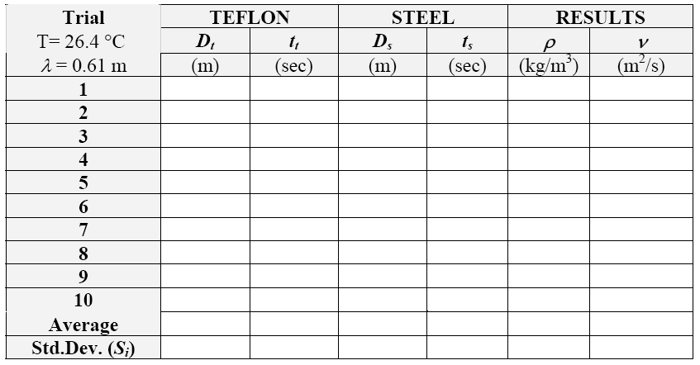

3.3 Data reduction
Figure 2 illustrates the block diagram of the measurement systems and data reduction equations for the results. Use Lab1_Data_Reduction_Sheet for the data reduction procedure after importing the data from the Sample.
Data reduction includes the following steps
1. Calculate the statistics (mean and standard deviations) of the repeated measurements.
2. Calculate the fluid density for each individual measurement using equation (5).
2. Calculate the kinematic viscosity for each individual measurement using equation (4).

3.4 Uncertainty analysis
Uncertainties for the experimentally determined glycerin density and kinematic viscosity will be evaluated. Lab1_Data_Reduction_Sheet should be used to evaluate the uncertainties in density and viscosity. The methodology for estimating uncertainties follows the AIAA S-071-1995 Standard (AIAA, 1995) as summarized in Stern et al. (1999) for multiple tests. The block diagram for propagation of errors in the measured density and viscosity is provided in Figure 3. The data reduction equations for density and viscosity of glycerin are equation (5) and (4), respectively. First, the elemental errors for each of the independent variable, X_{i}, in data reduction equations should be identified using the best available information (for bias errors) and repeated measurements (for precision errors). Table 1 contains the
summary of the elemental errors assumed for the present experiment. In the present analysis we will neglect the contribution of the correlated bias errors.
Figure 3. Block diagram of the experiment including: measurement systems, data reduction equations, and results
Table 1. Assessment of the bias limits for the independent variables
Bias limit | Bias Limit | Estimation
B_{D}= B_{Ds} = B_{Dt} | 0.000005 m | ½ instrument resolution
B_{t} = B_{ts} = B_{tt} | 0.01 s | Last significant digit
B_{λ} | 0.00079 m | ½ instrument resolution

Density of glycerin
The total uncertainty for the density measurement is:
$U_{{\bar{ρ}}_{G}}=\sqrt{B_{ρ_{G}}^{2}+P_{{\bar{ρ}}_{G}}^{2}}$ (6)
The bias limit $B_{ρ_{G}}$, and the precision limit $P_{{\bar{ρ}}_{G}}$, for the result are given by:
$B_{ρ_{G}}^{2}=\sum_{i=1}^{j}{θ_{i}^{2}}B_{i}^{2}=θ_{D_{t}}^{2}B_{D_{t}}^{2}+θ_{t_{t}}^{2}B_{t_{t}}^{2}+θ_{D_{s}}^{2}B_{D_{s}}^{2}+θ_{t_{s}}^{2}B_{t_{s}}^{2}+2θ_{D_{t}}θ_{D_{s}}B_{D_{t}}B_{\text{Ds}}+2θ_{t_{t}}θ_{t_{s}}B_{t_{t}}B_{\text{ts}}$ (7)
$P_{{\bar{ρ}}_{G}}=2⋅S_{{\bar{ρ}}_{G}}\sqrt{M}$ (8)
where, the sensitivity coefficients (calculated using mean values for the independent variables) are:
(9) (10)
(11) (12)
Note that the bias limits for D_{t} and D_{s} as well as t_{t} and t_{s} are correlated because the sphere diameters and fall times are measured with the same instrumentation. The last two terms of equation (7) represent correlated bias errors. The standard deviation for density of glycerin is calculated using the following formula (M = 10)
$S_{{\bar{ρ}}_{G}}={\left[\sum_{k=1}^{M}{\frac{{\left(ρ_{k}−\bar{ρ}\right)}^{2}}{M−1}}\right]}^{1/2}$ (13)
Viscosity of glycerin
Uncertainty assessment for the glycerin viscosity will be based on the measurements conducted with the teflon spheres instead of steel spheres. This selection is due to a better agreement with Stokes' law requirements (Re << 1). The total uncertainty for the viscosity measurement is given by equation (24) in Stern et al. (1999):
$U_{\bar{ν}}=\sqrt{B_{ν}^{2}+P_{\bar{ν}}^{2}}$ (14)
The bias limit $B_{ν}$, and the precision limit $P_{\bar{ν}}$, for viscosity (neglecting correlated bias errors) is given by equations (14) and (23) in Stern et al. (1999), respectively.
$B_{ν}^{2}=\sum_{i=1}^{j}{θ_{i}^{2}}B_{i}^{2}=θ_{D_{t}}^{2}B_{D_{t}}^{2}+θ_{t_{t}}^{2}B_{t_{t}}^{2}+θ_{ρG}^{2}B_{ρG}^{2}+θ_{λ}^{2}B_{λ}^{2}$ (15)
$P_{\overline{ν}}=2⋅S_{\bar{ν}}\sqrt{M}$ (16)
The bias limits for B_{Dt} , B_{tt}, B_{ρ} were evaluated previously in conjunction with the estimation of $U_{ρ_{G}}$. The value for is provided in Table 1. The sensitivity coefficients, θ_{i}, are calculated using mean values in the following equations:
(17) (18)
(19) (20)
Note that unlike density, there are no correlated bias errors contributing to the viscosity result. The standard deviation for the viscosity of glycerin for M=10 repeated measurements is calculated using the following formula
$S_{\bar{ν}}={\left[\sum_{k=1}^{M}{\frac{{\left(ν_{k}−\bar{ν}\right)}^{2}}{M−1}}\right]}^{1/2}$ (21)

3.5 Data analysis
The measured values from the completed Lab1_Data_Reduction_Sheet, will be compared with the benchmark data (figure 3) based on information provided by the manufacturer. The following questions help to evaluate fluid physics, EFD process and uncertainty analysis and the answers should be included in the Lab report.
- What aspects of the present “hands-on” experiment would increase the accuracy of the results if the measurement system would be automated?
- Calculate the effective Reynolds numbers for our experiment, i.e., Re = VD/ν << 1, where is the sphere fall velocity. Can we use Stokes equation for calculating the drag force acting on the spheres?
- How does viscosity of glycerin change with temperature and why?
- What is the major difference in estimating the bias and precision limits in equations (7) and (8), respectively?
- Does always the consideration of the correlated bias errors in equation (14), Stern et al. (1999) increase the magnitude of the bias limit?

Figure 3. Reference data for the density and viscosity of 100% aqueous glycerin solutions
(Proctor & Gamble Co., Product Catalogue, 1995)

4. References
AIAA (1995). AIAA S-071-1995 Standard, American Institute of Aeronautics and Astronautics, Washington, DC.
Batchelor, G.K. (1967). An Introduction to Fluid Dynamics, Cambridge University Press, London
Granger, R.A. (1988). Experiments in Fluid Mechanics, Holt, Rinehart and Winston, Inc. New York, NY Proctor & Gamble Co., 1995, Product Catalogue.
Stern, F., Muste, M., Beninati, M-L, and Eichinger, W.E. (1999). “Summary of Experimental Uncertainty Assessment Methodology with Example,” IIHR Report No. 406, The University of Iowa, Iowa City, IA.
White, F.M. (1994). Fluid Mechanics, 3rd edition, McGraw-Hill, Inc., New York, NY.
Visualization clips: http://css.engineering.uiowa.edu/fluidslab/referenc/concepts.html - Viscosity

