57:020 EFD Lab 3 and CFD Lab 2 Concepts

- Background
EFD Lab 3 (Measurement of pressure distribution and forces acting on an airfoil) will provide students hands-on experience with Wind tunnel test facility and modern measurement systems including Scani-valve, Load cells and computerized data acquisition using Labview. CFD PreLab2 (Simulation of turbulent flow around an airfoil) and CFD Lab2 (Parametric studies of turbulent flow around an airfoil) will provide students hands-on experience following the “CFD Process” by an interactive step-by-step method. Students will validate their simulation results using their own measured data in EFD Lab 3 (life, drag, and pressure coefficients). Students will also conduct parametric studies on the effect of angle of attack and effect of different turbulence models. Students will analyze the differences and possible numerical errors, and present results in Lab report.

- Concepts covered

  - Flow around an airfoil
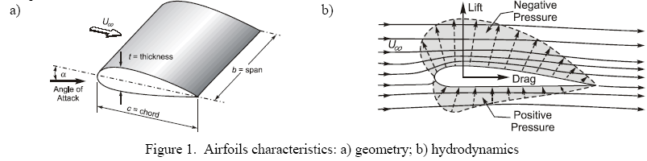

  - Calibration of load cell

Principle
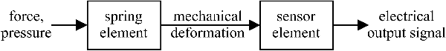

Load cells measure forces and moments by sensing the deformation of elastic elements such as springs. Usually it comprises of two parts
  - The spring: deforms under the load (usually made of steel)
  - Sensing element: measures the deformation (usually a strain gauge glued to the
deforming element).

- The load cell is calibrated to obtain a relationship between its output in volts and lift/drag forces (Newton). A series of loads are applied to the load cell and the output is recorded. The calibration coefficients are obtained from linear regression of the recorded data.

  - Lift and drag forces

Lift coefficient, C_{L}, is given by
$$C_{L}\left[L,ρ,U_{∞},b,c\right]=\frac{2L}{{ρU}_{∞}^{2}\text{bc}}$$

where, L is the lift force acting on the airfoil surface, $U_{∞}$, b is the airfoil span, and c is the airfoil chord (as shown in Figure 1.a). The lift force can be obtained in two ways. By integrating the measured pressure distribution over the airfoil

$$L=\int_{s}{\left(p_{i}−p_{∞}\right)}\text{sin}\left(θ_{i}\right)\text{ds}$$
where, θ_{i} is the angle of surface normal to free-stream flow on the airfoil surface or by direct measurement using the load cell. The drag coefficient C_{D} is given by

$$C_{D}\left[D,ρ,U_{∞},b,c\right]=\frac{2D}{{ρU}_{∞}^{2}\text{bc}}$$

Variation of C_{L} and C_{D} with angle of attack (AOA):

Stall

2.4 Validation of CFD

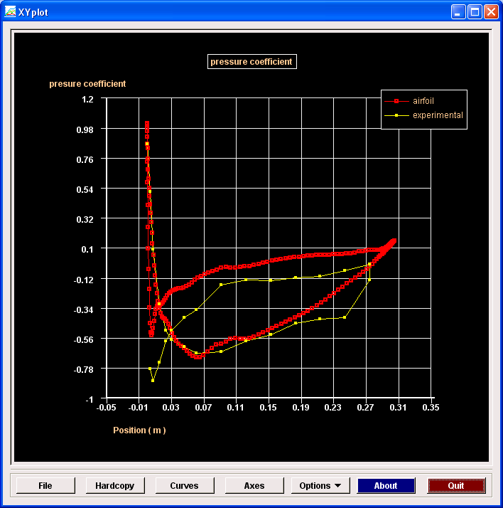
Validation of CFD using EFD data for pressure coefficient.

