57:020 EFD Lab 2 and CFD Lab 1 Concepts

- Background
EFD Lab 2 (Measurement of Flow Rate, Velocity Profile and Friction Factor in Pipe Flows) will provide students hands-on experience with Pipe stand test facility and modern measurement systems including pressure transducers and Pitot probes and computerized data acquisition using Labview. To measure flow rate, velocity profiles and friction factors in smooth and rough pipes, determine the measurement uncertainties, and compare the results with benchmark data. CFD PreLab 1 (Simulation of Laminar Pipe Flow) and CFD Lab 1 (Simulation and Validation of Turbulent Pipe Flow) will provide students “hands-on” experiences using the CFD Educational Interface to compute axial velocity profile, centerline velocity, centerline pressure and friction factor. Students will compare simulation results with AFD data for laminar pipe flow, with their own EFD data for turbulent pipe flows.

- Concepts covered
  - Averaged velocity
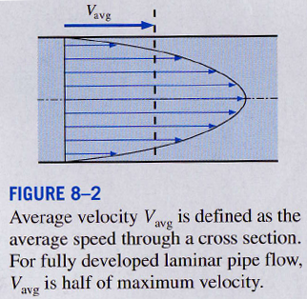
The fluid velocity in a pipe changes from zero at the pipe wall to a maximum at the pipe centerline. By conservation of mass:
Where is the cross-section area and is the velocity profile.

The tubes sensing static and stagnation pressures are usually combined into one instrument known as pitot static tube.

  - Reynolds number
The ratio of the inertial forces to viscous forces in the fluid is called the Reynolds number

  - Laminar vs. turbulent pipe flows
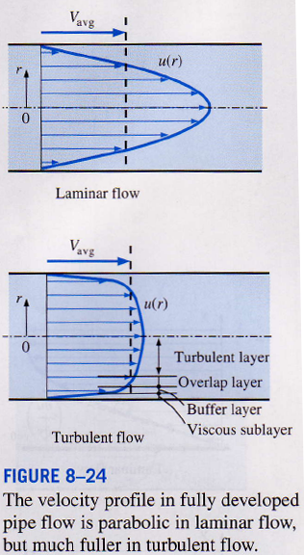

laminar flow
transitional flow
turbulent flow
For fully developed region in laminar pipe flow, the velocity profile has analytical solution:

  - Developing vs. developed flows
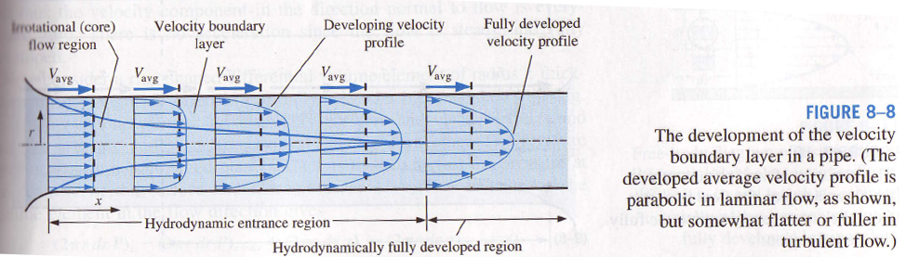

  - Flow rate computation

Direct method using venturimeter:
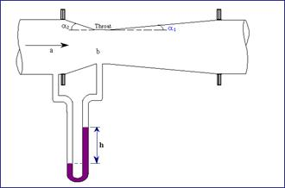 | 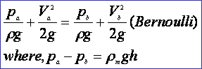

Integration method:

  - Pressure drop
The fluids in pipes are driven by the pressure gradient, which is related to the power requirements of the pump to maintain the flow:
- Pressure caused only by molecular collisions is known as static pressure.
- The pressure tap is a small opening in the wall of a duct (Fig a.)
- Pressure tap connected to any pressure measuring device indicates the static pressure. (note: there is no component of velocity along the tap axis).
- The stagnation pressure at a point in a fluid flow is the pressure that could result if the fluid was brought to rest isentropically (i.e., the entire kinetic energy of the fluid is utilized to increase its pressure only).

  - Friction factor
In the fully developed flow region of a pipe, the velocity profile does not change downstream, and thus the wall shear stress remains constant as well
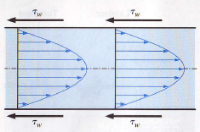
Friction factor f is , laminar pipe flow:

