These are the cells where you need to fill in your own data:

APPENDIX B DATA REDUCTION SHEET (two sheets, one for smooth and one for rough pipe)
G7 -> G8
H7 -> H8
K7 ( according to G9 )
k8 ( according to H9 )
k9 ( according to H9 )
C12 -> C13
B32 -> B44
C32 -> C44
F32 -> F41
For G14, refer to the example shown in the next page. The flow rate obtained from integration method is substituted in G14. The procedure is described in the next page.
Note: To calculate flow rate use cells A32-A38 and D32-D38.
H32 -> H41
B18 -> B21
H18 -> H27
J18 -> J27
For APPENDIX C_UA_F sheet:
B94
B99
For APPENDIX C_UA_F sheet:
B96
B101

Note: Please refer next page for calculation of flow rate (G14-appendix B)

Instructions for calculating pipe flow rate

Step1. In a separate excel file, make two columns, one for radial position of pitot tube and the other for velocity at each position. For the radial position copy cells A32-A38 and for velocity copy cells D32-D38 from the Lab2 appendix B.

Step2. Plot the velocity versus radial position using excel graph (see figure below). On the X-axis plot radial position and on Y-axis plot velocity.

Step3. Fit a third order polynomial curve to the plot, using excel curve fit technique. Display the equation on the chart. The equation gives the actual velocity profile, where y represents the velocity and x represents the radial position.

Step4. Integrate the third order curve to obtain flow rate Q as shown below.
$Q_{i}=2π\int_{0}^{R}{u(r)\text{rdr}}$, where R = 0.024m.
Substitute the u(r) from the curve fit equation obtained from excel.
$$Q_{i}=2π\int_{0}^{R}{({\text{ -1E+06r}}^{3}{\text{ + 22352r}}^{2}\text{ - 337}\text{.}\text{43r + 40}\text{.}\text{199})\text{rdr}}$$
Perform the above integration, either analytically or using calculator. The result gives the flow rate in the pipe.

Step5. Substitute this value of flow rate in cell G14 in Lab2 appendix B.
Radial position |  | velocity | 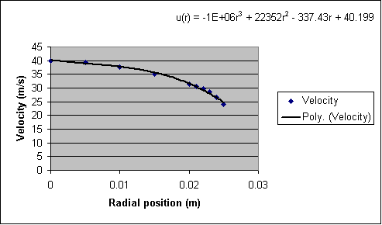
of pitot tube (m) |  | (m/s)
0.024 |  | 26.49449
0.023 |  | 28.56371
0.022 |  | 29.72074
0.021 |  | 30.66826
0.02 |  | 31.44146
0.015 |  | 34.965
0.01 |  | 37.69995
0.005 |  | 39.36392
0 |  | 40.00759

