57:020 Mechanics of Fluids and Transfer Processes
Exercise Notes for the Pipe Flow TM

Measurement of Flow Rate, Velocity Profile and Friction Factor in Pipe Flows
S. Ghosh, M. Muste, M. Wilson and F. Stern

1. Purpose
To provide students hands-on experience with Pipe stand test facility and modern measurement systems including pressure transducers and pitot probes and computerized data acquisition using Labview. To measure flow rate, velocity profiles and friction factors in smooth and rough pipes, determine the measurement uncertainties, and compare the results with benchmark data.

2. Experimental Design
The experiments are conducted in an instructional airflow pipe facility (Figure 1). The air is blown into a large reservoir located at the upstream end of the system. Pressure built up in the reservoir, forces the air to flow through any of the three horizontal pipes. Pressure taps are located on each pipe along intervals of 1.524m, for static pressure measurements. The pipe characteristics for each of the pipes are provided in Appendix A. At the downstream end of the system, the air is directed downward and back, through any of the three pipes of varying diameters fitted with Venturi meters (Figure 2). The top three valves control flow through the experimental pipes, while the bottom three valves control the Venturi meter to be used. The venture meter with 5.08cm diameter is used to measure the total flow rate, the other two are kept closed. Six gate valves are used for directing the flow. The top and bottom 5.08cm pipes are only used for measurements while the middle one is kept closed during the experiment. Velocity measurements in the top and bottom pipes are obtained using pitot probe (Figure 3).

Figure1. Airflow pipe system | Figure 2. Venturimeter | Figure 3. Pitot-probe

Pressures are acquired either manually, using simple and differential manometers for data acquisition, or automatically whereby the manometers are connected to an automated Data Acquisition (DA) system that converts pressure to voltages using pressure transducers. Data acquisition is controlled and interfaced by Labview software described in Appendix B. The schematic of the two alternative measurement systems is provided in Figure 4.

Figure4. Manual and automated measurement systems used in the experiment

All pressure taps on the pipes, venturimeters and pitot probes have 0.635cm diameter quick coupler connections that can be hooked up to the pressure transducers.

2.1 Data reduction (DR) equations
In a fully developed, axi-symmetric pipe flow, the axial velocity (u = u (r)) at a radial distance r from the pipe centerline, is independent of the direction in which r is considered (Figure 5). However, the shape of the velocity profile is different for laminar and turbulent flows.
Laminar and turbulent flow regimes are distinguished by the flow Reynolds number defined as
$\text{Re}=\frac{\text{VD}}{ν}=\frac{4Q}{πDν}$ (1)
Where, V is the average pipe velocity, D is the pipe diameter, Q is the pipe flow rate, and ν is the kinematic viscosity of the fluid. For fully developed laminar flow (Re < 2000), analytical solution for the differential equations of the fluid flow (Navier-Stokes and continuity) can be obtained. For turbulent pipe flows (Re > 2000), there is no exact solution, hence semi-empirical laws for velocity distribution are used instead.
The pipe-head loss due to friction is obtained from the Darcy-Weisbach equation:
Figure 5. Velocity distributions for fully developed pipe flow: a) laminar flow; b) turbulent flow
$h_{f}=f\frac{L}{D}\frac{V^{2}}{2g}$ (2) where, f is the (Darcy) friction factor, L is the length of the pipe over which the loss occurs, h_{f} is the head loss due to viscous effects, and g is the gravitational acceleration. Moody diagram provides the friction factor for pipe flows with smooth and rough walls in laminar and turbulent regimes. The friction factor depends on Re and relative roughness k/D of the pipe (for large enough Re, the friction factor is solely dependent on the relative roughness).
Velocity distributions in the pipes are measured with Pitot tubes housed in glass-walled boxes (Figure 3). The data reduction equation (DRE) for the measurement of the velocity profiles is obtained by applying Bernoulli’s equation for the Pitot tube
$u(r)={\left[\frac{2⋅{gρ}_{w}}{ρ_{a}}⋅\left[z_{{\text{SM}}_{\text{Stag}}}\left(r\right)−z_{{\text{SM}}_{\text{Stat}}}\right]\right]}^{1/2}$ (3)
where, u(r) is the velocity at the radial position r, g is the gravitational acceleration, $z_{{\text{SM}}_{\text{Stag}}}(r)$ is the stagnation pressure head determined by the Pitot probe located at radial position r, $z_{{\text{SM}}_{\text{Stat}}}$is the static pressure head in the pipe, equal to that of the ambient pressure inside the glass-walled box. The readings of the pressure heads in Equation (3) are in height of a liquid column (ft of water). ρ_{w}, is the density of water and ρ_{a} is the density of air. DRE for the friction factor is one of the Darcy Weisbach equation forms (Roberson & Crowe, 1997)
$f=\frac{{gπ}^{2}D^{5}}{8{\text{LQ}}^{2}}\frac{ρ_{w}}{ρ_{a}}\left(z_{{\text{SM}}_{i}}−z_{{\text{SM}}_{j}}\right)$ (4)
where, L is the pipe length between the taps i and j, and $z_{{\text{SM}}_{i}}−z_{{\text{SM}}_{j}}$ is the difference in pressure between the taps i and j. The flow rate Q is directly measured using the calibration equations for the Venturi meters (Rouse, 1978)
$Q=C_{d}A_{t}\sqrt{2{gΔz}_{\text{DM}}⋅\frac{ρ_{w}}{ρ_{a}}}$ (5)
where, C_{d} is the discharge coefficient, $A_{t}$ is the contraction area, ${Δz}_{\text{DM}}$ is the head drop across the Venturi, measured in height of liquid column (ft of water) by the differential manometer or the pressure transducer. Appendix A lists Venturi meter characteristics. Alternatively, the flow rate can be determined by integrating the measured velocity distribution over the pipe cross-section.
$Q_{i}=2π\int_{0}^{r}{u(r)\text{rdr}}$ (6)
3. Experimental Process

Figure6. EFD Process

3.1. Test-setup
The experimental measurement systems for the manual and automated configurations are shown below:

Manual Data Acquisition | Automated Data Acquisition
Facility (Figure 1) | Facility (Figure 1)
Thermometers (room and inside the setup) | Thermometers (room and inside the pipe)
Venturi meter (Figure 2) | Venturi meter (Figure 2)
Pitot-tube assembly (Figure 3) | Pitot-tube assembly (Figure 3)
Micrometer for Pitot positioning (Figure 3) | Micrometer for Pitot positioning (Figure 3)
Simple manometer | DA (see Appendix B)
Differential manometer | DA (see Appendix B)
DA manifold | DA manifold

3.2. Data Acquisition
Each student group will obtain velocity distributions and determine the friction factor for one of the 5.08cm (rough or smooth) pipes. Data acquired with the DA are recorded electronically and subsequently used for data reduction. The Data reduction sheet will be used for data reduction. The experimental procedure follows the sequence described below:

- Starting with the low velocity initially set, increase gradually the flow rate until the desired Re (= 96,000) in the test section is attained (the desired Re can be achieved for both upper and lower pipes, with a setting of 35% on the blower motor controller and control valves fully open). Make at least five flow rate measurements with the venture-meter of 5.08cm contraction diameter. The other two venture-meters are kept closed. For the five measurements, the blower setting should start from 15% and reach 35%, with 5% increment each time (recommended settings: 15%, 20% 25% 30% 35%). Record your readings from both the manometer and pressure transducer. The remaining experiment is carried out at 35% blower settings. Use Labview to record the venturimeter reading.

- Take temperature readings with the digital thermometer (resolution 0.1 ˚F) for ambient air and inside the pipe for calculating the corresponding water and air densities, respectively. Input the temperature readings as requested by DA software interface. Since the temperature increases during the experiment, take three temperature readings at the beginning, in the middle, and at the end of the measurements.

- Velocity distribution is obtained with the DA by measuring stagnation heads across the full pipe diameter along with the readings of the static heads using the appropriate Pitot-tube assembly. Measure stagnation heads at radial intervals no greater than 5 mm (recommended spacing for half diameter of the upper and lower pipes is 0, 5, 10, 15, 20, 23, and 24 mm). Positioning of the Pitot tube within the pipe is made with a micrometer (resolution of 0.01 mm). To establish precision limits for velocity profiles, measurements near the pipe wall (at 24mm) should be taken at least 10 times. The same procedure is used for the upper (smooth) and lower (rough) pipes.

- Keeping the blower setting at 35%, measure the pressure heads at pressure taps 1, 2, 3, and 4 sequentially as indicated in Figure 1 using the DA by connecting each tap to the pressure transducer. To establish precision limits for the friction factor, measurements, preferably at taps 3 and 4 should be repeated 10 times. The repeated measurements should be made alternatively between tap 3 and 4. It is important to note that the pressure in the pipe system fluctuates when opening or closing manifold valves, hence it is necessary to wait a few seconds between consecutive measurements, for the pressure fluctuation to settle down. The data acquisition procedure is same for both rough and smooth pipes.

3.3 Data Reduction
Data reduction includes the following steps:
- Using the average temperatures, ${\overline{T}}_{w}$and ${\overline{T}}_{a}$ to determine ρ_{w}, ρ_{a}, and ν_{a} from fluid property tables. Determine the flow rate (Q) in the individual pipes using Equation (6) and Re using Equation (1). The method for calculating flow rate (Equation 6) in individual pipes is explained in the Data reduction sheet.
- Compare the flow rate readings taken with the manometer and pressure transducer.
- Calculate velocity distribution profiles for the tested pipe using Equation (3). Plot the measured velocity profile including the velocity total uncertainties calculated for centerline and near the wall measurements. Compare the measured velocity distribution with the benchmark data provided in Figure 8.
- Calculate the friction factor for the tested pipe using Equation (4). Use readings at taps 3 and 4, where the flow is fully developed. Compare f with benchmark data, including uncertainty band for the measured f.

3.4 Uncertainty Analysis
Uncertainties for the experimentally measured velocities and friction factor will be evaluated. The methodology for estimating uncertainties follows the AIAA S-071 Standard (AIAA, 1995) as summarized in Stern et al. (1999) for multiple tests (M = 10). The block diagrams for error propagations in the measurements are provided in Figure 7. Elemental errors for each of the measured independent variable in data reduction equations should be identified using the best available information (for bias errors) and repeated measurements (for precision errors). We will consider in the analysis only the largest bias limits and neglect correlated bias errors. The spreadsheet for evaluating the uncertainties is provided in Data reduction sheet. The spreadsheet includes bias limit estimates for the individual measured variables.
The DRE for the velocity profile, Equation (3), is of the form: $u(r)=F(g,ρ_{w},ρ_{a},z_{\text{SM} \text{stag}},z_{\text{SM} \text{stat}})$. We will only consider bias limits for z_{SM stag} and z_{SM stat}. The total uncertainty for velocity measurements is
$U_{u}^{2}=B_{u}^{2}+P_{u}^{2}$ (7)
The bias limit, B_{u}, and the precision limit, P_{u}, for velocities are given by
$B_{u}^{2}=\sum_{i=1}^{j}{θ_{i}^{2}}B_{i}^{2}=θ_{Z_{\text{SM} \text{stag}}}^{2}B_{Z_{\text{SM} \text{stag}}}^{2}+θ_{Z_{\text{SM} \text{stat}}}^{2}B_{Z_{\text{SM} \text{stat}}}^{2}$ (8)
(9)
where the coefficients θ are calculated using mean values for the independent variables
$Θ_{Z_{\text{SM} \text{stag}}}=\frac{1}{{\left(z_{\text{SM} \text{stag}}−z_{\text{SM} \text{stat}}\right)}^{0\text{.}5}}{\left(0\text{.}5g\frac{ρ_{w}}{ρ_{a}}\right)}^{0\text{.}5} \left(s^{−1}\right);$ $Θ_{Z_{\text{SM} \text{stat}}}=\frac{−1}{{\left(z_{\text{SM} \text{stag}}−z_{\text{SM} \text{stat}}\right)}^{0\text{.}5}}{\left(0\text{.}5g\frac{ρ_{w}}{ρ_{a}}\right)}^{0\text{.}5} \left(s^{−1}\right)$ (10)

and S_{u} is the standard deviation of the repeated velocity measurements. K = 2 for (M =) 10 repeated measurements.
The DRE for the friction factor, Equation (4), is of the form: $f=F(g,D,L,Q,ρ_{w},ρ_{a},z_{\text{SM} i},z_{\text{SM} j})$. We will only consider bias limits for z_{SM i} and z_{SM j}. The total uncertainty for the friction factor is:
$U_{f}^{2}=B_{f}^{2}+P_{f}^{2}$ (11)
The bias limit, B_{f}, and the precision limit, P_{f}, for the result are given by
$B_{f}^{2}=\sum_{i=1}^{j}{θ_{i}^{2}}B_{i}^{2}=θ_{z_{\text{SM} i}}^{2}B_{z_{\text{SM} i}}^{2}+θ_{z_{\text{SM} j}}^{2}B_{z_{\text{SM} j}}^{2}$ (12)
(13)
where, the coefficients θ are calculated using mean values for the independent variables:
$θ_{Z_{\text{SM} i}}=\frac{{gπ}^{2}D^{5}}{8{\text{LQ}}^{2}}\frac{ρ_{w}}{ρ_{a}}\left(1\right) (m^{−1})$ $θ_{Z_{\text{SM} j}}=\frac{{gπ}^{2}D^{5}}{8{\text{LQ}}^{2}}\frac{ρ_{w}}{ρ_{a}}\left(−1\right) (m^{−1})$ (14)
and S_{f} is the standard deviation of the repeated friction factor measurements. K = 2 for (M =) 10 repeated measurements.
a) | b)
Figure 7. Block diagrams for uncertainty estimation: a) velocity; b) friction factor
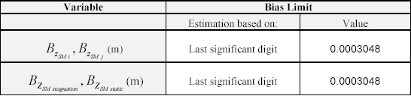
Table1. Bias limits for the individual variables included in the data reduction equations

3.5. Data Analysis
Measurements obtained in the experiments will be compared with benchmark data. The benchmark data for velocity distribution is provided in numerical and graphical form in Figure 8. The benchmark data for friction factor is provided by the Moody diagram (Figure 9) and by the Colebrook-White-based formula (Roberson and Crowe, 1997)
$f=\frac{0\text{.}\text{25}}{{\left[\text{log}\left(\frac{k/D}{3\text{.}7}+\frac{5\text{.}\text{74}}{{\text{Re}}^{0\text{.}9}}\right)\right]}^{2}}$ (15)
The following questions help to evaluate fluid physics, EFD process, and uncertainty analysis. The solutions to these questions must be included in the Data analysis section of the lab report. Use data reduction sheet and attach it to your lab reports.
- Comment on the differences in flow rate readings obtained by the manometer and pressure transducer.
- Plot the velocity profile u(r) obtained from the experiment normalized by maximum velocity in pipe (u/U_{max}) against radial distance r, normalized by maximum radius (r/R). Plot the Schlichting data given in Figure 8 on the same plot. Compare the two profiles. Choose a point near the wall where, the value of r/R, is close to 1. Show the total percentage uncertainty at that point using an uncertainty band.
- Plot the head (in ft of air) at each pressure tap as a function of distance along the pipe. Comment on the pressure head drop distribution along the pipe and comment on uncertainties and unaccounted error sources.
- Calculate the friction factor and compare results with the Moody diagram. Show the experimental value of the friction factor on the Moody diagram along with the uncertainty band.
- What is the advantage of using non-dimensional forms for variables such as those shown in Figures (8) and (9)?

r/R
u/U_{max}
0.0000 | 1.0000
0.1000 | 0.9950
0.2000 | 0.9850
0.3000 | 0.9750
0.4000 | 0.9600
0.5000 | 0.9350
0.6000 | 0.9000
0.7000 | 0.8650
0.8000 | 0.8150
0.9000 | 0.7400
0.9625 | 0.6500
0.9820 | 0.5850
1.0000 | 0.4300

 | Figure 8. Benchmark data for the velocity  profile | Figure 9. Benchmark data (Moody chart) for pipe friction factor

4. References
Roberson, J.A. and Crowe, C.T. (1997). Engineering Fluid Mechanics, 7th edition, Houghton Mifflin, Boston, MA.
Schlichting, H. (1968). Boundary-Layer Theory, McGraw-Hill, New York, NY.
Rouse, H. (1978). Elementary Mechanics of Fluids, Dover Publications, Inc., New Yoirk, NY.
Stern, F., Muste, M., Beninati, L-M, Eichinger, B. (1999). “Summary of Experimental Uncertainty Assessment Methodology with Example,” IIHR Report No. 406, Iowa Institute of Hydraulic Research, The University of Iowa, Iowa City, IA.

APPENDIX A

SPECIFICATIONS FOR THE EXPERIMENTAL FACILITY COMPONENTS

Table A1. Pipe characteristics
Table 1. Pipe characteristics
Experimental Pipe | Top | Middle | Bottom
Diameter (mm) | 52.38 | 25.4 | 52.93
Internal Surface | Smooth, k = 0.025 mm | Smooth | Rough, k =0.04 mm
Number of Pressure Taps | 4 | 8 | 4
Tap Spacing (ft) | 5 | 2.5 | 5

Table A2. Venturi meter characteristics
Venturi specifications | Small | Medium | Large
Contraction Diameter, D_{t} (mm) | 12.7 | 25.4 | 51.054
Discharge Coefficient, C_{d} | 0.915 | 0.937 | 0.935

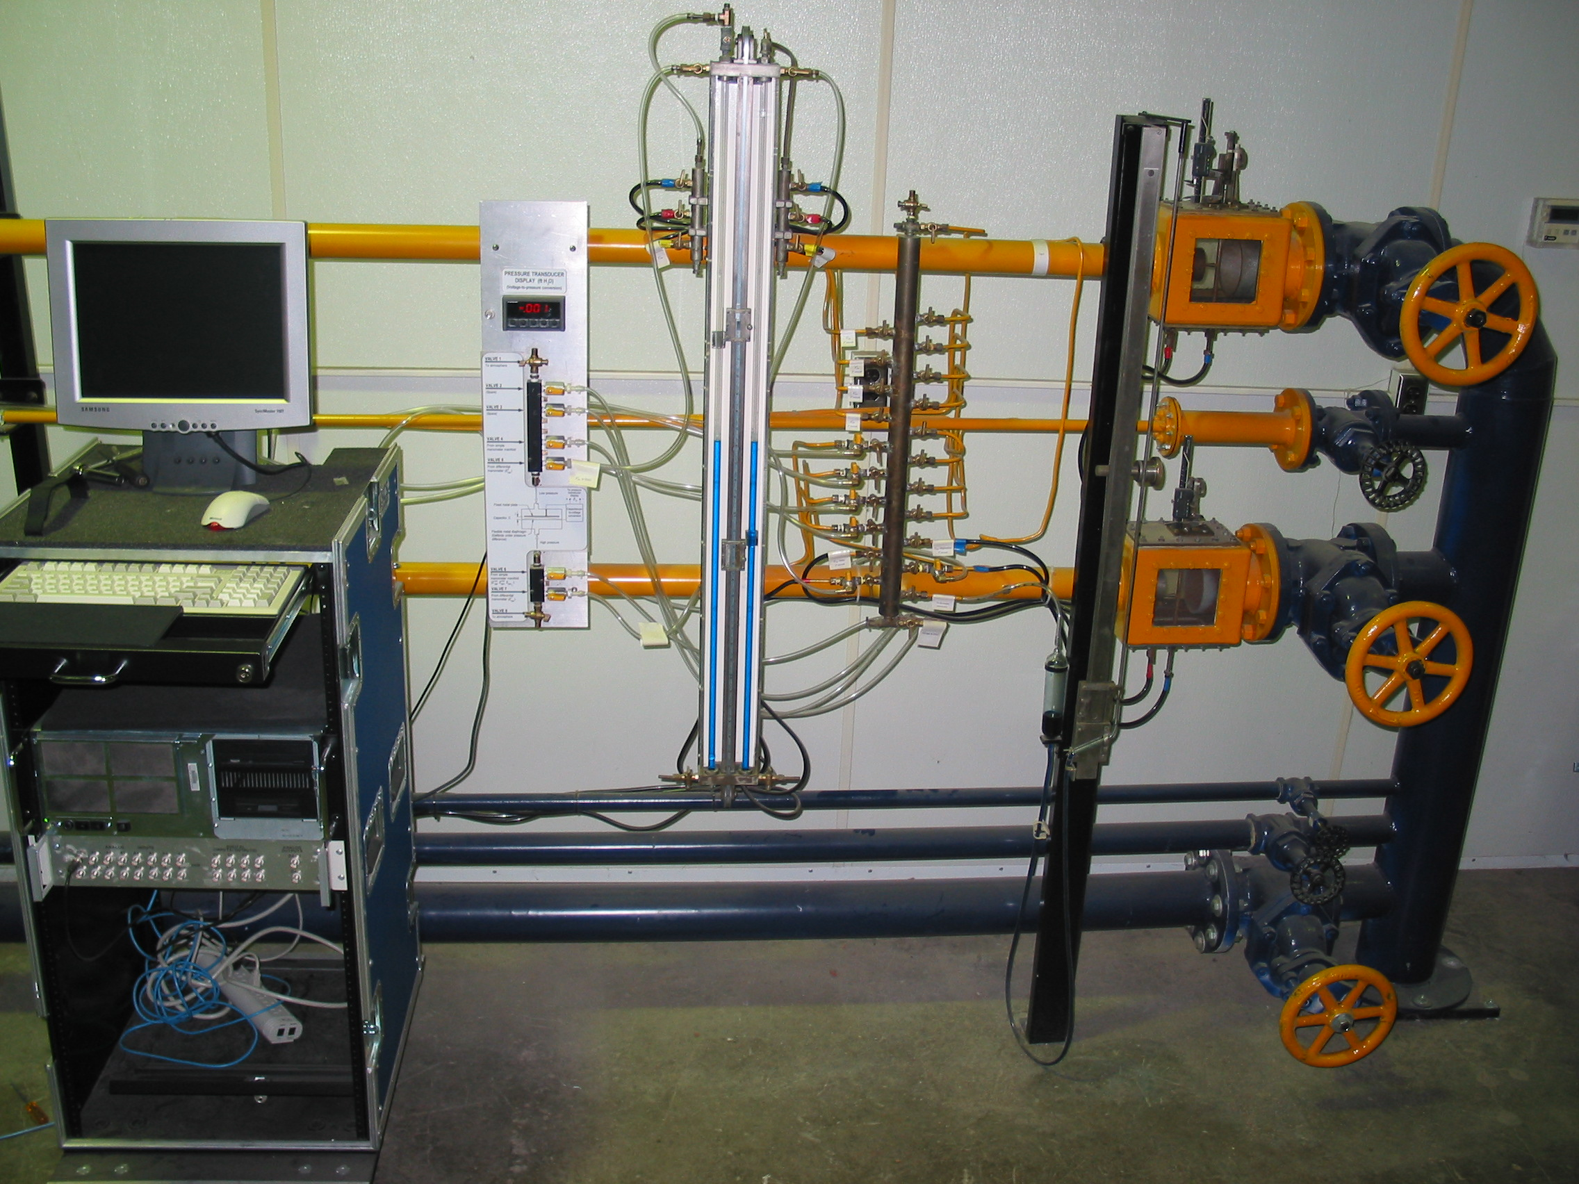
a) Photograph of experimental setup | b) Schematic of experimental setup
Figure A.1. Layout of the data acquisition systems

APPENDIX B
THE AUTOMATED DATA ACQUISITION SYSTEM (ADAS)

Step 1: Initial Setup
1. Getting Started with DA  Double click on the shortcut found on the DA computer: Pipe_flowv7.vi. A window as shown in Figure B.1 will open. Hit Run to run the program. | 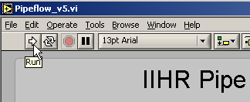  Figure B.1. Hit Run to run the program
2. Under Specifications (see Figure B.2), TAs/students can add comments regarding the experiment if needed. (characteristics of pipe selected for the measurements, targeted Re, etc.). | 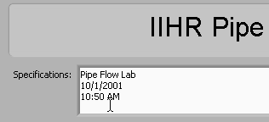  Figure B.2. Experiment Specifications area
- Type in the reading of the air temperature (ºC) in the facility in the Temperature window, as shown in Figure B.3. | 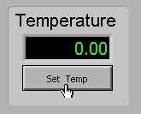  Figure B.3. Set pipe air temperature

Step 2: Discharge Measurements
- Select the DPD menu to measure the flow discharge in the pipe. To select it, click on the DPD tab as shown in Figure B.4. Connect the largest venturimeter in the lowermost pipe directly to the pressure transducer. | 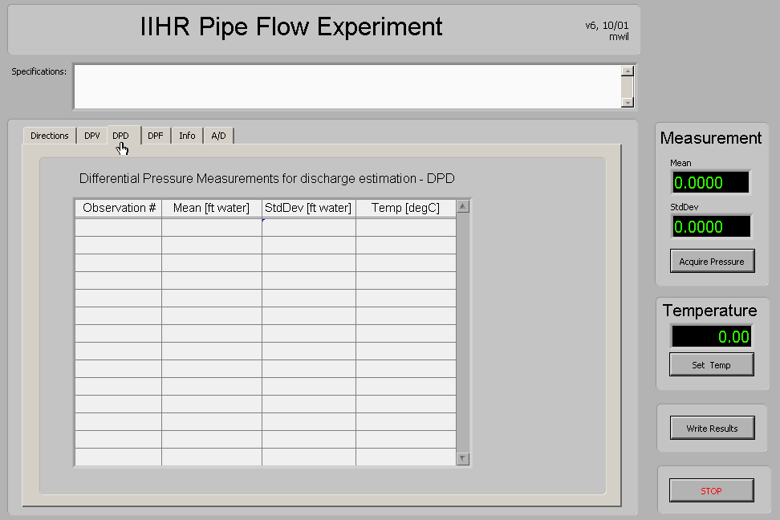Figure B.4. Open DPD menu
- Click Acquire Pressure button in the Measurement window on the right side of the interface to obtain a reading of the head drop on the Venturi meter (Figure B.5).  Note: Discharge measurements are taken at the beginning and at the end of the experiment. The average of the two discharges is considered for the lab report to account for the variation of the temperature during the experiment. | 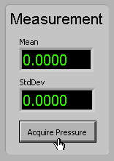  Figure B.5. Click on Acquire Pressure
Step 3: Velocity Distribution Measurements
Velocity data will be measured with the appropriate pitot-tube according to the instructions given by the TA. Select the DPV tab, see Figure B.6. Connect the stagnation point on the pitot probe to the high side of the transducer and leave the low side open. | 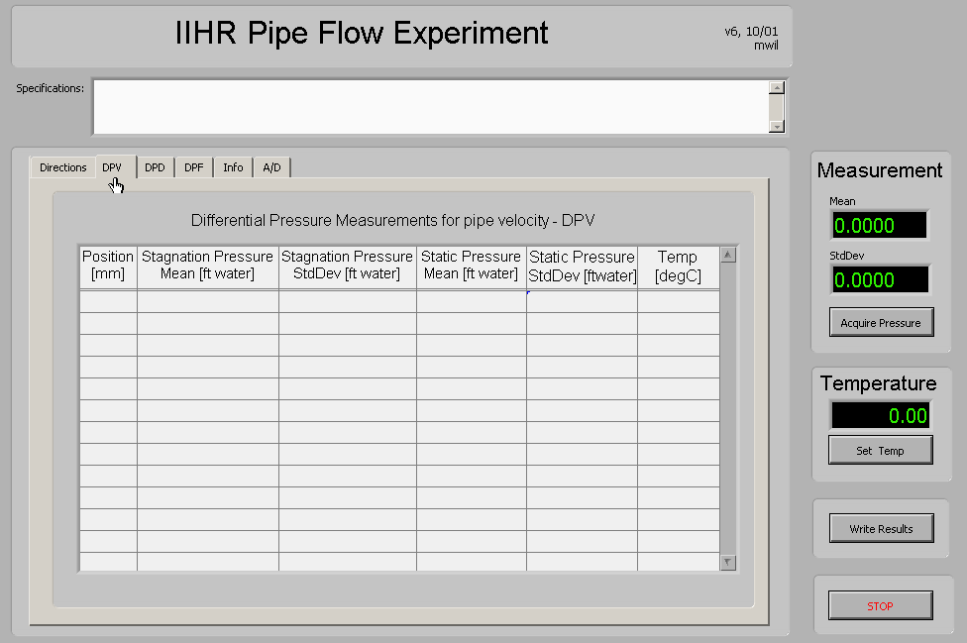Figure B.6. Click on DPV tap to measure Differential Pressure for Velocity
- Move the Pitot tube in the housing at the desired location for the velocity measurement (e.g. 20 mm from the centerline). Click Acquire Pressure (Figure B.7). The screen shown in Figure B.7 will then prompt the user for the pitot-tube location. Enter Pitot-tube position in the dialog box. Click OK to start the measurement. | 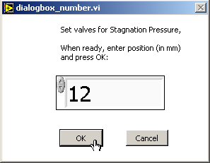  Figure B.7. Enter position of pitot-tube
- Following step 7, the screen shown in Figure B.8 will appear. Open the stagnation point and connect the static point from the pitot probe to the high side of the transducer, in this case also the low side of the transducer remains open. Click OK on the screen shown in Figure B.8.  Note: To establish precision limits for the simple manometer measurements, measurements should be taken at least 10 times. The repeated measurements should be made using an alternative pattern to avoid successive measurements at the same location. Velocities are displayed graphically in a window after each measurement is taken. | 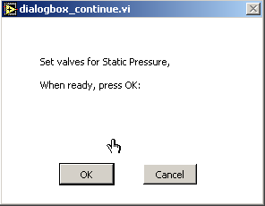  Figure B.8. Click OK when ready for static pressure measurement
- Record final ambient and pipe air temperatures as indicated in step 3.
Step 4: Friction Factor Measurements
- Select DPF tab in the main menu (Figure B.9). Choose the desired pressure tap that is to be measured and connect it to the high side of the pressure transducer and leave the low side open to atmosphere. | 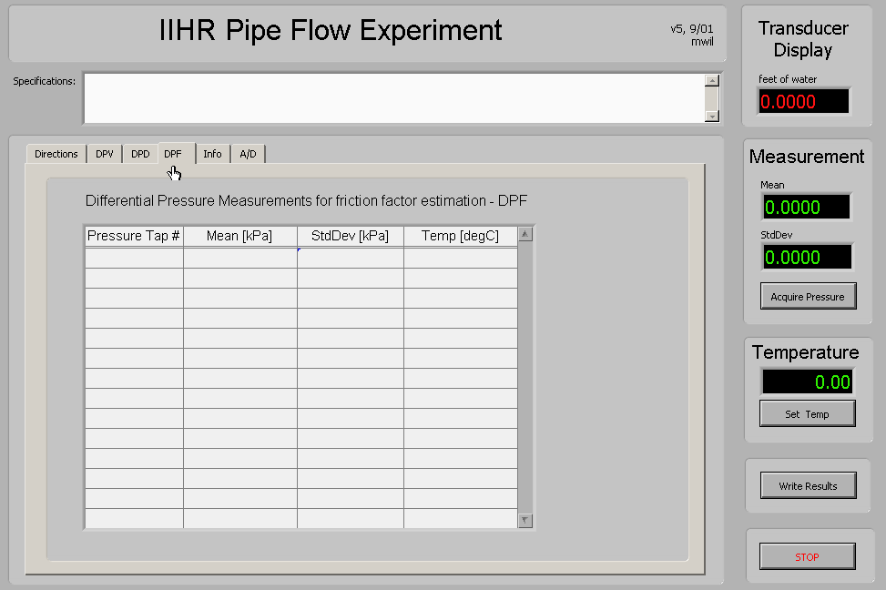  Figure B.9. Click on DPF tap to measure Differential Pressure for Friction Factor
- Then enter the pressure tap number in the window shown in Figure B.10. Click OK. Click on Acquire Pressure as shown at Step 7 to make the measurement. Close the finger valve on the manifold and open the valve leading to the next measurement location.  Note: The pressure drop along the pipe is shown on a plot and ideally a linear curve should be observed. | 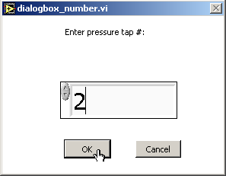  Figure B.10. Enter 1 for tap Z_{sm1}, 2 for tap Z_{sm2,} ...etc.
- Write measurements to a file. Click on Write Results (see Figure B.11). | 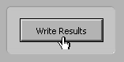  Figure B.11. Click on Write Results
13. The screen indicated in Figure B.12 will appear. Save the result file in the directory indicated by the TAs using a .txt extension for the file name. The data is outputted in Excel compatible file format. Units for the measured variables are specified in the output file. | 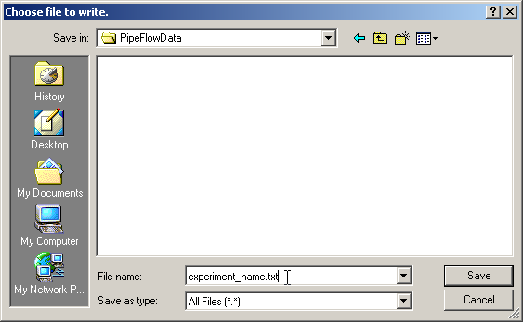  Figure B.12. Write results to a file

