Simulation of Turbulent Flow around an Airfoil

57:020 Mechanics of Fluids and Transfer Processes

CFD PRELAB 2

By Tao Xing and Fred Stern
IIHR-Hydroscience & Engineering
The University of Iowa
C. Maxwell Stanley Hydraulics Laboratory
Iowa City, IA 52242-1585

1. Purpose

The Purpose of CFD PreLab 2 is to simulate turbulent flow around Clarky airfoil following “CFD process” by an interactive step-by-step approach. Students will have “hands-on” experiences using FlowLab to compute pressure, lift and drag coefficients using both viscous and inviscid models. Students will validate simulation results with EFD data measured at EFD Lab 3, analyze the differences and possible numerical errors, and present results in Lab report.
Geometry
Post-processing
Report
Physics
Mesh
Contours
Vectors
Streamlines
Solve
Iterations
Conver-gent.
Limit
Precisions

Single
Double
Numerical Schemes

1st order
2nd order
QUICK
Steady/
Unsteady?
Coarse
Medium
Fine
Automatic
Manual
Structured
Unstruct-ured
Boundary
Conditions
Flow Properties
Viscous
Models
One Eq.
Two Eq.
Density and viscosity
Laminar
Turbulent
Inviscid
SA
k-e
k-w
Heat Transfer?
Incompress-ible?
Initial
Conditions
Clarky
NACA12
LS(1) 0417
Import Profile
Chord length
Angle of attack
Select domain
Select geometry
Wall shear stress
Skin friction Factor
XY plots
Verification and validation
Coefficient of lift
Coefficient of drag
Residuals
Pressure coef. Distri.
Shear stress Distri.
Airfoil Y plus

Flow chart for ISTUE teaching module for airfoil flow (red color illustrates the options you will use in this CFD PreLab 2)

2. Simulation Design

In EFD Lab 3, you have conducted experimental study for turbulent flow around a ClarkY airfoil (Re=300,000) for two angles of attack 0 and 16 degrees. The pressure on the foil surface you have measured will be used for CFD PreLab 2. In CFD PreLab 2, simulation will be conducted under the same conditions of EFD Lab 3 (geometry, Reynolds number, fluid properties) at angle of attack 0 degree using both viscous and inviscid models. Simulation results will be validated by your own EFD data.

The problem to be solved is turbulent flow around the ClarkY airfoil with angle of attack (α)
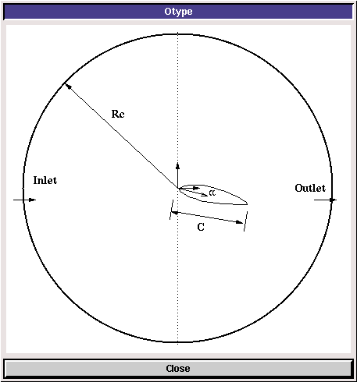
In the figure above, C is the chord length of the airfoil, α is the angle of attack, and Rc is the radius of the “O” domain.

3. CFD Process

Step 1: (Geometry)
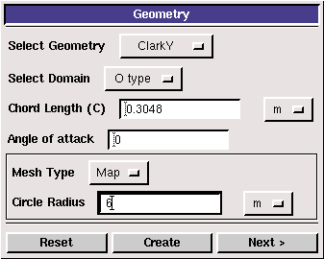
Choose “ClarkY” airfoil and “O type” domain, input the chord length of the foil and angle of attack 0 degree.
- Select Geometry (Clarky)
- Select domain (O type)
- Chord length (0.3048 m)
- Angle of attack (0)
- Mesh type (Map)
- Circle Radius Rc (6m)

Click <<Create>>→<<Next>>.

Step 2: (Physics)
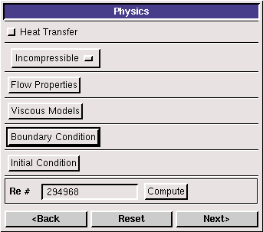

(1). With or without Heat Transfer?

Since we are not dealing with the thermal aspects of the flow, like heat transfer, etc., switch the <<Heat Transfer >> button OFF, which is the default setup.

(2). Incompressible

Use “Incompressible”. “Compressible” option is not available for current template.

(3). Flow Properties
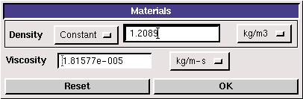
Use the air properties at the room temperature when you conducted EFD Lab3 and click <<OK>>. You can use the following website to calculate air properties from the temperature:
http://www.mhtl.uwaterloo.ca/old/onlinetools/airprop/airprop.html
NOTE: viscosity used in FlowLab is the dynamic viscosity (), NOT kinematic viscosity ()

(4). Viscous Model
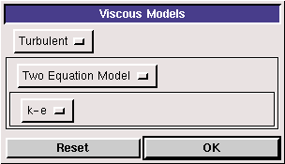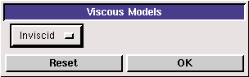
For turbulent flow simulations, choose turbulent model (k-e). For Inviscid flows, choose “inviscid” and click <<OK>>.

(5). Boundary Conditions

At “Inlet”, we use constant pressure and constant velocity. Inlet velocity should be computed from the EFD data reduction sheet and could be different from 15 . Use default values for turbulent quantities “k” and “e”.
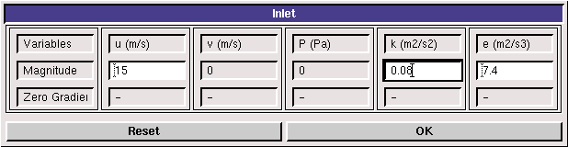
Turbulent

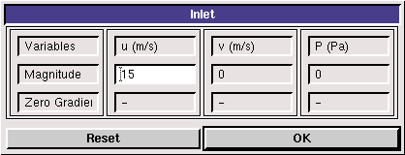
Inviscid

At “Outlet”, FlowLab uses magnitude for pressure and zero gradients for axial and radial velocities. Input “0” for the Gauge pressure and click <<OK>>.
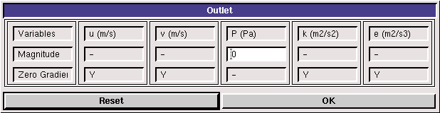
Turbulent

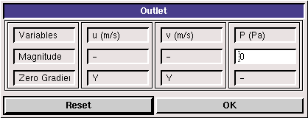
Inviscid

On “Airfoil”, if flow is turbulent, FlowLab uses no-slip boundary conditions for velocities and zero-pressure gradient. Turbulent quantities k and e are also specified to be zero. If flow is inviscid, then zero gradient is used for pressure and certain boundary conditions (not discussed in this lab due to its complexity) are used for velocities. Read all the values and click <<OK>>
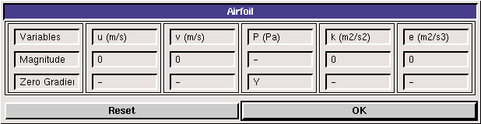
Turbulent
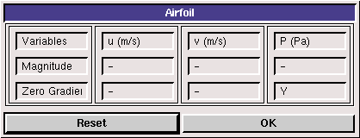
Inviscid

(6). Initial Conditions

Use the default setup for initial conditions.
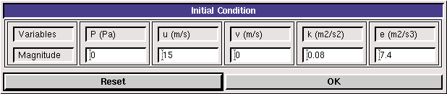
Turbulent
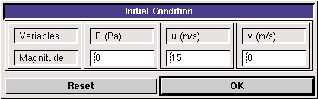
Inviscid

After specifying all the above parameters, click <<Compute>> button and FlowLab will automatically calculate the Reynolds number based on the inlet velocity and airfoil chord you entered.
Click <<Next>>. This takes you to the next step, “Mesh”.

Step 3: (Mesh)
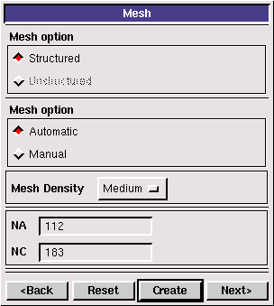

For CFD PreLab 2, use “Automatic” meshing and “Medium” mesh. Click <<Create>>, The mesh generated will be displayed in the graphic window. NA and NC are the numbers of grid points on the airfoil surface and radial direction, respectively.
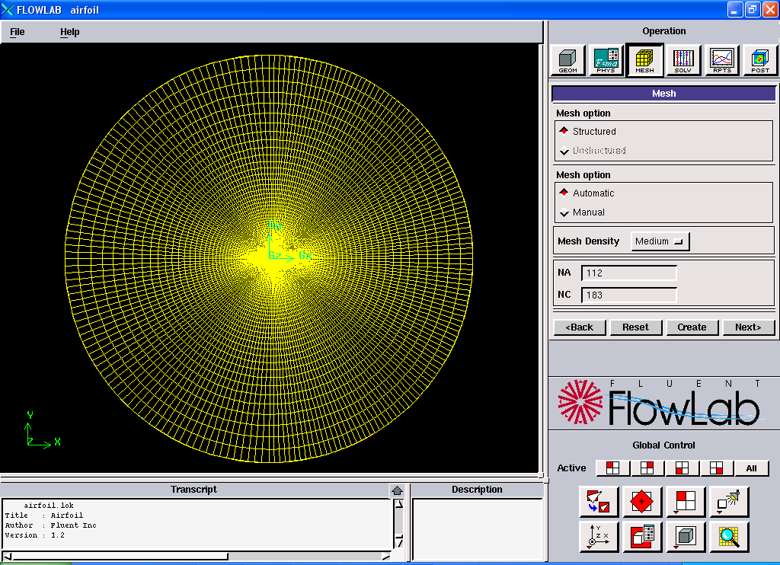

Step 4: (Solve)
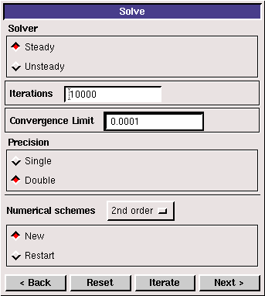

Specify the iteration number and convergence limit to be 10000 and 10⁻⁴, respectively. Choose “Double Precision”, “2nd order” for numerical schemes, and “New” calculation. Click <<Iterate>>, FlowLab will fire the XY plot for residuals that is dynamically updated during the calculation. Whenever you see the window, “Solution Converged”, click <<OK>>.

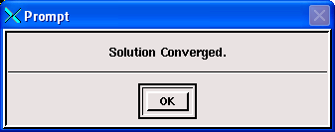

Step 5: (Reports)

“Reports” first provides you the information on “wall shear stress”, “skin friction factor”, “coefficient of lift”, and “coefficient of drag”. XY plot provide plots for “residuals”, “pressure distribution”, “pressure Coefficient”, and “Shear Stress Distribution”, etc. In this Lab, only XY plots for “residuals” and “pressure coefficient” are required.
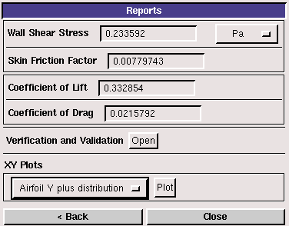
“XY Plots” provides the following options:
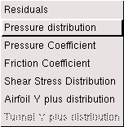

To import the EFD data on top of the above CFD results, just click <<File>> button and use the browse button to locate the data file you need and click <<Import>>. Details have been described in previous CFD PreLab 1 for laminar pipe flow.
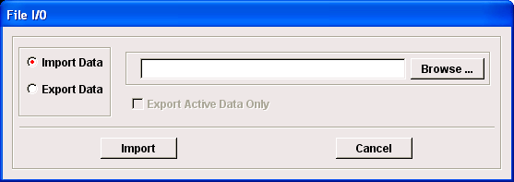
In this Lab:
- EFD data for pressure coefficient distribution should be created in your folder under
H: \myflowlab\SESSION-NAME\*.xy” (Example: H: \myflowlab\prelab2\pressure-EFD.xy)

The following figure is an example:
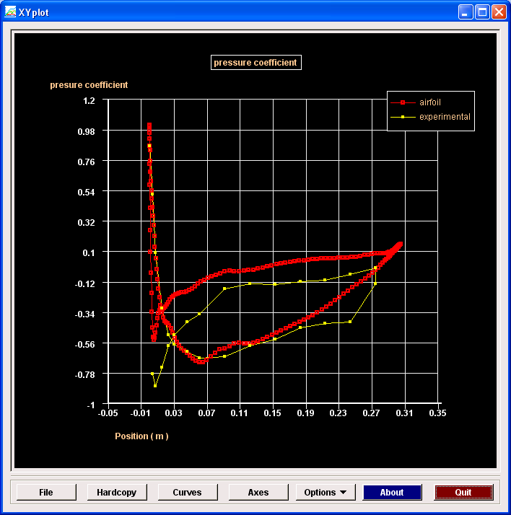

Step 6: (Post-processing)

Use the “contour”, “vector” buttons to show pressure contours and velocity vectors. All the details on how to plot those figures have been explained in details in CFD Lab 1 and the workshop. The following shows some sample results.
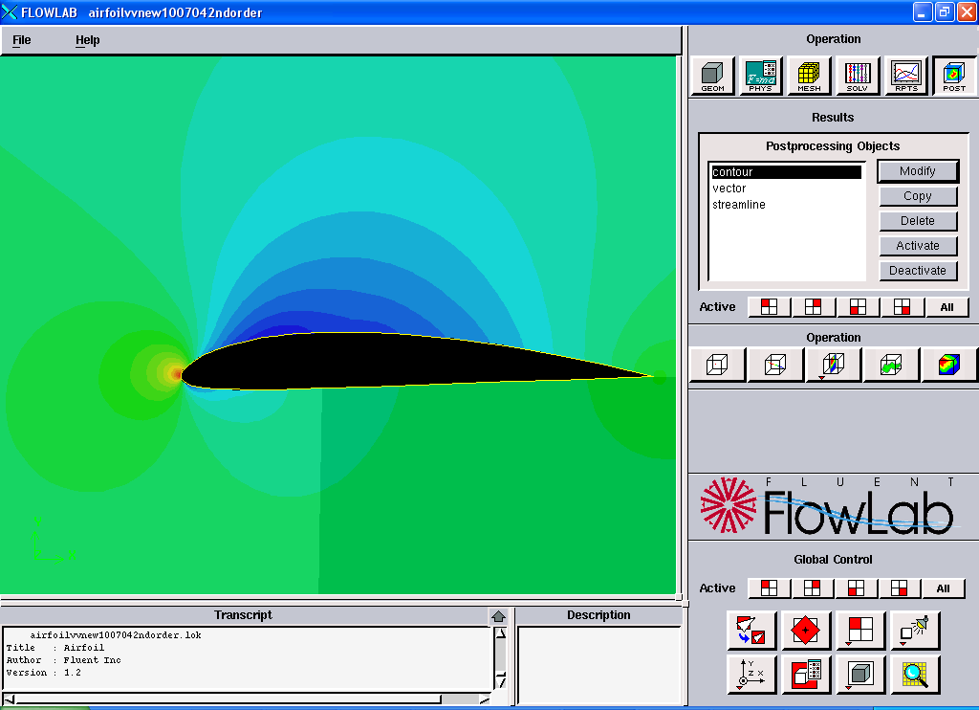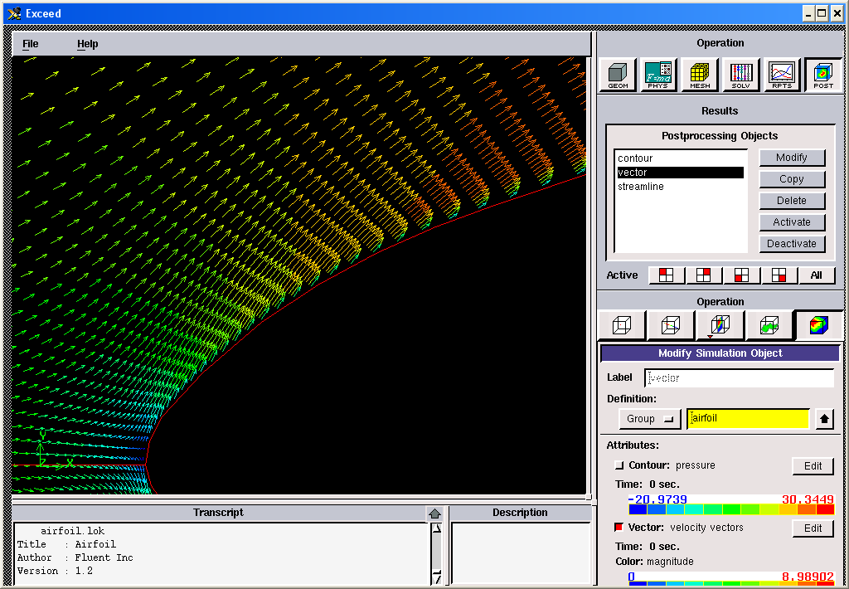
To plot “streamlines”, first <<Deactivate>> “contour” or “velocity vector”, then click “Streamline” and <<Activate>>. Click <<Modify>> button and the contour variable will be “stream-function”. Usually, the default stream-function values range from the minimum to maximum values through the whole domain. To illustrate the streamlines close to the airfoil surface, we need re-specify the range of stream-function values. Click <<Edit>>, using <<lines>> instead of <<Bands>>. Specify appropriate contour “intervals” and “minimum” and “maximum” stream function values, then you can zoom in the region close to airfoil surface to show the streamlines, as you see in the figure below.
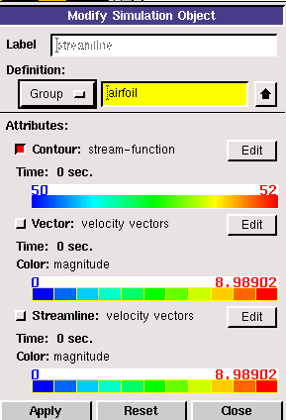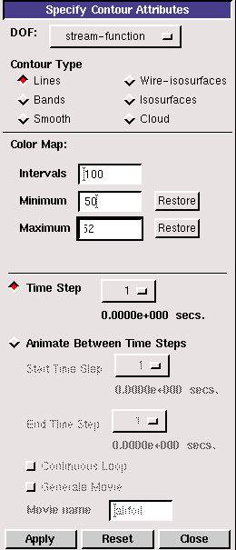

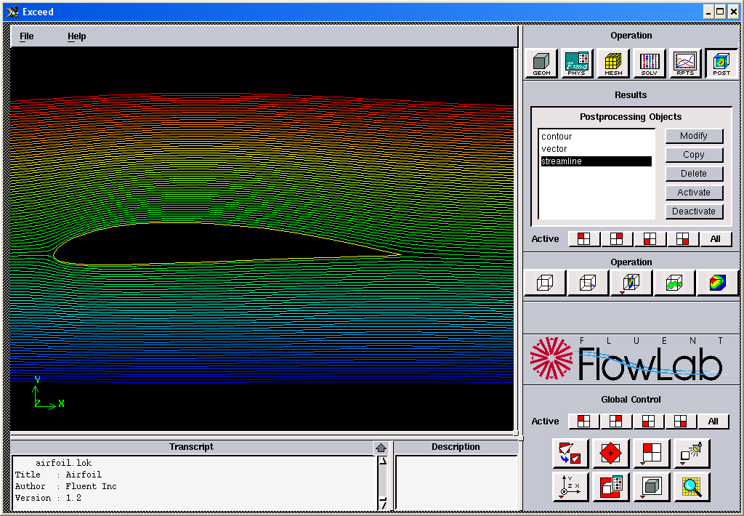

4. Exercises

Simulation of Turbulent Flow around an Airfoil

You must complete all the following assignments and present results in your CFD Lab 2 reports following the CFD Lab Report Instructions.

- Validation using EFD Lab 3 data
(1). Use the same flow conditions as those in your EFD Lab 3, including geometry (chord length,
angle of attack 0) and physics (Flow properties, inlet velocity). Use “O” mesh with domain size 6
meters, k-e model, automatic medium mesh, 2nd order scheme, double precision with iteration
number (10000) and convergent limit (1e-4). Run the simulation.
(2). Modify your EFD data of pressure coefficient in FlowLab format (sample EFD data format has been provided in CFD Lab 1) and import it into XY plot for pressure coefficient distribution and conduct validation. Also compare the CFD lift coefficient value with EFD data.
- Figures need to be saved: 1. Time history of residuals (residual vs. iteration number); 2. Pressure coefficient distribution (CFD and EFD), 3. Contour of pressure, 4. Contour of velocity magnitude, 5. Velocity vectors (show the region that is interesting, such as the separation region when angle of attack is large or close to the leading edge of the airfoil), and 6. Streamlines close to airfoil surface.
- Data need to be saved: lift and drag coefficients

- Inviscid flow simulation
Use the same conditions as those in exercise 1, except choose “inviscid” for “viscous model” and set
up the boundary conditions following instructions part, set the iteration number to be (10000), and
convergent limit to be 10⁻⁴. Conduct the simulation and compare solutions with viscous flow
results in exercise 1.
- Figures need to be saved: 1. Time history of residuals; 2. Pressure coefficient distribution (CFD only), 3. Contour of pressure, 4. Contour of velocity magnitude, 5. Velocity vectors (show the same region that your picked in exercise 1), and 6. Streamlines close to airfoil surface.
- Data need to be saved: lift and drag coefficients

- Questions need to be answered in CFD Lab 2 report:
3.1. Does inviscid flow has boundary layer near the wall? Zoom in the near wall region and describe
the differences of velocity vectors near the airfoil surface for inviscid and viscous flows.
3.2. What are the correct boundary conditions for velocity and pressure at “inlet” and “outlet”.
3.3. What are the values for lift and drag coefficients for inviscid flow around the airfoil? Are they
both zero?
3.4. Where are the highest and lowest locations for pressure and velocity magnitude? Why? Is
pressure constant for inviscid flows around airfoil?
3.5. For turbulent flow around airfoil, try to qualitatively explain why there is a lift force (vertical up)
on an airfoil using the contour plot of pressure or the XY plot of pressure coefficient
distribution.

