Simulation and Validation of Turbulent Pipe Flows

57:020 Mechanics of Fluids and Transport Processes

CFD LAB 1

By Tao Xing and Fred Stern
IIHR-Hydroscience & Engineering
The University of Iowa
C. Maxwell Stanley Hydraulics Laboratory
Iowa City, IA 52242-1585

1. Purpose

The Purpose of CFD Lab 1 is to teach students how to use the CFD Educational Interface (FlowLab 1.2), practice more options in each step of CFD Process, and relate simulation results to EFD and AFD concepts. Students will simulate turbulent pipe flow following the “CFD process” by an interactive step-by-step approach. The flow conditions will be the same as they used in EFD Lab2. Students will have “hands-on” experiences using FlowLab to compute axial velocity profile, centerline velocity, centerline pressure and friction factor. Students will compare simulation results with their own EFD data, analyze the differences and possible numerical/experimental errors, and present results in CFD Lab report.
Solve
Iterations/
Steps
Converge-nt
Limit
Precisions

Single
Double
Numerical Schemes

1st order
upwind
2nd order upwind
Quick
Steady/
Unsteady?

Geometry

Physics

Mesh
Post-processing
Report

Unstruct-ured
Coarse
Automatic
Total pressure drop
Heat Transfer?
Medium
Manual
Structured
Fine
Wall friction force
Incompress-ible?
XY plot
Validation
Verification
Density and viscosity
Flow Properties
Contours
Laminar
Vectors
Viscous
Models
One Eq.
Turbulent
SA
Streamlines
Two Eq.
Inviscid
k-e
Boundary
Conditions
Initial
Conditions
k-w

Residual

Centerline Velocity
Pipe
Pipe Radius
Pipe Length
Centerline Pressure
Profiles of Axial Velocity

Flow chart for ISTUE teaching module for pipe flow (red color illustrates the options you will use in CFD Lab 1)

2. Simulation Design

In EFD Lab 2, you have conducted experimental study for turbulent pipe flow. The data you have measured include centerline pressure distribution and fully developed axial velocity profile. These data will be used in this Lab for comparisons with CFD predictions.

The problem to be solved is that of turbulent flows through a circular pipe. Reynolds number based on pipe diameter and inlet velocity should be computed from your own EFD data and is much higher than the Reynolds number used in CFD Prelab1.
Outlet
Inlet
Symmetry Axis
Pipe Wall
The problem formulation is similar to that in CFD PreLab1 and will not be repeated here. The Reynolds number is much higher and students need specify turbulence model, and thus more variables need to be specified in boundary conditions, as will be discussed in details later.

3. CFD Process

Step 1: (Geometry)
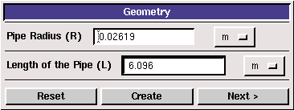

- Radius of pipe (pipe radius in your EFD Lab2, use 0.02619 m if not available)
- Length of pipe (6.096m)

NOTE: The actual length of the pipe is 30 feet (9.144m), However, in CFD simulation, we need specify “outlet pressure”, and we don’t have pressure transducer at the pipe outlet. So we choose the outlet of the pipe we will simulate to be the location of the last pressure transducer, that is 6.096 meters from the pipe inlet. Click <<Create>>, after you see the pipe geometry created, click <<Next>>.

Step 2: (Physics)

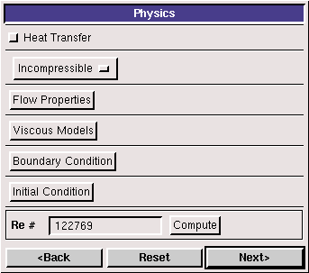

1. With or without Heat Transfer?

Since we are dealing only with the flow and not with the thermal aspects of the flow like heat transfer etc, switch the <<Heat Transfer >> button off, which is the default setup.

2. Incompressible or compressible

Choose “Incompressible”, which is the default setup.

- Flow Properties
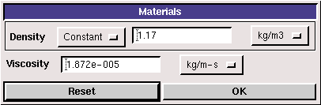

use the flow property values in your EFD Lab2, if you only know the room temperature when you conducted EFD Lab2, you can use the following website to easily get the corresponding density and dynamic viscosity for air:
Hhttp://www.mhtl.uwaterloo.ca/old/onlinetools/airprop/airprop.html

H
NOTE: viscosity used in FlowLab is the dynamic viscosity (), NOT kinematic viscosity ()

4. Viscous Model
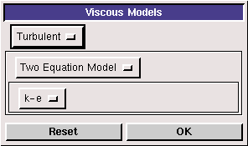

In CFD Lab 1, two equation k-epsilon (k-e) model will be applied.

5. Boundary Conditions

At “Inlet”, we use zero gradient for pressure and default values for turbulent intensity and length scale. You must calculate the inlet velocity u, which is uniform, based on the flow rate(m³/s) you computed in EFD Lab2, and cross section area of the pipe , i.e. . Since inlet flow is parallel to the x axis, magnitude of v velocity is 0. Use default values for turbulence quantities and click <<OK>>.
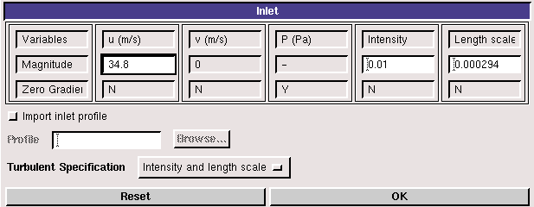
At “Axis”, FlowLab uses zero gradient for axial velocity and Pressure and specify the magnitude for radial velocity to be zero. Read all the values and click <<OK>>
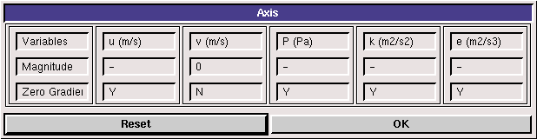
At “Outlet”, FlowLab uses magnitude for pressure and zero gradients for axial and radial velocities. You need transform the four pressure tap pressure values from “feet water” to “Pascal” and input pressure tap #4 value as the “outlet pressure”. For example, if the pressure tap #4 has value of 0.2502 feet water, you need input 747 Pascal.
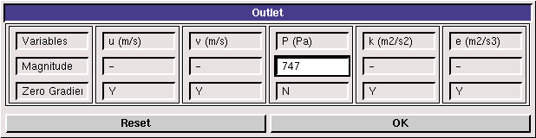
At “Wall”, no-slip boundary conditions are fixed for both axial and radial velocity, gradient for pressure is zero. Input the pipe roughness of the pipe you used in EFD Lab2 and choose the convenient unit you need. For example, user inputs 0.025 mm for smooth pipe.
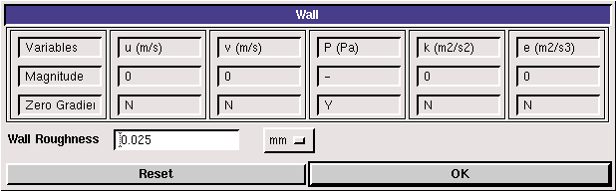

6. Initial Conditions

Use the outlet pressure for P (Pa), inlet velocity for u (m/s) and default values for turbulent quantities.
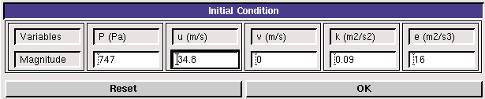

After specifying all the above parameters, click <<Compute>> button and FlowLab will automatically calculate the Reynolds number based on the inlet velocity and pipe diameter you input. Click the <<Next>>, this takes you to the next step, “Mesh”.

Step 3: (Mesh)
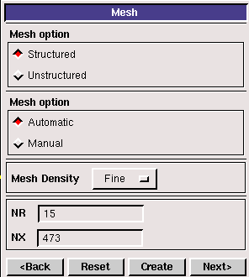
For CFD Lab 1, “Structured” meshes will be generated using “Automatic fine” option. Click <<Create>>, FlowLab will automatically create the Fine mesh and display the grid intervals NR, NX.

Step 4: (Solve)
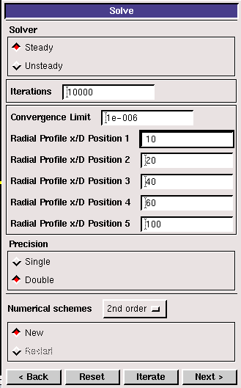

The flow is steady, so turn on the “Steady” option. Specify the iteration number and convergence limit using different values, as shown above. Use 10, 20, 40, 60, 100 for radial profile x/D positions and choose “Double precision” with “2nd order scheme”. Use “New” calculation for this Lab. Then click <<Iterate>> and FlowLab will begin the calculation.

The iterative history of residuals for continuity equation, X and Y momentum equations, k equation, and epsilon equations will be shown automatically.
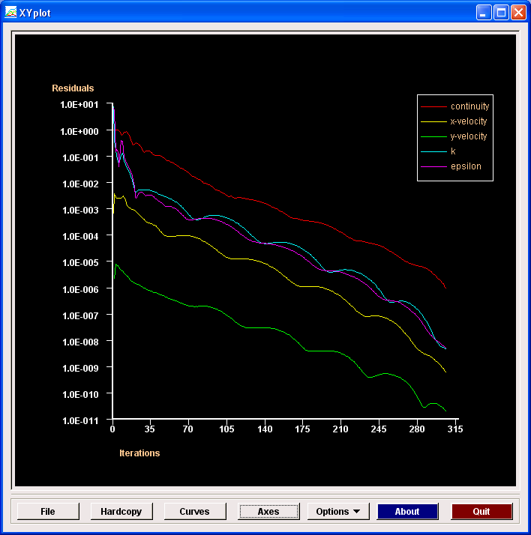
whenever you see the window, “Solution Converged”. Click <<OK>>.
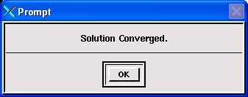

Step 5: (Reports)
Plot the XY plot for “wall friction factor distribution” and record the “wall friction factor” in the developed region (near outlet) and compare its value with your EFD data. XY plots for “axial velocity profile” and “centerline pressure distribution” need to be compared with EFD by import EFD data you collected in EFD Lab2. For procedures of how to import data to XY plot, please refer to CFD PreLab1.
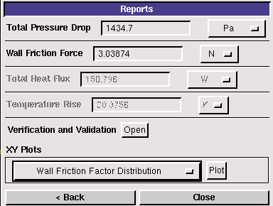
In this Lab, you need put your own EFD data for developed turbulent pipe flow in FlowLab format and put in your directory created under:
C:\Documents and Settings\Fluidslab\myflowlab\your-directory-name\ *.xy.

Experimental data include:
1. fully developed axial velocity profile;
2. centerline pressure distribution
The following is an example of EFD data for turbulent pipe flow:
~~~~~~~~~~~~~~~~~~~~~~~~~~~~~~~~~~~~~~~~~~~~~~~~~~~~~~~~~~~~
(title "Velocity Magnitude")
(labels "Position" "Velocity Magnitude")

((xy/key/label "experimental")
0.00 41.7763
0.005 40.9734
0.01 39.5572
0.015 37.4582
0.02 34.0642
0.023 31.3114
0.024 29.8924
0.026 0.0
)
~~~~~~~~~~~~~~~~~~~~~~~~~~~~~~~~~~~~~~~~~~~~~~~~~~~~~~~~~~~~~~~~~~~~
You may copy this into NOTEPAD and replace the data in blue with your own data. You can use similar procedures to create the centerline pressure distribution of your EFD data.

The following figures are examples for comparison between CFD and EFD for axial velocity profile and centerline pressure distribution.
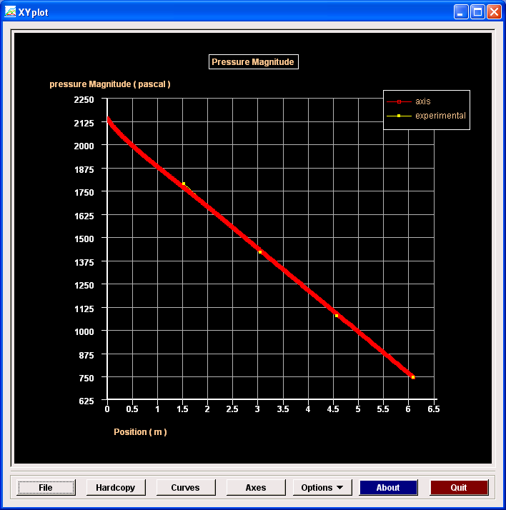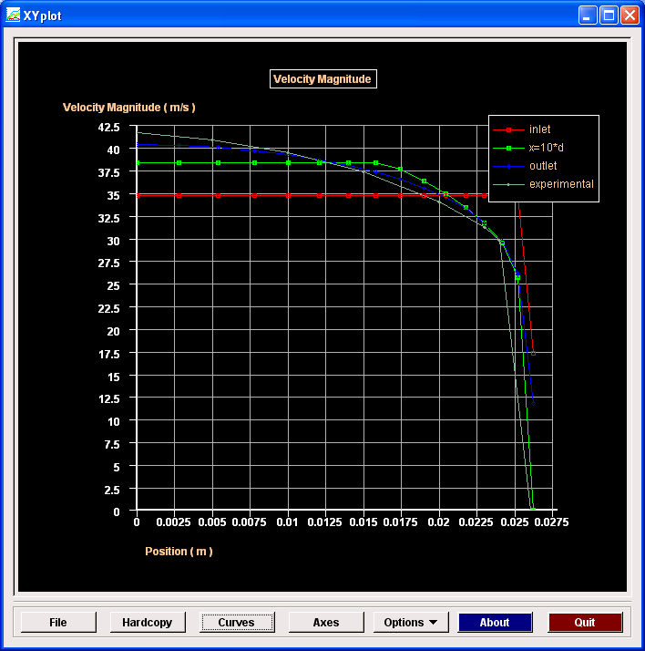

Step 6: (Post-processing)

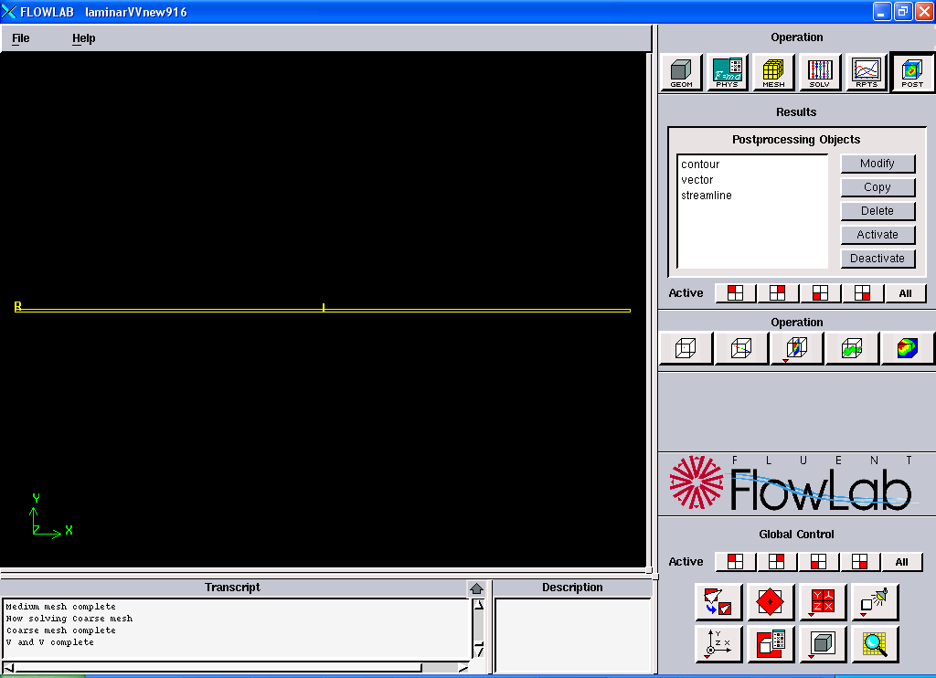
Procedures on how to plot contours, velocity vectors have been described in details in the CFD PreLab 1 and FlowLab quick user guide and will not be repeated here.

4. Exercises
You need to complete the following assignments and present results in your lab reports following the lab report instructions
Simulation and Validation of Turbulent Pipe Flow
* You can save each case file for each exercise using “file”→ “save as”

- Validation of CFD using EFD data
Follow instructions and setup the simulation case using the same flow conditions as in your EFD Lab2, use the values in instruction part for other parameters, iterate the simulation until it converges. Find the relative error between EFD friction factor and friction factor computed by CFD, which is computed by:
Use XY plots to show the comparison between CFD and EFD on: fully developed axial velocity profile and pressure distribution along the pipe.

      - Figures need to be saved: 1. residual history, 2. centerline pressure with EFD, 3. profiles of axial velocity at all axial locations (x/D=10, 20, 40, 60, 100) with EFD data, 4. centerline velocity distribution, 5. wall friction factor distribution, 6. contour of axial velocity, and 7. velocity vectors (pick up the region where flow begins to become fully developed).
- Data need to be saved: 1. wall friction factor in the developed region, 2. developing Length, 3. total pressure drop.

- Normalized developed axial velocity profile
2.1. Export the axial velocity profile data at x=100D only.
2.2. Use EXCEL to open the file you exported and normalize the profile using the
centerline velocity magnitude, which is the maximum value of the profile. Save the
normalized velocity profile in the FlowLab format (*.xy), use one XY plot to import
the normalized laminar velocity profile (“normalized-velocity-CFD-laminar-pipe.xy”,
can be downloaded from class website) and the normalized turbulent velocity profile
and compare them with each other.

- Questions need to be answered in CFD Lab 1 report
3.1. Zoom in the mesh created by FlowLab and tell where the mesh was clustered? Near
the wall or near the axis? Why?
  - In the developed region, is the pressure constant? Where are the minimum and maximum pressure locations? What does the axial velocity profile look like? Where does it reach maximum and minimum?
  - Where is the developing region? How can you determine the length of the developing region? (hint: centerline velocity). What is the difference for axial velocity profile between “developing” region and “developed” region?
3.4. Compare the normalized axial velocity profiles for laminar and turbulent pipe flows
at x=100D, discuss the difference of axial velocity gradient (du/dy) on the wall, which
is larger?
3.5. What are the correct boundary conditions (velocities u, v and pressure) on the pipe
wall and on the pipe centerline?
3.6. Summarize your findings and use the knowledge you learned from classroom
lectures, textbooks and FlowLab figures to answer questions.

