Simulation of Turbulent Flow around an Airfoil

ENGR:2510 Mechanics of Fluids and Transfer Processes

CFD Pre-Lab 2

(ANSYS 17.1; Last Updated: Nov. 7, 2016)

By Timur Dogan, Michael Conger, Andrew Opyd, Dong-Hwan Kim
Maysam Mousaviraad, Tao Xing and Fred Stern

IIHR-Hydroscience & Engineering
The University of Iowa
C. Maxwell Stanley Hydraulics Laboratory
Iowa City, IA 52242-1585

- Purpose

The Purpose of CFD PreLab 2 is to simulate turbulent flow around a Clark-Y airfoil following the “CFD process” with an interactive step-by-step approach. Students will have “hands-on” experiences using ANSYS to compute pressure, lift and drag coefficients using both viscous and inviscid models. Students will validate simulation results with EFD data measured at EFD Lab 3, analyze the differences and possible numerical errors, and present results in Lab report.

Geometry
Physics
Mesh
Solution
Results
Airfoil (ANSYS Design Modeler)
Structured (ANSYS Mesh)
General (ANSYS Fluent - Setup)
Model (ANSYS Fluent - Setup)
Boundary Conditions (ANSYS Fluent -Setup)
Reference Values (ANSYS Fluent - Setup)
Turbulent
Solution Methods (ANSYS Fluent - Solution)
Monitors (ANSYS Fluent - Solution)
Solution Initialization (ANSYS Fluent -Solution)
Plots (ANSYS Fluent- Results)
Graphics and Animations (ANSYS Fluent- Results)

O-Domain (ANSYS Design Modeler)
Solution Initialization
(ANSYS Fluent - Solution)
Solution Controls (ANSYS Fluent - Solution)
Run Calculation
(ANSYS Fluent - Solution)
Flow chart for “CFD Process” for airfoil flow

Simulation Design

In EFD Lab 3, you have conducted experimental study for turbulent flow around a Clark-Y airfoil (Re=300,000) for two angles of attack 0 and 16 degrees. The pressure on the foil surface you have measured will be used for CFD PreLab 2. In CFD PreLab 2, simulation will be conducted under the same conditions of EFD Lab 3 (geometry, Reynolds number, fluid properties) at angle of attack 0 degree using both viscous and inviscid models. Simulation results will be validated by your own EFD data.

The problem to be solved is turbulent flow around the Clark-Y airfoil with angle of attack (α)

Table 1 - Geometry dimensions
Parameters | Symbol | Unit | Value
Chord Length | C | m | 0.3048
Domain radius | Rc | m | 6
Angle of attack | α | m | 0

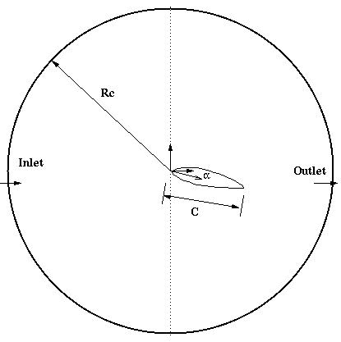
Figure 1 – Geometry

- Open ANSYS Workbench

  - Start > All Programs > ANSYS 17.1 > Workbench 17.1

  - From the ANSYS Workbench home screen (Project Schematic), drag and drop a Geometry, Mesh, and Fluent component from the Component Systems drop down menu onto the Project Schematic. The Project Schematic should resemble the schematic below. Rename the components as per below.
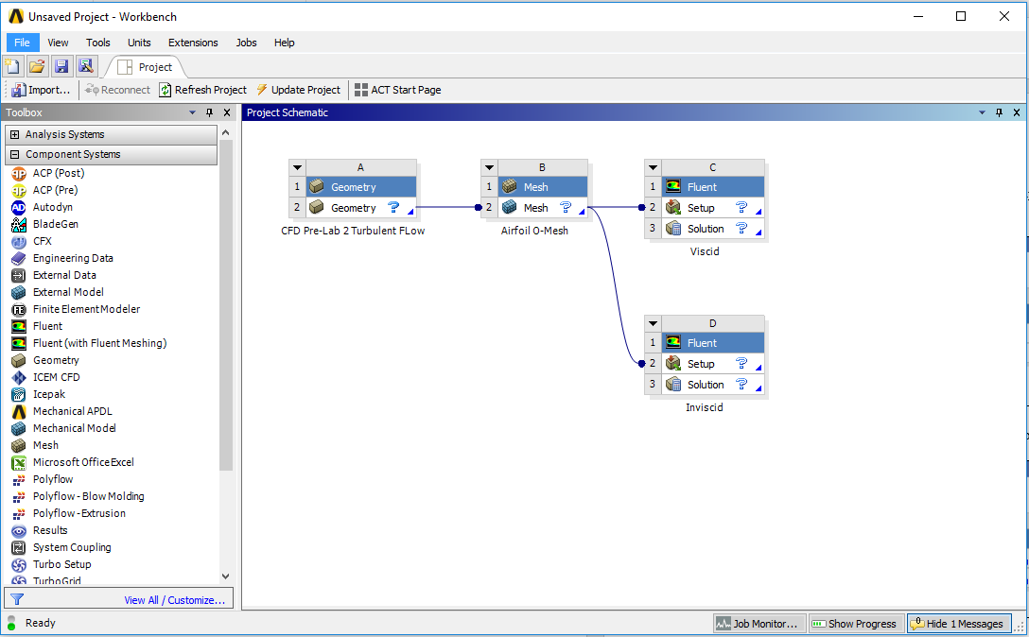

  - Create a Folder on the H: Drive called “CFD Pre-Lab 2”.
  - Save the project file by clicking File > Save As…
  - Save the project onto the H: Drive in the folder you just created and name it “CFD Pre-Lab 2 Turbulent Flow”.
- Geometry

  - Right click Geometry then select Import Geometry > Browse… Select intro_airfoil.igs and click OK.

  - Right click Geometry and select Edit Geometry in DesignModeler…

  - Click Generate to generate the airfoil geometry.

  - Select XYPlane and click New Sketch button.
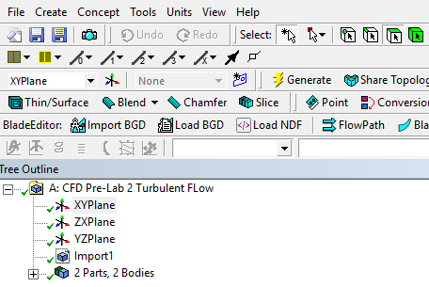

  - Select the sketch you created and click Sketching button.
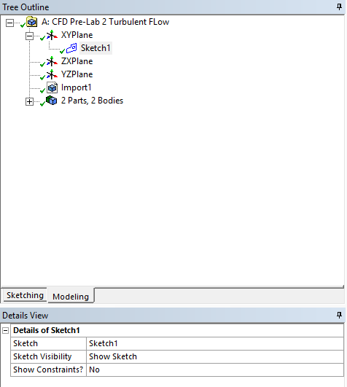

  - Sketching Toolbox > Draw > Circle. Click on the xy-plane origin, “P” should pop up when you are on the origin, and click off, encapsulating the airfoil geometry. (Click z-arrow at right bottom to change the view as perpendicular to xy plane)
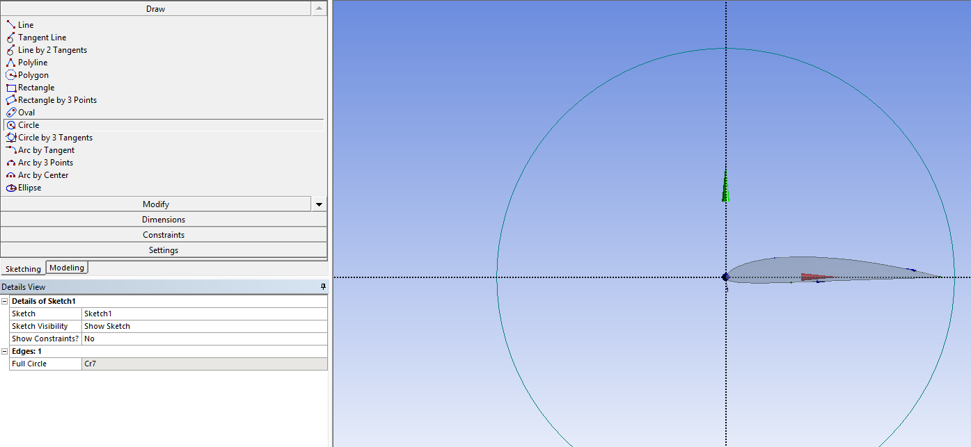

  - Sketching Toolboxes > Dimensions > General. Click on the circle and change the diameter to 12m.
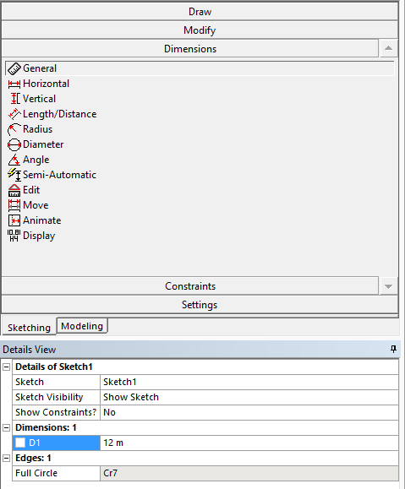

  - Select the Modeling tab. Concept > Surfaces From Sketches. Select your sketch, click apply in the Details View for Base Objects, and click the Generate button.

  - Create > Boolean. Change operation to Subtract then select the circle for Target Bodies then select the airfoil (click on the airfoil until only the airfoil’s color turns yellow) for Tool Bodies and click Generate. This will subtract the airfoil surface from the circle.

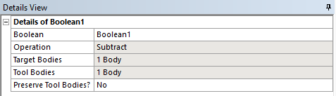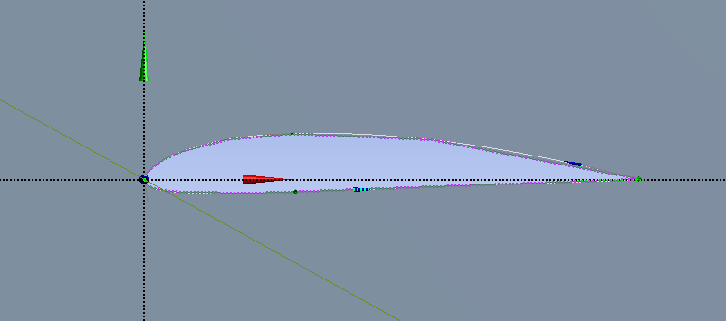
  - Concept > Split Edges. Select the perimeter of the circle, make sure the Fraction is 0.5, and click Apply. Select Generate. This should split the circle into two semicircles. You can see the semicircles by selecting the perimeter above and below the x-axis.
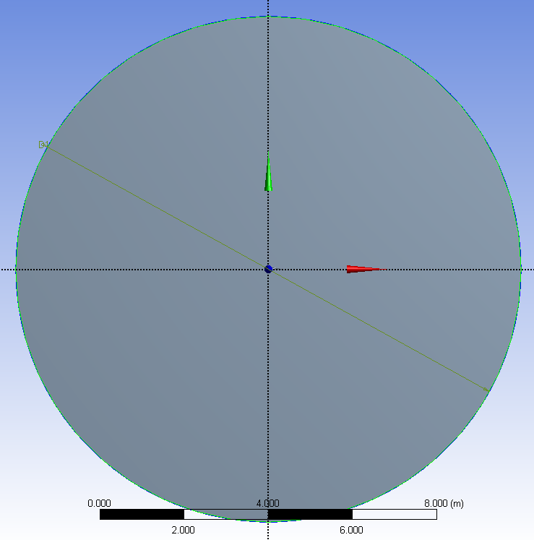

  - Repeat the process from 4.10 on the two semicircles. This should yield four circular quadrants.

  - Concept > Lines From Points. Draw a line from the point on the circle to the point on the airfoil making sure to hold Ctrl while doing so. (Note: The point on the front part of the airfoil is not exactly on the origin, you need to make sure to select the point on the airfoil and not the origin. Zoom in and find the point just below the origin and select that point. The images below show the locations of the points circled. When selecting points to generate lines with, be sure to select the point on circle and then the point on the airfoil as to avoid complications when sizing mesh). Apply View > Display Vertices to alleviate this issue.
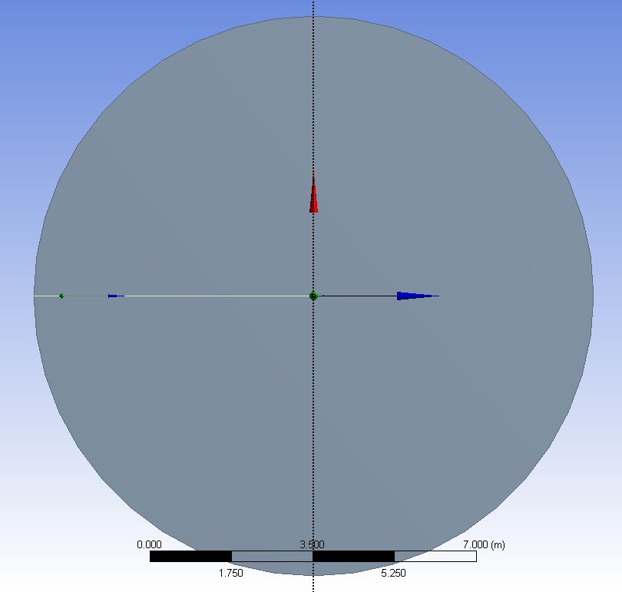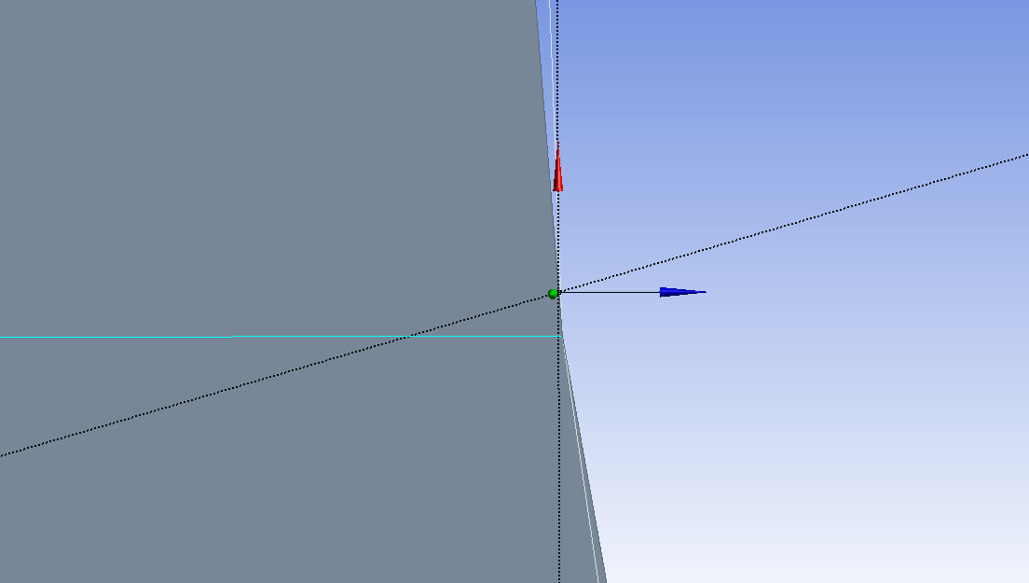
Line should be connected to this point
origin

airfoil
fluid domain
end

start

  - Once you select both points hit Apply. Then click Generate.

  - Repeat this process creating lines from the edge of the circle to the airfoil starting from the circle and ending at the airfoil (A to A’, B to B’ and C to C’). The images below show the locations of the points on the airfoil and the points on the circle.
A
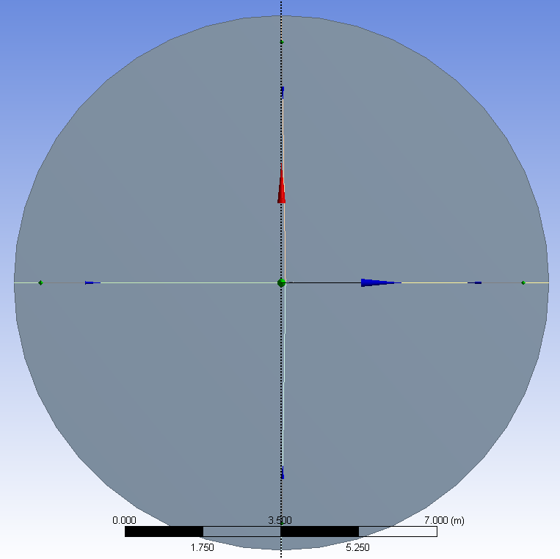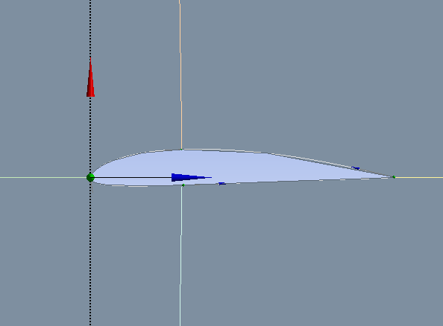
C

A’
B’
C’

B

  - Tools > Projection. Select the four edges you created for Edges and click Apply then select the domain circle for Target and click Apply, then click Generate. This will split your geometry into four sections.
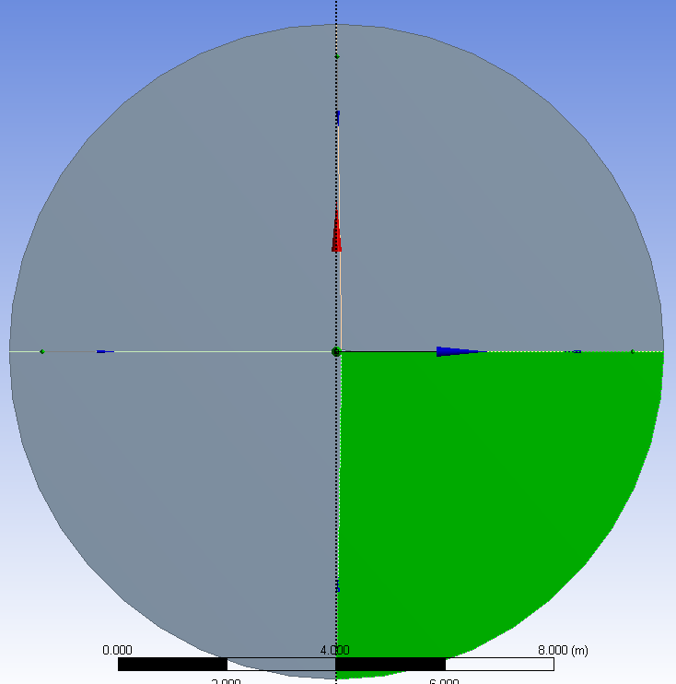.

  - File > Save project and exit.
- Mesh Generation

  - From Workbench home screen right click on Mesh and select Edit… from the dropdown menu.

  - Right click Mesh then Insert > Face Meshing. Select the four surfaces while holding Ctrl then click Apply.

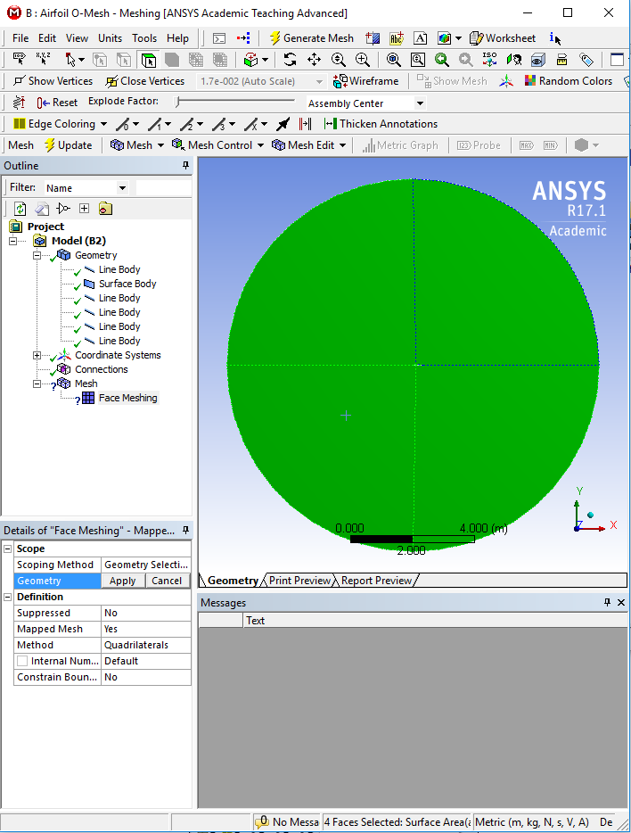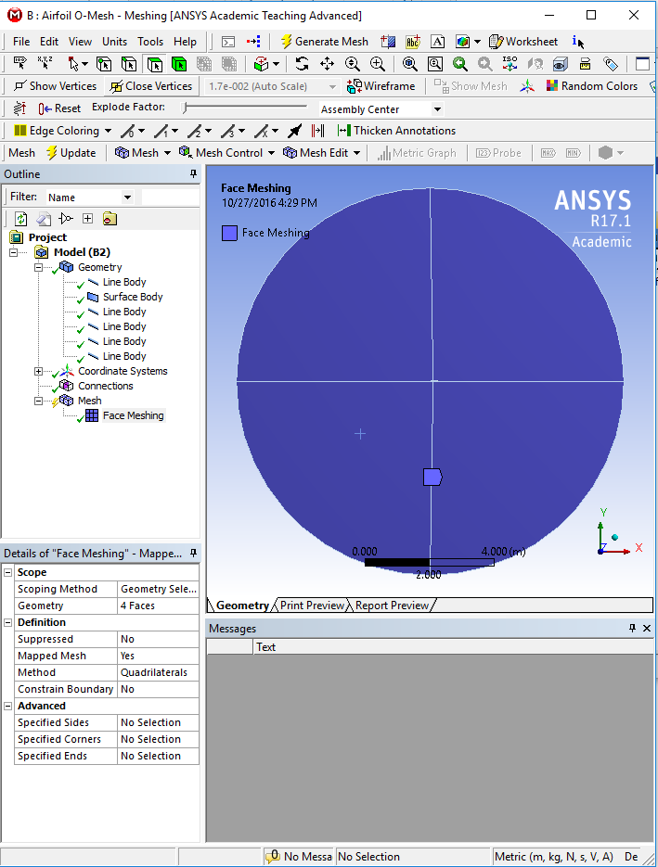

  - Right click Mesh and Insert > Sizing. Make sure to change the selection tool to edge and select two edges as per below and change the parameters as per below (Click ‘Edge selector’ from the top).

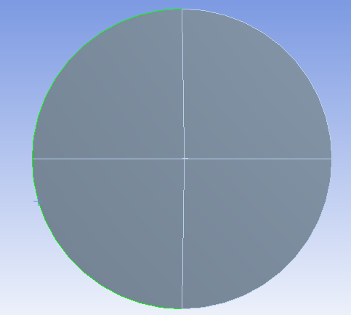

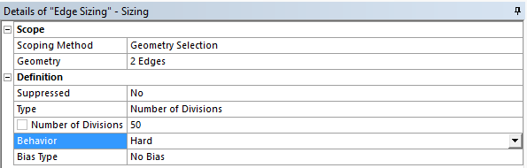

  - Right click Mesh and Insert > Sizing. Select two edges as per below and change the parameters as per below.
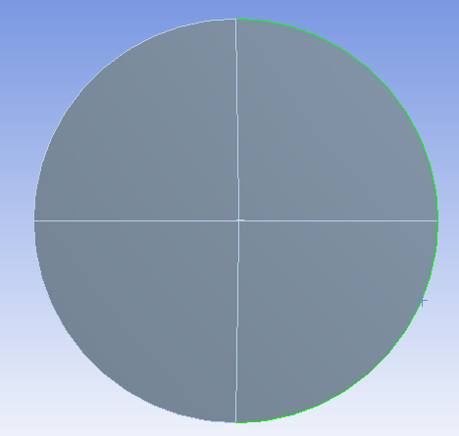

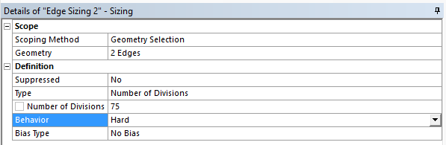

  - Right click Mesh and Insert > Sizing. Select all for lines leading from the circle to the airfoil surface, and click Apply. Change parameters as per below. (Note: If you did not create the lines starting from the outer circle and ending on the airfoil surface, you may have issues with biasing. If this is your case, size the lines individually making sure that the sizing is finest at the surface of the airfoil.)

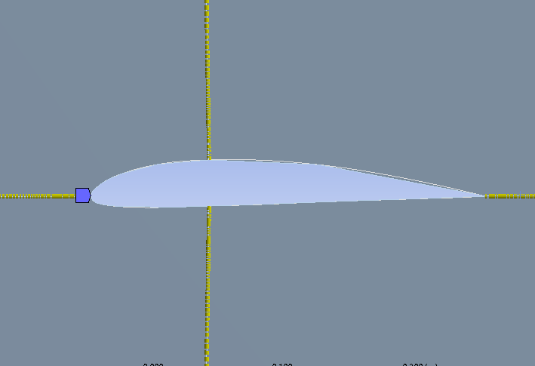

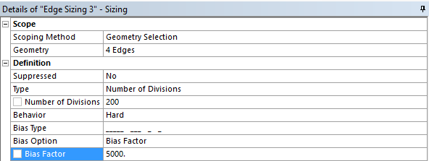

  - Right click Mesh and Insert > Sizing. Select the surface at the top of leading edge of the airfoil and click Apply. Change Parameters as per below.
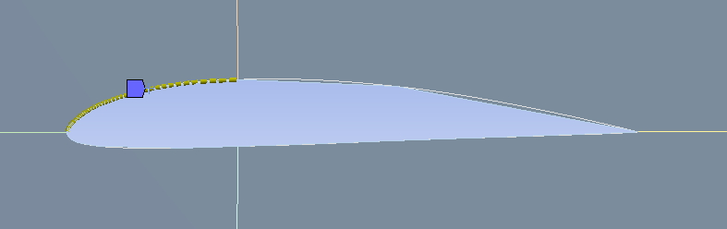

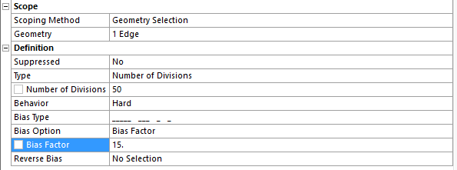

  - Right click Mesh and Insert > Sizing. Select the surface at the bottom of leading edge of the airfoil and click Apply. Change Parameters as per below.
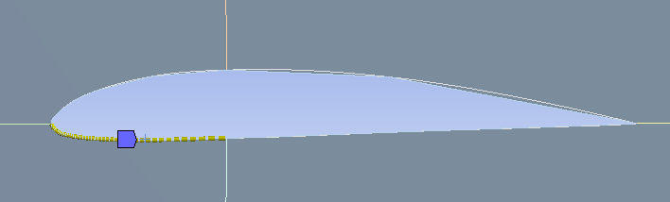

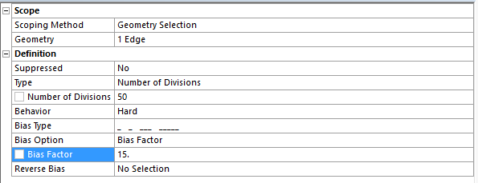

  - Right click Mesh and Insert > Sizing. Select the surface at the top of trailing edge of the airfoil and click Apply. Change Parameters as per below.
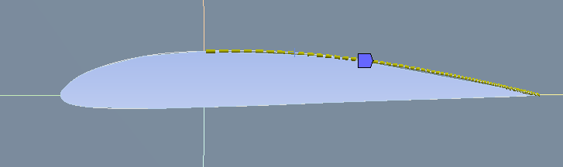

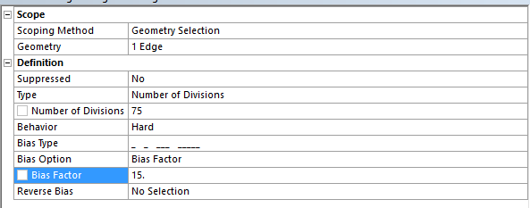

  - Right click Mesh and Insert > Sizing. Select the surface at the bottom of trailing edge of the airfoil and click Apply. Change Parameters as per below.
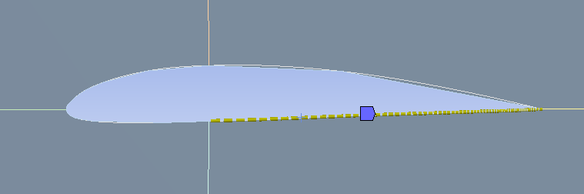

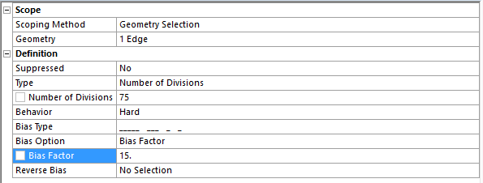

  - Click on Mesh in the Outline, this will bring up Details of “Mesh”, under Physics Preference, change the mesh type to CFD from Mechanical.

  - Click Generate Mesh. Click on the Mesh button under the Outline and make sure it resembles the mesh below.
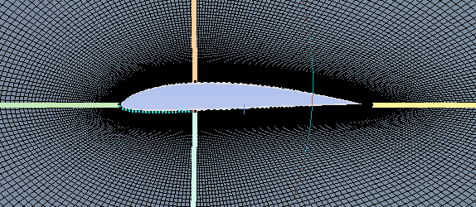

  - Hold Ctrl and select the two left most semicircle arcs, right click on them and select Create Named Selection, name the selection inlet. Use the edge select button from the toolbar.

  - Do the same for the two right most semicircle arcs and name them outlet.

  - Select the four regions that make the airfoil, right click and Create Named Selection and name it airfoil.

  - Now use the ‘Face selector’ button to select the four semicircle quadrants and Create Named Selection and name them fluid.

  - File > Save Project. Exit the window
- Setup

  - If there is not a checkmark next to Mesh, right click Mesh, and click the Update.

  - From the Workbench home screen right click on Setup and select Edit…

  - Select Double Precision and click OK.
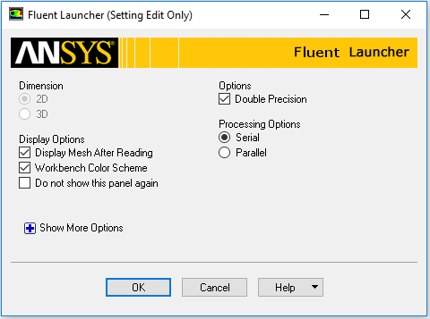

  - If this note pops up, click OK

  - Setup > Models > Viscous –Laminar > Edit… Change the parameters as per below and click OK. (For the inviscid case, select Inviscid from the Viscous Model menu.)
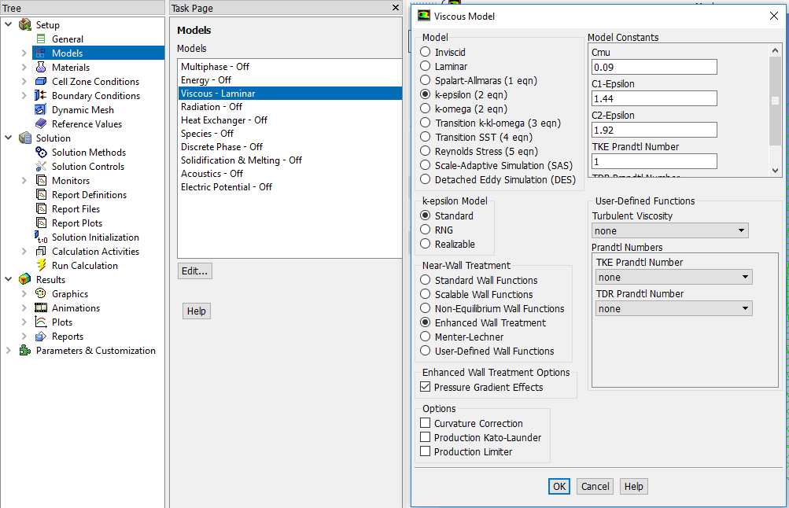

  - Setup > Materials > air > Create/Edit… Change parameters as per experimental data and click Change/Create and then Close. (For inviscid model, you do not need to input Viscosity parameter.)
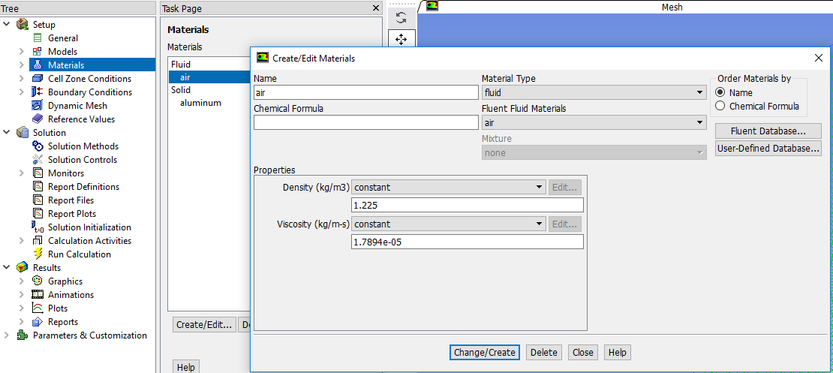

Use the air properties at the room temperature when you conducted EFD Lab3. You can use the following website to calculate air properties from the temperature:
http://www.mhtl.uwaterloo.ca/old/onlinetools/airprop/airprop.html
The values in the figure above are for 24° temperature.
NOTE: viscosity used in ANSYS is the dynamic viscosity (), NOT kinematic viscosity ()
  - Setup > Boundary Conditions > inlet > Edit… Change parameters as per experimental data (blue box) and default values (red boxes) and click OK. The experimental value can be found from the EFD Lab 3 data reduction sheet. (For inviscid model you do not need to specify turbulence parameters.)
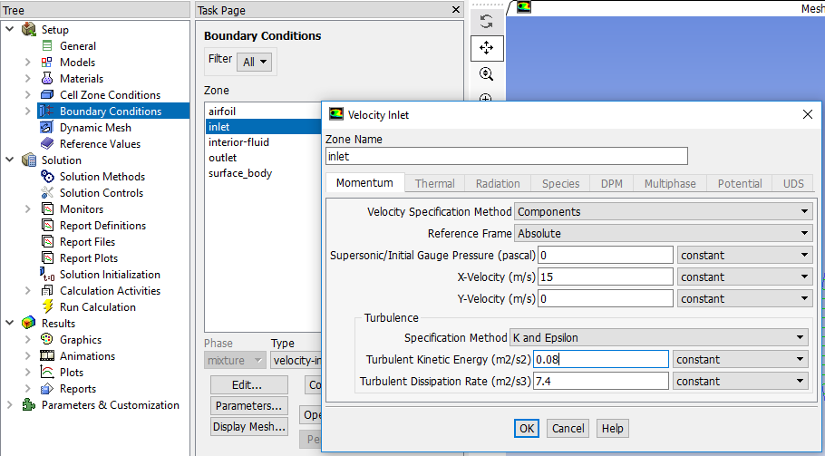

  - Setup > Boundary Conditions > Outlet > Edit… Change the parameters as per below and click OK. (For inviscid model you do not need to specify turbulence parameters.)
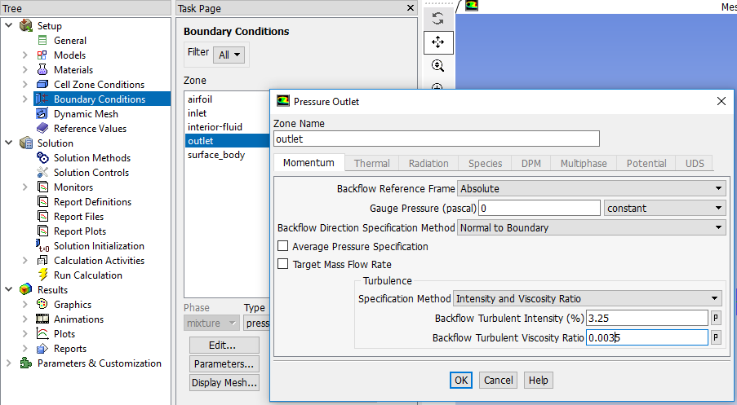

  - Setup > Reference Values. Change parameters as per below. The velocity, temperature, density, and viscosity should be entered from EFD data.
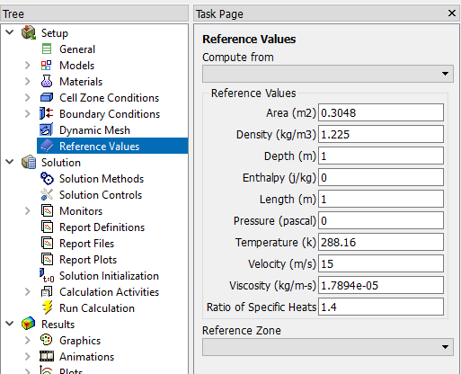

  - Solution > Solution Methods. Change parameters as per below. (For inviscid case you do not need to input turbulence parameters.)
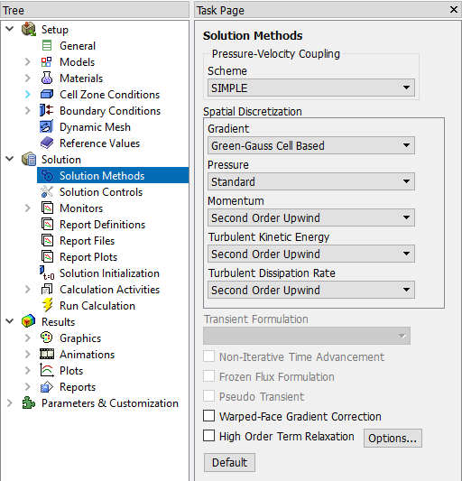

  - Solution > Solution Controls. Change Parameters as per below. (If you have problems with the solution converging, you may decrease the Under –Relaxation Factors.) (For inviscid case you do not need to specify turbulence parameters.)
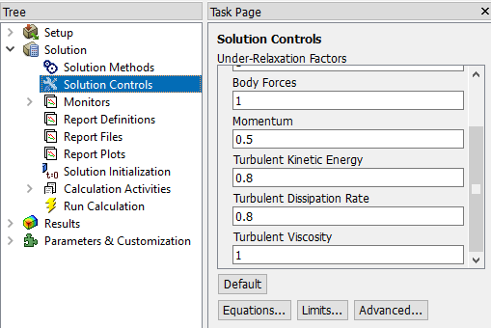

Make sure you scrolled down

  - Solution > Monitors > Residuals –Print, Plot > Edit…. Change the convergence limit to 1e-05 for all five equations and click OK. (For inviscid case you do not need to specify convergence criterion for turbulence parameters. You only need to specify criterion for three equations.)
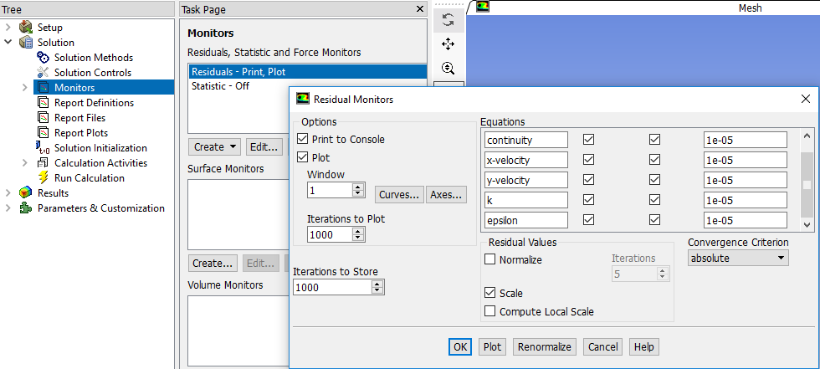

  - Solution > Solution Initialization. Change the parameters as per below and click Initialize. (For inviscid case you do not need to initialize turbulence parameters.)
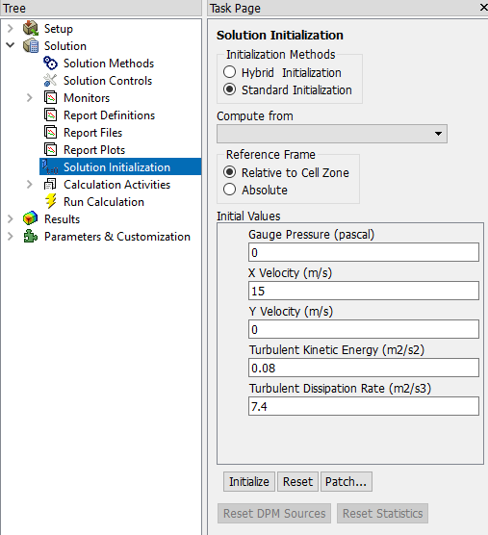

  - Solution > Run Calculation. Change the Number of Iterations to 10000 and click Calculate.
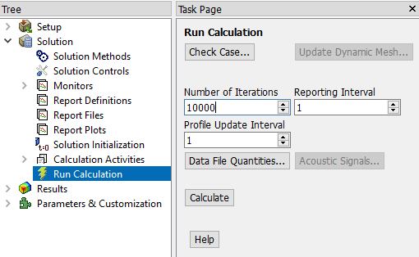

Residual history should look similar to the one below.
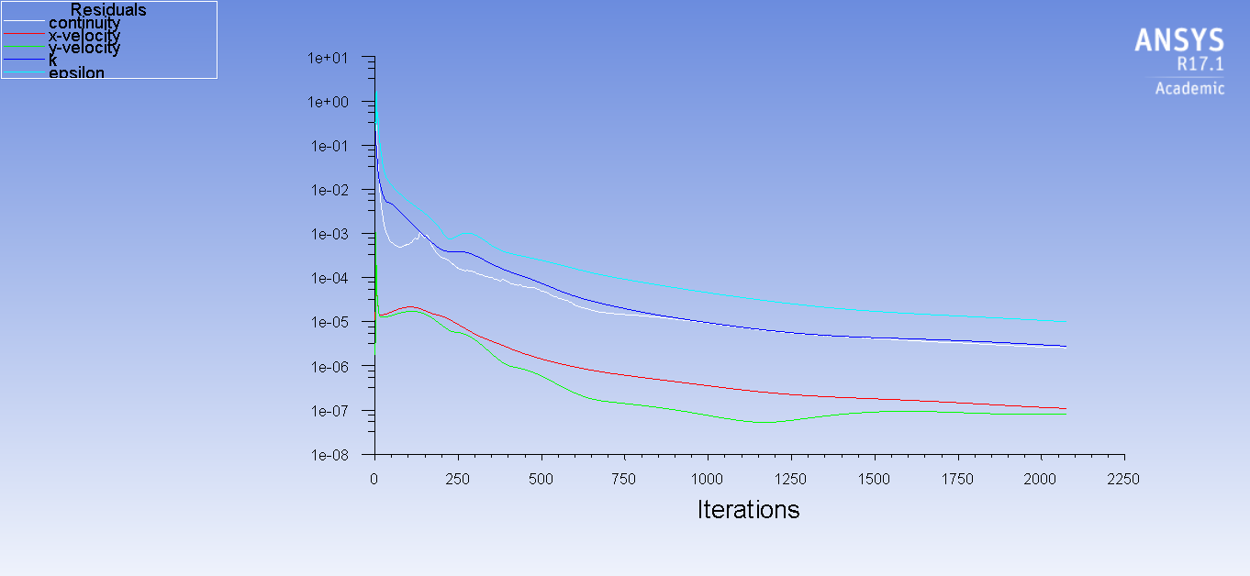

  - File > Save Project.

- Results

  - Saving Pictures

File > Save Picture… > Save… You can take a snapshop of a current display by using this tool. Please make sure to save pictures in your working folder by navigating correctly when you enter the browser.
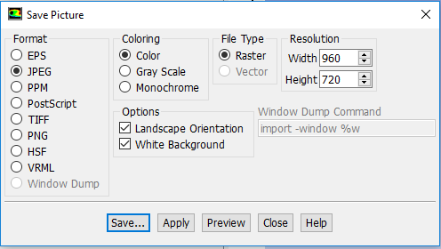

  - Plotting Residual History

Solution > Monitors > Residuals –Print, Plot > Edit… > Plot > OK. Make sure the parameters are as per below. Name the file “CFD Pre-Lab 2 Residual History” when you save the picture.
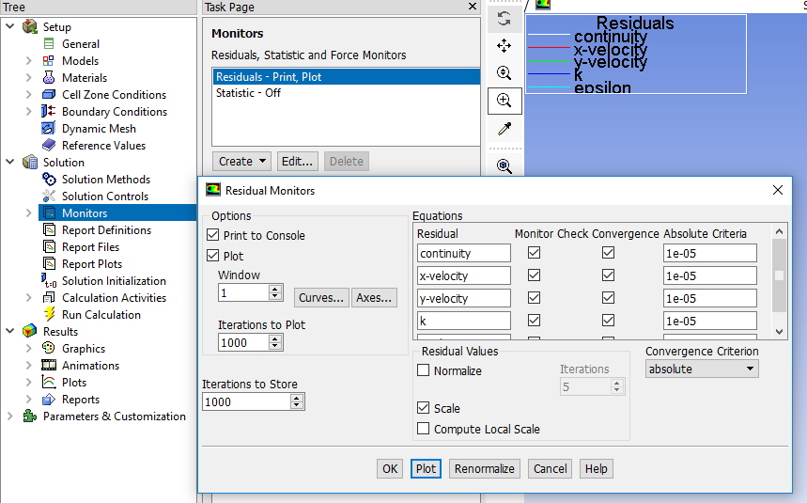

  - Plotting Pressure Coefficient Distribution with CFD and EFD Data

Results > Plots > XY Plot > Set Up… > Load File… Select Pressure-coef-attack0.xy. Change the parameters as per below and click Plot. Name the file “CFD Pre-Lab 2 Pressure Coefficient Distribution” when you save the picture.
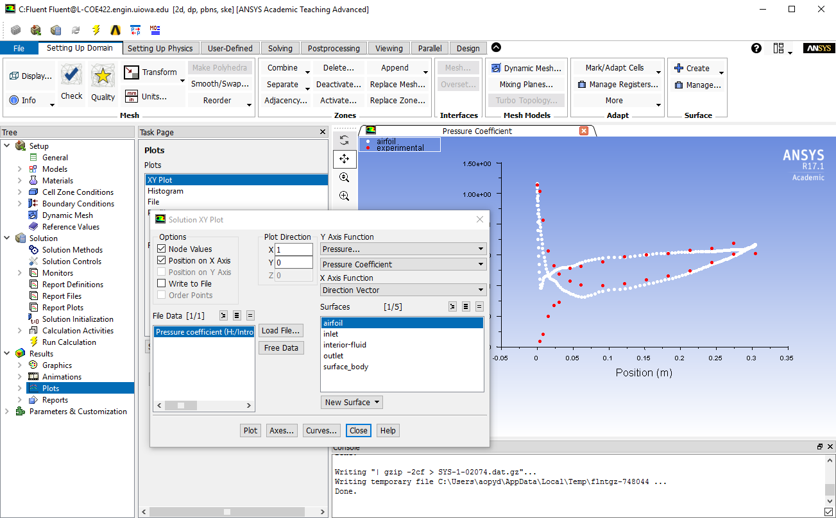

  - Plotting Contour of Pressure

Results > Graphics and Animations > Contours > Set Up… Change the parameters as per below and click Display. Name the file “CFD Pre-Lab 2 Contour of Pressure” when you save the picture.
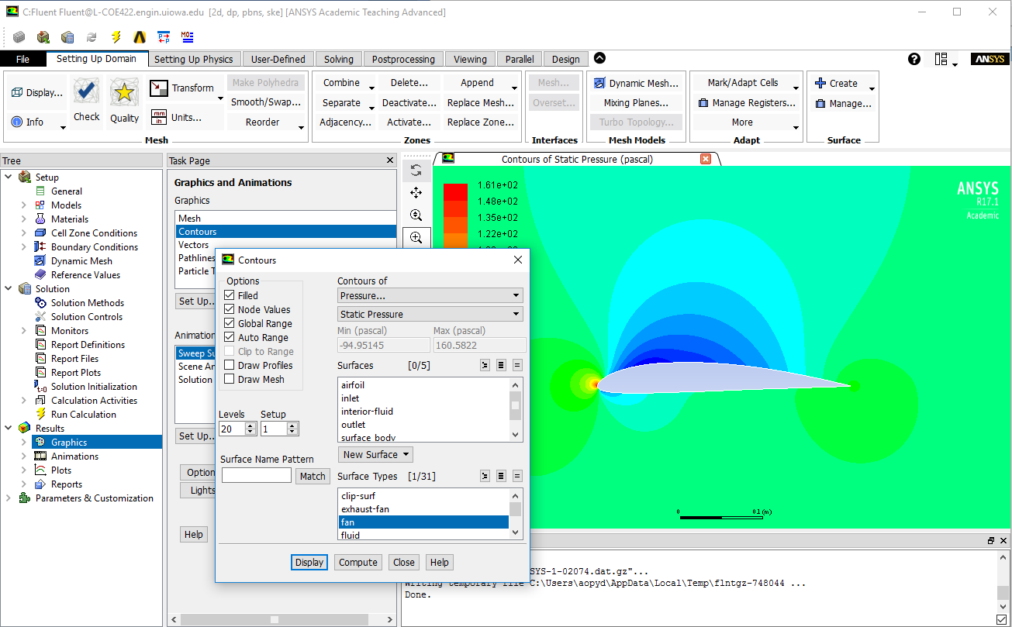

  - Plotting Contour of Velocity Magnitude

Results > Graphics and Animations > Contours > Set Up… Change the parameters as per below and click Display. Name the file “CFD Pre-Lab 2 Contour of Velocity Magnitude” when you save the picture. Zoom in where you can see the airfoil clearly and the change in contour levels around the airfoil.
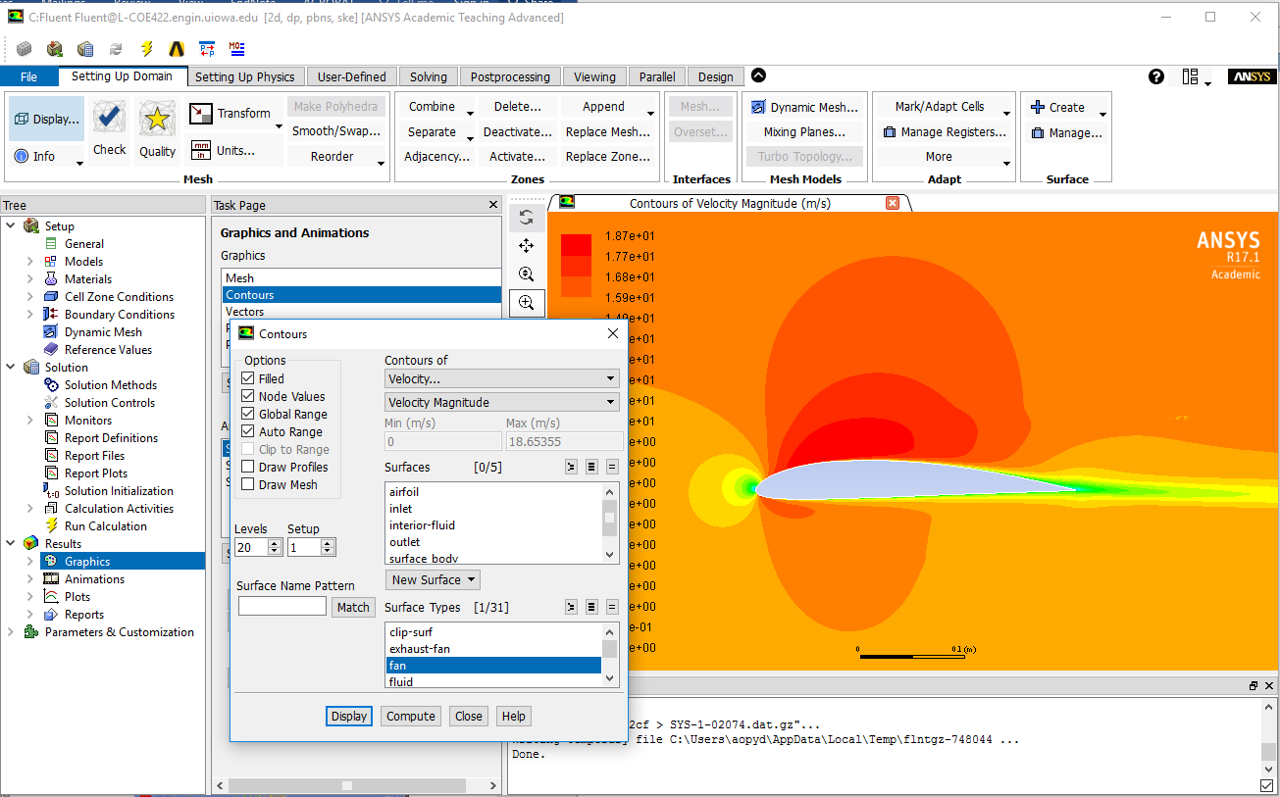

  - Plotting Velocity Vectors at Leading Edge

Results > Graphics and Animations > Vectors > Set Up… Change parameters as per below and click Display. Name the file “CFD Pre-Lab 2 Vectors of Velocity at Leading Edge” when you save the picture. Zoom in on the leading edge.
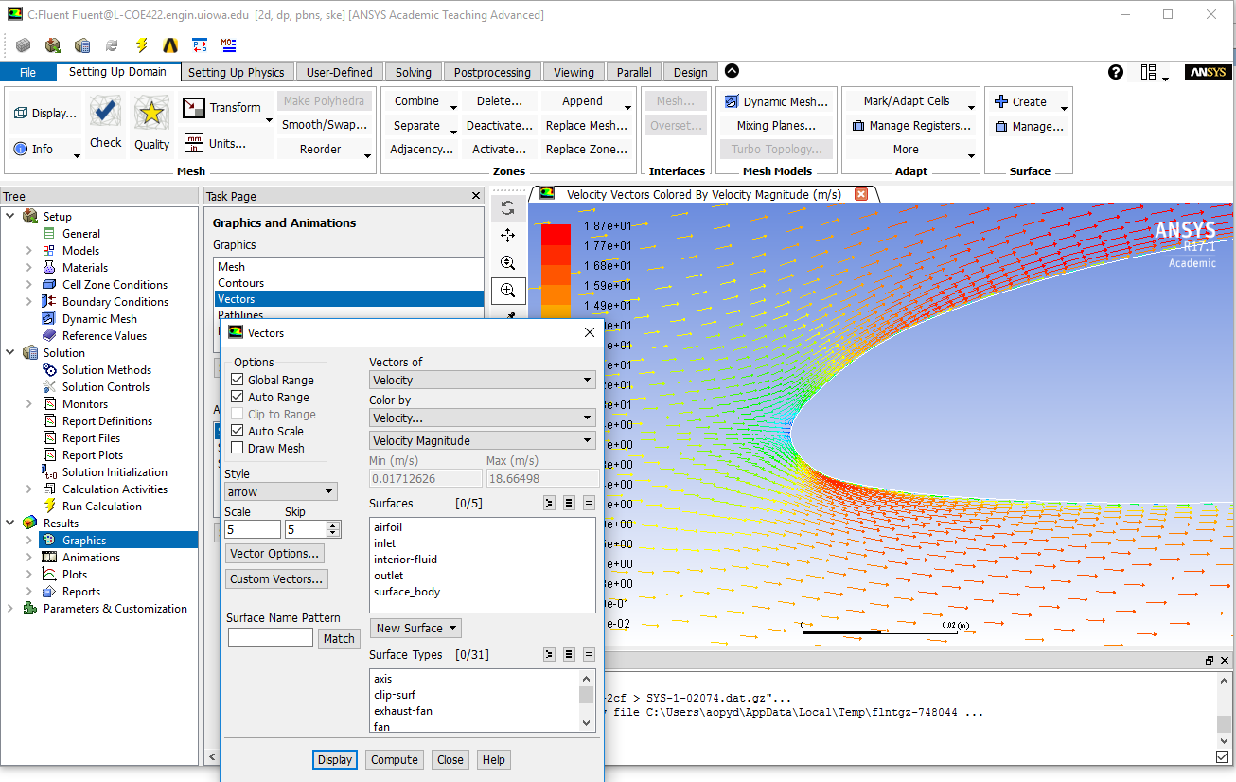

  - Plotting Streamlines Close to Airfoil Surface

Results > Graphics and Animations > Contours > Set Up… Change parameters as per below and click display. Name the file “CFD Pre-Lab 2 Streamlines Close to Surface” when you save the picture. (Note: You may need to change the Min and Max to adjust the streamlines around the airfoil.)
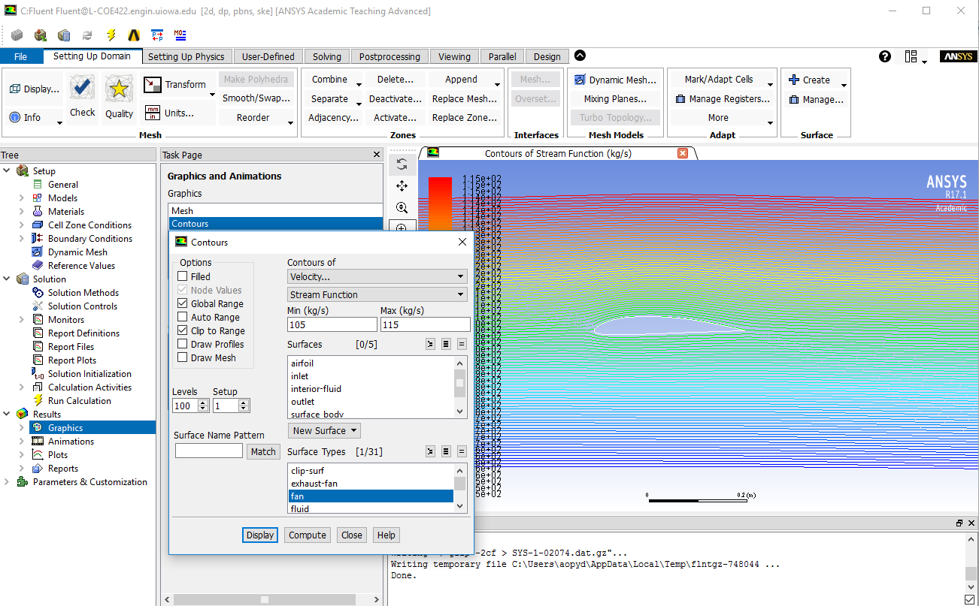

  - Printing Lift and Drag Coefficients

Results > Reports > Forces > Set Up… Change parameters as per below and click Print. This prints out the drag force. If you change the X parameter to 0 and the Y parameter to 1, this prints out the lift force. If you change the X parameter to 1 and the Y parameter to 0, this prints out the drag force. Save these values on to the CFD Lab 2 report template.
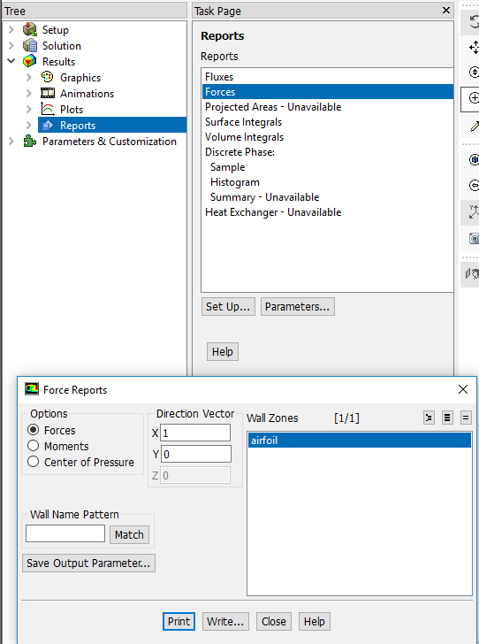

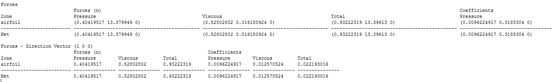

Exercises

Simulation of Turbulent Flow around an Airfoil

You must complete all the following assignments and present results in your CFD Lab 2 reports following the CFD Lab Report Instructions.

  - Validation using EFD Lab 3 data
(1). Use the same flow conditions as those in your EFD Lab 3, including geometry (chord length, angle of attack 0) and Setup (Flow properties, inlet velocity). Use k-e model, 2nd order scheme, double precision with iteration number (10000) and convergent limit (1e-05). Run the simulation.
(2). Modify your EFD data of pressure coefficient in ANSYS format (sample EFD data format has been provided in CFD Lab 1) and import it into ANSYS Fluent for pressure coefficient distribution and conduct validation. Also compare the CFD lift coefficient value with EFD data.
- Figures need to be saved: (1) Time history of residuals (residual vs. iteration number); (2) Pressure coefficient distribution (CFD and EFD); (3) Contour of pressure; (4) Contour of velocity magnitude; (5) Velocity vectors (show the region that is interesting, such as the separation region when angle of attack is large or close to the leading edge of the airfoil) and (6) Streamlines close to airfoil surface.
- Data need to be saved: lift and drag coefficients

  - Inviscid flow simulation
Use the same conditions as those in exercise 1, except choose “inviscid” for “viscous model”, set the iteration number to be (10000), and convergent limit to be 10⁻⁵. Conduct the simulation and compare solutions with viscous flow results in exercise 8.1.
- Figures need to be saved: (1) Time history of residuals; (2) Pressure coefficient distribution (CFD only); (3) Contour of pressure; (4) Contour of velocity magnitude; (5) Velocity vectors (show the same region that your picked in exercise 8.1) and (6) Streamlines close to airfoil surface.
- Data need to be saved: lift and drag coefficients

  - Questions need to be answered in CFD Lab 2 report:
    - Does inviscid flow has boundary layer near the wall? Zoom in the near wall region and describe the differences of velocity vectors near the airfoil surface for inviscid and viscous flows.
    - What are the correct boundary conditions for velocity and pressure at “inlet” and “outlet”.
    - What are the values for lift and drag coefficients for inviscid flow around the airfoil? Are they both zero?
    - Where are the highest and lowest locations for pressure and velocity magnitude? Why? Is pressure constant for inviscid flows around airfoil?
    - For turbulent flow around airfoil, try to qualitatively explain why there is a lift force (vertical up) on an airfoil using the contour plot of pressure or the XY plot of pressure coefficient distribution.

