Rajan’s Book Chapter 3: Structural Design Fundamentals

What is Design?
Design – a process by which an optimum solution is obtained.

-- Emphasizing minimum weight (minimum cost).
-- Mixture of art and science.

Material Behavior

Stress and strain
Shear stress and strain

Material Properties

Linearly elastic range
Initial yielding – perfectly plastic rang
Strain hardening phase
Ultimate stress
Fracture

Stress-Strain Relationship

Young’s modulus (modulus of elasticity), E
Shear modulus, G
Poisson’s ration, ν

Principal Stress and Strain

Stresses on a plane at an angle θ
Maximum direct stress
Maximum shear stress
Mohr’s circle to represent state of stress at a point

Stress and Strain Computations

Need cross-sectional properties: centroid, area, moment of inertia
Axial force: stress = force /area = N_{x}/A
Bending moment: 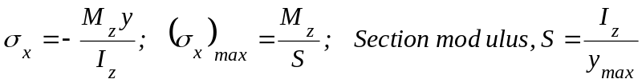
Shear force: 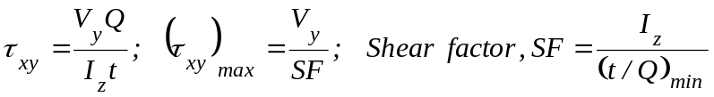
Combined stress: 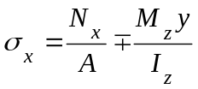

Theories of Failure

Some causes of structural failure:
Yielding
low stiffness
buckling
crushing
fracture.

Failure criteria:
Von Mises Criterion: Octahedral shearing, strain energy density of distortion
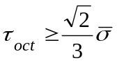
Maximum Principal Stress Criterion: 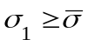
Buckling: 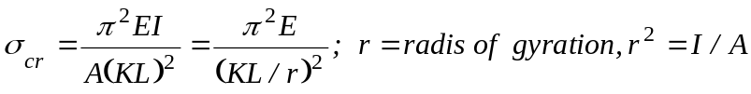
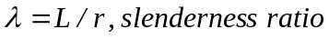

Steel Materials and Properties

1. Steels

- Steels for structural use may be classified as:

-- Carbon steels:
* Increased carbon percent raises the yield stress but reduces ductility.
* Typical: A36, general structural purpose, mainly for buildings.

-- High-strength low-alloy steels:
* Yield strength ranging from 40 to 70 ksi.
* Typical: A572, structural shapes

-- Alloy steels:
* Yield strength ranging from 80 to 110 ksi, no well-defined yield point.
* Typical: A514, primarily for welded bridges.

2. Mechanical Properties

- Uniaxial stress-strain curve:

-- Modulus of elasticity (Young’s modulus): E=29,000 ksi.

-- Yield strength 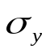: yield point, or stress at an offset strain of 0.2%.

-- Plastic range (plateau) and strain hardening.

-- Ductility: permanent strain (plastic strain) up to the point of fracture.

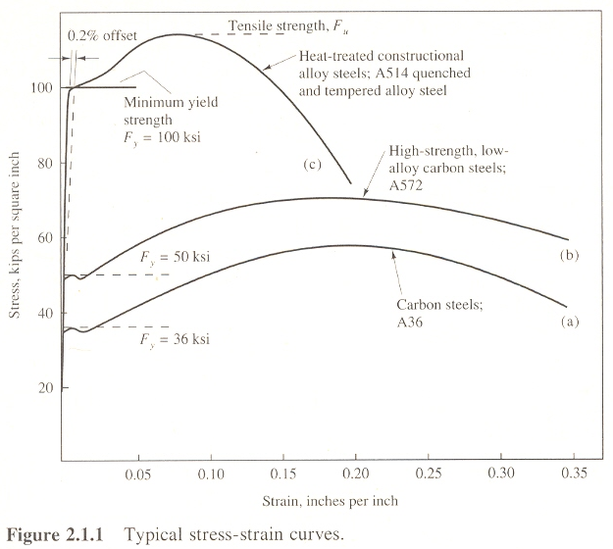

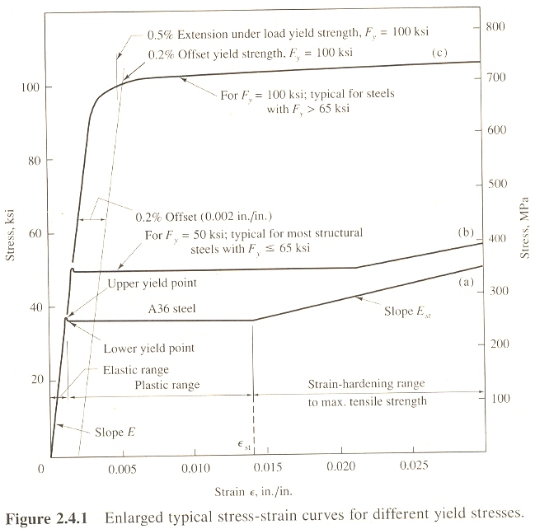

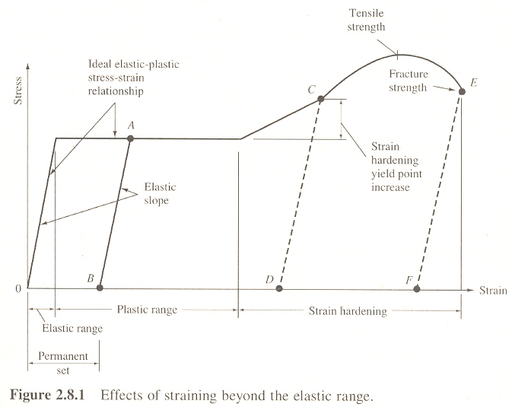

Modeling the Structure and the Loads

Truss model
Frame model
Loads: dead, live, snow, wind, earthquake (ASCE 7-02)

1. Loads

- Dead load: a fixed-position gravity service load.

-- Weight of the structure
-- Attachments to the structure (pipes, suspended ceilings, lighting fixtures, etc.)

- Live load: gravity loads acting when the structure is in service, but varying in magnitude and location.

-- For example, human occupants, furniture, movable equipment.
-- Difficult to determine; need empirical and conservative estimation.
-- Typical live loads (from ASCE 7 Standard, 2002):
Hotel guest rooms, school classrooms: 40 psf.
Office: 50 psf.
Library reading rooms: 60 psf.
Library stack rooms: 150 psf.

- Snow load: live loading for which roofs are designed.

-- Basic snow load used in design varies 30 ~ 40 psf in the northern/eastern states.
-- Basic snow load used in design is about 20 psf in southern states.

- Wind load: all structures are subject to wind load, but it is usually only those more than three or four stories high, as well as long bridges, for which special consideration of wind is required.

- Earthquake load: the effect of horizontal motion of the ground during earthquake is thought of as earthquake load.

2. Steel Structures and Their Members

- Structures may be divided into three general categories:

-- Framed structures: beams and columns, most typical building construction.
-- Shell-type structures: axial forces predominate. (e.g., water tanks)
-- Suspension-type structures: tension cables are major supporting elements. (bridges)

- Steel members: tension members, compression members, beams, and columns.

- Standard steel rolled shapes: (cross section)

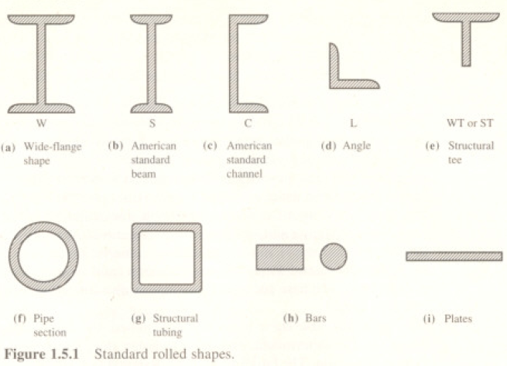

- Wide-flange shape: most commonly used section.

-- For example, W18x97: nominally 18 in. deep (18.59 in.) and 97 lb/ft weight.

