Manufacturing Systems Spring 2004 NAME ____Solution (20 Points)______
Quiz 2 Date: February 5, 2004
☺☺☺☺☺

  - (4) Name the four main types of manufacturing layout
Process
Product
Cellular
Fixed-position

  - (4) Show where the four types are approximately located on a graph, with variety along the horizontal axis and volume on the vertical axis

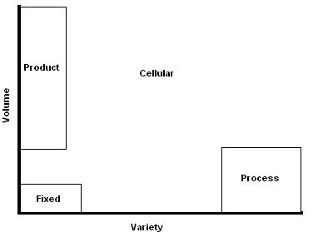

  - (2) An item that costs $874 has a reorder point of 250, with a mean demand of 20 per day and an expected lead time of 5 days. What is the safety stock level?

SS = r – τD = 250 – 20*5 = 150

  - (5) Give 5 reasons why inventory is kept.

Effective preventative maintenance
Price breaks for purchasing large quantities
Unreliable suppliers
Seasonal demand
Readily available products

  - (3) How is mass production used in the Dell supply chain?

Parts are mass produced by suppliers then shipped to Dell distribution centers where they are assembled to customer specifications then shipped out to the respective customers. During the assembly process, each person completes a specialized task then sends the product down the line to another individual.

  - (2) Describe an advantage that push systems have over pull systems and an advantage that pull systems have over push systems

Push systems – higher inventory, products are readily available
Pull systems – lower inventory, made to order products

